Branch coverage:

Registrant controller:

1- registration function:

Test cases:

#fill it with inputs in the code

|  |  |
| --- | --- |
| Input | EO |
| New registrant | Registration successful |
| Another registrant has the same email | This email belongs to another ssn |
| Registered in the same course before | You are already registered to this course |
| Ssn larger than 14 numbers | Ssn should be 14 numbers only |

Execution : failure in test case 4

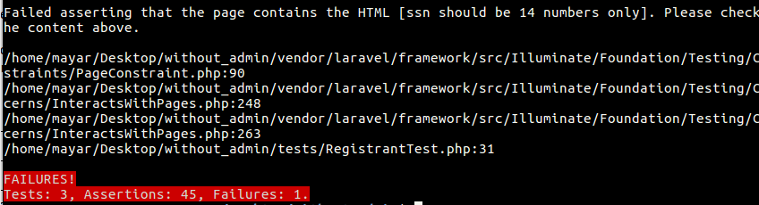

==============================================================

2- Add review Function

Test cases:

|  |  |
| --- | --- |
| Input | EO |
| Course Id=-1 | Redirect back to page |
| Empty review | The review field is required |
| Registrant confirmed | **Review Added successfully** |
| Registrant not confirmed | **your registration isn't confirmed yet to add a review** |
| Not registered in this course | **you aren't registered in this course** |

Execution:

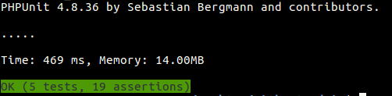

3-Add rating function:

Test cases:

|  |  |
| --- | --- |
| Input | EO |
| Course Id=-1 | Redirect back to page |
| Empty rating | The rating field is required |
| Registrant confirmed and hasn’t rated before | **Rating Added successfully** |
| Registrant confirmed but already rated | **your already rated this course** |
| Registrant not confirmed | **your registration isn't confirmed yet to rate** |
| Not registered in this course | **you aren't registered in this course** |

Execution:

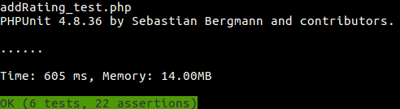

###########################################################################

Logic Coverage: (RACC)  
1- Registration function:

Predicates :

* $this->validate(), always active

|  |  |  |
| --- | --- | --- |
| $this->validate() | Input | Expected output |
| True | Successful registration input | Registration successful |
| False | SSN >14 digits | Ssn should be 14 digits |

* ($regist!=**null** && $regist->**ssn**!=$req->**ssn**) reachability:validate is true  
  Using shortcut for cnf form

|  |  |  |  |
| --- | --- | --- | --- |
| $regist!=**null** | $regist->**ssn**!=$req->**ssn** | Input | Expected output |
| True | True | Adding same email with different ssn than the one in the database | This email belongs to another ssn |
| False | True | New registration | Registration successful |
| True | False | Already registered in the same course | You are already registered in this course |

* ($regist===**null**) reachability: p2 is true

|  |  |  |
| --- | --- | --- |
| $regist===**null** | Input | Expected output |
| True | New registrant( not registered in any other course) | Registration successful |
| False | Already registered | You are already registered in this course |

* ($course_reg==**null**) reachbility: p2 is false

|  |  |  |
| --- | --- | --- |
| $course_reg===**null** | Input | Expected output |
| True | New registration (wether registered for another course or not) | Registration successful |
| False | Already registered | You are already registered in this course |

Minimal test case to satisfy RACC coverage -->same as branch coverage

|  |  |
| --- | --- |
| input | Expected output |
| New successful registration (not in database before) | Registration successful |
| Invalid input (ssn<14) | Ssn should be <14 |
| Adding same email with different ssn than the one in the database | This email belongs to a different ssn |
| Already registered in the course | You are already registered in this course |

Execution: failure in test case 2

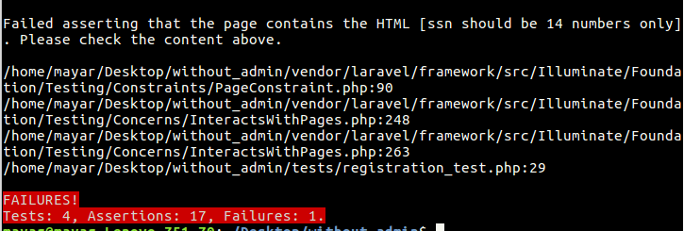

2-Add review function

Predicates :

* $this->validate

|  |  |  |
| --- | --- | --- |
| $this->validate | Input | Expected output |
| True | Successful review | Review added successfully |
| False | Empty review | The review field is required |

* (!**empty**($course)), reachability : p1=true

|  |  |  |
| --- | --- | --- |
| (!**empty**($course)) | Input | Expected output |
| True | Successful review | Review added successfully |
| False | Course id=-1 | Redirect back |

* (Hash::*check*($req->**code**,$reg->**code**)) reachability: p2=true

|  |  |  |
| --- | --- | --- |
| (Hash::*check*($req->**code**,$reg->**code**)) | Input | Expected output |
| True | Code matches one of the registrants of the course | Review added successfully |
| False | Code doesn’t match any registrant | You aren’t registered in this course |

* (!$reg->**confirmed**) reachability: p3 true

|  |  |  |
| --- | --- | --- |
| (!$reg->**confirmed**) | Input | Expected output |
| True | Code matches but not confirmed | You aren’t confirmed to add a review |
| False | Code matches and is confirmed | Review added sucessfully |

Minimal test case to satisfy RACC:

|  |  |
| --- | --- |
| Input | Expected output |
| Successful review (correct input, valid course, code matches,confirmed) | Review added successfully |
| Course code not valid | Redirect back |
| Empty review field | Review field is required |
| Code doesn’t match any registrant | You aren’t registered in this course |
| Code matches but not confirmed | You aren’t confirmed to add a review |

**Execution: no failures**



3- Add rating function

Exactly the same with one additional predicate:

($user_ratings !=0) reachbility: confirmed=true

|  |  |  |
| --- | --- | --- |
| ($user_ratings !=0) | Input | Expected output |
| True | Successful registration | Rate successfult |
| False | Already rated the course | You already rated |

Minimal test case

|  |  |
| --- | --- |
| Input | Expected output |
| Successful rating (correct input, valid course, code matches,confirmed) | Rating added successfully |
| Course code not valid | Redirect back |
| Empty rating field | rating field is required |
| Code doesn’t match any registrant | You aren’t registered in this course |
| Code matches but not confirmed | You aren’t confirmed to add a rating |
| User already rated the course | You already rated |

**Execution: no failures**



**Logic coverage on specifications (preconditions**)

**Registration function :**

All fields are required, name doesn’t contain numbers, email of valid format, national id consists of numbers only , national id is 14 digits , phone number consists of numbers only, phone number is 11 digits, name is less than 100 characters, course id is a positive integer

Predicate: !empty(name) ^ !empty (email) ^ !empty( ssn) ^ !empty(address) ^ !empty(phone number) ^ !numeric(name) ^ valid_format(email) ^ len(ssn) =14 ^ len(name)<100 ^len(phone number)=11 ^ numeric(ssn) ^ numeric(phone number) ^ integer(course id) ^ greater_than_zero(course id)

RACC COVERAGE:

|  |  |  |  |  |  |  |  |  |  |  |  |  |  |
| --- | --- | --- | --- | --- | --- | --- | --- | --- | --- | --- | --- | --- | --- |
| a | b | c | d | e | f | g | h | i | j | k | L | m | n |
| T | T | T | T | T | T | T | T | T | T | T | T | T | T |
| F | T | T | T | T | T | T | T | T | T | T | T | T | T |
| T | F | T | T | T | T | T | T | T | T | T | T | T | T |
| T | T | F | T | T | T | T | T | T | T | T | T | T | T |
| T | T | T | F | T | T | T | T | T | T | T | T | T | T |
| T | T | T | T | F | T | T | T | T | T | T | T | T |  |
| T | T | T | T | T | F | T | T | T | T | T | T | T | T |
| T | T | T | T | T | T | F | T | T | T | T | T | T | T |
| T | T | T | T | T | T | T | F | T | T | T | T | T | T |
| T | T | T | T | T | T | T | T | F | T | T | T | T | T |
| T | T | T | T | T | T | T | T | T | F | T | T | T | T |
| T | T | T | T | T | T | T | T | T | T | F | T | T | T |
| T | T | T | T | T | T | T | T | T | T | T | F | T | T |
| T | T | T | T | T | T | T | T | T | T | T | T | F | T |
| T | T | T | T | T | T | T | T | T | T | T | T | T | F |

Test cases:

|  |  |
| --- | --- |
| Input | Expected output |
| All valid inputs | Registration successful |
| Empty name | Name field is required |
| Empty email | Email field is required |
| Empty ssn | Ssn field is required |
| Empty address | Address field is required |
| Empty phone number | Phone number field is required |
| Numeric name | Name can’t be numeric |
| len(ssn)=12 | Ssn must be 14 digits |
| Ssn contains letters | Ssn must be numeric |
| Phone number contains letters | Phone numbers must be numeric |
| Invalid email | Email format is invalid |
| len(name)>100 | Name must be smaller than 100 characters |
| len(phone number)=13 | Phone number must be 11 digits |
| Non integer course id | Redirect back without registration |
| Negative course id | Redirect back without registration |

**Execution: 4 failures**

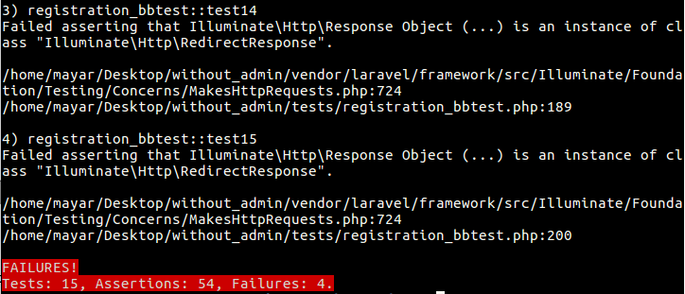

**Add review function**

Preconditions: review field is required and code field is required

Predicate : !empty(review) ^ !empty(code) ^ integer (course_id) ^ positive (course_id)

RACC coverage:

|  |  |  |  |  |  |
| --- | --- | --- | --- | --- | --- |
| Clause a | Clause b | Clause c | Clause d | input | Expected out |
| T | T | T | T | Valid inputs | Review added successfully |
| F | T | T | T | Empty review | Review field is required |
| T | F | T | T | Empty code | Code field is required |
| T | T | F | T | Non integer course id | Redirect back without adding review |
| T | T | T | F | Negative course id | Redirect back without adding review |

**Execution: no failures**

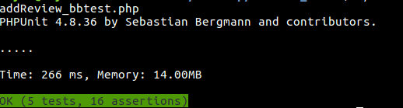

**Add rating function**

Preconditions: rating field is required, code field is required , rating must be a number

Predicate: !empty(rating) ^ !empty(code) ^ numeric (rating) ^ integer (course_id) ^ positive (course_id)

RACC coverage:

|  |  |  |  |  |  |  |
| --- | --- | --- | --- | --- | --- | --- |
| Clause a | Clause b | C | D | E | input | Expected out |
| T | T | T | T | T | Valid inputs | rating added successfully |
| F | T | T | T | T | Empty rating | rating field is required |
| T | F | T | T | T | Empty code | Code field is required |
| T | T | F | T | T | Rating is a letter | Rating must be numeric |
| T | T | T | F | T | Non integer course id | Redirect back without adding review |
| T | T | T | T | F | Negative course id | Redirect back without adding  review |

**Execution: no failures**

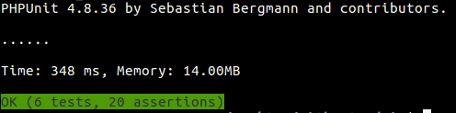

**Input space partitioning: base choice**

1-Registration:

Applying interface based partitioning

*bold is the base choice

|  |  |  |  |
| --- | --- | --- | --- |
| characteristic | blocks | | |
| a-Name is empty | True | **False** |  |
| b-Name is a number | True | **False** |  |
| c-Name size | **<=100** | >100 |  |
| d-Address is empty | True | **False** |  |
| e-Phone number is empty | True | **False** |  |
| f-Phone number size | <11 | **=11** | >11 |
| g-Phone number is an integer | **True** | False |  |
| h-Email is empty | True | **False** |  |
| i-Email format | **valid** | Not valid |  |
| j-Ssn is empty | True | **False** |  |
| k-Ssn is an integer | **True** | False |  |
| l-Ssn size | <14 | **=14** | >14 |
| m-Course id is an integer | **True** | False |  |
| n-Course id relation to zero | <=0 | **>0** |  |

**Base choice coverage requirements**

|  |  |  |  |  |  |  |  |  |  |  |  |  |  |  |
| --- | --- | --- | --- | --- | --- | --- | --- | --- | --- | --- | --- | --- | --- | --- |
| char | a | b | c | d | e | f | g | h | i | j | k | l | m | n |
|  | F | F | <=100 | F | F | =11 | T | F | valid | F | T | =14 | T | >0 |
|  | F | F | <=100 | F | F | =11 | T | F | valid | F | T | =14 | T | **<=0** |
|  | F | F | <=100 | F | F | =11 | T | F | valid | F | T | =14 | **F** | >0 |
|  | F | F | <=100 | F | F | =11 | T | F | valid | F | T | **<14** | T | >0 |
|  | F | F | <=100 | F | F | =11 | T | F | valid | F | T | **>14** | T | >0 |
|  | F | F | <=100 | F | F | =11 | T | F | valid | F | **F** | =14 | T | >0 |
|  | F | F | <=100 | F | F | =11 | T | F | valid | **T** | T | =14 | T | >0 |
|  | F | F | <=100 | F | F | =11 | T | F | **invalid** | F | T | =14 | T | >0 |
|  | F | F | <=100 | F | F | =11 | T | **T** | valid | F | T | =14 | T | >0 |
|  | F | F | <=100 | F | F | =11 | **F** | F | valid | F | T | =14 | T | >0 |
|  | F | F | <=100 | F | F | **<11** | T | F | valid | F | T | =14 | T | >0 |
|  | F | F | <=100 | F | F | **>11** | T | F | valid | F | T | =14 | T | >0 |
|  | F | F | <=100 | F | **T** | =11 | T | F | valid | F | T | =14 | T | >0 |
|  | F | F | <=100 | **T** | F | =11 | T | F | valid | F | T | =14 | T | >0 |
|  | F | F | **>100** | F | F | =11 | T | F | valid | F | T | =14 | T | >0 |
|  | F | **T** | <=100 | F | F | =11 | T | F | valid | F | T | =14 | T | >0 |
|  | **T** | F | <=100 | F | F | =11 | T | F | valid | F | T | =14 | T | >0 |

Test cases:

|  |  |
| --- | --- |
| Input | Expected output |
| All valid inputs | Registration successful |
| Empty name | Name field is required |
| Empty email | Email field is required |
| Empty ssn | Ssn field is required |
| Empty address | Address field is required |
| Empty phone number | Phone number field is required |
| Numeric name | Name can’t be numeric |
| len(ssn)=12 | Ssn must be 14 digits |
| Ssn contains letters | Ssn must be numeric |
| Phone number contains letters | Phone numbers must be numeric |
| Invalid email | Email format is invalid |
| len(name)>100 | Name must be smaller than 100 characters |
| len(phone number)=13 | Phone number must be 11 digits |
| Non integer course id | Redirect back without registration |
| Negative course id | Redirect back without registration |
| Ssn size >14 | Ssn must be 14 digits |
| Phone number <11 | Phone number must be 11 digits |

**Execution: 6 failures**



2- Add review

|  |  |  |  |
| --- | --- | --- | --- |
| characteristic | blocks | | |
| A-rating is empty | True | **False** |  |
| B-code is empty | True | **False** |  |
| c-Course id is an integer | **True** | False |  |
| d-Course id relation to zero | <=0 | **>0** |  |
| E-rating is a number | **True** | False |  |
| F-rating relation to 0 | <0 | **>=0 and <=5** | >5 |

**Base choice coverage requirements**

|  |  |  |  |  |  |  |
| --- | --- | --- | --- | --- | --- | --- |
| char | a | b | c | d | e | f |
|  | F | F | T | >0 | T | >=0 and <=5 |
|  | **T** | F | T | >0 | T | >=0 and <=5 |
|  | F | **T** | T | >0 | T | >=0 and <=5 |
|  | F | F | **F** | >0 | T | >=0 and <=5 |
|  | F | F | T | **<=0** | T | >=0 and <=5 |
|  | F | F | T | >0 | **F** | >=0 and <=5 |
|  | F | F | T | >0 | T | **<0** |
|  | F | F | T | >0 | T | **>5** |

Test cases:

|  |  |
| --- | --- |
| input | Expected out |
| Valid inputs | Review added successfully |
| Empty review | Review field is required |
| Empty code | Code field is required |
| Non integer course id | Redirect back without adding review |
| Negative course id | Redirect back without adding review |

**Execution:no failures**

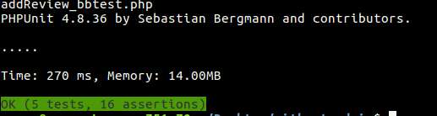

2- Add rating

|  |  |  |  |
| --- | --- | --- | --- |
| characteristic | blocks | | |
| A-review is empty | True | **False** |  |
| B-code is empty | True | **False** |  |
| c-Course id is an integer | **True** | False |  |
| d-Course id relation to zero | <=0 | **>0** |  |

**Base choice coverage requirements**

|  |  |  |  |  |
| --- | --- | --- | --- | --- |
| char | a | b | c | d |
|  | F | F | T | >0 |
|  | **T** | F | T | >0 |
|  | F | **T** | T | >0 |
|  | F | F | **F** | >0 |
|  | F | F | T | **<=0** |

Test cases:

|  |  |
| --- | --- |
| input | Expected out |
| Valid inputs | rating added successfully |
| Empty rating | rating field is required |
| Empty code | Code field is required |
| Rating is a letter | Rating must be numeric |
| Non integer course id | Redirect back without adding review |
| Negative course id | Redirect back without adding  review |
| Rating <0 | Rating must be between 0 and 5 |
| Rating >5 | Rating must be between 0 and 5 |

Execution: 2 failures

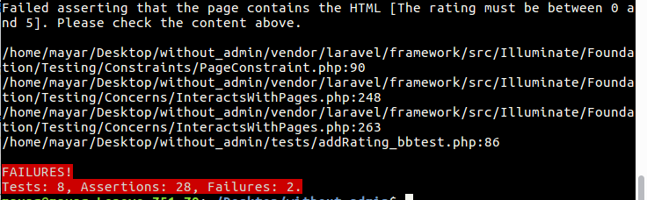

**Course Controller:**

*Search Public*

**Black box Specs:**

Input: Search field -> non-empty string

Base Choice Characteristics: empty (True, false)

Logic Predicate: SearchField ! empty

|  |  |  |
| --- | --- | --- |
| Coverage Criteria | Test Requirement | Test Case |
| Logic Coverage | infeasible | Infeasible |
| Branch Coverage | Valid request | T1 |
|  | Invalid request | T2 |
| Logic Coverage | P = [True] | T1 |
|  | P = [False] | T2 |
| Base Choice Coverage | [True] | T2 |
|  | [False] | T1 |

Notes: For these test cases, there should be at least one course in the data base.

e.g. Course {Category= “soft skills”, name= “Management”}

|  |  |  |  |
| --- | --- | --- | --- |
| Test Case | Input | Expected Output | Results |
| 1 | Search field = “Management” | Management Course Page | Passed |
| 2 | Search field = “” | “The name field is required” | Passed |

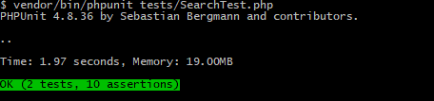

*Course Description*

**Black box specs:**

Inputs: course id -> non-empty, integer, number, greater than zero.

Logic Coverage: (C1, C2, C3) = (non-empty && integer && greater than zero)

Base choice:

Characteristics:

0: Number: true, false => (2,a)

1: integer: integer, notInteger => (2,0.5)

2: Empty: true, false => (‘’,2)

3: Compared to zero: negative, zero, positive => (-1,0,2)

|  |  |  |
| --- | --- | --- |
| Coverage Criteria | Test Requirement | Test Case |
| Logic Coverage | Infeasible | Infeasible |
| Branch Coverage | Cover the only one branch | T1 |
| Base Choice | Base:  [number, integer, not empty, positive] | T1 |
|  | [number, integer, not empty, positive] (Infeasible)  => [notNumber, not empty] | T2 |
|  | [number, float, not empty, positive] | T3 |
|  | [number, integer, empty, positive] (infeasible)   * [empty] | T4 |
|  | [number, integer, not empty, negative] | T5 |
|  | [number, integer, not empty, zero] | T6 |
| Black box: Logic coverage | [T,T,T] | T1 |
|  | [F,T,T] | Infeasible |
|  | [T,F,T] | T3 |
|  | [T,T,F] | T5 |

|  |  |  |  |
| --- | --- | --- | --- |
| Test case | Input | EO | Results |
| T1 | Course ID = 2 | Management Course Description Page | Passed |
| T2 | Course ID = g | Redirect back to home page | Failed |
| T3 | Course ID = 0.5 | Redirect back to home page | Failed |
| T4 | Course ID = “” | Redirect back to home page | Failed |
| T5 | Course ID = -1 | Redirect back to home page | Failed |
| T6 | Course ID = 0 | Redirect back to home page | Failed |

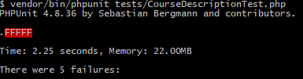

*Download*

Logic Coverage CACC

Clauses: Valid request: V, Empty course: E, Reg Confirmed: R

**Black box Specs:**

Registration Code -> non-empty string

Characteristics: Empty: True, false (‘’, 0170faf)

Course ID -> non-empty, integer, number, greater than zero.

Same characteristics as previous.

Predicate Reg code! empty && course id! Empty && course id number && course id integer && course id>0

|  |  |  |
| --- | --- | --- |
| Coverage Criteria | Test Requirements | Test Cases |
| Branch Coverage | Invalid Registration Code | T2 |
|  | Course id doesn’t exist | T3 |
|  | Other registrations exist for the course (More than one) | T6 |
|  | No Registrations for the course | T5 |
|  | Registration hasn’t been confirmed | T4 |
|  | Reg code isn’t registered | T6 |
|  | Registration is confirmed | T1 |
| Logic Coverage | [T T T] | T1 |
|  | [F T T] | T2 |
|  | [T F T] | T3 |
|  | [T T F] | T4 |
| Basic Choice | Reg code: [False]  (base) | T1 |
|  | Reg code: [True] | T2 |
|  | Course id:  [number, integer, not empty, positive]  (base) | T1 |
|  | Course id:  [number, integer, not empty, positive] (Infeasible)  => [notNumber, not empty] | T7 |
|  | Course id:  [number, float, not empty, positive] | T8 |
|  | Course id:  [number, integer, empty, positive] (infeasible)  [empty] | T9 |
|  | Course id:  [number, integer, not empty, negative] | T10 |
|  | Course id:  [number, integer, not empty, zero] | T11 |
| Black box Logic Coverage | [T T T T T] | T1 |
|  | [F T T T T] | T2 |
|  | [T F T T T] | T9 |
|  | [T T F T T] | T7 |
|  | [T T T F T] | T8 |
|  | [T T T T F] | T10 |

|  |  |  |
| --- | --- | --- |
| **Test Case** | **Input** | **Expected Output** |
| T1  Registration is confirmed  (Success Scenario) | Course id: 2  Reg code: 0170faf  Registrant => Confirmed = 1 | File is downloaded  Session flash: download successful |
| T2 | Course id: 2  Reg code: “” | Redirect back  File isn’t downloaded |
| T3 | Course id: 123  Reg code: 123 | Redirect back  File isn’t downloaded |
| T4 | Course id: 2  Reg code: 44ad48e  Registrant => Confirmed = 0 | Redirect back  File isn’t downloaded |
| T5 | Course id: 4  Reg code: 123 | Redirect back  File isn’t downloaded |
| T6 | Course id: 3  Reg code: 123 | Redirect back  File isn’t downloaded |
| T7 | Course ID = g  Reg code: 123 | Redirect back  File isn’t downloaded |
| T8 | Course ID = 0.5  Reg code: 123 | Redirect back  File isn’t downloaded |
| T9 | Course ID = “”  Reg code: 123 | Redirect back  File isn’t downloaded |
| T10 | Course ID = -1  Reg code: 123 | Redirect back  File isn’t downloaded |
| T11 | Course ID = 0  Reg code: 123 | Redirect back  File isn’t downloaded |

**Message Controller**

*Feedback*

**Black Box Specs:**

Name-> non-empty string without numbers, email-> non-empty & follows the email format, Message-> non-empty string.

Characteristics:

Name:

empty: true, false (“”, Ahmed)

contains numbers-> true, false (Ahmed23, Ahmed)

Email:

empty: true, false (“”, [ahmed@yahoo.com](mailto:ahmed@yahoo.com))

follow Format: true, false ([ahmed@yahoo.com](mailto:ahmed@yahoo.com), ahmed@com)

Message:

empty: true, false (“”,This is a message)

Logic:

Clauses:

Name: Required, matches format (n_r, n_f)

Email: Required, matches format(e_r,e_f)

Message: Required (m)

|  |  |  |  |  |  |  |
| --- | --- | --- | --- | --- | --- | --- |
| Coverage Criteria | Test Requirements | | | | | Test Cases |
| Logic coverage | infeasible | | | | | Infeasible |
| Branch Coverage | Valid inputs | | | | | T1 |
|  | Invalid inputs (e.g. email) | | | | | T2 |
| Base Choice | Name: [Non-empty, noNumbers]  (base) | | | | | T1 |
|  | Name:[empty, noNumbers]   * [empty] | | | | | T3 |
|  | Name: [Non-empty, containsNumbers] | | | | | T4 |
|  | Email: [Matches Format]  (base) | | | | | T1 |
|  | Email: [Doesn’t Match Format] | | | | | T2 |
|  | Message: [Non-empty]  (base) | | | | | T1 |
|  | Message: [empty] | | | | | T6 |
| Black box Logic coverage | N_r | N_f | E_r | E_f | M |  |
|  | [T T T T T] | | | | | T1 |
|  | [F T T T T] | | | | | T3 |
|  | [T F T T T] | | | | | T4 |
|  | [T T F T T] | | | | | T5 |
|  | [T T T F T] | | | | | T2 |
|  | [T T T T F] | | | | | T6 |

|  |  |  |
| --- | --- | --- |
| **Test Case** | **Input** | **Expected Output** |
| T1  Valid Request | Name= Ahmed  Email= ahmed@yahoo.com  Message= This is a message. | “Success! Message submited.”  Msg appears |
| T2  Invalid Request | Name= Ahmed  Email= ahmed@com  Message= This is a message. | The email must be a valid email address. |
| T3 | Name= “”  Email= ahmed@yahoo.com  Message= This is a message. | The name field is required. |
| T4 | Name= Ahmed23  Email= ahmed@yahoo.com  Message= This is a message. | The name format is invalid. |
| T5 | Name= Ahmed  Email= “”  Message= This is a message. | The email field is required. |
| T6 | Name= Ahmed  Email= ahmed@yahoo.com  Message=”” | The message field is required. |

