GIPCR

MayarAl Mohajer

3/2/2022

Read Data

library("readxl")  
GIPCR <- read_excel("GIPCR.xlsx",skip=1)

Describe data

library(psych)  
describe(GIPCR)

## vars n mean sd median trimmed  
## Study Period* 1 188 1.57 0.50 2.0 1.59  
## MRN 2 188 4465725.86 2016148.59 5245994.0 4619913.24  
## Stool Culture Ordered* 3 188 2.48 0.51 2.0 2.48  
## Stool Culture Results* 4 187 3.47 0.60 3.0 3.46  
## GI Panel Ordered* 5 188 2.20 0.98 3.0 2.24  
## GI Panel Results* 6 187 9.43 1.73 10.0 9.54  
## Abx of interest Ordered?* 7 129 33.16 17.01 30.0 33.70  
## DOT per med* 8 128 34.84 23.34 35.5 34.12  
## DOT 9 128 9.29 9.84 6.0 7.39  
## LOT 10 128 6.84 7.11 4.0 5.49  
## Patient Days Present* 11 184 19.90 9.63 22.0 20.53  
## mad min max range skew kurtosis  
## Study Period* 0.00 1 2 1 -0.28 -1.93  
## MRN 2090735.83 298671 6774609 6475938 -0.47 -1.23  
## Stool Culture Ordered* 0.00 1 3 2 -0.03 -1.71  
## Stool Culture Results* 0.00 1 6 5 0.11 1.58  
## GI Panel Ordered* 0.00 1 3 2 -0.40 -1.85  
## GI Panel Results* 1.48 1 16 15 -1.65 9.63  
## Abx of interest Ordered?* 23.72 1 57 56 -0.13 -1.24  
## DOT per med* 27.43 1 80 79 0.14 -1.10  
## DOT 5.19 1 65 64 2.69 9.46  
## LOT 2.97 1 51 50 2.86 11.58  
## Patient Days Present* 10.38 1 33 32 -0.57 -1.01  
## se  
## Study Period* 0.04  
## MRN 147042.75  
## Stool Culture Ordered* 0.04  
## Stool Culture Results* 0.04  
## GI Panel Ordered* 0.07  
## GI Panel Results* 0.13  
## Abx of interest Ordered?* 1.50  
## DOT per med* 2.06  
## DOT 0.87  
## LOT 0.63  
## Patient Days Present* 0.71

table(GIPCR$`Study Period`)

##   
## Post-Intervention Group Pre-Intervention Group   
## 81 107

table(GIPCR$`Stool Culture Ordered`)

##   
## Negative NO YES   
## 1 96 91

table(GIPCR$`Stool Culture Results`)

##   
## Aeromonas caviae   
## 1   
## Campylobacter jejuni   
## 2   
## n/a   
## 96   
## No organism detected   
## 85   
## No organism detected; No organism detected   
## 2   
## Shigella sonnei   
## 1

table(GIPCR$`GI Panel Ordered`)

##   
## NO No GI Panel Performed YES   
## 75 1 112

table(GIPCR$`GI Panel Results`)

##   
## astrovirus   
## 2   
## campylobacter   
## 1   
## campylobacter; cryptosporidium   
## 1   
## campylobacter; cryptosporidium; shigella/enteroinvasive e. coli (eiec)   
## 1   
## cryptosporidium   
## 2   
## enteropathogenic e. coli (epec)   
## 3   
## giardia lamblia   
## 1   
## giardia lamblia; norovirus gi/gii   
## 1   
## n/a   
## 75   
## No organism detected   
## 83   
## norovirus gi/gii   
## 11   
## norovirus gi/gii; shigella/enteroinvasive e. coli (eiec)   
## 1   
## norovirus gi/gii; yersinia enterocolitica   
## 1   
## salmonella   
## 2   
## shigella/enteroinvasive e. coli (eiec)   
## 1   
## vibrio (parahaemolyticus, vulnificus); vibrio cholerae   
## 1

table(GIPCR$`Abx of interest Ordered?`)

##   
## amoxicillin-clavulanate; cefepime; metronidazole   
## 1   
## amoxicillin-clavulanate; metronidazole; piperacillin-tazobactam   
## 1   
## amoxicillin-clavulanate; piperacillin-tazobactam   
## 1   
## ampicillin-sulbactam; cefepime; metronidazole   
## 2   
## azithromycin; cefepime   
## 4   
## azithromycin; cefepime; levofloxacin   
## 1   
## azithromycin; cefepime; levofloxacin; meropenem   
## 1   
## azithromycin; cefepime; levofloxacin; metronidazole   
## 1   
## azithromycin; ceftriaxone   
## 1   
## azithromycin; ceftriaxone; cefepime   
## 1   
## azithromycin; ceftriaxone; cefepime; meropenem; metronidazole   
## 1   
## azithromycin; ceftriaxone; metronidazole   
## 1   
## cefepime   
## 8   
## cefepime; ciprofloxacin; ertapenem; metronidazole   
## 1   
## cefepime; ciprofloxacin; meropenem   
## 1   
## cefepime; ciprofloxacin; metronidazole   
## 2   
## cefepime; levofloxacin   
## 1   
## cefepime; levofloxacin; meropenem   
## 2   
## cefepime; levofloxacin; meropenem; metronidazole   
## 1   
## cefepime; levofloxacin; meropenem; metronidazole; piperacillin-tazobactam   
## 1   
## cefepime; levofloxacin; metronidazole   
## 1   
## cefepime; levofloxacin; metronidazole; piperacillin-tazobactam   
## 1   
## cefepime; meropenem   
## 1   
## cefepime; meropenem; metronidazole   
## 1   
## cefepime; meropenem; metronidazole; piperacillin-tazobactam   
## 1   
## cefepime; metronidazole   
## 14   
## cefepime; metronidazole; piperacillin-tazobactam   
## 2   
## cefepime; piperacillin-tazobactam   
## 2   
## ceftriaxone   
## 7   
## ceftriaxone; cefepime   
## 3   
## ceftriaxone; cefepime; ciprofloxacin; ertapenem; metronidazole   
## 1   
## ceftriaxone; cefepime; ertapenem; meropenem   
## 1   
## ceftriaxone; cefepime; levofloxacin; metronidazole   
## 1   
## ceftriaxone; cefepime; meropenem   
## 1   
## ceftriaxone; cefepime; meropenem; metronidazole   
## 1   
## ceftriaxone; ciprofloxacin   
## 1   
## ceftriaxone; ciprofloxacin; metronidazole   
## 2   
## ceftriaxone; ciprofloxacin; metronidazole; piperacillin-tazobactam   
## 1   
## ceftriaxone; ciprofloxacin; piperacillin-tazobactam   
## 1   
## ceftriaxone; levofloxacin; meropenem; metronidazole; piperacillin-tazobactam   
## 1   
## ceftriaxone; meropenem   
## 1   
## ceftriaxone; metronidazole   
## 3   
## ceftriaxone; piperacillin-tazobactam   
## 1   
## ciprofloxacin   
## 3   
## ciprofloxacin; metronidazole   
## 4   
## ciprofloxacin; metronidazole; piperacillin-tazobactam   
## 3   
## ertapenem; meropenem   
## 1   
## levofloxacin   
## 1   
## levofloxacin; metronidazole   
## 1   
## levofloxacin; piperacillin-tazobactam   
## 1   
## meropenem   
## 7   
## meropenem; metronidazole   
## 4   
## meropenem; metronidazole; piperacillin-tazobactam   
## 1   
## meropenem; piperacillin-tazobactam   
## 1   
## metronidazole   
## 8   
## No   
## 1   
## piperacillin-tazobactam   
## 11

table(GIPCR$`Patient Days Present`)

##   
## 1 10 11 12   
## 2 7 6 6   
## 13 14 15 16   
## 4 5 2 4   
## 18 19 2 20   
## 3 2 8 1   
## 22 23 24 26   
## 2 1 2 1   
## 28 3 31 33   
## 1 14 2 1   
## 37 4 43 47   
## 3 20 1 1   
## 5 58 6 64   
## 20 1 23 1   
## 7 8 82 9   
## 15 9 1 9   
## outpatient collect   
## 6

table(GIPCR$`GI Panel Results`,GIPCR$`Study Period`)

##   
## Post-Intervention Group  
## astrovirus 0  
## campylobacter 1  
## campylobacter; cryptosporidium 0  
## campylobacter; cryptosporidium; shigella/enteroinvasive e. coli (eiec) 1  
## cryptosporidium 2  
## enteropathogenic e. coli (epec) 3  
## giardia lamblia 1  
## giardia lamblia; norovirus gi/gii 0  
## n/a 0  
## No organism detected 58  
## norovirus gi/gii 10  
## norovirus gi/gii; shigella/enteroinvasive e. coli (eiec) 0  
## norovirus gi/gii; yersinia enterocolitica 1  
## salmonella 2  
## shigella/enteroinvasive e. coli (eiec) 1  
## vibrio (parahaemolyticus, vulnificus); vibrio cholerae 1  
##   
## Pre-Intervention Group  
## astrovirus 2  
## campylobacter 0  
## campylobacter; cryptosporidium 1  
## campylobacter; cryptosporidium; shigella/enteroinvasive e. coli (eiec) 0  
## cryptosporidium 0  
## enteropathogenic e. coli (epec) 0  
## giardia lamblia 0  
## giardia lamblia; norovirus gi/gii 1  
## n/a 75  
## No organism detected 25  
## norovirus gi/gii 1  
## norovirus gi/gii; shigella/enteroinvasive e. coli (eiec) 1  
## norovirus gi/gii; yersinia enterocolitica 0  
## salmonella 0  
## shigella/enteroinvasive e. coli (eiec) 0  
## vibrio (parahaemolyticus, vulnificus); vibrio cholerae 0

table(GIPCR$`Abx of interest Ordered?`,GIPCR$`Study Period`)

##   
## Post-Intervention Group  
## amoxicillin-clavulanate; cefepime; metronidazole 1  
## amoxicillin-clavulanate; metronidazole; piperacillin-tazobactam 1  
## amoxicillin-clavulanate; piperacillin-tazobactam 1  
## ampicillin-sulbactam; cefepime; metronidazole 1  
## azithromycin; cefepime 1  
## azithromycin; cefepime; levofloxacin 1  
## azithromycin; cefepime; levofloxacin; meropenem 0  
## azithromycin; cefepime; levofloxacin; metronidazole 1  
## azithromycin; ceftriaxone 1  
## azithromycin; ceftriaxone; cefepime 0  
## azithromycin; ceftriaxone; cefepime; meropenem; metronidazole 1  
## azithromycin; ceftriaxone; metronidazole 0  
## cefepime 6  
## cefepime; ciprofloxacin; ertapenem; metronidazole 0  
## cefepime; ciprofloxacin; meropenem 1  
## cefepime; ciprofloxacin; metronidazole 2  
## cefepime; levofloxacin 1  
## cefepime; levofloxacin; meropenem 1  
## cefepime; levofloxacin; meropenem; metronidazole 0  
## cefepime; levofloxacin; meropenem; metronidazole; piperacillin-tazobactam 1  
## cefepime; levofloxacin; metronidazole 0  
## cefepime; levofloxacin; metronidazole; piperacillin-tazobactam 0  
## cefepime; meropenem 1  
## cefepime; meropenem; metronidazole 1  
## cefepime; meropenem; metronidazole; piperacillin-tazobactam 0  
## cefepime; metronidazole 4  
## cefepime; metronidazole; piperacillin-tazobactam 0  
## cefepime; piperacillin-tazobactam 2  
## ceftriaxone 1  
## ceftriaxone; cefepime 1  
## ceftriaxone; cefepime; ciprofloxacin; ertapenem; metronidazole 1  
## ceftriaxone; cefepime; ertapenem; meropenem 1  
## ceftriaxone; cefepime; levofloxacin; metronidazole 0  
## ceftriaxone; cefepime; meropenem 0  
## ceftriaxone; cefepime; meropenem; metronidazole 1  
## ceftriaxone; ciprofloxacin 1  
## ceftriaxone; ciprofloxacin; metronidazole 2  
## ceftriaxone; ciprofloxacin; metronidazole; piperacillin-tazobactam 0  
## ceftriaxone; ciprofloxacin; piperacillin-tazobactam 0  
## ceftriaxone; levofloxacin; meropenem; metronidazole; piperacillin-tazobactam 1  
## ceftriaxone; meropenem 0  
## ceftriaxone; metronidazole 2  
## ceftriaxone; piperacillin-tazobactam 0  
## ciprofloxacin 2  
## ciprofloxacin; metronidazole 0  
## ciprofloxacin; metronidazole; piperacillin-tazobactam 2  
## ertapenem; meropenem 0  
## levofloxacin 0  
## levofloxacin; metronidazole 0  
## levofloxacin; piperacillin-tazobactam 1  
## meropenem 5  
## meropenem; metronidazole 3  
## meropenem; metronidazole; piperacillin-tazobactam 0  
## meropenem; piperacillin-tazobactam 1  
## metronidazole 4  
## No 0  
## piperacillin-tazobactam 3  
##   
## Pre-Intervention Group  
## amoxicillin-clavulanate; cefepime; metronidazole 0  
## amoxicillin-clavulanate; metronidazole; piperacillin-tazobactam 0  
## amoxicillin-clavulanate; piperacillin-tazobactam 0  
## ampicillin-sulbactam; cefepime; metronidazole 1  
## azithromycin; cefepime 3  
## azithromycin; cefepime; levofloxacin 0  
## azithromycin; cefepime; levofloxacin; meropenem 1  
## azithromycin; cefepime; levofloxacin; metronidazole 0  
## azithromycin; ceftriaxone 0  
## azithromycin; ceftriaxone; cefepime 1  
## azithromycin; ceftriaxone; cefepime; meropenem; metronidazole 0  
## azithromycin; ceftriaxone; metronidazole 1  
## cefepime 2  
## cefepime; ciprofloxacin; ertapenem; metronidazole 1  
## cefepime; ciprofloxacin; meropenem 0  
## cefepime; ciprofloxacin; metronidazole 0  
## cefepime; levofloxacin 0  
## cefepime; levofloxacin; meropenem 1  
## cefepime; levofloxacin; meropenem; metronidazole 1  
## cefepime; levofloxacin; meropenem; metronidazole; piperacillin-tazobactam 0  
## cefepime; levofloxacin; metronidazole 1  
## cefepime; levofloxacin; metronidazole; piperacillin-tazobactam 1  
## cefepime; meropenem 0  
## cefepime; meropenem; metronidazole 0  
## cefepime; meropenem; metronidazole; piperacillin-tazobactam 1  
## cefepime; metronidazole 10  
## cefepime; metronidazole; piperacillin-tazobactam 2  
## cefepime; piperacillin-tazobactam 0  
## ceftriaxone 6  
## ceftriaxone; cefepime 2  
## ceftriaxone; cefepime; ciprofloxacin; ertapenem; metronidazole 0  
## ceftriaxone; cefepime; ertapenem; meropenem 0  
## ceftriaxone; cefepime; levofloxacin; metronidazole 1  
## ceftriaxone; cefepime; meropenem 1  
## ceftriaxone; cefepime; meropenem; metronidazole 0  
## ceftriaxone; ciprofloxacin 0  
## ceftriaxone; ciprofloxacin; metronidazole 0  
## ceftriaxone; ciprofloxacin; metronidazole; piperacillin-tazobactam 1  
## ceftriaxone; ciprofloxacin; piperacillin-tazobactam 1  
## ceftriaxone; levofloxacin; meropenem; metronidazole; piperacillin-tazobactam 0  
## ceftriaxone; meropenem 1  
## ceftriaxone; metronidazole 1  
## ceftriaxone; piperacillin-tazobactam 1  
## ciprofloxacin 1  
## ciprofloxacin; metronidazole 4  
## ciprofloxacin; metronidazole; piperacillin-tazobactam 1  
## ertapenem; meropenem 1  
## levofloxacin 1  
## levofloxacin; metronidazole 1  
## levofloxacin; piperacillin-tazobactam 0  
## meropenem 2  
## meropenem; metronidazole 1  
## meropenem; metronidazole; piperacillin-tazobactam 1  
## meropenem; piperacillin-tazobactam 0  
## metronidazole 4  
## No 1  
## piperacillin-tazobactam 8

Changing Negative to No for stool culture ordered Remove duplicate from Stool culture result Changing NO GI Perfomred to No in GI Panel performed Replace outpatient collect in Patient Days Present with NA. Chanding it to numeric and obtaining summary

GIPCR$`Stool Culture Ordered` <- gsub("Negative", "NO", GIPCR$`Stool Culture Ordered`)  
table(GIPCR$`Stool Culture Ordered`)

##   
## NO YES   
## 97 91

GIPCR$`Stool Culture Results` <- gsub("No organism detected; No organism detected", "No organism detected", GIPCR$`Stool Culture Results`)  
table(GIPCR$`Stool Culture Results`)

##   
## Aeromonas caviae Campylobacter jejuni n/a   
## 1 2 96   
## No organism detected Shigella sonnei   
## 87 1

GIPCR$`GI Panel Ordered` <- gsub("No GI Panel Performed", "NO", GIPCR$`GI Panel Ordered`)  
table(GIPCR$`GI Panel Ordered`)

##   
## NO YES   
## 76 112

GIPCR$`Patient Days Present` <- gsub("outpatient collect", "NA", GIPCR$`Patient Days Present`)  
GIPCR$`Patient Days Present` <- as.numeric(GIPCR$`Patient Days Present`)

## Warning: NAs introduced by coercion

summary(GIPCR$`Patient Days Present`)

## Min. 1st Qu. Median Mean 3rd Qu. Max. NA's   
## 1.00 5.00 7.00 10.34 11.75 82.00 10

Antibiotic use description

summary(GIPCR$DOT)

## Min. 1st Qu. Median Mean 3rd Qu. Max. NA's   
## 1.000 4.000 6.000 9.289 12.000 65.000 60

summary(GIPCR$LOT)

## Min. 1st Qu. Median Mean 3rd Qu. Max. NA's   
## 1.000 3.000 4.000 6.844 8.250 51.000 60

hist(GIPCR$DOT)

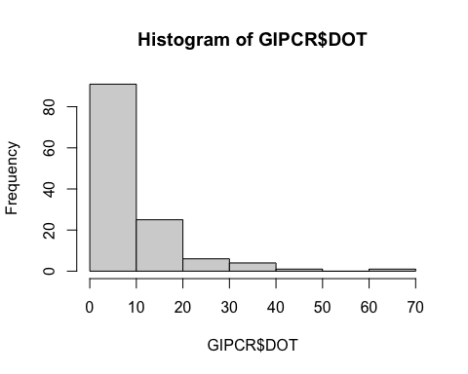

hist(GIPCR$DOT,main ="Days of therapy",xlab="Days of therapy",breaks =30)

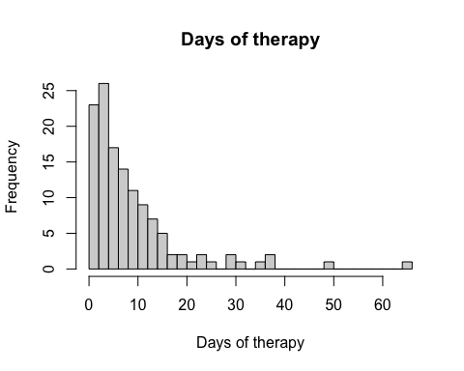

hist(GIPCR$LOT,main ="Length of therapy",xlab="Length of therapy",breaks =30)

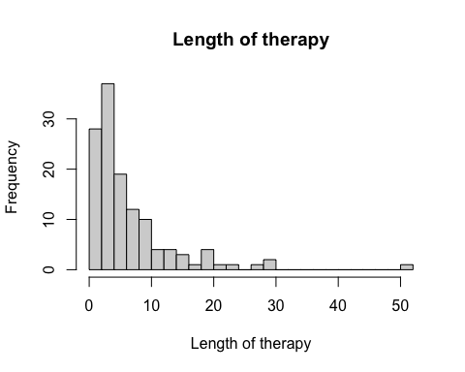

Data not normally distrbuted (mean different from median, right tail).

Create new varibales for DOT per Patient Days Present and DOT per Patient Days Present

GIPCR$DOTperPDP <- round(GIPCR$DOT/GIPCR$`Patient Days Present`,2)  
GIPCR$LOTperPDP <- round(GIPCR$LOT/GIPCR$`Patient Days Present`,2)  
hist(GIPCR$LOTperPDP,main ="Length of Therapy Per Patient Days Present",xlab="Length of therapy per patient days present",breaks=30)

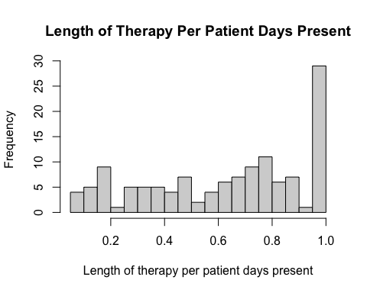

hist(GIPCR$DOTperPDP,main ="Days of Therapy Per Patient Days Present",xlab="Days of therapy per patient days present",breaks=30)

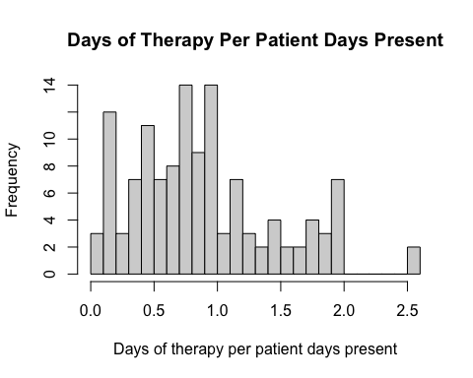

Data per Study Period

table(GIPCR$`Stool Culture Ordered`,GIPCR$`Study Period`)

##   
## Post-Intervention Group Pre-Intervention Group  
## NO 81 16  
## YES 0 91

table(GIPCR$`Stool Culture Results`,GIPCR$`Study Period`)

##   
## Post-Intervention Group Pre-Intervention Group  
## Aeromonas caviae 0 1  
## Campylobacter jejuni 0 2  
## n/a 81 15  
## No organism detected 0 87  
## Shigella sonnei 0 1

table(GIPCR$`GI Panel Ordered`,GIPCR$`Study Period`)

##   
## Post-Intervention Group Pre-Intervention Group  
## NO 0 76  
## YES 81 31

tapply(GIPCR$DOT, GIPCR$`Study Period`, mean, na.rm=T)

## Post-Intervention Group Pre-Intervention Group   
## 10.590164 8.104478

wilcox.test(GIPCR$DOT~GIPCR$`Study Period`)

##   
## Wilcoxon rank sum test with continuity correction  
##   
## data: GIPCR$DOT by GIPCR$`Study Period`  
## W = 2279, p-value = 0.2607  
## alternative hypothesis: true location shift is not equal to 0

No difference in median DOT between the two groups

tapply(GIPCR$LOT, GIPCR$`Study Period`, mean, na.rm=T)

## Post-Intervention Group Pre-Intervention Group   
## 8.081967 5.716418

wilcox.test(GIPCR$LOT~GIPCR$`Study Period`)

##   
## Wilcoxon rank sum test with continuity correction  
##   
## data: GIPCR$LOT by GIPCR$`Study Period`  
## W = 2391.5, p-value = 0.09562  
## alternative hypothesis: true location shift is not equal to 0

No difference in median LOT between the two groups

library(incidence)

Now compare the rate of DOT and LOT per PDP

tapply(GIPCR$DOTperPDP, GIPCR$`Study Period`, mean, na.rm=T)

## Post-Intervention Group Pre-Intervention Group   
## 0.8545902 0.9384848

library(incidence)  
library(epiR)

## Warning: package 'epiR' was built under R version 4.1.2

## Loading required package: survival

## Package epiR 2.0.43 is loaded

## Type help(epi.about) for summary information

## Type browseVignettes(package = 'epiR') to learn how to use epiR for applied epidemiological analyses

##

events <- tapply(GIPCR$DOT, GIPCR$`Study Period`, sum,na.rm=T)  
events

## Post-Intervention Group Pre-Intervention Group   
## 646 543

persontime <- tapply(GIPCR$`Patient Days Present`, GIPCR$`Study Period`, sum,na.rm=T)  
persontime

## Post-Intervention Group Pre-Intervention Group   
## 901 940

tab_studyperiod <- cbind(events, persontime)   
tab_studyperiod <- tab_studyperiod[c(2,1),]  
tab_studyperiod

## events persontime  
## Pre-Intervention Group 543 940  
## Post-Intervention Group 646 901

epi.2by2(tab_studyperiod, method = "cohort.time")

## Outcome + Time at risk Inc rate *  
## Exposed + 543 940 57.8  
## Exposed - 646 901 71.7  
## Total 1189 1841 64.6  
##   
## Point estimates and 95% CIs:  
## -------------------------------------------------------------------  
## Inc rate ratio 0.81 (0.72, 0.90)  
## Attrib rate in the exposed * -13.93 (-21.29, -6.57)  
## Attrib fraction in the exposed (%) -24.12 (-39.38, -10.56)  
## Attrib rate in the population * -7.11 (-13.75, -0.48)  
## Attrib fraction in the population (%) -11.01 (-13.29, -8.71)  
## -------------------------------------------------------------------  
## Wald confidence limits  
## CI: confidence interval  
## * Outcomes per 100 units of population time at risk

Increase in DOT incidence rate after intrevention (adjusted per patient days)

tapply(GIPCR$LOTperPDP, GIPCR$`Study Period`, mean, na.rm=T)

## Post-Intervention Group Pre-Intervention Group   
## 0.6321311 0.6506061

events2 <- tapply(GIPCR$LOT, GIPCR$`Study Period`, sum,na.rm=T)  
events2

## Post-Intervention Group Pre-Intervention Group   
## 493 383

tab_studyperiod2 <- cbind(events2, persontime)   
tab_studyperiod2 <- tab_studyperiod2[c(2,1),]  
tab_studyperiod2

## events2 persontime  
## Pre-Intervention Group 383 940  
## Post-Intervention Group 493 901

epi.2by2(tab_studyperiod2, method = "cohort.time")

## Outcome + Time at risk Inc rate *  
## Exposed + 383 940 40.7  
## Exposed - 493 901 54.7  
## Total 876 1841 47.6  
##   
## Point estimates and 95% CIs:  
## -------------------------------------------------------------------  
## Inc rate ratio 0.74 (0.65, 0.85)  
## Attrib rate in the exposed * -13.97 (-20.30, -7.65)  
## Attrib fraction in the exposed (%) -34.29 (-53.88, -17.27)  
## Attrib rate in the population * -7.13 (-12.90, -1.37)  
## Attrib fraction in the population (%) -14.99 (-17.56, -12.39)  
## -------------------------------------------------------------------  
## Wald confidence limits  
## CI: confidence interval  
## * Outcomes per 100 units of population time at risk

Increase in LOT incidence rate after intrevention (adjusted per patient days)

library(ggplot2)

##   
## Attaching package: 'ggplot2'

## The following objects are masked from 'package:psych':  
##   
## %+%, alpha

p1 <- ggplot(GIPCR,aes(DOT)) + geom_histogram() +facet_wrap(~`Study Period`)  
p1

## `stat_bin()` using `bins = 30`. Pick better value with `binwidth`.

## Warning: Removed 60 rows containing non-finite values (stat_bin).

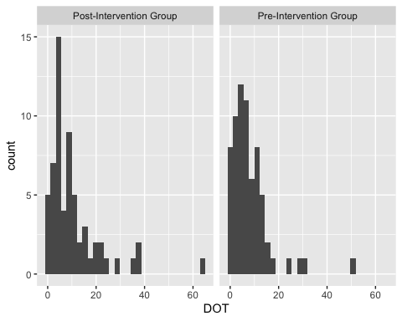

p2 <- ggplot(GIPCR,aes(LOT)) + geom_histogram() +facet_wrap(~`Study Period`)  
p2

## `stat_bin()` using `bins = 30`. Pick better value with `binwidth`.

## Warning: Removed 60 rows containing non-finite values (stat_bin).

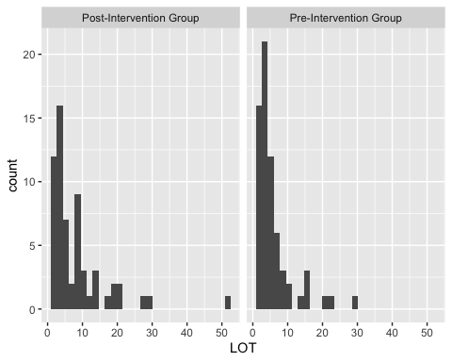

p3 <- ggplot(GIPCR,aes(DOTperPDP)) + geom_histogram() +facet_wrap(~`Study Period`)  
p3

## `stat_bin()` using `bins = 30`. Pick better value with `binwidth`.

## Warning: Removed 61 rows containing non-finite values (stat_bin).

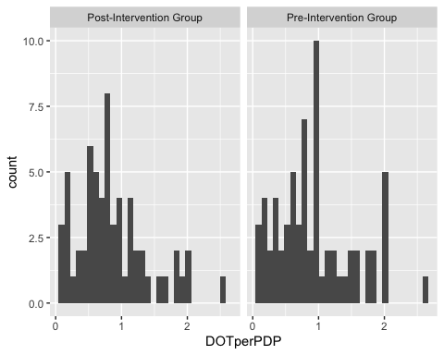

p4 <- ggplot(GIPCR,aes(LOTperPDP)) + geom_histogram() +facet_wrap(~`Study Period`)  
p4

## `stat_bin()` using `bins = 30`. Pick better value with `binwidth`.

## Warning: Removed 61 rows containing non-finite values (stat_bin).

