**Project Details**

|  |  |
| --- | --- |
| Project number | *19* |
| Project title | *Mega Store Corporation* |
| Corresponding TA\LA | *Dina Abbas* |
| Deliverable | *1* |

**Team Details**

|  |  |  |
| --- | --- | --- |
| **Student ID** | **Student name** | **Lab Group** |
| 20200629 | يارا محمد سعد محمد | S5 |
| 20200165 | حنين محمد عويس | S7 |
| 20201102 | شيرين شوقى حسن أحمد | S5 |
| 20201183 | ميار محمد حامد عبدالمجيد | S8 |
| 20200595 | ندين بدر الدين عبد العاطى | S8 |
| 20200387 | كاريمان أيمن عبداللطيف | S8 |
| 20200732 | ياسمين سامى عبد القوى | S8 |

1. Use cases model:
   1. **Using Event Decomposition technique:**

Table - Types of Events

* + 1. Types of Events

|  |  |
| --- | --- |
| Event | Type  (External/State/temporal) |
| Customer search for item | External |
| Customer view all items | External |
| Customer fill the shopping cart | External |
| Customer remove item from shopping cart | External |
| Customer buy items | External |
| Customer pay the bill for the items | External |
| Customer ask for reusable bag | External |
| Customer gain points | Temporal |
| Bank verify credit card | External |
| Customer returns the item | External |
| Accept the return | state |
| Reject the return | state |
| Adding items | state |
| Removing items | state |
| Updating items | state |
| Apply events offers | Temporal |
| Supplier Providing items | External |

* + 1. Formalize events with use cases

Table 2- Formalizing Events to use cases

|  |  |  |
| --- | --- | --- |
| Event | Type  (External/State/temporal) | Use case |
| Customer search for item | External | Search items |
| Customer view all items | External | View items |
| Customer fill the shopping cart | External | Fill shopping cart |
| Customer remove item from shopping cart | External | Update shopping cart |
| Customer buy items | External | Make checkout |
| Customer pay the bill for the items | External | Pay the bill |
| Customer ask for reusable bag | External | Ask for reusable bag |
| Customer gain points | Temporal | Gain points |
| Bank verify credit card | External | Verify credit card |
| Customer returns the item | External | Return item |
| Accept the return | state | Accept return |
| Reject the return | state | Reject return |
| Adding items | state | Add item |
| Removing items | state | Remove item |
| Updating items | state | Update item |
| Apply events offers | Temporal | Apply offers |
| Supplier Providing items | External | Provide items |

* + 1. Use case Descriptions:

Table 3 - Use cases descriptions

|  |  |  |
| --- | --- | --- |
| Use case name | Actor | Description |
| Search Items | Customer | Customer can search for items and the system will display the matching results. |
| View Items | Customer | Customer can view items from different categories that are available on the system. |
| Fill Shopping Cart | Customer | Customer can fill the shopping cart after searching for or viewing the products that he wants to purchase. |
| Update Shopping Cart | Customer | Customer can update the items that he added in the shopping cart. |
| Ask for Reusable Bag | Customer | Customer can ask for reusable bags either after making checkout or without buying anything. |
| Make Checkout | Customer | Customer can make checkout after filling the shopping cart. |
| Pay the Bill | Customer | Customer can pay the bill for the products that he chose after making checkout, he has several payment methods to choose from. |
| Pay by Cash | Customer | Customer can pay by cash for the products that he chose. |
| Pay by Points | Customer | Customer can pay by the points that he has gained for the products that he chose. |
| Pay by Credit Card | Customer | Customer can pay by credit card for the products that he chose. |
| Verify Credit Card | Bank System | Bank system must verify the credit card of the customer in order to complete the paying process. |
| Gain Points | Customer | Customer can gain points after asking for reusable bags and after paying the bill. |
| Return Item | Customer | Customer can ask to return an item after paying the bill. |
| Accept Return | Logistics | Logistics can accept the return request that the customer asked for. |
| Reject Return | Logistics | Logistics can reject the return request that the customer asked for. |
| Provide Items | Supplier | Supplier provides items to the mega store corporation. |
| Add Item | IT Personnel | IT Personnel can add items to the stores. |
| Remove Item | IT Personnel | IT Personnel can remove items from the stores. |
| Update Item | IT Personnel | IT Personnel can update item’s information. |
| Apply Offers | IT Personnel | IT Personnel can apply offers to the products based on events occurrence. |
| Apply Local Event Offers | IT Personnel | IT Personnel can apply offers to the products during the occurrence of local events. |
| Apply Global Event Offers | IT Personnel | IT Personnel can apply offers to the products during the occurrence of global events. |

* + 1. Matrix that maps all domain classes to the set of use cases

|  |  |  |  |  |
| --- | --- | --- | --- | --- |
| Domain (vs) use case | Class domain1 | Class domain2 | Class domain3 | Class domain 4 |
| Search item | customer | product | country |  |
| View item | product |  |  |  |
| checkout | product | Sale product | Stores | Megastores |
| Pay for item | customer | Sale product | payment | points |
| Ask for reusable bags | Special bags | points |  |  |
| Return item (accept) | Sale product | Return product | payment | points |
| Return product (refuse) | Sale product | Return product | points |  |
| Add item | product | warehouse | stores | megastore |
| Apply offer | product | offer | country |  |
| Provide product | product | supplier | warehouse | megastore |
| Remove product | product | megastore | stores | megastore |
| Gain points | points | Customer |  |  |
| Update product | product | warehouse | stores | megastore |

* + 1. Use case Diagram:

[Using draw.io]

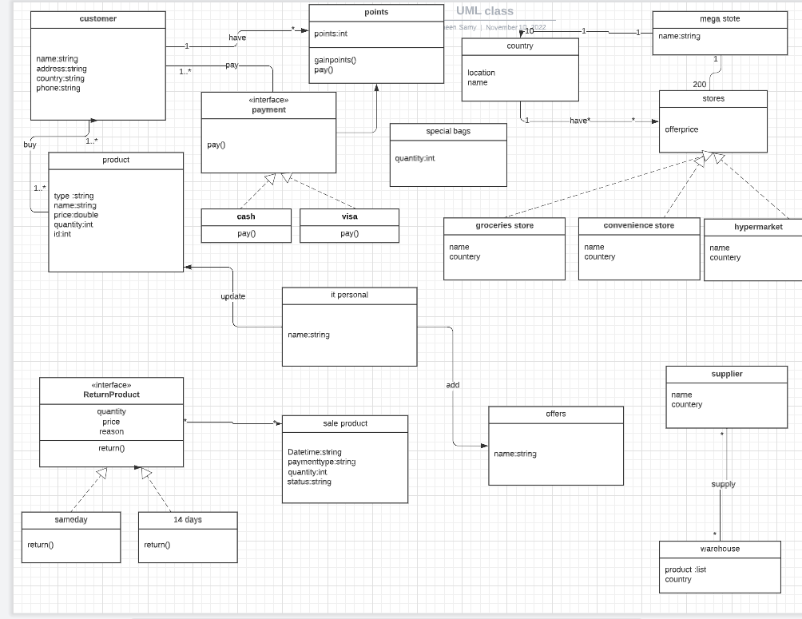

Assumptions list

* We assume that we have many actors as a coatomers using the system offsite or OneSite.
* The bank system is responsible for verifying credit card transactions.
* The logistics department is responsible for verify the products status to make sure that it meets the standards of the current policy.
* IT personnel is the personal in charge of updating, adding or removing the products on the system whether online or in store.
* We assume the user can pay by pints gained from purchases.