**Project Details**

|  |  |
| --- | --- |
| Project number | *19* |
| Project title | *Mega Store Corporation* |
| Corresponding TA\LA | *Dina Abbas* |
| Deliverable | *2* |

**Team Details**

|  |  |  |
| --- | --- | --- |
| **Student ID** | **Student name** | **Lab Group** |
| 20200629 | يارا محمد سعد محمد | S5 |
| 20200165 | حنين محمد عويس | S7 |
| 20201102 | شيرين شوقى حسن أحمد | S5 |
| 20201183 | ميار محمد حامد عبدالمجيد | S8 |
| 20200595 | ندين بدر الدين عبد العاطى | S8 |
| 20200387 | كاريمان أيمن عبداللطيف | S8 |
| 20200732 | ياسمين سامى عبد القوى | S8 |

**1.CRUD technique:**

CRUD table showing use cases and corresponding domain classes

|  |  |  |  |  |  |  |  |  |  |  |  |  |
| --- | --- | --- | --- | --- | --- | --- | --- | --- | --- | --- | --- | --- |
| Use case (vs) domain | customer | product | Sale product | Return product | payment | Special bags | points | offer | warehouse | Country | stores | Mega sore |
| Search item | R\U | R |  |  |  |  |  |  |  | R |  |  |
| View item |  | R |  |  |  |  |  |  |  |  |  |  |
| checkout |  | U | C |  |  |  |  |  |  |  | U | U |
| Pay for item | C |  | R |  | C |  | C\U |  |  |  |  |  |
| Ask for reusable bags |  |  |  |  |  | C | C\U |  |  |  |  |  |
| Return item(accept) |  |  | D | C | U\D |  | U\D |  |  |  |  |  |
| Return item(refuse) |  |  | R | D |  |  | R |  |  |  |  |  |
| Add item |  | R |  |  |  |  |  |  | R |  | U | U |
| Apply offer |  | U |  |  |  |  |  | C |  | R |  |  |
| Provide product |  | R/U |  |  |  |  |  |  | R |  |  | R |
| Remove product |  | R/U |  |  |  |  |  |  |  |  | R | R |
| Gain points | U/R |  |  |  |  |  | U/R |  |  |  |  |  |
| Update product |  | R\U |  |  |  |  |  |  | R |  | R/U | R/U |

Verify use cases using CRUD technique

|  |  |  |
| --- | --- | --- |
| Domain Class | CRUD | Verified Use case |
| Customer | create | Pay for item |
|  | Read/Update | Search item  Gain points |
| Product | Read | Search item  View item  Add item  Provide product  Remove product  Update product |
|  | Update | Apply offer  Update product  Provide product  Remove product |
| Sale product | Create | checkout |
|  | Read | Pay for item  Return item(refuse) |
|  | Delete | Return item(accept) |
| Return product | Create | Return item(accept) |
|  | Delete | Return item(refuse) |
| payment | Create | Pay for item |
|  | Update/Delete | Return item(accept) |
| Special bags | Create | Ask for reusable bags |
| offer | Create | Apply offer |
| Country | Read | Search item  Apply offer |
| stores | Update | Checkout  Update product  Add item |
|  | Read | Update product  Remove product |
| Mega sore | Update | Checkout  Update product  Add item |
|  | Read | Update product  Remove product  Provide product |
| warehouse | Read | Add item  Provide product  Update product |

**2.Domain Class Model**

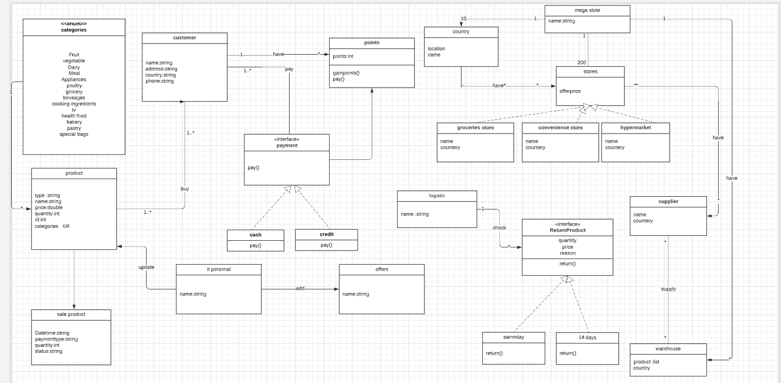

**3.State Machine Model**

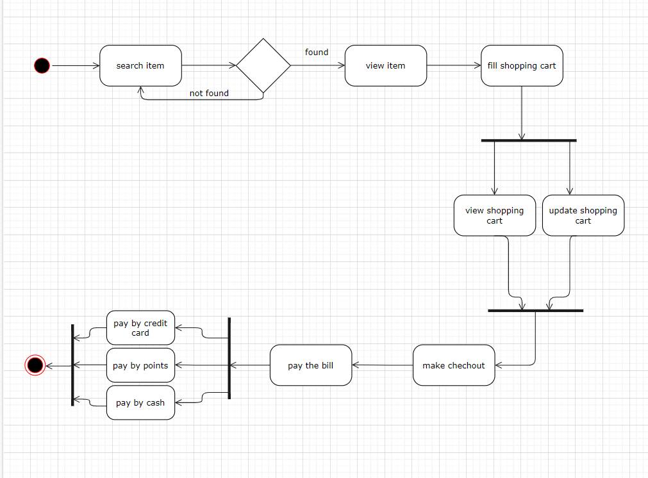

**4.Activity Diagrams**

-Payment Activity Diagram

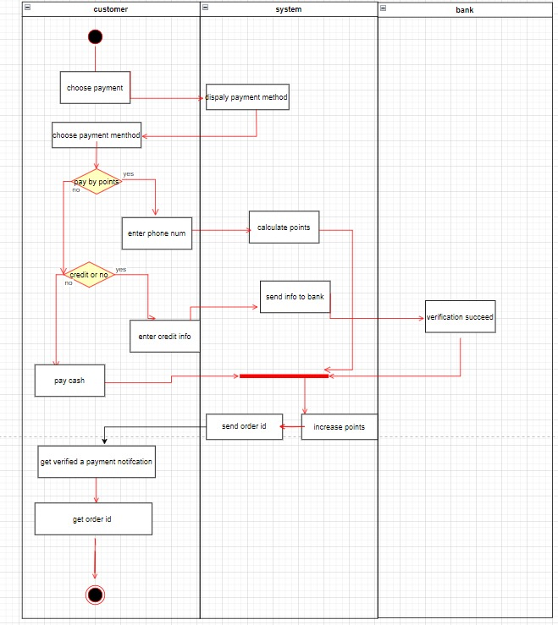

-fill shopping cart activity diagram

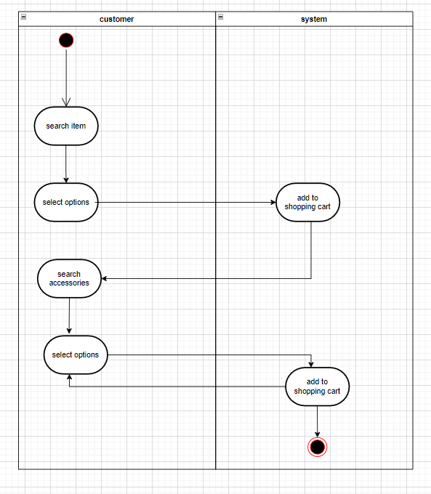

-Make Checkout Activity Diagram

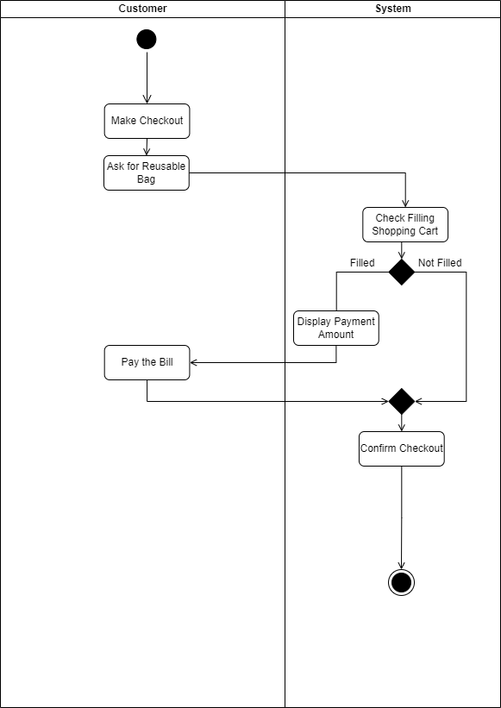

**4.System Sequence Diagrams**

**-Payment Sequence Diagram**

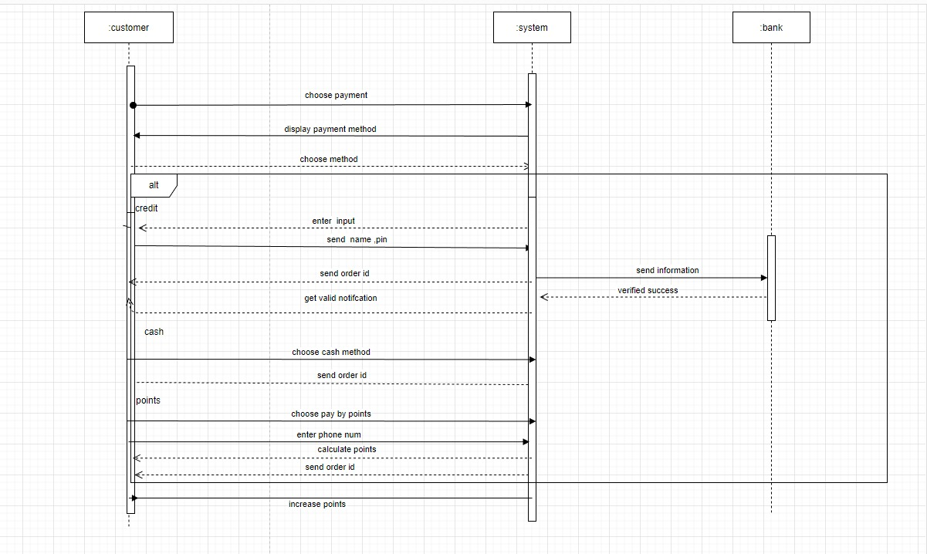

-fill shopping cart sequence diagram

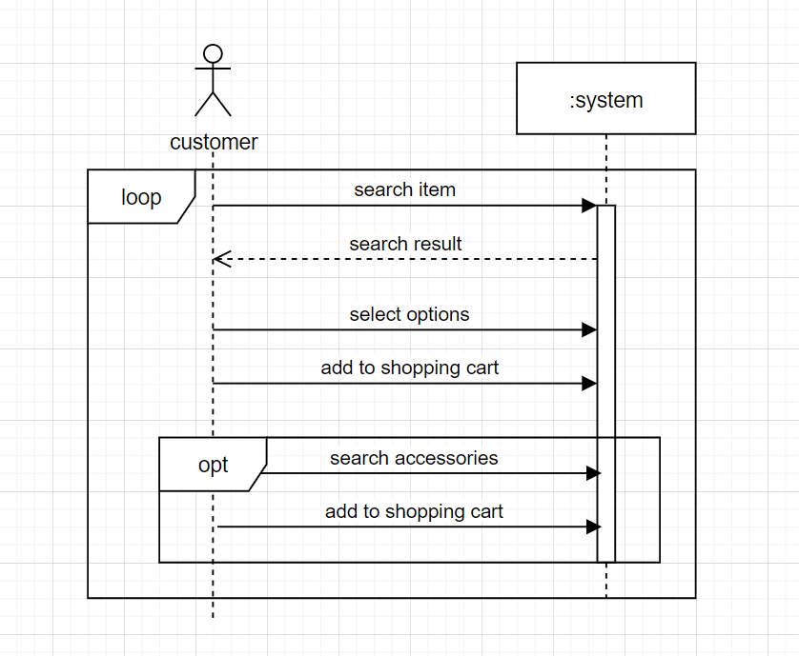

-Make checkout sequence diagram

