Cairo University  
Faculty of Computers and Artificial Intelligent

**CS251**

**Software Engineering I**

Parking garage

Software Design

Team Names

Contents

Instructions [To be removed] 3

Team 3

Document Purpose and Audience 3

System Models 3

I. Class diagrams 3

Important Algorithm 4

II. Sequence diagrams 5

Class - Sequence Usage Table 6

Ownership Report 6

Policy Regarding Plagiarism: 7

# Team

|  |  |  |  |
| --- | --- | --- | --- |
| **ID** | **Name** | **Email** | **Mobile** |
| 20201183 | Mayar Mohamed Hamed | mayarmohamedhamed12345@gmail.com | 01024079836 |
| 20200595 | Nadeen Badr Eldin | Nadeenbadr0@gmail.com | 01122062048 |
| 20200095 | Amira Ahmed Ibrahim | am27335102@gmail.com | 01114989003 |
| 20201218 | Walaa Soudy Ibrahim | Walaasoudy36@gmail.com | 01150324662 |

# Document Purpose and Audience

# The project allows the customer to park the vehicle through the garage. This is the purpose of the project, and we do this by showing the customer the available properties, and if the customer parks his vehicle, we will show him his cost. This is the purpose of the project in short, and his audience will be general System Models

## 

## I. Class diagrams

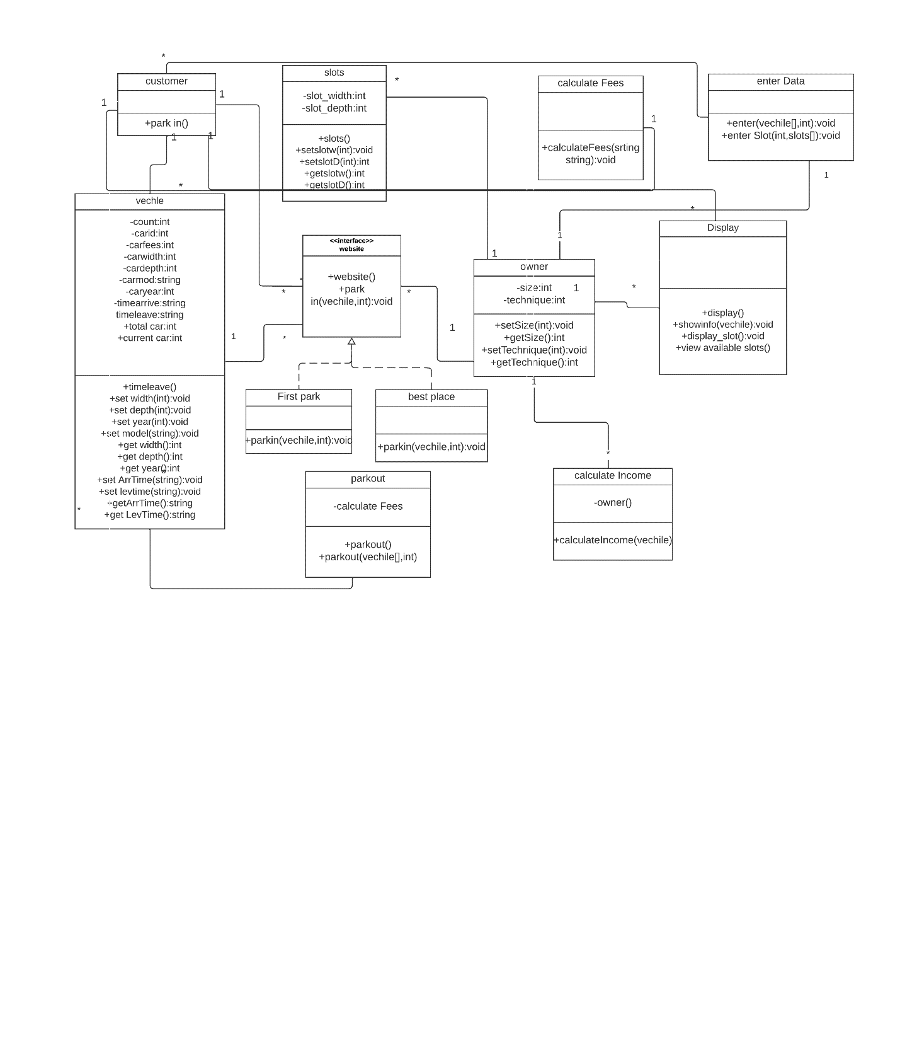

| **Class ID** | **Class Name** | **Description & Responsibility** |
| --- | --- | --- |
| 1 | vehical | Take the data from the customer through it |
| 2 | Park in | The customer chooses the way in which he will be parked, and records the time of entering the garage |
| 3 | Park out | Record the time the vehicle is out of the garage |
| 4 | Calculate income | calculate the income |
| 5 | payment | pay money through it |
| 6 | slot | It stores data about places and the customer can know the available places through it |
| 7 | Display | It displays the available places and the cost and displays anything that happens between the customer and the garage |
| 8 | Calculate fees | calculate the fees through it |
| 9 | bestplace | Find the best place to park |
| 10 | owner | owns the garage |
| 11 | First place | Find the first place to park |
| 12 | website | A interface through which the customer enters to park |

## II. Sequence diagrams

1-Park out and fees:

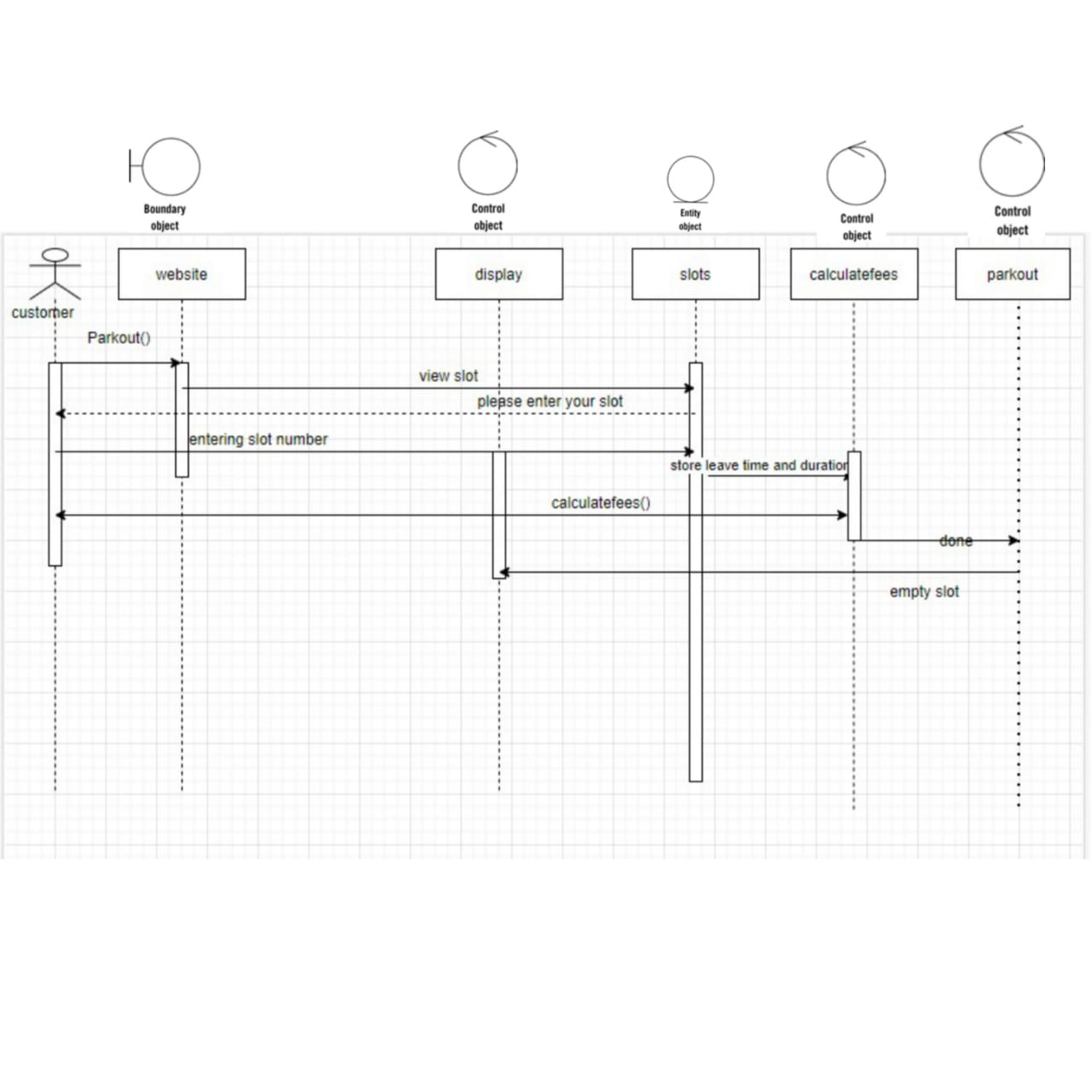

2-View slots:

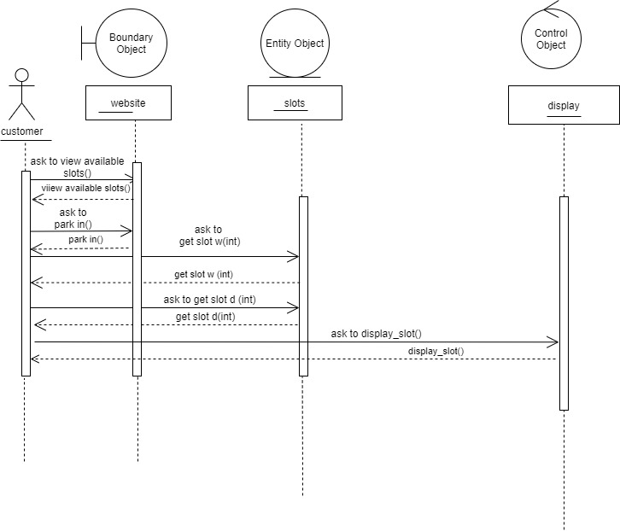

3-Park in :

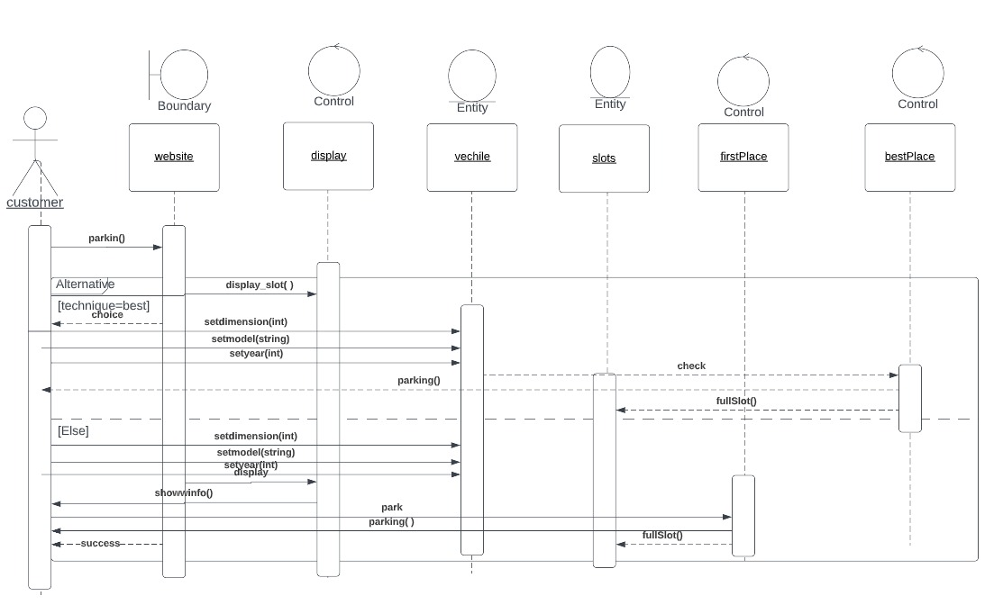

4-Income:

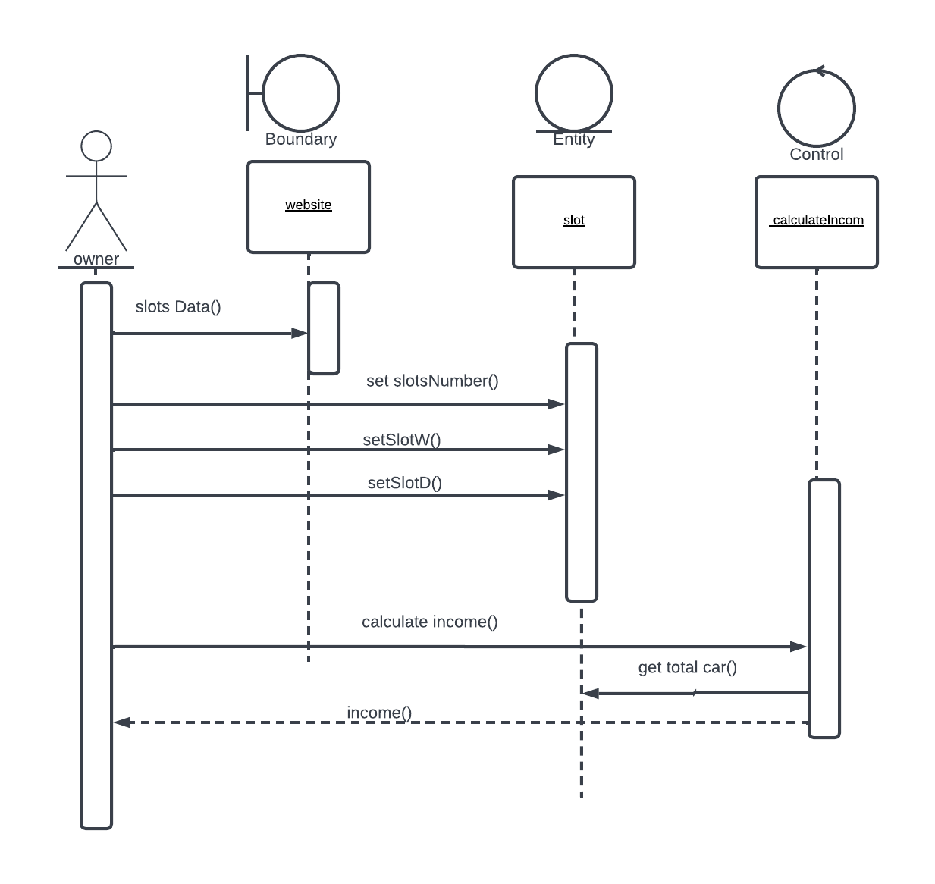

5-Garage owner:

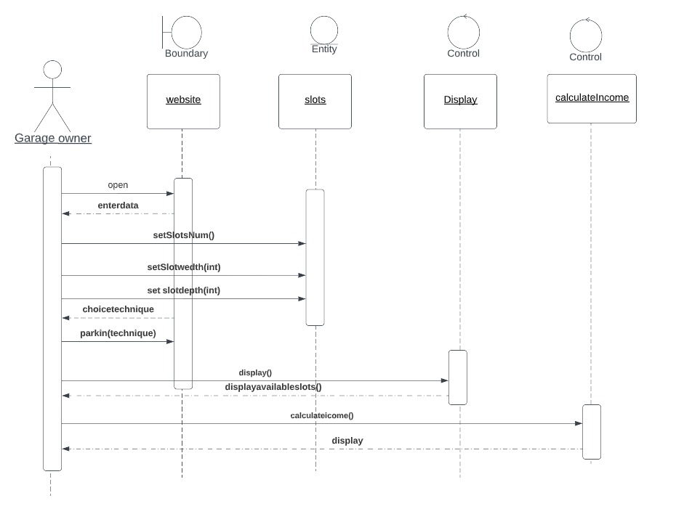

6 - Details

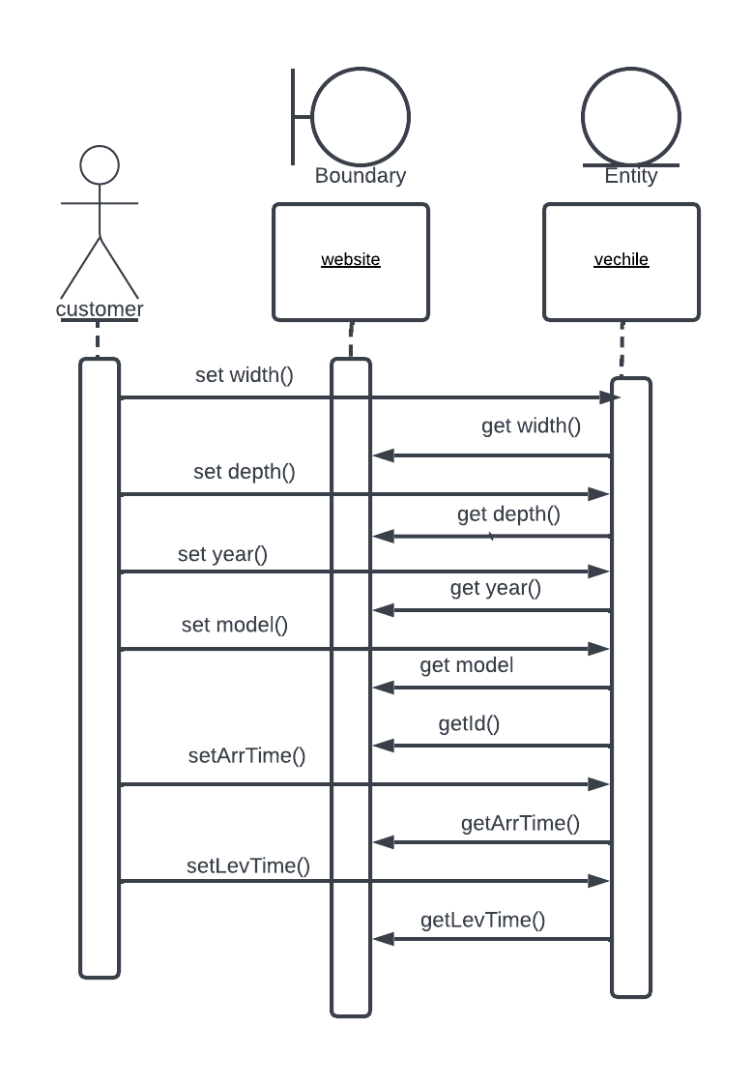

### 

### Class - Sequence Usage Table

| **Class Name** | **Sequence Diagrams** | **Overall used methods** |
| --- | --- | --- |
| display | 1,2, 3, 5 | Display_slot – show info – display payment – display fees – display success - display payment fall |
| slots | 2,5 | get slot w – get slot d – setslotnum – set slot w-set slot d - update data -fall |
| vehical | 4 | get depth - get width - set depth - set width – set year - get year – set model - get model |
| website | 1,2,3,5 | Open – enter data – view available slots –park in – choice technique – parking – success – check data – park out |
| Calculate income | 5 | calculateincome |
| Bestplace | 3 | Check – full slot |
| firstplace | 3 | Full slot - parking |
| Calculate fees | 1 | calculatefees |

# Ownership Report

|  |  |
| --- | --- |
| **Item** | **Owners** |
| Java code, SOLID | *Mayar, Nadeen* |
| Sequence diagrams , class diagram , use case diagram, requirements | *All team* |
| Drawing class diagram | *Amira* |
| Drawing use case diagram | *Walaa* |
| Purpose n scope , introduction, design specifications, Design pattern | *Amira , Walaa* |