Estimating the Intrinsic Dimension of High-Dimensional Data
PCA, Correlation Dimension, and k-Nearest Neighbors Analysis
Final Submission Version
Automatically Generated Figure Report
Language: English

1. Introduction
Intrinsic dimension refers to the minimum number of variables required to represent the underlying structure of a dataset. In many practical cases, the ambient dimension is much larger than the true number of degrees of freedom governing the data.
This report presents the visual results of intrinsic-dimension analysis for four datasets: a two-dimensional plane embedded in ten dimensions, the Swiss roll dataset, Gaussian noise, and MNIST handwritten digit images.
Three complementary estimation methods were applied. Principal component analysis (PCA) was used to examine the number of linear components required to explain most of the variance, correlation dimension was used to characterize local geometric scaling, and a k-nearest neighbors (kNN) estimator was used to provide an additional neighborhood-based estimate of intrinsic dimensionality.

2. Methods Overview
- PCA was evaluated through cumulative explained variance curves and scree plots.
- Correlation dimension was estimated from the slope of the linear scaling region in log-log correlation-integral plots.
- A kNN-based Levina-Bickel maximum-likelihood estimator was used to estimate intrinsic dimension from nearest-neighbor distances.
- The combined analysis was designed to compare linear variance structure with intrinsic geometric complexity.

3. Results and Figure Analysis

3.1 2D Plane Embedded in 10D
This subsection summarizes the visual results obtained for the 2D Plane Embedded in 10D dataset.
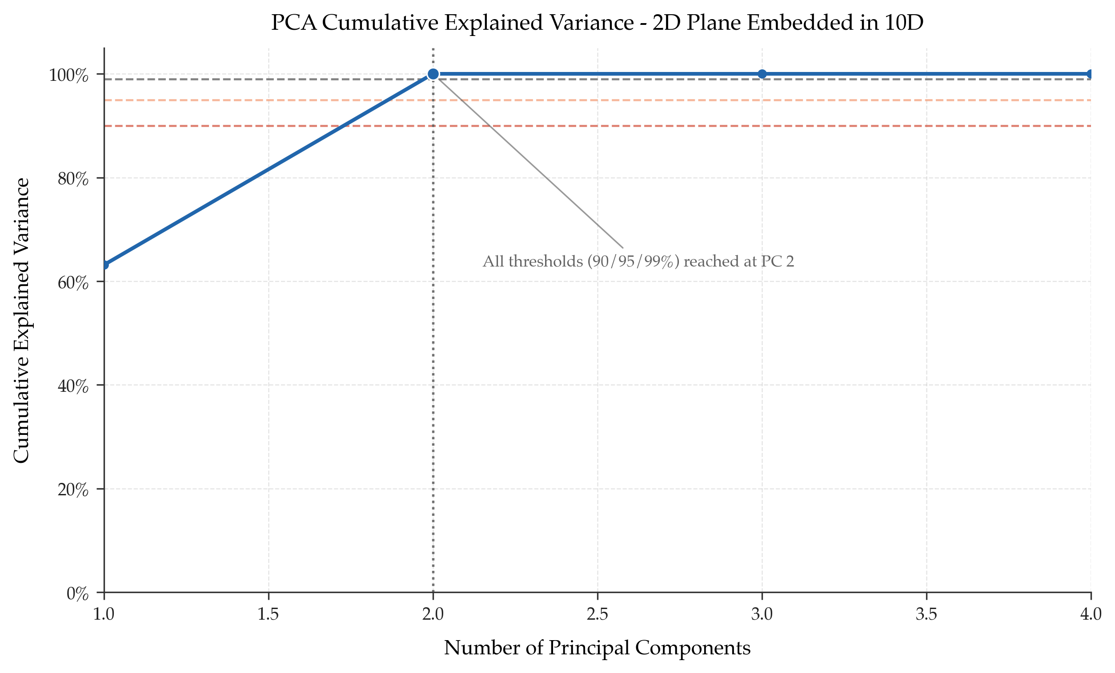
Figure 1. Cumulative explained variance curve for the 2D Plane Embedded in 10D dataset.
The cumulative explained variance curve shows that almost all variance is captured by the first two principal components. This is exactly the expected result for a linear two-dimensional manifold embedded in a higher-dimensional ambient space.
The figure therefore confirms that PCA successfully recovers the known intrinsic structure of this dataset.
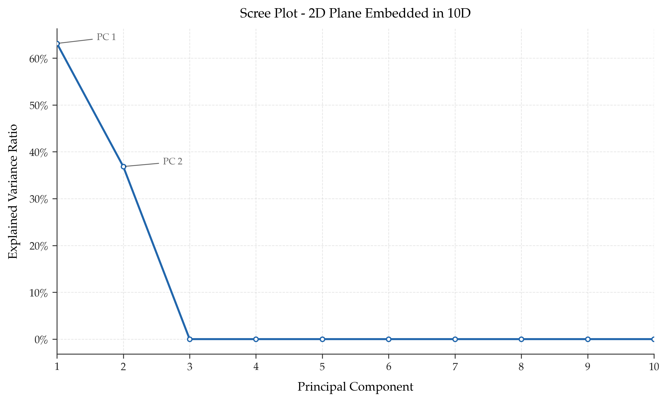
Figure 2. Scree plot for the 2D Plane Embedded in 10D dataset.
The scree plot shows a clear dominance of the first two components, while the remaining components contribute essentially no meaningful variance.
This is the strongest possible visual indication of a low-dimensional linear structure.
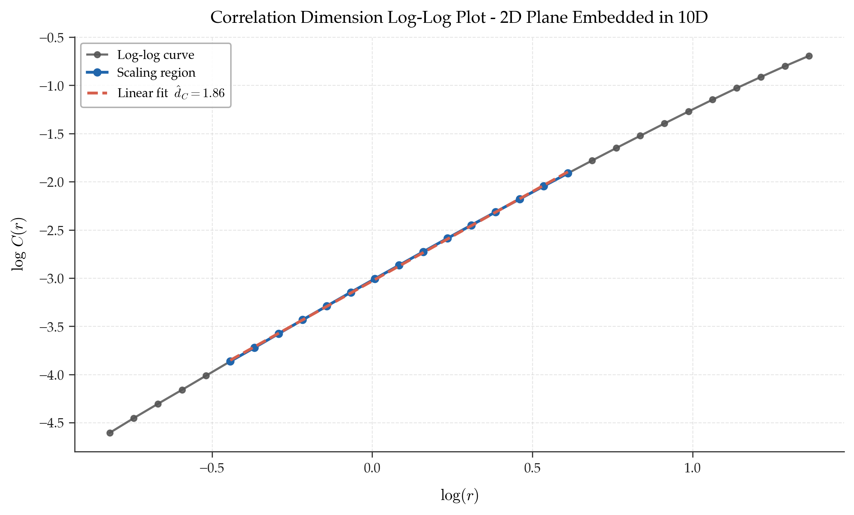
Figure 3. Correlation-dimension log-log plot for the 2D Plane Embedded in 10D dataset.
The correlation-dimension estimate is very close to 2, which matches the theoretical intrinsic dimensionality of the dataset.
The agreement between PCA and correlation dimension validates both the dataset construction and the analysis workflow.
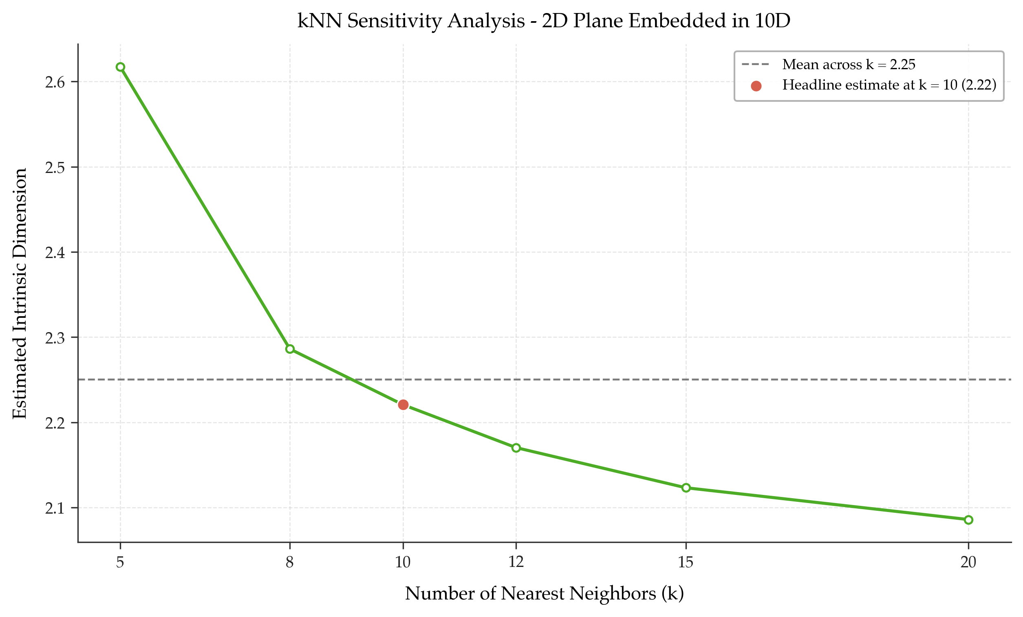
Figure 4. kNN sensitivity analysis for the 2D Plane Embedded in 10D dataset across multiple values of k.
The kNN sensitivity plot shows that the estimated intrinsic dimension remains close to 2 over the full tested range of neighborhood sizes.
This provides further support for the conclusion that the dataset is intrinsically two-dimensional and that the estimate is stable.

3.2 Swiss Roll
This subsection summarizes the visual results obtained for the Swiss Roll dataset.
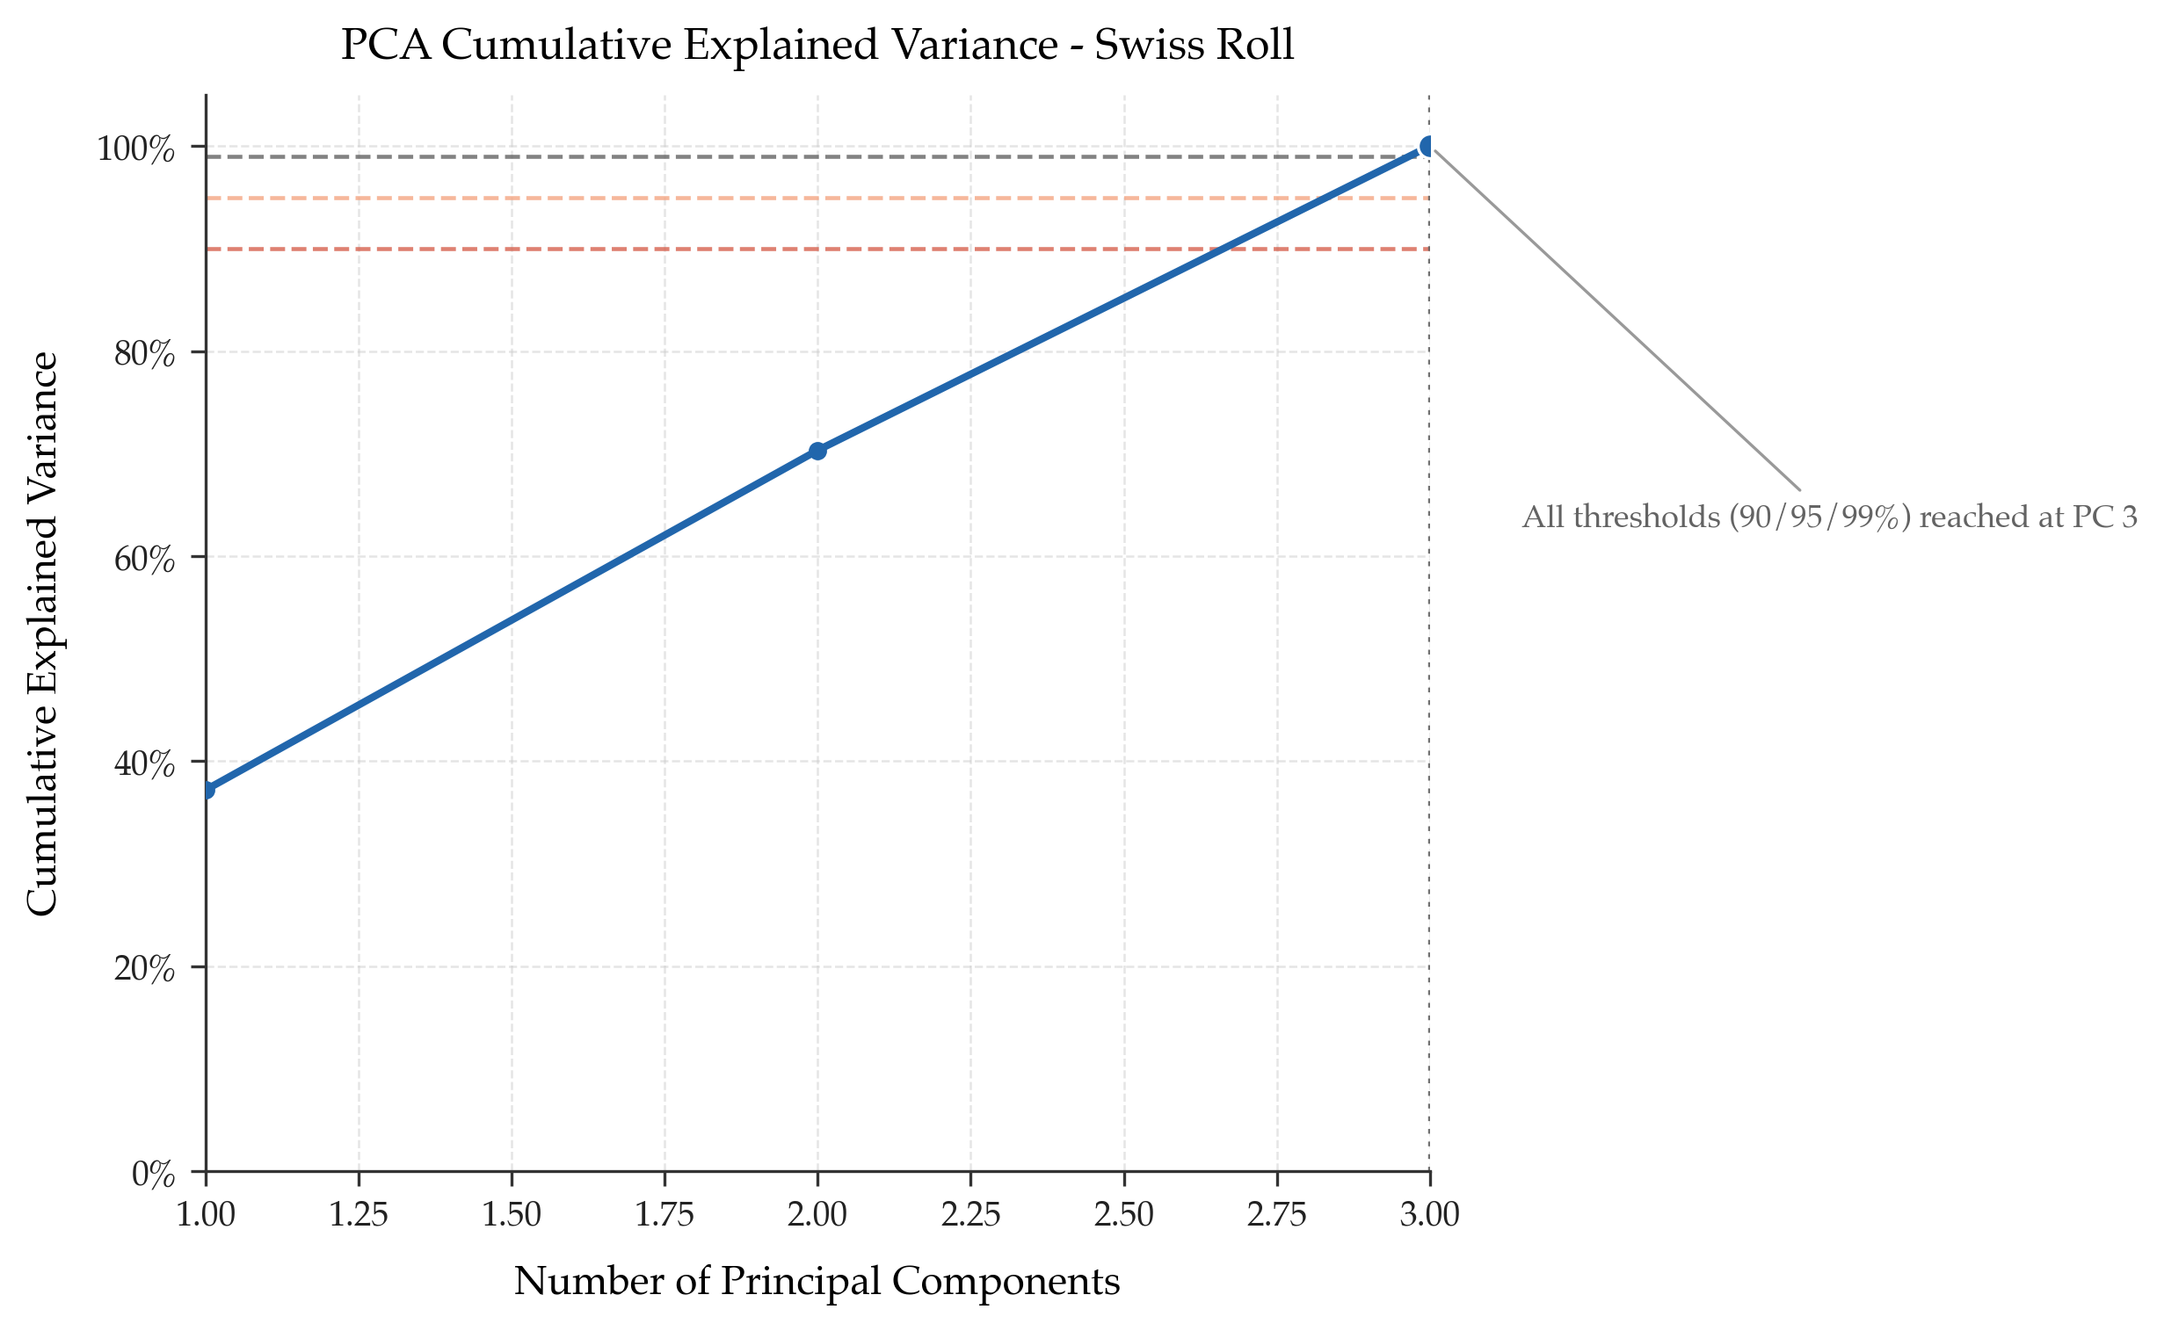
Figure 5. Cumulative explained variance curve for the Swiss Roll dataset.
The cumulative explained variance plot indicates that multiple principal components are required to preserve most of the variance.
This occurs because the Swiss roll is intrinsically two-dimensional but geometrically curved, and PCA is limited to linear directions.
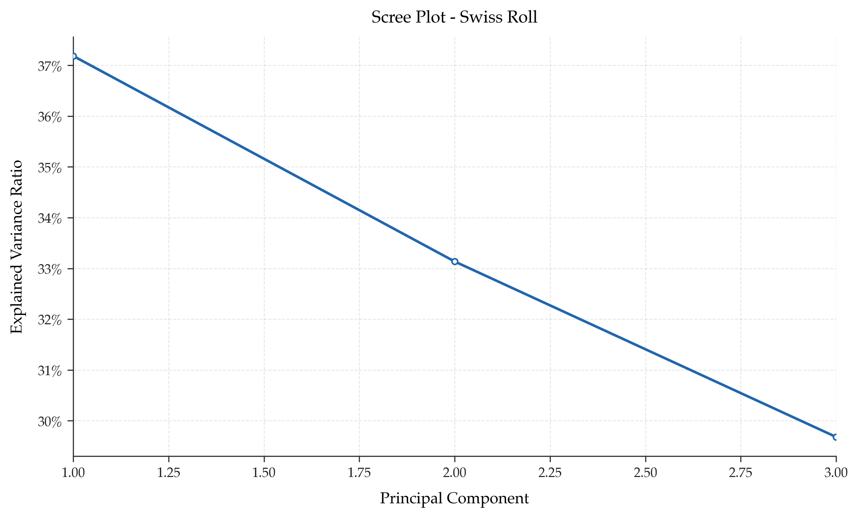
Figure 6. Scree plot for the Swiss Roll dataset.
The scree plot does not collapse sharply after the first two components, which reflects the nonlinear geometry of the manifold.
This behavior is expected when a curved low-dimensional structure is analyzed using a linear projection method.
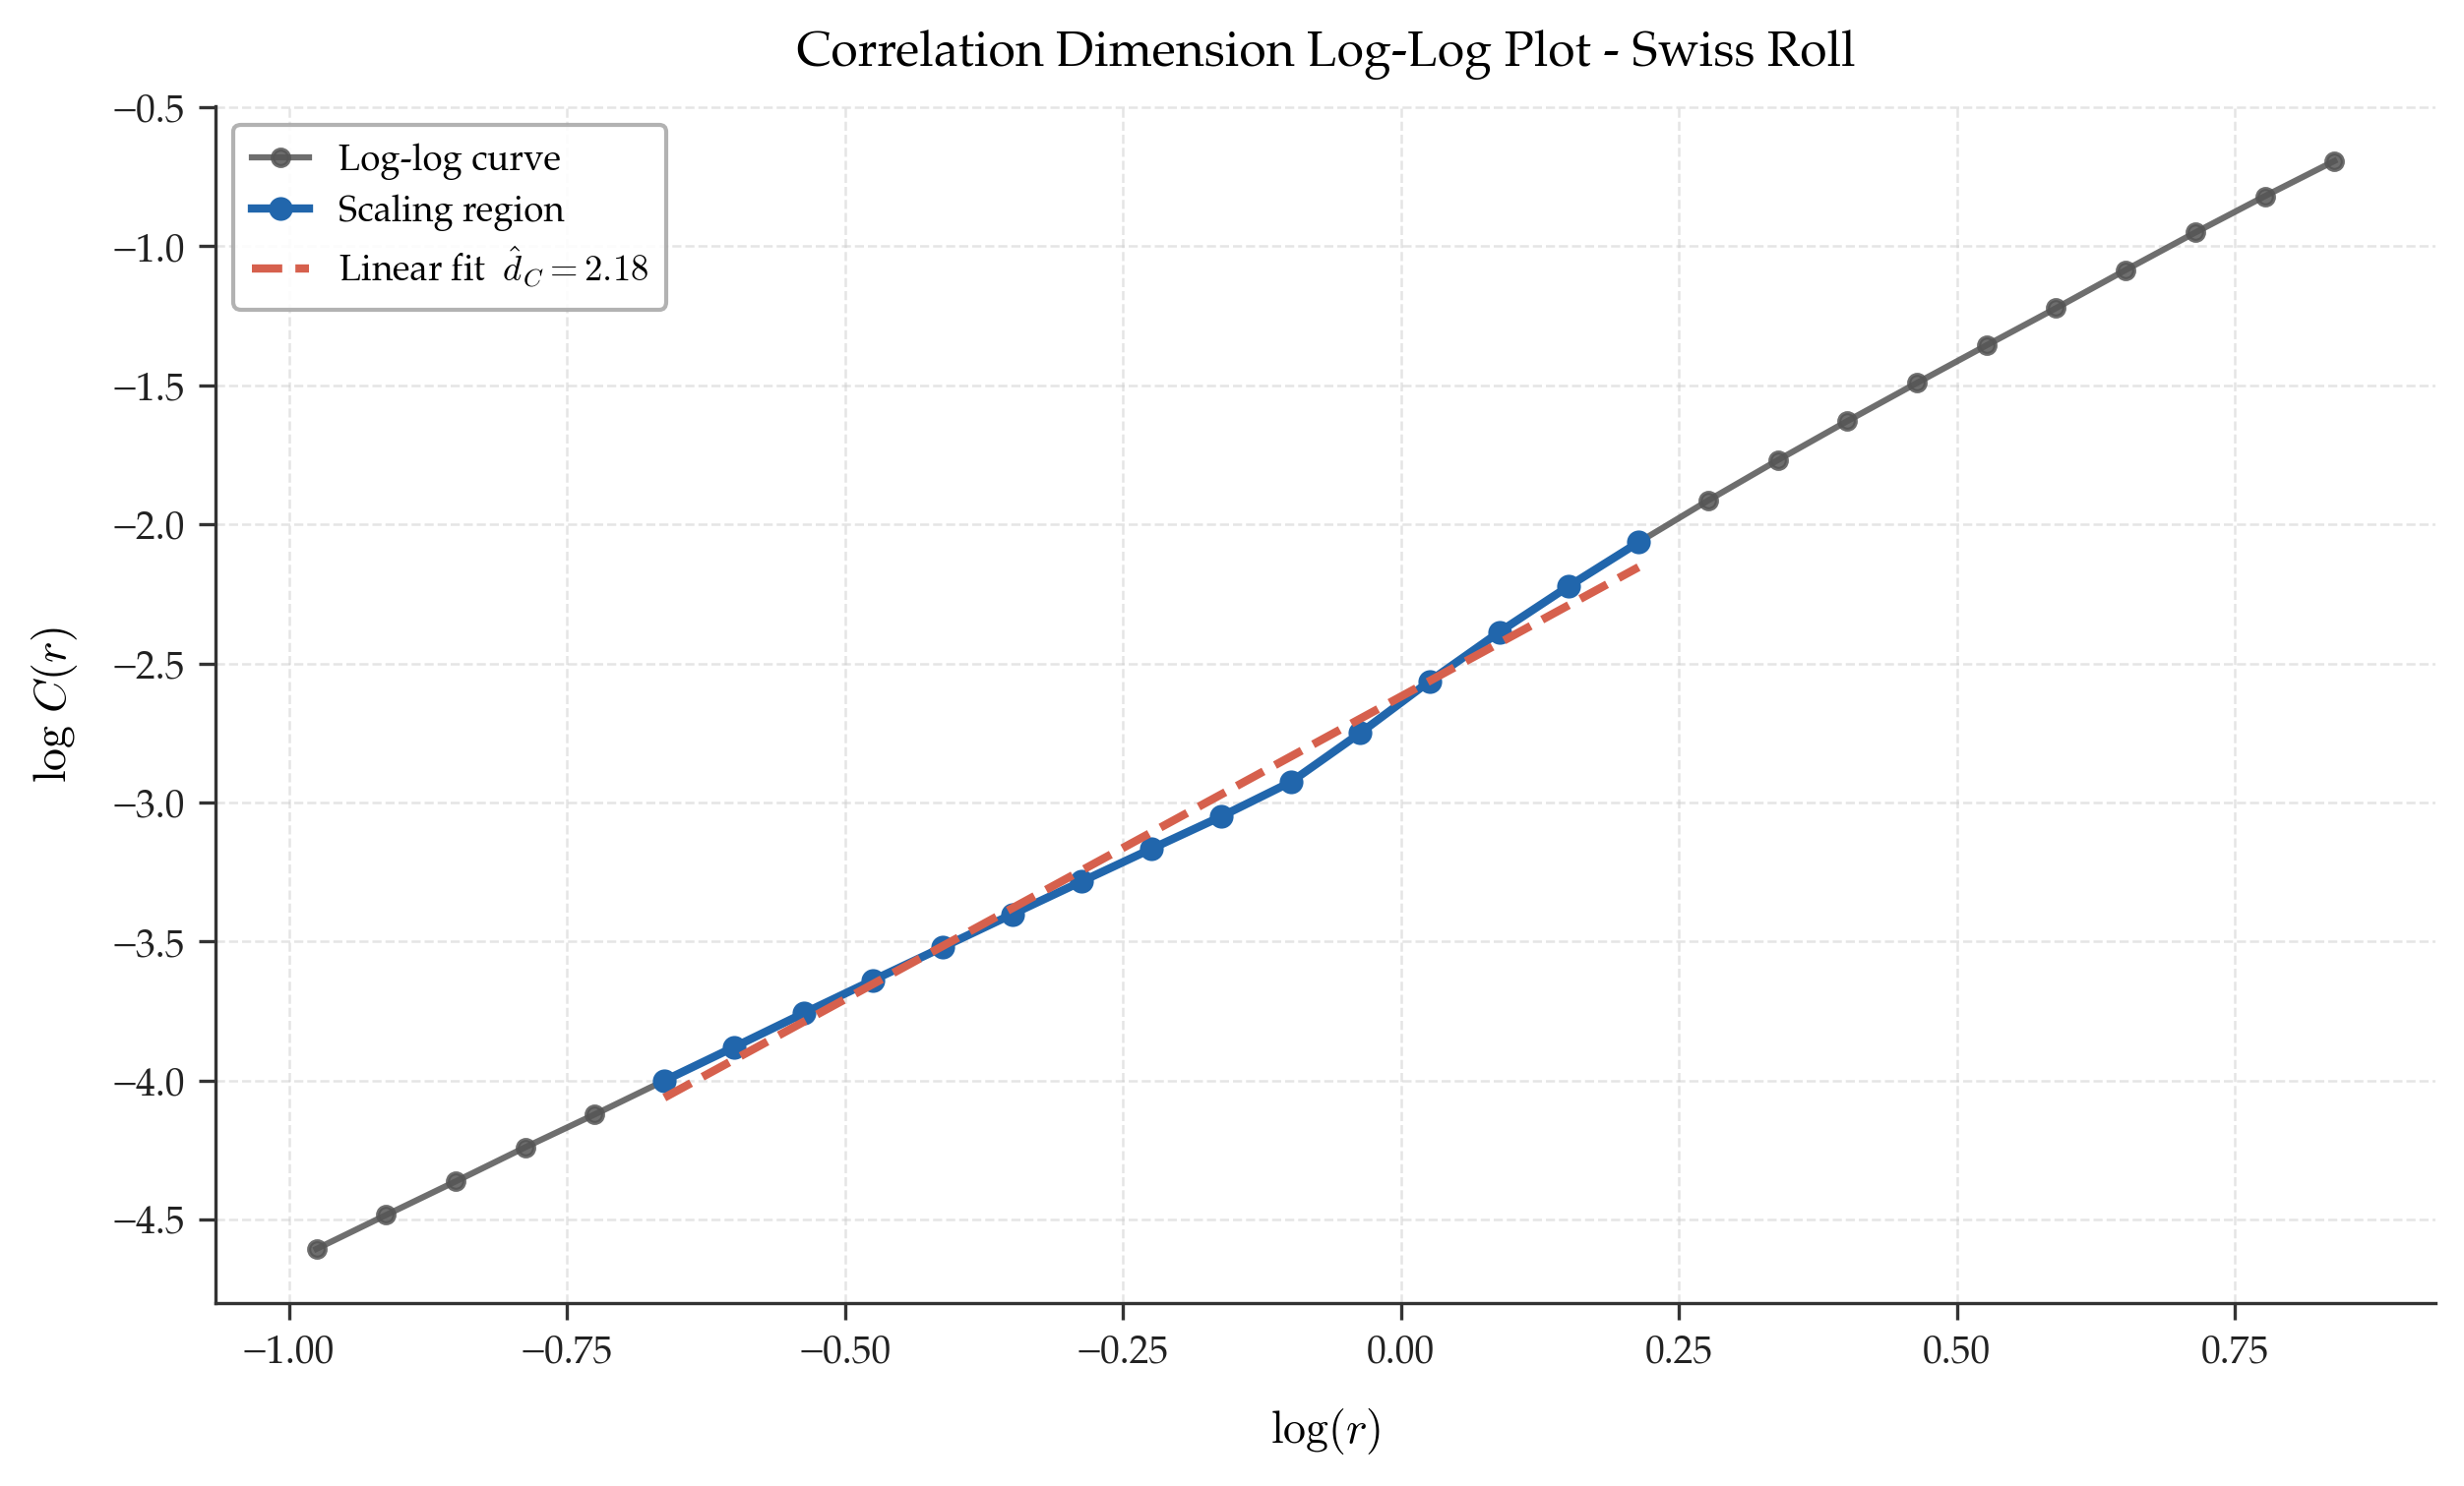
Figure 7. Correlation-dimension log-log plot for the Swiss Roll dataset.
The correlation-dimension estimate remains close to 2, which is much more faithful to the true intrinsic structure of the Swiss roll.
This dataset therefore illustrates why geometric methods are especially valuable for nonlinear manifolds.
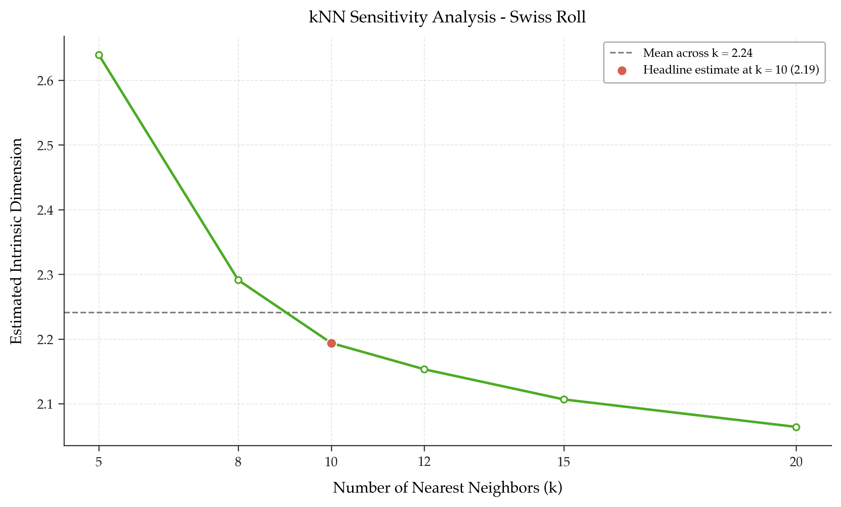
Figure 8. kNN sensitivity analysis for the Swiss Roll dataset across multiple values of k.
The kNN-based estimates remain close to 2 for all tested values of k, indicating strong stability.
Together with the correlation-dimension result, this confirms that the Swiss roll is intrinsically low-dimensional despite its nonlinear embedding.

3.3 Gaussian Noise
This subsection summarizes the visual results obtained for the Gaussian Noise dataset.
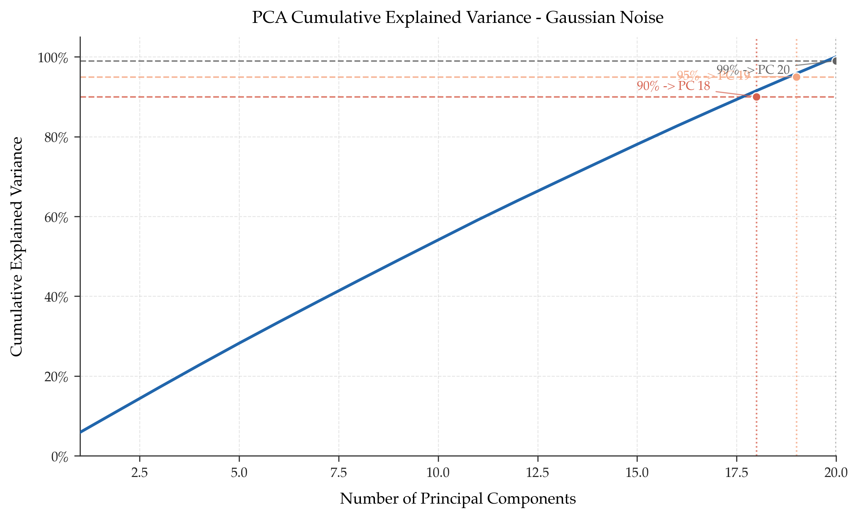
Figure 9. Cumulative explained variance curve for the Gaussian Noise dataset.
The cumulative explained variance increases gradually rather than sharply, indicating that variance is distributed across many directions.
This is the expected pattern for isotropic high-dimensional noise without a compact low-dimensional linear subspace.
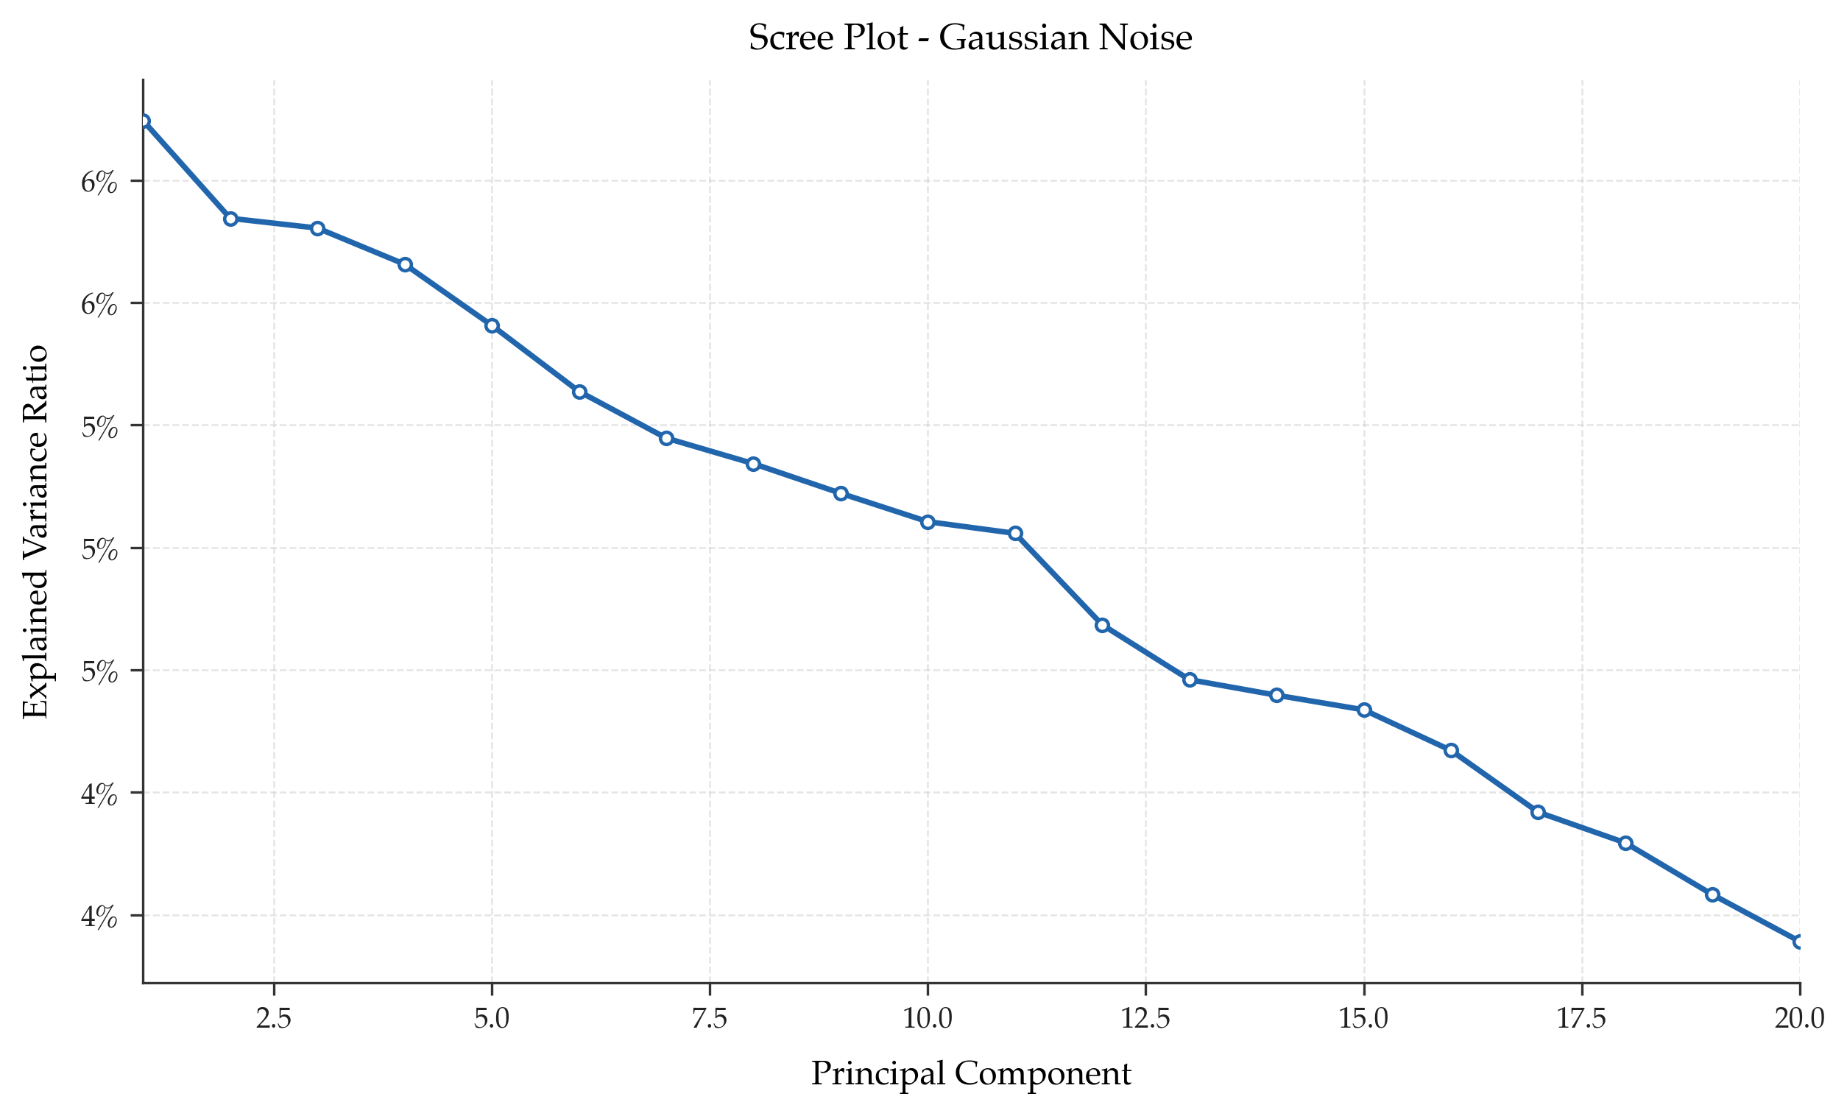
Figure 10. Scree plot for the Gaussian Noise dataset.
The scree plot shows no pronounced elbow and no small subset of components that dominates the variance structure.
This confirms the absence of a strong linear low-dimensional representation.
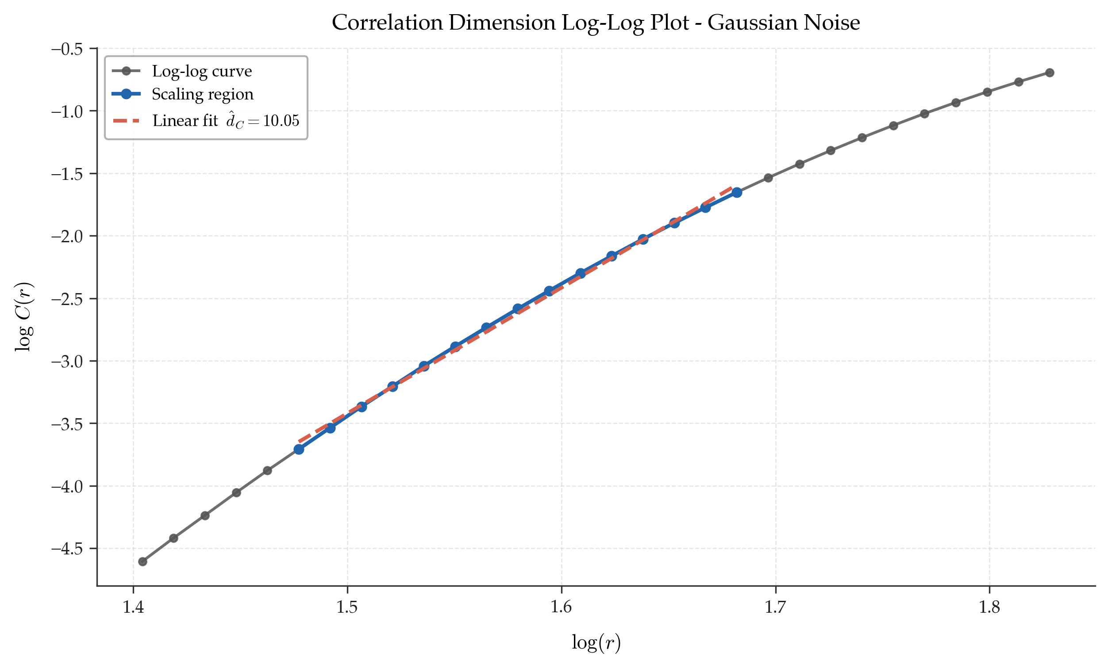
Figure 11. Correlation-dimension log-log plot for the Gaussian Noise dataset.
The correlation-dimension estimate is comparatively high, which is consistent with the noise-like nature of the data.
Together, the PCA and correlation results distinguish Gaussian noise clearly from the more structured datasets.
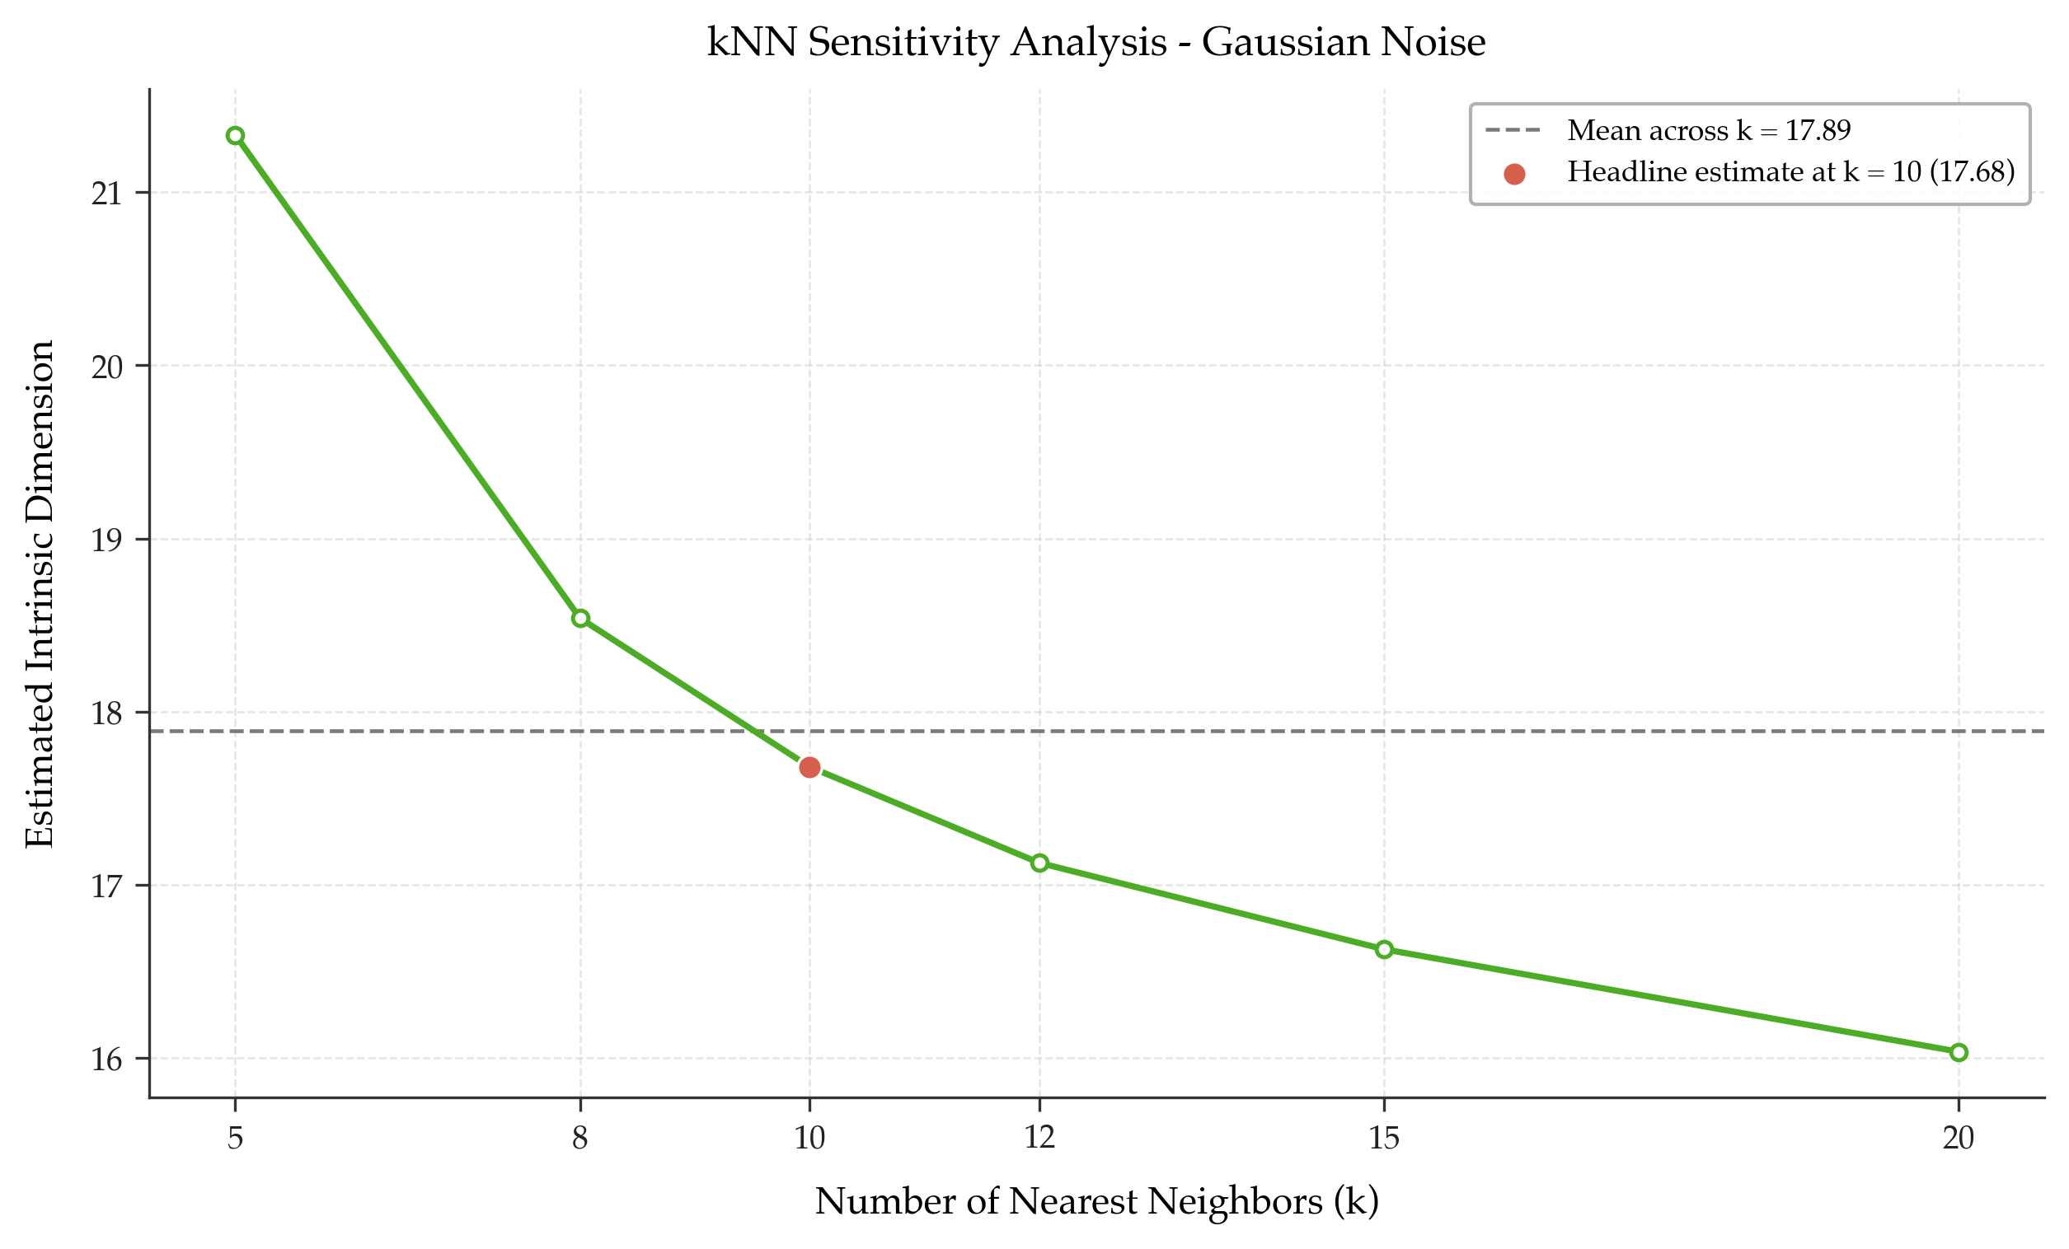
Figure 12. kNN sensitivity analysis for the Gaussian Noise dataset across multiple values of k.
The kNN sensitivity plot remains in a high-dimensional regime across all tested values of k, although the estimates vary more than in the low-dimensional synthetic datasets.
This moderate variability is expected for a dataset that does not lie on a sharply defined low-dimensional manifold.

3.4 MNIST
This subsection summarizes the visual results obtained for the MNIST dataset.
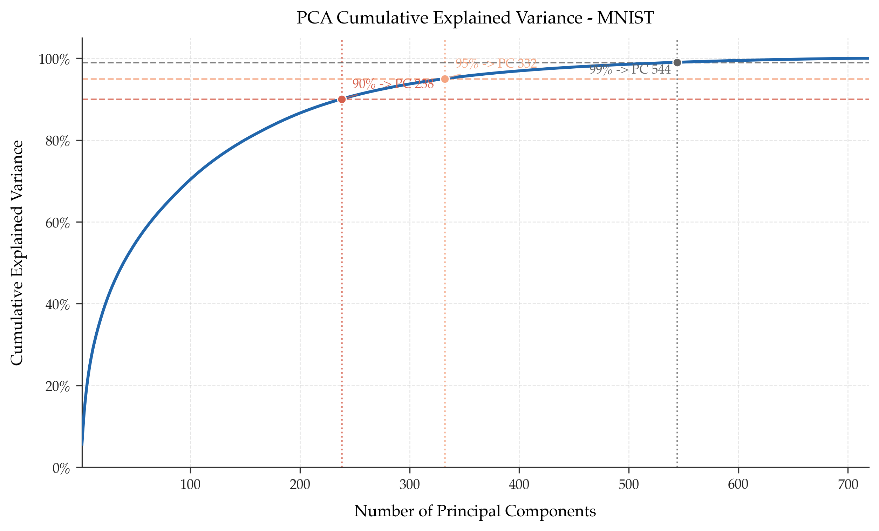
Figure 13. Cumulative explained variance curve for the MNIST dataset.
The cumulative explained variance curve shows that a very large number of principal components are required to preserve 90%, 95%, and 99% of the total variance.
This reflects the fact that image variability in pixel space is distributed across many linear directions.
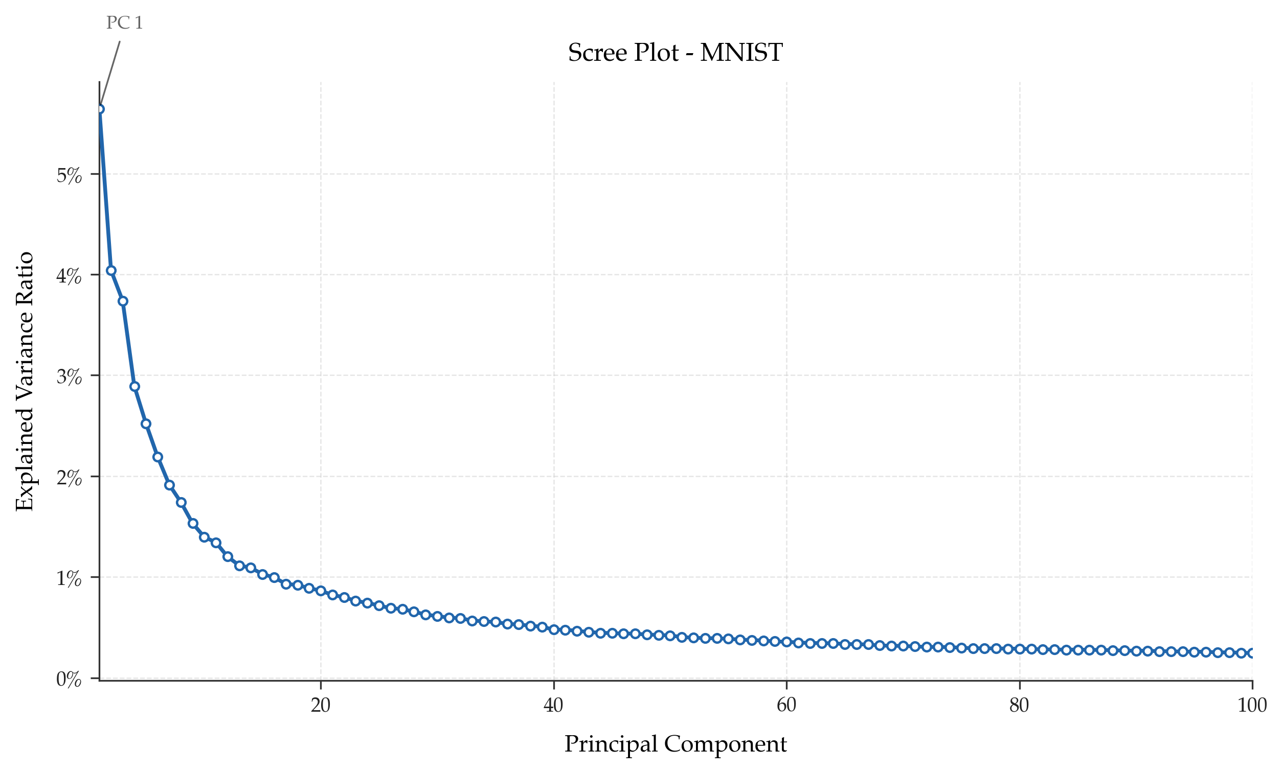
Figure 14. Scree plot for the MNIST dataset.
The scree plot decays gradually, indicating that many components contain non-negligible information.
Such behavior is typical for structured image datasets with rich variability in writing style, thickness, curvature, and placement.
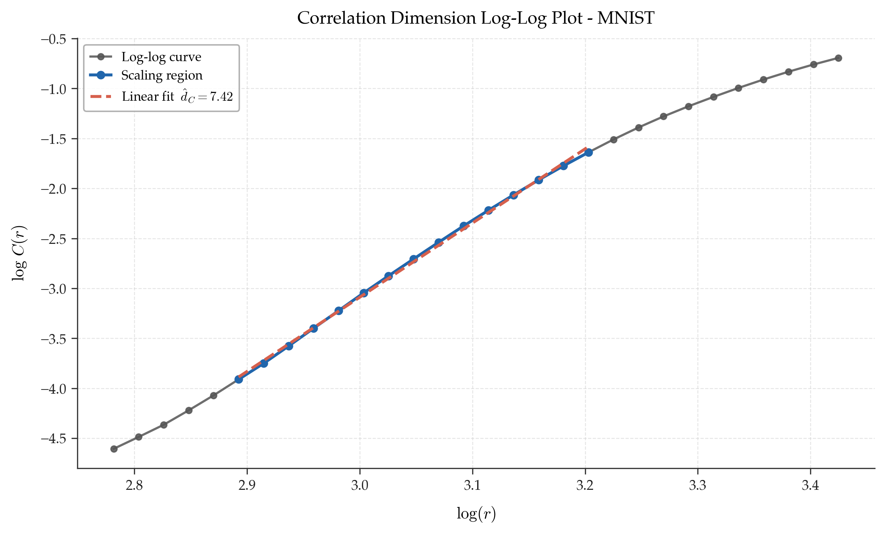
Figure 15. Correlation-dimension log-log plot for the MNIST dataset.
The correlation-dimension estimate is much lower than the number of PCA components required for high variance retention.
This gap suggests that MNIST occupies a structured nonlinear region of the ambient space rather than a diffuse cloud filling the full pixel space.
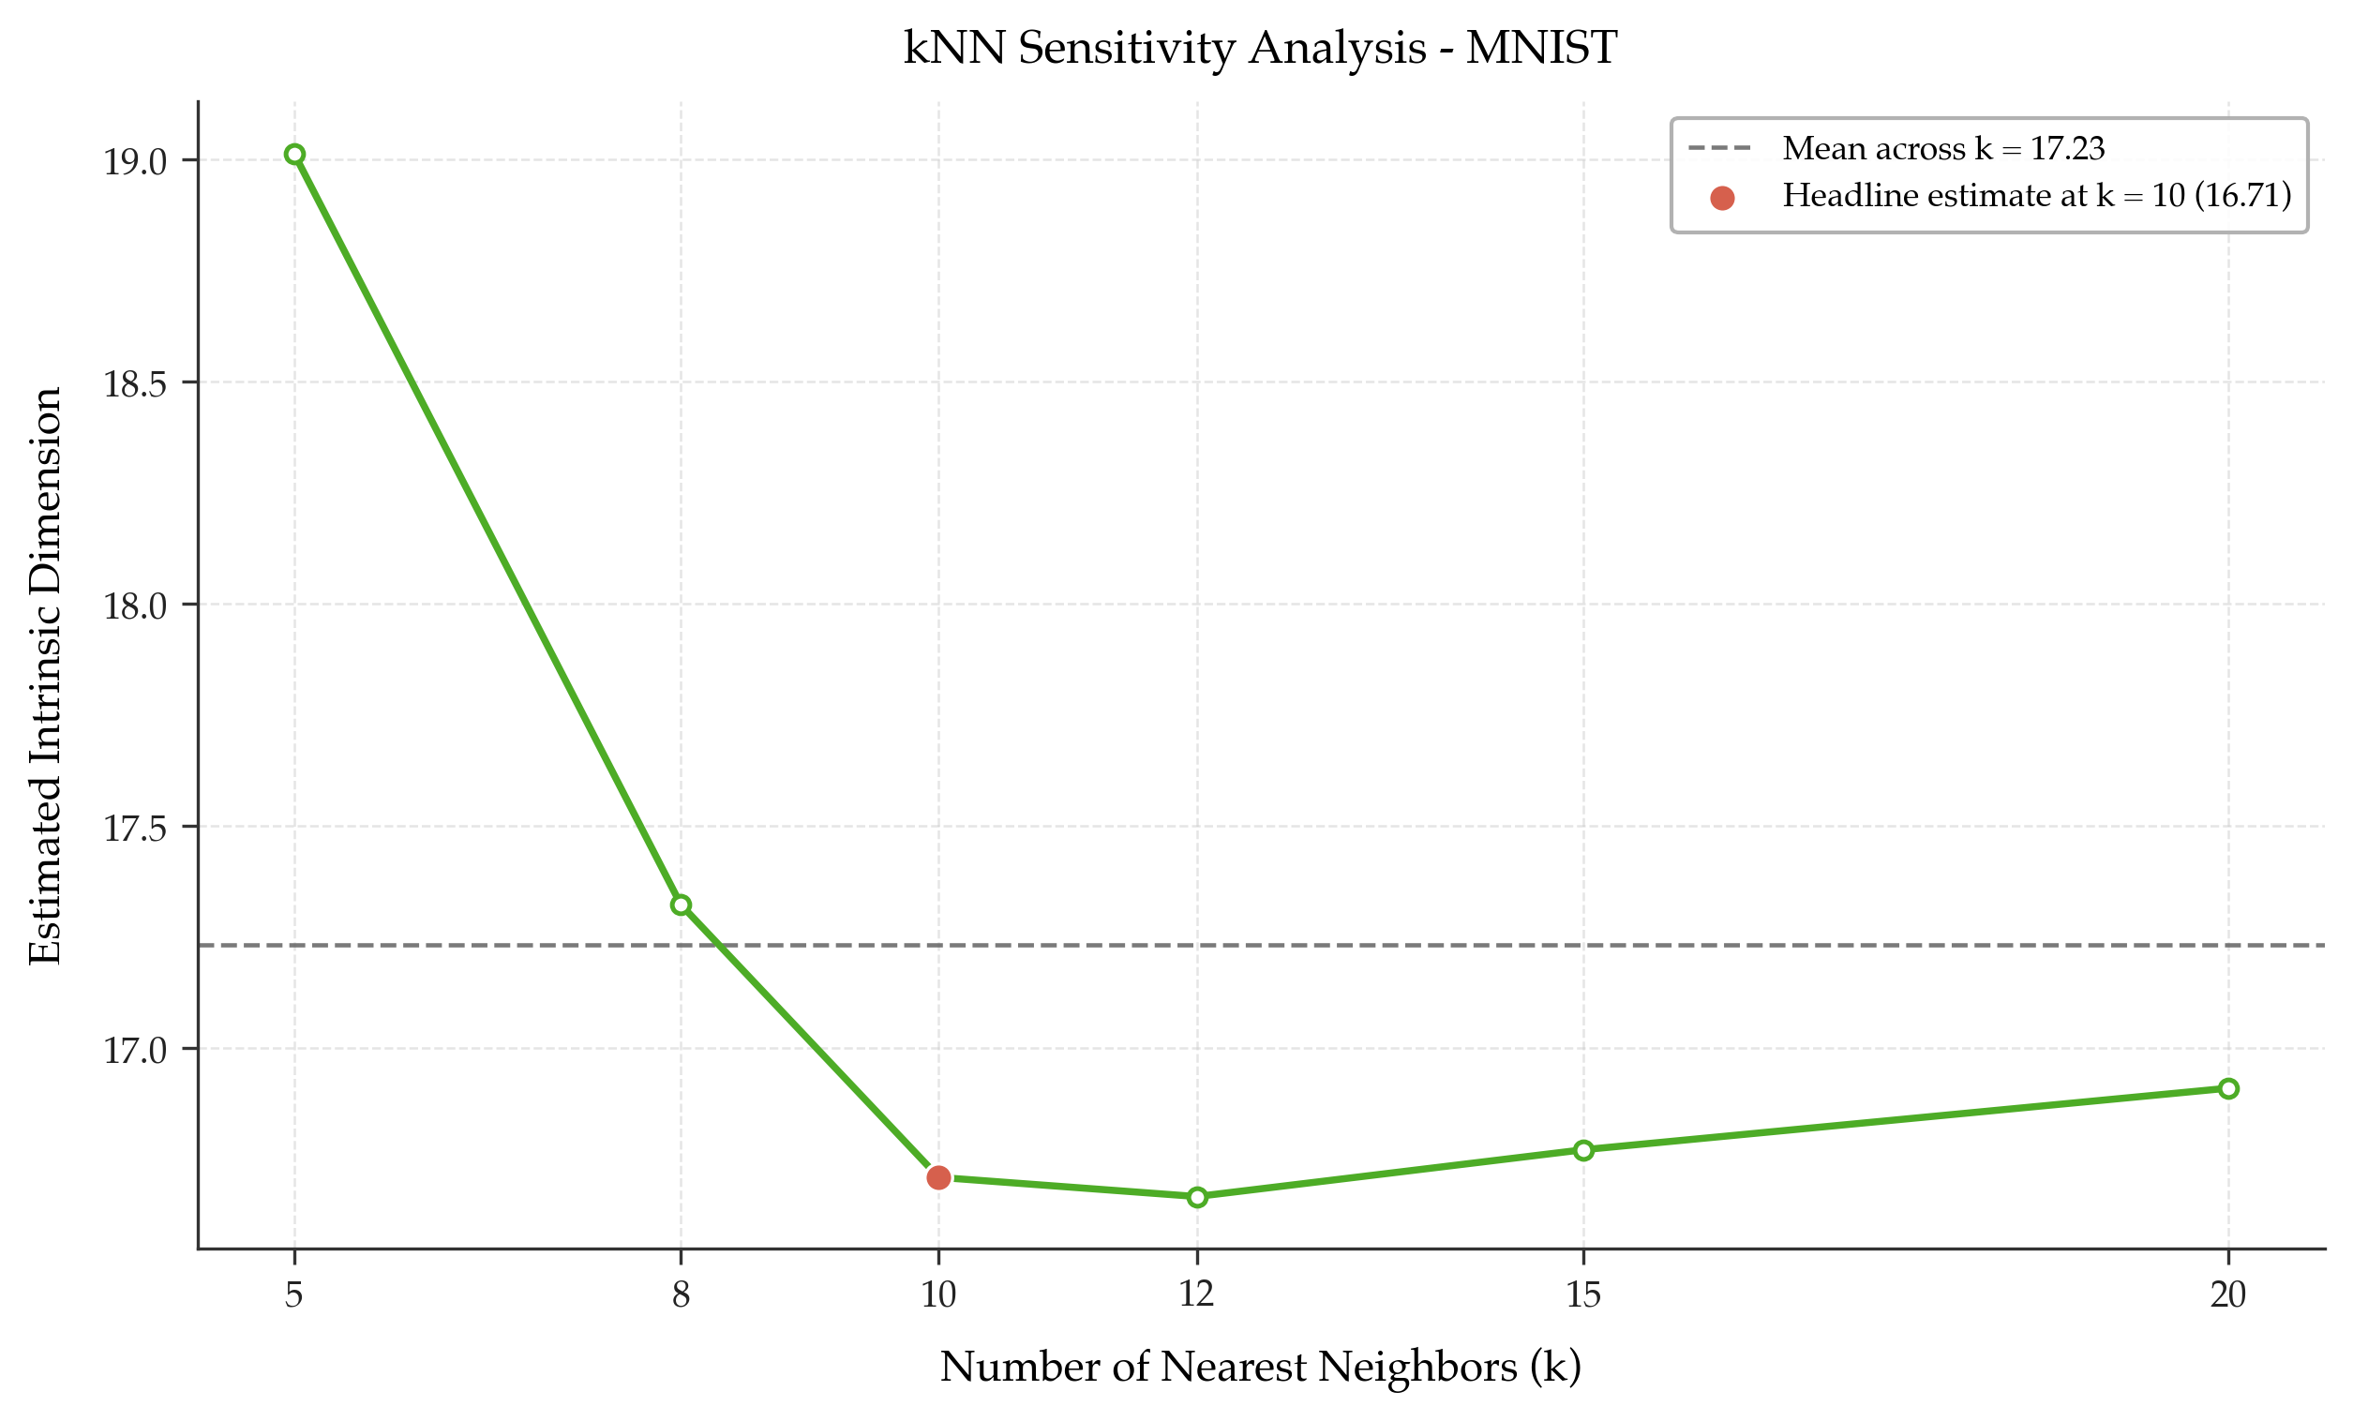
Figure 16. kNN sensitivity analysis for the MNIST dataset across multiple values of k.
The kNN sensitivity analysis produces estimates in the high-teen range and shows good stability across the tested neighborhood sizes.
The kNN estimate lies between the PCA-based and correlation-dimension estimates, which supports the interpretation that MNIST has a structured yet moderately complex intrinsic geometry.

4. k-Nearest Neighbors Based Intrinsic Dimension Estimation
To complement the PCA-based analysis and the correlation-dimension approach, a third estimator based on k-nearest neighbors was applied. This method provides an additional local geometric perspective on intrinsic dimensionality and does not rely on global linear projections.
In this project, intrinsic dimension was estimated using the Levina-Bickel maximum-likelihood estimator. For each point, the estimator uses the distances to its nearest neighbors and computes a local estimate of intrinsic dimension. These local estimates are then aggregated across the dataset to obtain a global estimate.
The same preprocessing pipeline used in the rest of the project was applied before the kNN analysis. Constant features were removed, the data were standardized, and no additional normalization was applied. For MNIST, the estimator was computed on a random sample of 1000 observations in order to maintain computational efficiency.
A headline estimate was computed with k=10, and a sensitivity analysis was performed over the range k in {5, 8, 10, 12, 15, 20}. This made it possible to evaluate the stability of the estimator with respect to neighborhood size.

4.1 kNN Summary Table
Dataset | Samples Used | Processed Dimension | kNN Estimate (k=10) | Mean Across k | Std. Across k
MNIST (sampled) | 1000 | 599 | 16.71 | 17.23 | 0.83
Gaussian Noise | 2000 | 20 | 17.68 | 17.89 | 1.73
2D Plane Embedded in 10D | 2000 | 10 | 2.22 | 2.25 | 0.18
Swiss Roll | 2000 | 3 | 2.19 | 2.24 | 0.19

The kNN-based results are highly consistent with the overall interpretation of the datasets. For the 2D plane embedded in 10D and for the Swiss roll dataset, the kNN estimates were both very close to 2, which strongly supports the conclusion that both datasets are intrinsically two-dimensional despite differences in their global geometry.
For Gaussian noise, the kNN estimate remained high, which is fully consistent with the absence of a compact low-dimensional manifold. For MNIST, the estimate was much lower than the ambient dimension but substantially larger than for the simple synthetic manifolds, indicating a structured yet nontrivial intrinsic geometry.

5. Global Comparison Across Datasets
After analyzing each dataset individually, it is useful to compare the final PCA-based, correlation-dimension, and kNN-based estimates across all datasets.
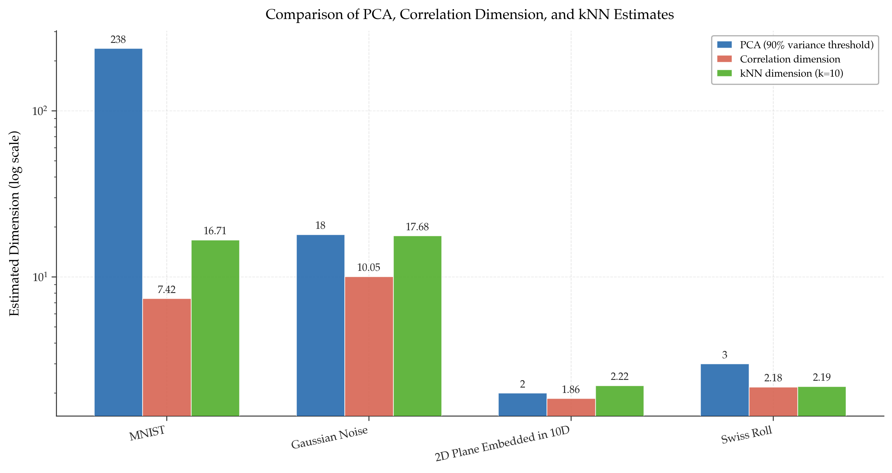
Figure 17. Comparison of PCA, correlation-dimension, and kNN-based dimensionality estimates across all datasets.
The full comparison clearly shows that the three methods capture different aspects of structure. PCA is variance-oriented and linear, correlation dimension is locally geometric, and the kNN estimator provides a neighborhood-based estimate that often lies between the other two.
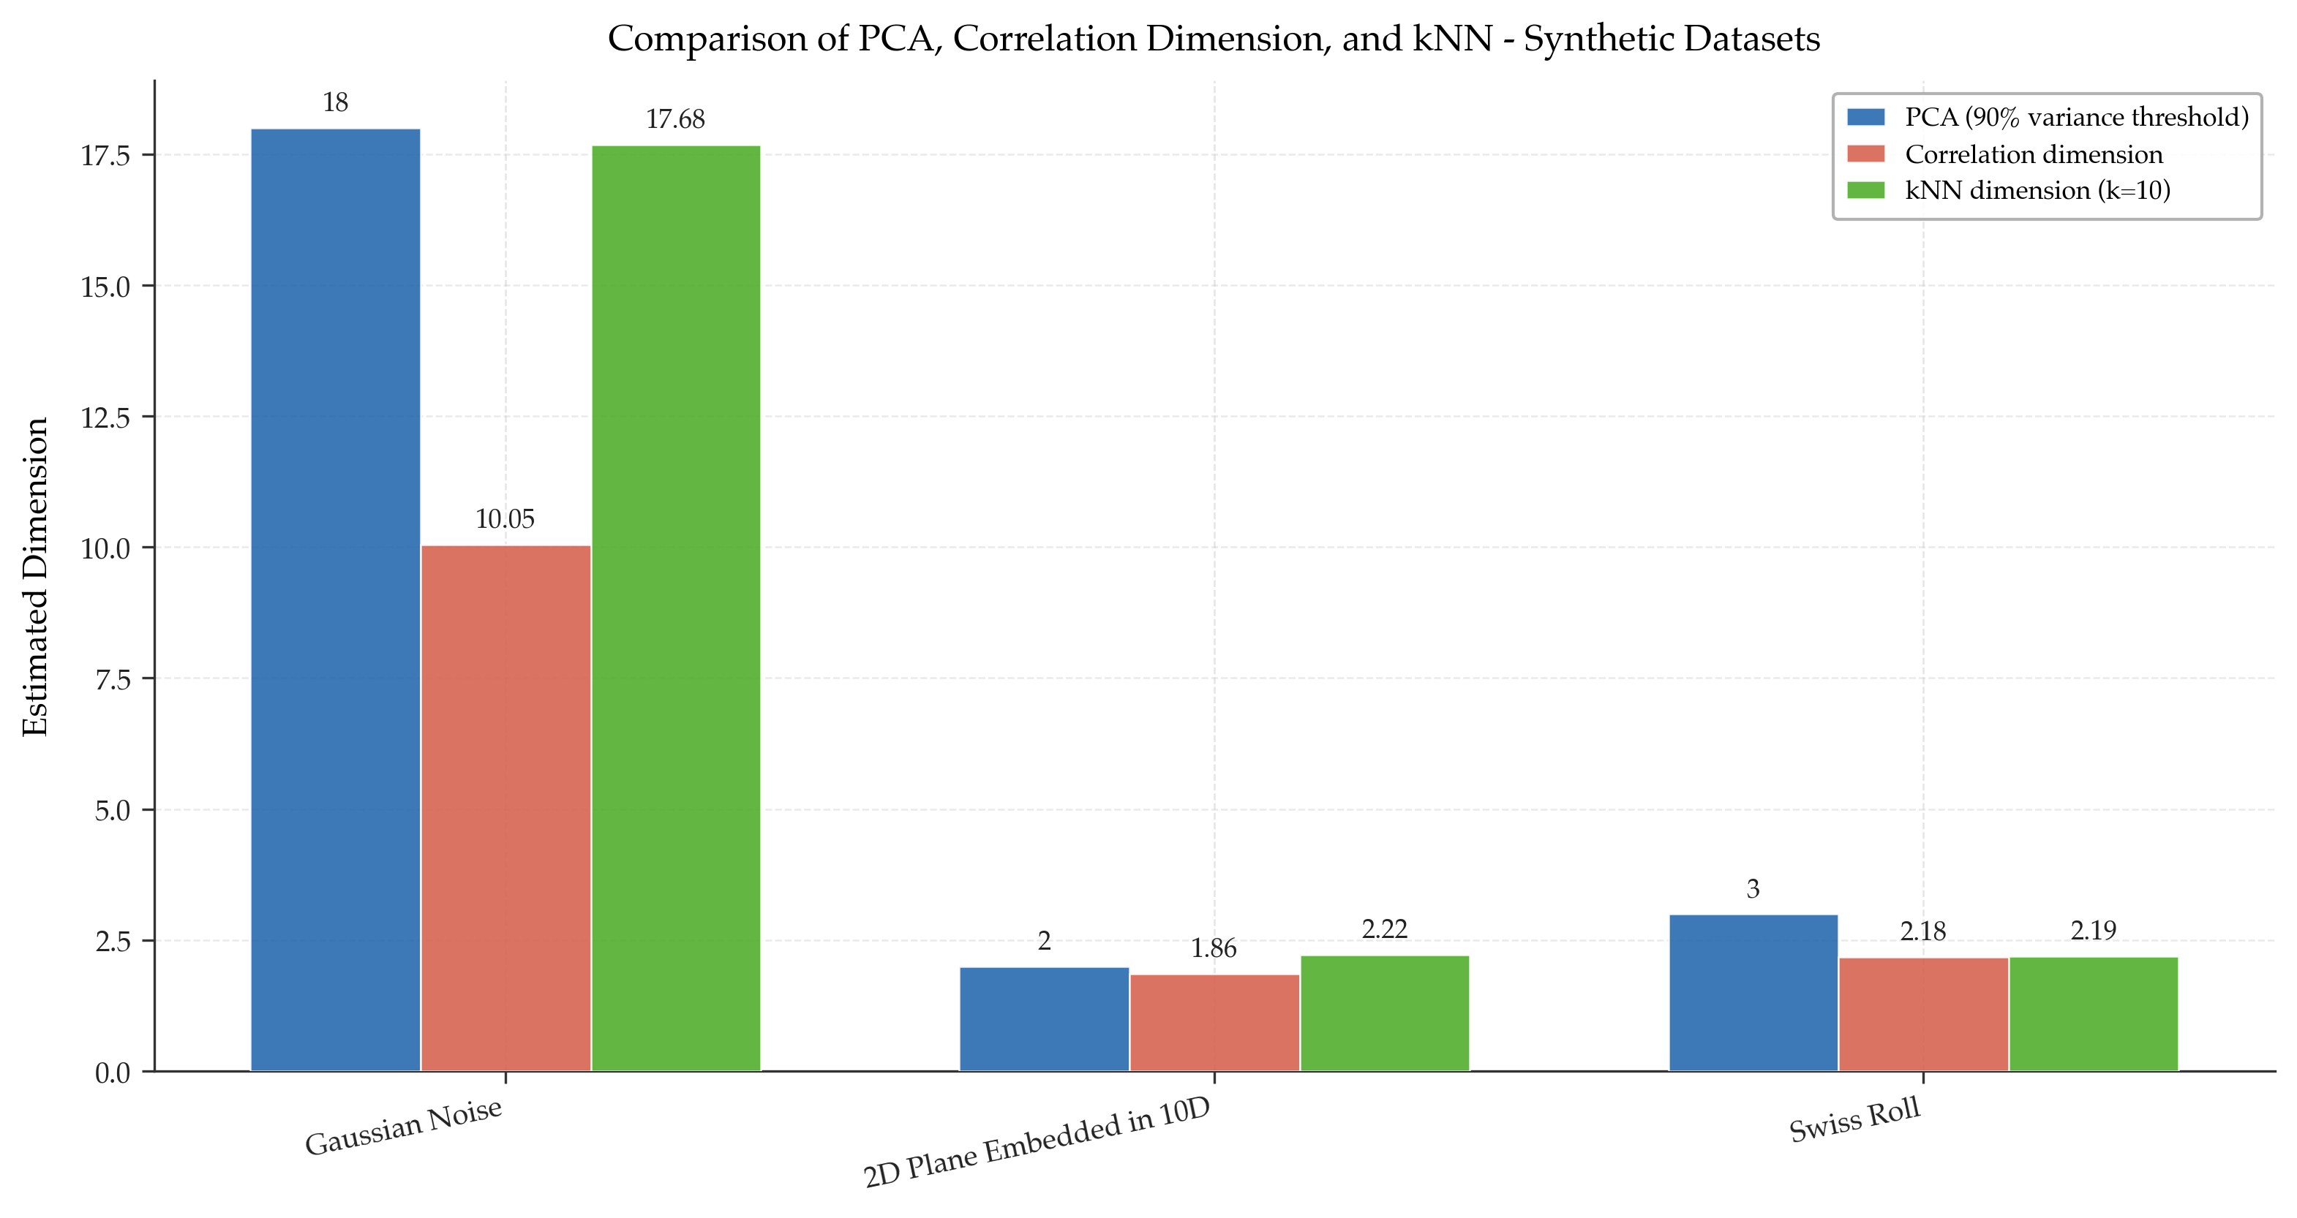
Figure 18. Comparison of PCA, correlation-dimension, and kNN estimates restricted to the synthetic datasets.
The synthetic-only comparison makes the relationships among the controlled datasets easier to interpret. It shows especially clearly that the 2D plane and the Swiss roll are intrinsically close to two-dimensional, while Gaussian noise remains high-dimensional.

6. Visual Reference for MNIST
A sample of MNIST images is included below to provide visual context for the type of data analyzed in the experiment.
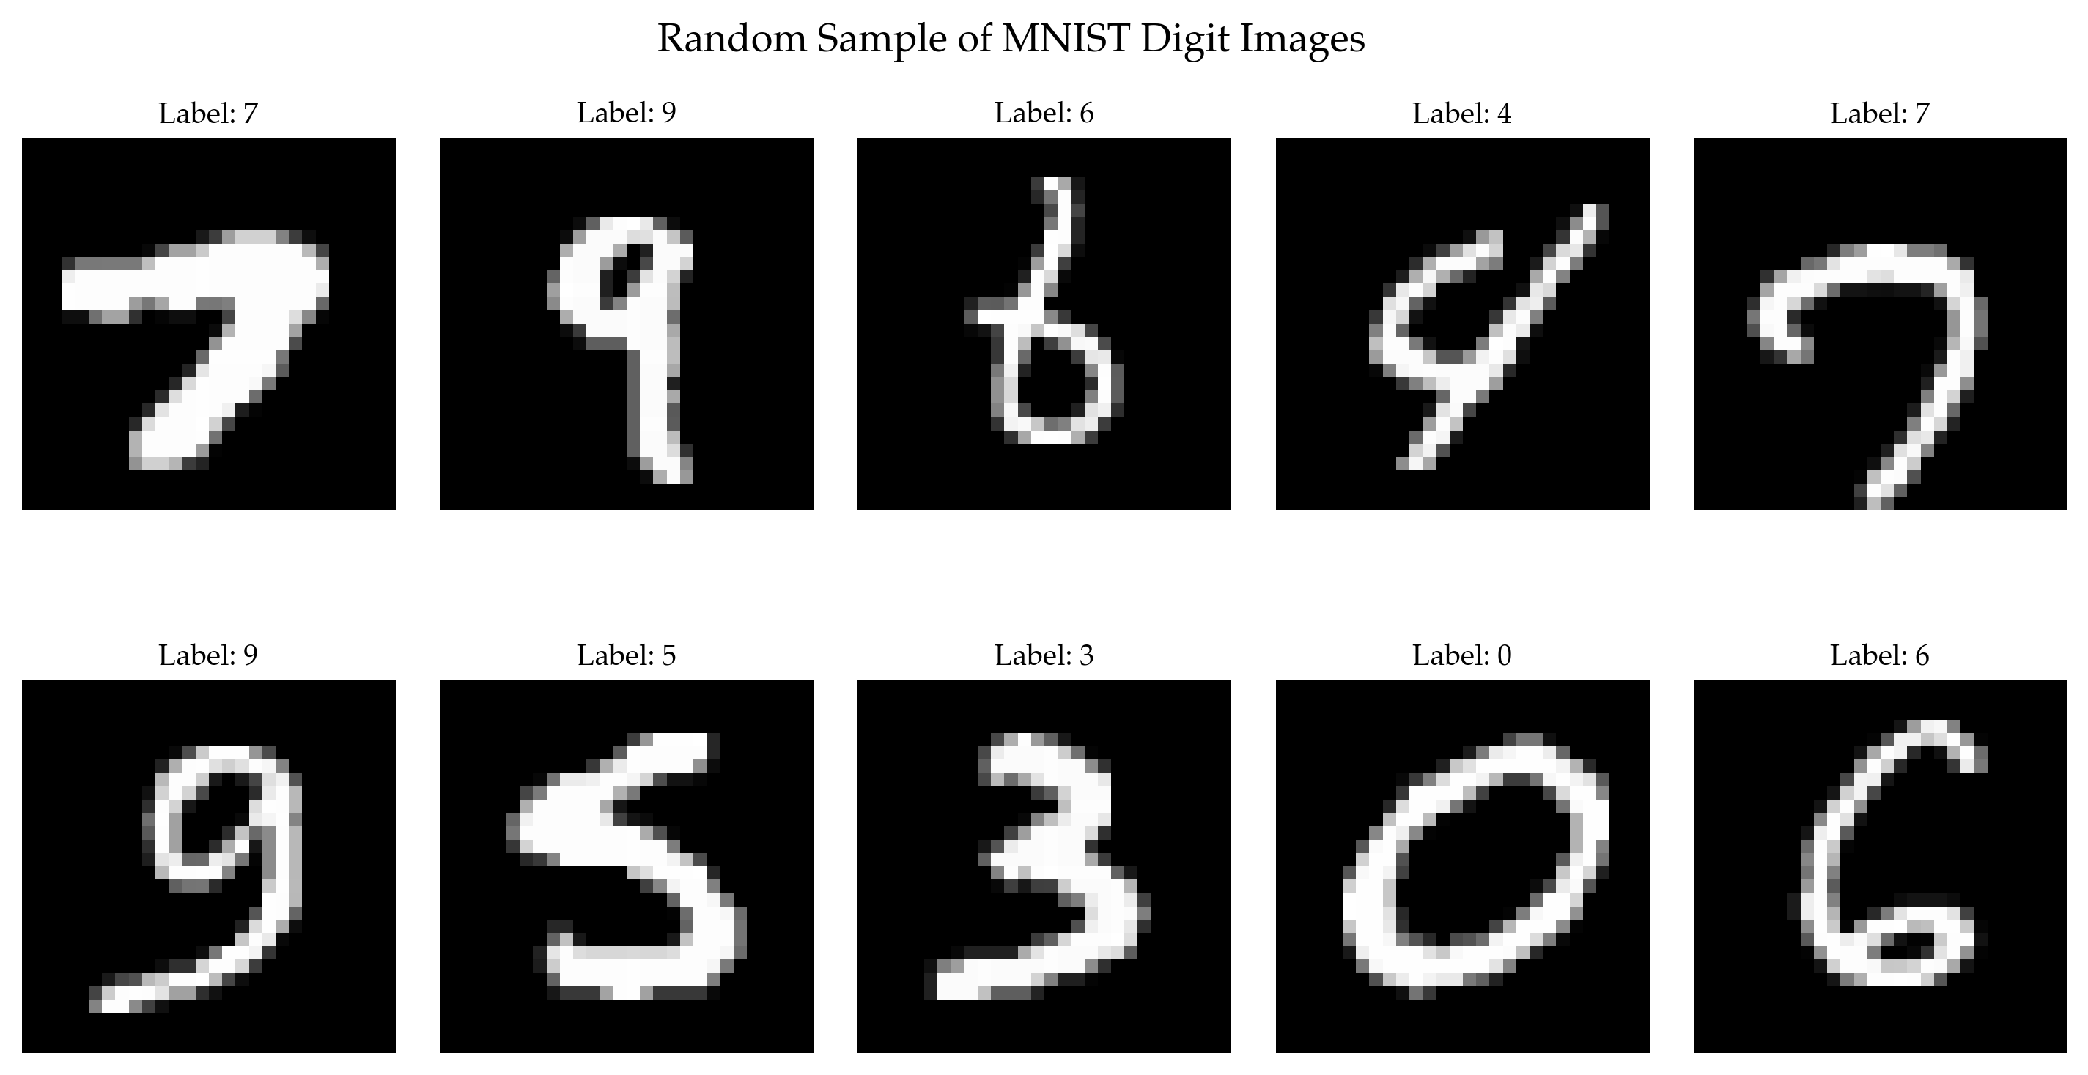
Figure 19. Random sample of MNIST handwritten digit images.
Although each image is represented numerically as a 784-dimensional vector, the visual variation is governed by a much smaller set of semantic factors, including digit identity, stroke thickness, slant, and writing style.

7. Discussion and Conclusion
The results demonstrate that intrinsic dimension is not a single quantity that all methods recover identically. Instead, the estimate depends on what aspect of structure is being measured.
- PCA is most informative when the data are approximately linear and the goal is variance preservation.
- Correlation dimension is better suited to capturing nonlinear geometric structure.
- The kNN estimator provides an additional neighborhood-based perspective and complements both PCA and correlation dimension.
- Agreement between the methods is strongest for simple linear datasets, while disagreement becomes informative for nonlinear and complex real-world data.
Overall, the 2D plane embedded in 10D served as a clear sanity check, the Swiss roll highlighted the limitations of linear methods, Gaussian noise behaved as a high-dimensional unstructured dataset, and MNIST revealed a structured but nontrivial intrinsic geometry.
Taken together, the three estimators provide a richer and more balanced view of dataset complexity than any single method alone.

