Appointment Performance


WordPress plugin by ebla-tech

abilities:

1-detect appointment plugins on the WordPress platform (booking ultra pro and booked).
2-display statistics for the appointment plugins in tables and chart.
3-filter the result between two dates.
4-set staff identity table.
5-create restful API to exchange data to other components.

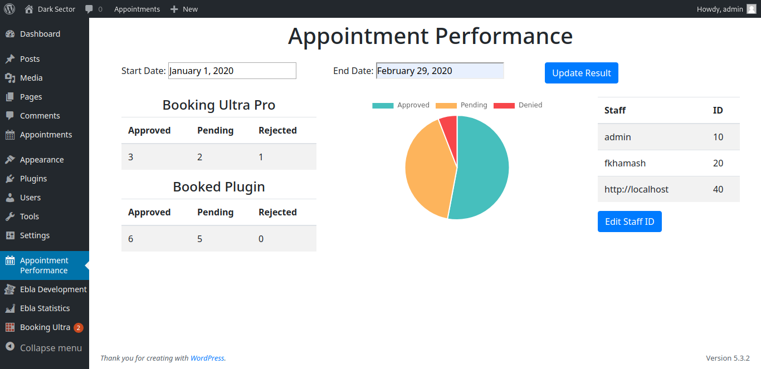
Appointment performance restful API introduction:

after activating the appointment performance plugin, a restful API web service will be created on the path:
http://[domain-name]/wp-content/plugins/appointment-performance/includes/restful-ws.php

the connect to this API is restricted due a security key, there is a file on the top level of plugin’s file data located on : wp-content/plugins/appointment-preformance/keys holds security keys, each line has a key, so the complete connect is should provide valid key, the administrator can update the content of key file via file manager or via API, all the arguments is sent with post json format.

Restful API tasks:
1-add security key:
URI: http://[domain-name]/wp-content/plugins/appointment-performance/includes/restful-ws.php/addKey
data: {"key": "zxcasdqwe", "new_key": "maxpain2"}
success response: {"action": "done"}
no key response: {"status": "no_ security _key","action": "failed"}
invalid key response: {"status": "error_key","action": "failed"}
2-clear all security keys else the key that is connected
URI: http://[domain-name]/wp-content/plugins/appointment-performance/includes/restful-ws.php/removeKeys
data: {"key": "zxcasdqwe"}
success response: {"action": "done"}
no key response: {"status": "no_ security_key","action": "failed"}
invalid key response: {"status": "error_key","action": "failed"}
remark: no key response and invalid key response are the same for all request so it will not be written any more.

3-get services:
URI: http://[domain-name]/wp-content/plugins/appointment-performance/includes/restful-ws.php/getServices
data: {"key": "zxcasdqwe"}
success response: ["Hack server","Disable technology","Inferction","Eliminate","Fight","Change ID","Change Docs","http://[domain-name]"]
remark: booked plugin doesn’t support services so if it was installed, the getServices command returns the domain name (in our example, the last element of array because of there are two appointments plugin).

4-get staff:
URI: http://[domain-name]/wp-content/plugins/appointment-performance/includes/restful-ws.php/getStaff
data: {"key": "zxcasdqwe"}
success response: ["Anna","Richardson","http://[domain-name]"]
remark: booked plugin doesn’t support multiple stall, so if it was installed, the getStaff command returns the domain name (in our example, the last element of array because of there are two appointments plugin).

5-get staff ids
URI: http://[domain-name]/wp-content/plugins/appointment-performance/includes/restful-ws.php/getStaffIds
data: {"key": "zxcasdqwe"}
success response: {"Anna":"10","Richardson":"30","http://[domain-name]":"20"}

the staff identities could be set by the appointment plugin gui, by click ‘edit staff id’ button under staff table

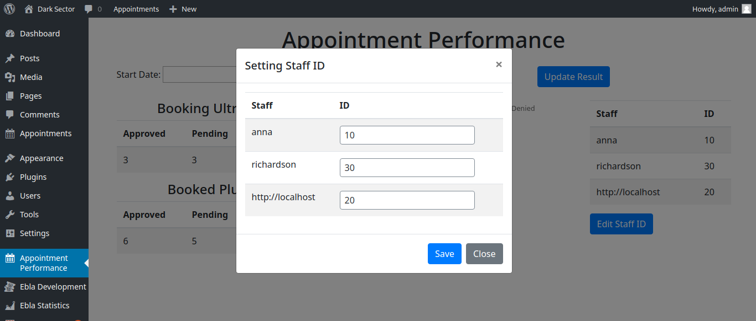
6-Get appointments:
uri: http://[domain-name]/wp-content/plugins/appointment-performance/includes/restful-ws.php/getAppointments

data: data can hold one or more filters with logical and operation between them, these filters are:
dataFrom: start date range of result in format ‘yyyy-mm-dd’, if the dateFrom is omitted, the result returns from beginning of time.
dataTo: end date range of result in format ‘yyyy-mm-dd’. if the dateTo is omitted, the result returns from beginning of time.
serviceName: the name of service, if the service name is omitted, all services’ result will returned.
staffId: the identity of staff that has been set on the GUI, is the staff id is omitted, all staff’s result will return.
groupBy: it can take two values, staff, so the result will group by staff id, or plugin so the result will group by plugin, if is omitted, the result is the only one record.

examples:
data:
{"key": "zxcasdqwe"}
response: {"pending":8,"approved":9,"rejected":1,"serviceName":"[ALL]","staffId":"[ALL]","dateFrom":"[NONE]","dateTo":"[NONE]"}

data:
{"key": "zxcasdqwe", "dateFrom": "2020-2-1", "dateTo": "2020-3-2"}
response: {"pending":6,"approved":6,"rejected":1,"serviceName":"[ALL]","staffId":"[ALL]","dateFrom":"2020-2-1","dateTo":"2020-3-2"}

data:
{"key": "zxcasdqwe", "dateFrom": "2020-1-1", "dateTo": "2020-3-2", "groupBy": "staff"}
response: [{"staffId":"10","appointments":{"approved":"3","pending":"2","rejected":"1"}},{"staffId":"30","appointments":{"approved":"0","pending":"1","rejected":"0"}},{"staffId":"20","appointments":{"approved":"6","pending":"5","rejected":0}}]

data:
{"key": "zxcasdqwe", "dateFrom": "2020-1-1", "dateTo": "2020-3-2", "groupBy": "plugin"}
response: [{"name":"bookingultra","appointments":{"approved":"3","pending":"3","rejected":"1"}},{"name":"booked","appointments":{"approved":"6","pending":"5","rejected":0}}]

data:
{"key": "zxcasdqwe", "dateFrom": "2020-2-1", "dateTo": "2020-3-2", "serviceName": "fight"}
response: {"pending":1,"approved":1,"rejected":0,"serviceName":"fight","staffId":"[ALL]","dateFrom":"2020-2-1","dateTo":"2020-3-2"}

data:
{"key": "zxcasdqwe", "dateFrom": "2020-2-1", "dateTo": "2020-3-2", "staffId": "10"}
response:
{"pending":1,"approved":1,"rejected":1,"serviceName":"[ALL]","staffId":"10","dateFrom":"2020-2-1","dateTo":"2020-3-2"}

