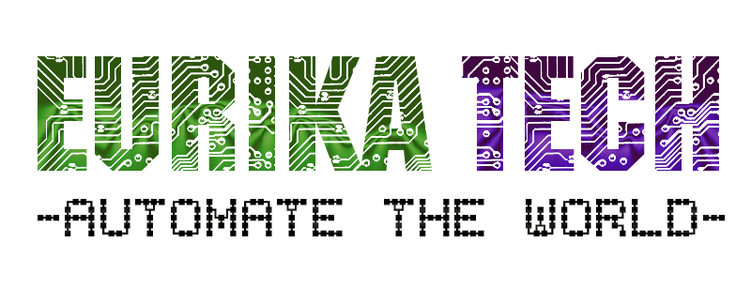
We are in Eurikatech© company are glad work on your project with long time support, We studied the basic requirement of your app and the server-side related system and created this solution.
Phase | Details | Period (hours)
Studying the requirement | Our engineers will study the requirement documents and create UML charts and DB schema | 28
System database | Create MySQL database on server and create plan for backup | 4
Server-side model | Create lessons model for each database entity using PHP programming language, and class to connect to database and perform CRUD operations. | 40
Control panel | We will design the main dashboard for managing your application by admins and configure it, we will create users with special privileges and create the user interface using react library used by java script. | 36
Rest api | We will create rest-api for mobile application using PHP programming language to process request and create response. | 12
Mobile app design | We will design the mobile app to perform your system functionality like register, login and acquire data from server using react-native framework. | 46
Mobile app implement | We will implement the rest-api function from server and process data. | 24
Android special teaks | Special configuration for android application | 6
IOS app special teaks | Special configuration for IOS application | 6
Final system test | Test the system on staging environment and study the performance | 10
System publish | Hosting the system and publish mobile apps to your account. | 6

We will complete your system in 218 hours (36 days) belong with long time support, we are glad to read from you, please contact us for further information: info@eurikatech.com

www.eurikatech.com – tel: +49 1516 5632880

