# 1) Please make a scatterplot that compares any of the two variables in the drinks.csv data sets.   
  
#getwd()  
#dir()  
#setwd("C:/Users/mayam/Desktop/MyRscript")  
#dir()  
  
# 1) Please make a scatterplot that compares any of the two variables in the drinks.csv data sets.   
  
data.drinks<-read.csv("datastore/drinks.csv", header=T,sep = ',')  
#View(data.drinks)  
  
plot(x=data.drinks$beer_servings,y=data.drinks$wine_servings,xlab = "beer", ylab = "wine",main = "Beer and wine servings plot",  
 pch=8,col=c('blue', 'red'))

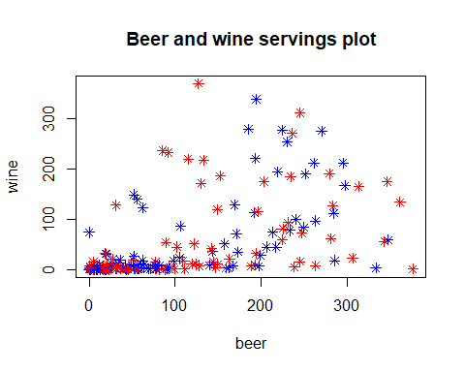  
  
  
# 2) Please open the Novel_SSRI.xls data set and make a plot where the bars represent the group means and the errorbars are the standard error of the mean of each group.   
library("ggplot2")

library("readxl")  
data.novel<-read_excel("datastore/Novel_SSRI.xls")  
df_novel<-data.frame(data.novel)  
print(df_novel)

## subjectNumber Placebo Drug  
## 1 1 12 30  
## 2 2 13 29  
## 3 3 15 28  
## 4 4 10 31  
## 5 5 14 32  
## 6 6 11 27  
## 7 7 12 30  
## 8 8 10 31  
## 9 9 20 25  
## 10 10 12 32  
## 11 11 126 30  
## 12 12 10 31  
## 13 13 11 32

# group means calculation  
  
df_novel_mean=c(mean((df_novel$Placebo),mean(df_novel$Drug)))  
  
df_novel_mean

## [1] 12

# Standard deviation calculation  
  
df_novel_Stdv=c(sd(df_novel$Placebo),sd(df_novel$Drug))  
df_novel_Stdv

## [1] 31.596819 2.115268

# Standard Error Mean calculation  
  
df_novel_StEm=c(sd(df_novel$Placebo, na.rm=TRUE) /   
 sqrt(length(df_novel$Placebo[!is.na(df_novel$Placebo)])),sd(df_novel$Drug, na.rm=TRUE) /   
 sqrt(length(df_novel$Drug[!is.na(df_novel$Drug)])))  
  
df_novel_StEm

## [1] 8.7633809 0.5866698

# assigning names to the bar(rows)  
  
df_novel_condition=c("Placebo","Drug")  
  
# creating final dataframe  
  
df_novel_final=data.frame(df_novel_condition,df_novel_mean,df_novel_Stdv,df_novel_StEm)  
  
df_novel_final

## df_novel_condition df_novel_mean df_novel_Stdv df_novel_StEm  
## 1 Placebo 12 31.596819 8.7633809  
## 2 Drug 12 2.115268 0.5866698

# Plotting bars represent the group means and the errorbars are the standard error of the mean of each group.   
  
# plotting group mean bars  
  
ggplot(df_novel_final) +  
 geom_bar( aes(x=df_novel_condition, y=df_novel_mean), stat="identity",width=0.5, colour="blue", alpha=0.9, size=2)

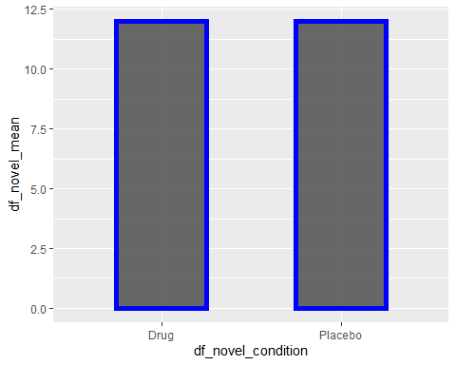

# plotting group errorbars with stdv  
  
ggplot(df_novel_final) +  
 geom_errorbar( aes(x=df_novel_condition, ymin=df_novel_mean-df_novel_Stdv, ymax=df_novel_mean+df_novel_Stdv),stat="identity", width=0.5, colour="orange", alpha=0.9, size=6)

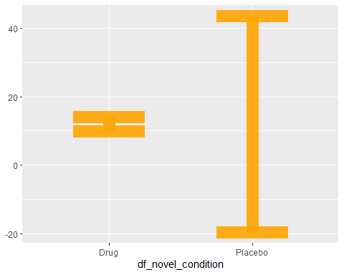

# plotting group errorbars with standard mean error  
  
ggplot(df_novel_final) +  
 geom_errorbar( aes(x=df_novel_condition,ymin = df_novel_mean-df_novel_StEm, ymax = df_novel_mean+df_novel_StEm),stat="identity", width=0.5, colour="red", alpha=0.9, size=6)

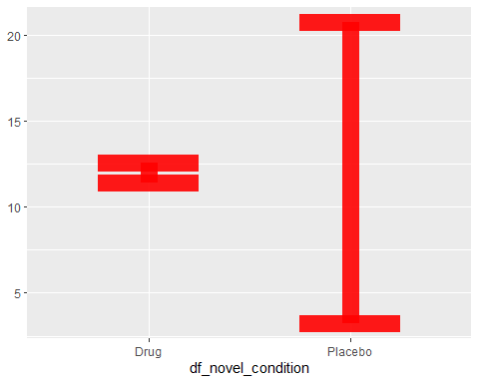

# 3) Please open the DeprScore.csv data set and make a plot where the bars represent the group means and the errorbars are the standard error of the mean of each group.  
#Please plot plot the bars that refer to treatment in different colors.   
  
library("ggplot2")  
data.DeprScore<-read.csv("datastore/DeprScore.csv", header=T,sep = ',')  
df_DeprScore<-data.frame(data.DeprScore)  
print(df_DeprScore)

## Exercise Treatment Score  
## 1 None Placebo 10  
## 2 None Placebo 12  
## 3 None Placebo 14  
## 4 None Placebo 18  
## 5 None Placebo 17  
## 6 None Tx 15  
## 7 None Tx 17  
## 8 None Tx 19  
## 9 None Tx 23  
## 10 None Tx 20  
## 11 Light Placebo 13  
## 12 Light Placebo 15  
## 13 Light Placebo 17  
## 14 Light Placebo 22  
## 15 Light Placebo 16  
## 16 Light Tx 18  
## 17 Light Tx 19  
## 18 Light Tx 22  
## 19 Light Tx 27  
## 20 Light Tx 21  
## 21 Heavy Placebo 15  
## 22 Heavy Placebo 19  
## 23 Heavy Placebo 20  
## 24 Heavy Placebo 25  
## 25 Heavy Placebo 19  
## 26 Heavy Tx 26  
## 27 Heavy Tx 30  
## 28 Heavy Tx 31  
## 29 Heavy Tx 36  
## 30 Heavy Tx 29

Exer_bar <- ggplot(df_DeprScore,aes(Exercise,Score)) +  
 geom_point(shape=17,size=6,aes(color=Score))  
   
Exer_bar

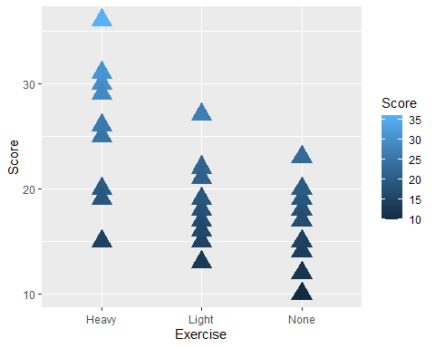

Treatment_bar <- ggplot(df_DeprScore,aes(Treatment,Score)) +  
 geom_point(shape=17,size=6,aes(color=Score))  
  
Treatment_bar

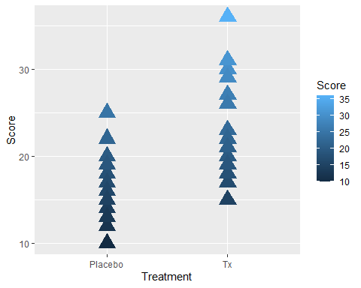

library("dplyr")

##   
## Attaching package: 'dplyr'

## The following objects are masked from 'package:stats':  
##   
## filter, lag

## The following objects are masked from 'package:base':  
##   
## intersect, setdiff, setequal, union

ggplot(data.DeprScore, aes(Exercise)) +   
 geom_bar(aes(fill = Treatment), position = "fill")

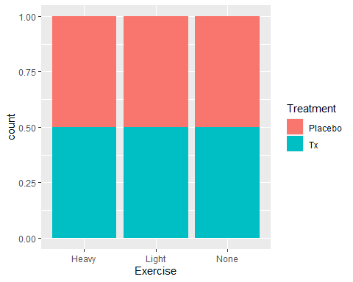

mean_ex <- tapply(data.DeprScore$Score, data.DeprScore$Exercise, mean)  
mean_ex

## Heavy Light None   
## 25.0 19.0 16.5

sd_ex <- tapply(data.DeprScore$Score, data.DeprScore$Exercise, sd, na.rm=TRUE)  
sd_ex

## Heavy Light None   
## 6.633250 4.109609 3.865805

mean_tr <- tapply(data.DeprScore$Score, data.DeprScore$Treatment, mean)  
mean_tr

## Placebo Tx   
## 16.80000 23.53333

sd_tr <- tapply(data.DeprScore$Score, data.DeprScore$Treatment, sd, na.rm=TRUE)  
sd_tr

## Placebo Tx   
## 3.913347 6.034030

mean_group<-c(mean_ex,mean_tr)  
mean_group

## Heavy Light None Placebo Tx   
## 25.00000 19.00000 16.50000 16.80000 23.53333

sd_group<-c(sd_ex,sd_tr)  
sd_group

## Heavy Light None Placebo Tx   
## 6.633250 4.109609 3.865805 3.913347 6.034030

# assigning names to the bar(rows)  
  
group_condition=c("Light","Heavy","None","Placebo","Tx")  
  
# creating final dataframe  
  
df_final=data.frame(group_condition,mean_group ,sd_group)  
  
df_final

## group_condition mean_group sd_group  
## Heavy Light 25.00000 6.633250  
## Light Heavy 19.00000 4.109609  
## None None 16.50000 3.865805  
## Placebo Placebo 16.80000 3.913347  
## Tx Tx 23.53333 6.034030

ggplot(df_final) +  
 geom_bar( aes(x=group_condition, y=mean_group), stat="identity",width=0.5, col=c('cyan','blue','green','orange','red'), alpha=0.9, size=2)

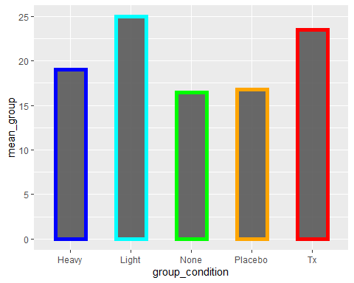

# plotting group errorbars with stdv  
  
ggplot(df_final) +  
 geom_errorbar( aes(x=group_condition, ymin=mean_group-sd_group, ymax=mean_group+sd_group),stat="identity", width=0.5, col=c('cyan','blue','green','orange','red'), alpha=0.9, size=6)

