10/19/2020

Please answer the following questions. These assume you have performed the readings and watched each of the lectures up to this point. Where necessary, please print your R output as your answer.

1: For this problem, please work the following ANOVA, by hand. There is no need to test assumptions or plot the data for this problem. I just want to see that you understand the computations that underlie the ANOVA.

Suppose you conduct an experiment examining the effects of different types of verbal reinforcement on learning in children. Hence, you have one factor (verbal reinforcement) with 3 levels: 1) praise; 2) criticism; and 3) no verbal reinforcement. Your dependent variable is the number of mistakes that children make in learning to do a task. Assume that each child was only tested once. After running the experiment here are your data:

Number of mistakes made

Level 1: Praise Level 2: Criticism Level 3: None

4 7 7  
 7 6 3  
 5 9 7  
 3 7 5  
 6 8 7  
 4 6 8  
 6 7 5

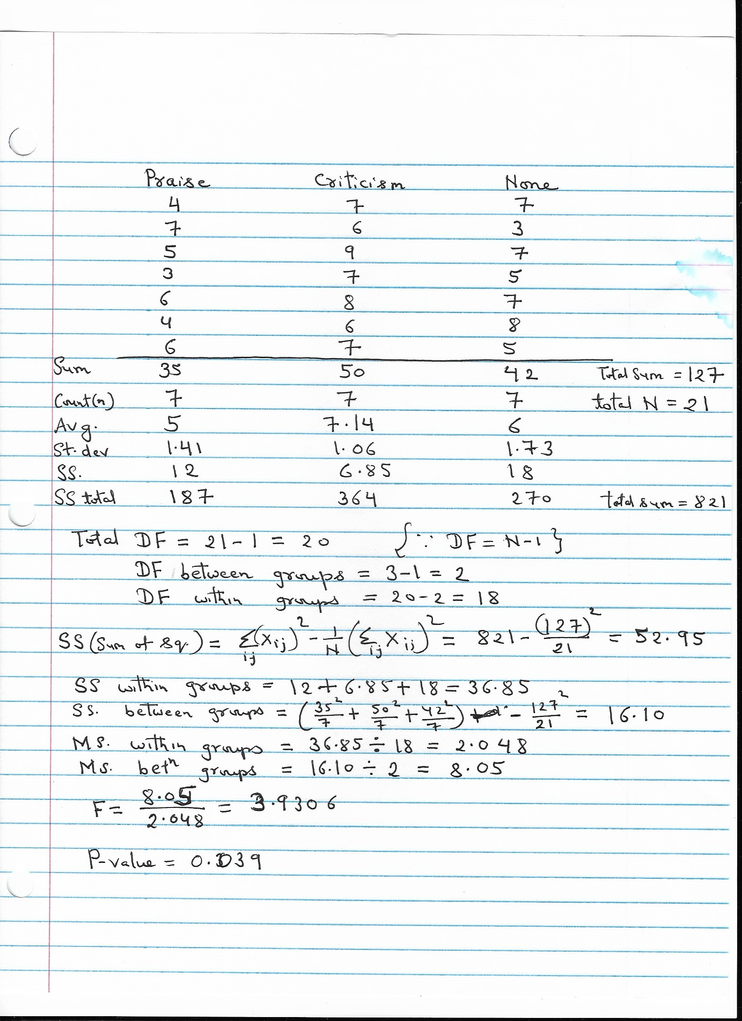

A caption

State your hypotheses. Then, conduct an ANOVA and complete the following ANOVA table (please show all of your work): Hypothesis here:

H0: μ1 = μ2 = μ3 (all 3 group population means are equal) H1: μ1 != μ2 != μ3 (all 3 group population means are not equal)

Source SS df MS FOBS p

Between Groups 16.10 2 8.05 3.9306 0.039

Within Groups 36.85 18 2.048

Total 52.95 20

What is your conclusion?

Since P-value< 0.05 and Fobs>Fcrit i.e. 3.93>3.56 and hence null hypothesis is rejected.

2: Please preform an ANOVA in R on the above data, please be sure to test all assumptions and plot the data.

# creating data frame using data table given   
  
Praise= c(4,7,5,3,6,4,6)  
Criticism = c(7,6,9,7,8,6,7)  
None= c(7,3,7,5,7,8,5)  
mydata<- data.frame(Praise,Criticism,None)   
mydata # Viewing dataframe

## Praise Criticism None  
## 1 4 7 7  
## 2 7 6 3  
## 3 5 9 7  
## 4 3 7 5  
## 5 6 8 7  
## 6 4 6 8  
## 7 6 7 5

# Hypothesis statement:  
#H0: μ1 = μ2 = μ3 (all 3 group population means are equal)  
#H1: μ1 != μ2 != μ3 (all 3 group population means are not equal)  
  
# initial plotting to check distribution  
  
hist(mydata$Praise,20)

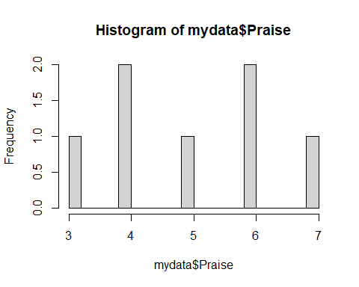

shapiro.test(mydata$Praise)

##   
## Shapiro-Wilk normality test  
##   
## data: mydata$Praise  
## W = 0.95244, p-value = 0.7518

hist(mydata$Criticism,20)

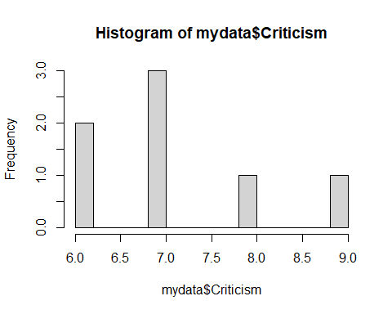

shapiro.test(mydata$Criticism)

##   
## Shapiro-Wilk normality test  
##   
## data: mydata$Criticism  
## W = 0.89358, p-value = 0.2939

hist(mydata$None,20)   
shapiro.test(mydata$None)

##   
## Shapiro-Wilk normality test  
##   
## data: mydata$None  
## W = 0.89059, p-value = 0.2778

# loading library  
library(car)

## Loading required package: carData

library(psych)

##   
## Attaching package: 'psych'

## The following object is masked from 'package:car':  
##   
## logit

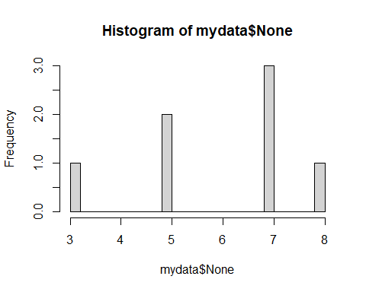

describe(mydata) # stat summary

## vars n mean sd median trimmed mad min max range skew kurtosis  
## Praise 1 7 5.00 1.41 5 5.00 1.48 3 7 4 0.00 -1.71  
## Criticism 2 7 7.14 1.07 7 7.14 1.48 6 9 3 0.47 -1.27  
## None 3 7 6.00 1.73 7 6.00 1.48 3 8 5 -0.49 -1.38  
## se  
## Praise 0.53  
## Criticism 0.40  
## None 0.65

# stacking data  
  
exdata=stack(mydata)  
  
# box plot so check normality  
  
boxplot(values~ind,exdata)

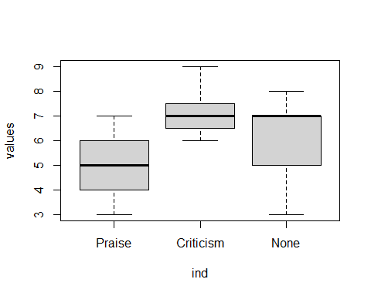

# Checking assumptions quantitatively   
  
by(exdata$values,exdata$ind,shapiro.test)

## exdata$ind: Praise  
##   
## Shapiro-Wilk normality test  
##   
## data: dd[x, ]  
## W = 0.95244, p-value = 0.7518  
##   
## ------------------------------------------------------------   
## exdata$ind: Criticism  
##   
## Shapiro-Wilk normality test  
##   
## data: dd[x, ]  
## W = 0.89358, p-value = 0.2939  
##   
## ------------------------------------------------------------   
## exdata$ind: None  
##   
## Shapiro-Wilk normality test  
##   
## data: dd[x, ]  
## W = 0.89059, p-value = 0.2778

# Homogeneity of variance  
leveneTest(values~ind,exdata)

## Levene's Test for Homogeneity of Variance (center = median)  
## Df F value Pr(>F)  
## group 2 0.5652 0.578  
## 18

# Running ANOVA using aov  
x=aov(values~ind,exdata)  
  
# summary of ANOVA results  
summary(x)

## Df Sum Sq Mean Sq F value Pr(>F)   
## ind 2 16.10 8.048 3.93 0.0383 *  
## Residuals 18 36.86 2.048   
## ---  
## Signif. codes: 0 '***' 0.001 '**' 0.01 '*' 0.05 '.' 0.1 ' ' 1

Conclusion: Since P-value< 0.05 and Fobs>Fcrit i.e. 3.93>3.56 and hence null hypothesis is rejected and both manual and R results are same.