October 10, 2020

1. Please discuss the differences between a independent samples versus repeated measures experimental design. Please be sure to address the following points in your question: Why might one use one design vs the other? Which one has more power and why?

Experimental design refers allocation of participants or group to various conditions in experiment. When different participants are assigned for each condition of the independent variable in the experiment then its independent sample measures. In independent samples subject in one group does not give any information about other and there is no way to pair them. For instance, drug trail has placebo and treatment group having different subjects.

When same participants are assigned for each condition of the independent variable in the experiment then its repeated measures. In this measure one group provides information about another and thus can be paired no matter group contains same subject or different. Independent sample measure experiment design is commonly used in hypothesis testing. There is no order issue as it is random assignment to various levels of IV. It requires many participants. Its error prone design and due to more participant requirement is expensive too. Repeated measures design is better as it has more accuracy than independent measure. This is statistically more powerful because of smaller standard error. It requires less participants so its economic. Counterbalancing will be there as order is used to control effects of boredom and practice.

There is increase power in paired sample design than independent design and hence for better accuracy and economic point of view repeated measure design stands better over independent sample design but for hypothesis testing independent sample design is commonly used.

1. Please open the file in the Canvas resources folder entitled “Novel_SSRI.csv”. You will find data from a preclinical study that looked at the effects of a novel Selective Serotonin Reuptake Inhibitor (SSRI) on depression scores. Please graph and assess the data to determine if the SSRI influences depression scores. In your graph, please plot summary statistics as well as each data point. In your assessment, be sure to test all assumptions. Assume a larger score means more depression symptoms are evident (10 pts). Hypothesis here is: H0: μ1 = μ2 (Larger score means more depression symptoms) H1: μ1! = μ2 (Larger score does not mean more depression symptoms)

# data loading and exploring  
  
Novel_Data=read.csv("Novel_SSRI.csv",header=TRUE)[ ,2:3]  
  
## Compute and look at MEAN & SD for each level of the IV  
ymean=apply(Novel_Data,2,mean)  
ysd=apply(Novel_Data,2,sd)  
  
# creating stacks  
  
Novel_subject=stack(Novel_Data)  
names(Novel_subject)

## [1] "values" "ind"

# Data visulaization and Graph errorbar plot   
#install.packages("Hmisc")  
library(ggplot2) # loading ggplot2  
graph=ggplot(Novel_subject,aes(Novel_subject$ind,Novel_subject$values))  
# fun.y applies to specific point, whereas fun.data applies to all of the data  
# mean_cl_normal = 95% confidence interval  
graph+stat_summary(fun.y=mean, geom="bar")+stat_summary(fun.data=mean_cl_normal,geom="errorbar")

## Warning: `fun.y` is deprecated. Use `fun` instead.

## Warning: Use of `Novel_subject$ind` is discouraged. Use `ind` instead.

## Warning: Use of `Novel_subject$values` is discouraged. Use `values` instead.

## Warning: Use of `Novel_subject$ind` is discouraged. Use `ind` instead.

## Warning: Use of `Novel_subject$values` is discouraged. Use `values` instead.

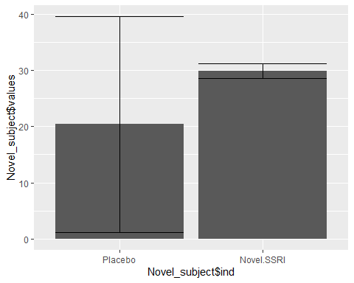

# mean_sdl = mean +/- std  
graph+stat_summary(fun.y=mean, geom="bar")+stat_summary(fun.data=mean_sdl,geom="errorbar")

## Warning: `fun.y` is deprecated. Use `fun` instead.

## Warning: Use of `Novel_subject$ind` is discouraged. Use `ind` instead.

## Warning: Use of `Novel_subject$values` is discouraged. Use `values` instead.

## Warning: Use of `Novel_subject$ind` is discouraged. Use `ind` instead.

## Warning: Use of `Novel_subject$values` is discouraged. Use `values` instead.

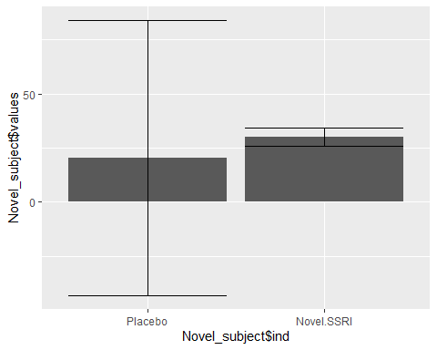

# mean_sdl = mean +/- se  
graph+stat_summary(fun.y=mean, geom="bar")+stat_summary(fun.data=mean_se,geom="errorbar")

## Warning: `fun.y` is deprecated. Use `fun` instead.

## Warning: Use of `Novel_subject$ind` is discouraged. Use `ind` instead.

## Warning: Use of `Novel_subject$values` is discouraged. Use `values` instead.

## Warning: Use of `Novel_subject$ind` is discouraged. Use `ind` instead.

## Warning: Use of `Novel_subject$values` is discouraged. Use `values` instead.

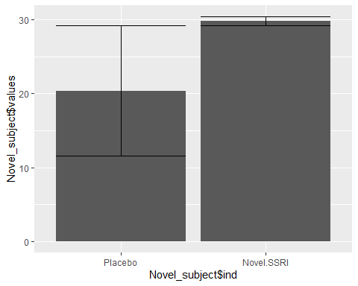

# Overall Graph looks good   
  
# Hypothesis:   
# H0: μ1 = μ2 (Larger score means more depression symptoms means two means are same)  
# H1: μ1! = μ2 (Larger score does not mean more depression symptoms)  
  
#Testing:  
   
# Checking Normality  
## Need to check each level of the IV separately  
  
hist(Novel_Data$Placebo,20) # Qualitative

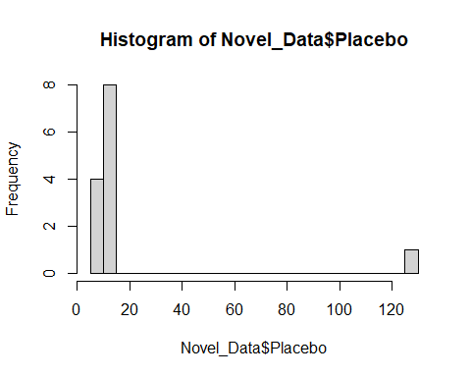

shapiro.test(Novel_Data$Placebo) # Quantitative

##   
## Shapiro-Wilk normality test  
##   
## data: Novel_Data$Placebo  
## W = 0.35935, p-value = 1.03e-06

#seems normality violation  
  
#Removal of outlier required  
k=which(Novel_Data$Placebo!=max(Novel_Data$Placebo))  
clean_Novel_Data=Novel_Data[k,]  
  
hist(clean_Novel_Data$Placebo,20) # Qualitative

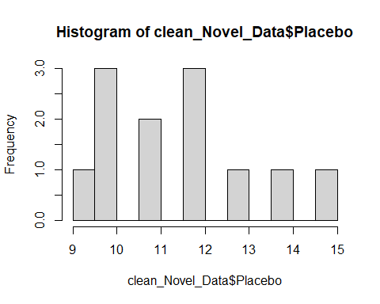

shapiro.test(clean_Novel_Data$Placebo) # Quantitative

##   
## Shapiro-Wilk normality test  
##   
## data: clean_Novel_Data$Placebo  
## W = 0.94988, p-value = 0.6352

# Now all look normal  
# rechecking for second variable  
  
hist(clean_Novel_Data$Novel.SSRI,20)

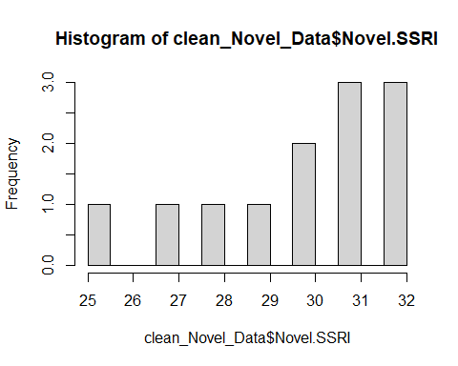

shapiro.test(clean_Novel_Data$Novel.SSRI)

##   
## Shapiro-Wilk normality test  
##   
## data: clean_Novel_Data$Novel.SSRI  
## W = 0.88036, p-value = 0.0886

# stacking again  
Novel_subject=stack(clean_Novel_Data)  
names(Novel_subject)

## [1] "values" "ind"

# Checking homogeneity of variance since Levene test is good for parametric   
library(car)

## Loading required package: carData

leveneTest(Novel_subject$values ~ Novel_subject$ind)

## Levene's Test for Homogeneity of Variance (center = median)  
## Df F value Pr(>F)  
## group 1 0.2255 0.6396  
## 22

# One sample t-test  
t.test(Novel_subject$values, alt="two.sided", mu=6.7)

##   
## One Sample t-test  
##   
## data: Novel_subject$values  
## t = 7.2044, df = 23, p-value = 2.464e-07  
## alternative hypothesis: true mean is not equal to 6.7  
## 95 percent confidence interval:  
## 16.68602 24.73065  
## sample estimates:  
## mean of x   
## 20.70833

# Two sample paired (dependent) t-test  
t.test(Novel_subject$values ~ Novel_subject$ind, paired=T, alt="two.sided",var.equal=T)

##   
## Paired t-test  
##   
## data: Novel_subject$values by Novel_subject$ind  
## t = -24.012, df = 11, p-value = 7.458e-11  
## alternative hypothesis: true difference in means is not equal to 0  
## 95 percent confidence interval:  
## -19.92282 -16.57718  
## sample estimates:  
## mean of the differences   
## -18.25

# Two sample unpaired (independent) t-test  
t.test(Novel_subject$values ~ Novel_subject$ind, paired=F, alt="two.sided",var.equal=T)

##   
## Two Sample t-test  
##   
## data: Novel_subject$values by Novel_subject$ind  
## t = -22.278, df = 22, p-value < 2.2e-16  
## alternative hypothesis: true difference in means is not equal to 0  
## 95 percent confidence interval:  
## -19.94891 -16.55109  
## sample estimates:  
## mean in group Placebo mean in group Novel.SSRI   
## 11.58333 29.83333

# fit linear model (compare t-value and p-value with independent t-test!)  
  
res=lm(Novel_subject$values ~ Novel_subject$ind)  
summary(res)

##   
## Call:  
## lm(formula = Novel_subject$values ~ Novel_subject$ind)  
##   
## Residuals:  
## Min 1Q Median 3Q Max   
## -4.8333 -1.5833 0.2917 1.2292 3.4167   
##   
## Coefficients:  
## Estimate Std. Error t value Pr(>|t|)   
## (Intercept) 11.5833 0.5793 20.00 1.34e-15 ***  
## Novel_subject$indNovel.SSRI 18.2500 0.8192 22.28 < 2e-16 ***  
## ---  
## Signif. codes: 0 '***' 0.001 '**' 0.01 '*' 0.05 '.' 0.1 ' ' 1  
##   
## Residual standard error: 2.007 on 22 degrees of freedom  
## Multiple R-squared: 0.9576, Adjusted R-squared: 0.9556   
## F-statistic: 496.3 on 1 and 22 DF, p-value: < 2.2e-16

According to shapiro test p-value = 1.03e-06 which looks extremely low which indicates violation in normal distribution. Histogram plot too clearly showed. To address the issue outlier is filtered and restacking is done. Once again ran tests where the results look normal.p-value>0.05 which was expected.p-value= 0.6396 which is higher than 0.05 in levene test is also acceptable. One sample t-test gives p-value< 6.7 and confidence-interval not 0 shows the result is statistically significant. Two sample dependent test results DF=12-1=11 and p-value<0.05 indicating statistics signifance. Two sample Independent test results DF=24-2=22 and p-value<0.05.Comparing independent and dependent two sample tests it is clear that there is increased in power with paired sample design for the accuracy. It shows that μ1 and μ2 are not same.Hence null hypothesis is rejected.

1. Please find the New_Drug.csv file and use the appropriate nonparametric test to determine if there is a difference between the Placebo and the Drug groups. Be sure to test the assumption and plot the data using a boxplot. (10 points)

# Loading and exploring data file  
  
Drug_Data=read.csv("New_Drug.csv",header=TRUE)[ ,2:3]  
  
Drug_Data=data.frame(Drug_Data)  
  
library(ggplot2)  
ggplot(Drug_Data) +  
 aes(x = Tx, y = Score) +  
 geom_boxplot(fill = "#0c4c8a") +  
 theme_minimal()

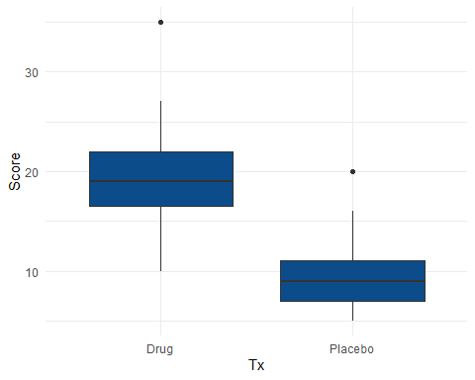

#boxplot(Score~Tx,Drug_Data)  
  
# visualizing distribution  
  
hist(subset(Drug_Data, Tx== "Drug")$Score,  
 main = "Drug Score",  
 xlab = "Score"  
)

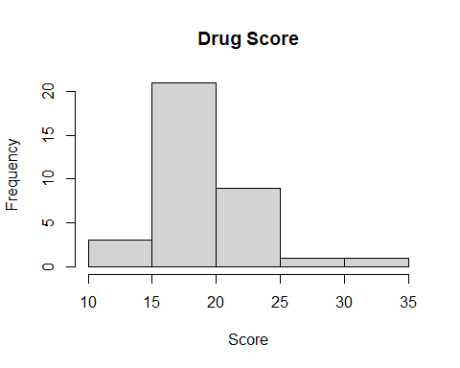

hist(subset(Drug_Data, Tx== "Placebo")$Score,  
 main = "Placebo Score",  
 xlab = "Score"  
)

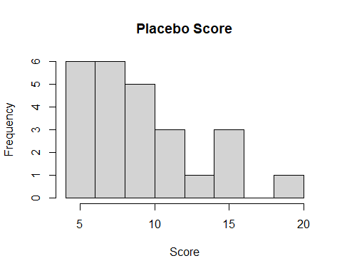

# Hypothesis is:  
#H0: Treatment method = Score (no effect of any treatment method)  
#H1: Treatment method != Score (Scores are effected by methods of treatment)  
  
  
#Testing:  
by(Drug_Data$Score,Drug_Data$Tx,shapiro.test)

## Drug_Data$Tx: Drug  
##   
## Shapiro-Wilk normality test  
##   
## data: dd[x, ]  
## W = 0.90838, p-value = 0.006694  
##   
## ------------------------------------------------------------   
## Drug_Data$Tx: Placebo  
##   
## Shapiro-Wilk normality test  
##   
## data: dd[x, ]  
## W = 0.89929, p-value = 0.01771

# Checking homogeneity of variance using levene test  
  
library(car)  
leveneTest(Drug_Data$Score ~ Drug_Data$Tx)

## Warning in leveneTest.default(y = y, group = group, ...): group coerced to  
## factor.

## Levene's Test for Homogeneity of Variance (center = median)  
## Df F value Pr(>F)  
## group 1 0.0588 0.8093  
## 58

# Run ANOVA using aov  
x=aov(Drug_Data$Score ~ Drug_Data$Tx)  
# look at summary of ANOVA results  
summary(x)

## Df Sum Sq Mean Sq F value Pr(>F)   
## Drug_Data$Tx 1 1376 1376.2 78.2 2.41e-12 ***  
## Residuals 58 1021 17.6   
## ---  
## Signif. codes: 0 '***' 0.001 '**' 0.01 '*' 0.05 '.' 0.1 ' ' 1

## Effect Size  
  
library(effectsize)  
eta_squared(x, partial = T, ci = 0.95)

## Parameter | Eta2 (partial) | 1e+02% CI  
## --------------------------------------------  
## Drug_Data$Tx | 0.57 | [0.41, 0.69]

omega_squared(x, partial = T, ci = 0.95)

## Parameter | Omega2 (partial) | 1e+02% CI  
## ----------------------------------------------  
## Drug_Data$Tx | 0.56 | [0.39, 0.68]

# p-value is <0.05 , very low indeed *** indicates there is effect of treatment on score, even small sample size  
  
# Assuming that outcome is NOT normally dictributed Non-Parametric test is the performed  
  
fligner.test(Drug_Data$Score ~ Drug_Data$Tx, Drug_Data)

##   
## Fligner-Killeen test of homogeneity of variances  
##   
## data: Drug_Data$Score by Drug_Data$Tx  
## Fligner-Killeen:med chi-squared = 0.045197, df = 1, p-value = 0.8316

kruskal.test(Drug_Data$Score ~ Drug_Data$Tx, Drug_Data)

##   
## Kruskal-Wallis rank sum test  
##   
## data: Drug_Data$Score by Drug_Data$Tx  
## Kruskal-Wallis chi-squared = 35.264, df = 1, p-value = 2.878e-09

The hypothesis here is no effect on score by treatment methods with alternative hypothesis is there is effect on score by treatment.Box plot and shapiro test with p-value>0.05 indicates that there is not normaility violation.Low p-value from ANOVA and looking into factsize assuring statistical significance and hence null hypothesis is rejected.Assuming that outcome is NOT normally dictributed Non-Parametric test is the performed. Flinger test gave p-value far > 0.05 and kruskal test p-value is much low which is statistically significant to reject null hypothesis here.