Class 6
Chapter 1: The Universe
- The circumference of the Earth at the equator is about 40,075 km but from pole-to-pole the meridional circumference of the Earth is only 40,008 km. This shape, caused by the flattening at the poles, is called an oblate spheroid.
- The stars that twinkle at night are several million kilometres away from the Sun. Their light is hidden from us because of the brightness of the Sun’s light. Hence we do not see the stars during the day.
- we use light year for measuring the distance between the Earth and the stars. The distance that light travels in one year is known as the light year. A light year is approximately 9.5 thousand billion (or million-million) kilometres. The speed of light is 300,000 kilometres per second. A light year is equal to 9,460,800,000,000 km (that is, 60 sec. x 60 min. x 24 hrs x 365 days x 300,000 km).
- The light from the Sun, which is also a star nearest to the Earth, takes 8.3 minutes to reach the Earth. Likewise it is possible to measure the distances to all other stars from the Earth using the time it takes for the light to reach the Earth from each of them.
- One of the stars nearer to the earth is the star Proxima Centauri. It is 4.3 light years away from the Earth. It is a red dwarf star, part of the Alpha Centauri system.
- The galaxy that the solar system belongs to is known as the Milky Way. The Milky Way galaxy has a spiral shape. In the outer ring are the Sun and the nine planets. The light of the stars in the Milky Way appears like a giant white ribbon and hence it is known as Milky Way.

Chapter-2: The Sun
- The Sun is the main source of energy. The life gets evolved
and multiplied on the earth because of Sun’s energy. Temperature at the surface of the Sun is 6,000⁰C. and the temperature at the centre of the Sun is more than 15,000,000 ⁰C.
- The Sun is a mixture of gases. It consists of 92% of hydrogen, 7.8% of helium and 0.2% of other gases. We all know that heat is being released while burning. The Sun converts 600 million tons of hydrogen into 596 tons of helium every second. The Sun shines as a consequence of the fusion of hydrogen into helium, which is constantly taking place in its core. The heat energy thus released illuminates the Sun. Hence the space scientists have named the Sun as a “Big Fire Ball” of the universe.
- The solar family consists of eight planets namely Mercury, Venus, Earth, Mars, Jupiter, Saturn, Uranus and Neptune and their satellites; Asteroids, Meteorites and Comets.
- The Sun with its planets revolve around the Milky Way Galaxy. The Milky Way Galaxy moves with innumerable galaxies in the Universe.
- There are thousands of rock fragments called Asteroids revolving the Sun between Mars and Jupiter. They range from 1km to 800km in diameter. These rock fragments are also called the “Flying Mountains” of the Universe.
- Meteors: Colliding with one another, the asteroids come within the earth’s gravitational force. Due to gravitational force the asteroids are pulled towards the earth. When they pass through the earth’s atmosphere at a high speed, they get burnt due to friction. Such a burning asteroid is named as Meteor or “Shooting Star”.
- Meteorites: Large asteroids do not burn up completely when they pass through the atmosphere. Portions of these rocks that are not burnt dash against the surface of the earth and produce large depressions. Such rock fragments are called the Meteorites.
- Comets: A comet is a feature with a coma and a long tail made up of dust particles. Comets are the most spectacular objects one could see in the solar system. The comets originate beyond Pluto and are being pulled towards the Sun by the gravitational force of Jupiter. They are made of frozen gases due to low temperature that holds together small pieces of rock and metallic materials. Such frozen objects are referred to as “Snowballs” of the universe. When such a snowball approaches the Sun, solar energy begins to vaporise the frozen gases, producing a glowing head called the Coma. From coma dust particles are pushed away by the radiation pressure of the Sun. Then the solar wind moves dust particles for a greater distance and this gives it the appearance of a tail. This feature is called the Comet. Some comets develop a tail that extends for millions of kilometres.
Chapter-3: The Solar Family
- The planets Mercury and Venus are positioned in between the Sun and the Earth. They have very high temperatures because they are very near to the Sun. The other planets namely, Mars, Jupiter, Saturn, Uranus, Neptune and Pluto are positioned far away from the Sun and these planets have very low temperatures.
The planets can be classified into Rocky planets and Gaseous planets based on their composition. Mercury, Venus, Earth and Mars are smaller in size. These planets are composed mostly of dense rocks with small amount of gases. Hence, these are called Rocky planets. The Jupiter, Saturn, Uranus and Neptune are bigger in size. These planets are composed mostly of gases with small amount of rocks. Hence, these planets are usually called Gaseous planets.
Pluto is very cold because of its distant position from the Sun. The average temperature of Pluto is about -210 ⁰ Celsius. This temperature is cold enough to solidify any gas that might be present. Consequently, Pluto is described as an Ice Ball.
- Mercury: The first planet positioned near the Sun is Mercury. Hence, the day temperature in this planet rises to a maximum of 350 ⁰ Celsius. This temperature is roughly six times higher than the maximum temperature of the Earth. Likewise at night the temperature goes down to a minimum of -170 ⁰ Celsius. This planet is unable to hold the heat it receives during the daytime because of the absence of a shield like Earth’s atmosphere.
This is the swiftest planet of the solar family.
- Venus: Venus is positioned second from the Sun and it is next to Mercury. The maximum temperature of this planet is about 480 ⁰ Celsius. This planet records the highest degree of temperature in the entire solar system. Because of its proximity to the Earth, Venus can usually be seen before dawn as the “Morning Star” in the eastern sky. Likewise, after Sunset the same planet shines as brightly as an “Evening Star” in the western sky.
This planet rotates from east to west.
- Earth: Earth is positioned third from the Sun. The Earth is at a distance from the Sun that makes its position exactly where it should be to receive adequate heat energy conducive for the origin as well as for the growth of the living organisms. Water accounts for 71 per cent and land 29 per cent of the total area of the Earth. There are seven continents and four oceans on the surface of the Earth.
Below is the list of the seven continents in order from largest to smallest according to land size:
  - Asia, Africa, North America, South America, Antarctica, Europe, Australia
Below is the list of the four oceans in order from largest to smallest according to size:
  - Pacific ocean, Atlantic ocean, Indian ocean, Arctic ocean
The blanket of air that envelops the Earth is the atmosphere. In the atmosphere, nitrogen accounts for 78 percent, oxygen 21 percent and other gases including carbon-di-oxide accounts for only 1 per cent. Water vapour and dust particles are also present in the atmosphere.
The land, water, air and the favourable climate facilitate the origin of life and help them in their development on the Earth. Thus the Earth is also known as Living Planet. No other planet of the solar family has life like that of the Earth.
- Mars: Mars is positioned fourth from the Sun. As it is far from the Sun, about 23 ⁰ Celsius temperature prevails during day and about -101 ⁰ Celsius during night. Dry rivers, extinct volcanoes, stony deserts, snow covered poles are discovered on the surface of this planet. Though these features look similar to those of the Earth, they do not possess a greenery like the Earth’s. The researchers believe that only dry landscape is present all over this planet.
High amount of iron oxides are found in the soils and the rocks of this planet. There are stormy winds with a speed of 270 km. per hour that blow for months together. They create a dusty layer making the planet appearing red.
- Jupiter: Jupiter is positioned fifth from the Sun. It is very cold because of its distance from the Sun. Though it is the biggest planet of the solar family, it is only one tenth of the size of the Sun. It has almost perpendicular axis. It rotates on its axis with an inclination of about only 2 ⁰ and hence the planet does not have any season like the Earth.
- Saturn: Saturn is positioned sixth from the Sun. It ranks second in size next to Jupiter. There are seven rings around this planet. This planet, with its 7 multi coloured rings, appears very elegant.
Cyclonic winds of 1500 km. per hour blow on this planet.
- Uranus: Uranus is positioned seventh from the Sun. Its axis is tilted about 98 ⁰ to the vertical plane. It rolls on its sides while revolving around the Sun but it does not spin as a top like other planets.
This planet rotates from east to west.
- Neptune: Neptune is positioned eighth from the Sun. This planet has not completed a single orbit of the Sun since it was identified in the year 1846. The scientists believe that it will complete its first orbit only in the year 2010.
Uranus and Neptune are much bigger in size than the Earth. They appear in blue because of the presence of methane gas in their atmosphere.
- Pluto: Pluto is the smallest and also the farthest planet of the solar system. The distance between the Sun and the Pluto is 40 times greater than the distance between the Sun and the Earth.
Because Pluto has an orbit around the Sun which is very elliptical, there are times when it crosses Neptune's orbit and becomes closer to the Sun than Neptune. For 20 years, from 1979 to 1999, Neptune was actually farther from the sun than Pluto. For now, Pluto is back to being farther from the sun. It will be more than 230 years before Neptune and Pluto trade places again. Pluto slips inside of Neptune's orbit once every 248 Earth years for a period of twenty years.
Since its discovery in the year 1930, Pluto has completed less than one fifth of its orbit around the Sun.
- Among the planets of the solar family, except for Mercury and Venus the rest have satellites of their own.
- Jupiter is the biggest and Mercury is the smallest among the planets. Below is the list of the eight planets in order from largest to smallest according to size:
  - Jupiter, Saturn, Uranus, Neptune, Earth, Venus, Mars, Mercury.
- Jupiter is the swiftest rotating planet and the slowest is Venus.
- Mercury is the swiftest revolving planet while the slowest is Neptune.
Planet | Period of rotation | Period of revolution
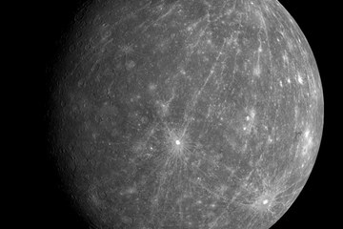  Mercury | 58 1⁄2 days | 88 days
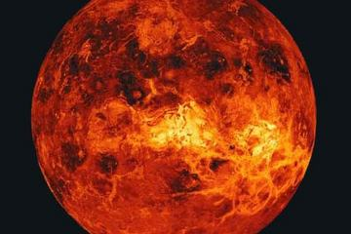  Venus | 243 days | 224 days
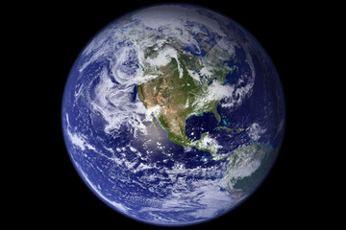  Earth | 24 hours | 365 1⁄4 days
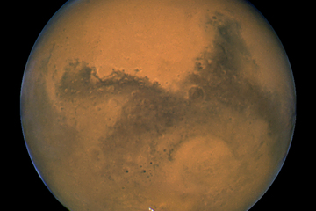  Mars | 24 1⁄2 days | 687 days
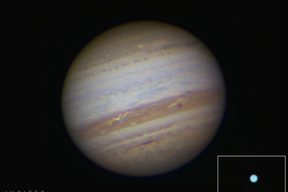  Jupiter | 10 hours | 12 years
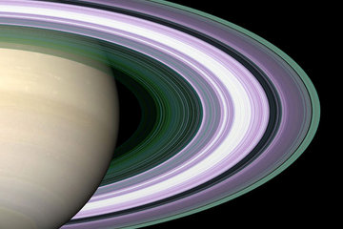  Saturn | 10 3⁄4 hours | 29 1⁄2 Years
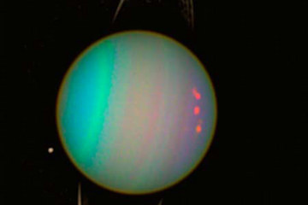  Uranus | 17 1⁄4 Hours | 84 years
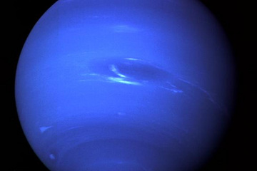  Neptune | 16 hours | 165 years
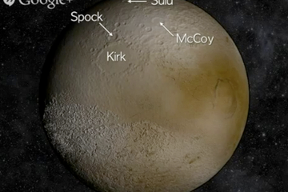  Pluto | 6.4 days | 248 years

Chapter-4: The Moon

