Implementation Evidence – Services 7–9
Omar Obeid
EECE 435L Final Project – Sprint I · Security Incident Detection and Response Management System
Services: Vulnerability Management (7), Notification and Alert Management (8), Security Playbook and Response Automation (9). Every screenshot was taken on my own machine: Postman sending the requests of postman/Omar_Obeid_Services_7-9.postman_collection.json, in collection order, to the running Flask server (http://127.0.0.1:5050) after python seed.py --reset; database screenshots are sqlite3 queries on security_system.db; GitHub screenshots are from the team repository.

Vulnerability Management Service (Service 7) (Omar Obeid)
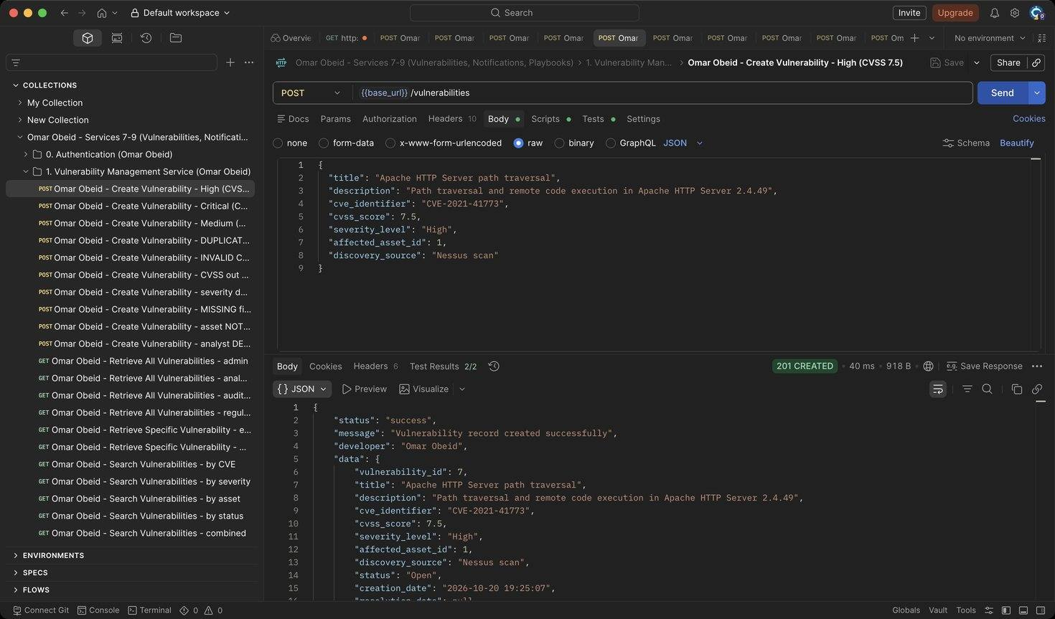
Figure 1: Omar Obeid – Create Vulnerability – High (CVSS 7.5): Records CVE-2021-41773 on asset 1. A High/Critical vulnerability also sends a Vulnerability Alert notification to the asset owner. (HTTP 201)
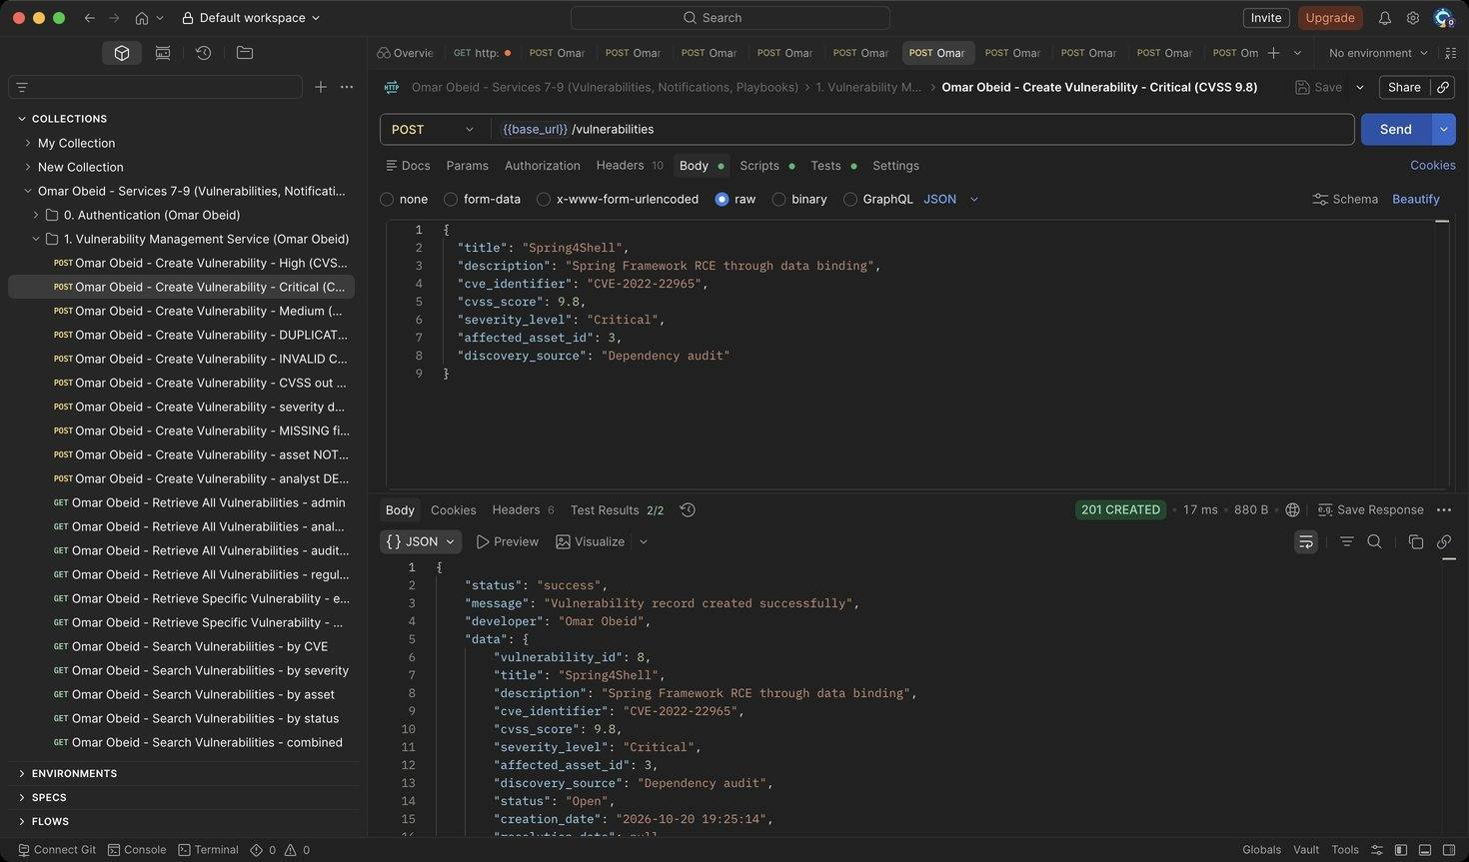
Figure 2: Omar Obeid – Create Vulnerability – Critical (CVSS 9.8): Spring4Shell on the customer database (HTTP 201)
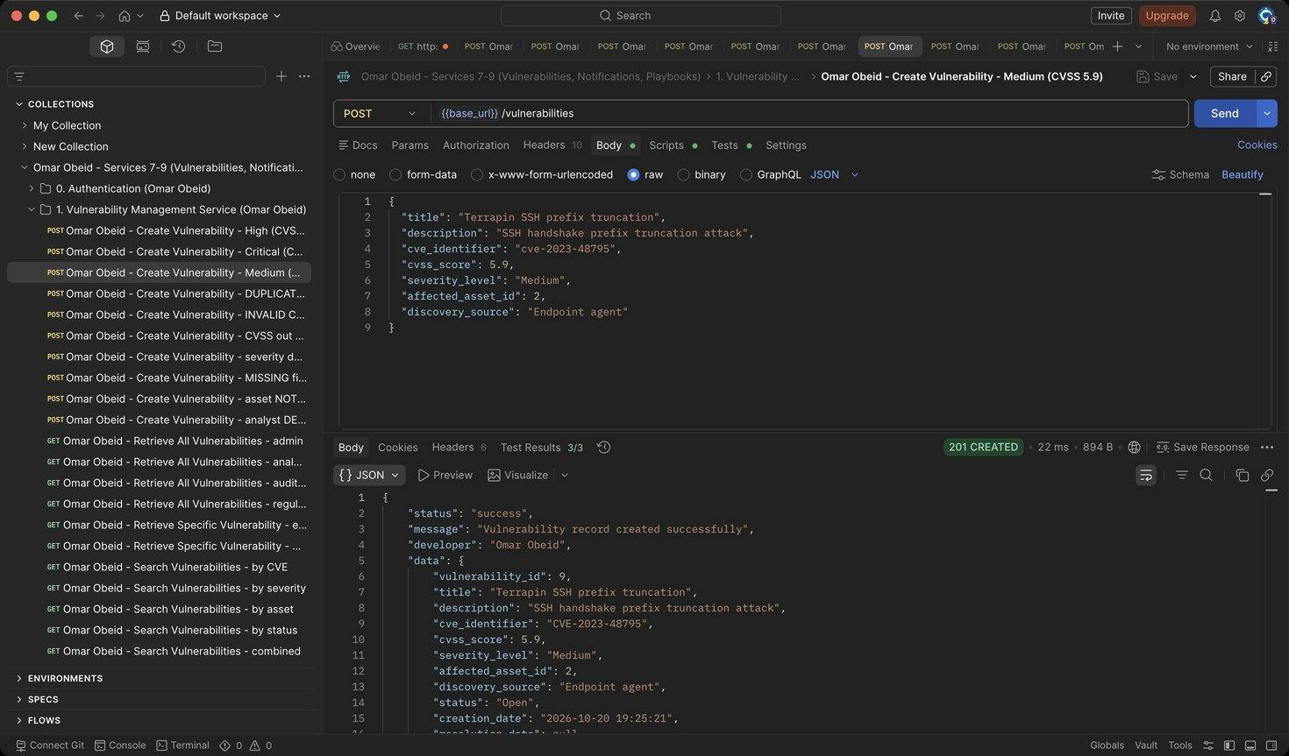
Figure 3: Omar Obeid – Create Vulnerability – Medium (CVSS 5.9): Terrapin SSH attack on the finance workstation. (HTTP 201)
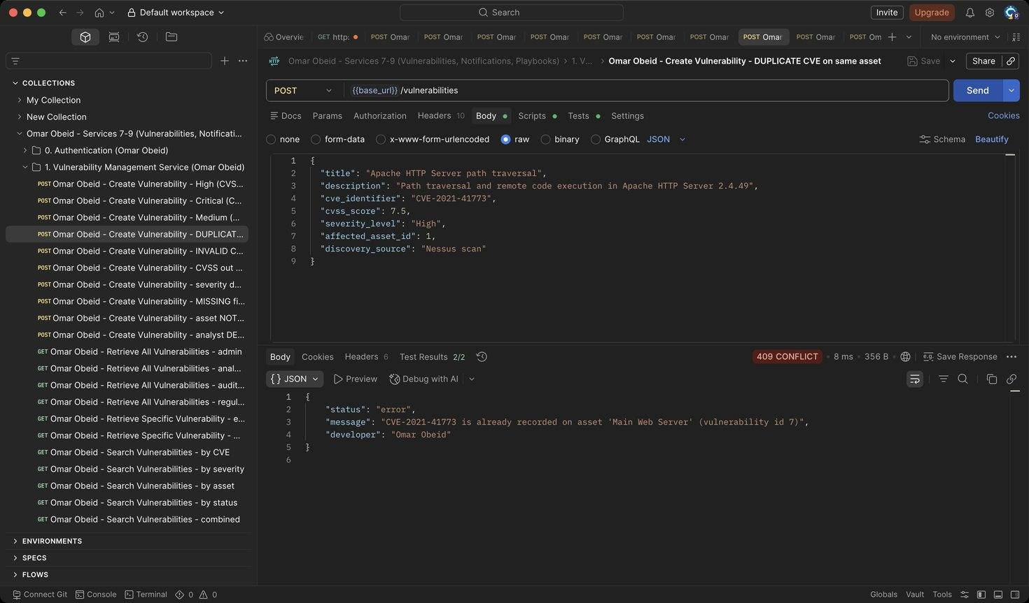
Figure 4: Omar Obeid – Create Vulnerability – DUPLICATE CVE on same asset: Same CVE on the same asset is rejected (HTTP 409)
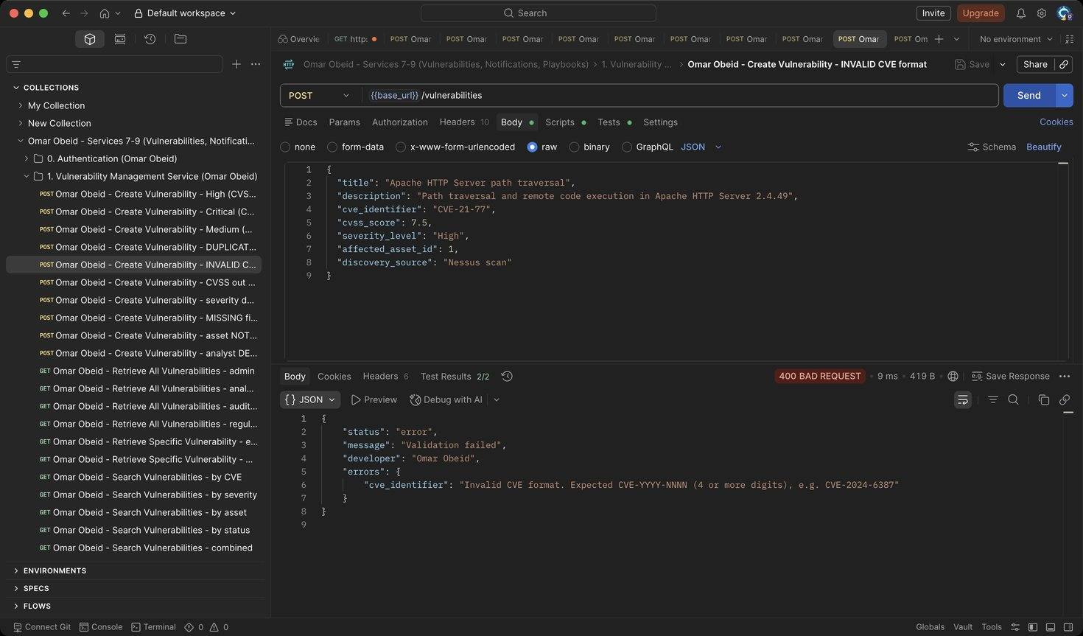
Figure 5: Omar Obeid – Create Vulnerability – INVALID CVE format: CVE must look like CVE-YYYY-NNNN (4+ digits) (HTTP 400)
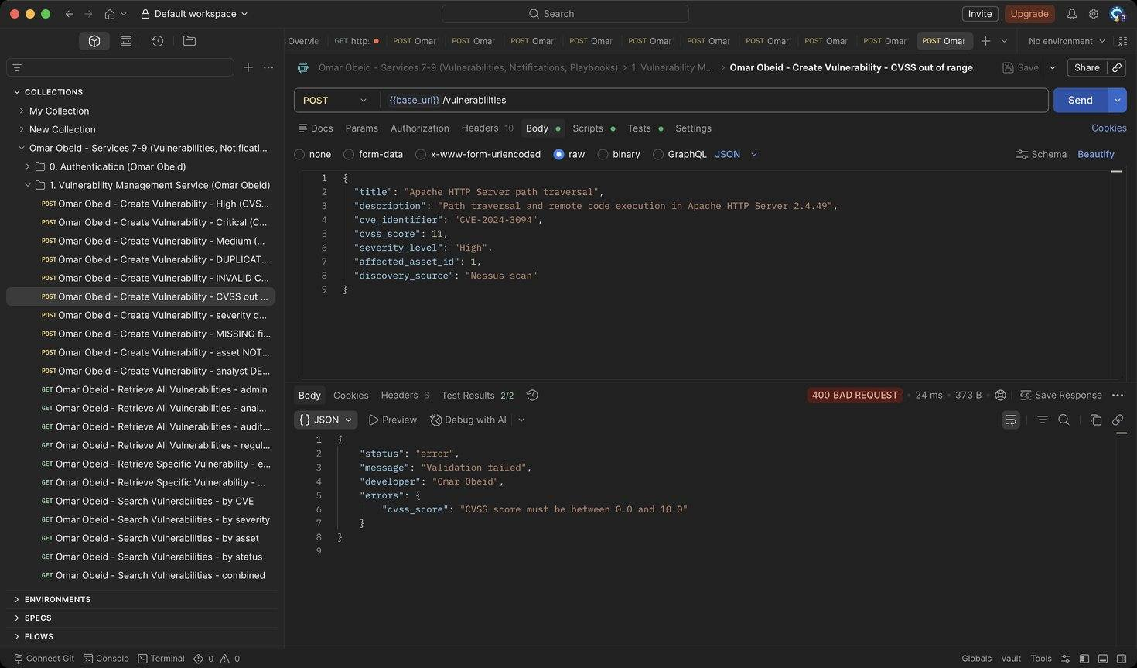
Figure 6: Omar Obeid – Create Vulnerability – CVSS out of range: CVSS must be between 0.0 and 10.0 (HTTP 400)
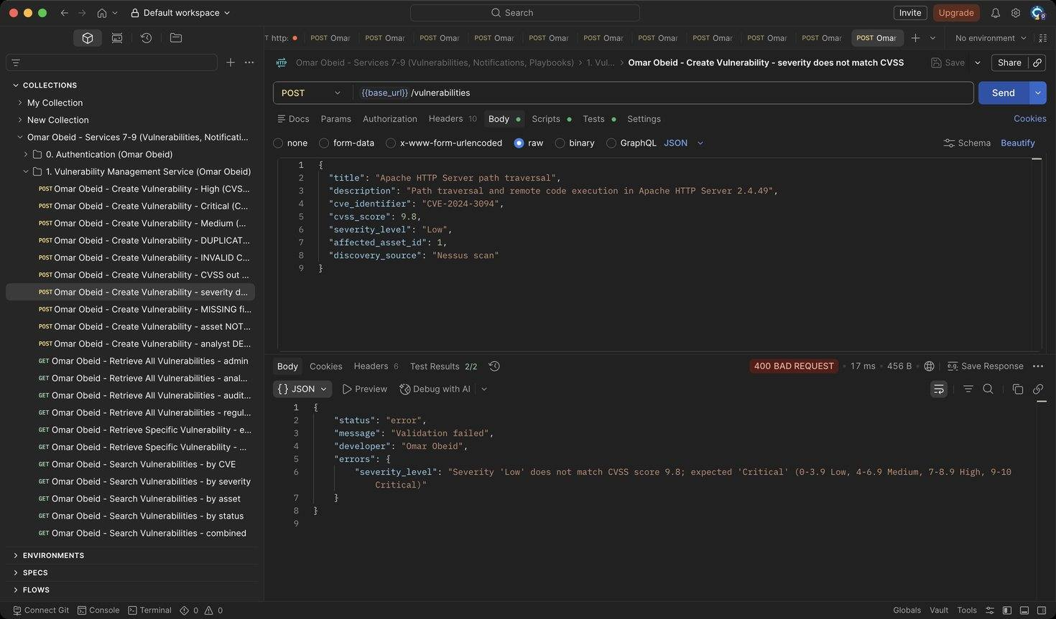
Figure 7: Omar Obeid – Create Vulnerability – severity does not match CVSS: CVSS 9.8 must be rated Critical, not Low (HTTP 400)
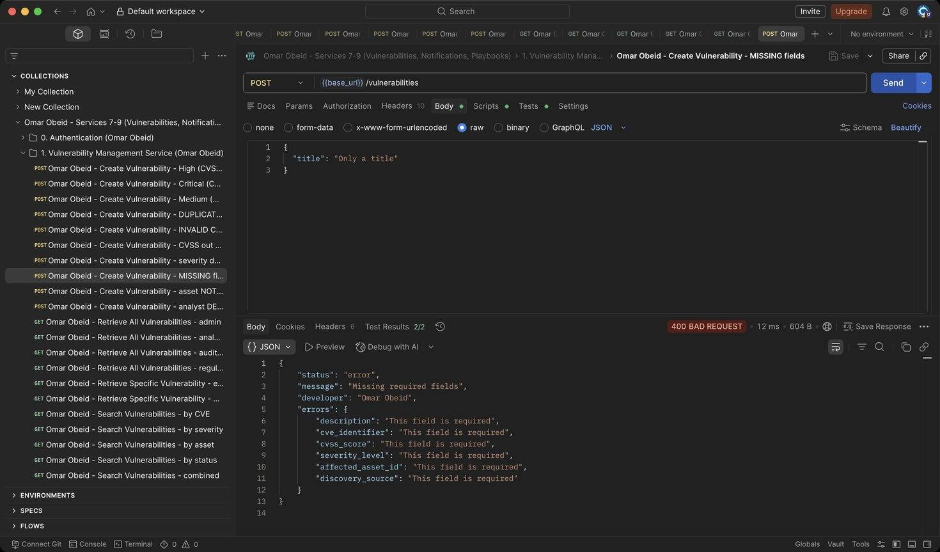
Figure 8: Omar Obeid – Create Vulnerability – MISSING fields: Every field is required (HTTP 400)
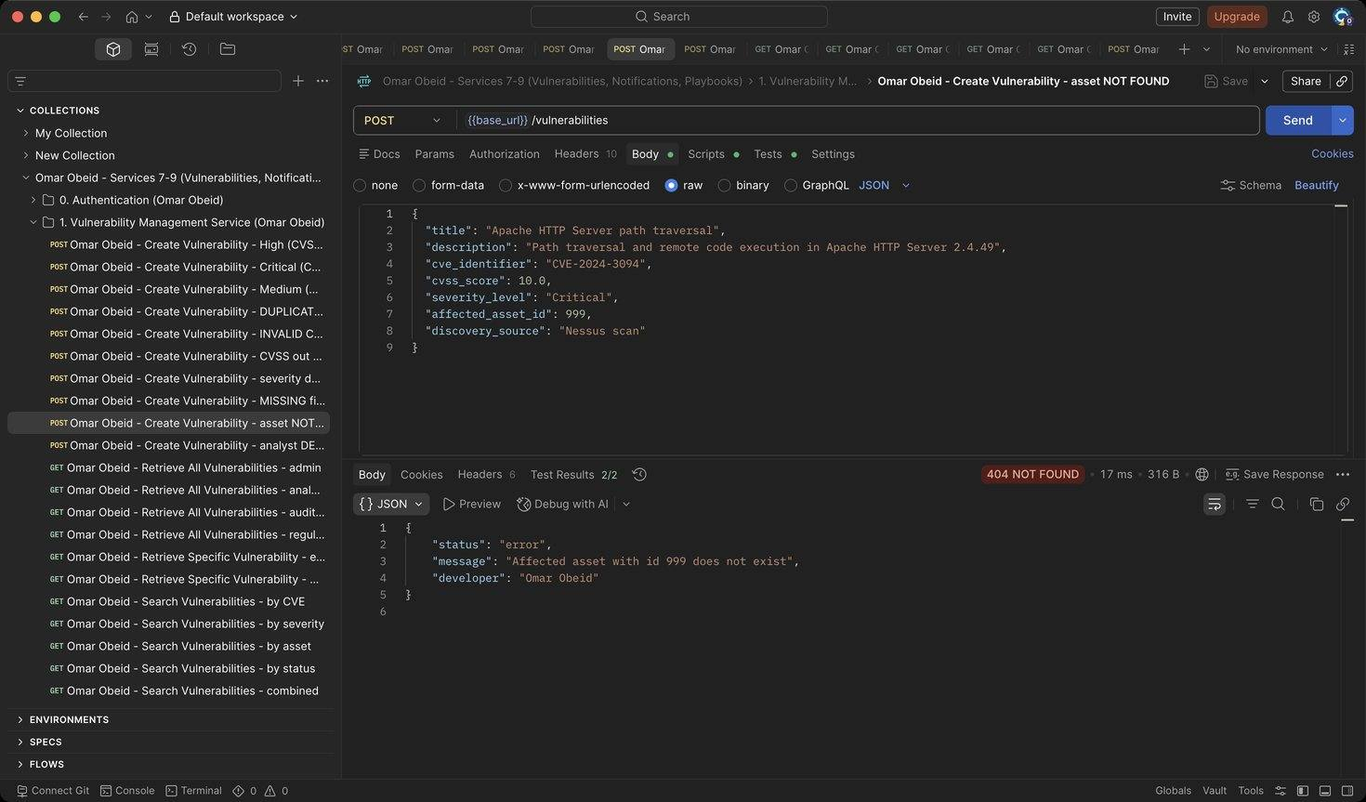
Figure 9: Omar Obeid – Create Vulnerability – asset NOT FOUND: The affected asset must exist (HTTP 404)
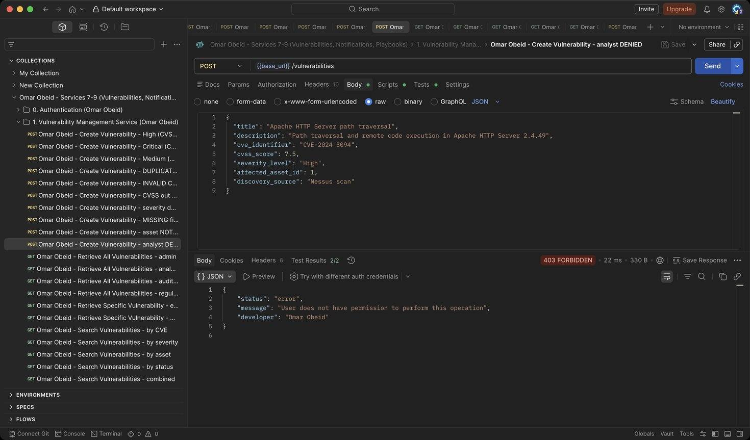
Figure 10: Omar Obeid – Create Vulnerability – analyst DENIED: Only the Security Administrator can create records (HTTP 403)
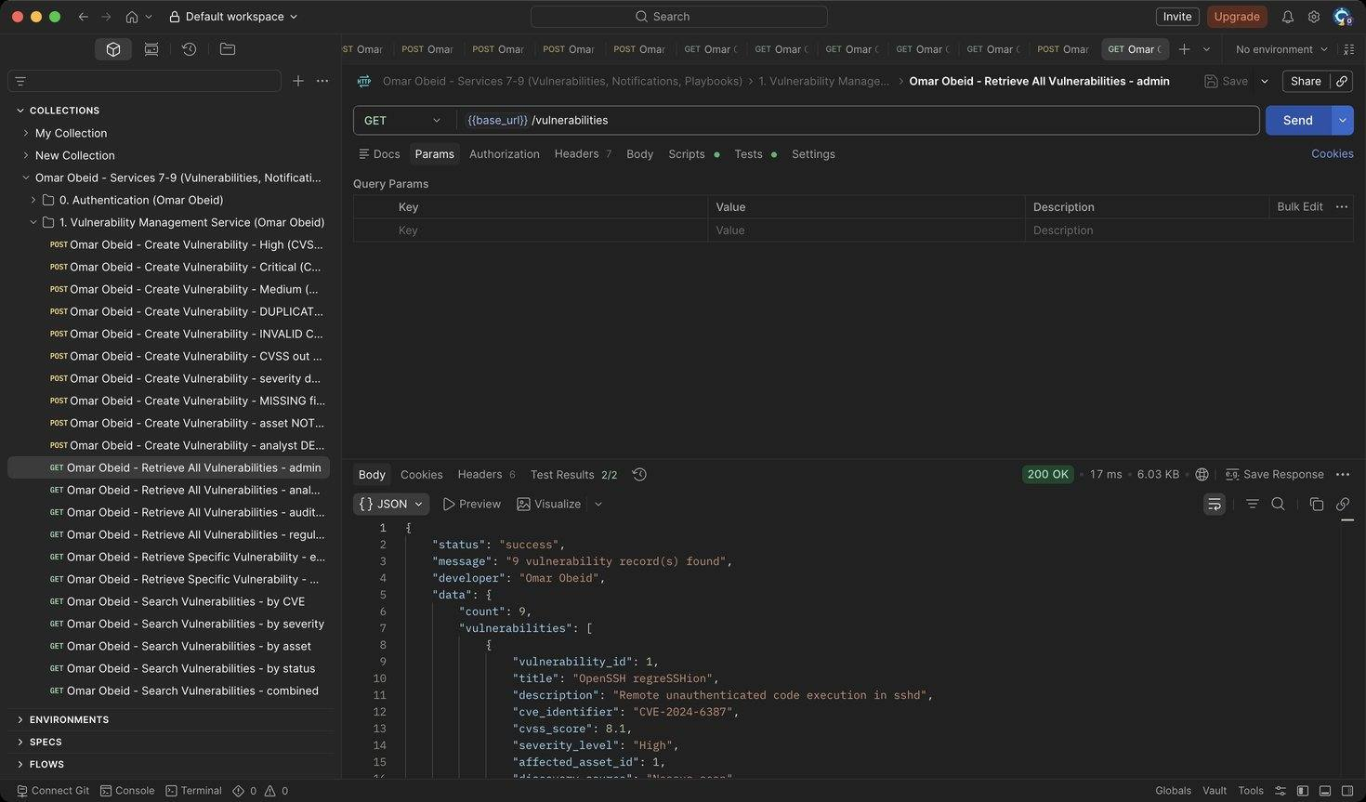
Figure 11: Omar Obeid – Retrieve All Vulnerabilities – admin: Lists every record (HTTP 200)
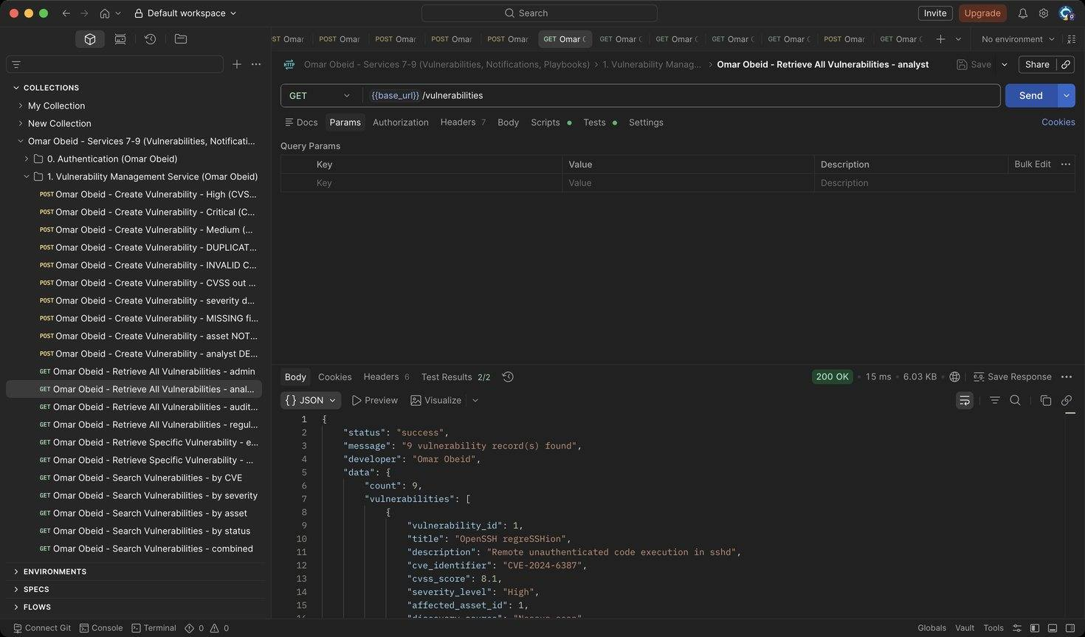
Figure 12: Omar Obeid – Retrieve All Vulnerabilities – analyst: Analysts can list (HTTP 200)
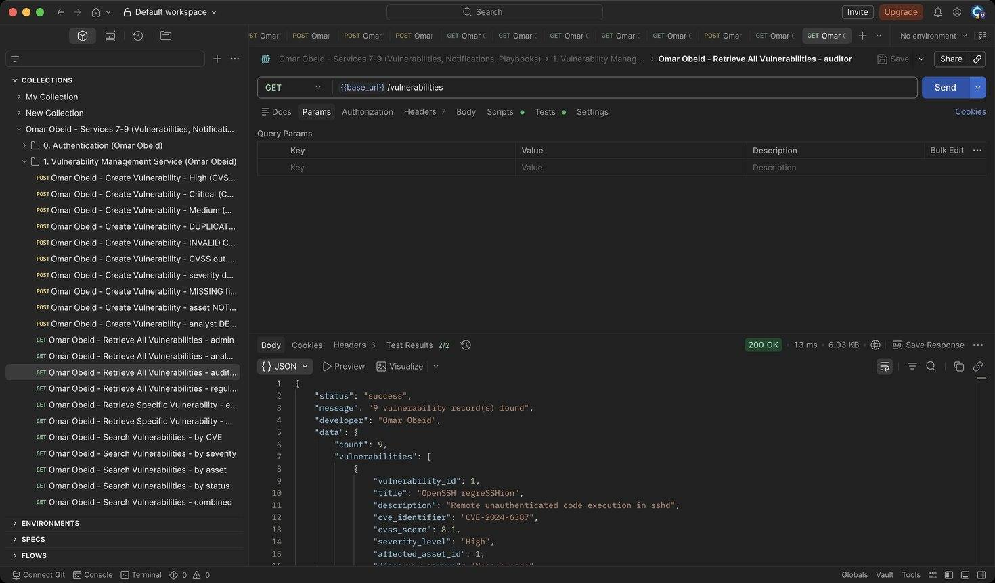
Figure 13: Omar Obeid – Retrieve All Vulnerabilities – auditor: Auditors can list (HTTP 200)
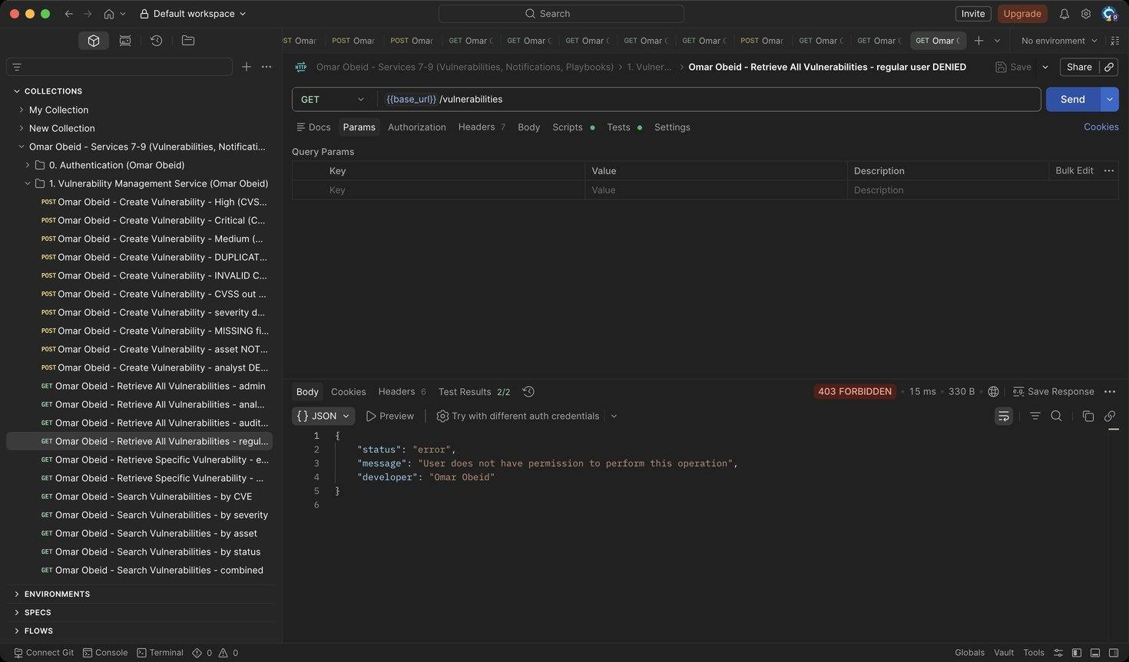
Figure 14: Omar Obeid – Retrieve All Vulnerabilities – regular user DENIED: Regular users have no access to vulnerabilities (HTTP 403)
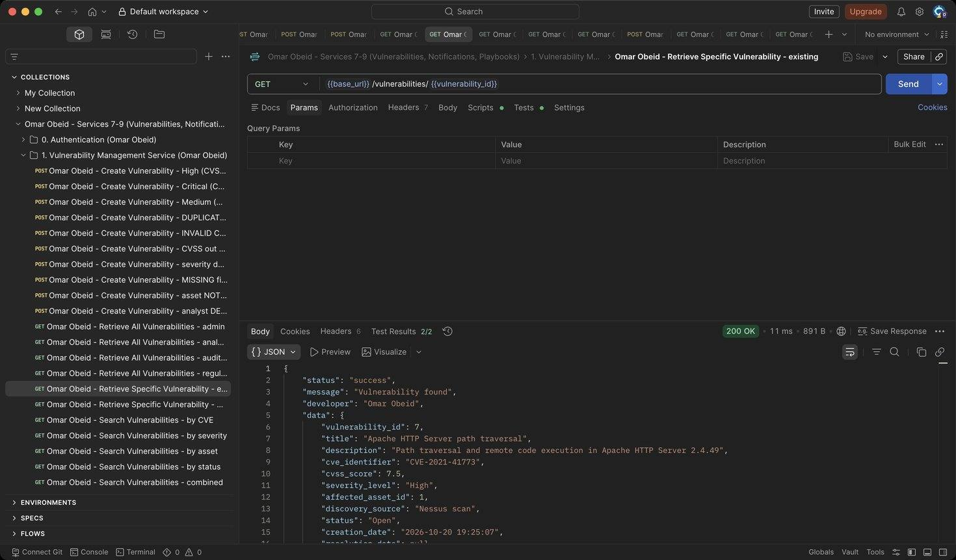
Figure 15: Omar Obeid – Retrieve Specific Vulnerability – existing: Includes the affected asset's name, IP and criticality (HTTP 200)
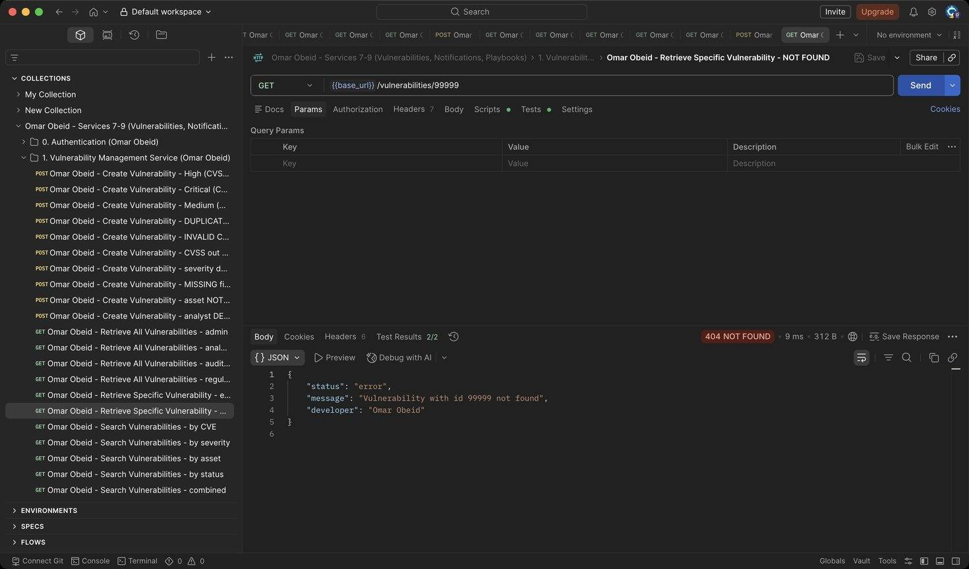
Figure 16: Omar Obeid – Retrieve Specific Vulnerability – NOT FOUND: Unknown id (HTTP 404)
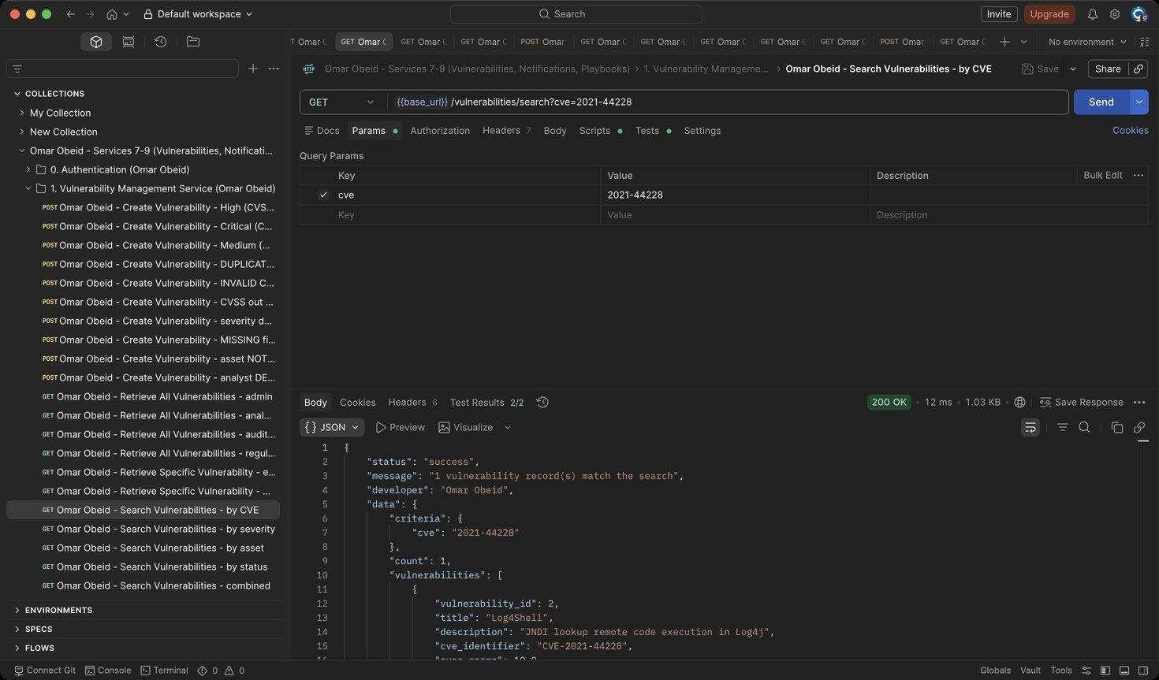
Figure 17: Omar Obeid – Search Vulnerabilities – by CVE: Partial, case-insensitive CVE match (Log4Shell) (HTTP 200)
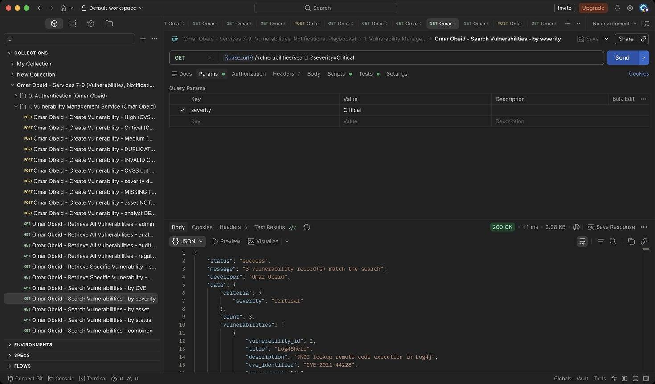
Figure 18: Omar Obeid – Search Vulnerabilities – by severity: Exact severity (HTTP 200)
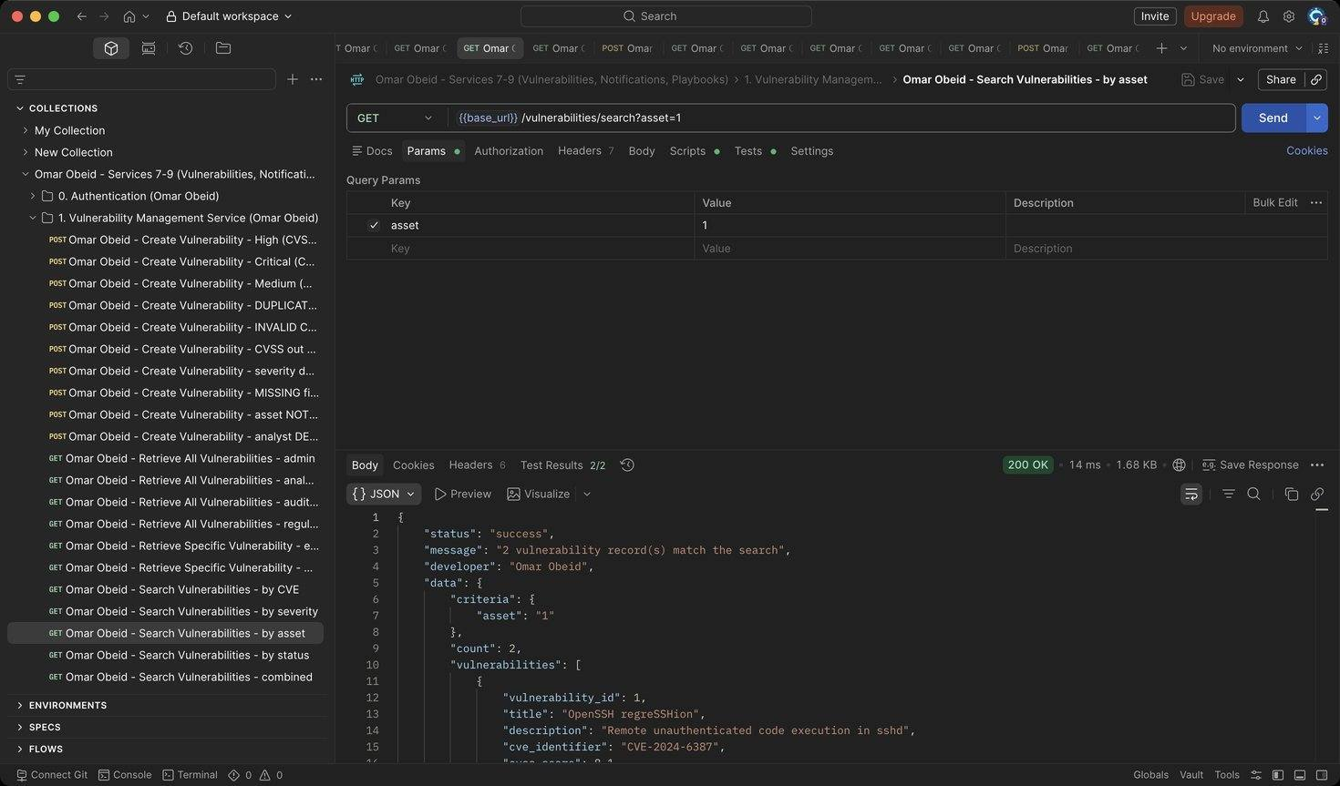
Figure 19: Omar Obeid – Search Vulnerabilities – by asset: All vulnerabilities on asset 1 (HTTP 200)
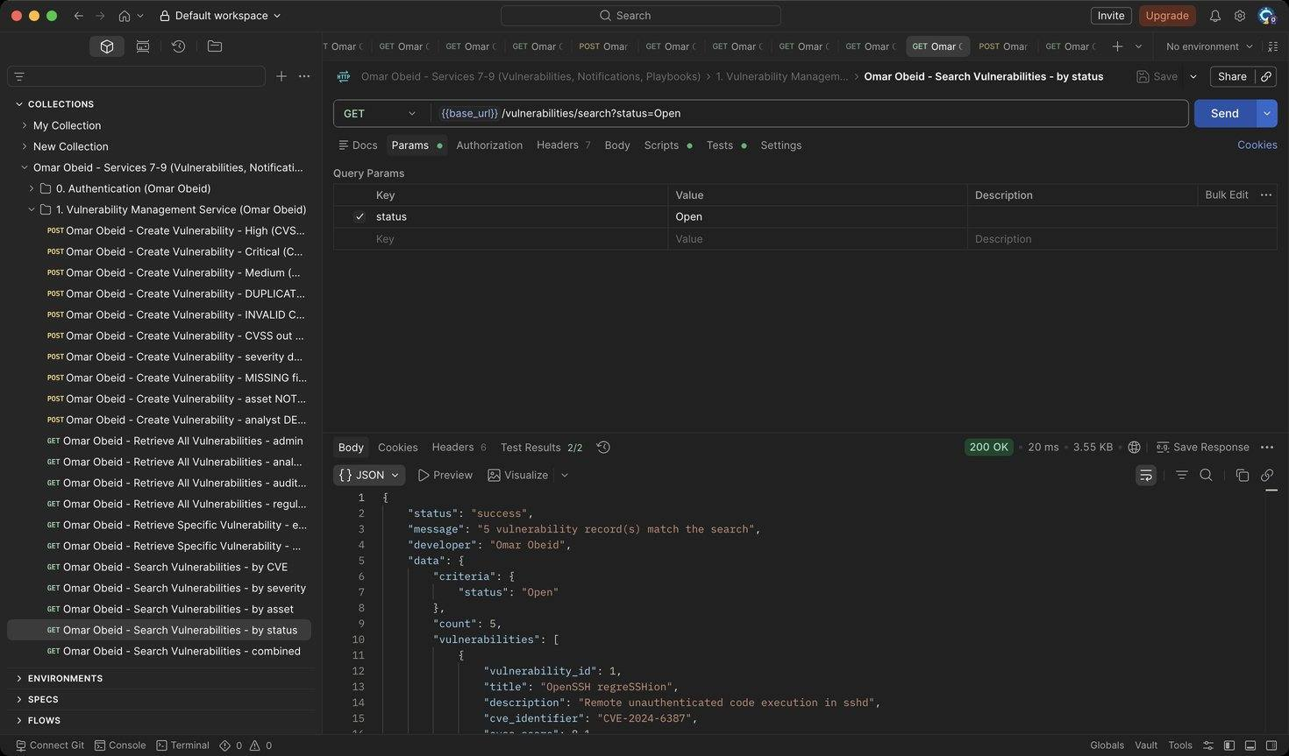
Figure 20: Omar Obeid – Search Vulnerabilities – by status: Exact status (HTTP 200)
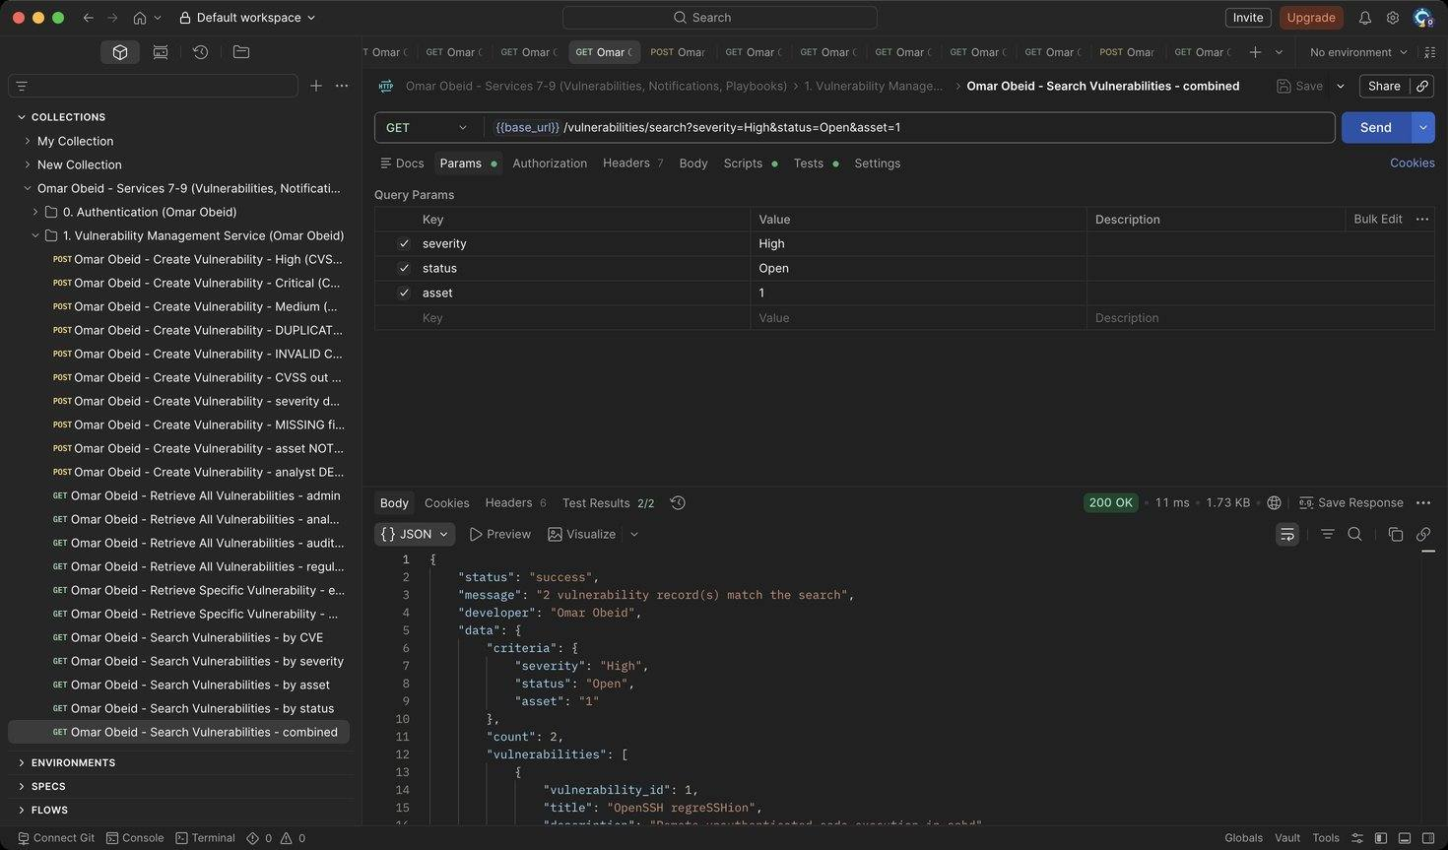
Figure 21: Omar Obeid – Search Vulnerabilities – combined: Criteria are combined with AND (HTTP 200)
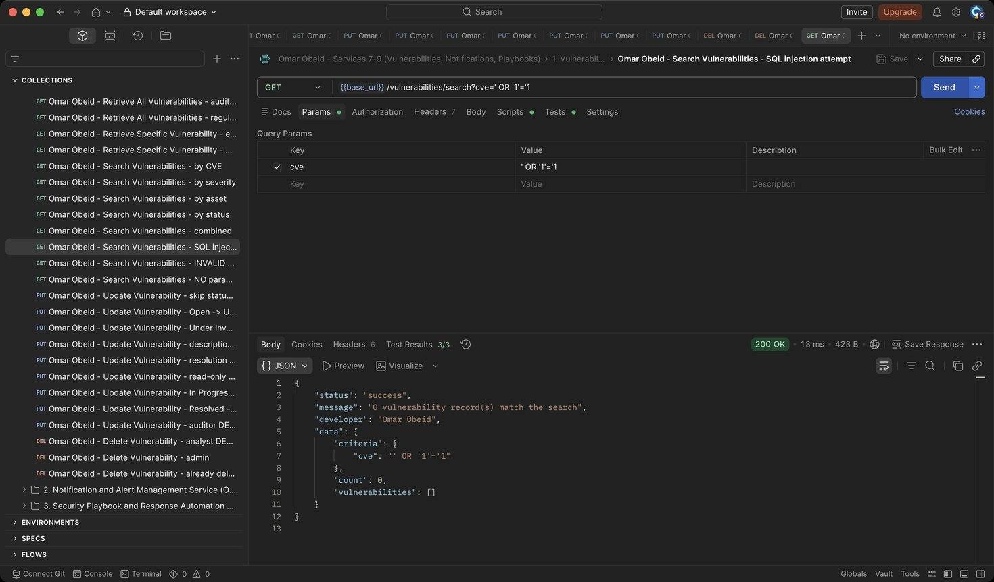
Figure 22: Omar Obeid – Search Vulnerabilities – SQL injection attempt: The value is a bound parameter: 0 results (HTTP 200)
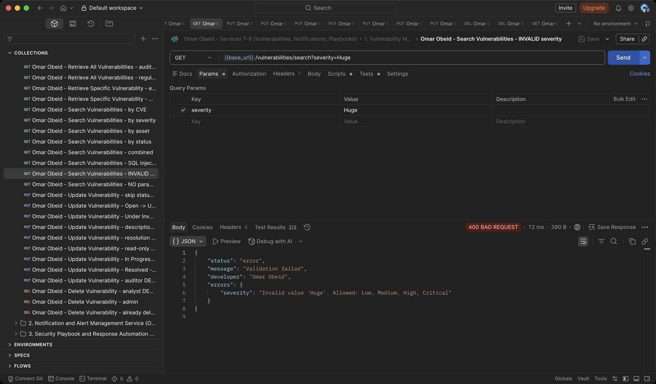
Figure 23: Omar Obeid – Search Vulnerabilities – INVALID severity: Severity must be Low, Medium, High or Critical (HTTP 400)
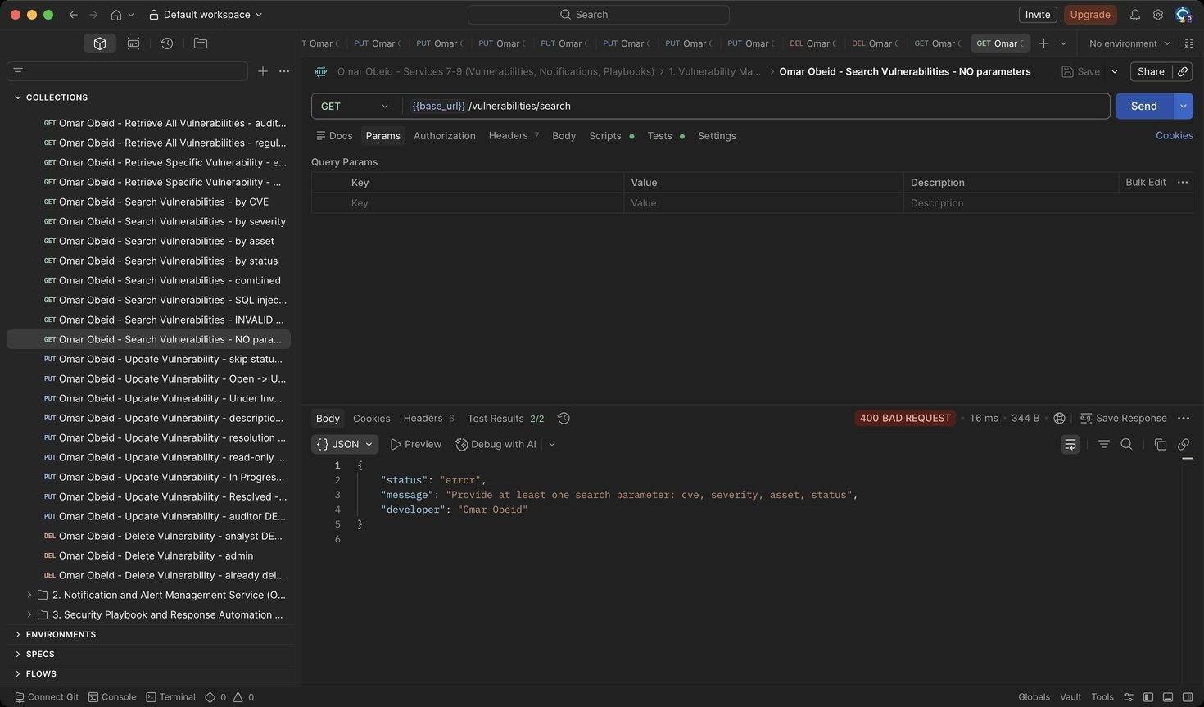
Figure 24: Omar Obeid – Search Vulnerabilities – NO parameters: At least one criterion is required (HTTP 400)
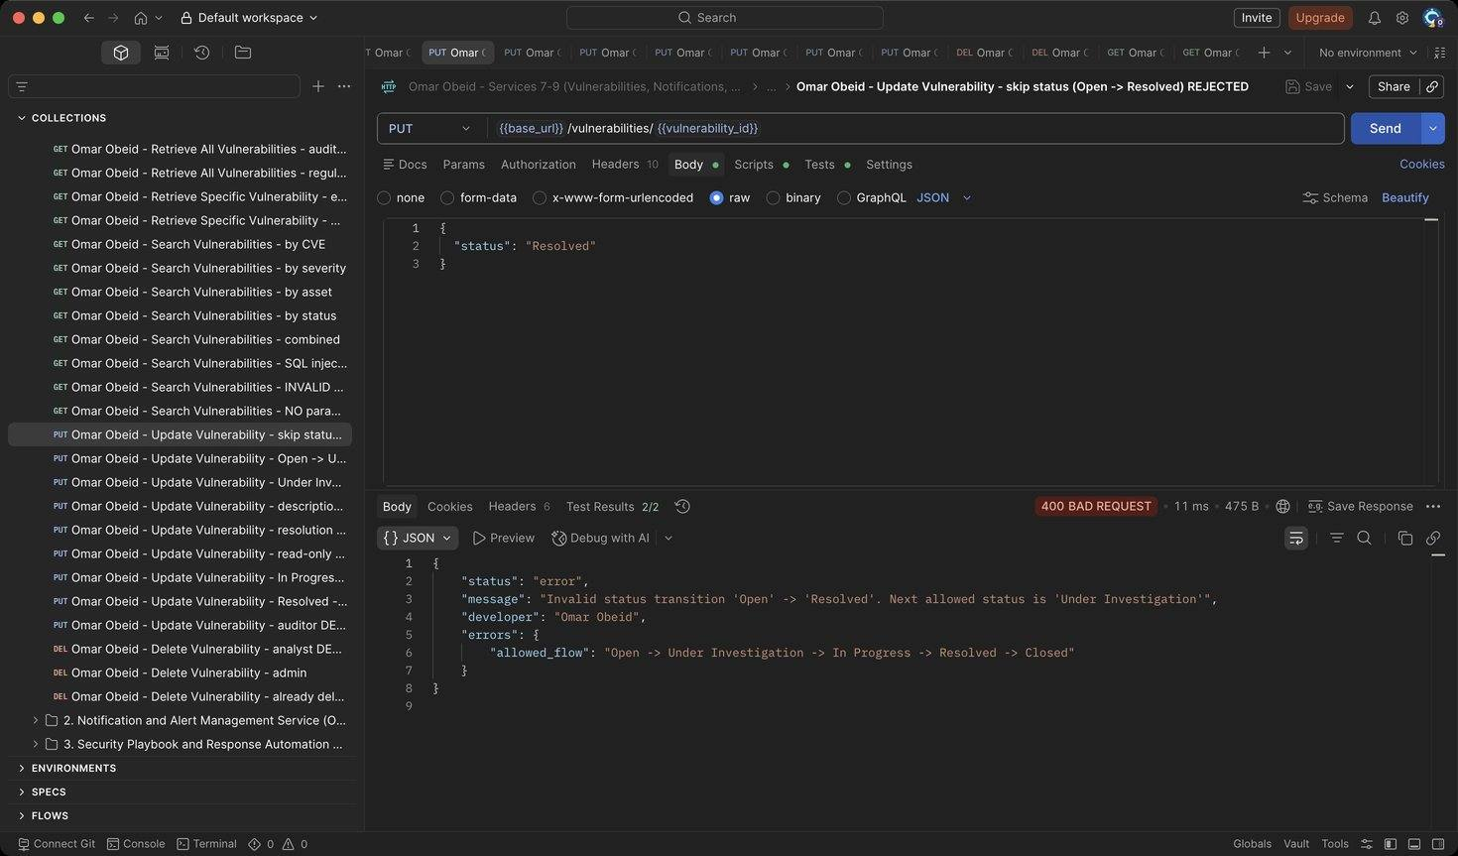
Figure 25: Omar Obeid – Update Vulnerability – skip status (Open -> Resolved) REJECTED: Status must follow Open -> Under Investigation -> In Progress -> Resolved -> Closed (HTTP 400)
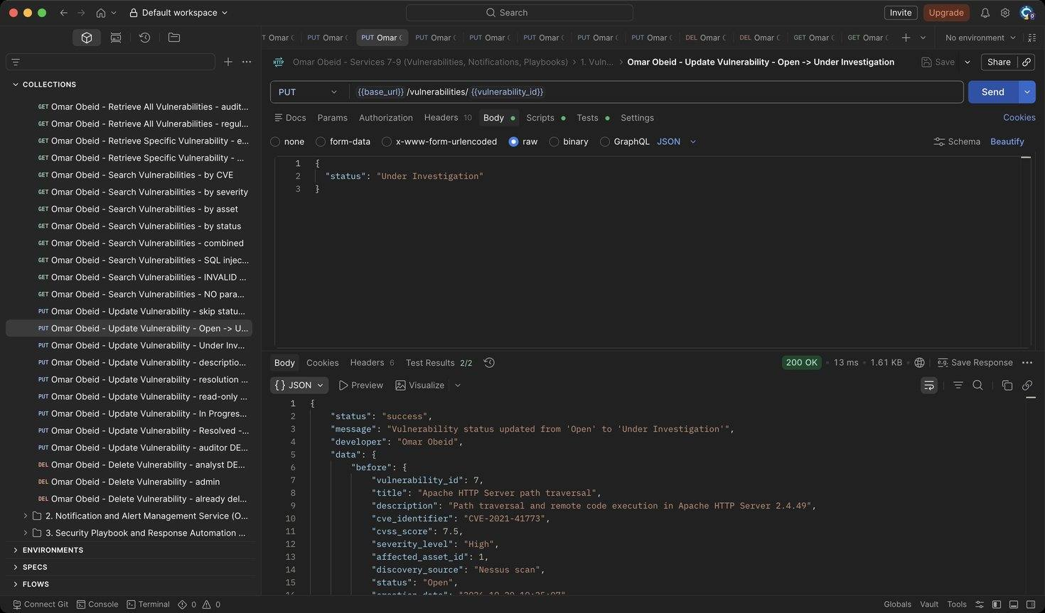
Figure 26: Omar Obeid – Update Vulnerability – Open -> Under Investigation: Response contains before and after (HTTP 200)
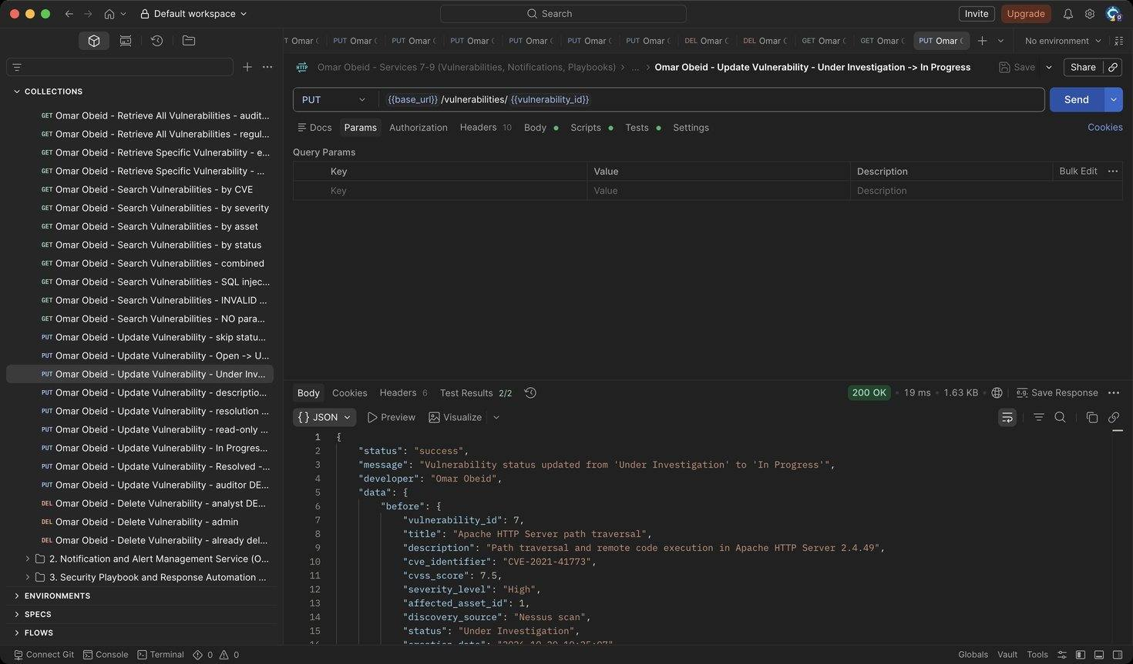
Figure 27: Omar Obeid – Update Vulnerability – Under Investigation -> In Progress: Next step (HTTP 200)
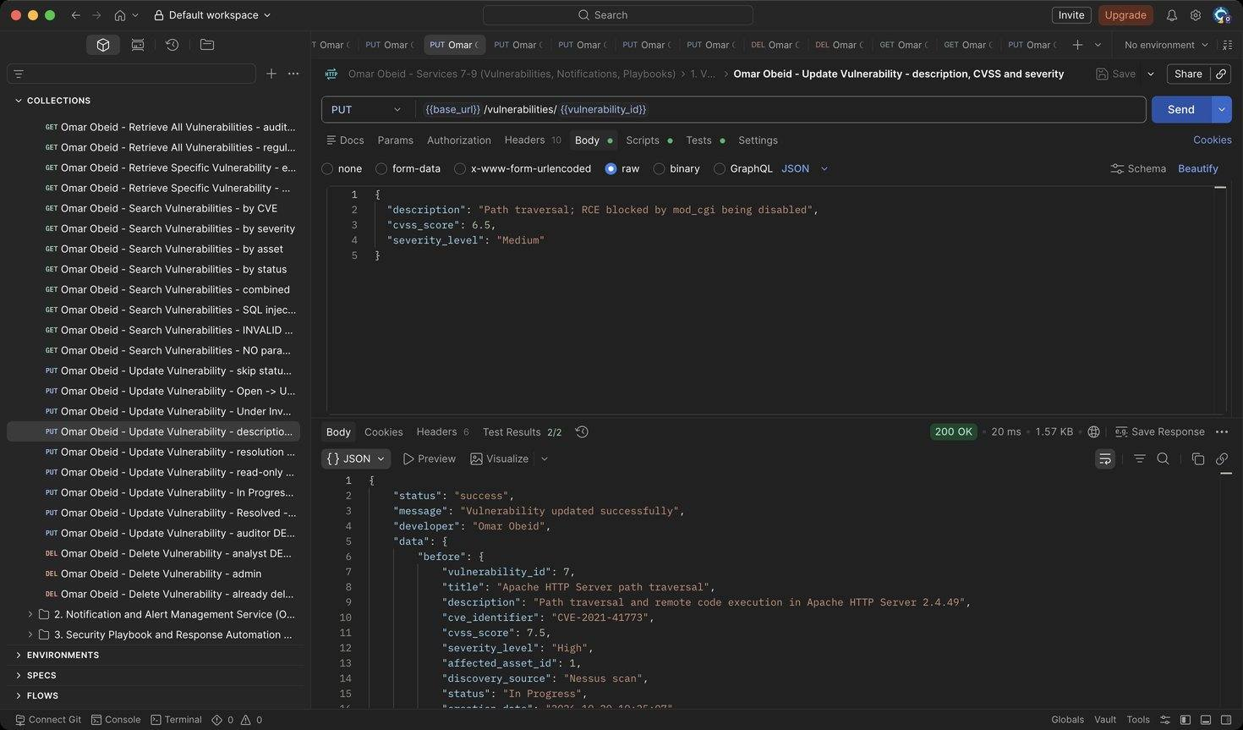
Figure 28: Omar Obeid – Update Vulnerability – description, CVSS and severity: CVSS 7.5 -> 6.5 so severity must become Medium (HTTP 200)
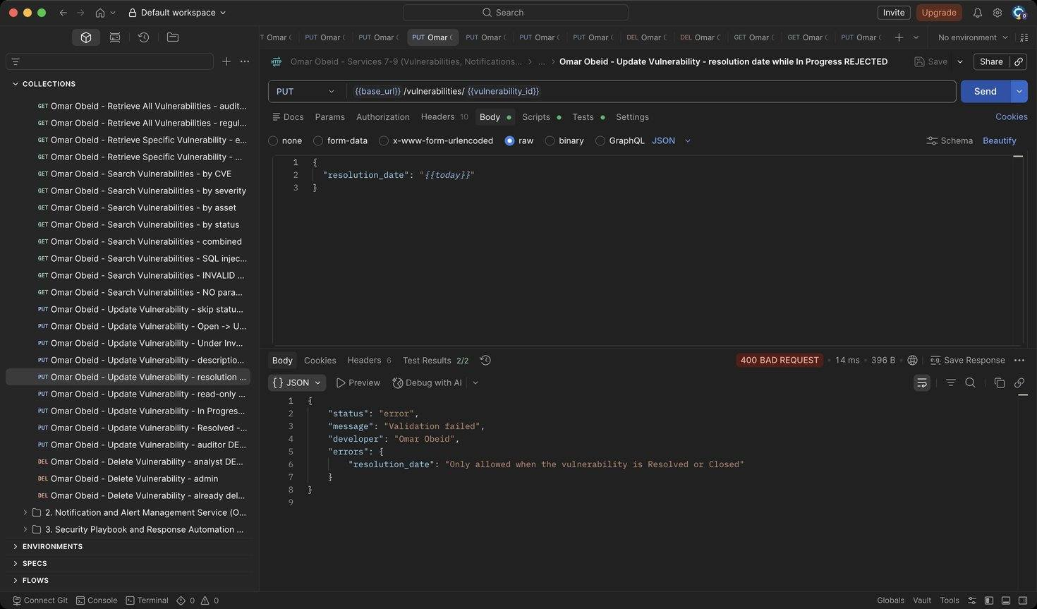
Figure 29: Omar Obeid – Update Vulnerability – resolution date while In Progress REJECTED: A resolution date is only allowed once the record is Resolved or Closed (HTTP 400)
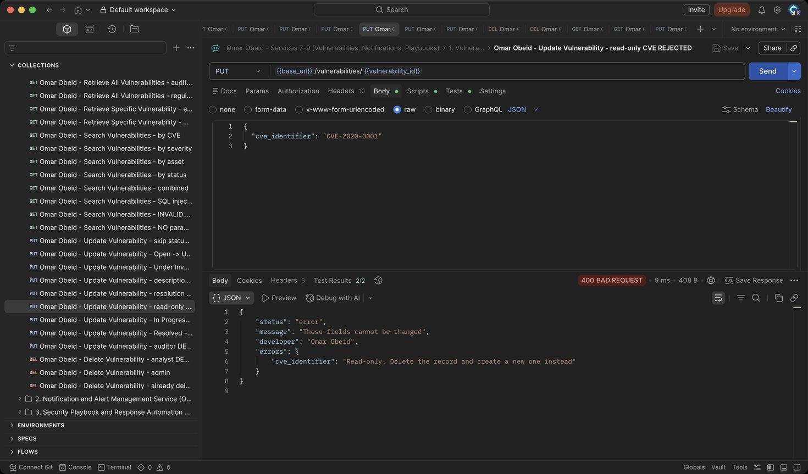
Figure 30: Omar Obeid – Update Vulnerability – read-only CVE REJECTED: CVE, title, asset and source cannot be changed (HTTP 400)
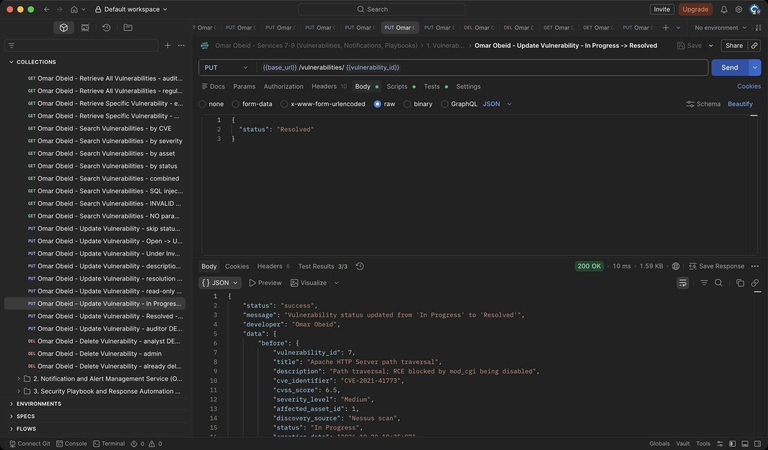
Figure 31: Omar Obeid – Update Vulnerability – In Progress -> Resolved: resolution_date is set automatically (HTTP 200)
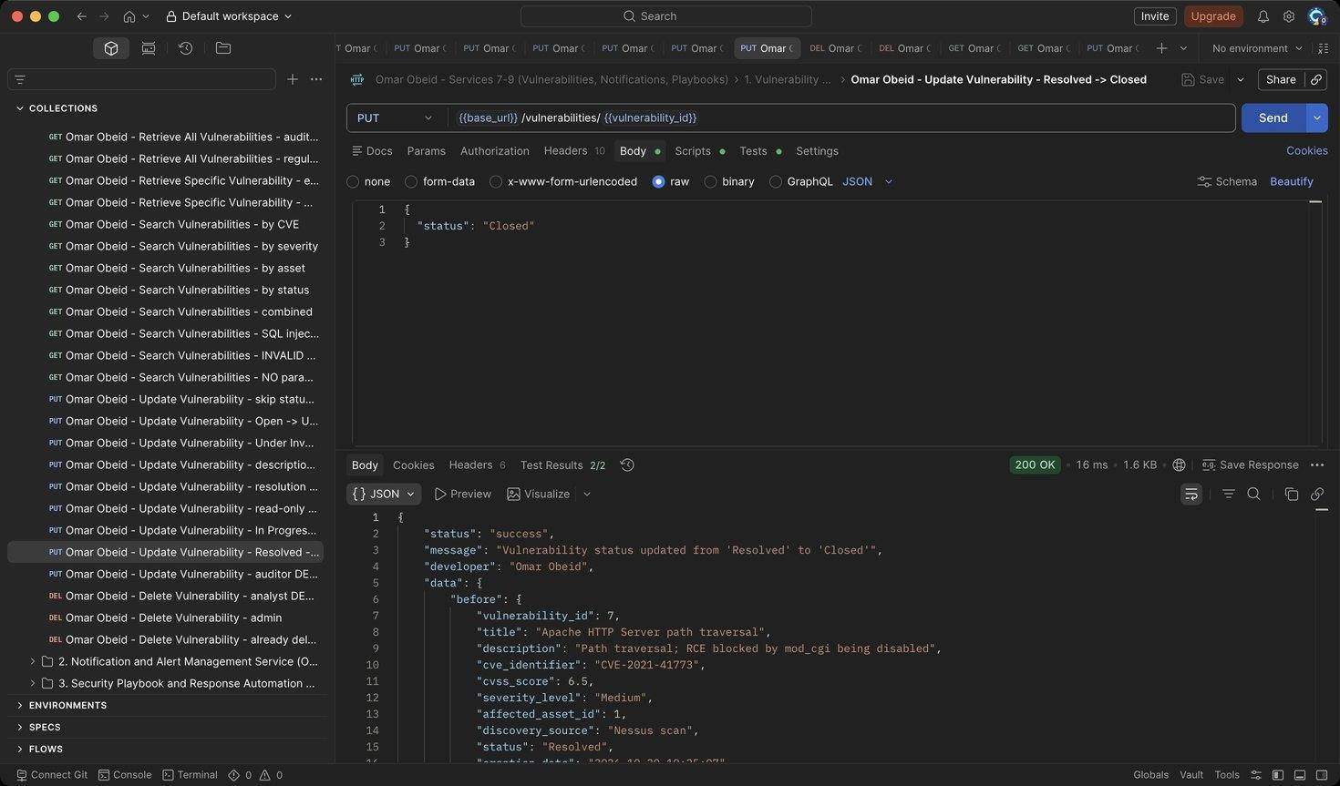
Figure 32: Omar Obeid – Update Vulnerability – Resolved -> Closed: Final state (HTTP 200)
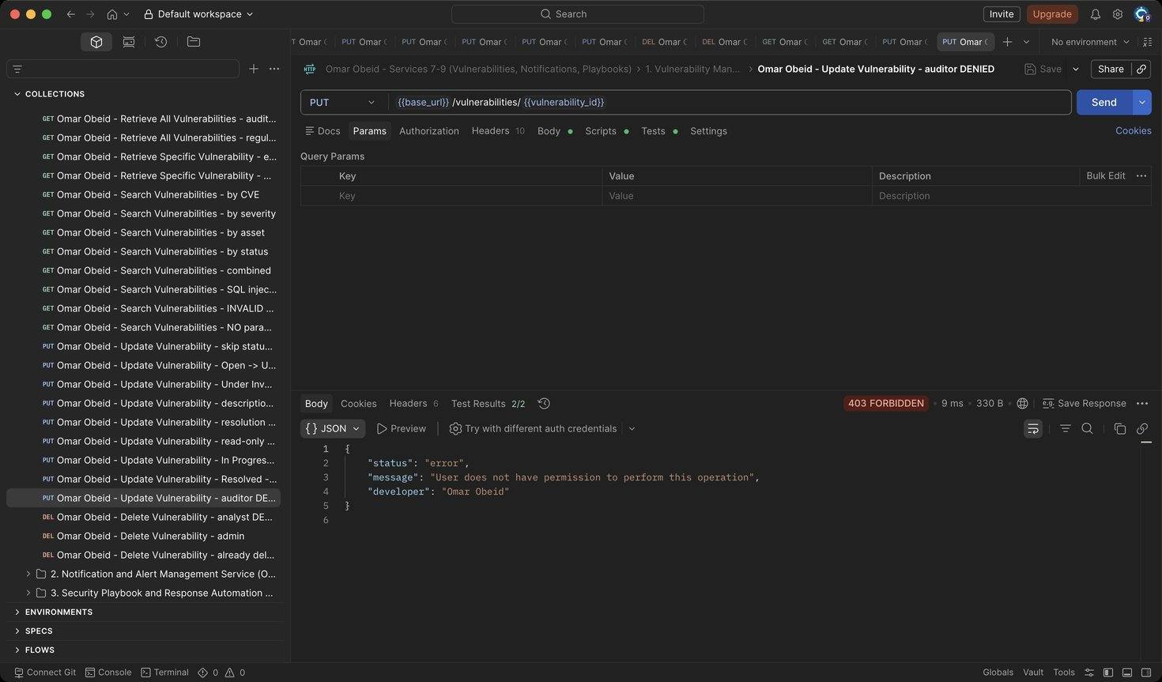
Figure 33: Omar Obeid – Update Vulnerability – auditor DENIED: Auditors are read-only (HTTP 403)
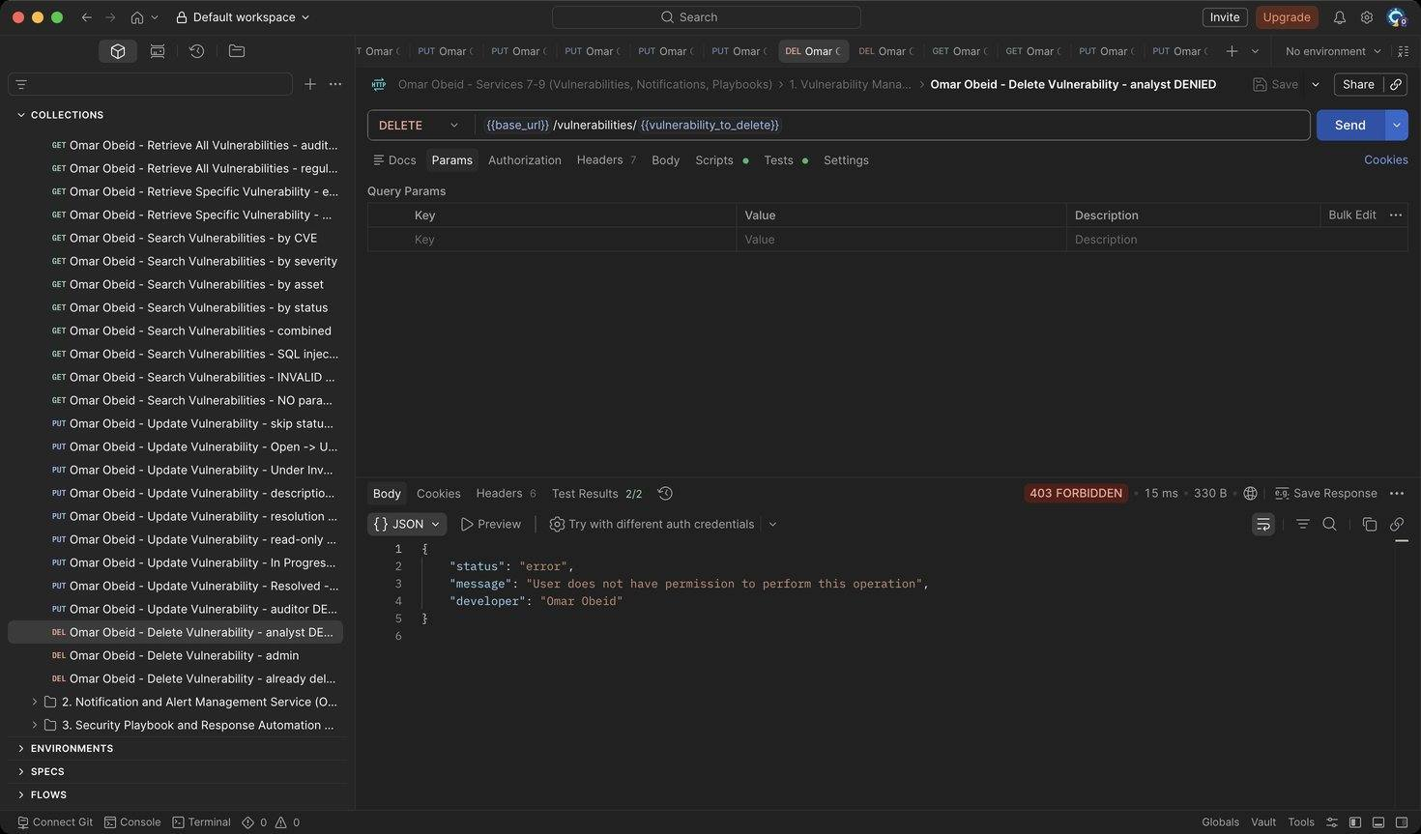
Figure 34: Omar Obeid – Delete Vulnerability – analyst DENIED: Only the Security Administrator can delete. The attempt is logged (HTTP 403)
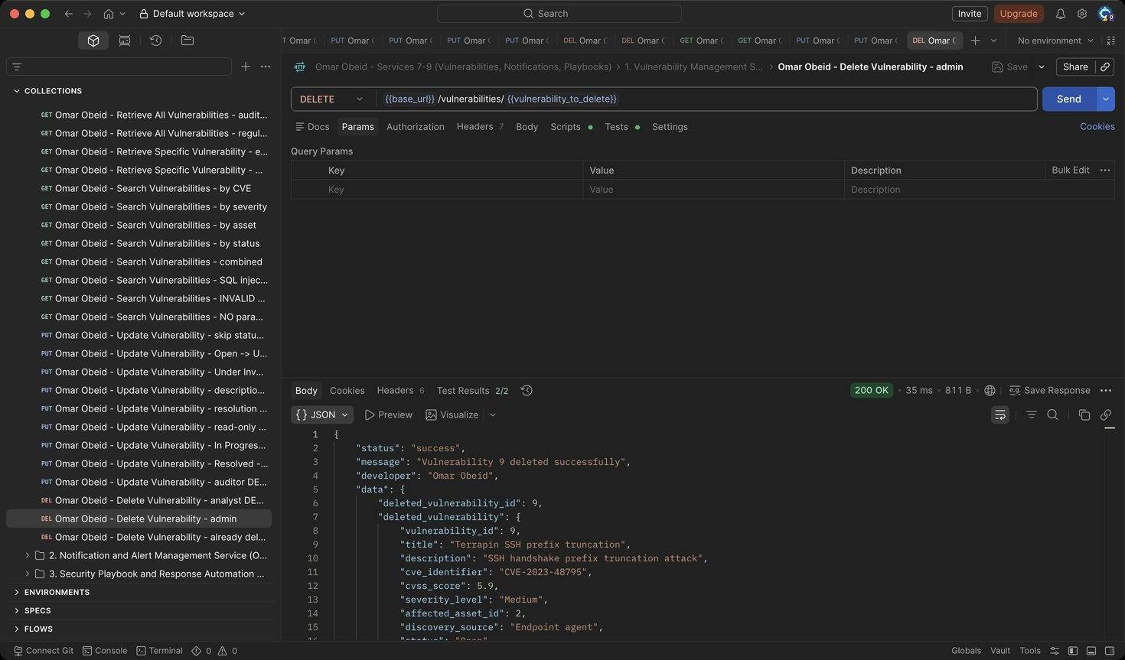
Figure 35: Omar Obeid – Delete Vulnerability – admin: Writes a VULNERABILITY_DELETED audit log (HTTP 200)
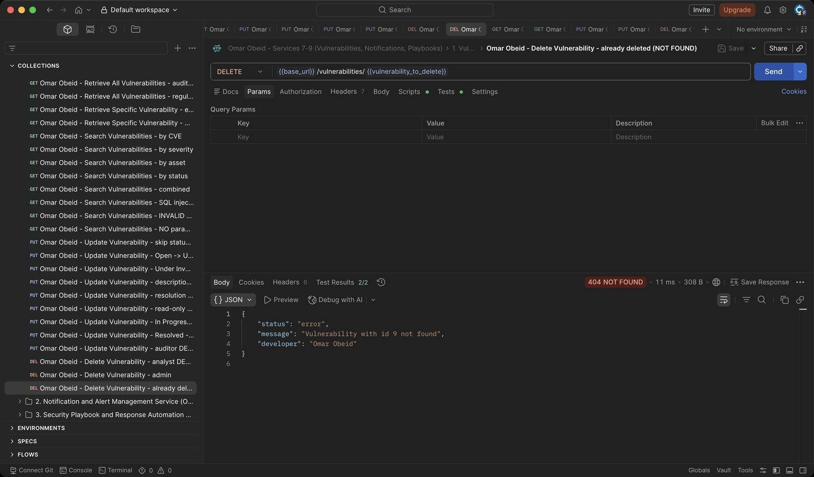
Figure 36: Omar Obeid – Delete Vulnerability – already deleted (NOT FOUND): The record is gone (HTTP 404)

Notification and Alert Management Service (Service 8) (Omar Obeid)
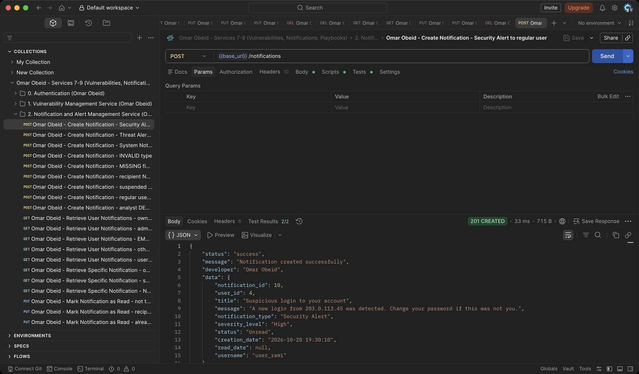
Figure 37: Omar Obeid – Create Notification – Security Alert to regular user: Starts as Unread. (HTTP 201)
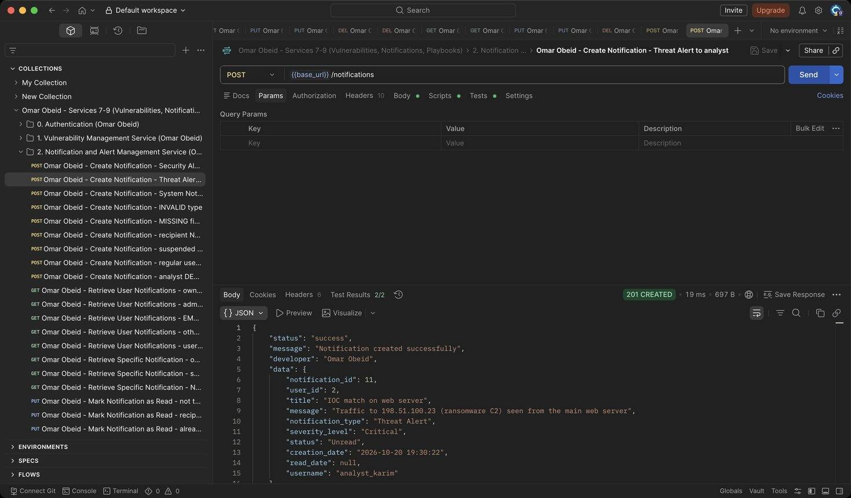
Figure 38: Omar Obeid – Create Notification – Threat Alert to analyst: Critical threat alert for analyst_karim (HTTP 201)
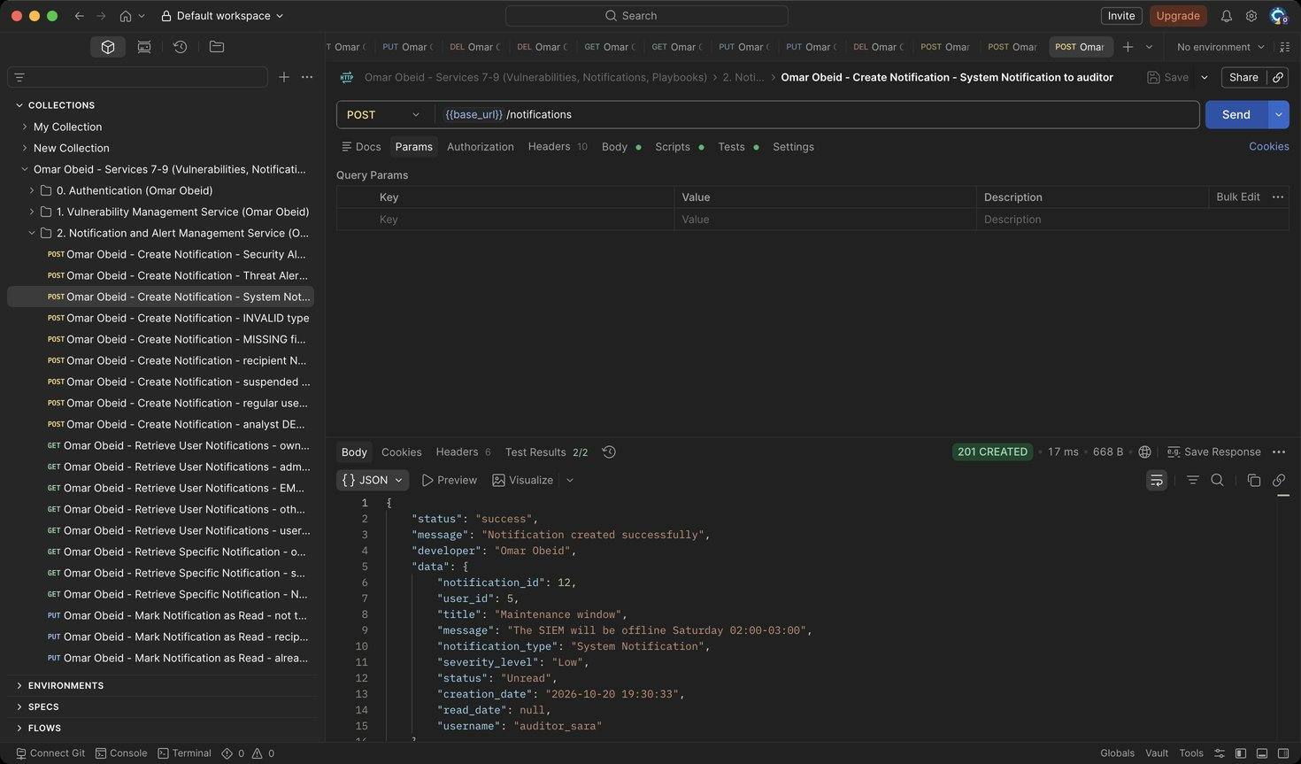
Figure 39: Omar Obeid – Create Notification – System Notification to auditor: Low-severity system message (HTTP 201)
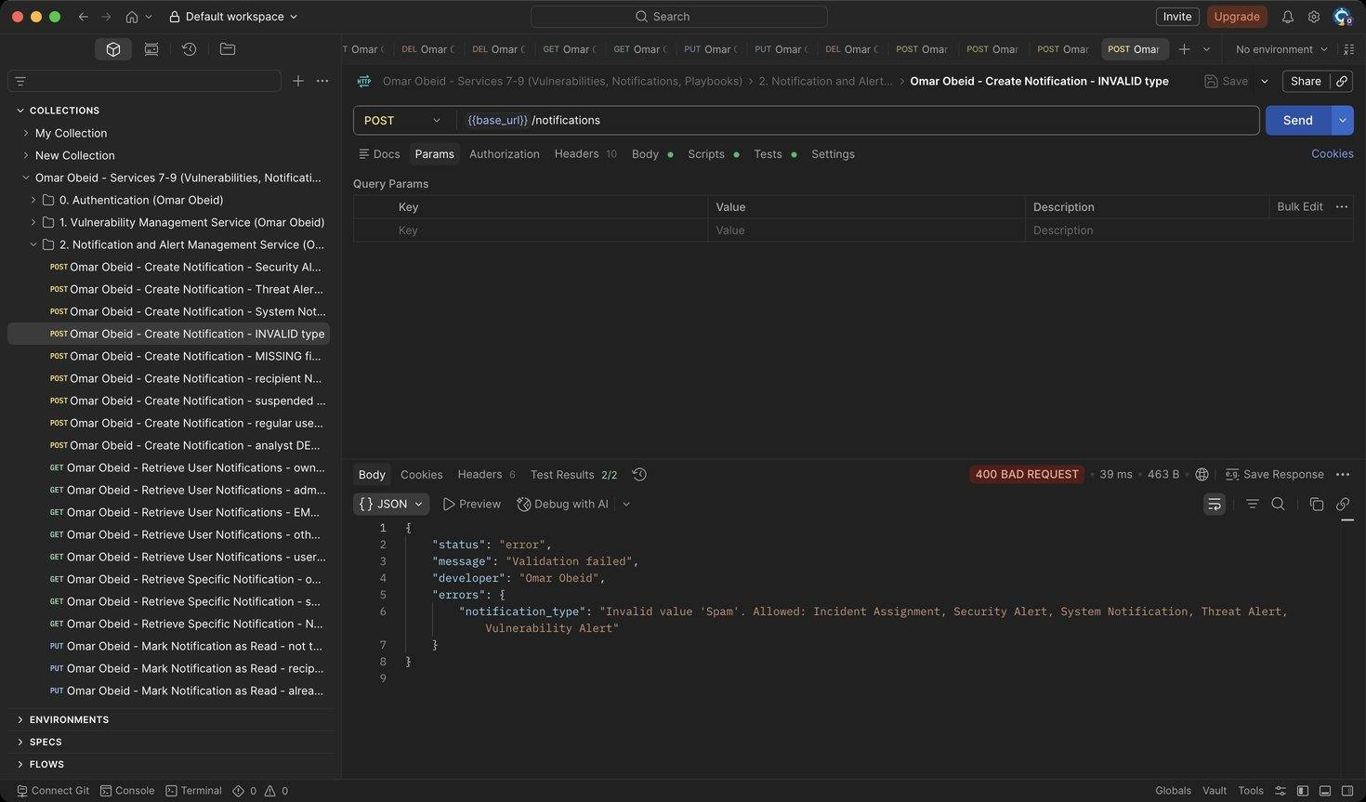
Figure 40: Omar Obeid – Create Notification – INVALID type: Type must be one of the five notification types (HTTP 400)
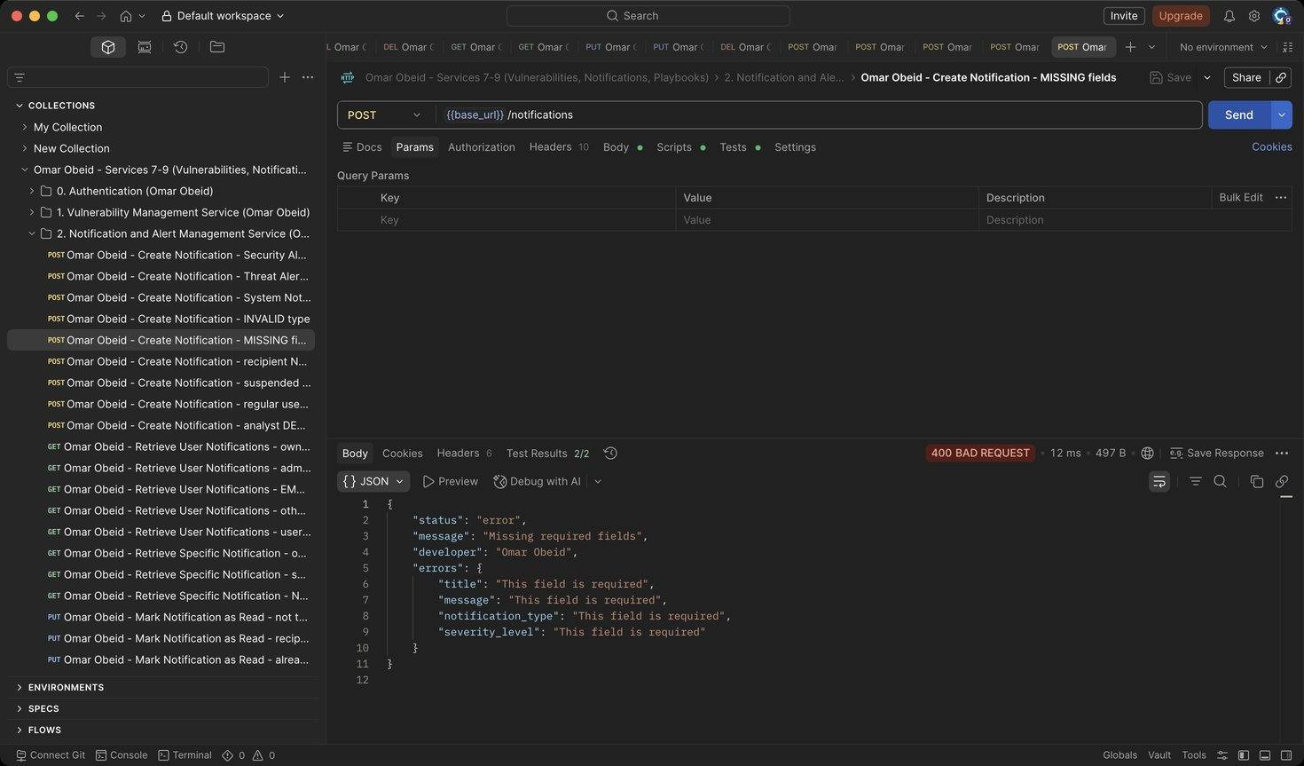
Figure 41: Omar Obeid – Create Notification – MISSING fields: All fields required (HTTP 400)
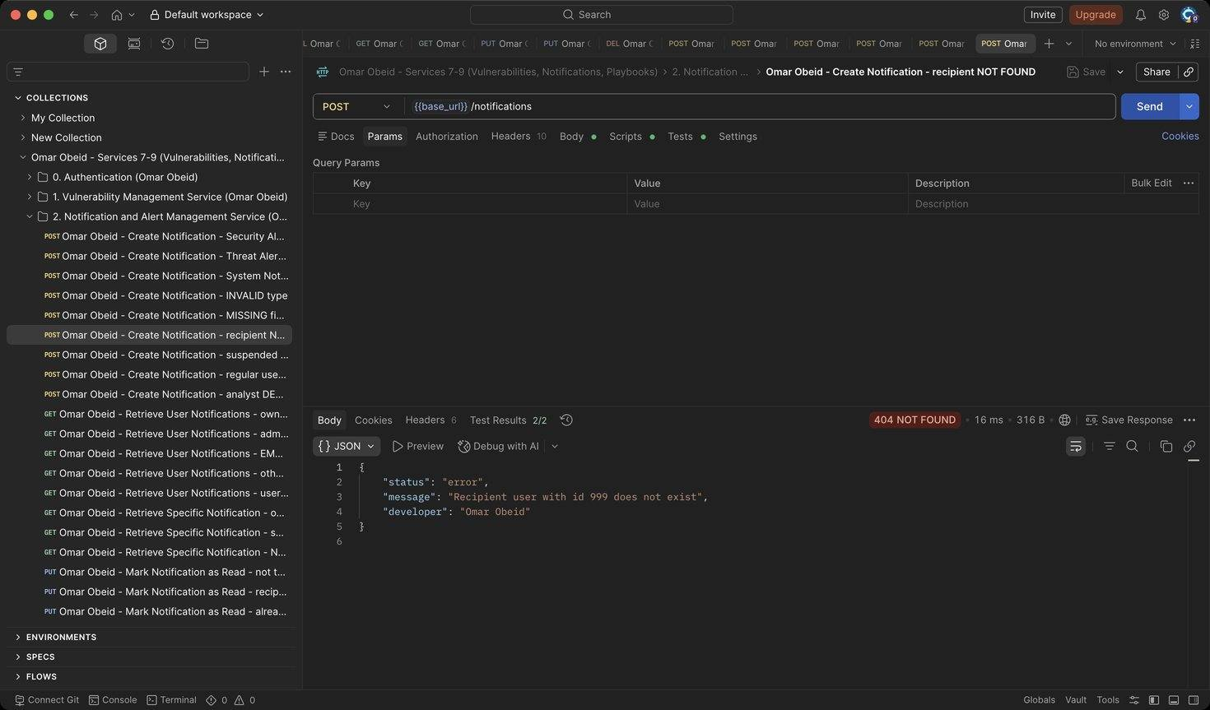
Figure 42: Omar Obeid – Create Notification – recipient NOT FOUND: The user must exist (HTTP 404)
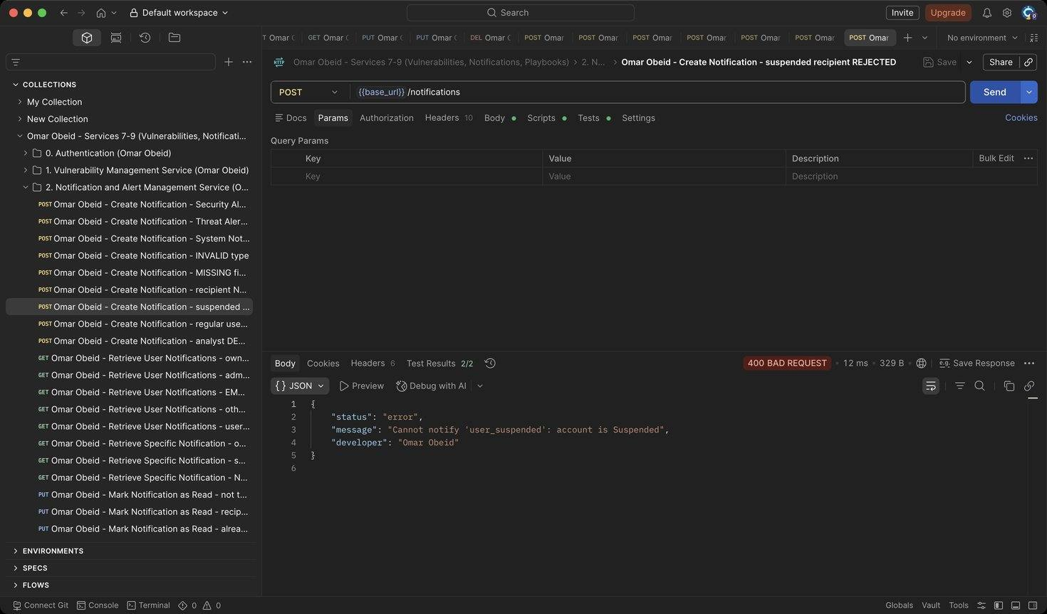
Figure 43: Omar Obeid – Create Notification – suspended recipient REJECTED: Suspended or inactive accounts cannot be notified (HTTP 400)
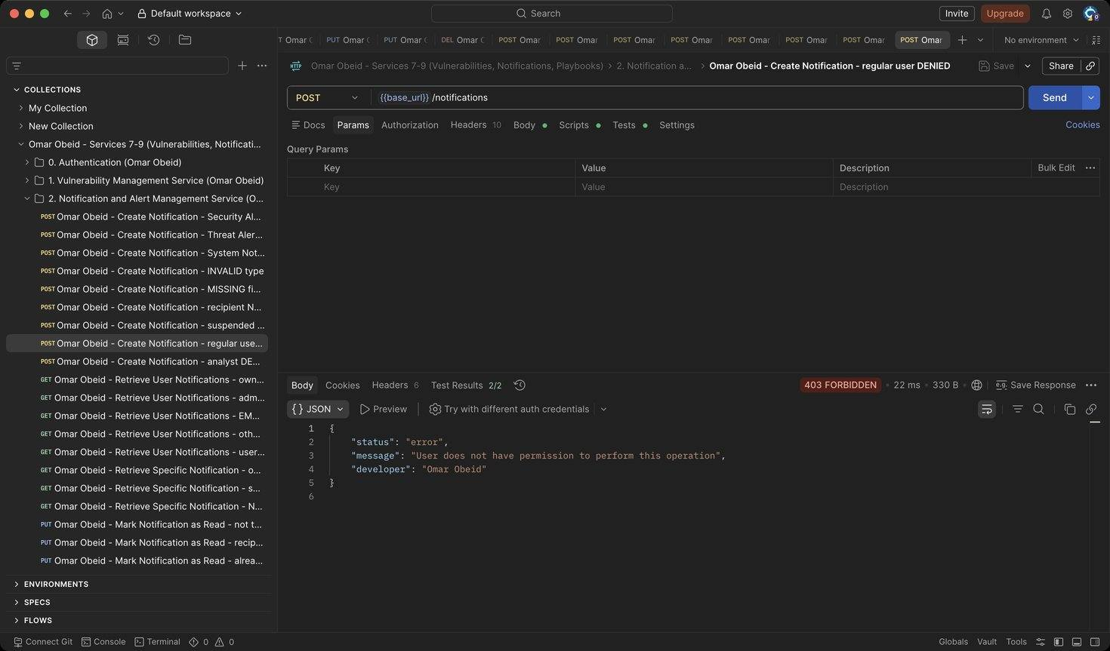
Figure 44: Omar Obeid – Create Notification – regular user DENIED: Only the Security Administrator creates notifications (HTTP 403)
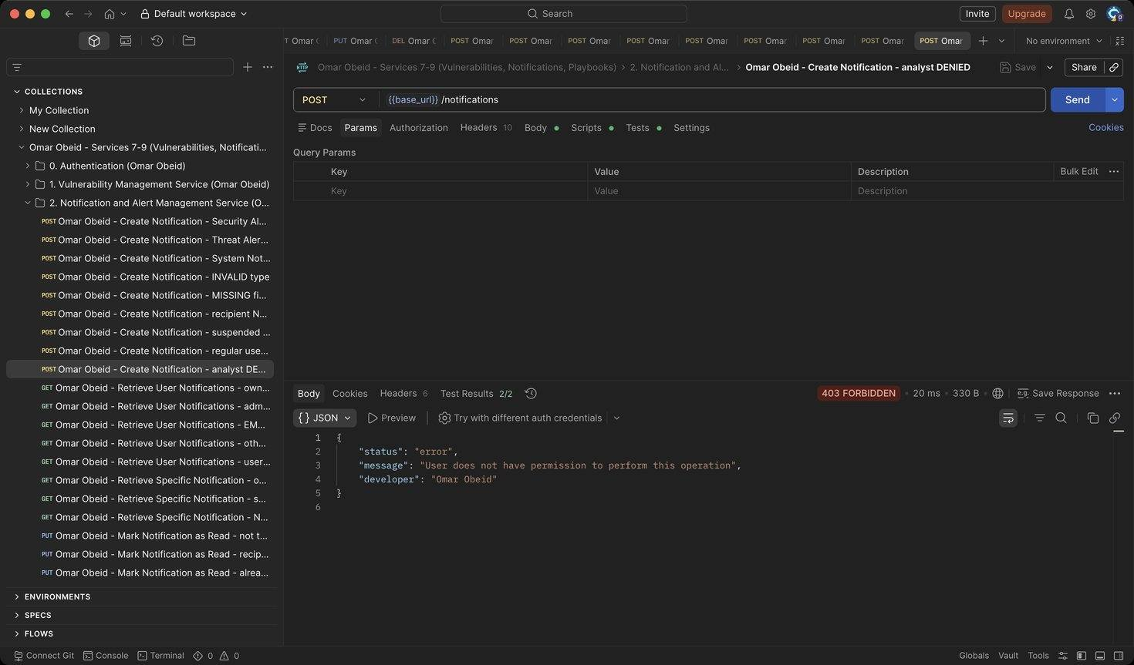
Figure 45: Omar Obeid – Create Notification – analyst DENIED: Only the Security Administrator creates notifications (HTTP 403)
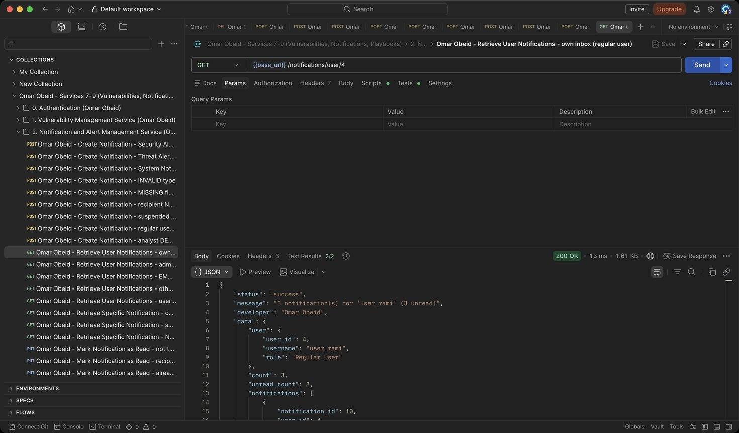
Figure 46: Omar Obeid – Retrieve User Notifications – own inbox (regular user): Newest first, with count and unread_count (HTTP 200)
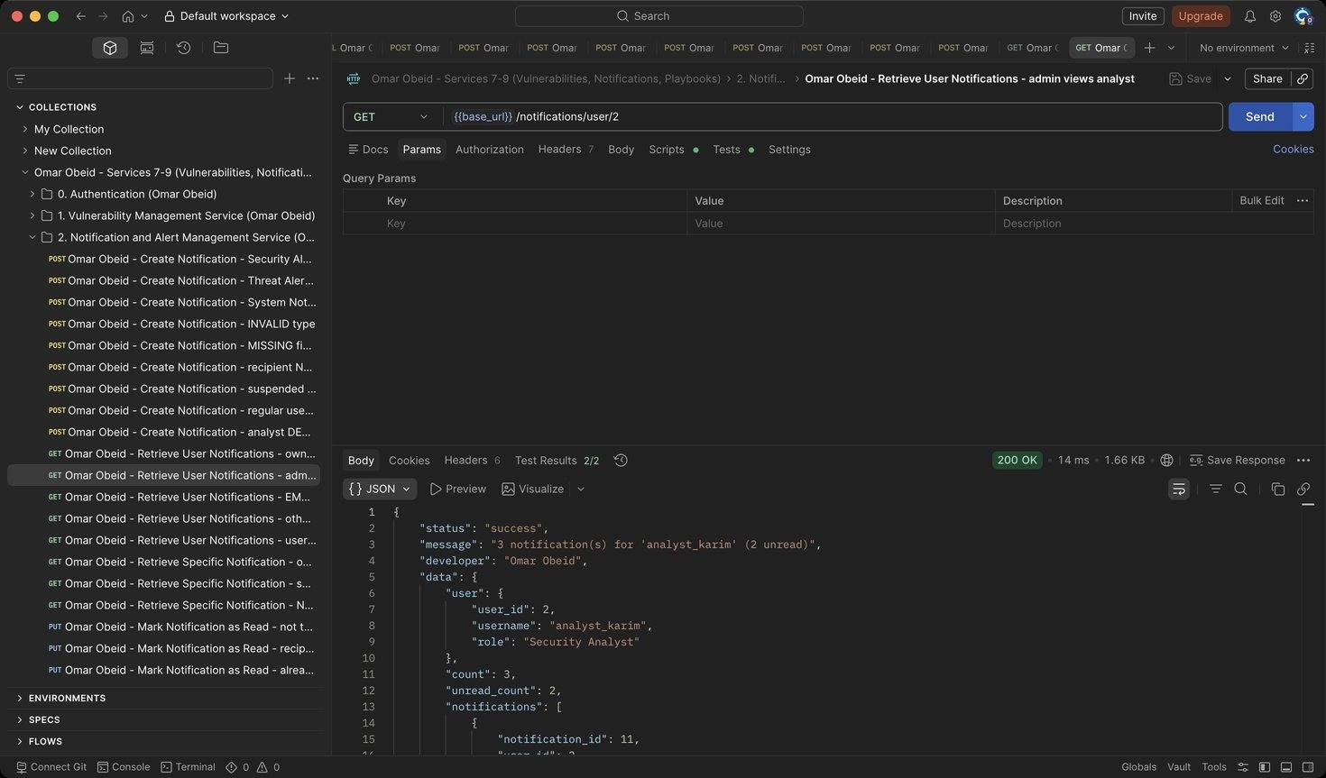
Figure 47: Omar Obeid – Retrieve User Notifications – admin views analyst: Administrators and Auditors can view any inbox (HTTP 200)
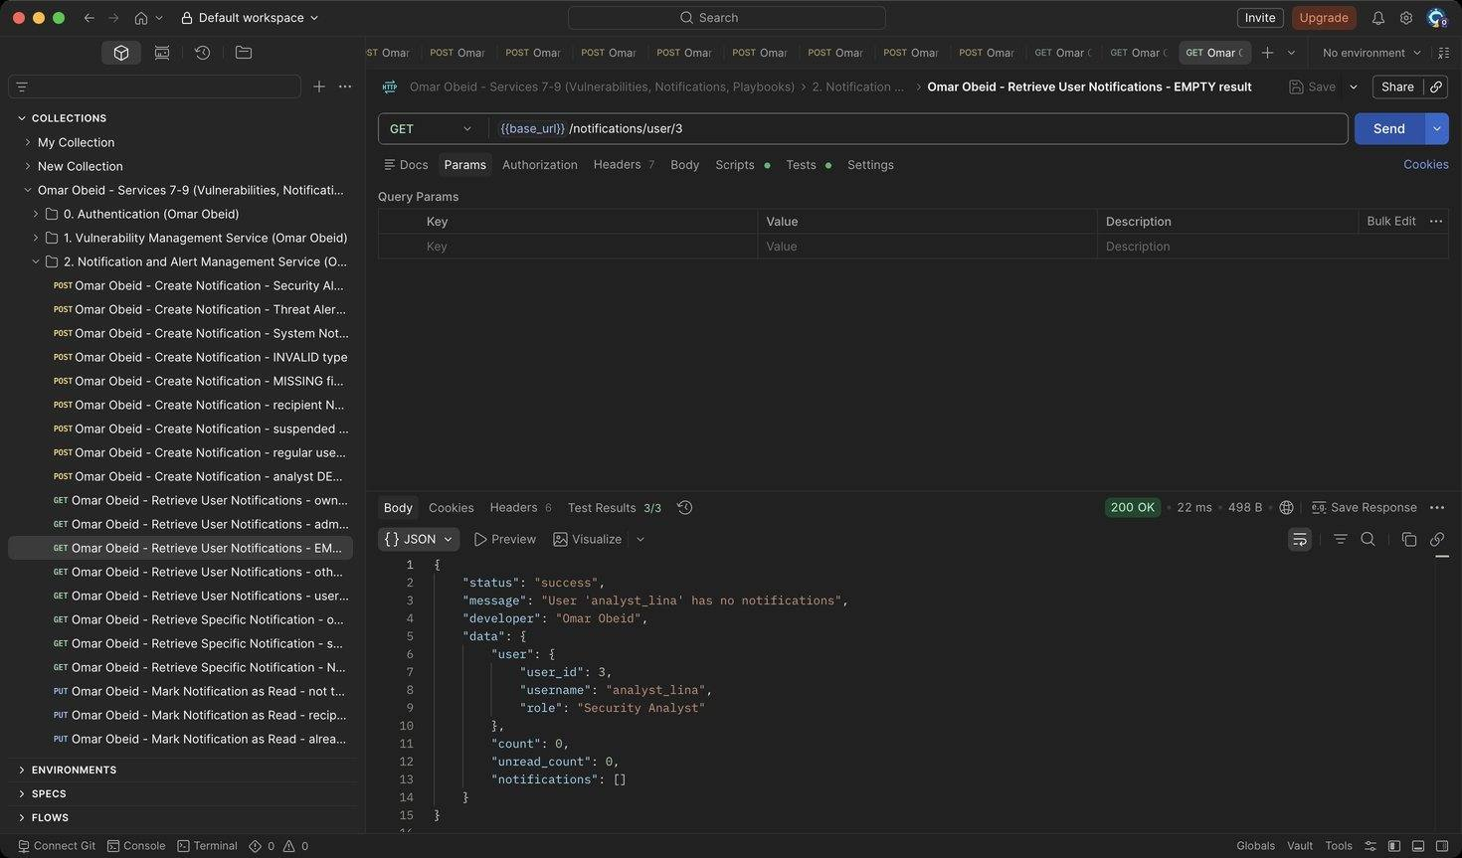
Figure 48: Omar Obeid – Retrieve User Notifications – EMPTY result: analyst_lina has no notifications: count 0 and an empty list (HTTP 200)
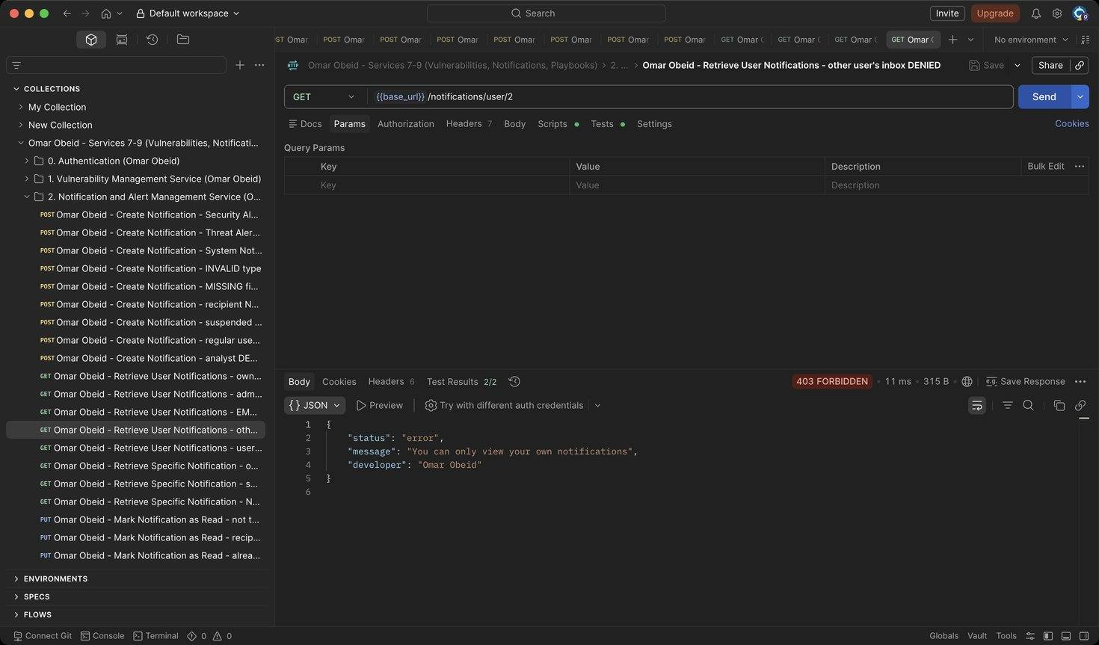
Figure 49: Omar Obeid – Retrieve User Notifications – other user's inbox DENIED: Users can only see their own notifications (HTTP 403)
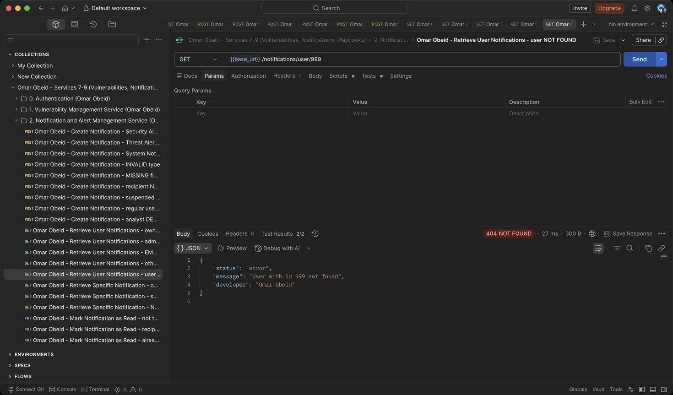
Figure 50: Omar Obeid – Retrieve User Notifications – user NOT FOUND: Unknown user (HTTP 404)
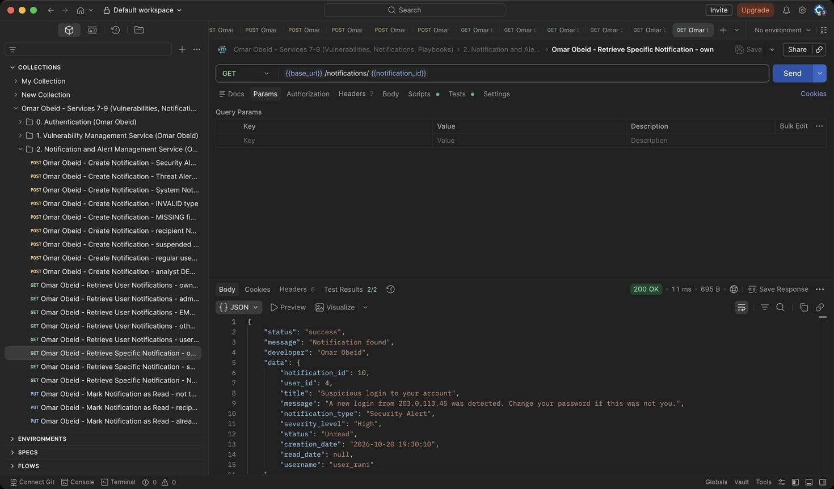
Figure 51: Omar Obeid – Retrieve Specific Notification – own: The recipient can open it (HTTP 200)
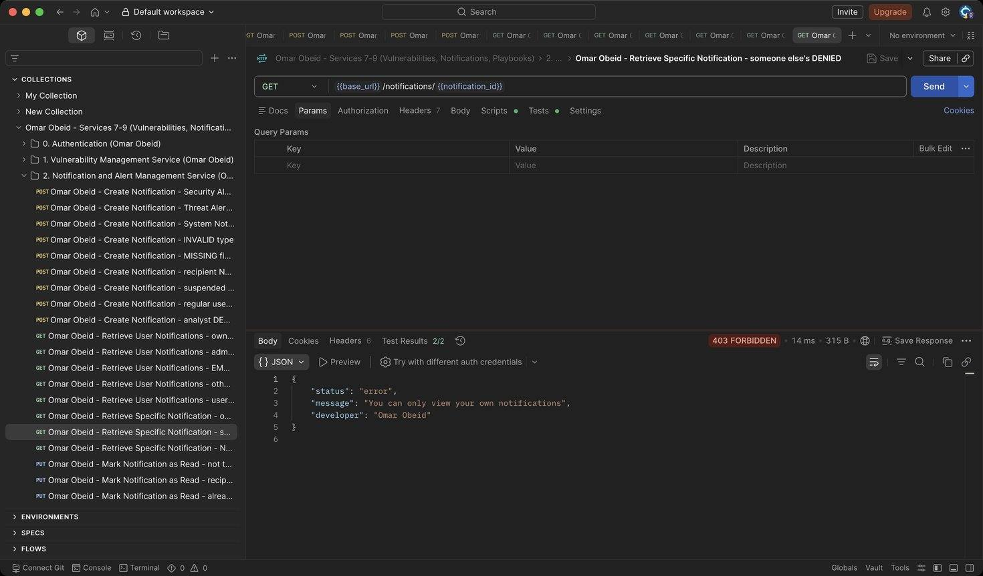
Figure 52: Omar Obeid – Retrieve Specific Notification – someone else's DENIED: Not the recipient (HTTP 403)
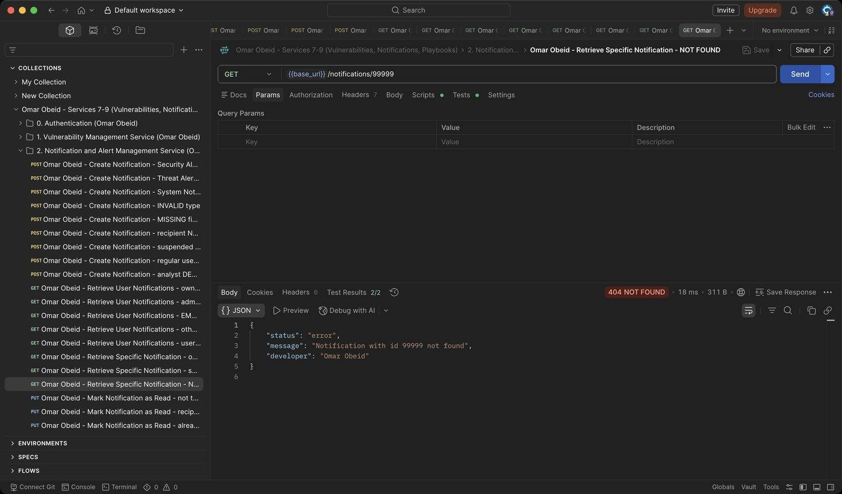
Figure 53: Omar Obeid – Retrieve Specific Notification – NOT FOUND: Unknown id (HTTP 404)
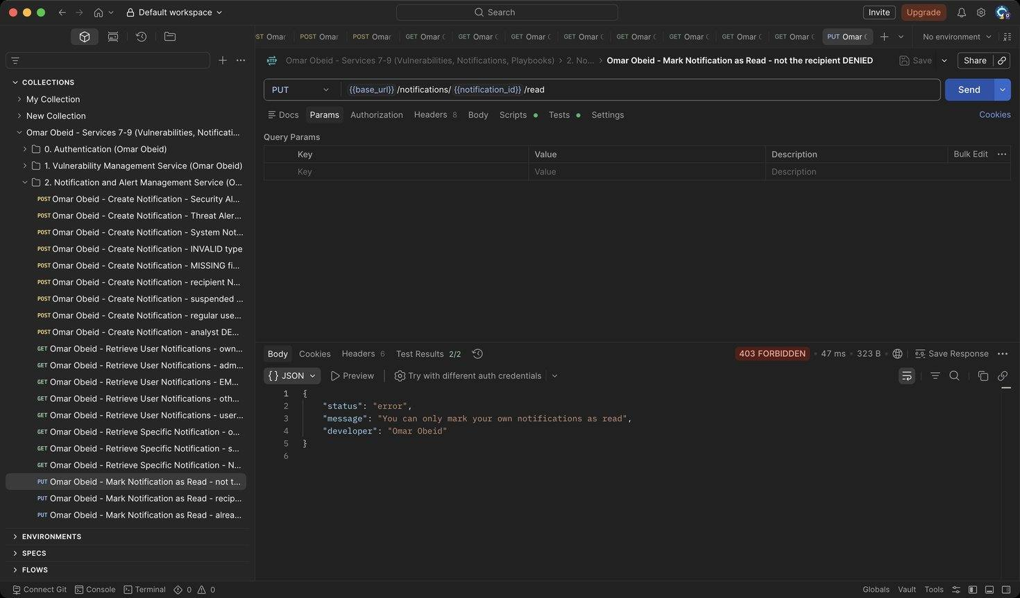
Figure 54: Omar Obeid – Mark Notification as Read – not the recipient DENIED: Only the recipient (or an administrator) can mark it read (HTTP 403)
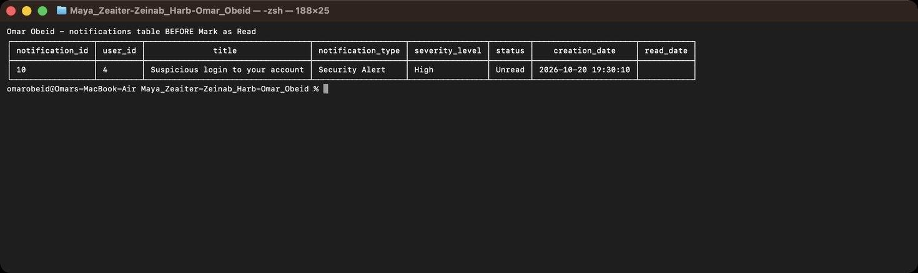
Figure 55: Omar Obeid – Mark Notification as Read – notifications row 10 in the database BEFORE the update (status Unread, read_date empty)
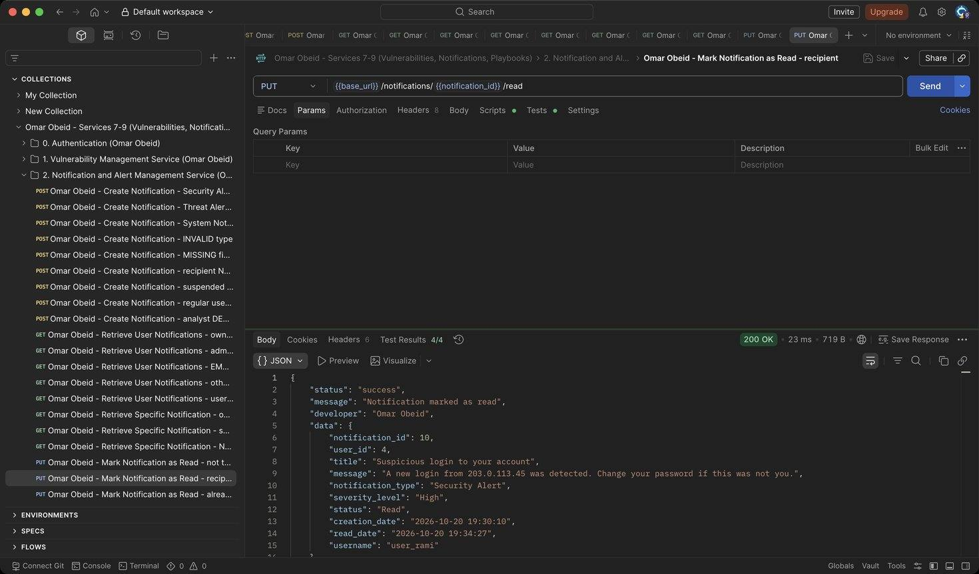
Figure 56: Omar Obeid – Mark Notification as Read – recipient: Status becomes Read and read_date is set (HTTP 200)
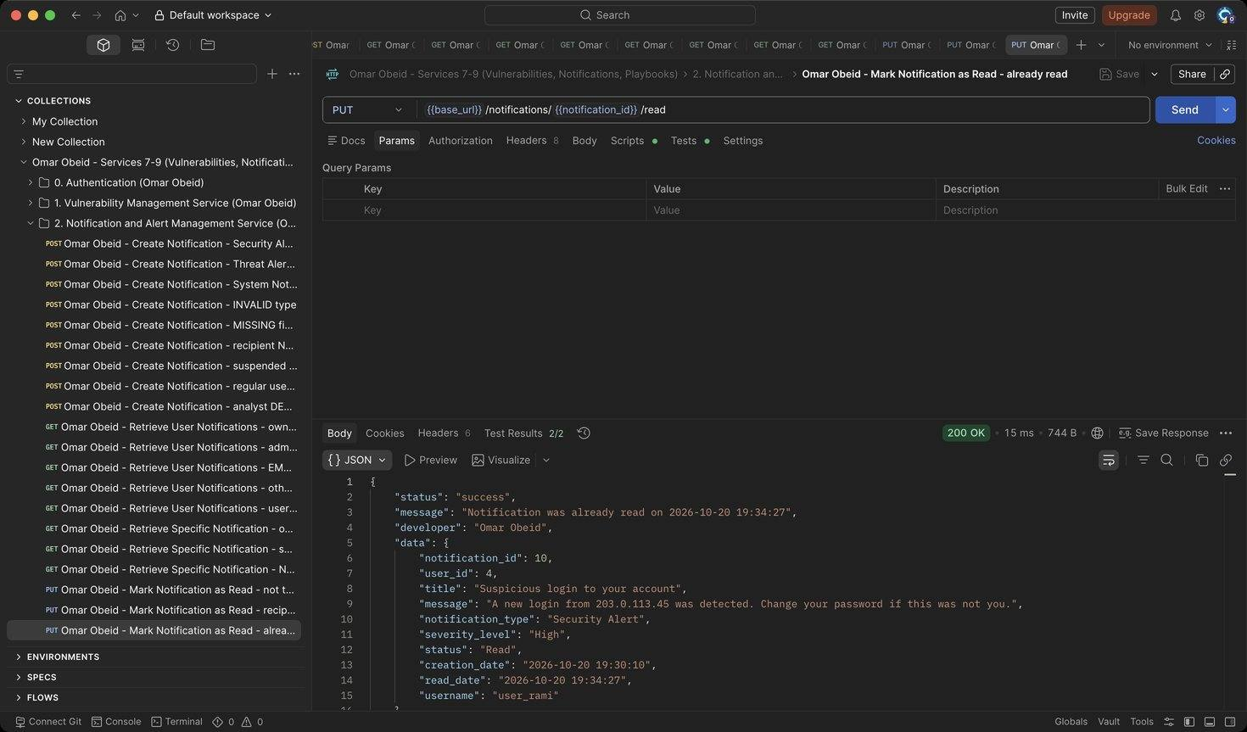
Figure 57: Omar Obeid – Mark Notification as Read – already read: Idempotent: the original read_date is kept (HTTP 200)
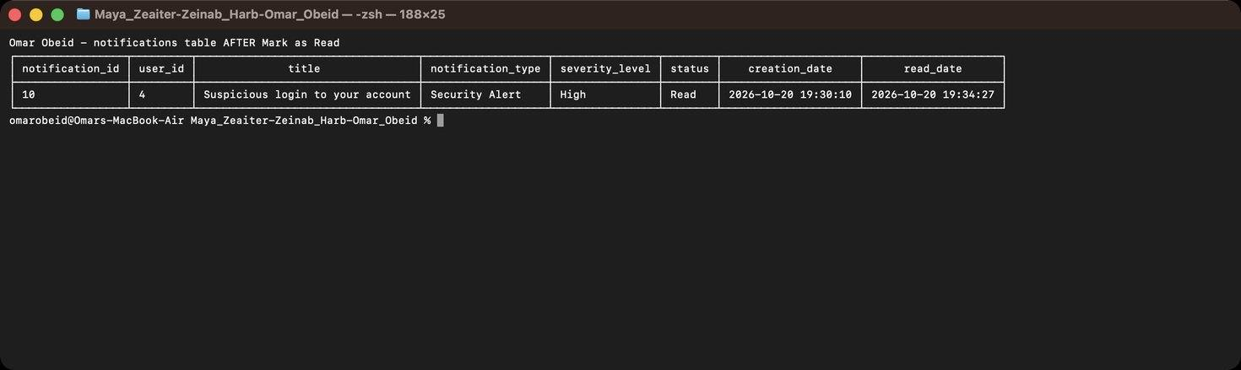
Figure 58: Omar Obeid – Mark Notification as Read – the same row AFTER the update (status Read, read_date set)
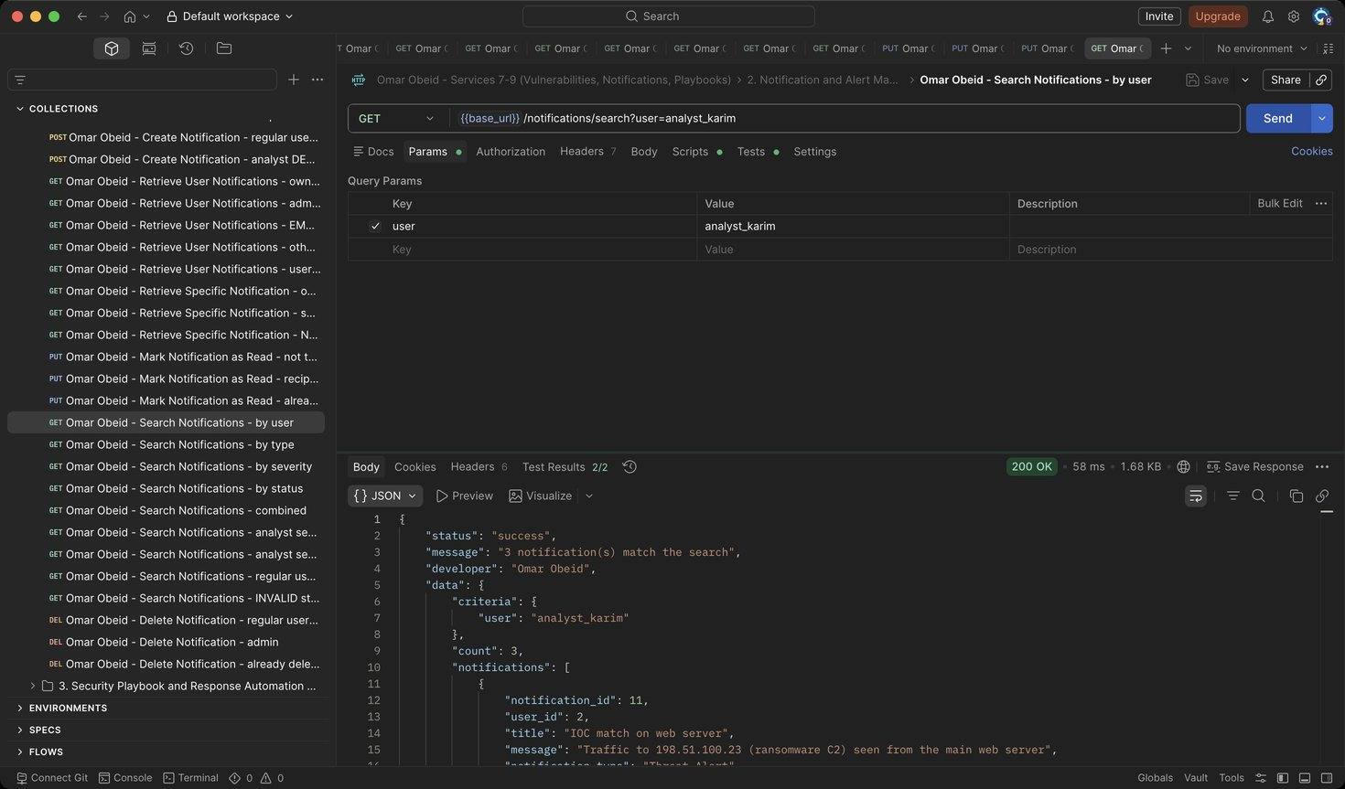
Figure 59: Omar Obeid – Search Notifications – by user: User id or username (HTTP 200)
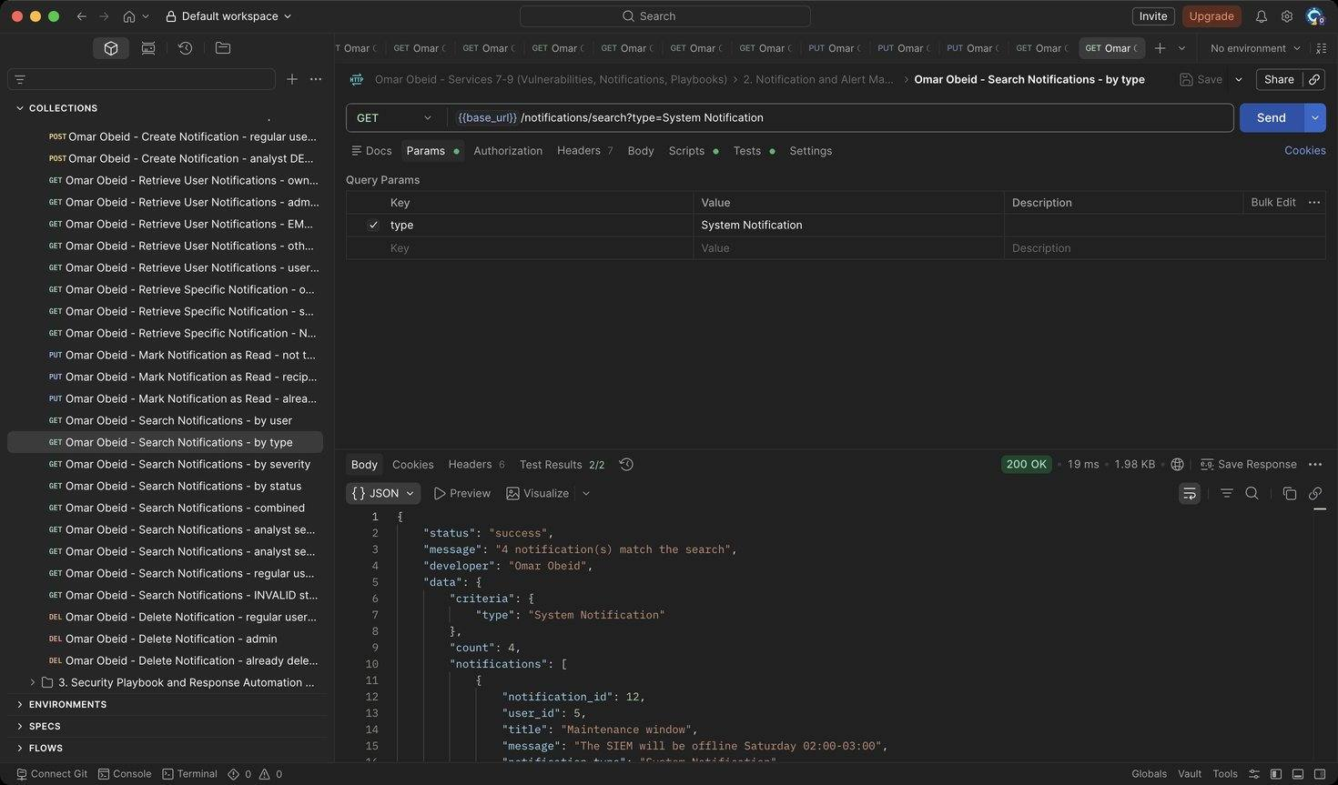
Figure 60: Omar Obeid – Search Notifications – by type: Exact type (HTTP 200)
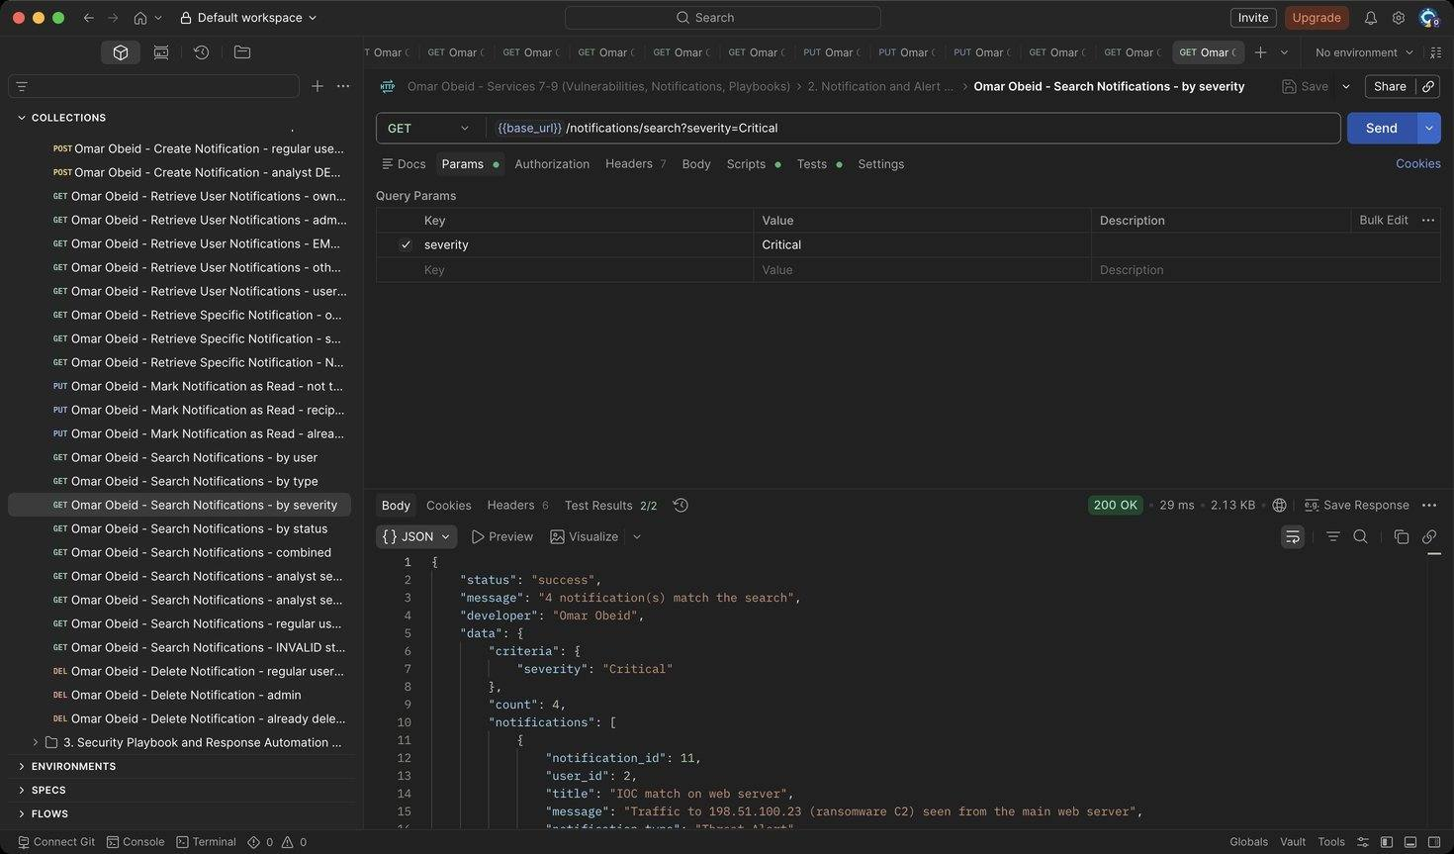
Figure 61: Omar Obeid – Search Notifications – by severity: Exact severity (HTTP 200)
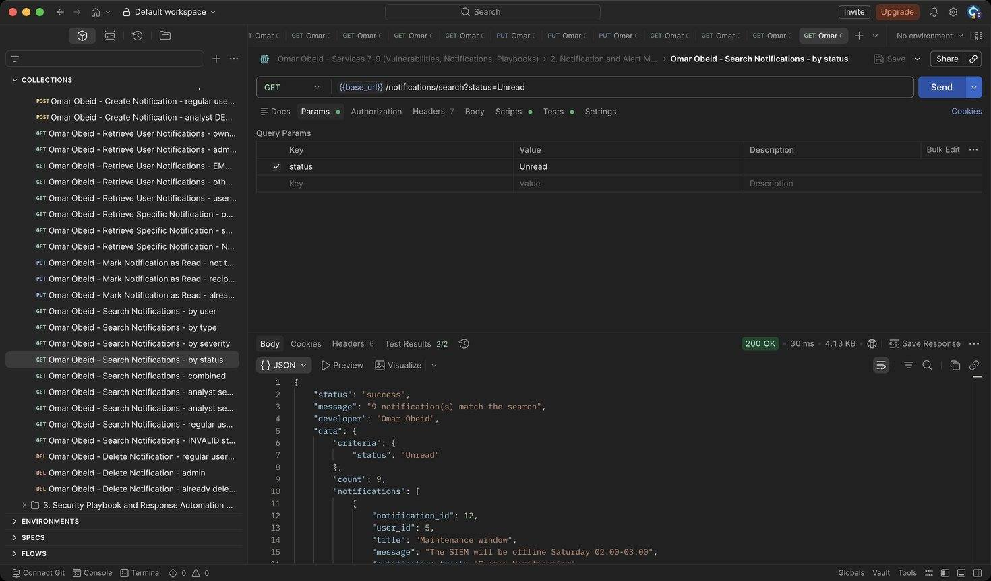
Figure 62: Omar Obeid – Search Notifications – by status: Unread or Read (HTTP 200)
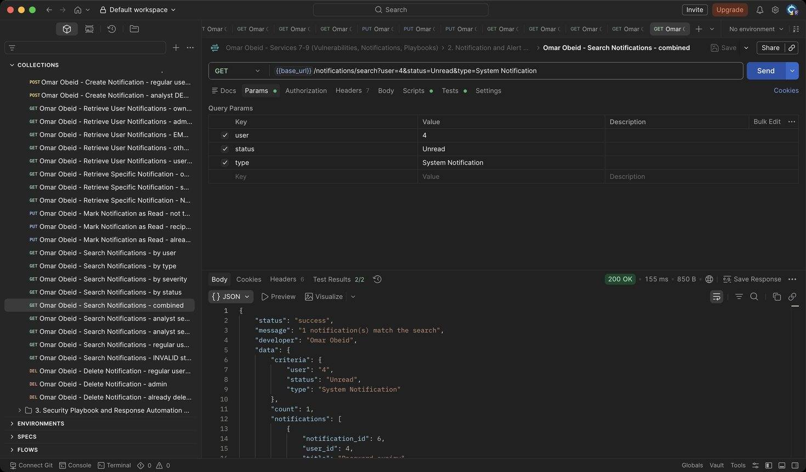
Figure 63: Omar Obeid – Search Notifications – combined: Criteria combined with AND (HTTP 200)
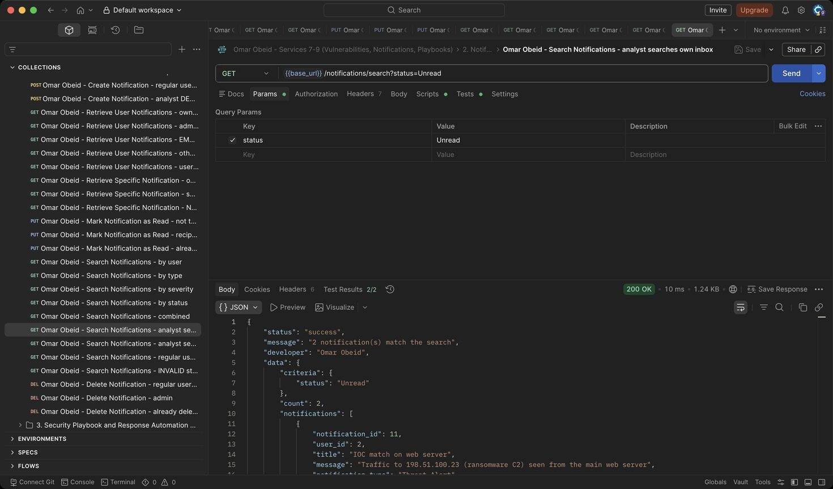
Figure 64: Omar Obeid – Search Notifications – analyst searches own inbox: Results are limited to the analyst's own notifications (HTTP 200)
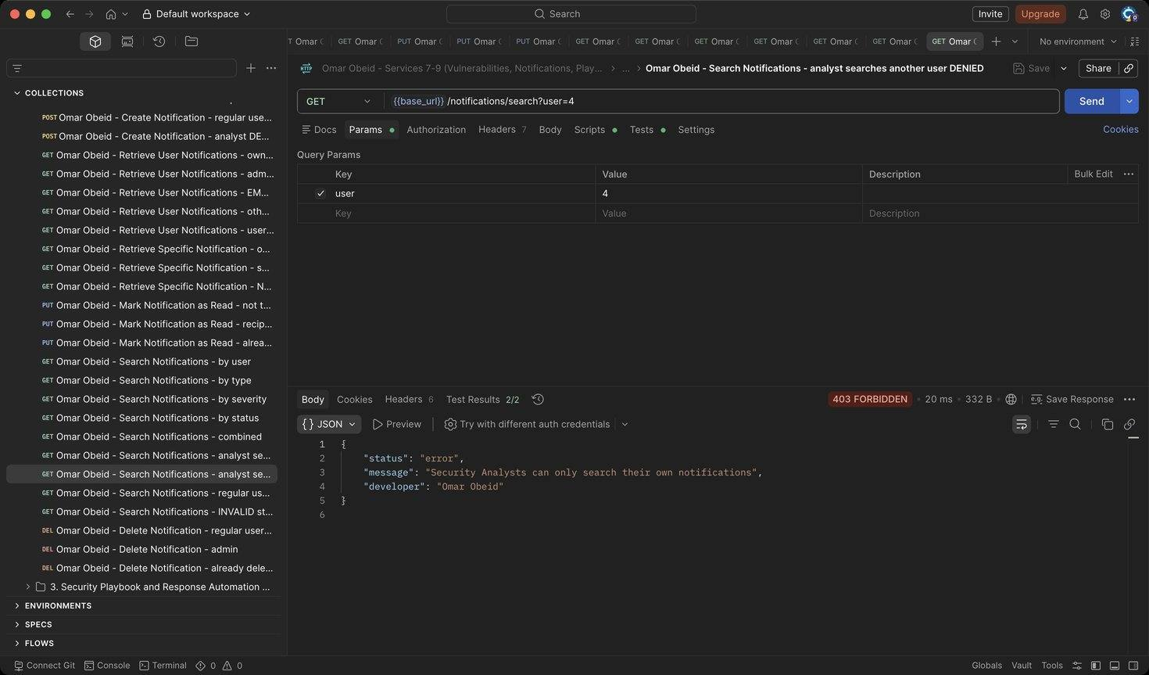
Figure 65: Omar Obeid – Search Notifications – analyst searches another user DENIED: Analysts cannot search other users' notifications (HTTP 403)
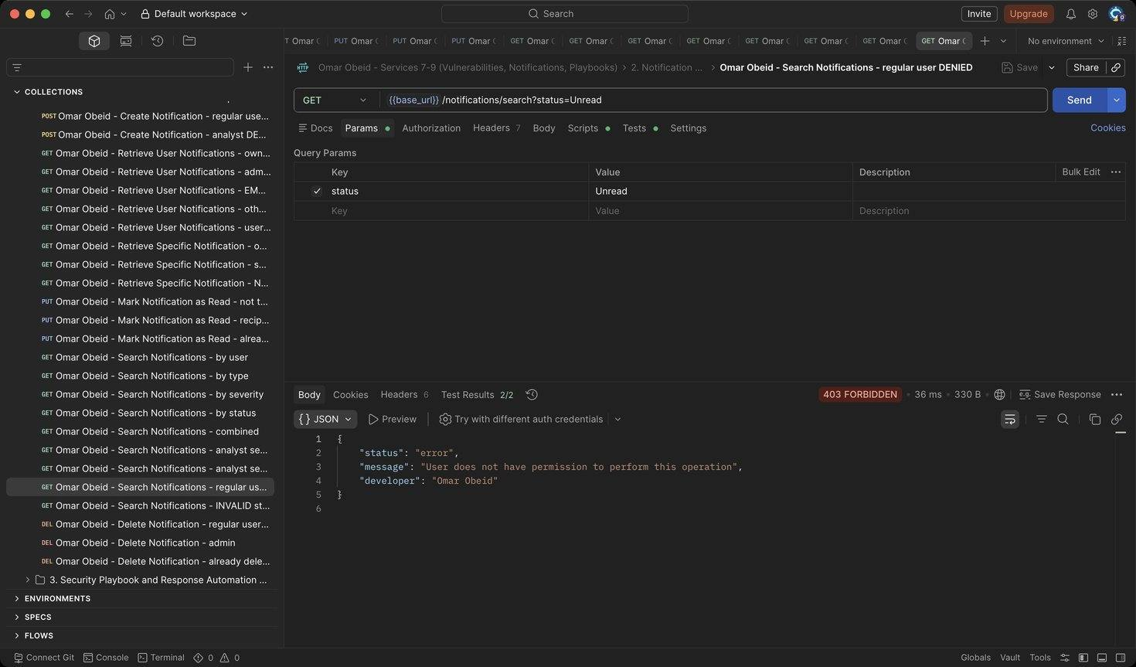
Figure 66: Omar Obeid – Search Notifications – regular user DENIED: Regular users have no search access (HTTP 403)
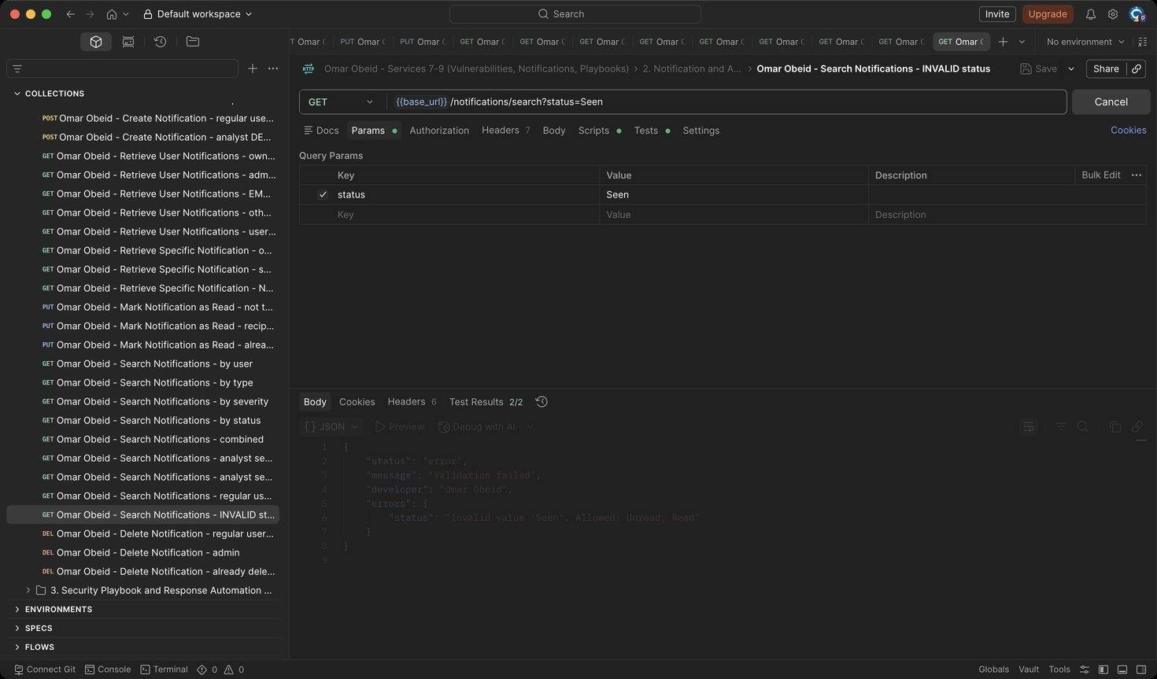
Figure 67: Omar Obeid – Search Notifications – INVALID status: Status must be Unread or Read (HTTP 400)
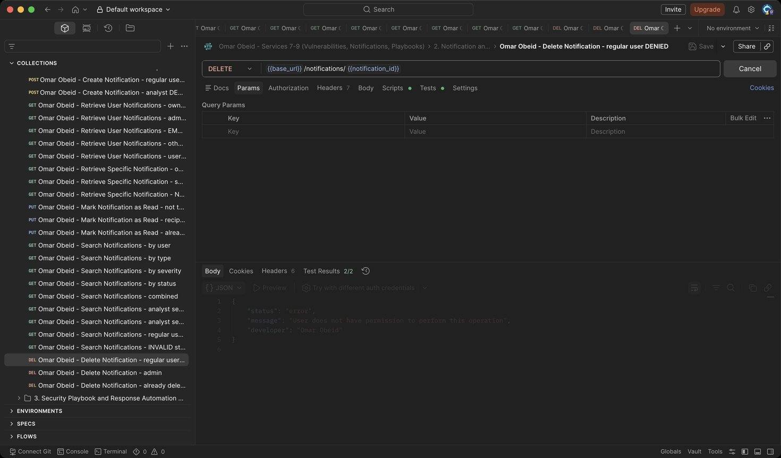
Figure 68: Omar Obeid – Delete Notification – regular user DENIED: Only the Security Administrator deletes (HTTP 403)
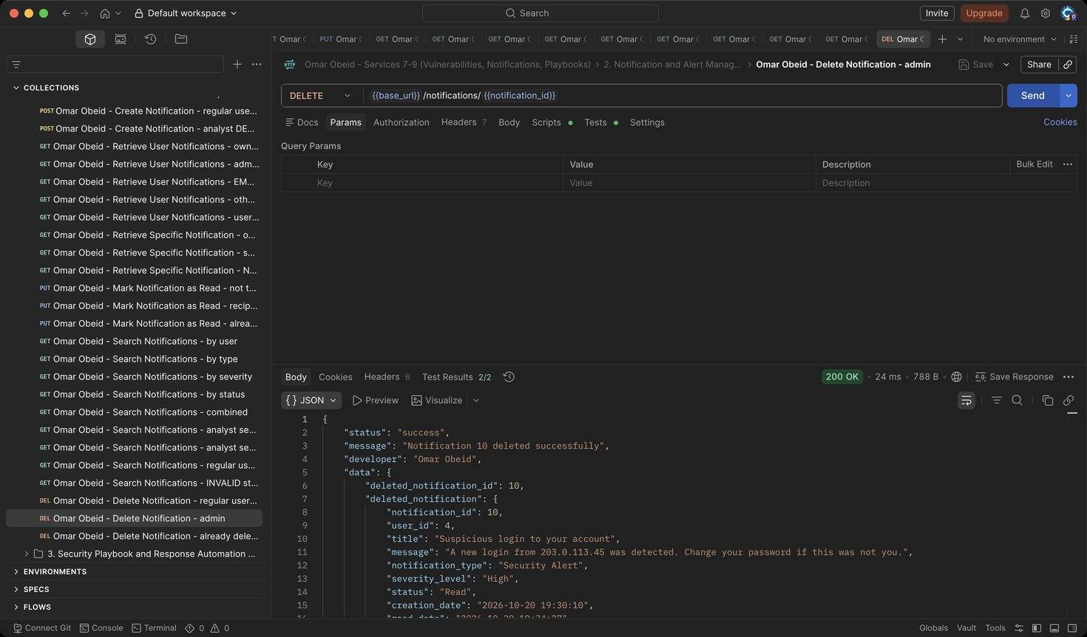
Figure 69: Omar Obeid – Delete Notification – admin: Writes an audit log (HTTP 200)
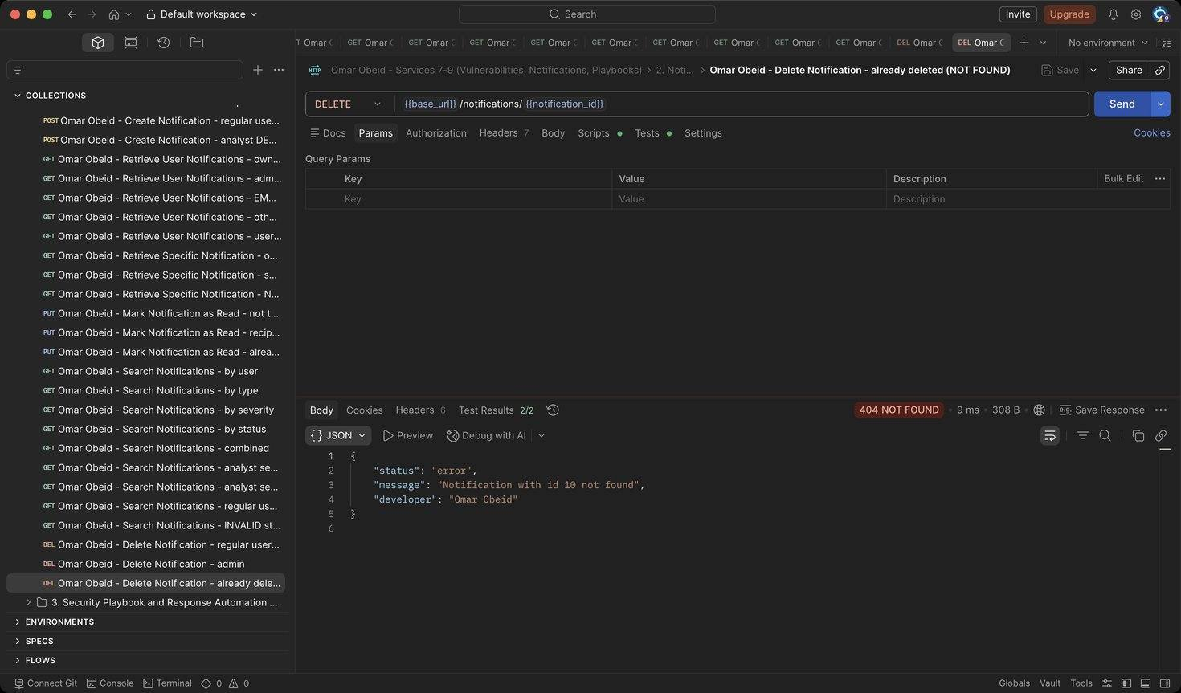
Figure 70: Omar Obeid – Delete Notification – already deleted (NOT FOUND): The record is gone (HTTP 404)

Security Playbook and Response Automation Service (Service 9) (Omar Obeid)
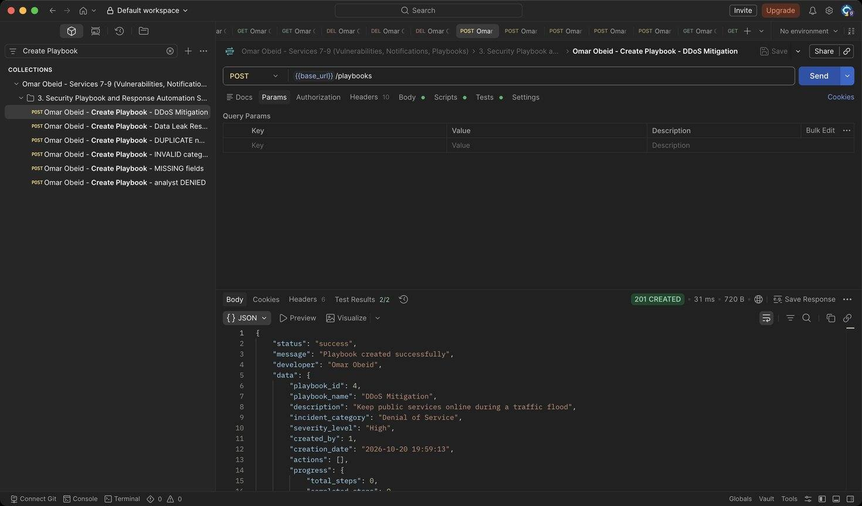
Figure 71: Omar Obeid – Create Playbook – DDoS Mitigation: created_by is the logged-in administrator. (HTTP 201)
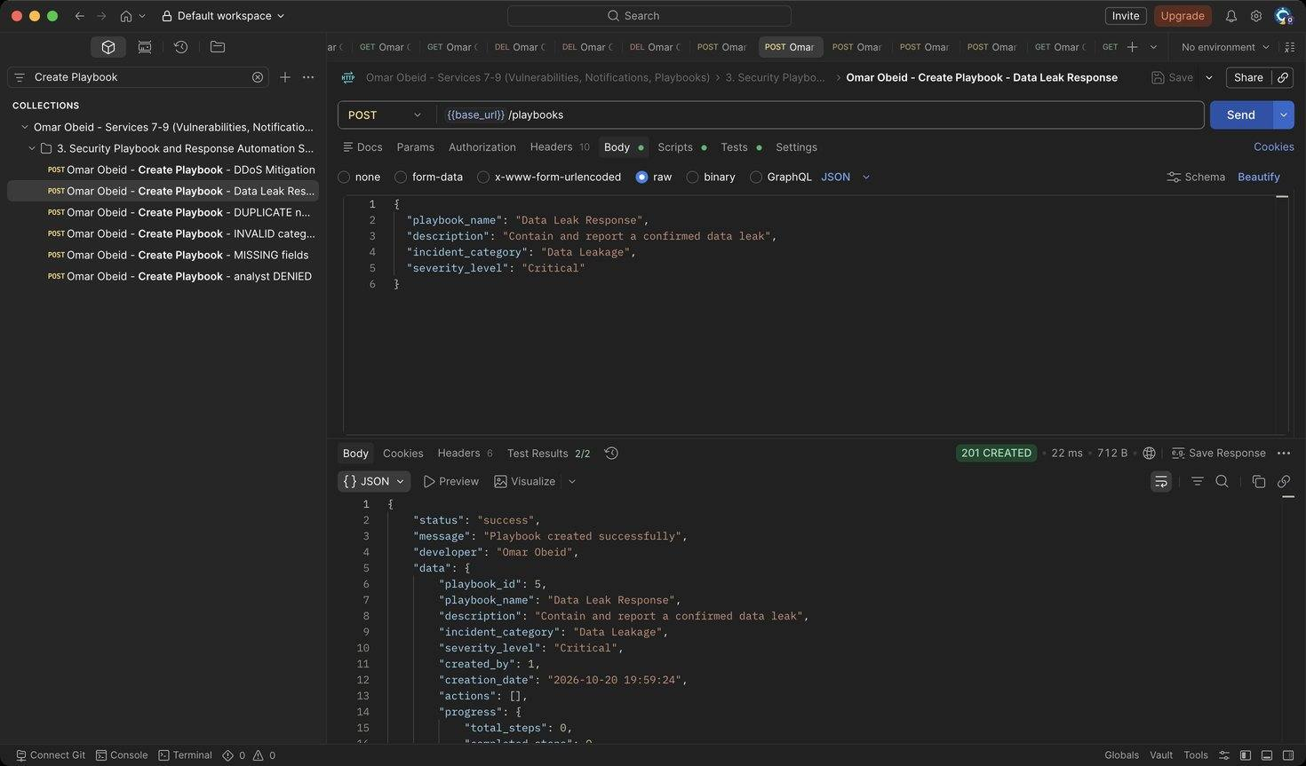
Figure 72: Omar Obeid – Create Playbook – Data Leak Response: Second playbook (deleted at the end). (HTTP 201)
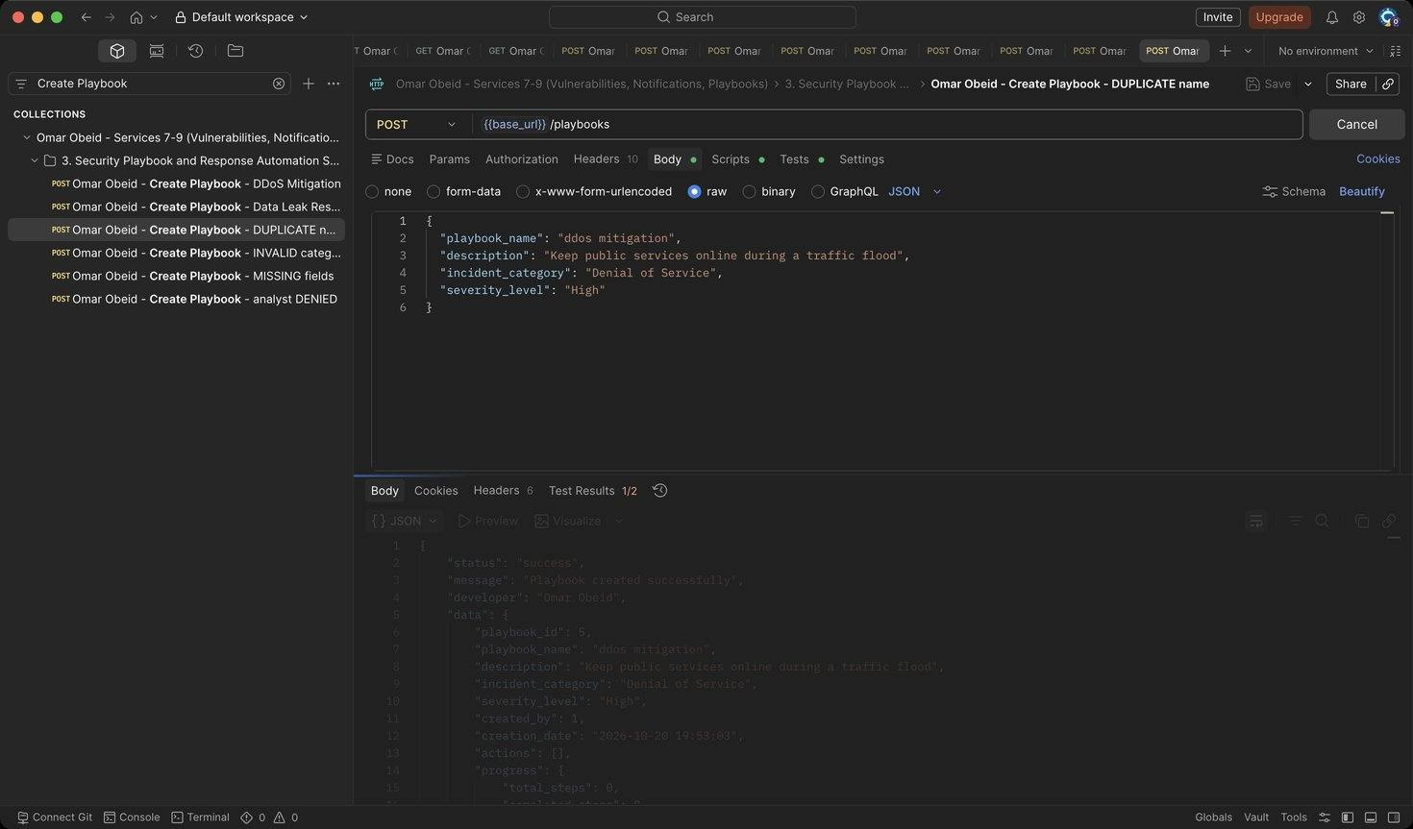
Figure 73: Omar Obeid – Create Playbook – DUPLICATE name: Names are unique (case-insensitive) (HTTP 409)
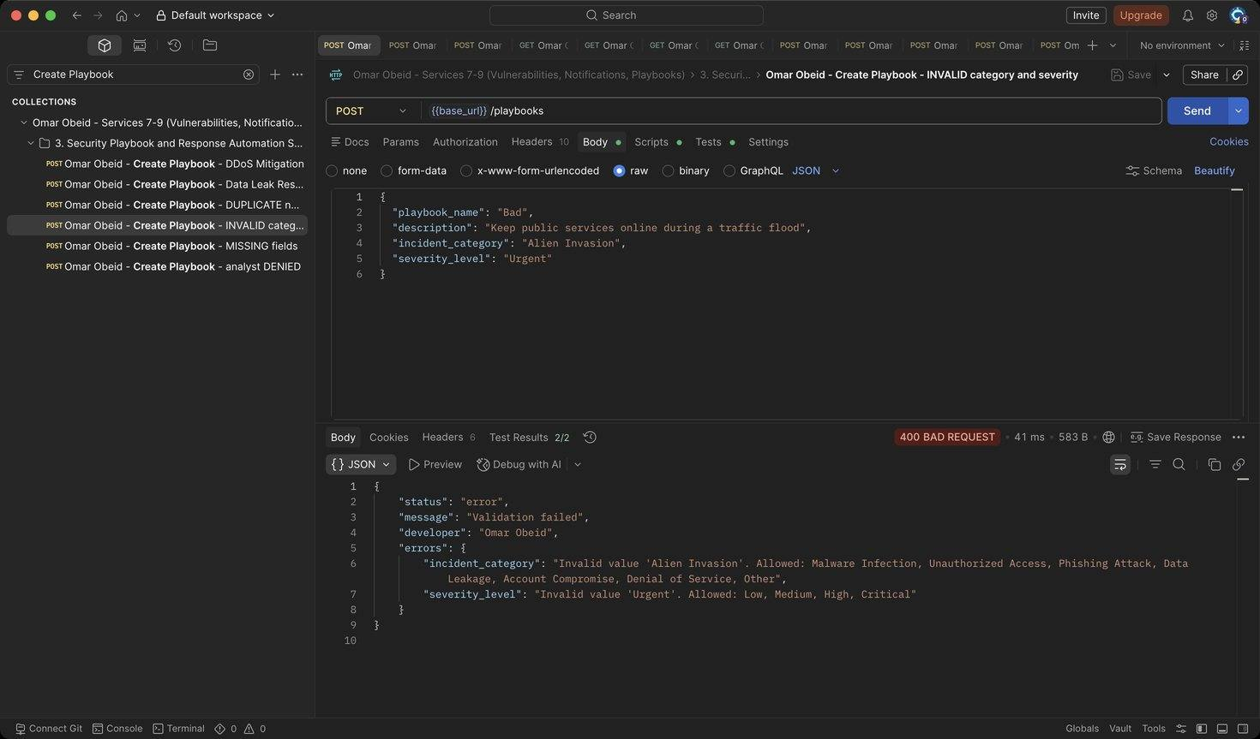
Figure 74: Omar Obeid – Create Playbook – INVALID category and severity: Category must be an incident category; severity Low-Critical (HTTP 400)
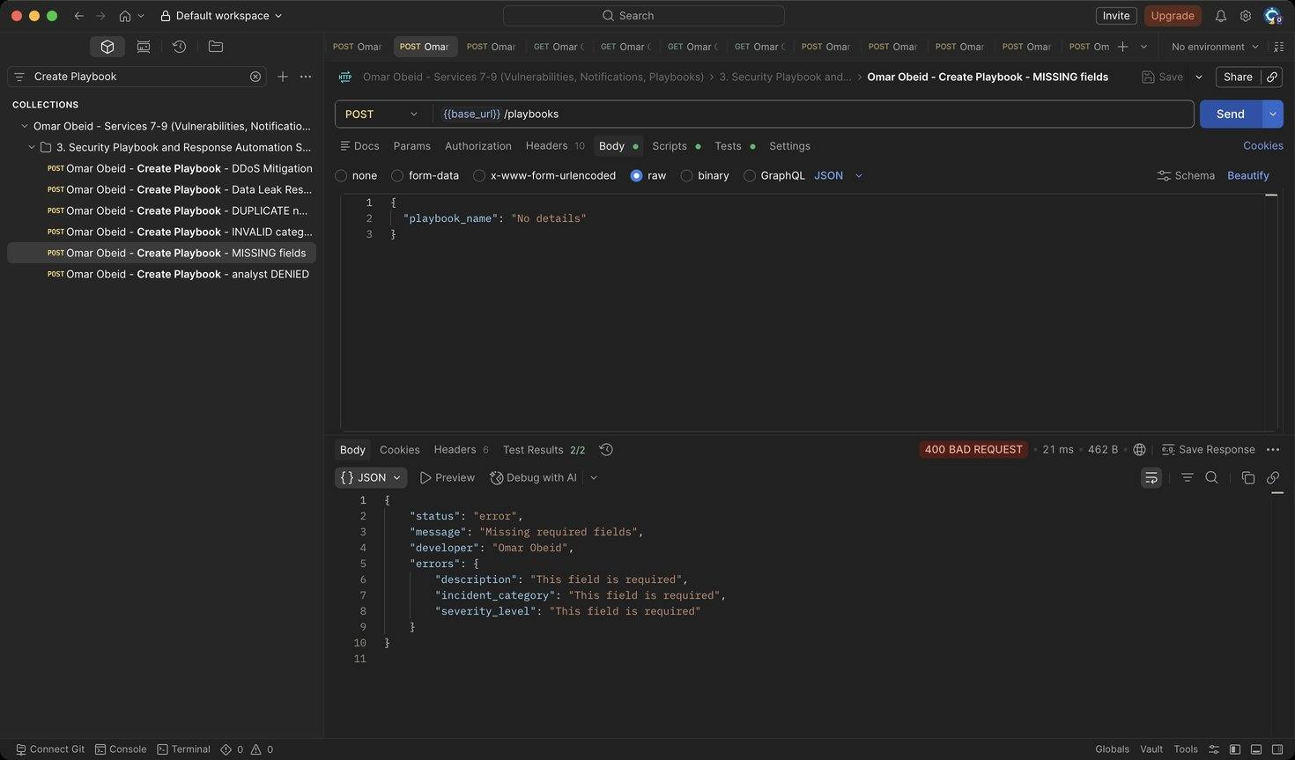
Figure 75: Omar Obeid – Create Playbook – MISSING fields: All fields required (HTTP 400)
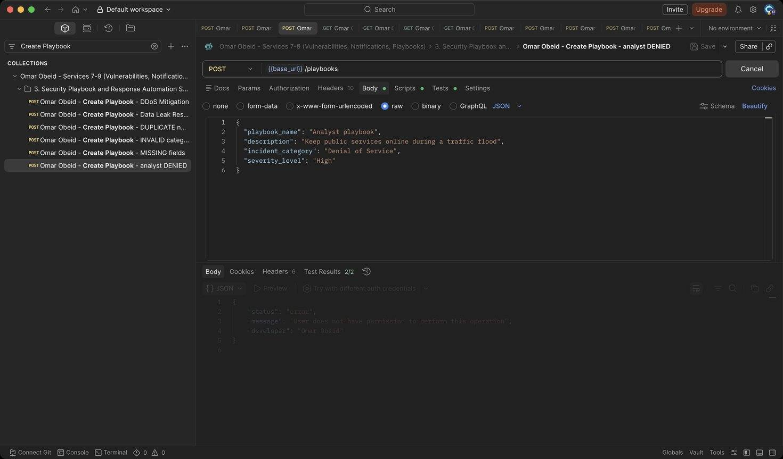
Figure 76: Omar Obeid – Create Playbook – analyst DENIED: Only administrators create (HTTP 403)
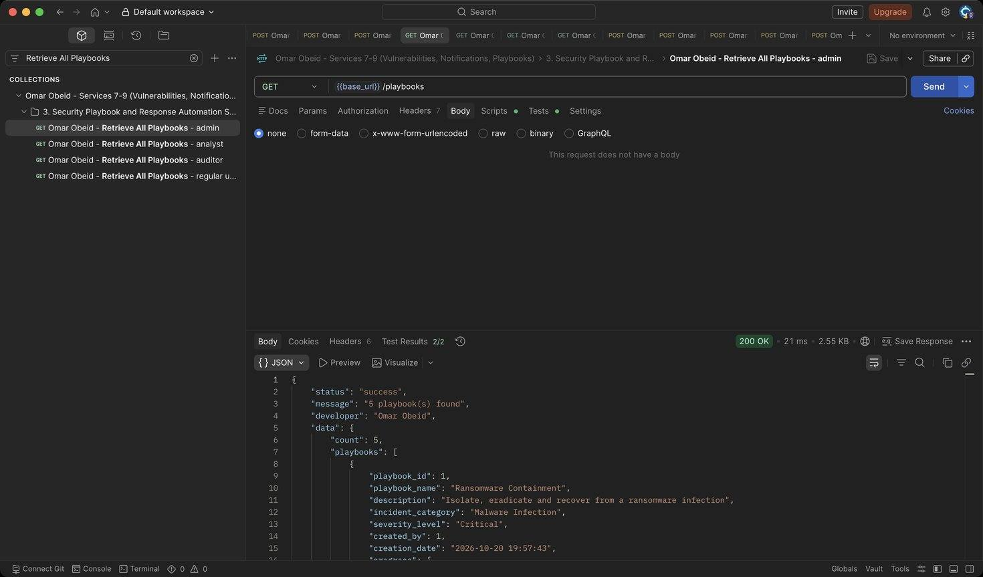
Figure 77: Omar Obeid – Retrieve All Playbooks – admin: Each playbook with its progress (HTTP 200)
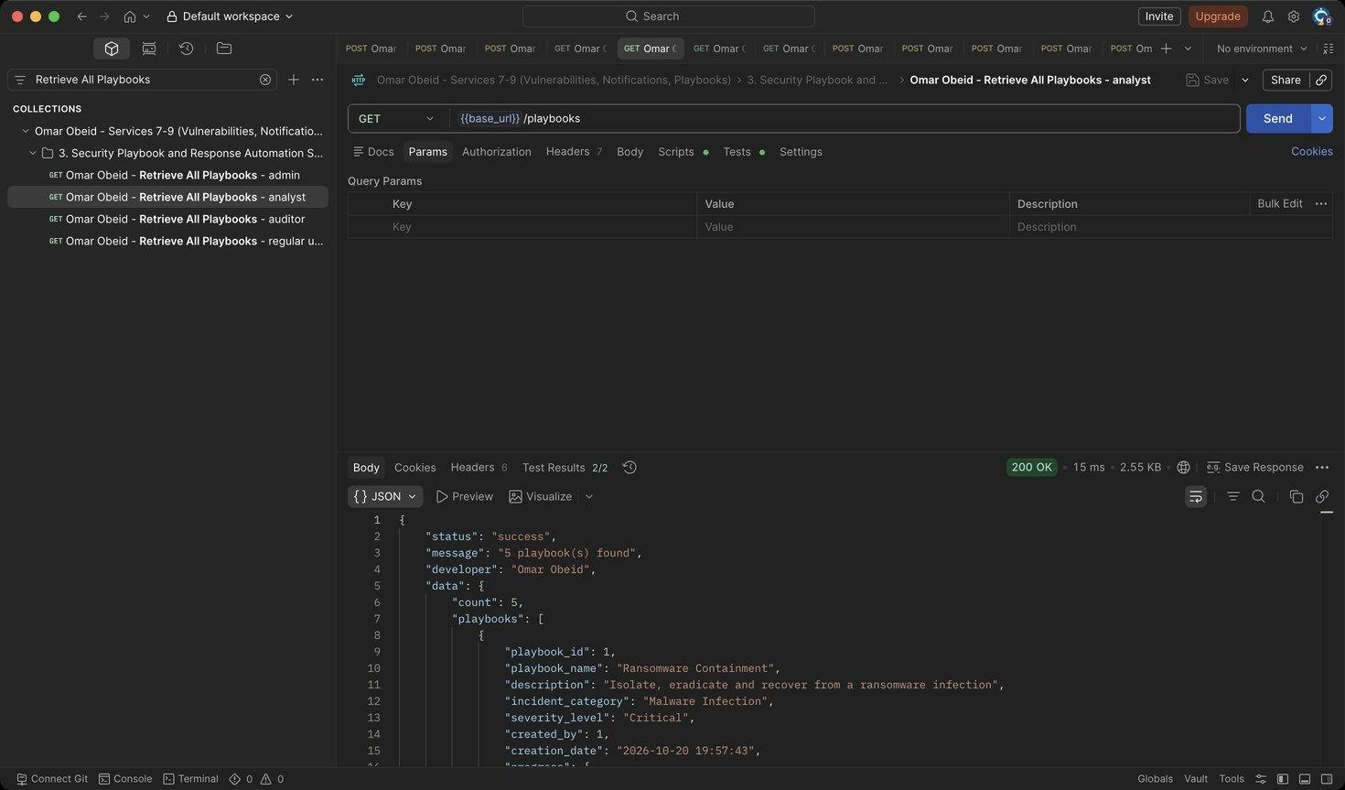
Figure 78: Omar Obeid – Retrieve All Playbooks – analyst: Analysts can list (HTTP 200)
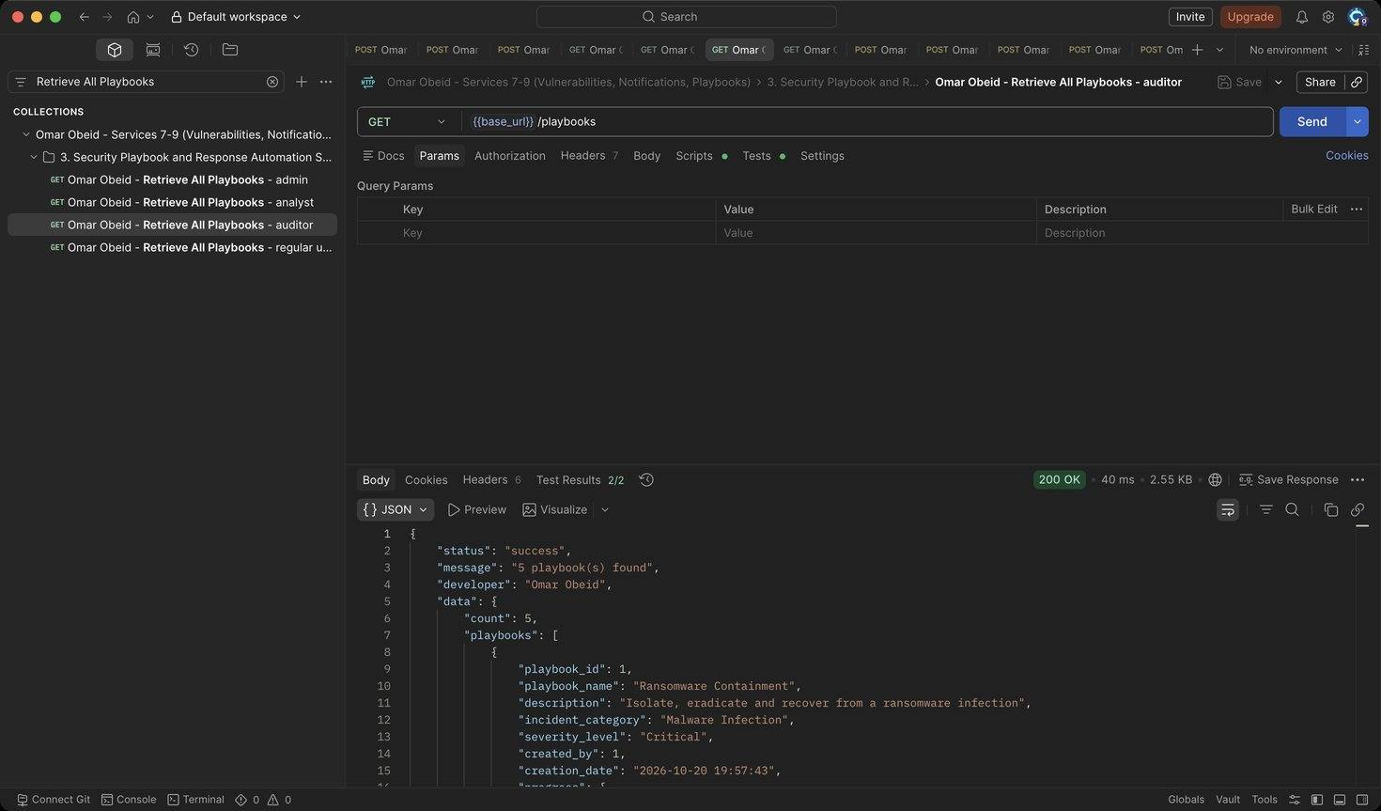
Figure 79: Omar Obeid – Retrieve All Playbooks – auditor: Auditors can list (HTTP 200)
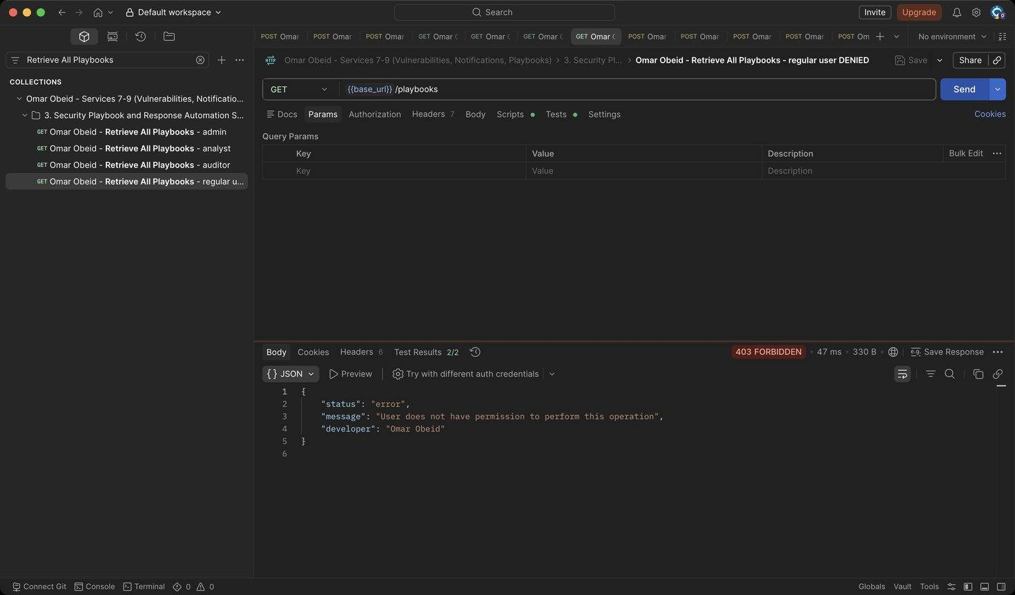
Figure 80: Omar Obeid – Retrieve All Playbooks – regular user DENIED: No access (HTTP 403)
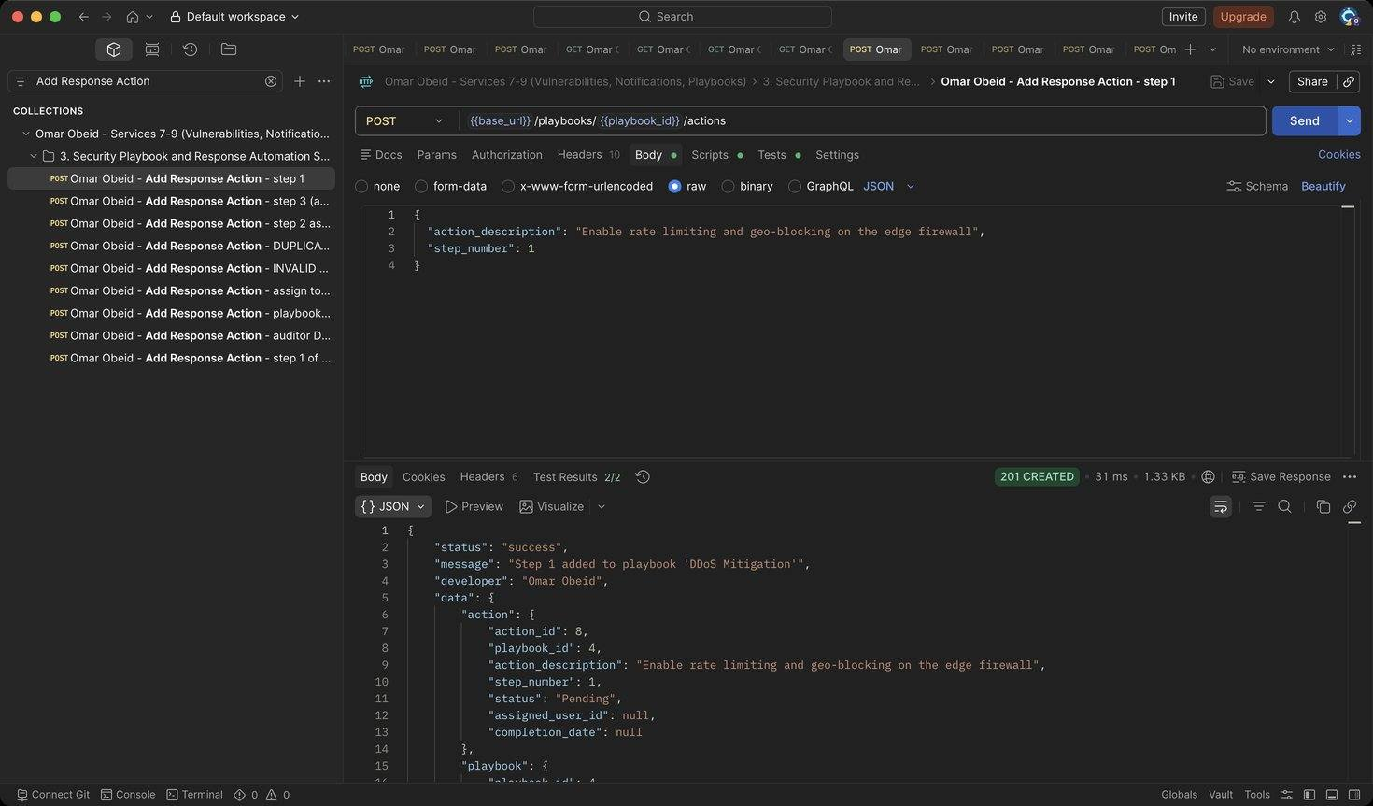
Figure 81: Omar Obeid – Add Response Action – step 1 (HTTP 201)
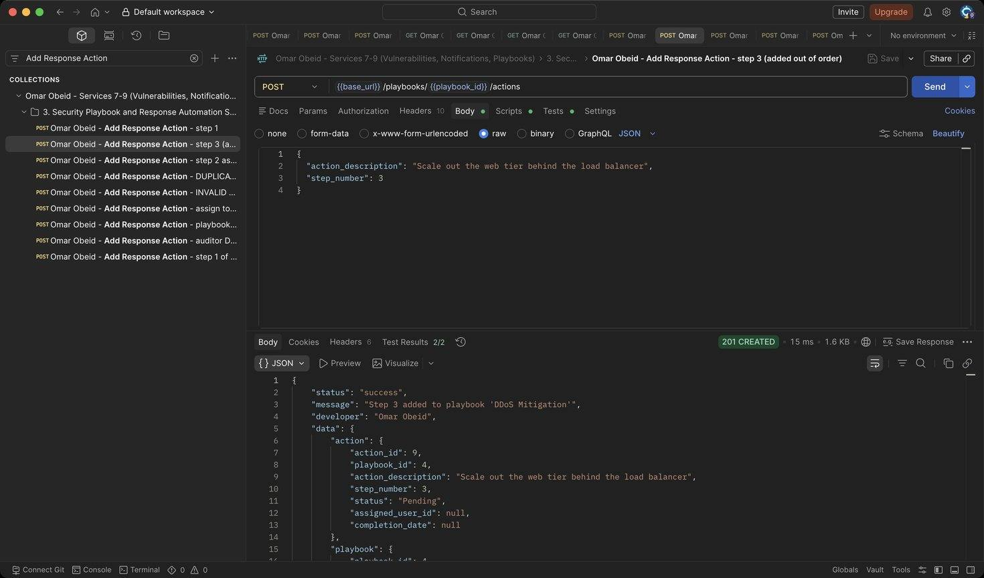
Figure 82: Omar Obeid – Add Response Action – step 3 (added out of order): Steps can be added in any order; they are returned sorted. (HTTP 201)
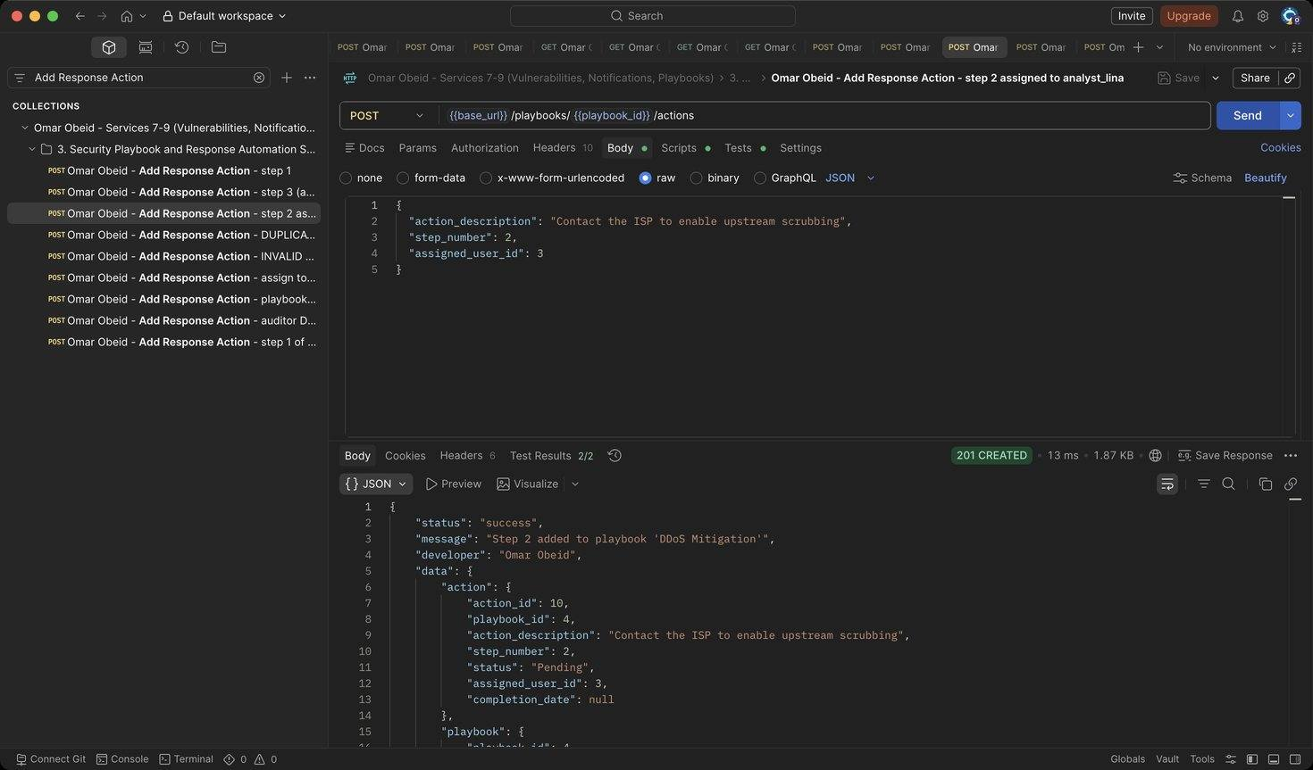
Figure 83: Omar Obeid – Add Response Action – step 2 assigned to analyst_lina: The assignee gets a System Notification. (HTTP 201)
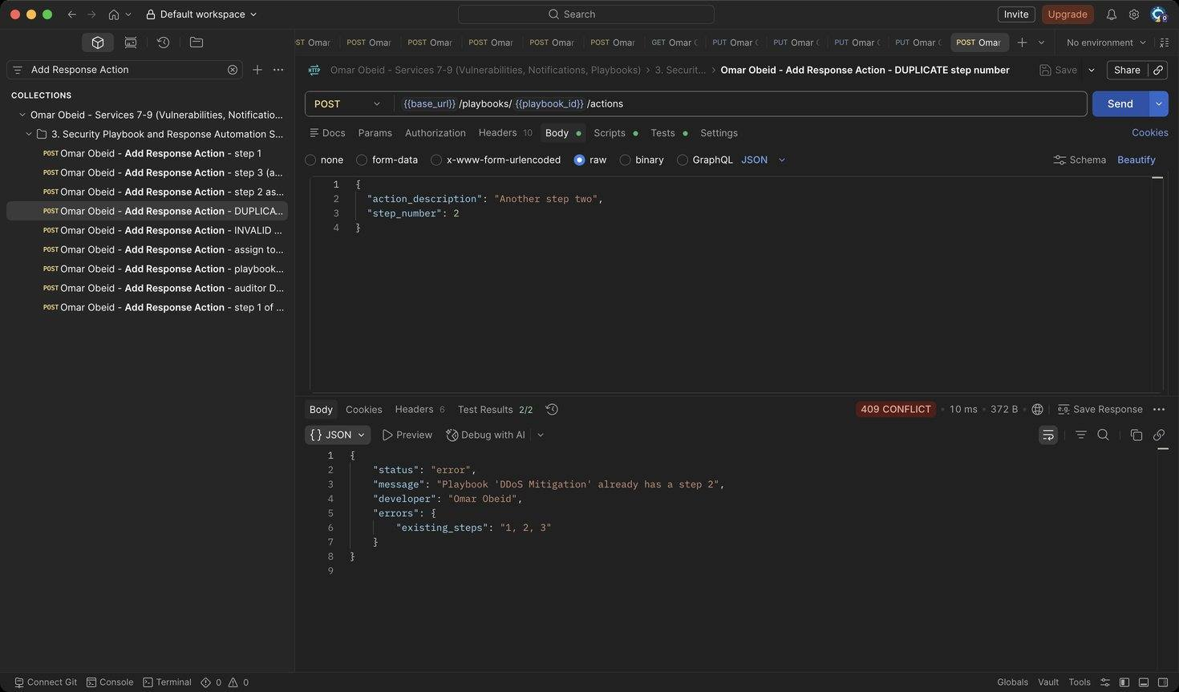
Figure 84: Omar Obeid – Add Response Action – DUPLICATE step number: step_number is unique per playbook (HTTP 409)
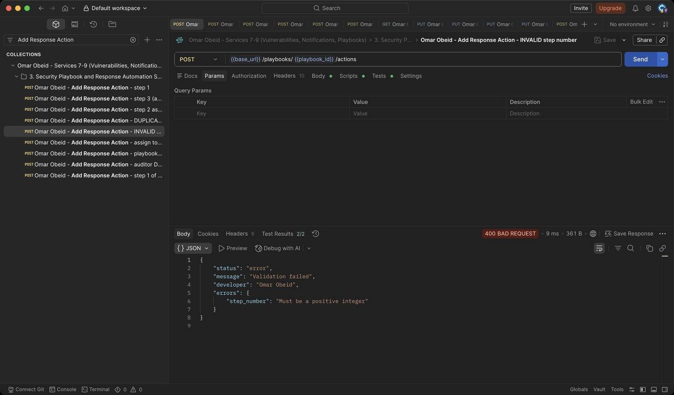
Figure 85: Omar Obeid – Add Response Action – INVALID step number: Must be a positive integer (HTTP 400)
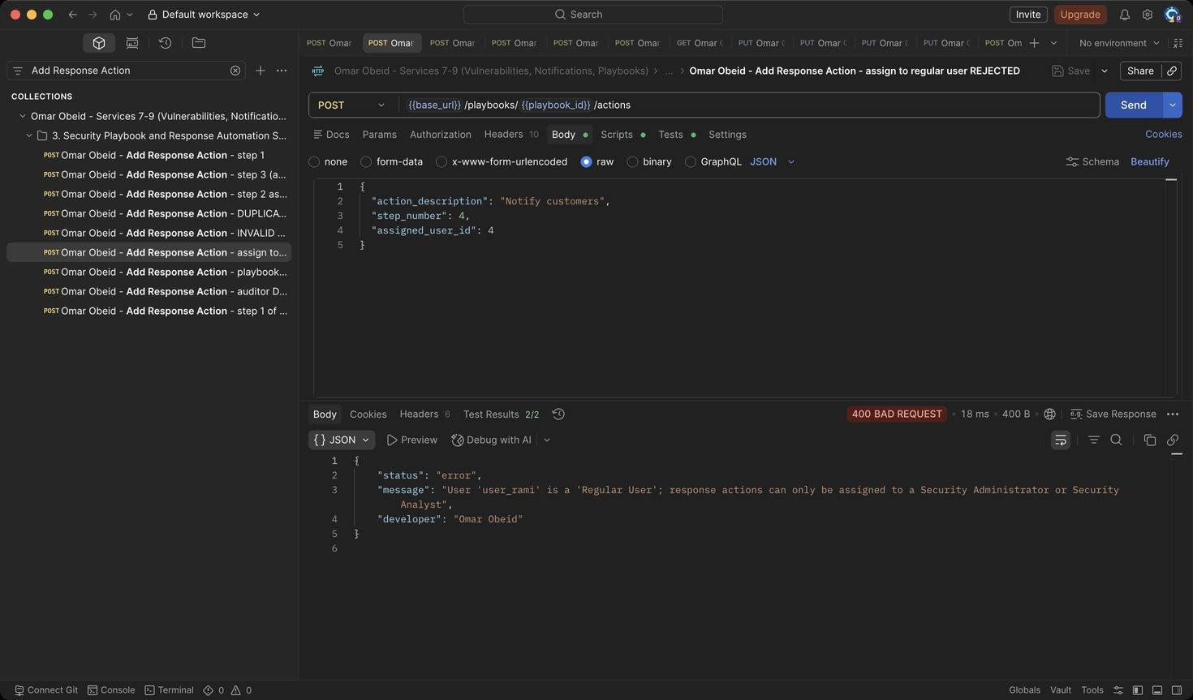
Figure 86: Omar Obeid – Add Response Action – assign to regular user REJECTED: Only administrators and analysts can be assigned (HTTP 400)
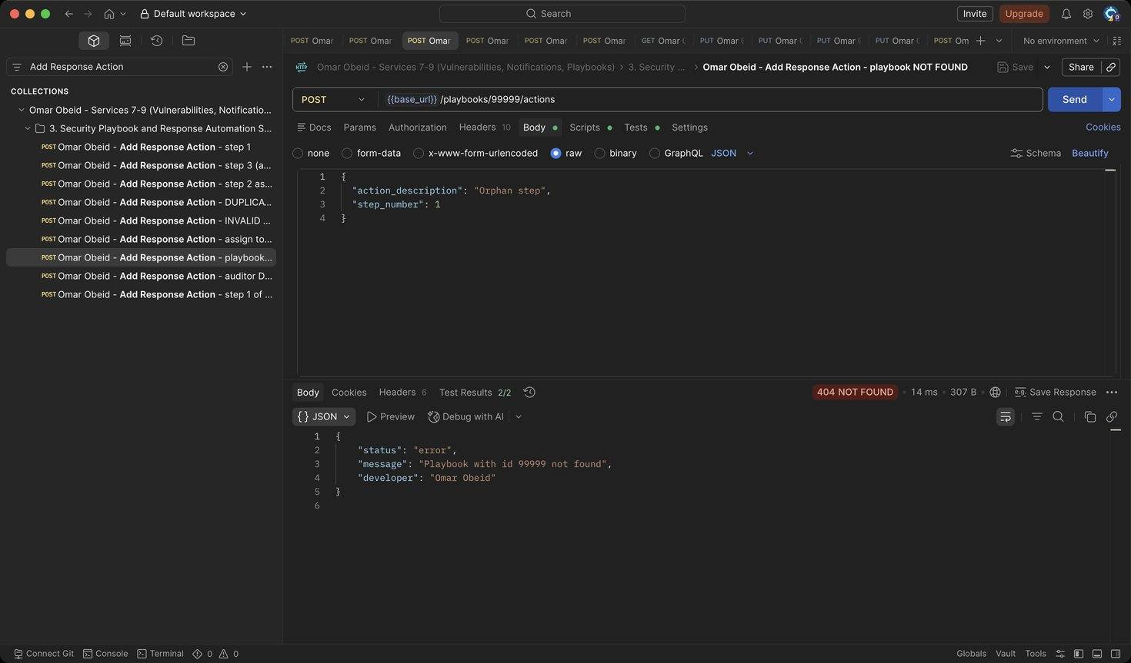
Figure 87: Omar Obeid – Add Response Action – playbook NOT FOUND: Unknown playbook (HTTP 404)
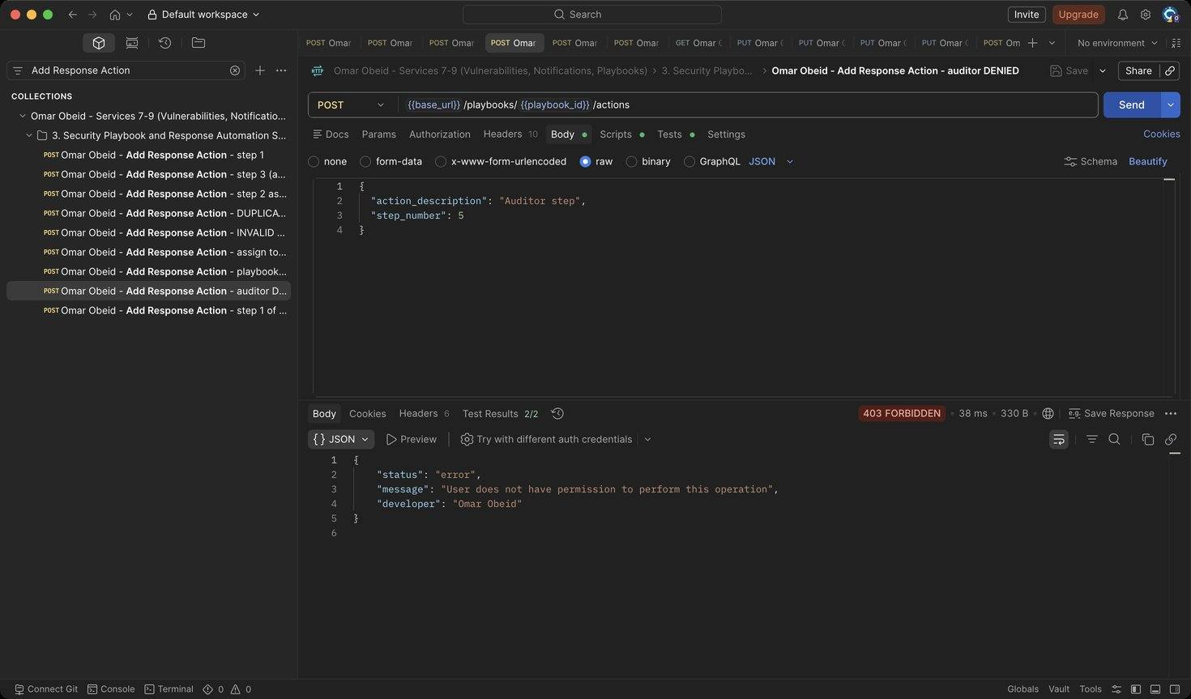
Figure 88: Omar Obeid – Add Response Action – auditor DENIED: Auditors are read-only (HTTP 403)
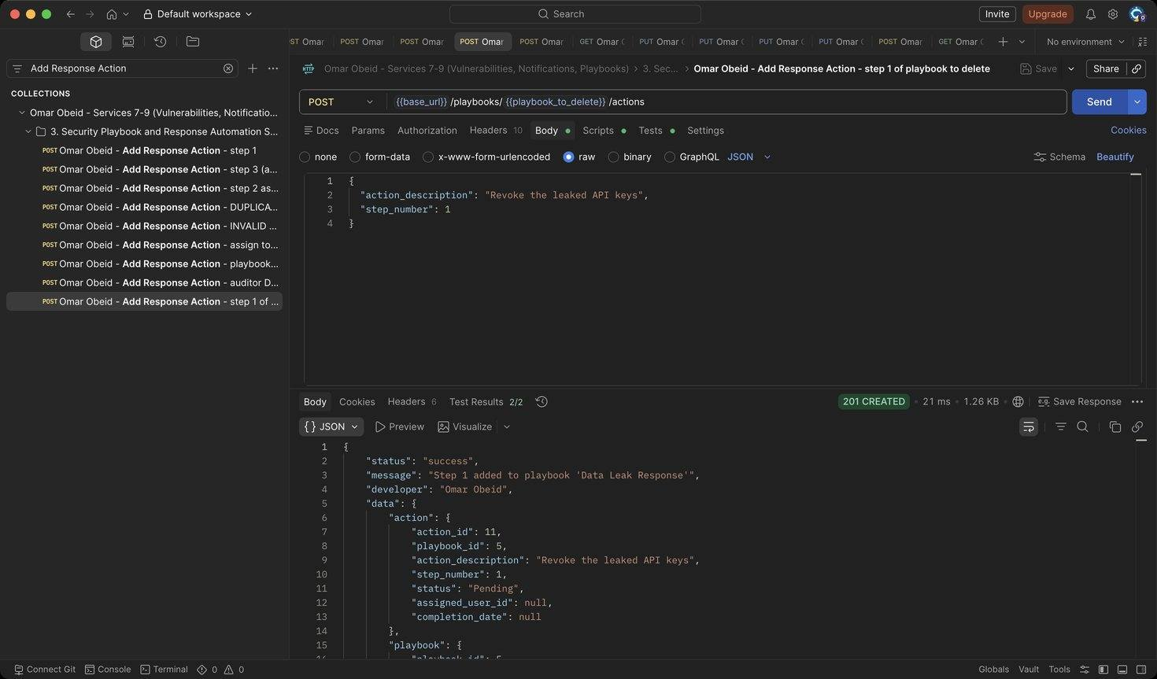
Figure 89: Omar Obeid – Add Response Action – step 1 of playbook to delete: Shows that deleting a playbook removes its actions (HTTP 201)
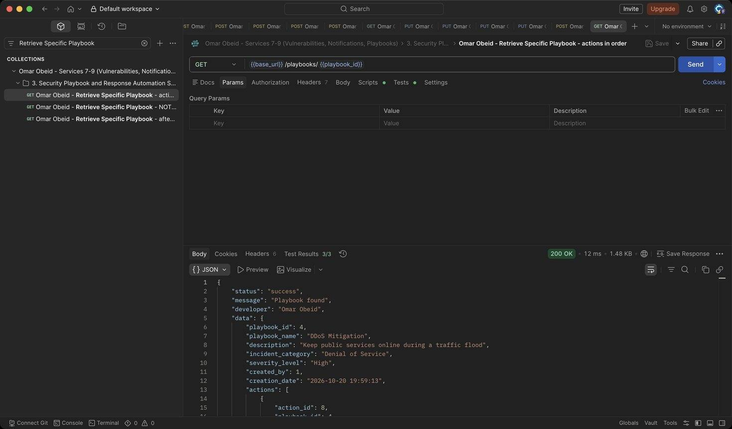
Figure 90: Omar Obeid – Retrieve Specific Playbook – actions in order: Steps returned 1, 2, 3 with progress 0% (HTTP 200)
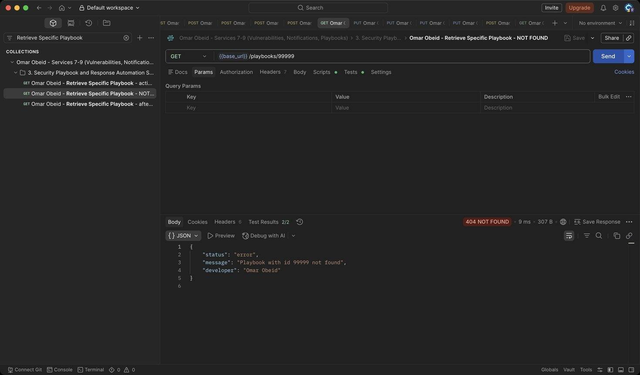
Figure 91: Omar Obeid – Retrieve Specific Playbook – NOT FOUND: Unknown id (HTTP 404)
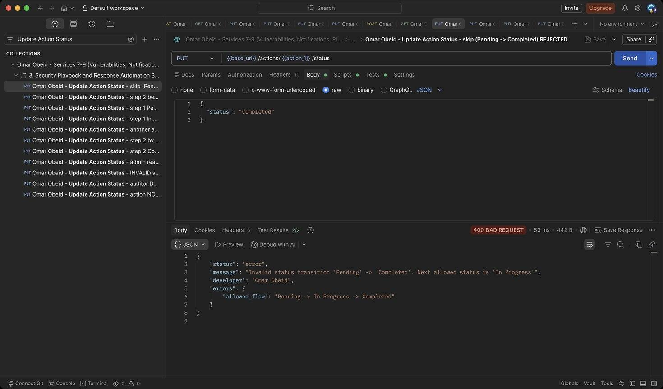
Figure 92: Omar Obeid – Update Action Status – skip (Pending -> Completed) REJECTED: Pending -> In Progress -> Completed only (HTTP 400)
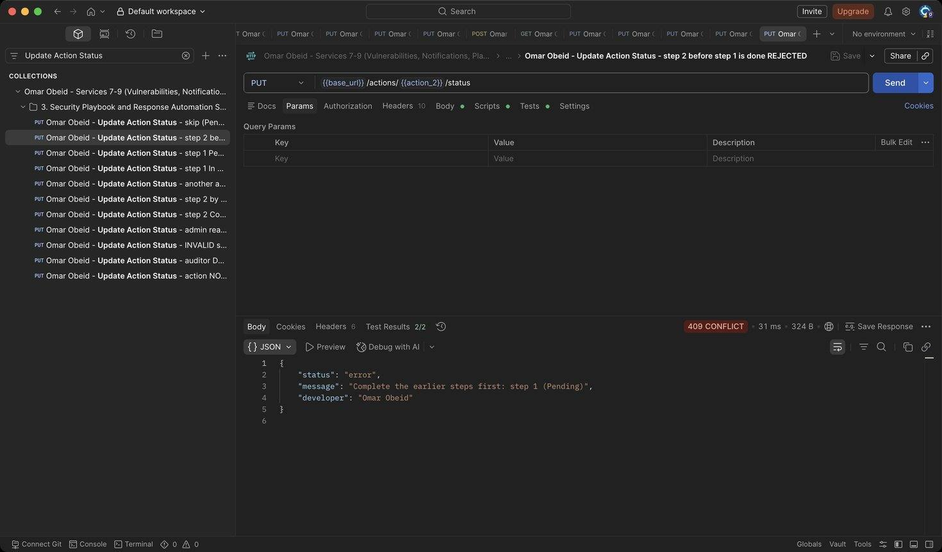
Figure 93: Omar Obeid – Update Action Status – step 2 before step 1 is done REJECTED: Steps are executed in order (HTTP 409)
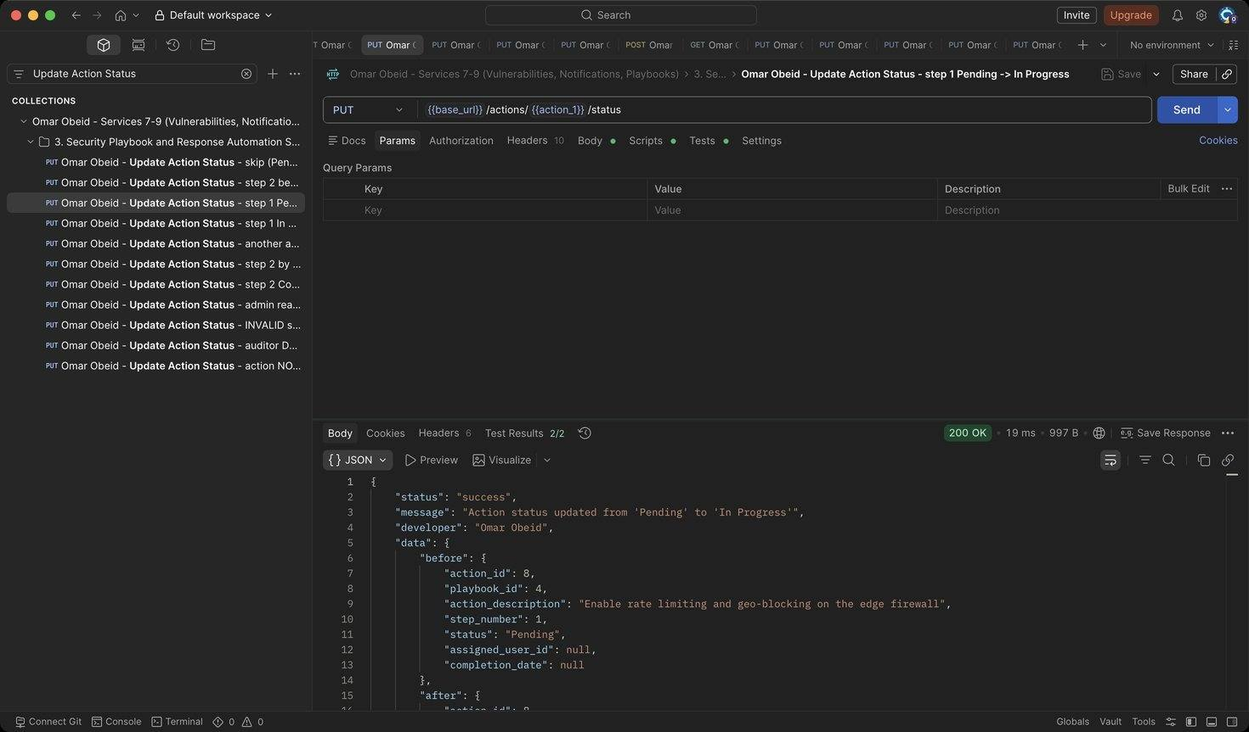
Figure 94: Omar Obeid – Update Action Status – step 1 Pending -> In Progress: Unassigned step: the analyst who starts it becomes the assignee (HTTP 200)
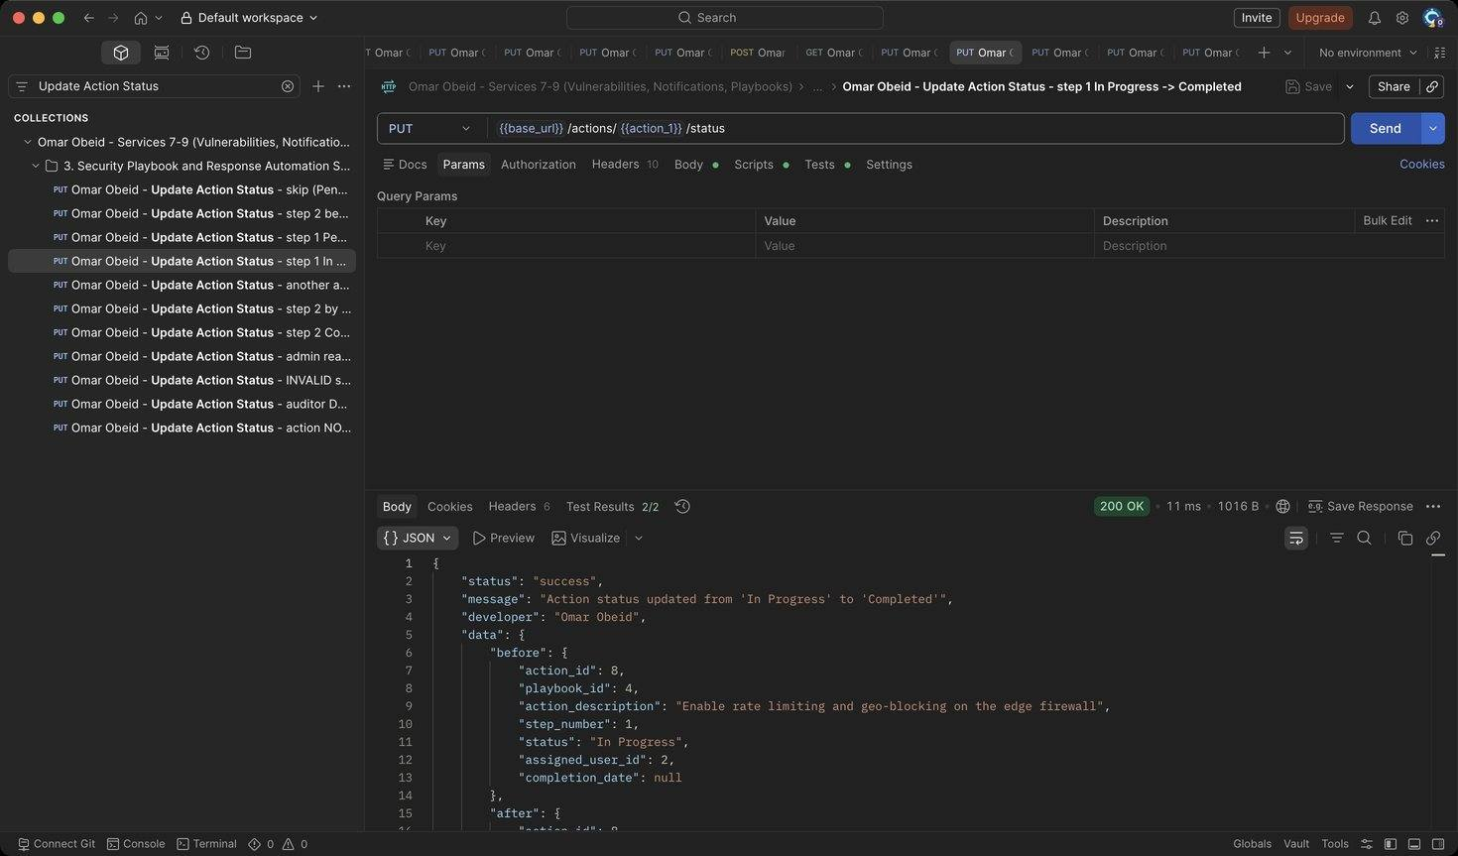
Figure 95: Omar Obeid – Update Action Status – step 1 In Progress -> Completed: completion_date is set automatically; progress 1/3 (HTTP 200)
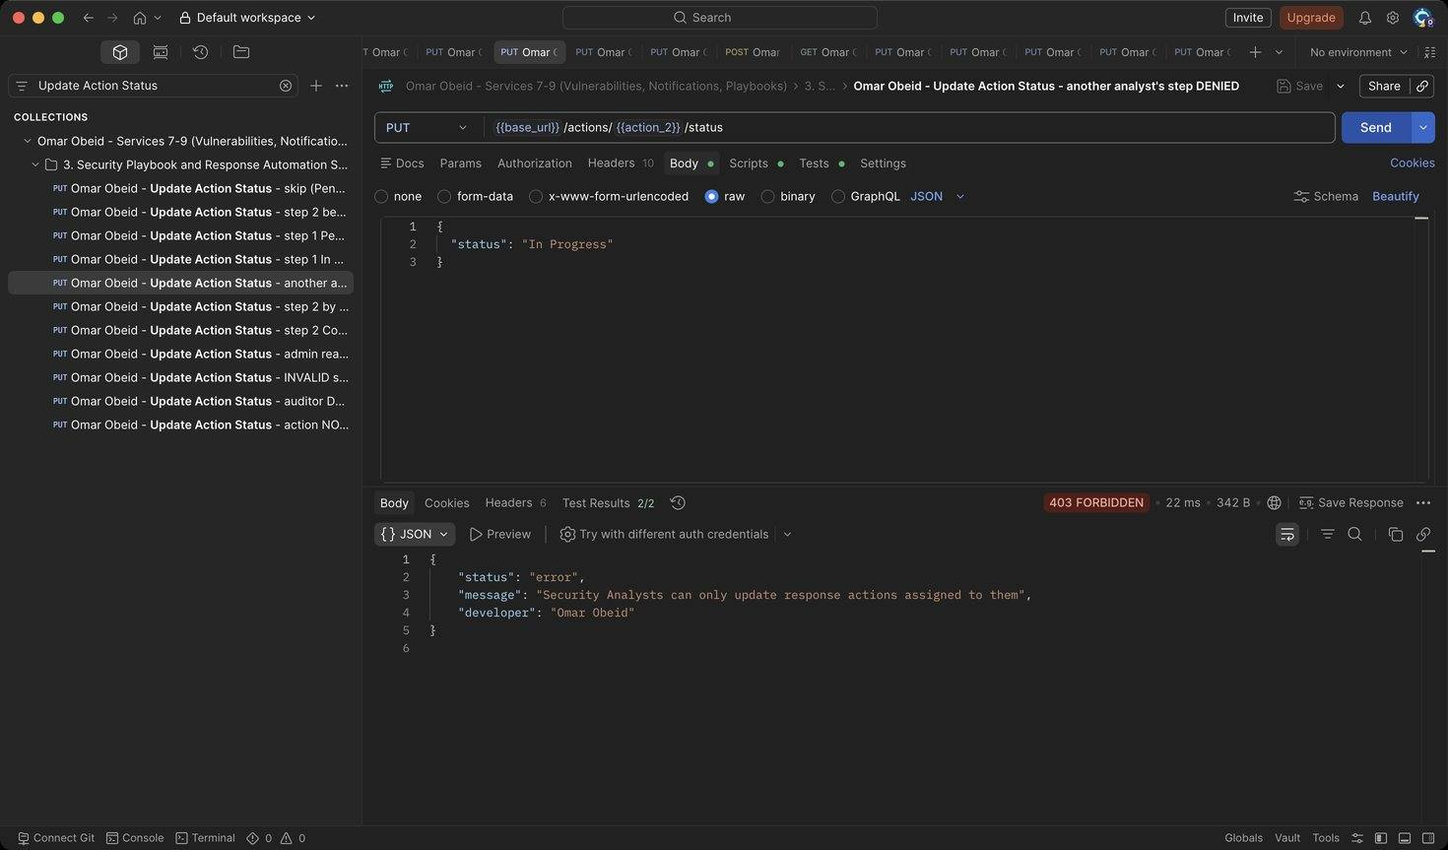
Figure 96: Omar Obeid – Update Action Status – another analyst's step DENIED: Step 2 belongs to analyst_lina (HTTP 403)
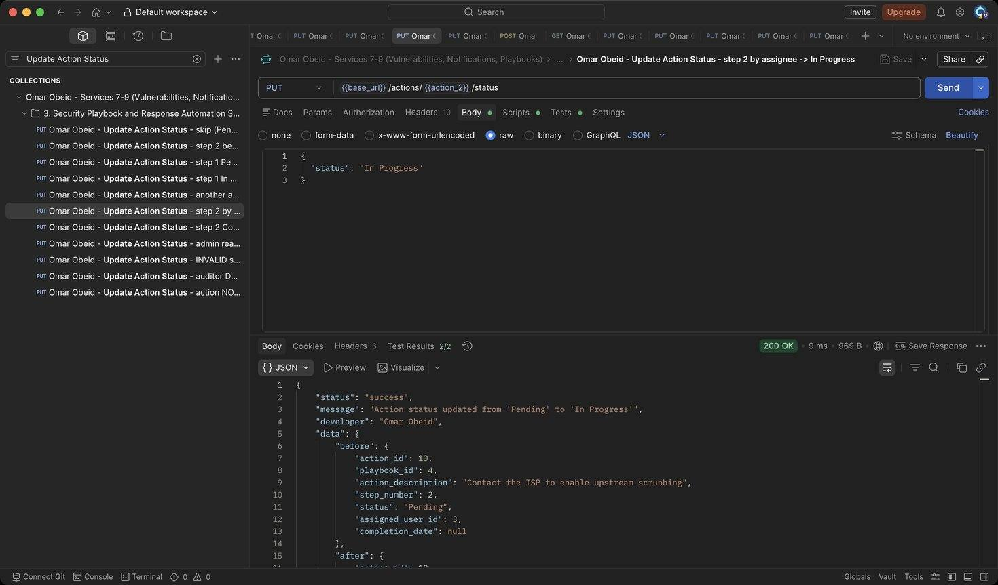
Figure 97: Omar Obeid – Update Action Status – step 2 by assignee -> In Progress: Assigned analyst starts the step (HTTP 200)
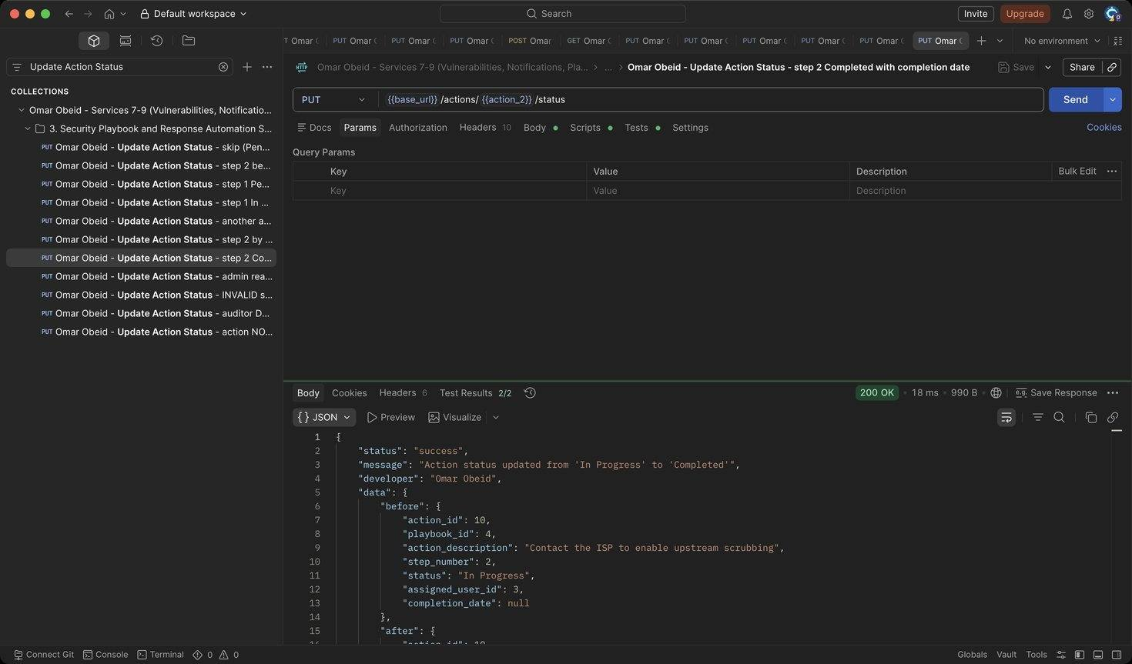
Figure 98: Omar Obeid – Update Action Status – step 2 Completed with completion date: Explicit completion date (YYYY-MM-DD) (HTTP 200)
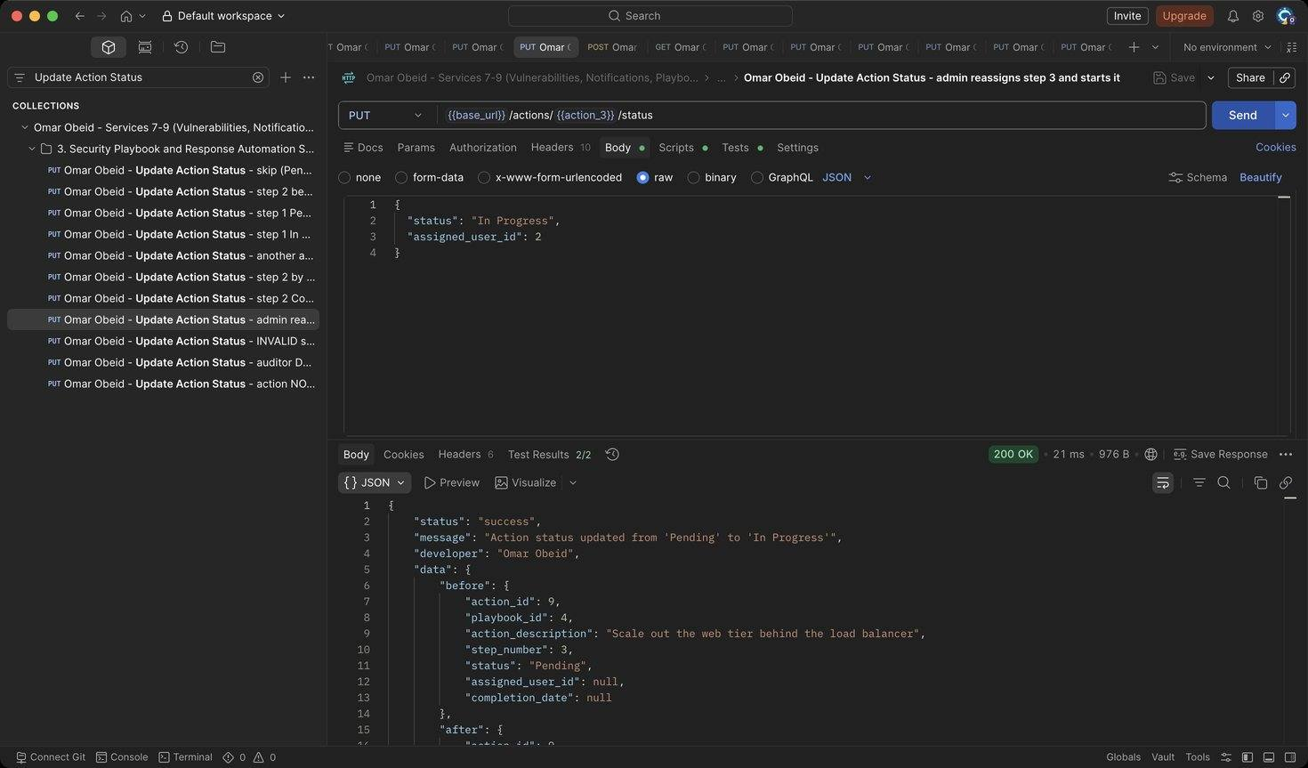
Figure 99: Omar Obeid – Update Action Status – admin reassigns step 3 and starts it: Assigns step 3 to analyst_karim (id 2), who is notified (HTTP 200)
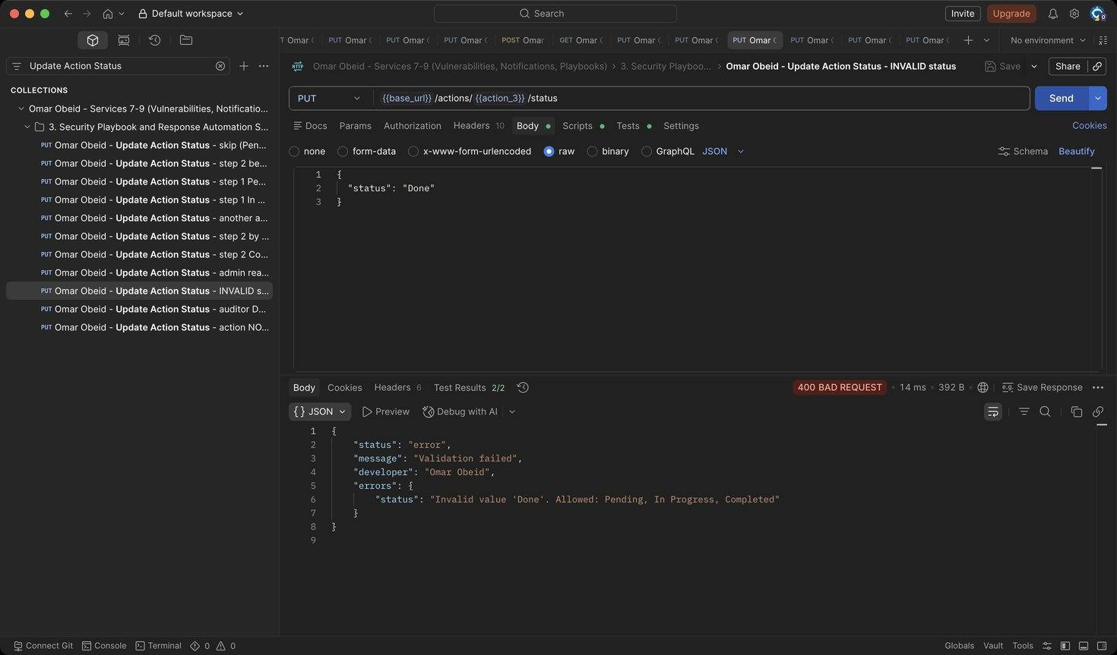
Figure 100: Omar Obeid – Update Action Status – INVALID status: Status must be Pending, In Progress or Completed (HTTP 400)
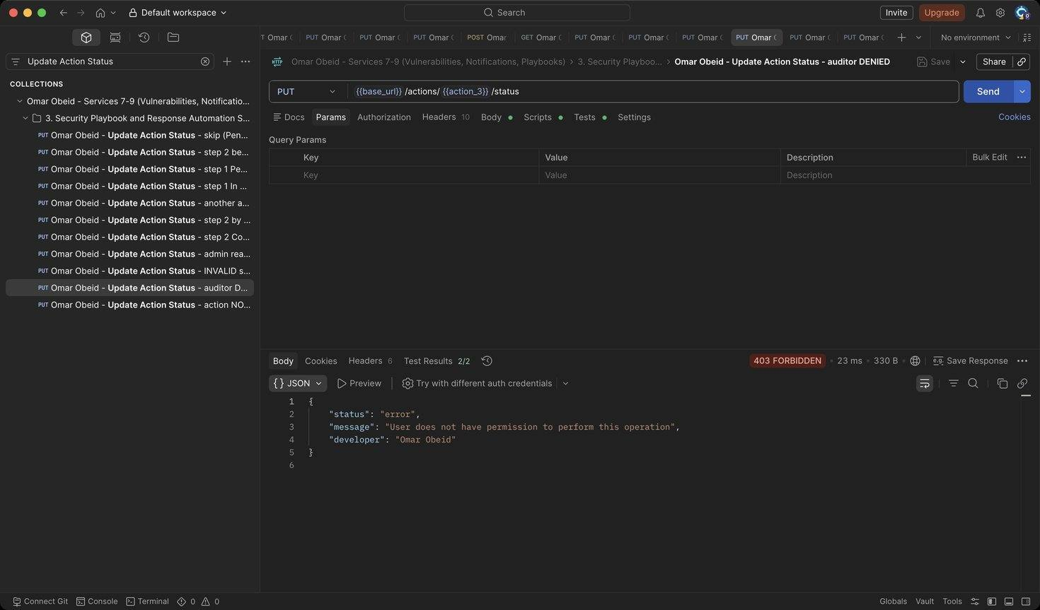
Figure 101: Omar Obeid – Update Action Status – auditor DENIED: Auditors are read-only (HTTP 403)
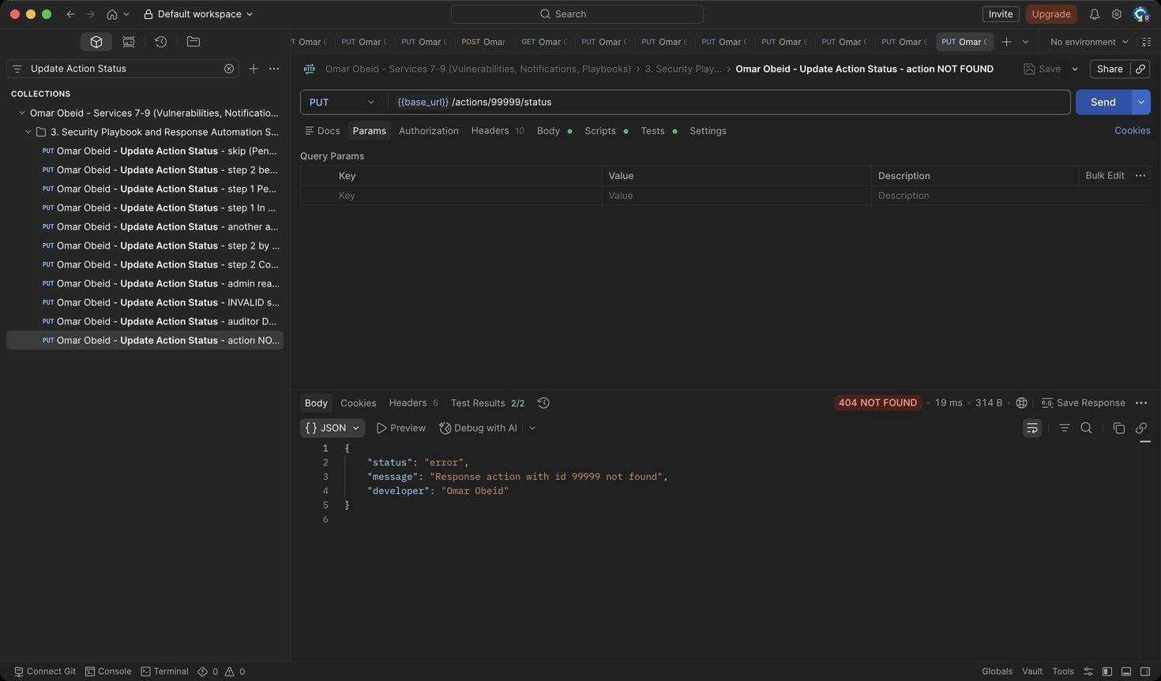
Figure 102: Omar Obeid – Update Action Status – action NOT FOUND: Unknown id (HTTP 404)
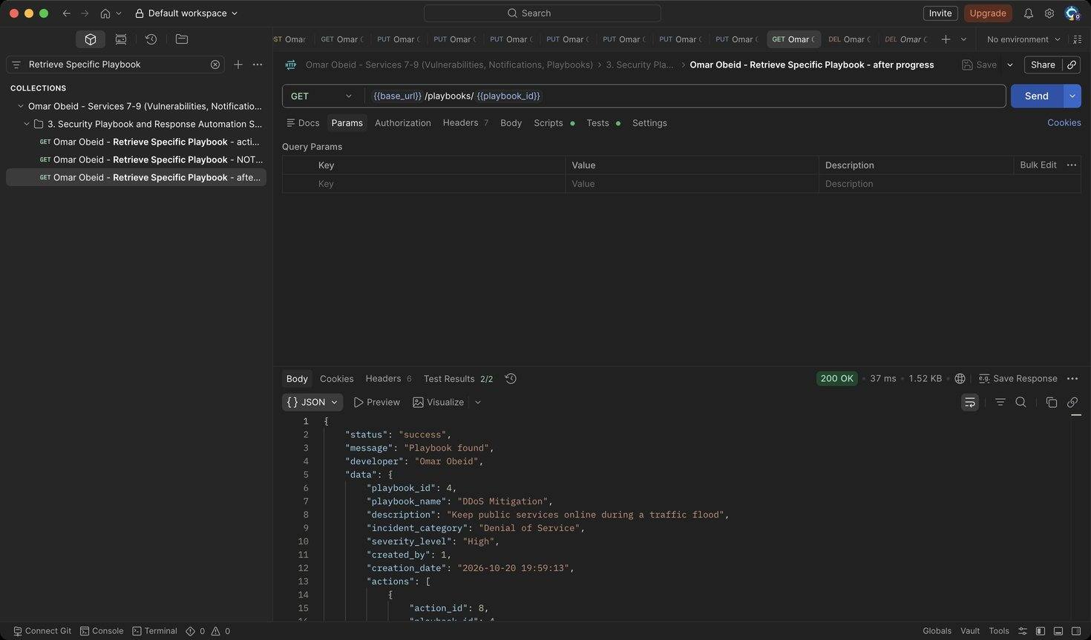
Figure 103: Omar Obeid – Retrieve Specific Playbook – after progress: 2 of 3 steps completed (67%) (HTTP 200)
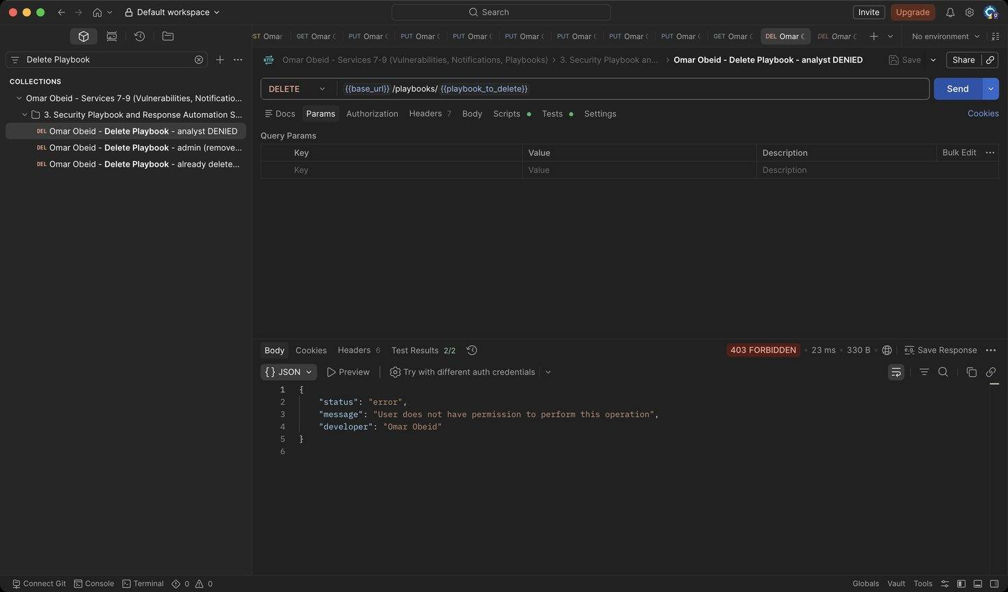
Figure 104: Omar Obeid – Delete Playbook – analyst DENIED: Only administrators delete playbooks (HTTP 403)
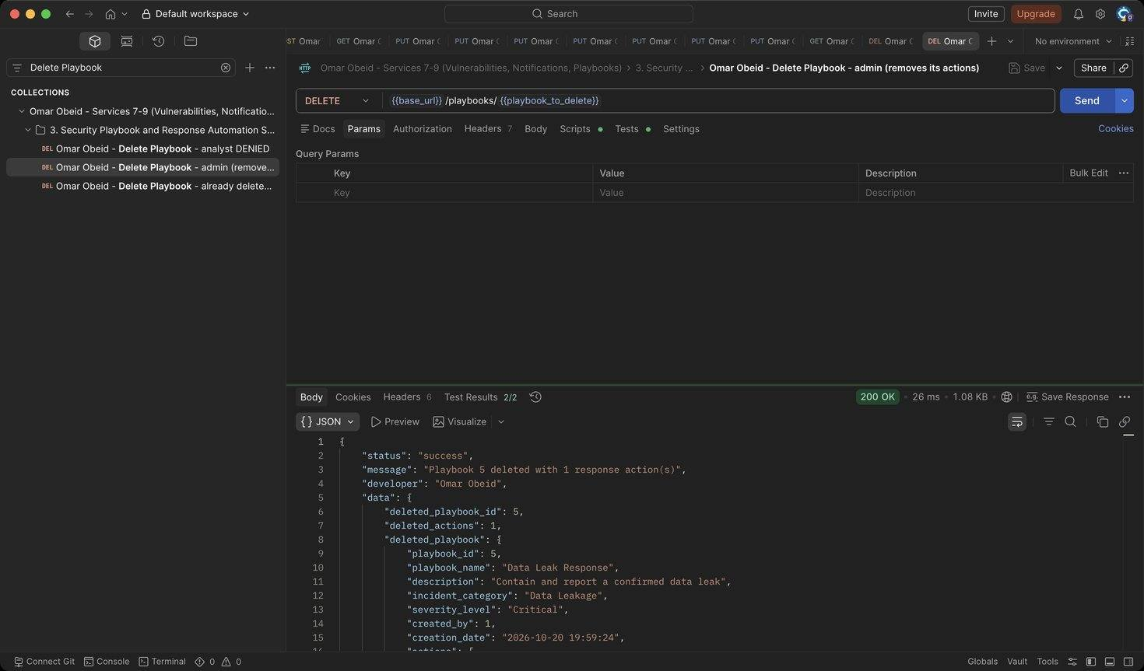
Figure 105: Omar Obeid – Delete Playbook – admin (removes its actions): Response shows how many response actions were removed (ON DELETE CASCADE) (HTTP 200)
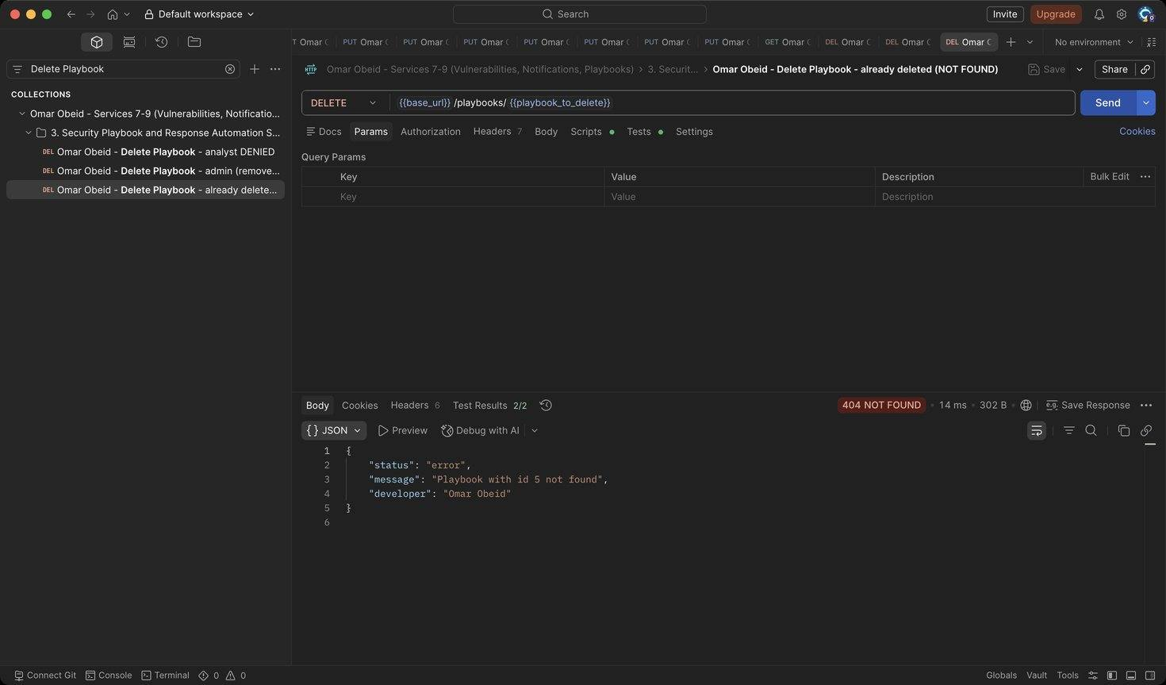
Figure 106: Omar Obeid – Delete Playbook – already deleted (NOT FOUND): The playbook is gone (HTTP 404)

Database records (DB evidence) (Omar Obeid)
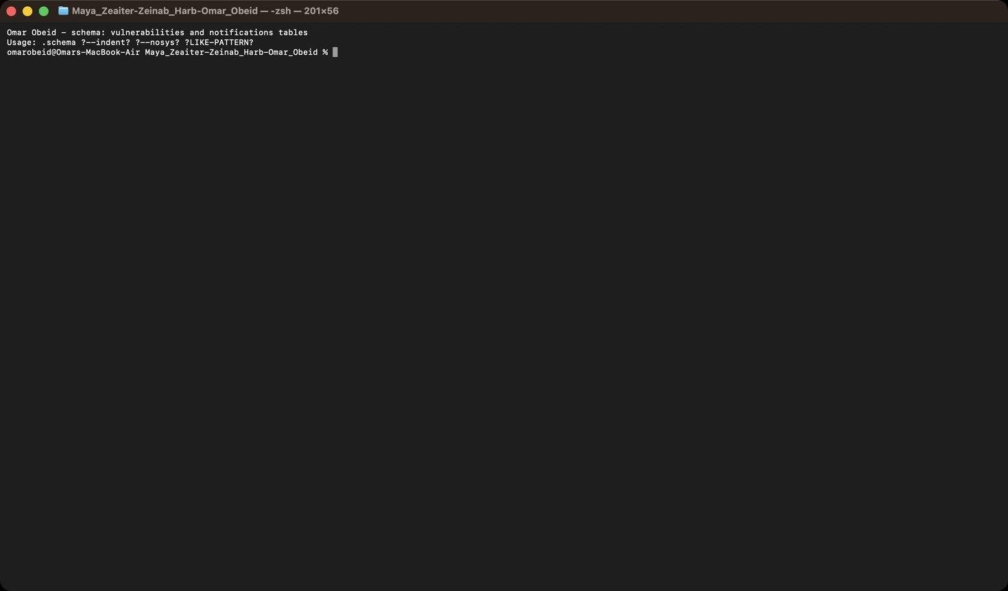
Figure 107: Omar Obeid – Database Design – schema of the vulnerabilities and notifications tables (PK, FK, CHECK constraints)
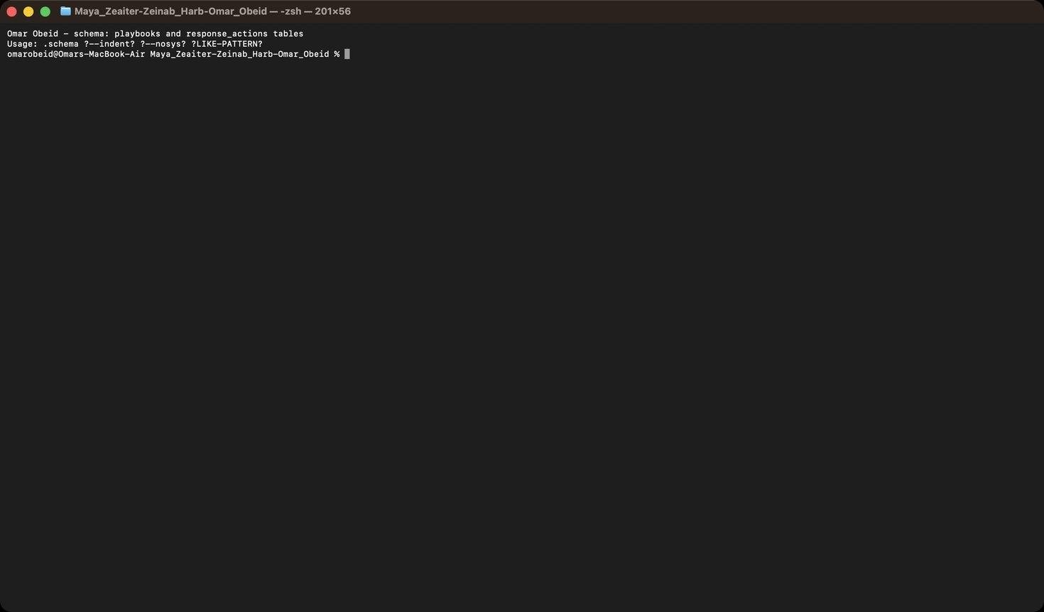
Figure 108: Omar Obeid – Database Design – schema of the playbooks and response_actions tables (FK, UNIQUE playbook_id + step_number)
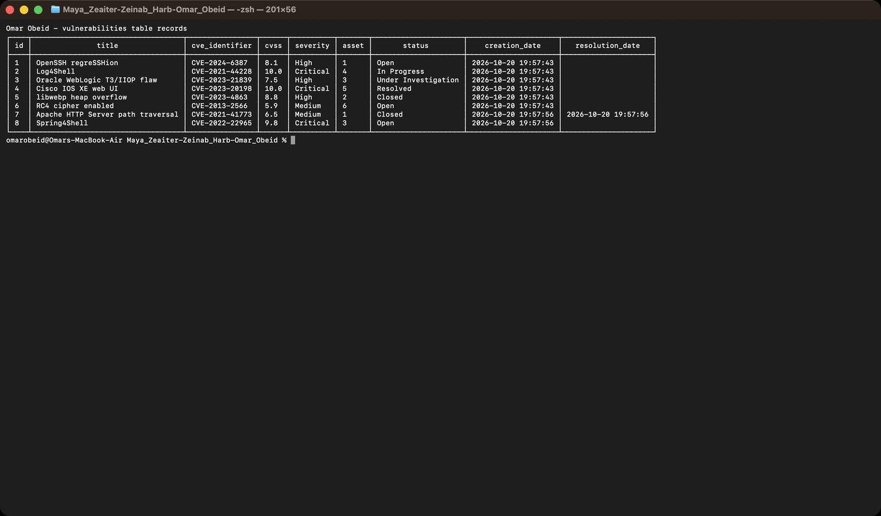
Figure 109: Omar Obeid – Database Design – stored vulnerability records after the Postman run (asset, CVE, CVSS, severity, status, resolution date)
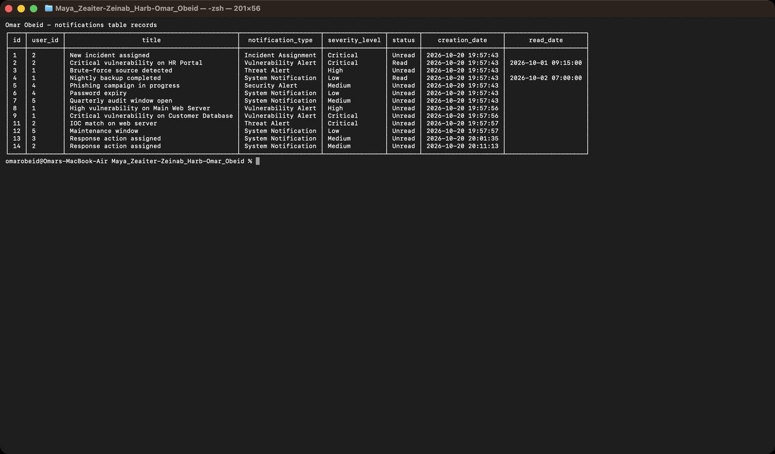
Figure 110: Omar Obeid – Database Design – stored notification records (types, severities, Unread/Read status, read dates)
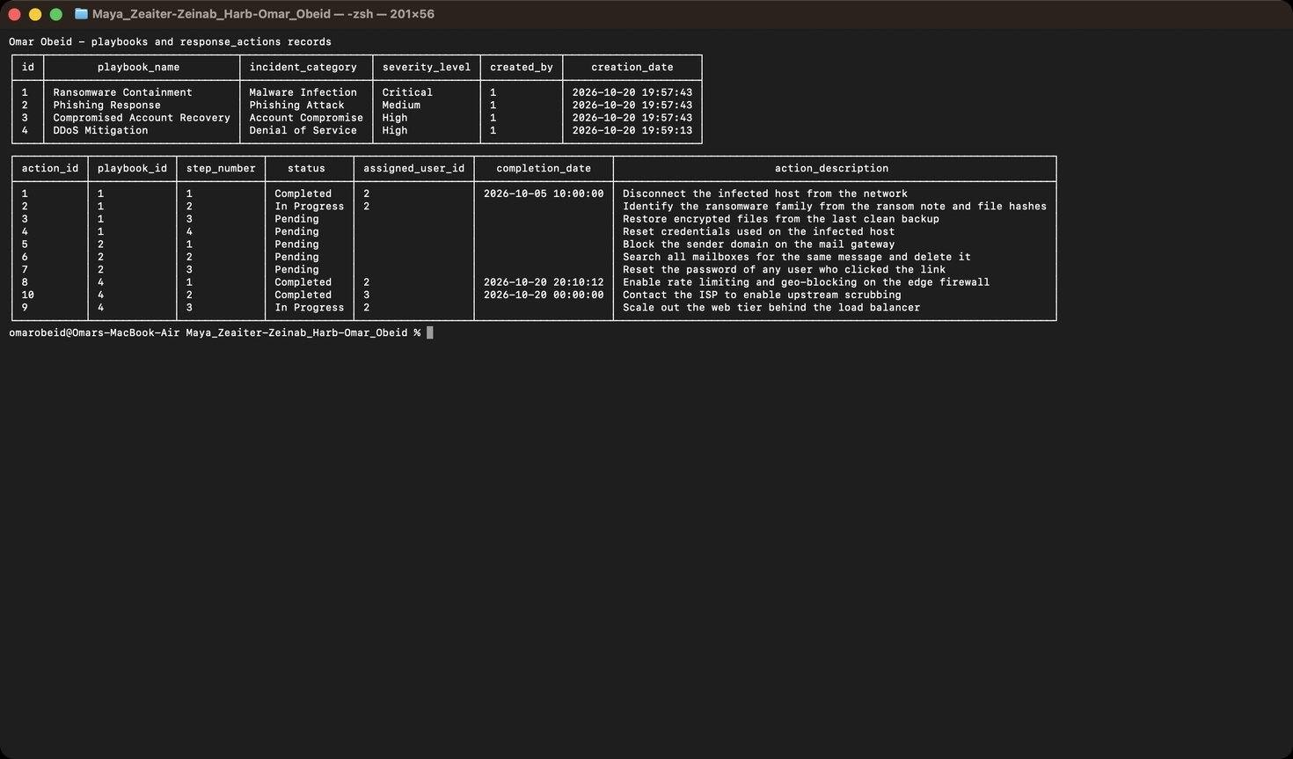
Figure 111: Omar Obeid – Database Design – stored playbooks and their ordered response actions (deleted playbook 5 and its actions are gone)
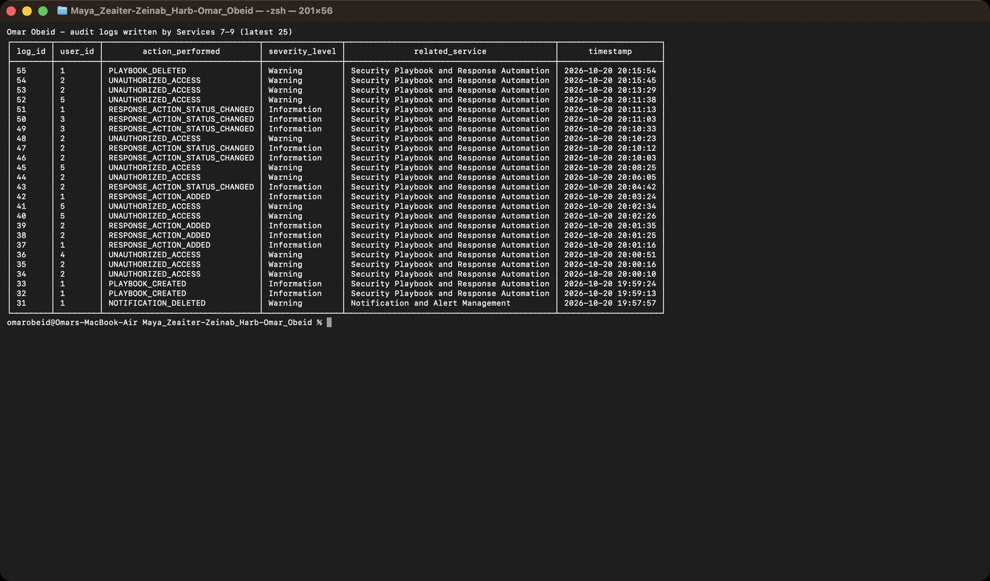
Figure 112: Omar Obeid – Security Audit Logging – log records written by Services 7–9 (creates, updates, deletes, reads, unauthorized attempts)

GitHub and version control (Omar Obeid)
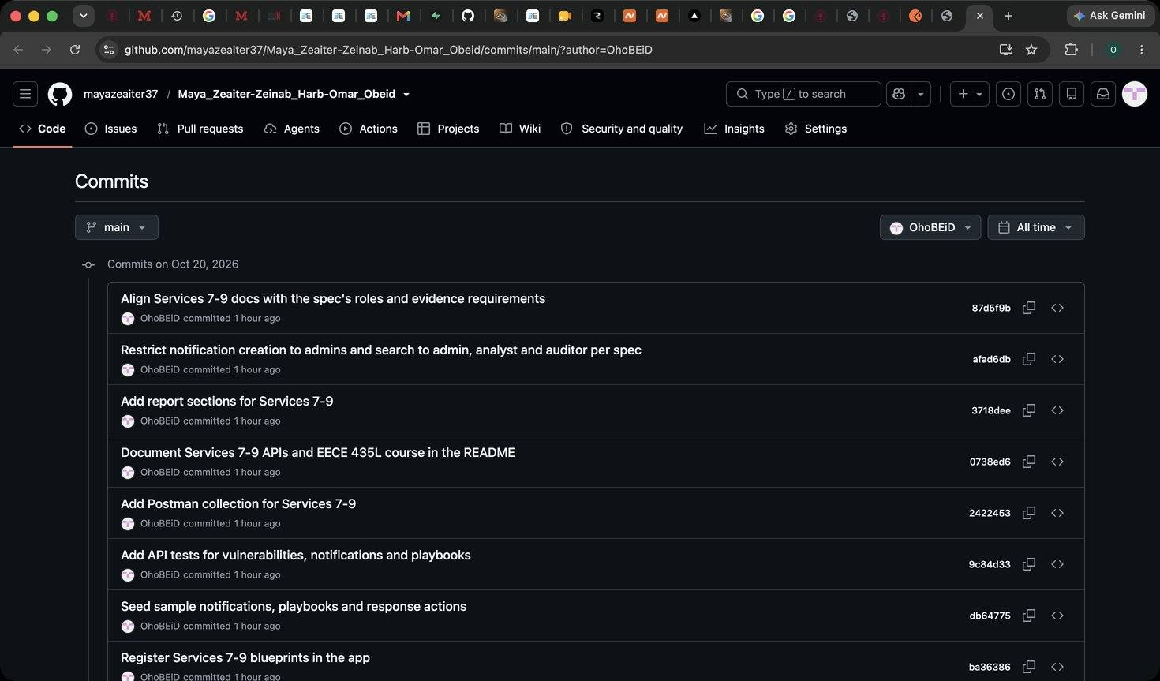
Figure 113: Omar Obeid – GitHub – commit history of the team repository filtered to my account (OhoBEiD)
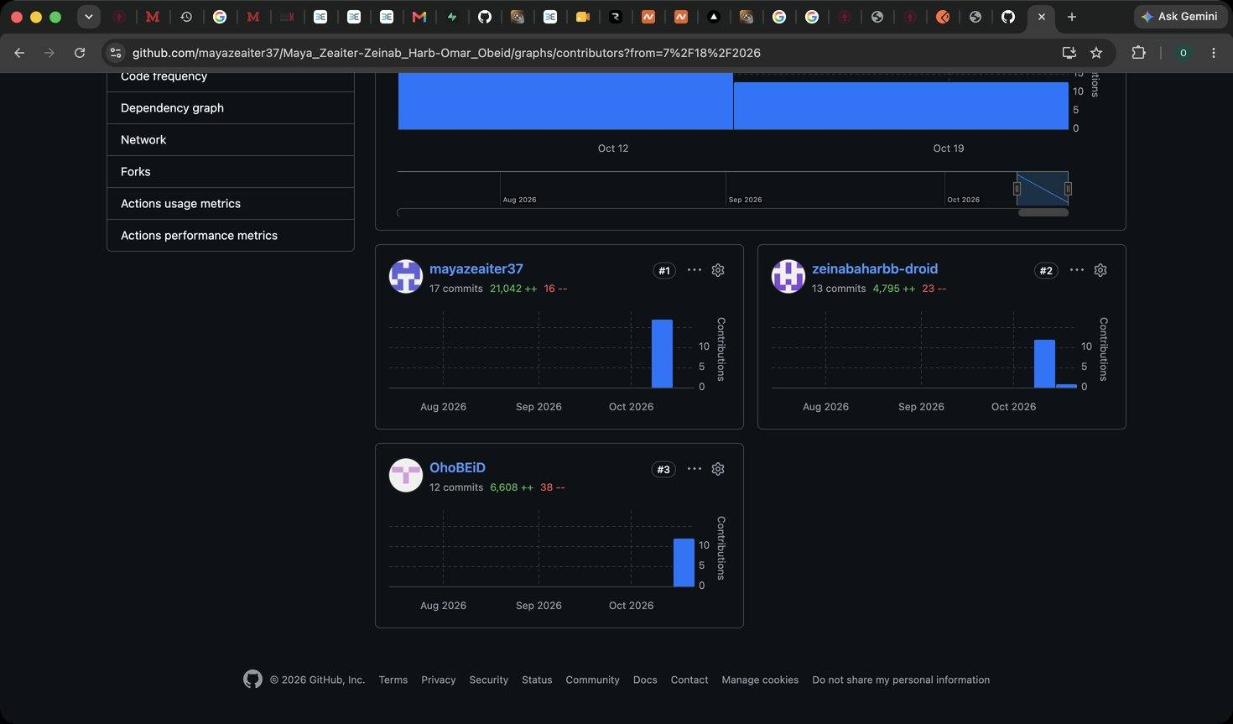
Figure 114: Omar Obeid – GitHub – contributors graph showing the commits of all three team members

