Postman Evidence – Services 1–3 (Maya Zeaiter)
All screenshots were taken from Postman sending requests to my own running Flask server (http://127.0.0.1:5050) on 14 October 2026, against a freshly seeded database. Each request ran once, in order.

0. Authentication (Maya Zeaiter)
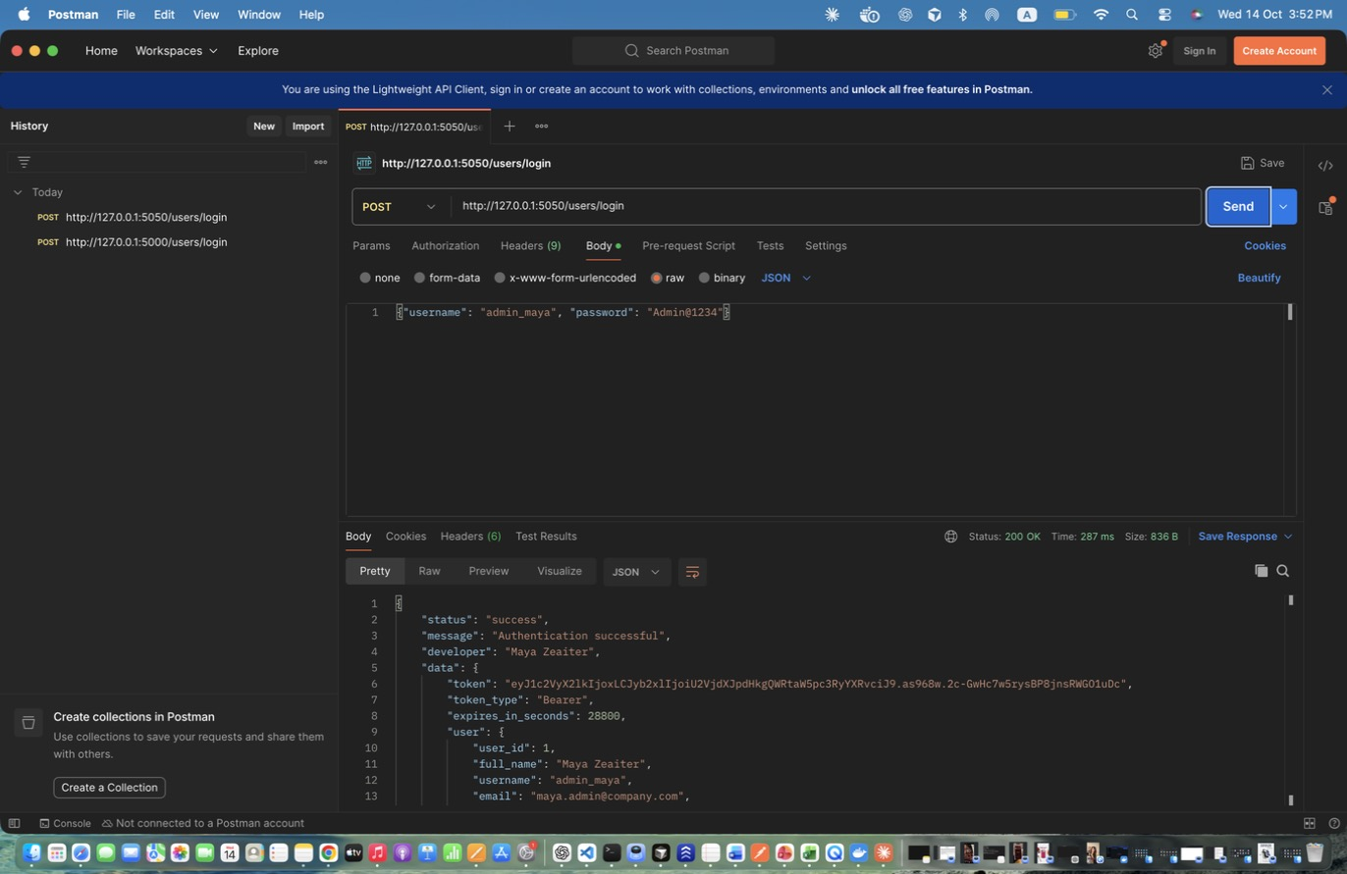
Figure 1: Maya Zeaiter – Login as Security Administrator – Successful login. Stores the token in admin_token.
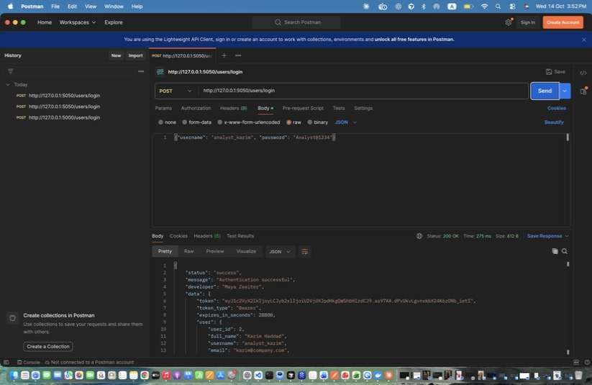
Figure 2: Maya Zeaiter – Login as Security Analyst (Karim) – Stores analyst_token.
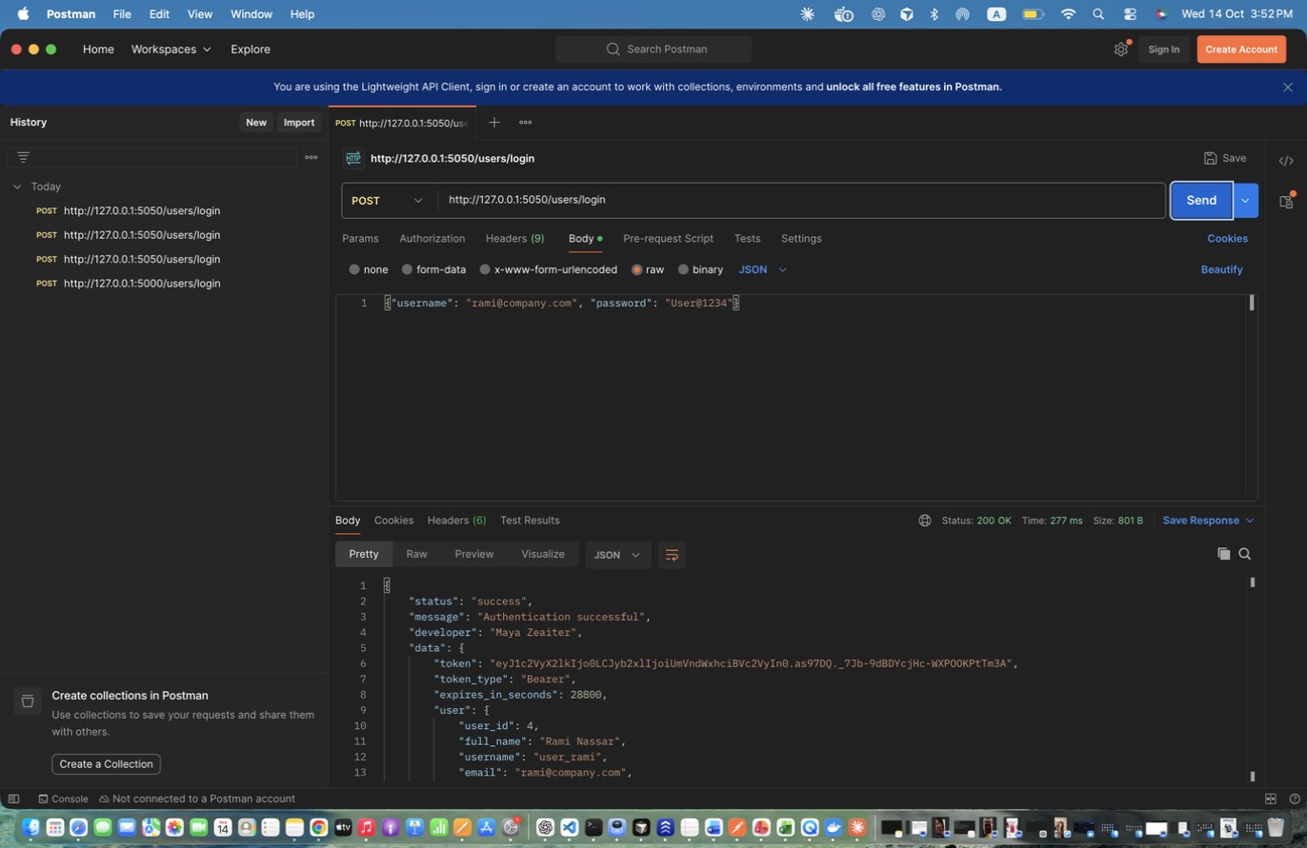
Figure 3: Maya Zeaiter – Login as Regular User (by email) – Login with the email instead of the username. Stores user_token.
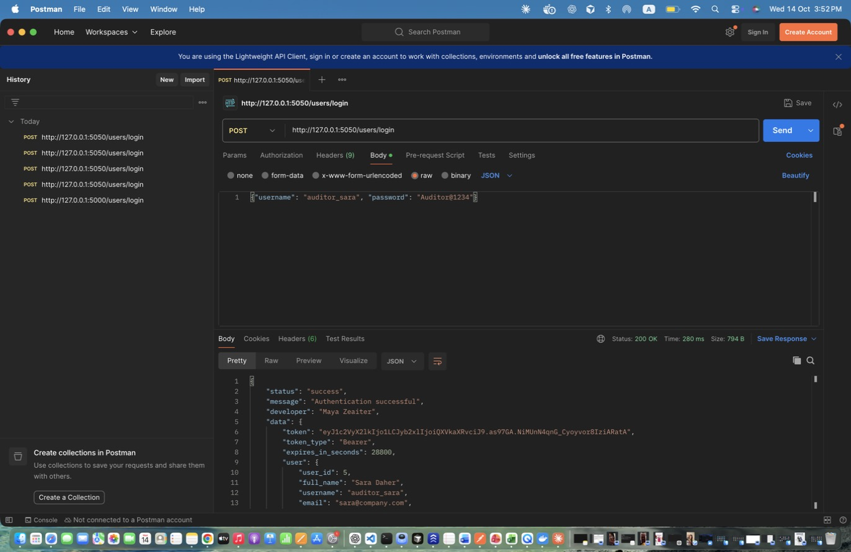
Figure 4: Maya Zeaiter – Login as Auditor – Stores auditor_token.
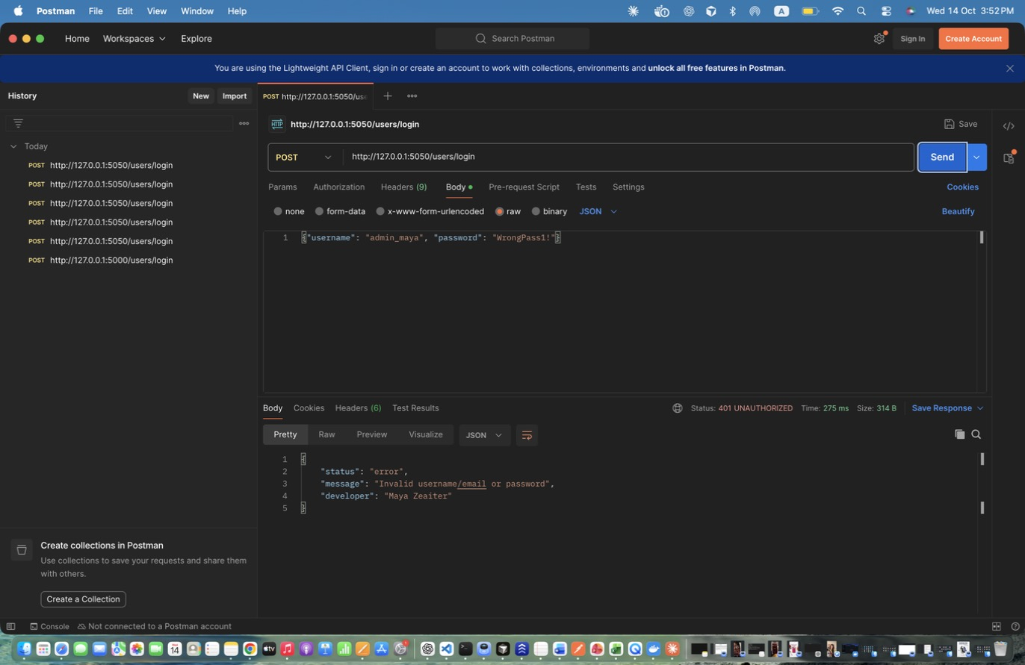
Figure 5: Maya Zeaiter – Login FAILED - wrong password – Unsuccessful login: returns 401 and writes a LOGIN_FAILED audit log.
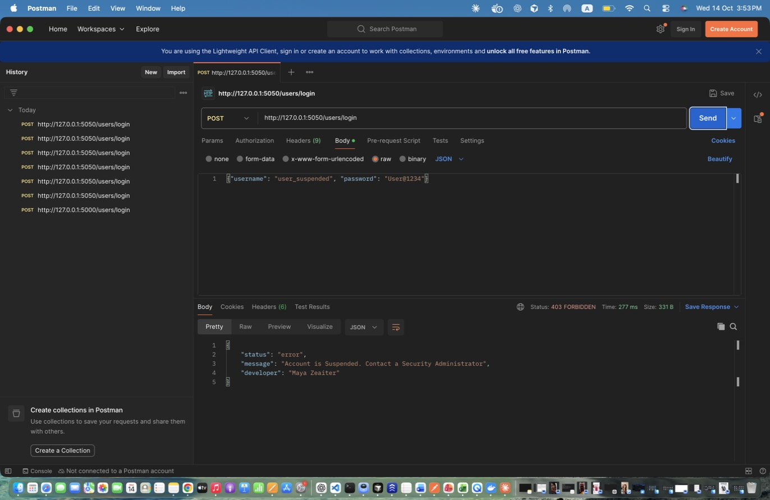
Figure 6: Maya Zeaiter – Login FAILED - suspended account – Suspended accounts cannot authenticate (403).

1. Users and Identity Management (Maya Zeaiter)
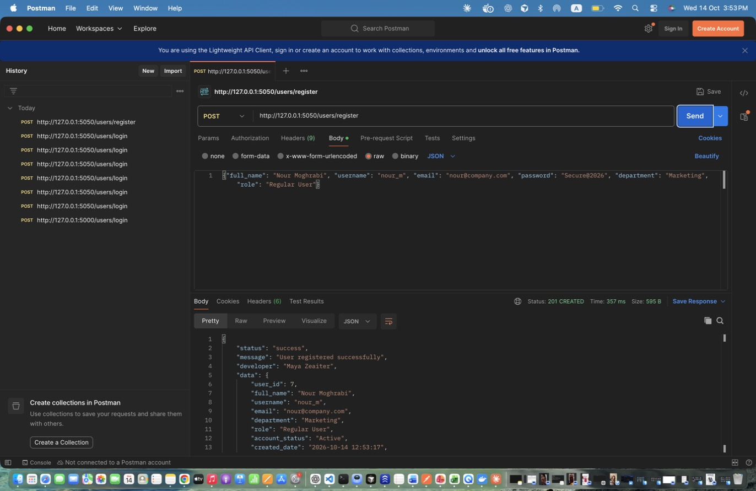
Figure 7: Maya Zeaiter – Register Regular User – Public registration. Password is hashed before storage. Stores the new id in new_user_id.
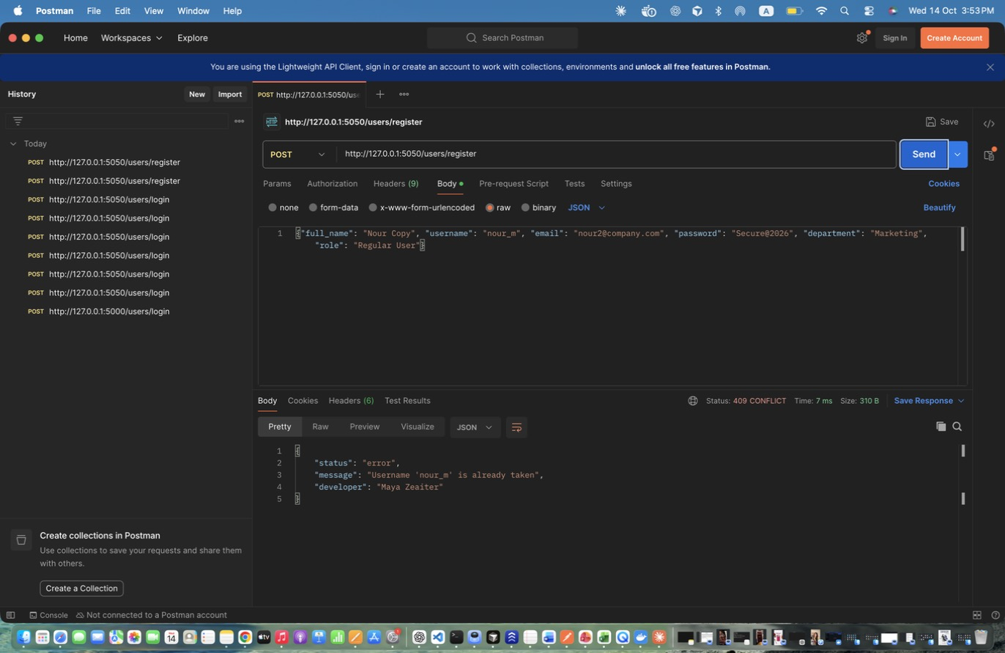
Figure 8: Maya Zeaiter – Register DUPLICATE username – Same username again -> 409 Conflict.
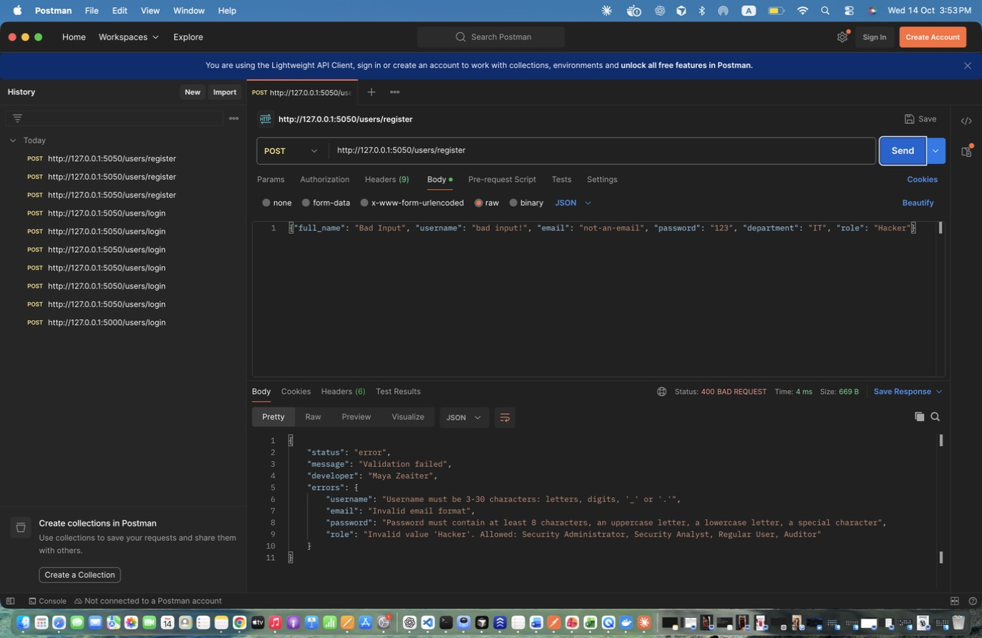
Figure 9: Maya Zeaiter – Register INVALID input – Invalid email, weak password, invalid role -> 400 with per-field errors.
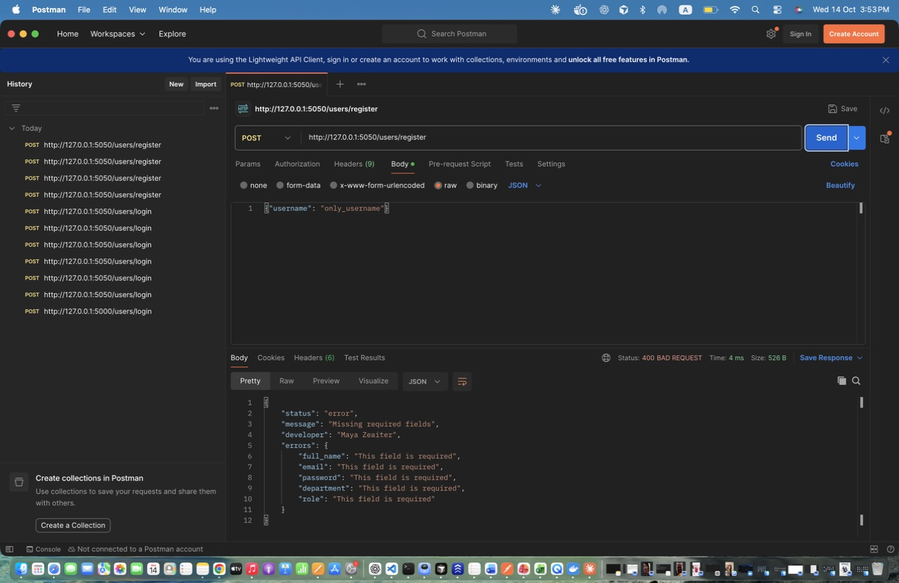
Figure 10: Maya Zeaiter – Register MISSING fields – Missing required fields -> 400.
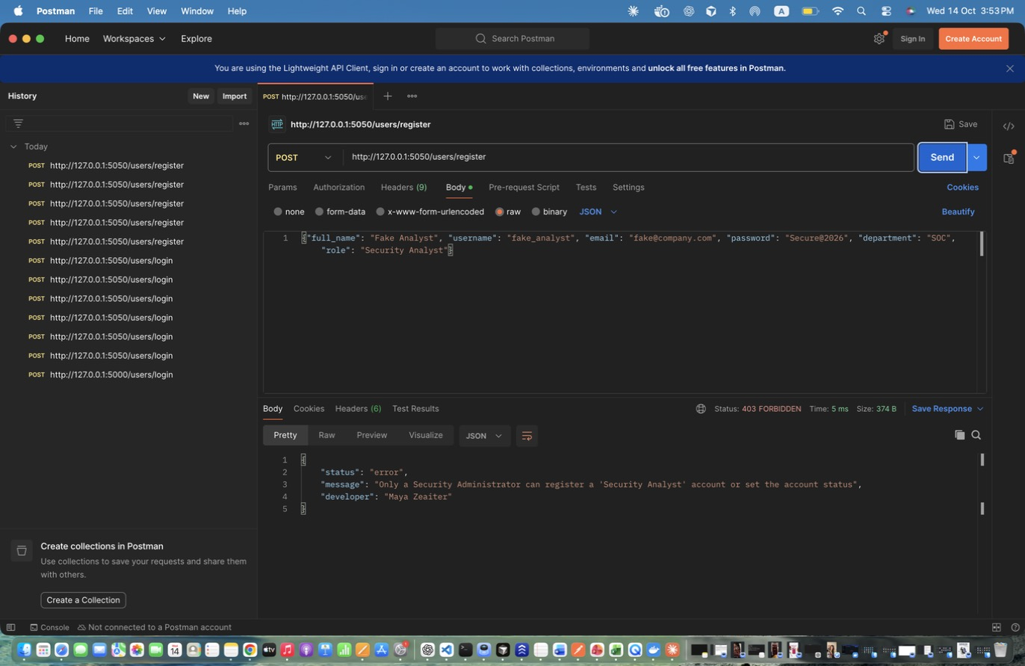
Figure 11: Maya Zeaiter – Register Analyst WITHOUT admin token – Privileged roles need an admin token -> 403.
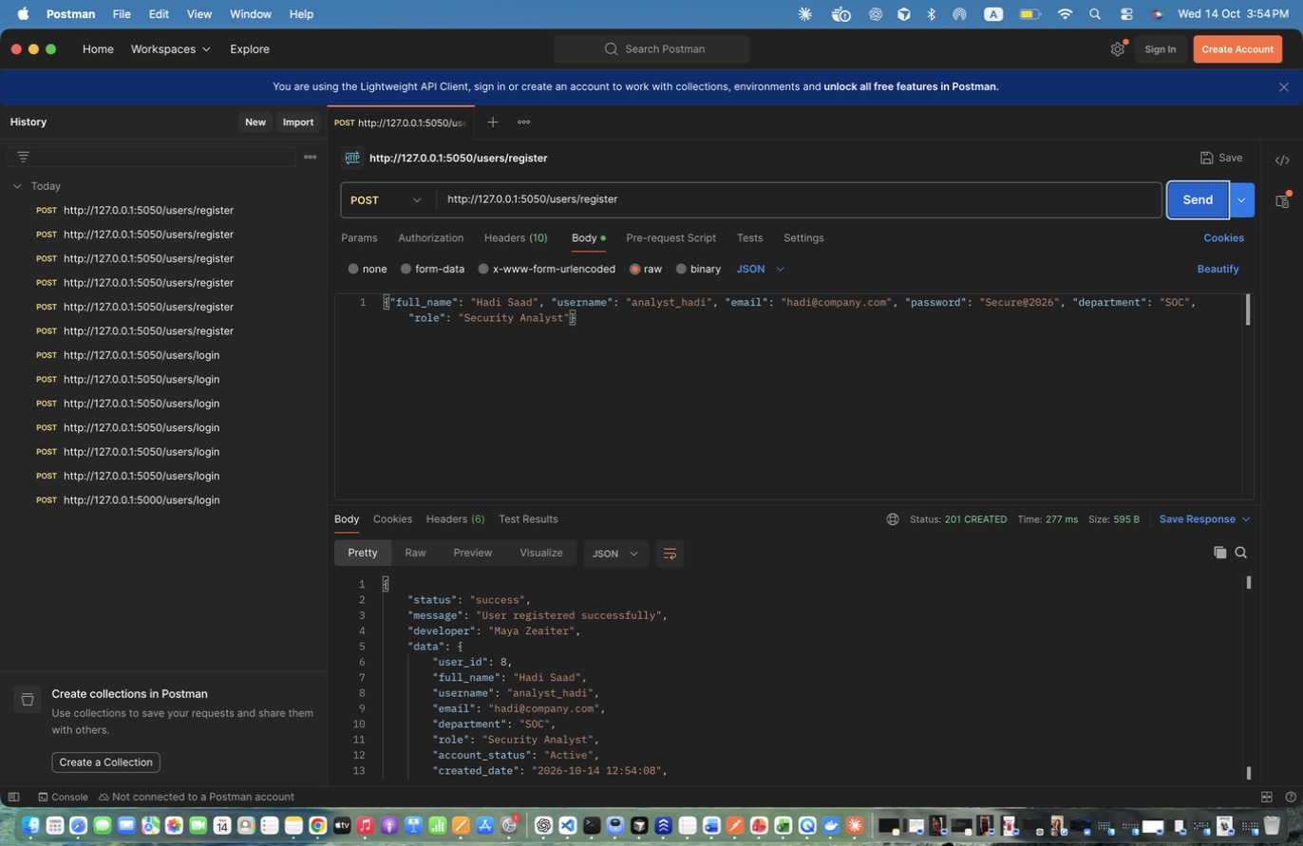
Figure 12: Maya Zeaiter – Register Analyst AS ADMIN – Admin can register any role.
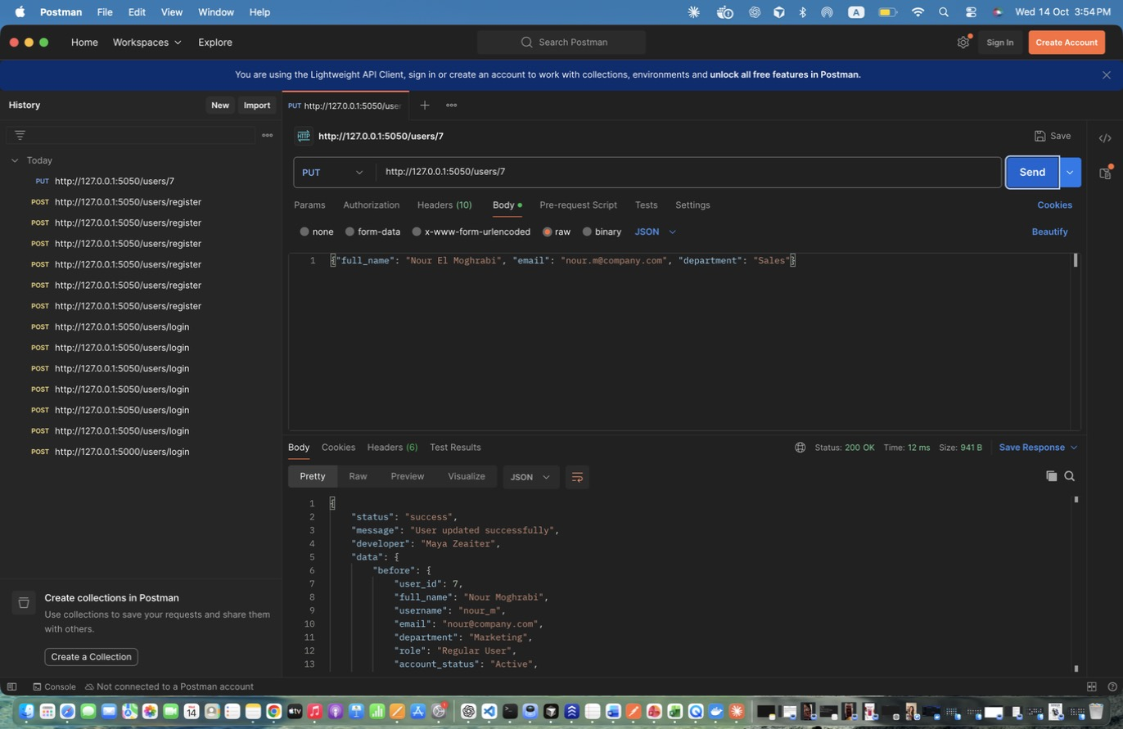
Figure 13: Maya Zeaiter – Update User (admin) – Admin updates name/email/department (and may change role/account_status). Response shows before and after.
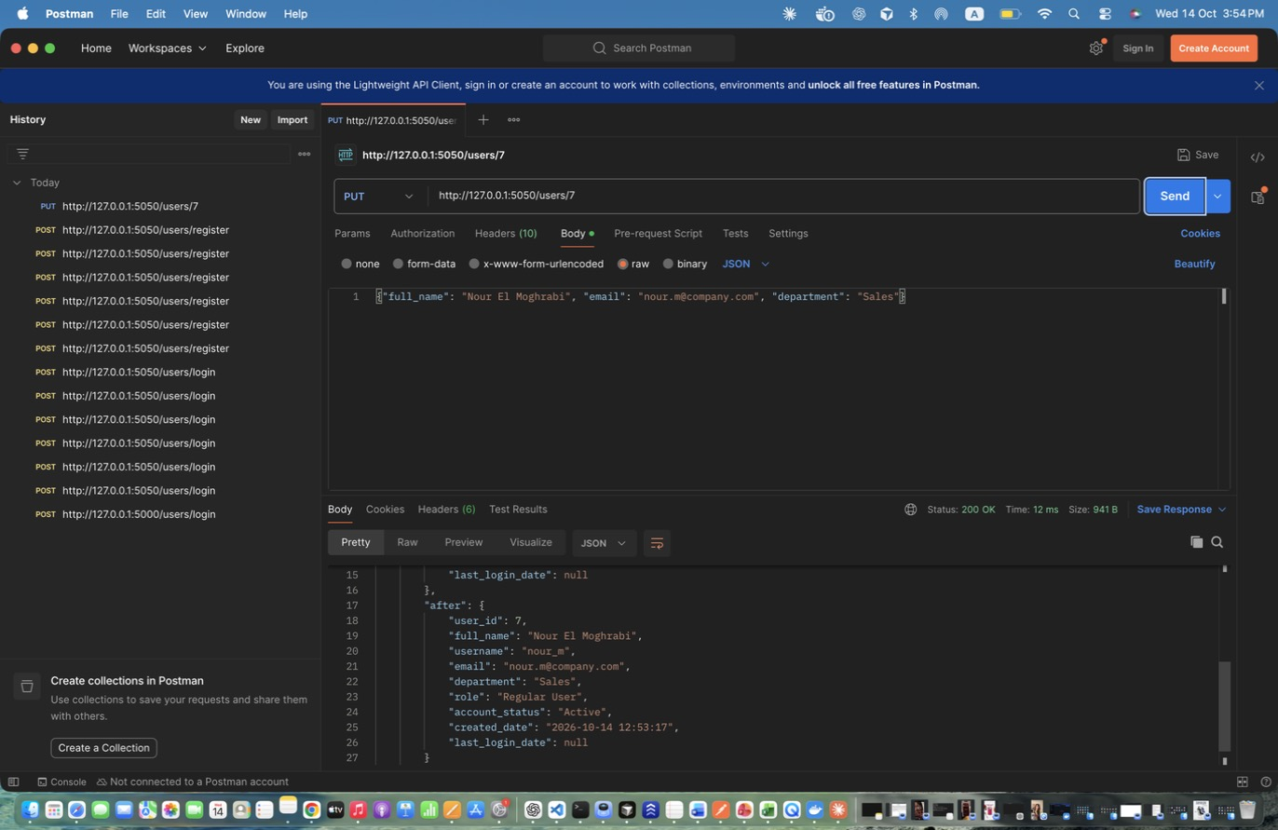
Figure 14: Maya Zeaiter – Update User (admin) – Admin updates name/email/department (and may change role/account_status). Response shows before and after. (response scrolled to show the rest)
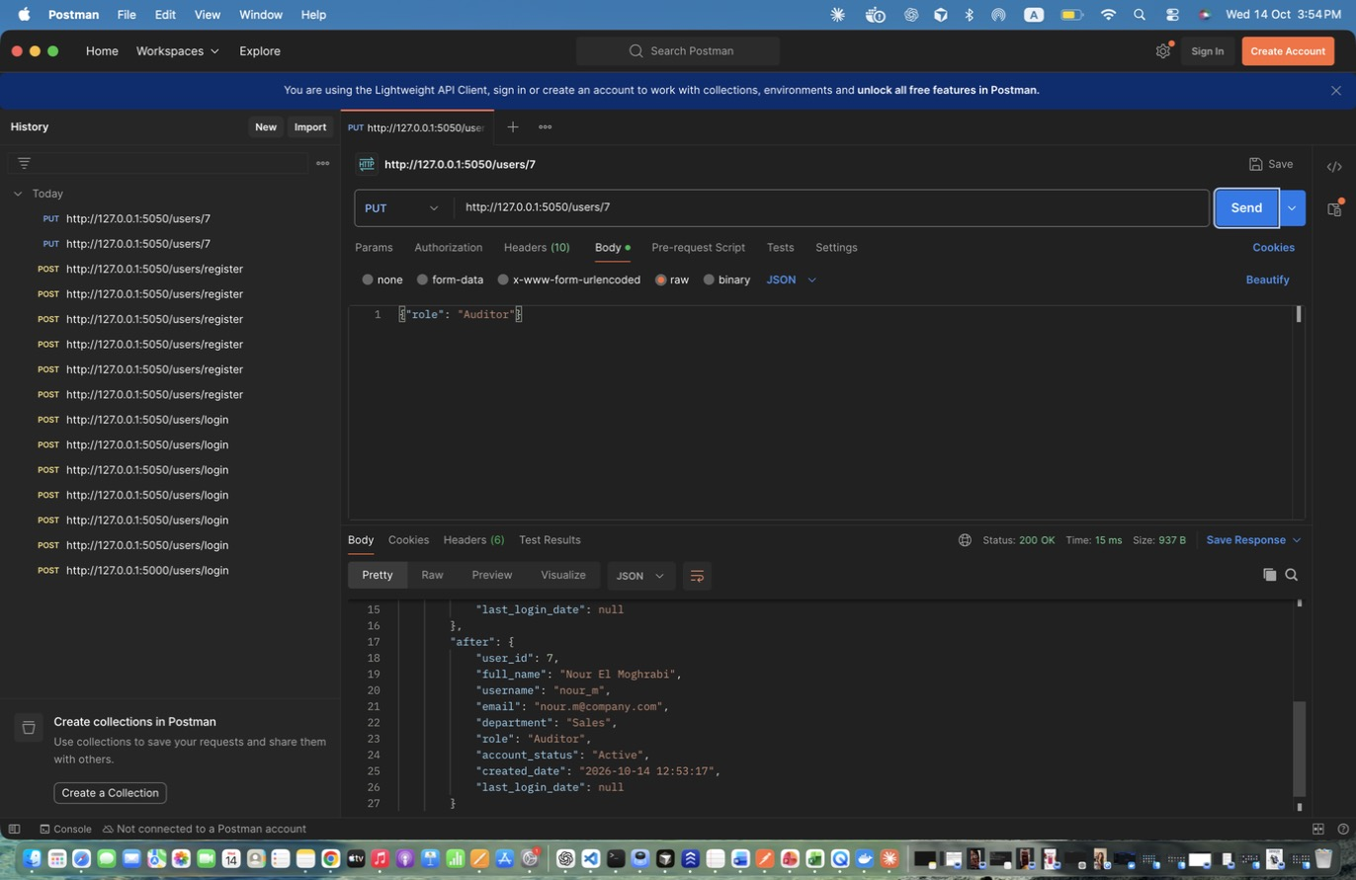
Figure 15: Maya Zeaiter – Update User - change role (admin) – Role change; writes a ROLE_CHANGED audit log.
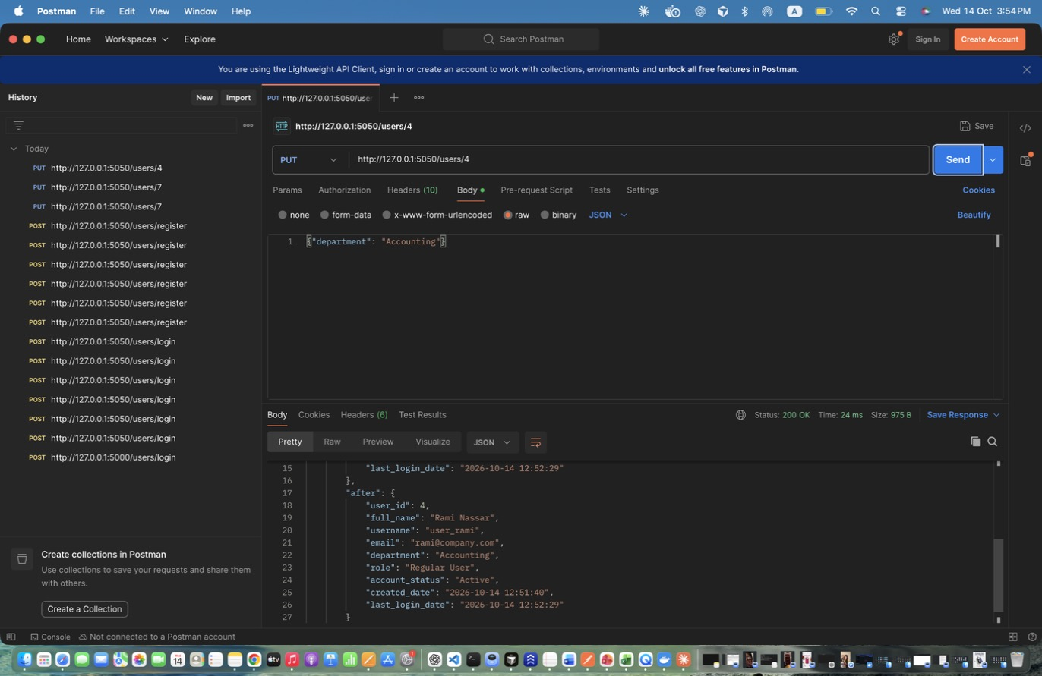
Figure 16: Maya Zeaiter – Update OWN info (regular user) – Regular user (id 4) updates their own department.
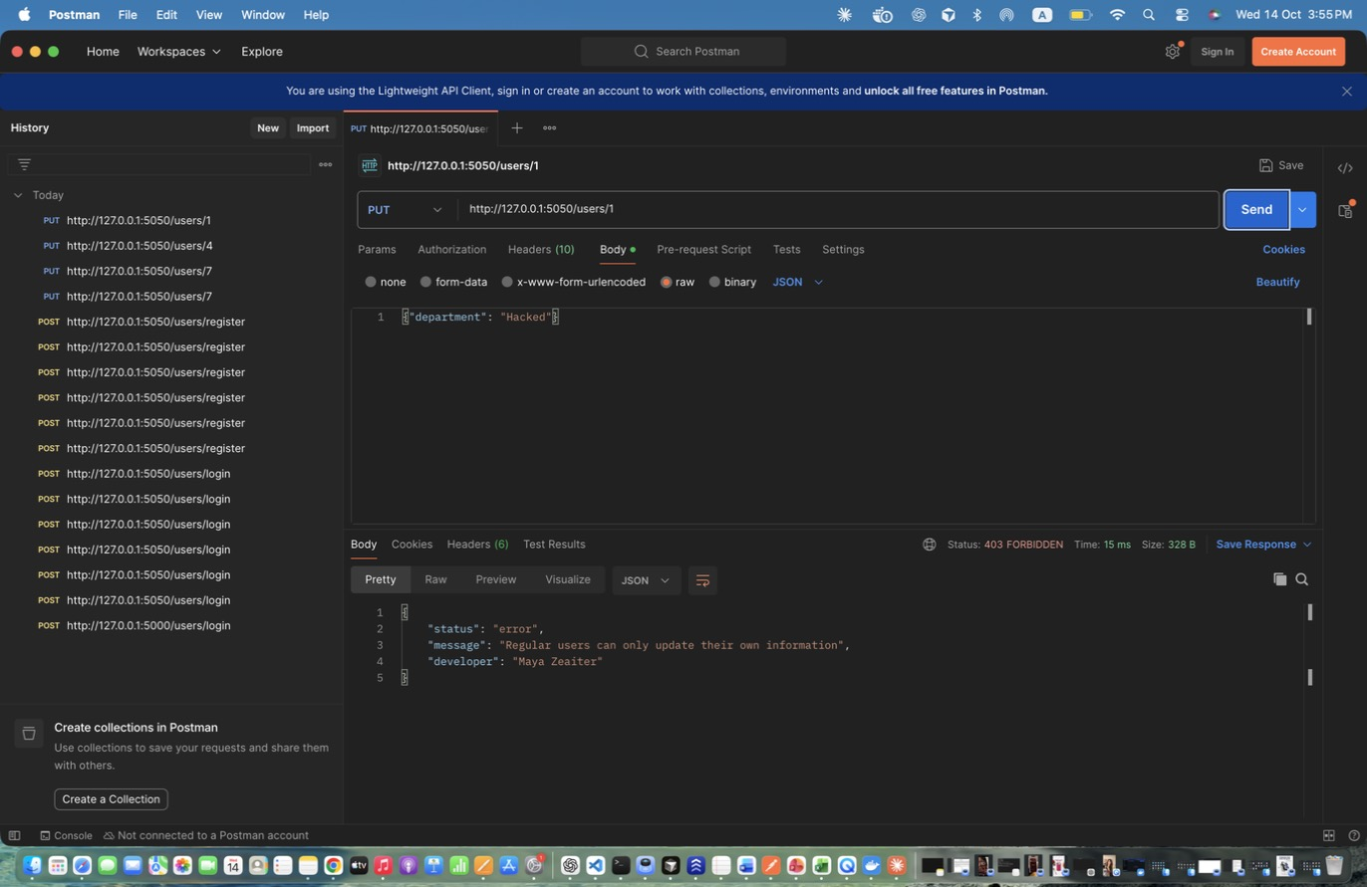
Figure 17: Maya Zeaiter – Update OTHER user (regular user) - DENIED – Regular user trying to edit someone else -> 403.
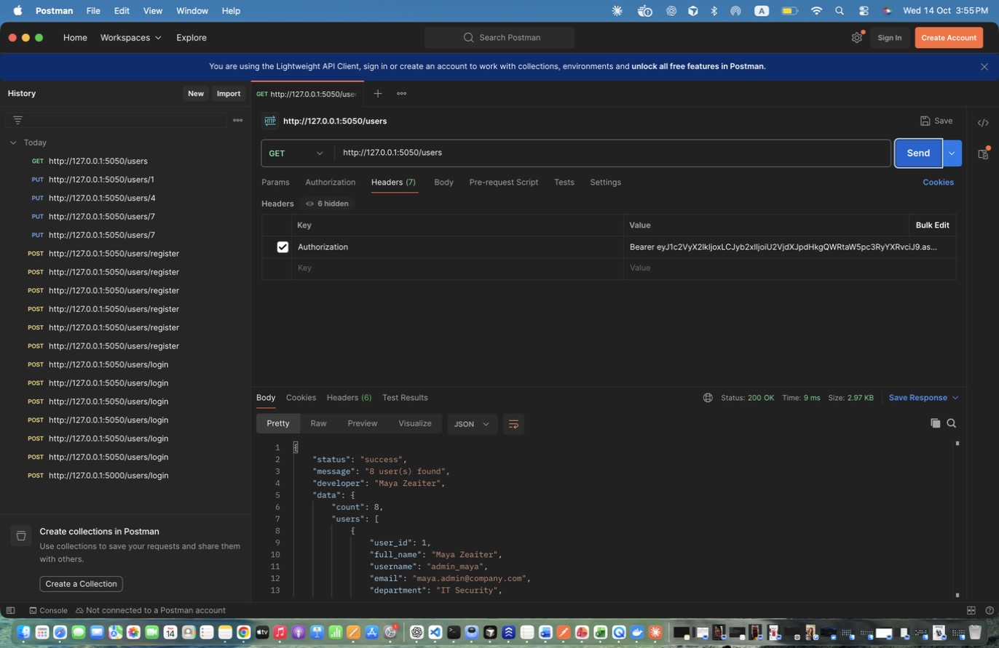
Figure 18: Maya Zeaiter – Retrieve All Users (admin) – Returns count + list of users (password hashes are never returned).
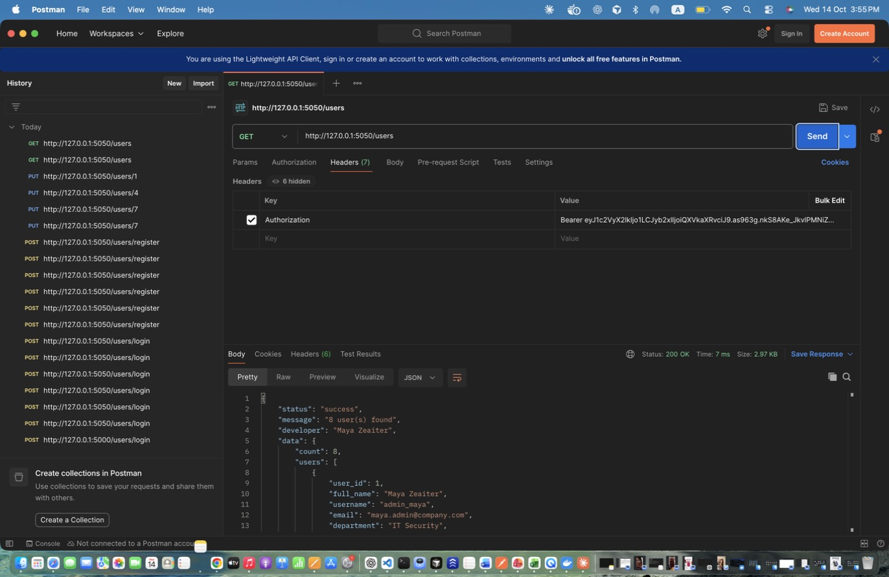
Figure 19: Maya Zeaiter – Retrieve All Users (auditor) – Auditor has read-only access.
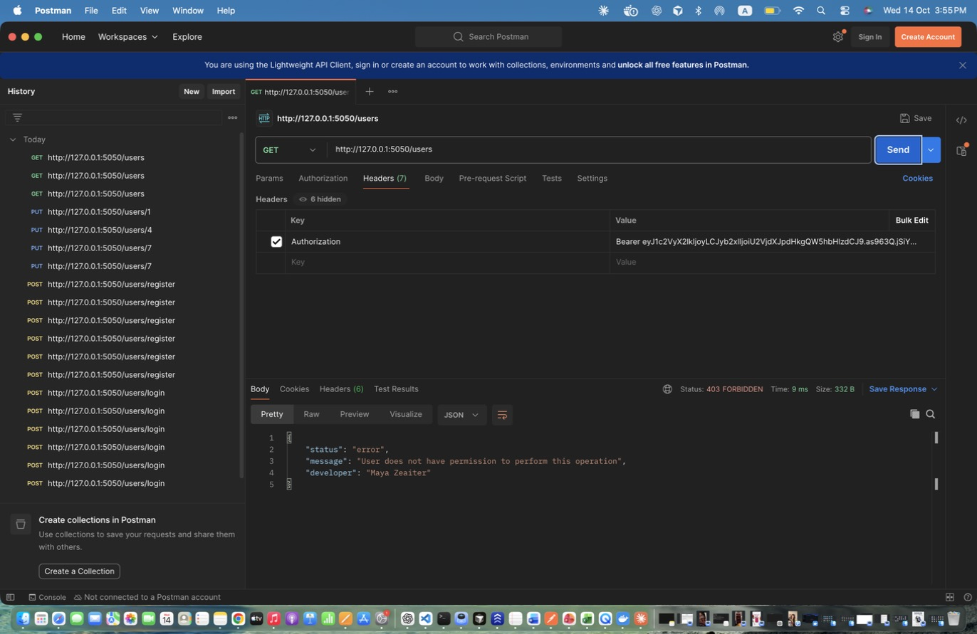
Figure 20: Maya Zeaiter – Retrieve All Users (analyst) - DENIED – Analysts have no user-management access -> 403.
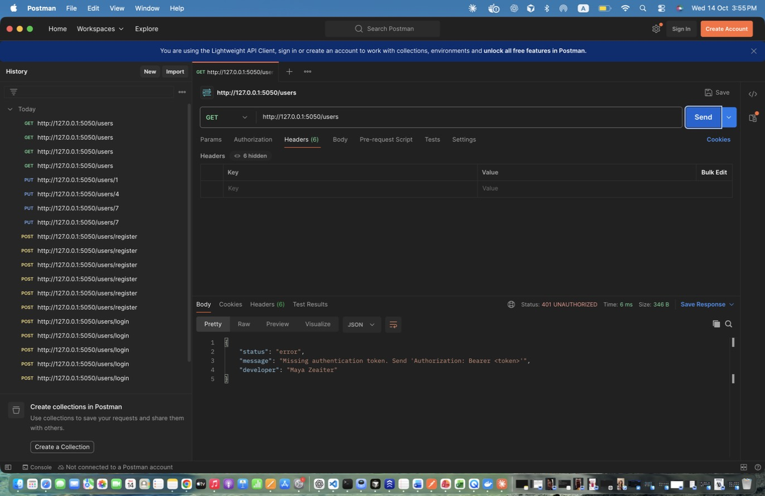
Figure 21: Maya Zeaiter – Retrieve All Users - NO TOKEN – Missing authentication -> 401.
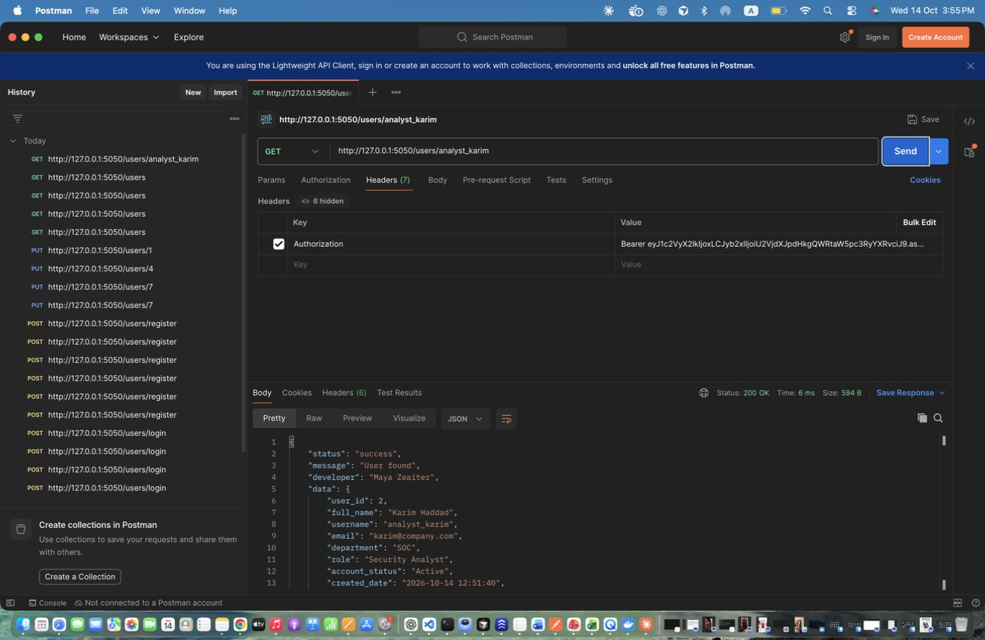
Figure 22: Maya Zeaiter – Retrieve User By Username - existing – Existing user -> 200.
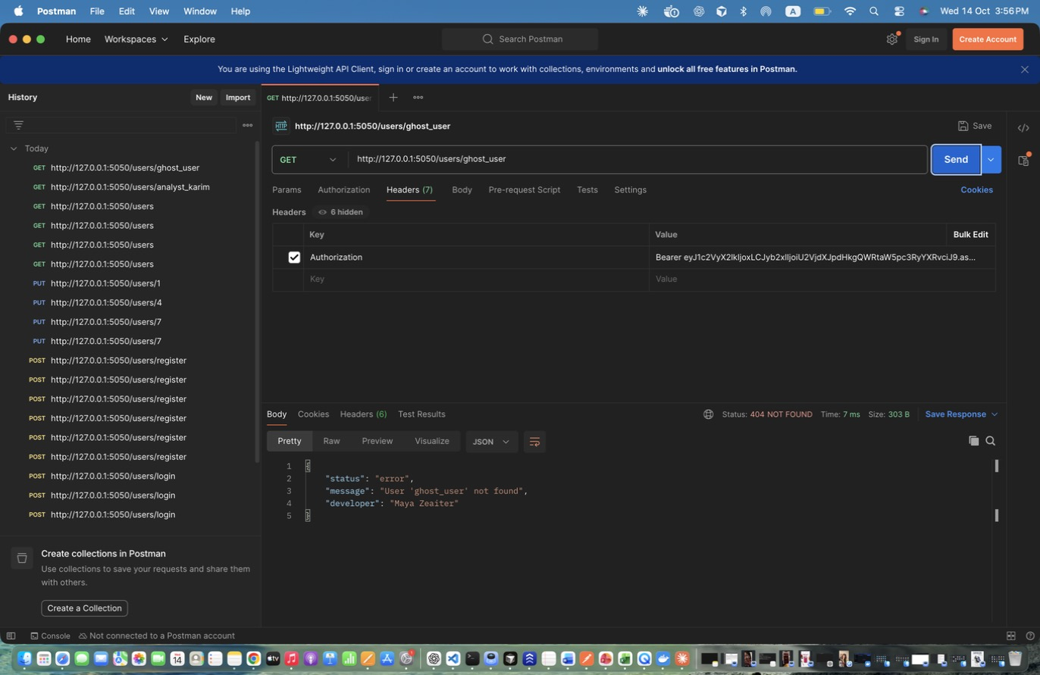
Figure 23: Maya Zeaiter – Retrieve User By Username - non-existing – Unknown username -> 404.
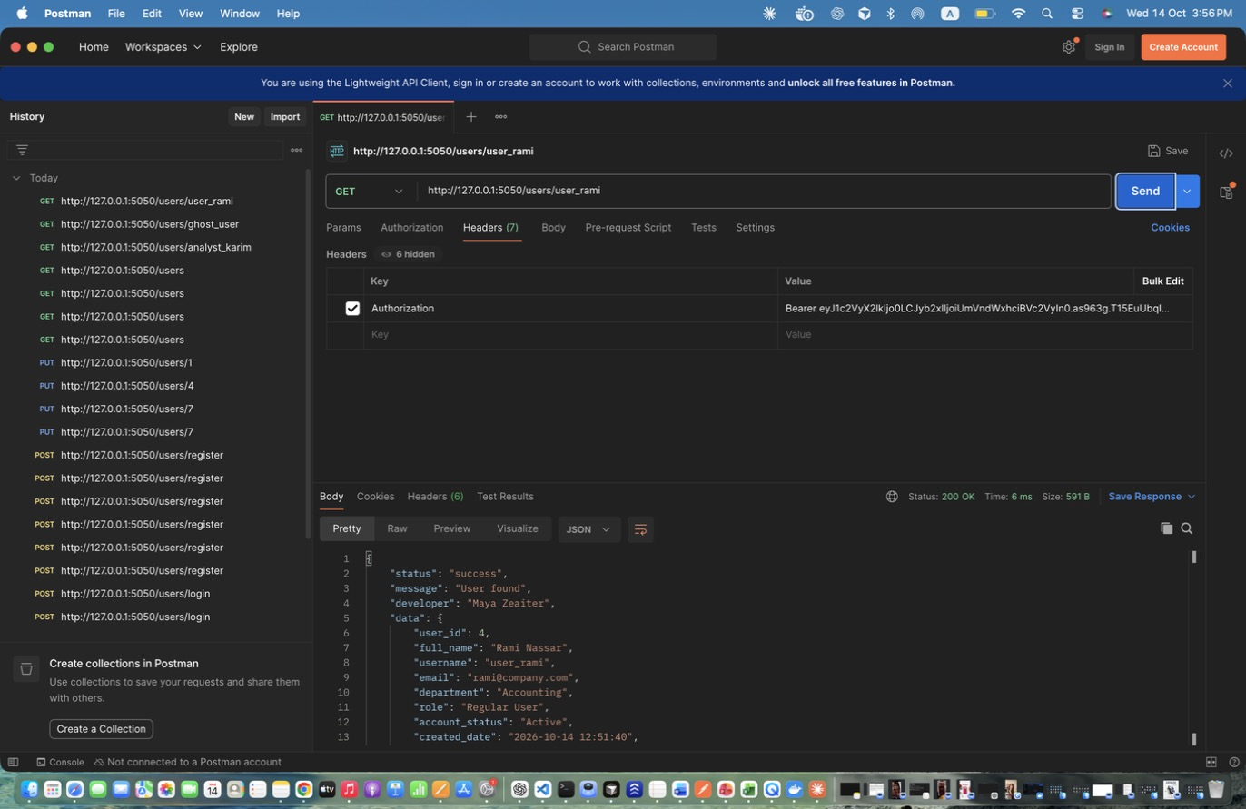
Figure 24: Maya Zeaiter – Retrieve OWN info (regular user) – Regular user reads their own profile.
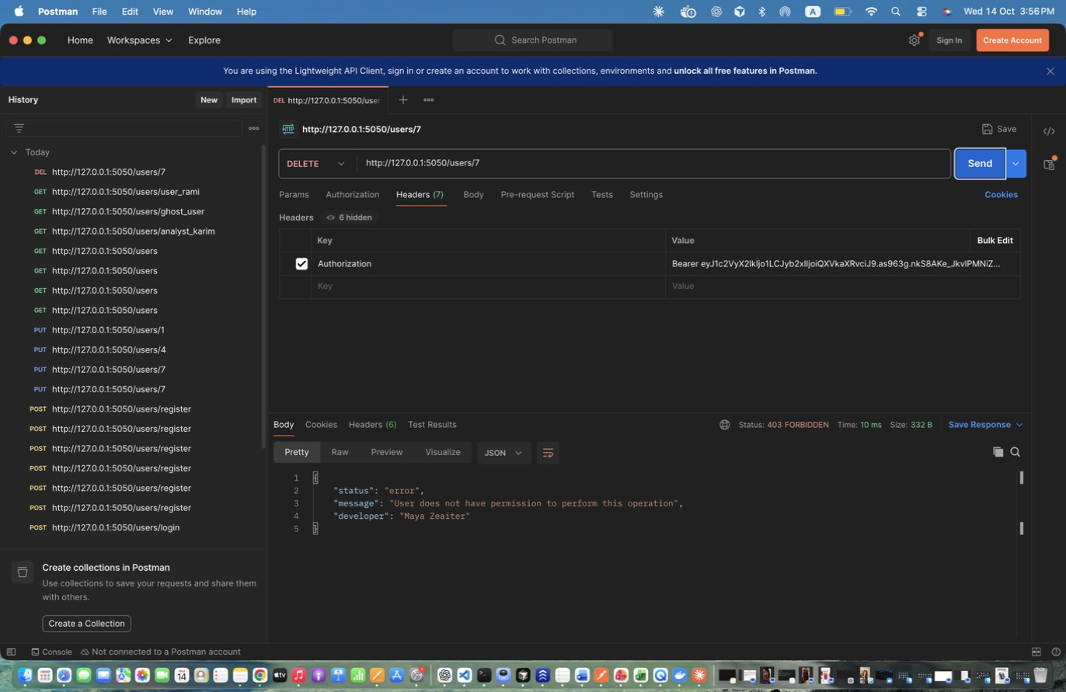
Figure 25: Maya Zeaiter – Delete User - unauthorized (auditor) – Auditor cannot delete -> 403 and UNAUTHORIZED_ACCESS log.
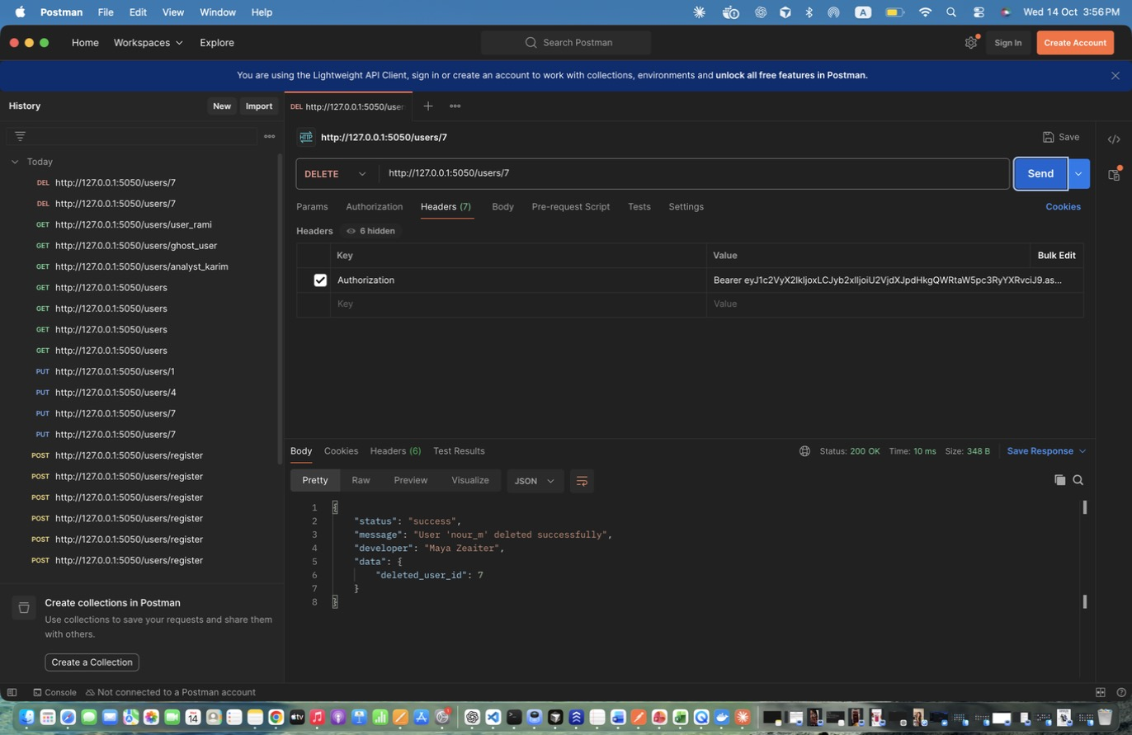
Figure 26: Maya Zeaiter – Delete User (admin) – Successful deletion; writes USER_DELETED log.
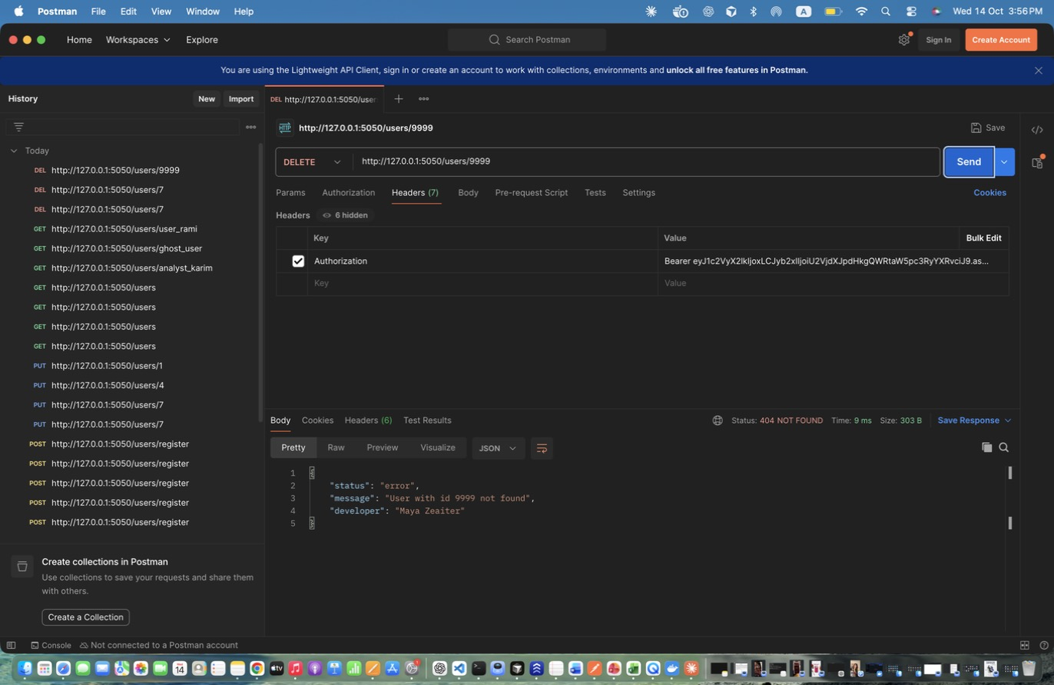
Figure 27: Maya Zeaiter – Delete User - not found – Unknown id -> 404.

2. Asset Management (Maya Zeaiter)
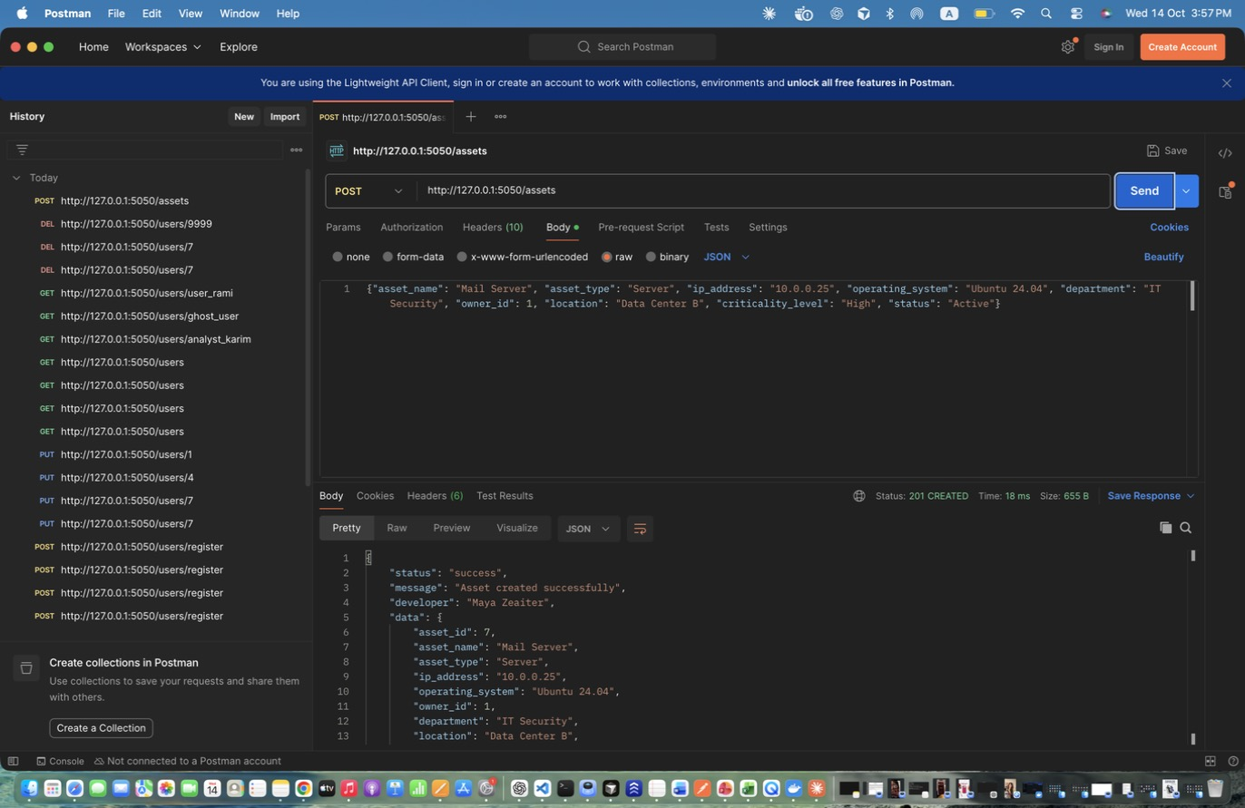
Figure 28: Maya Zeaiter – Add Asset - Server – Creates an asset. Stores id in asset_id.
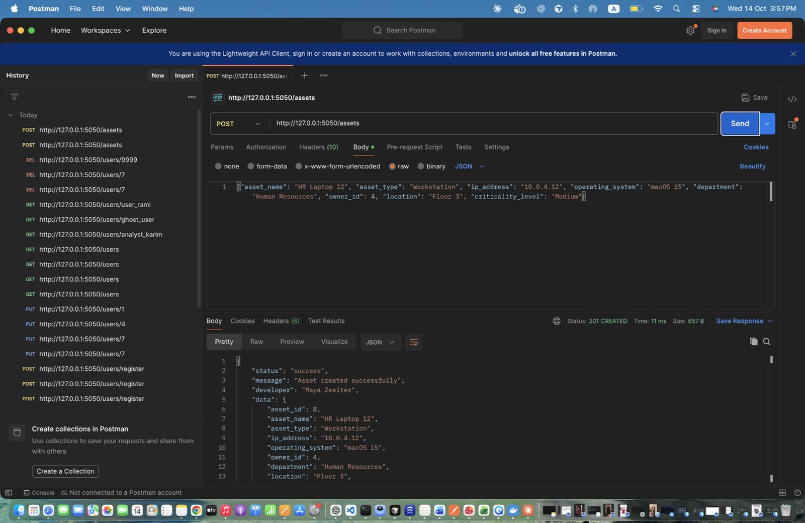
Figure 29: Maya Zeaiter – Add Asset - Workstation – Second asset with Medium criticality.
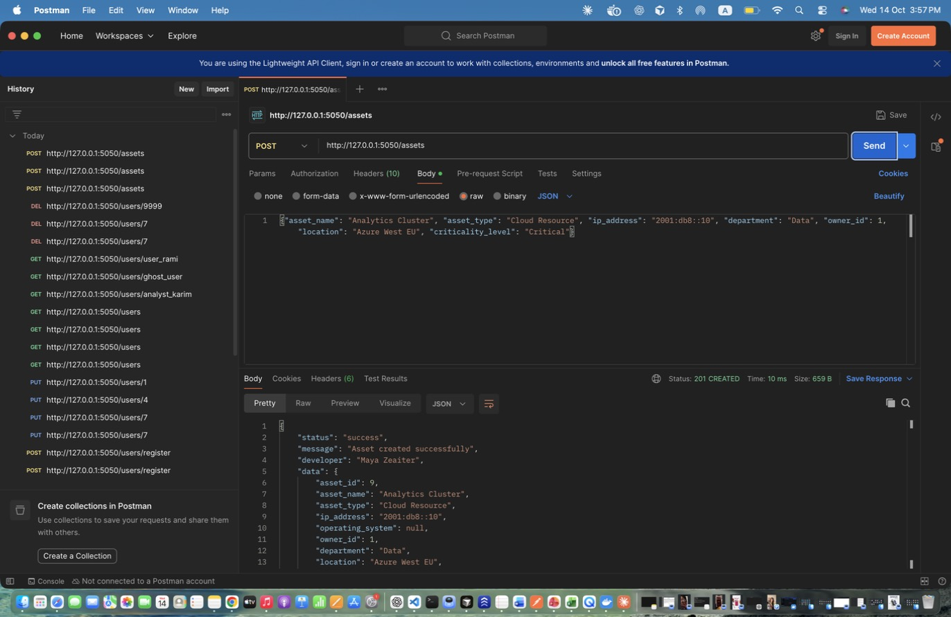
Figure 30: Maya Zeaiter – Add Asset - Cloud (IPv6) – IPv6 addresses are also accepted.
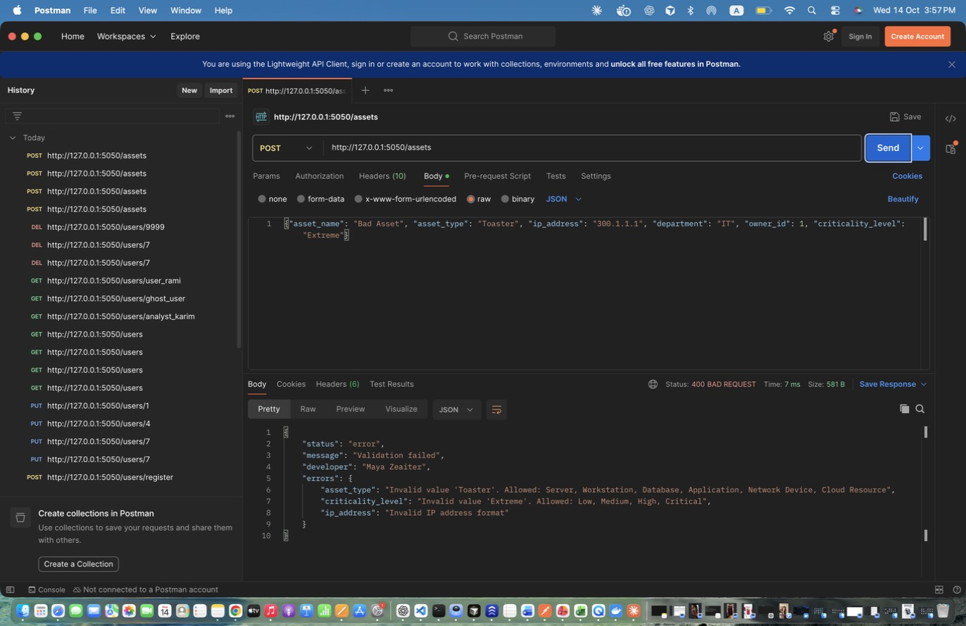
Figure 31: Maya Zeaiter – Add Asset - INVALID input – Invalid IP, type and criticality -> 400.
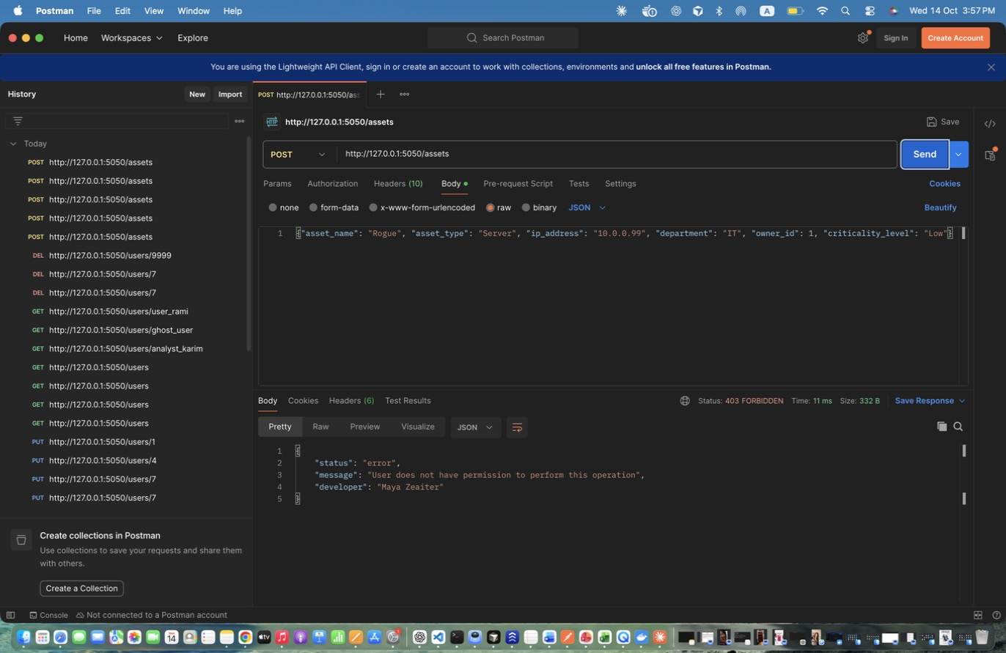
Figure 32: Maya Zeaiter – Add Asset - analyst DENIED – Only admins create assets -> 403.
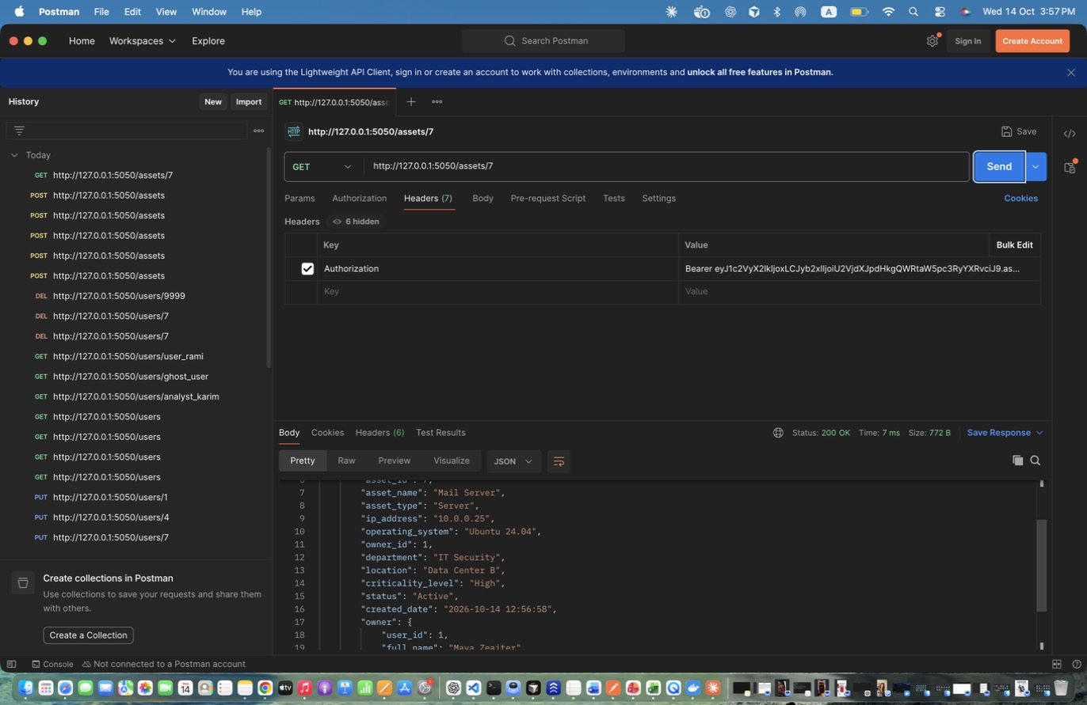
Figure 33: Maya Zeaiter – Retrieve Specific Asset (before update) – Use as the 'before' screenshot.
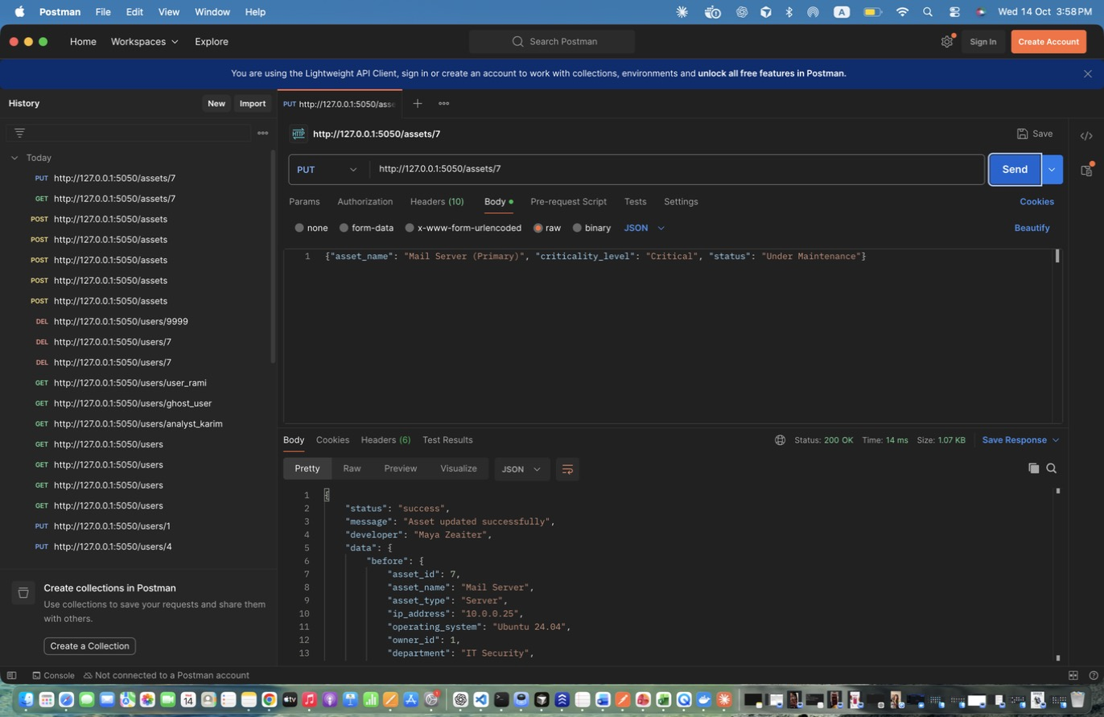
Figure 34: Maya Zeaiter – Update Asset – Updates name/owner/department/criticality/status; response includes before and after.
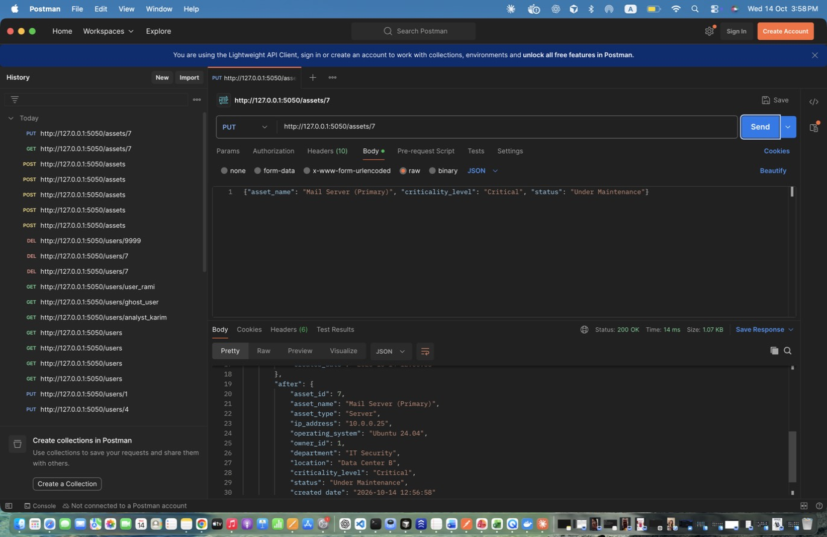
Figure 35: Maya Zeaiter – Update Asset – Updates name/owner/department/criticality/status; response includes before and after. (response scrolled to show the rest)
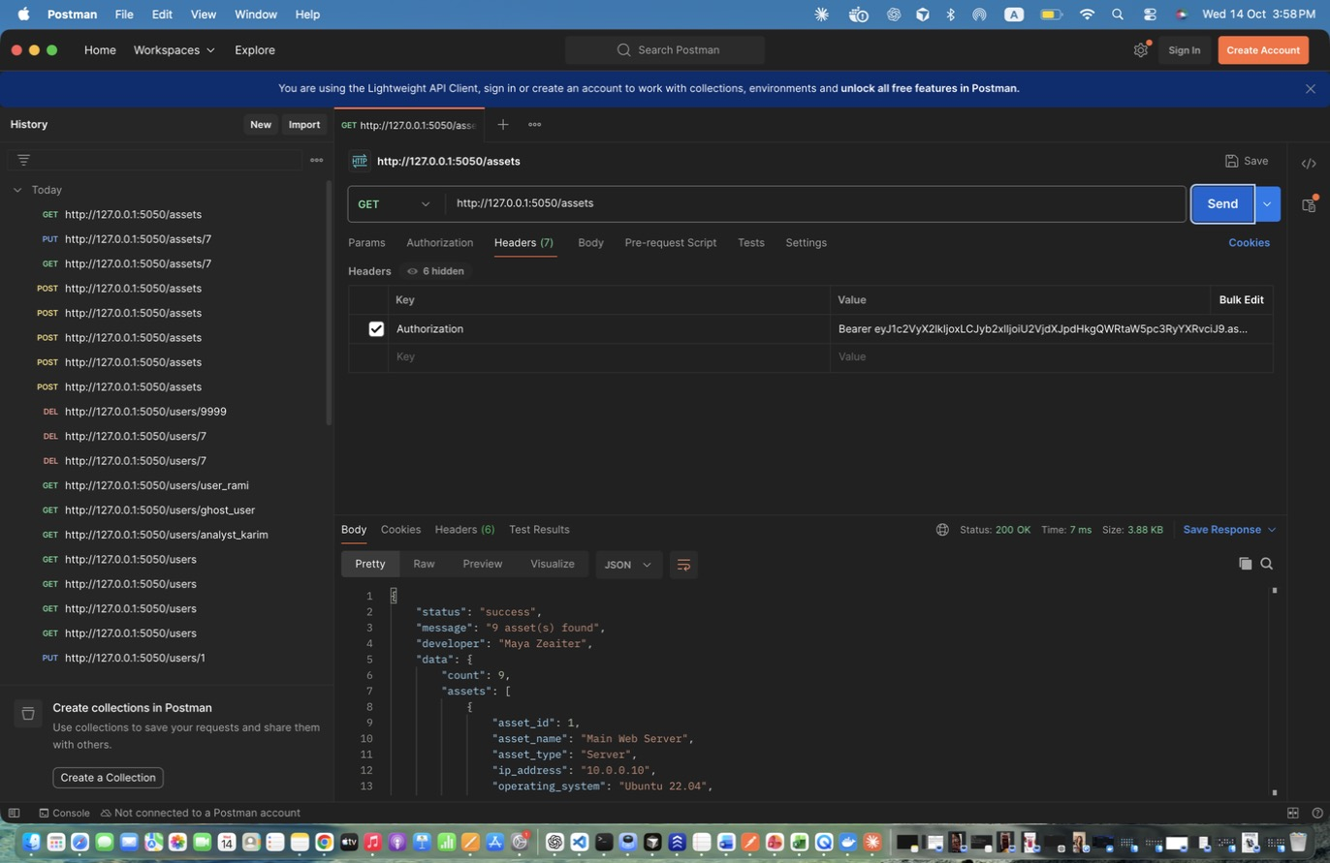
Figure 36: Maya Zeaiter – Retrieve All Assets (admin) – All assets with criticality and status.
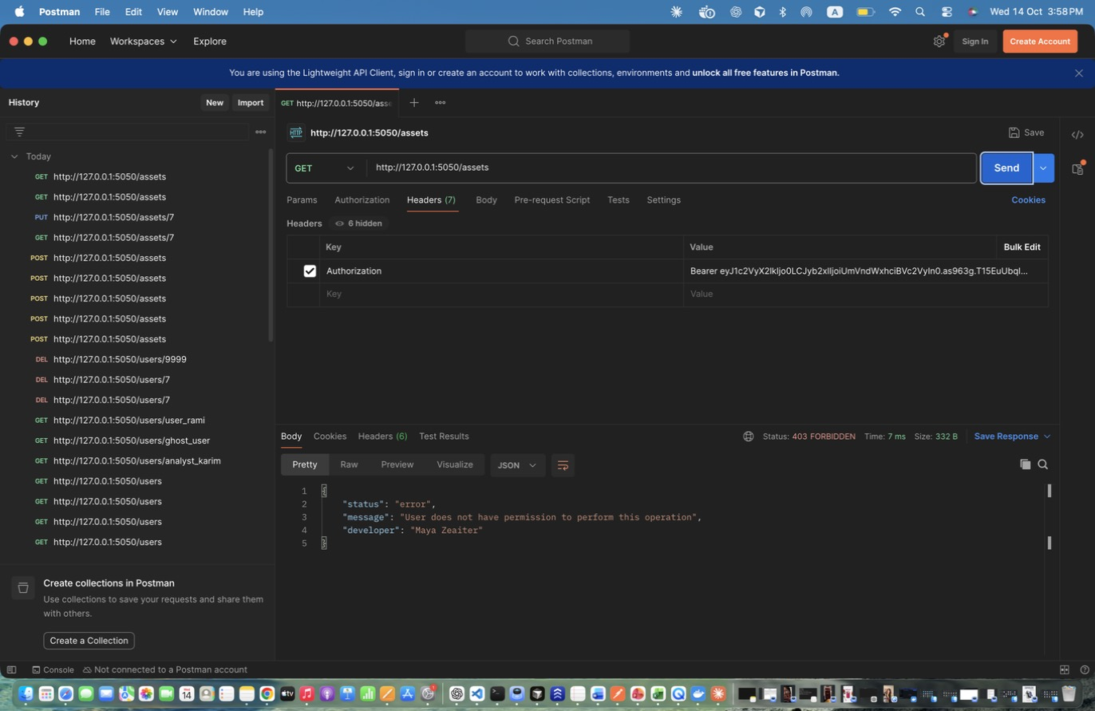
Figure 37: Maya Zeaiter – Retrieve All Assets (regular user) - DENIED – Regular users have no asset access -> 403.
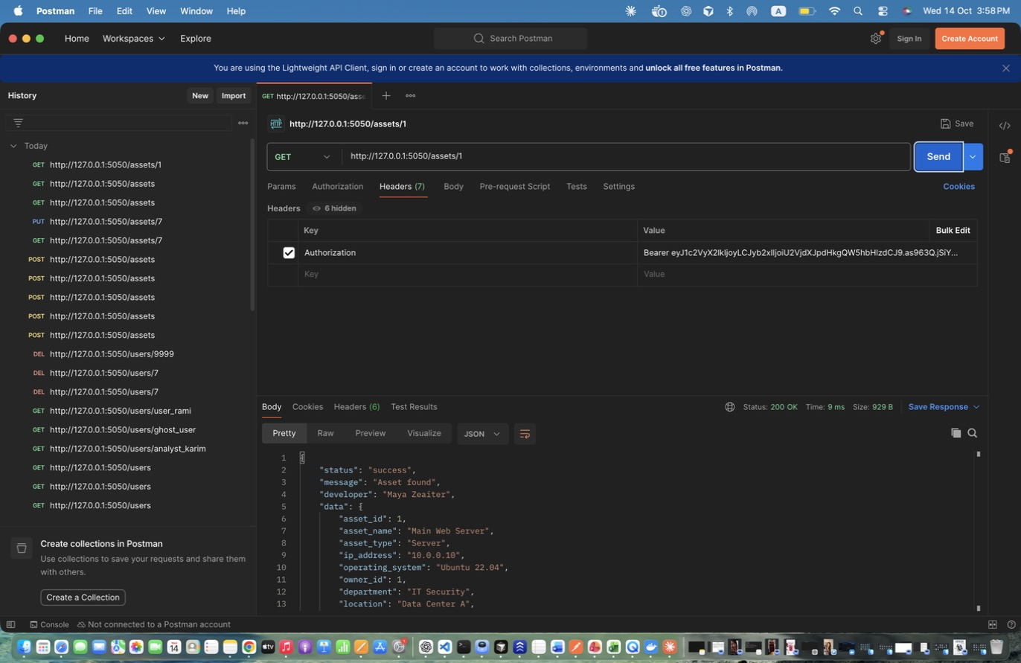
Figure 38: Maya Zeaiter – Retrieve Specific Asset (analyst) – Includes owner and related incidents.
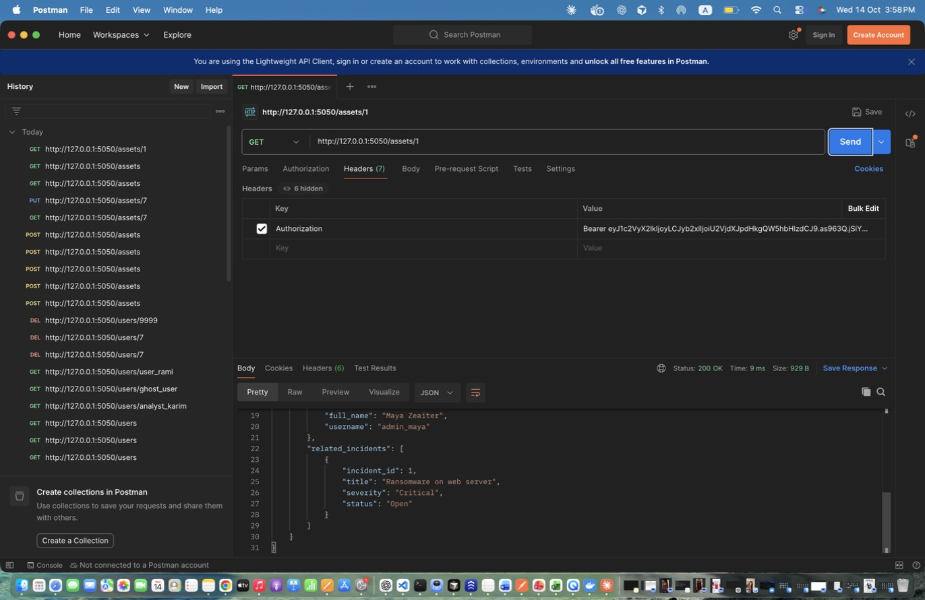
Figure 39: Maya Zeaiter – Retrieve Specific Asset (analyst) – Includes owner and related incidents. (response scrolled to show the rest)
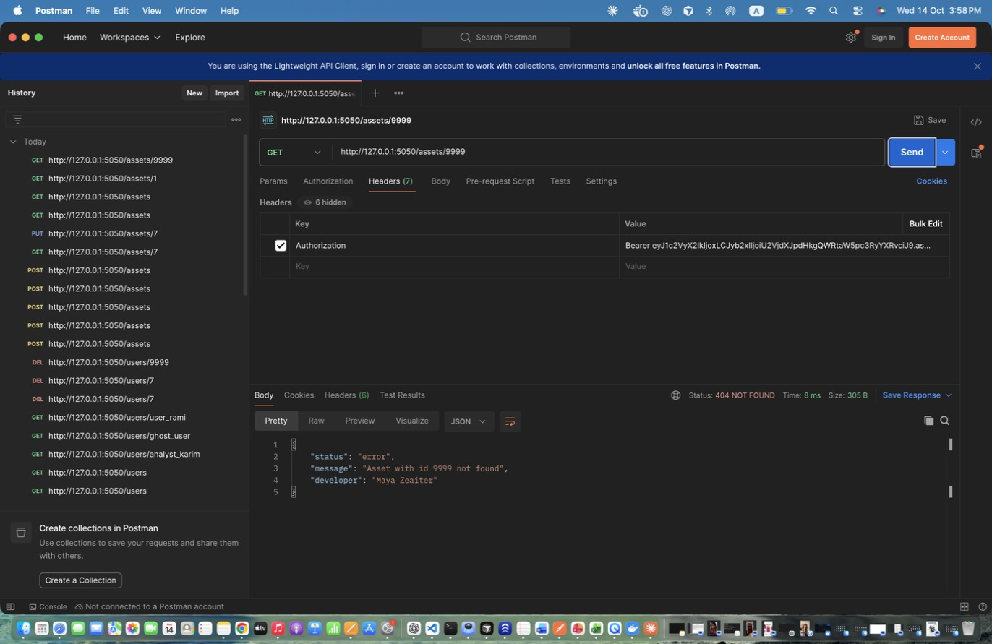
Figure 40: Maya Zeaiter – Retrieve Specific Asset - invalid id – -> 404.
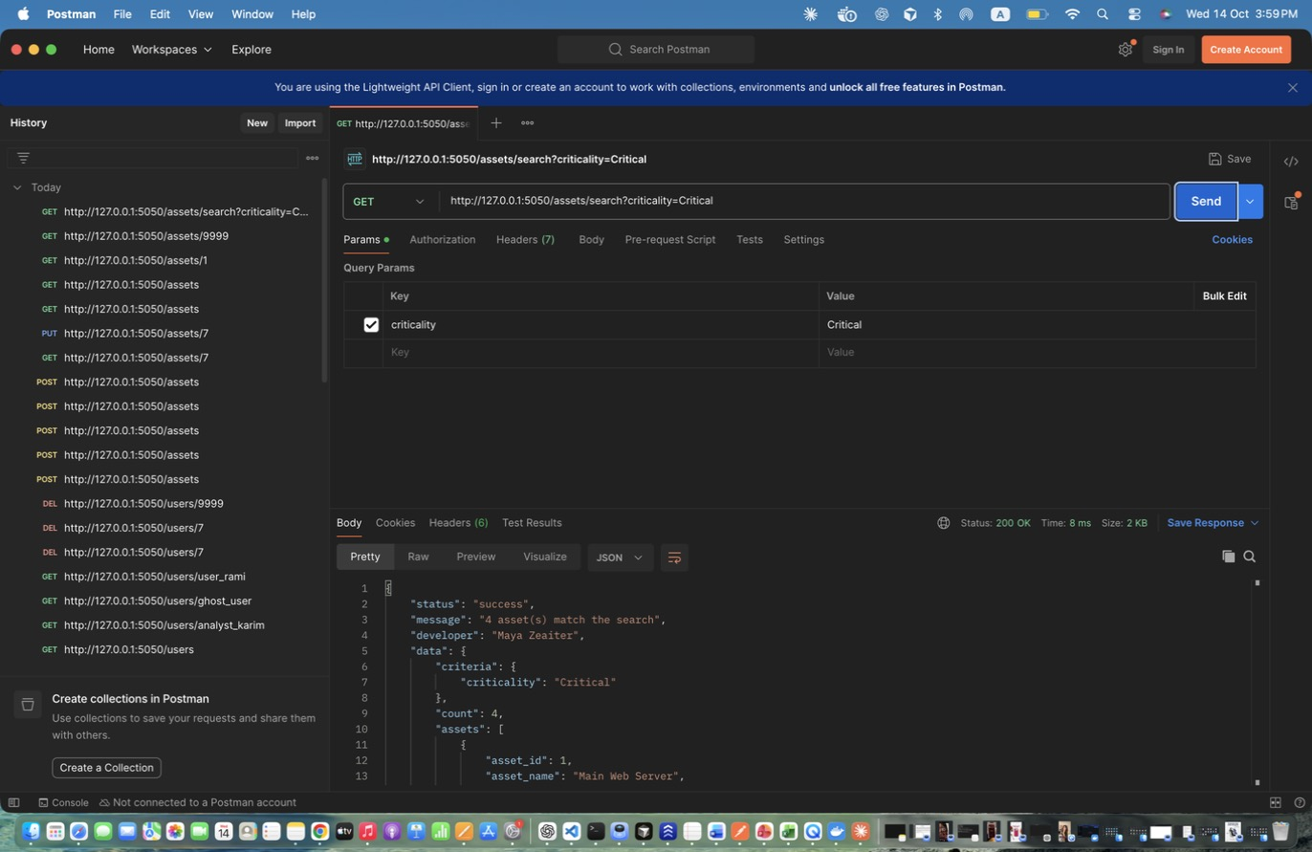
Figure 41: Maya Zeaiter – Search Assets - by criticality – Exact match on criticality level.
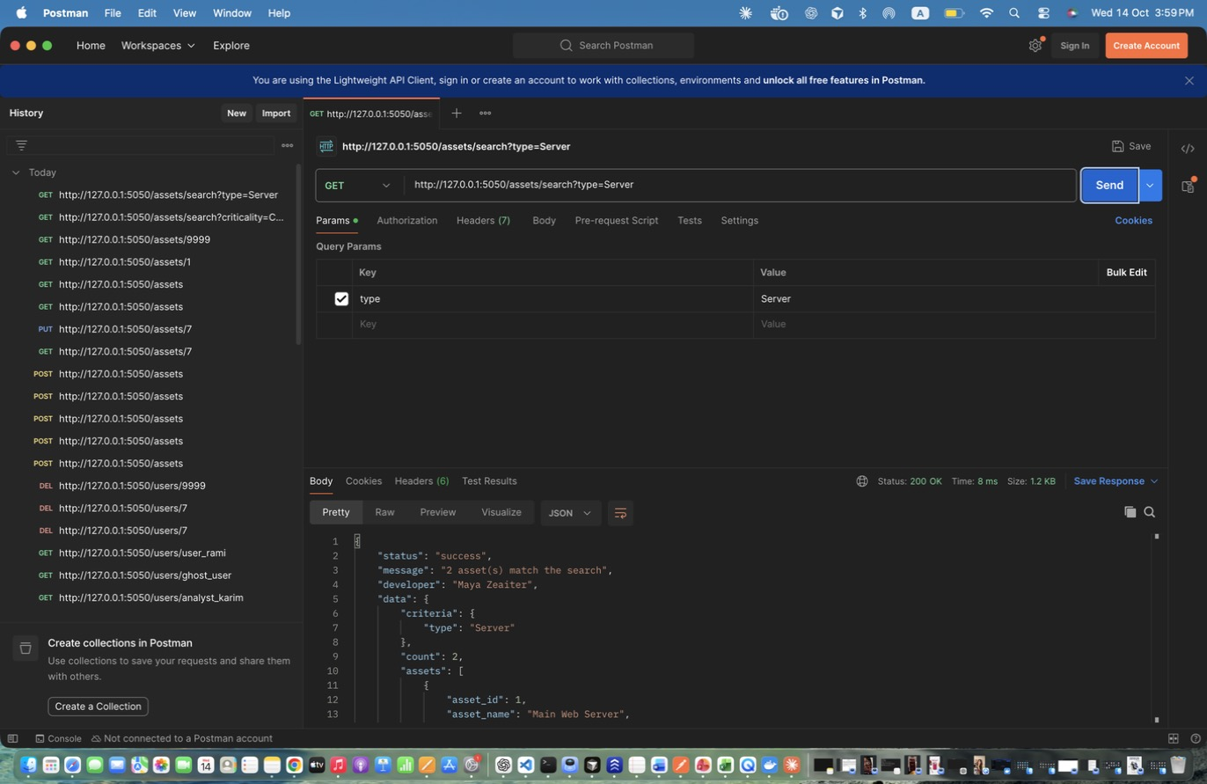
Figure 42: Maya Zeaiter – Search Assets - by type – Exact match on asset type.
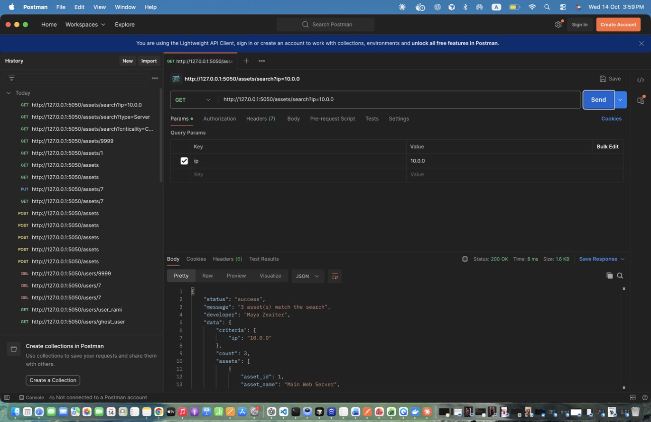
Figure 43: Maya Zeaiter – Search Assets - by IP prefix – Partial match on IP address.
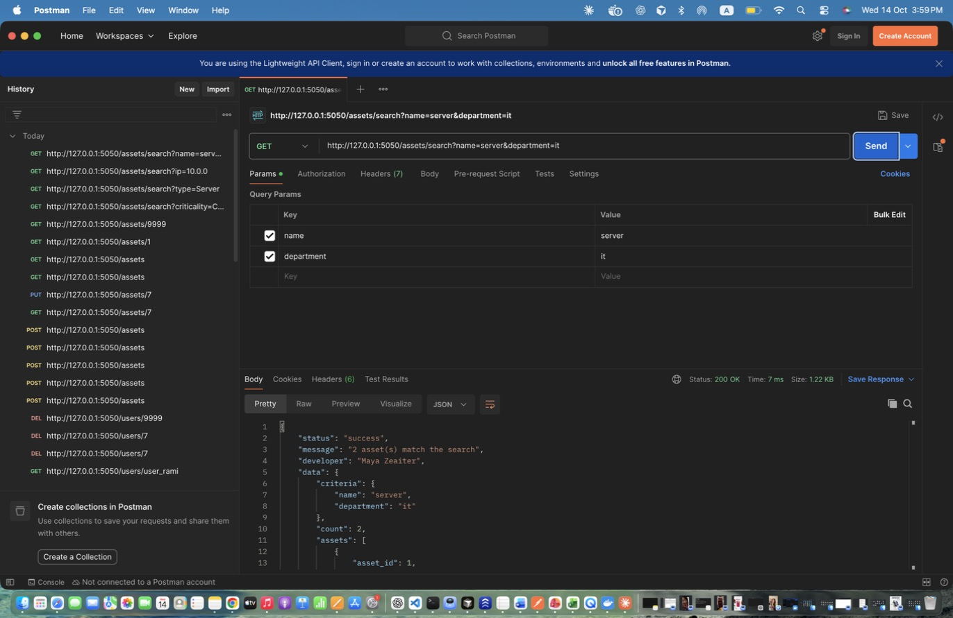
Figure 44: Maya Zeaiter – Search Assets - by name + department – Combined criteria (AND), case-insensitive partial match.
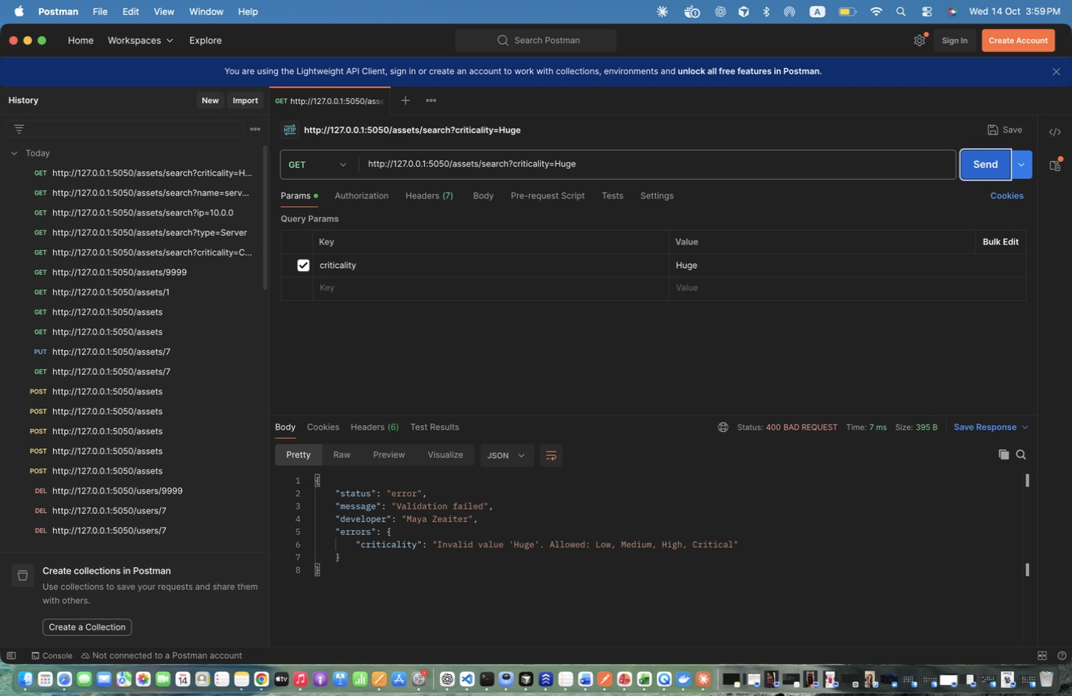
Figure 45: Maya Zeaiter – Search Assets - invalid criticality – -> 400.
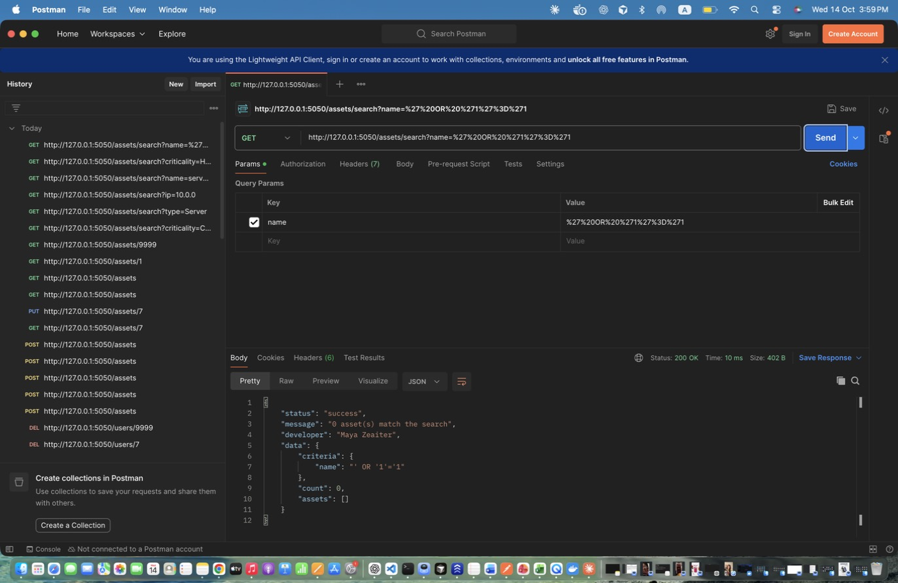
Figure 46: Maya Zeaiter – Search Assets - SQL injection attempt – Parameterised queries: returns 0 results instead of every row.
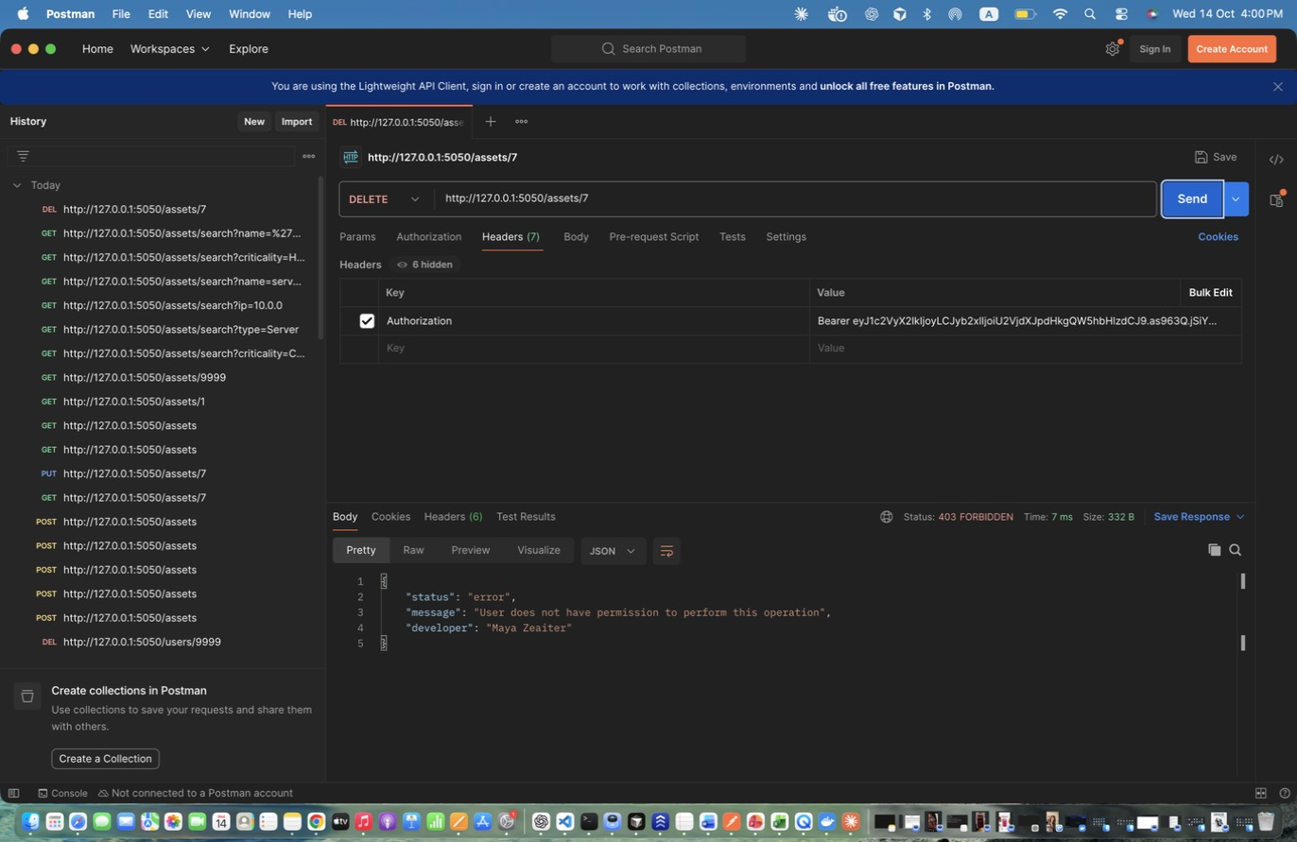
Figure 47: Maya Zeaiter – Delete Asset - analyst DENIED – -> 403.
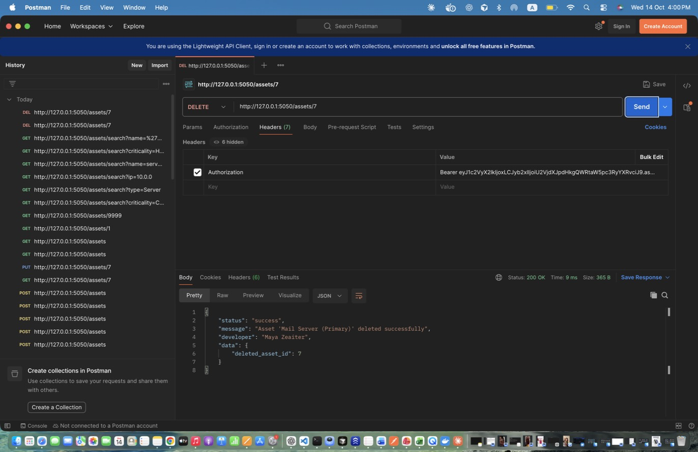
Figure 48: Maya Zeaiter – Delete Asset (admin) – Successful deletion.

3. Incident Management (Maya Zeaiter)
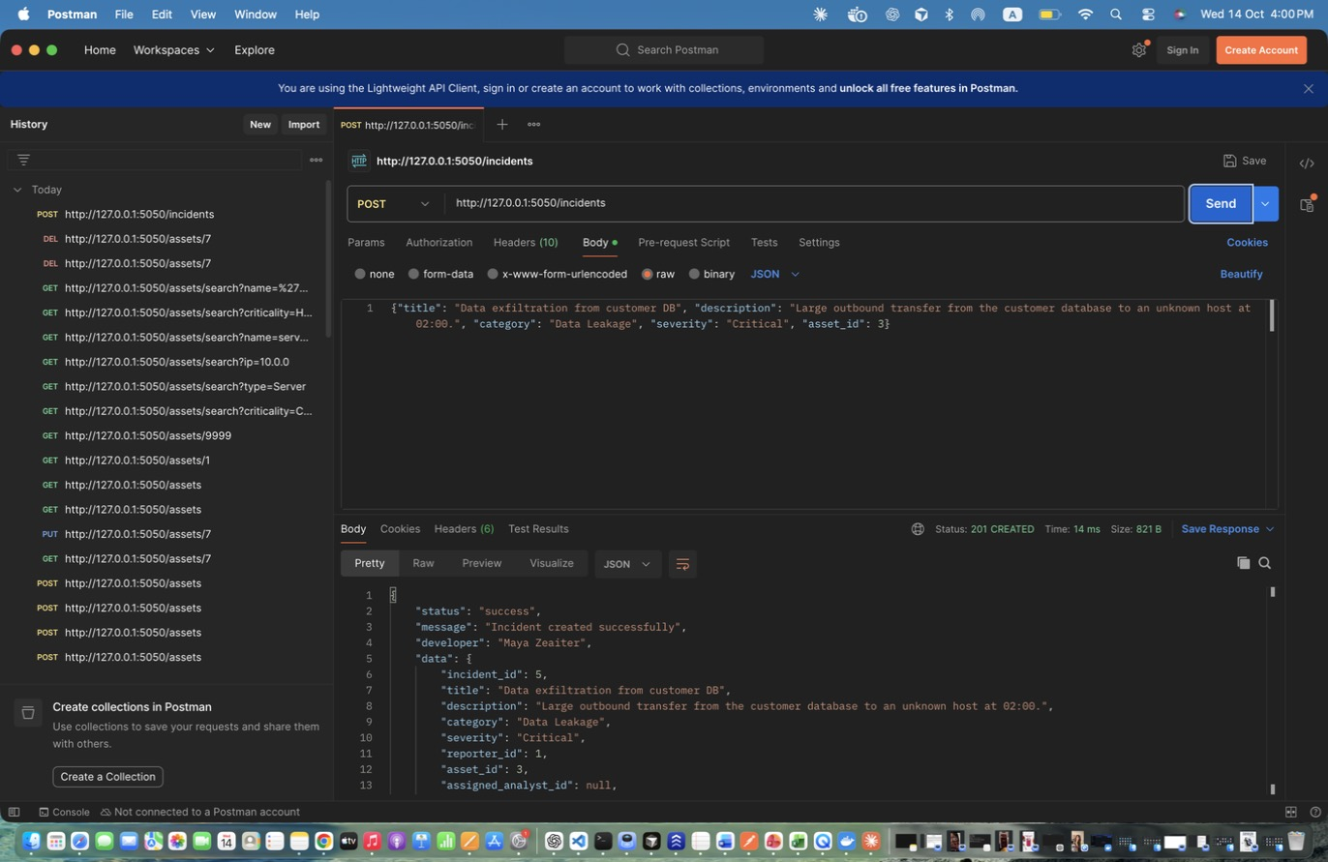
Figure 49: Maya Zeaiter – Create Incident - Critical (admin) – Admin reports a Critical incident. Stores id in incident_id.
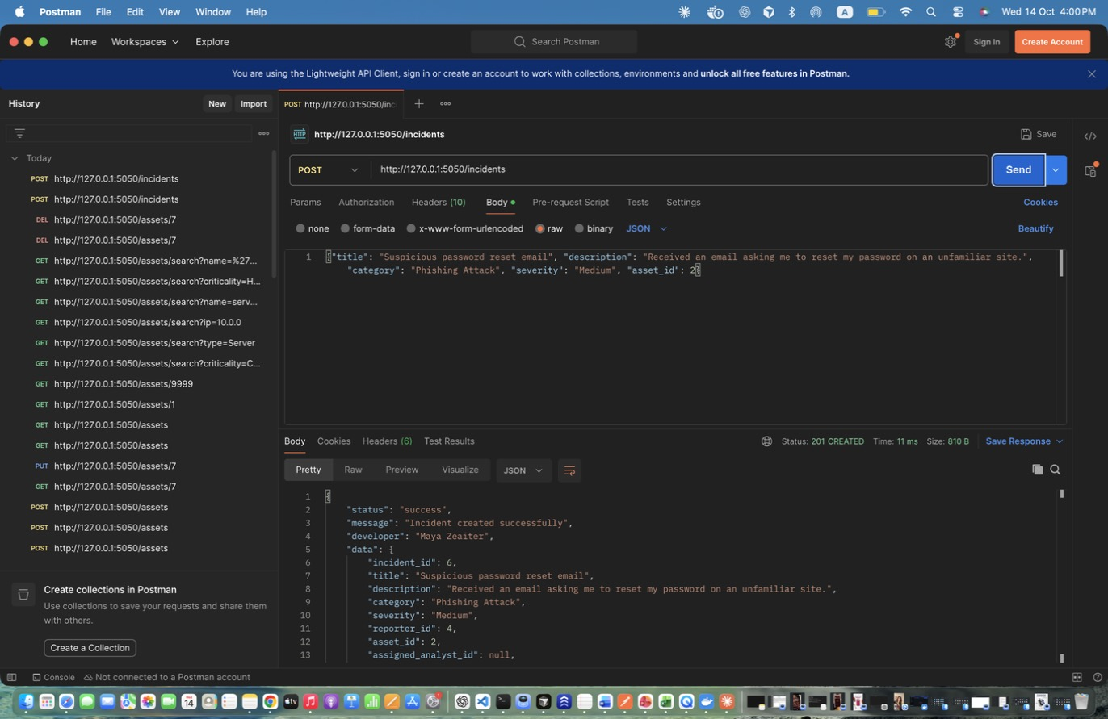
Figure 50: Maya Zeaiter – Create Incident - Medium (regular user) – Regular user reports; reporter is taken from the token.
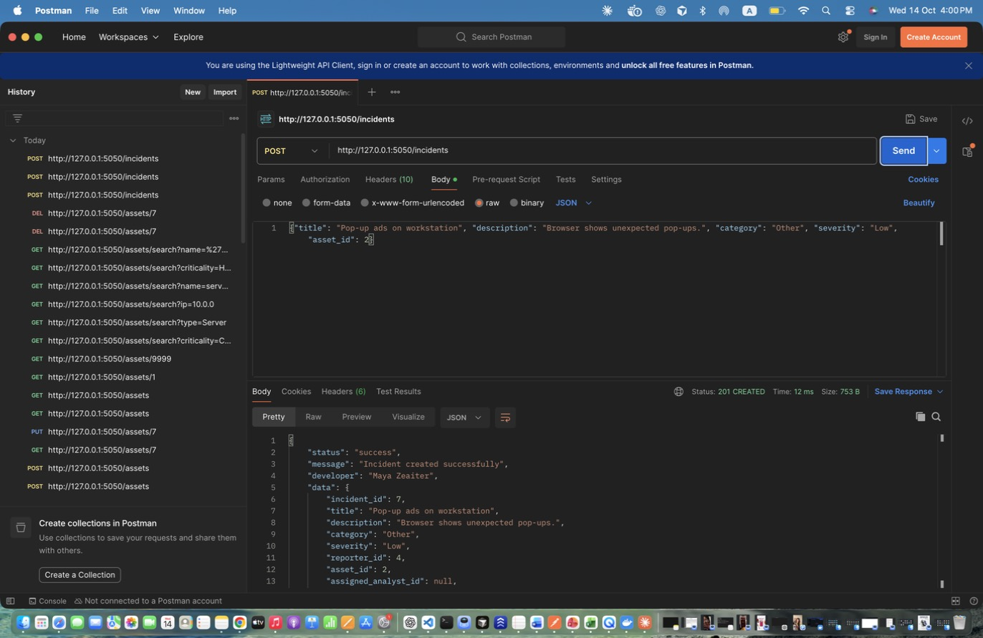
Figure 51: Maya Zeaiter – Create Incident - Low (regular user) – Low severity example.
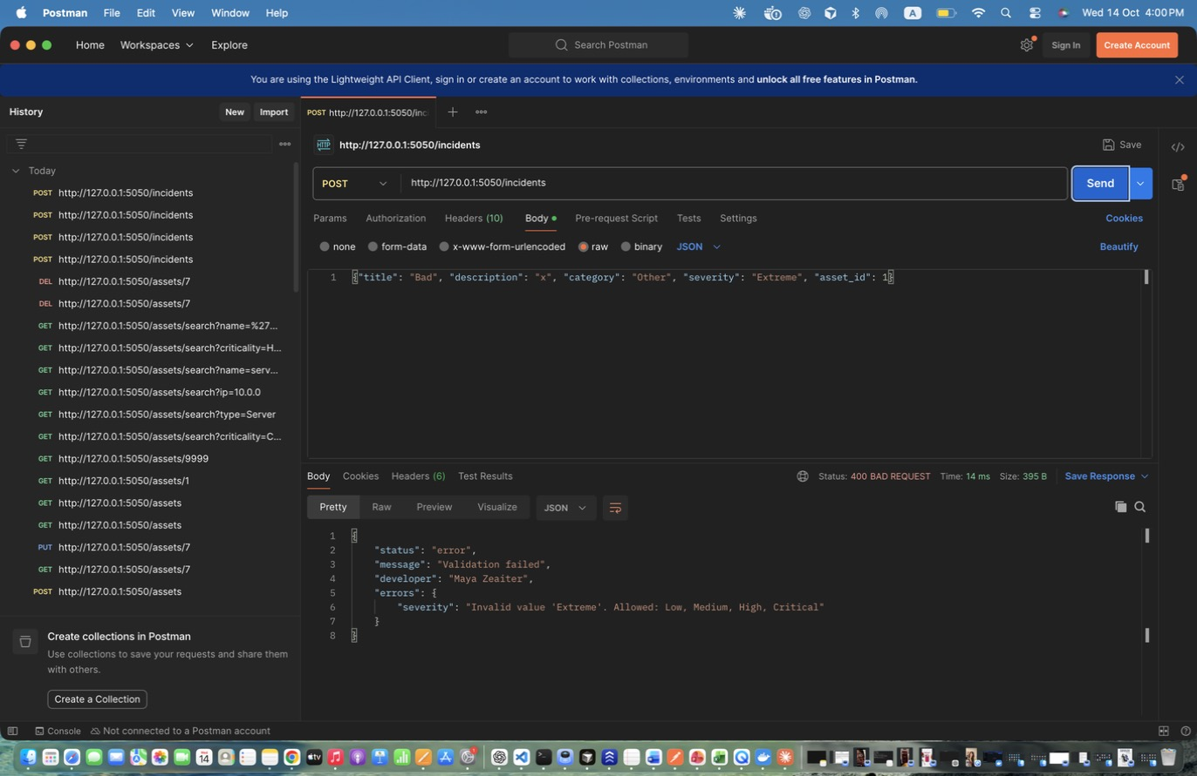
Figure 52: Maya Zeaiter – Create Incident - INVALID severity – -> 400.
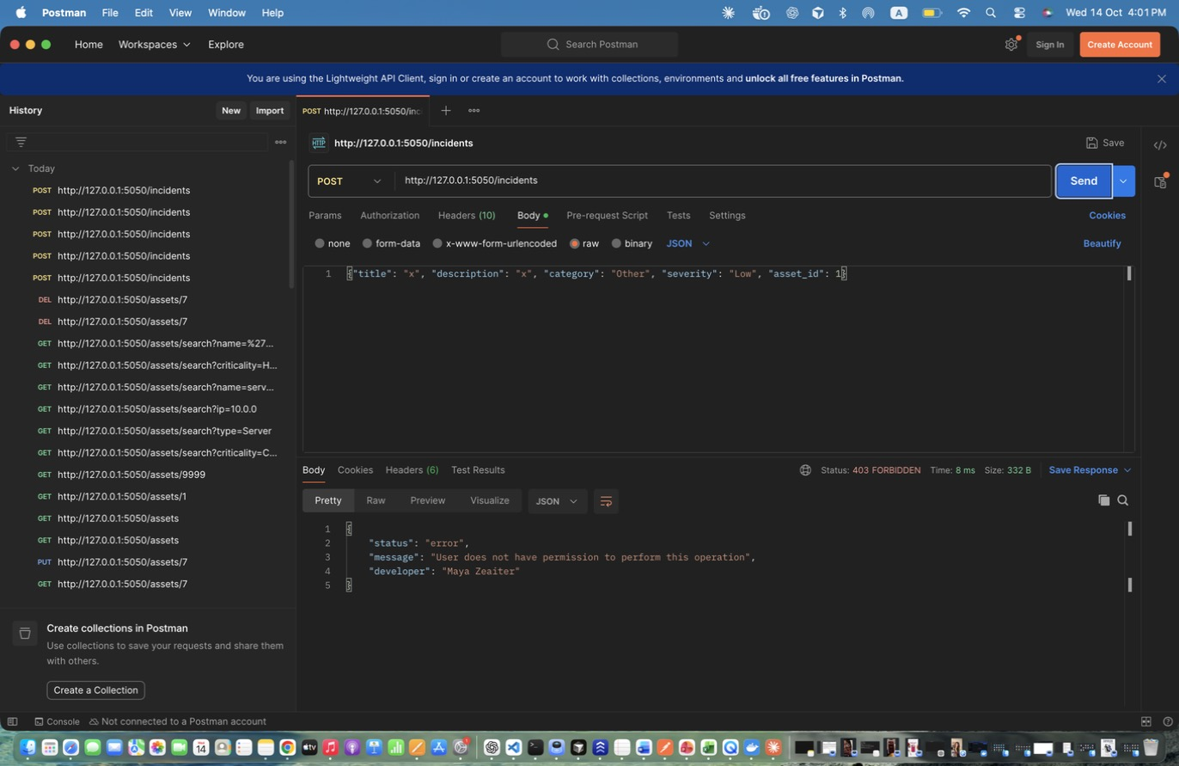
Figure 53: Maya Zeaiter – Create Incident - analyst DENIED – Analysts cannot create incidents -> 403.
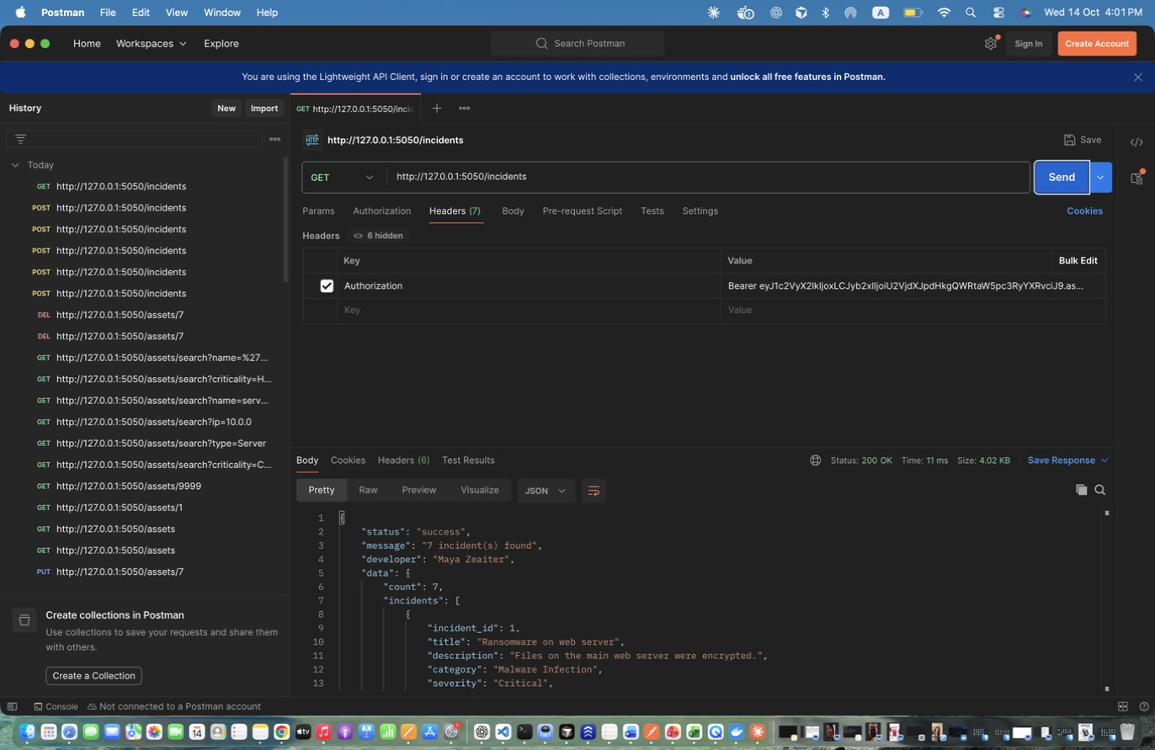
Figure 54: Maya Zeaiter – Retrieve All Incidents (admin) – Includes status and assigned analyst.
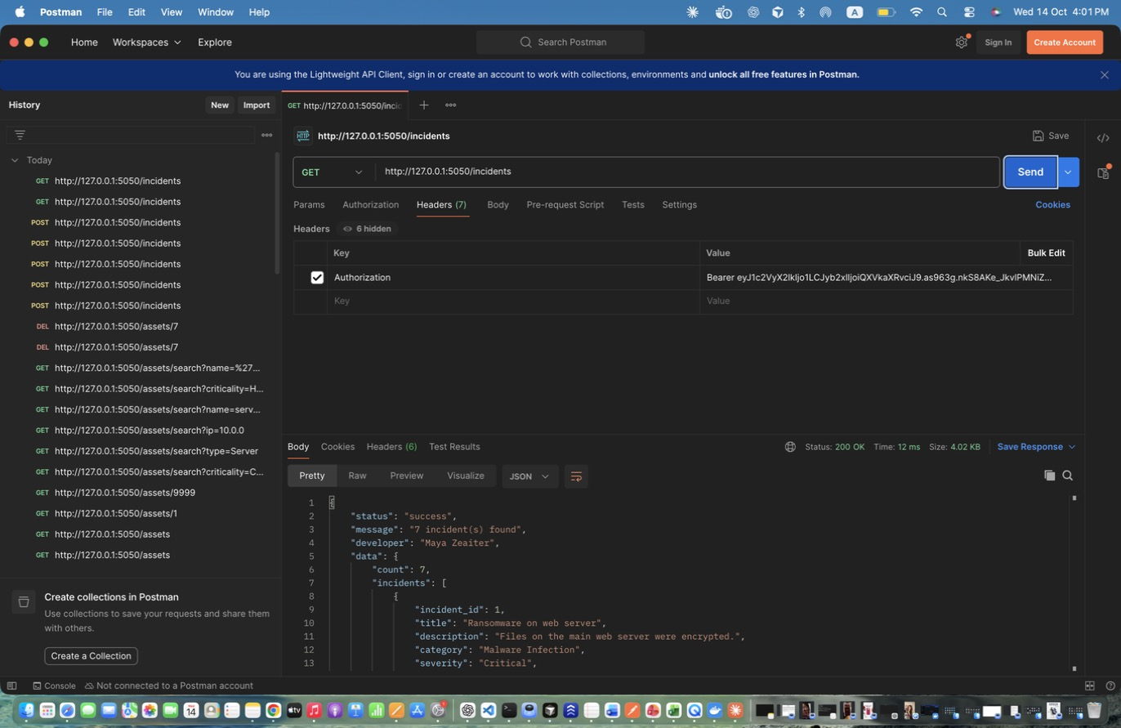
Figure 55: Maya Zeaiter – Retrieve All Incidents (auditor) – Read-only access.
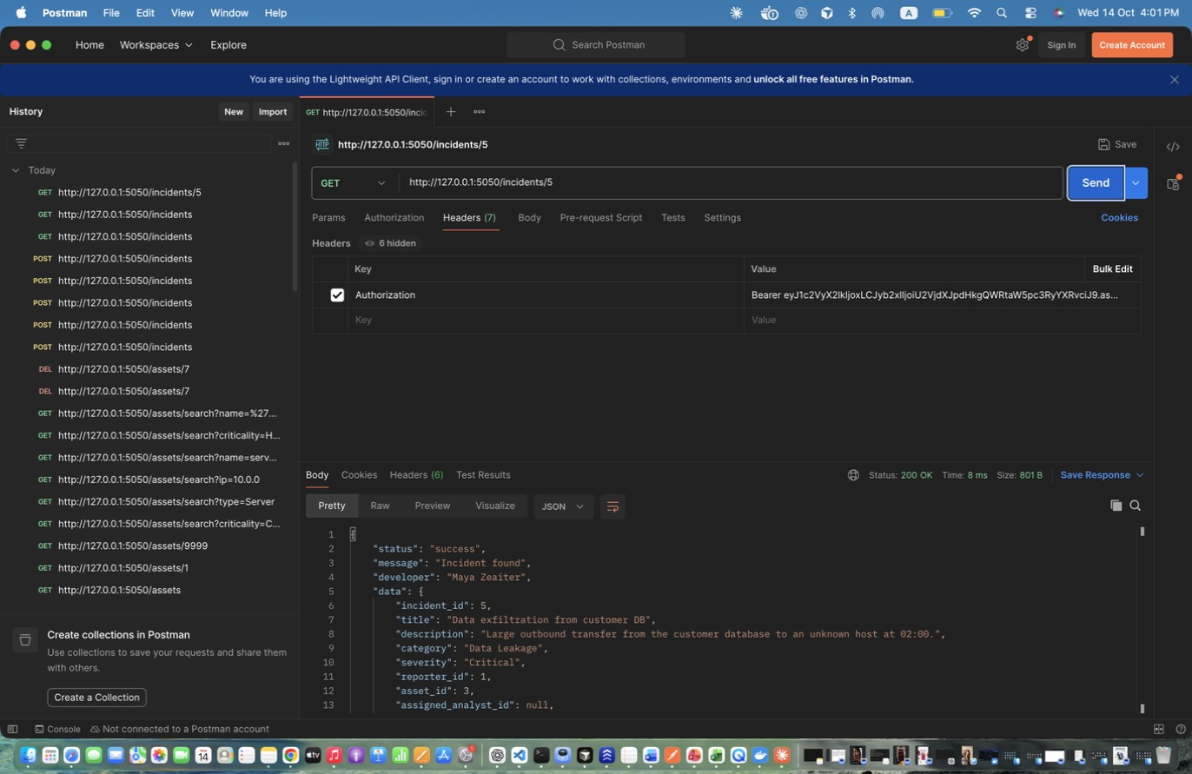
Figure 56: Maya Zeaiter – Retrieve Specific Incident – Full incident including notes.
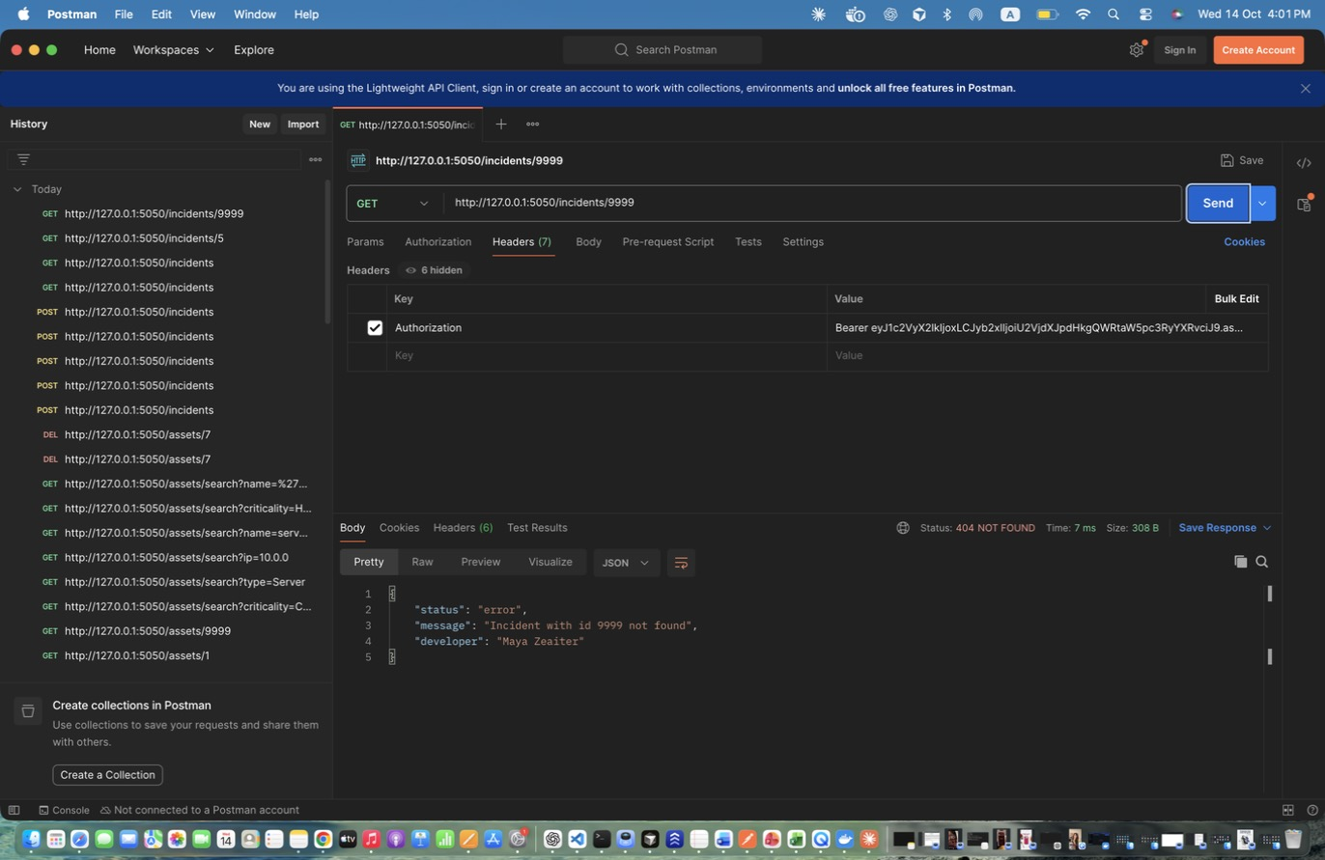
Figure 57: Maya Zeaiter – Retrieve Specific Incident - invalid id – -> 404.
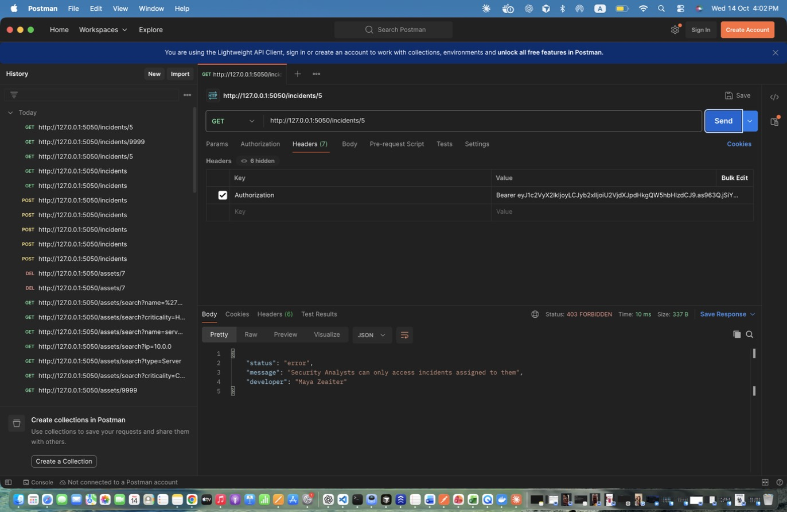
Figure 58: Maya Zeaiter – Retrieve Incident - analyst NOT assigned – Analysts only see incidents assigned to them -> 403 (until assigned).
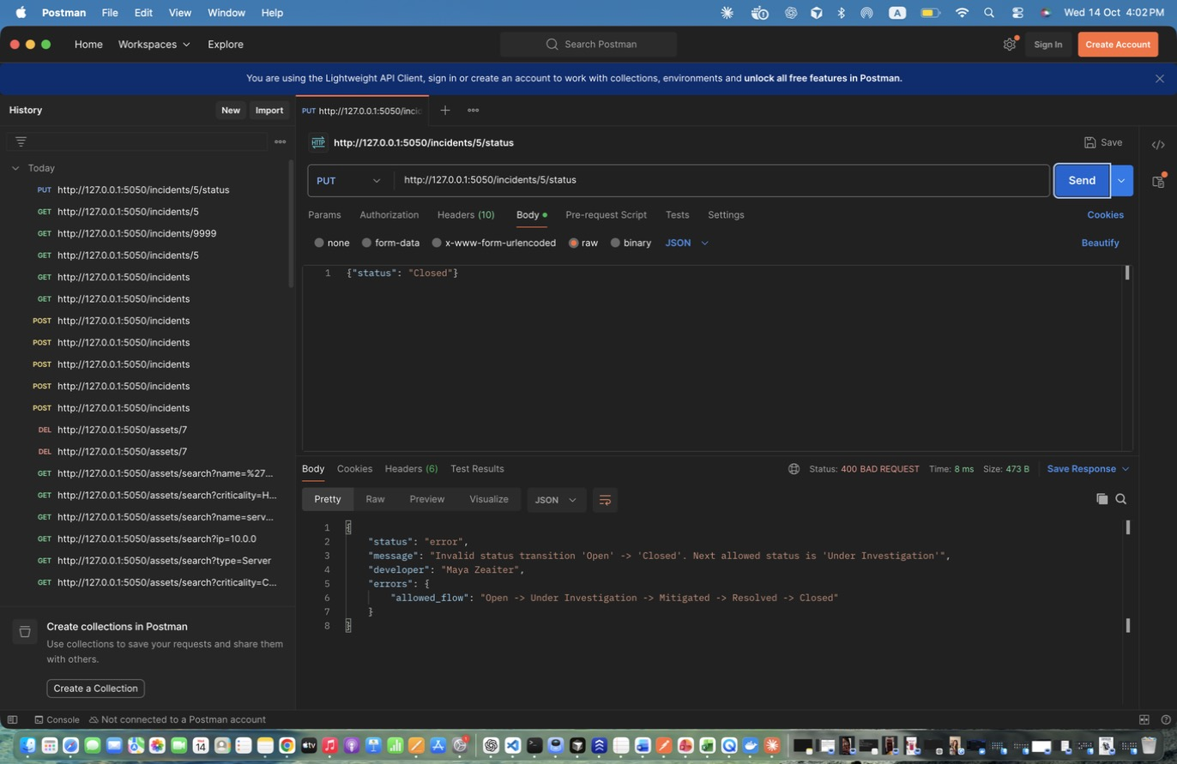
Figure 59: Maya Zeaiter – Update Status - skip steps (Open -> Closed) – Invalid transition -> 400.
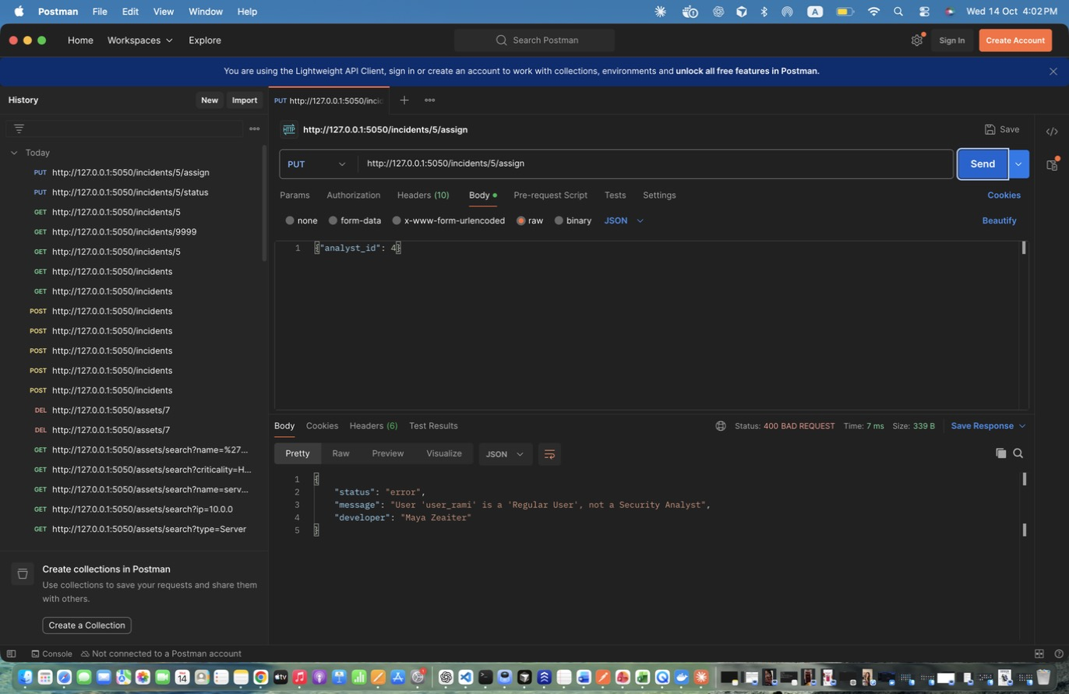
Figure 60: Maya Zeaiter – Assign Incident - to non-analyst – User 4 is a Regular User -> 400.
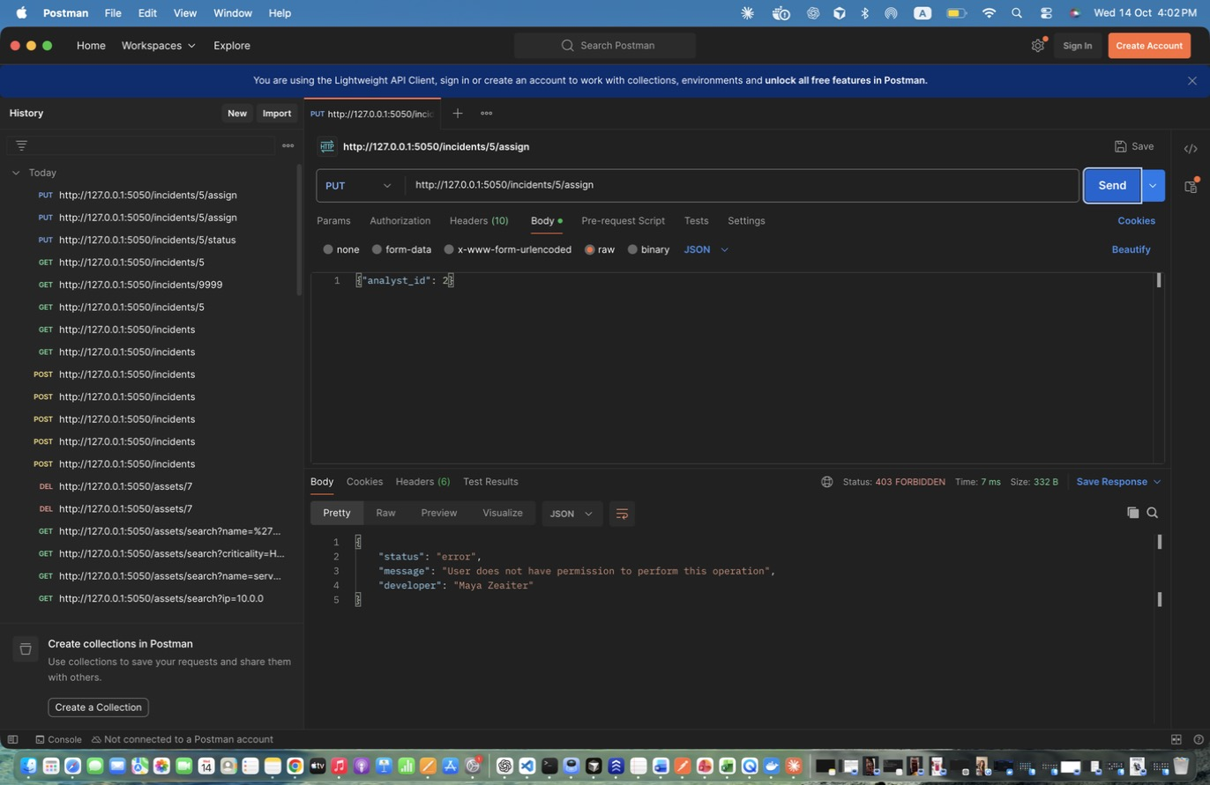
Figure 61: Maya Zeaiter – Assign Incident - by analyst DENIED – -> 403.
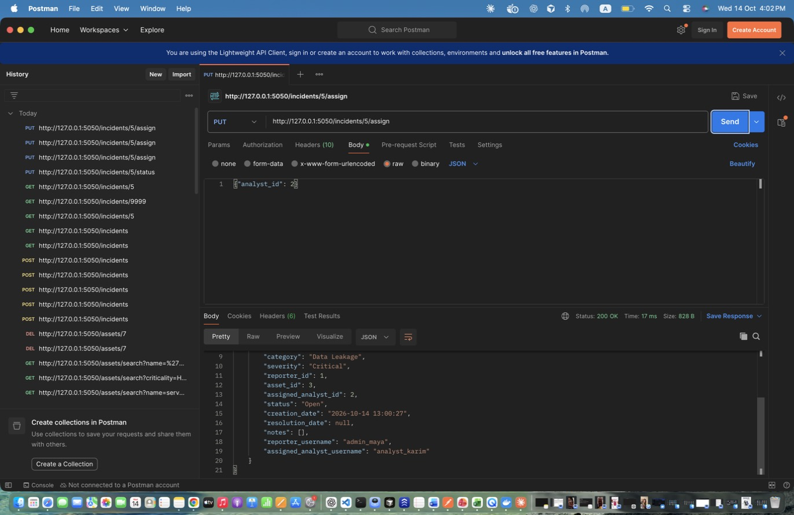
Figure 62: Maya Zeaiter – Assign Incident to Analyst – Assigns to analyst_karim (id 2); logs INCIDENT_ASSIGNED and creates a notification.
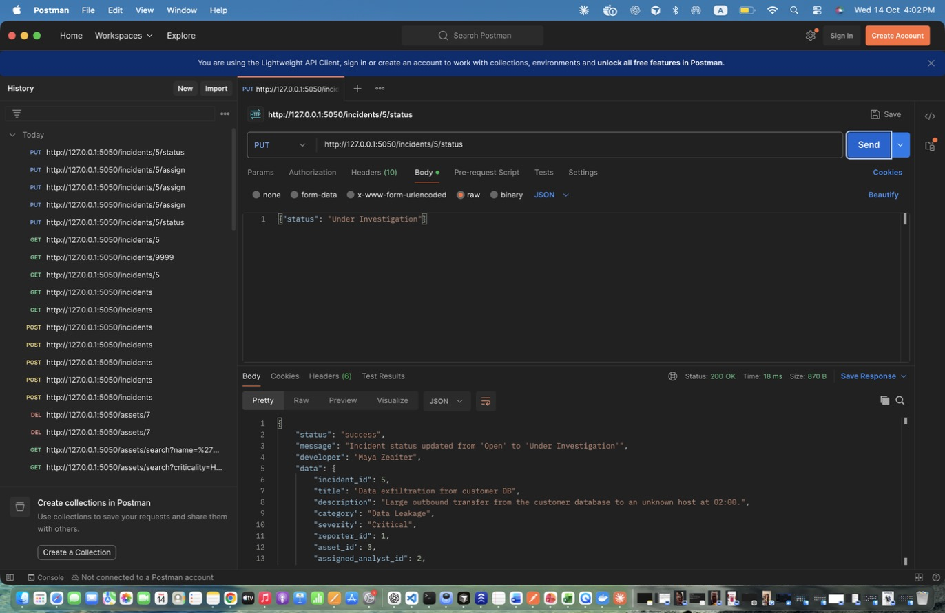
Figure 63: Maya Zeaiter – Status 1: Open -> Under Investigation – Status 1: Open -> Under Investigation
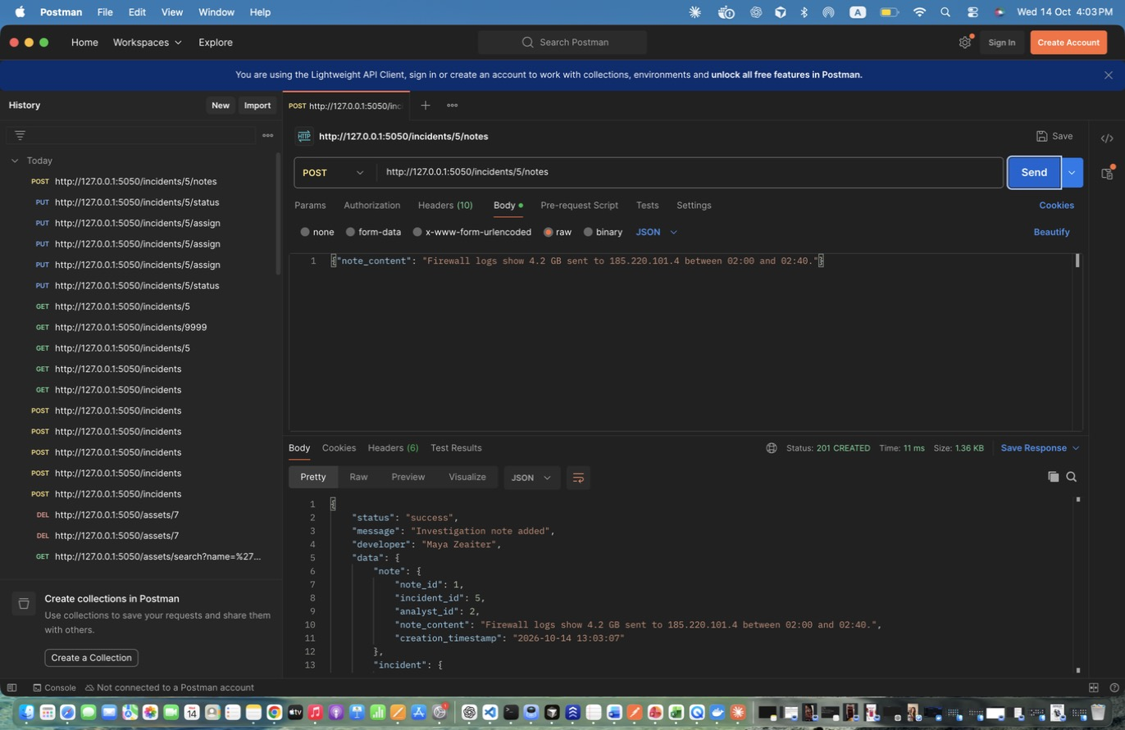
Figure 64: Maya Zeaiter – Add Investigation Note – Note linked to the incident and the analyst.
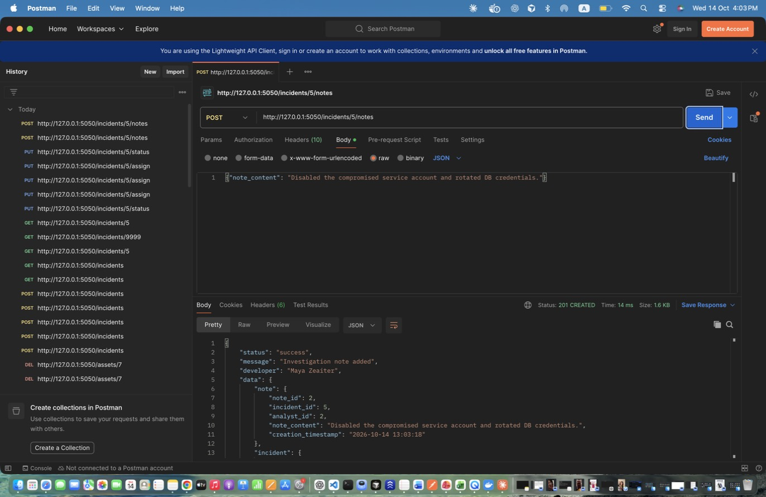
Figure 65: Maya Zeaiter – Add Investigation Note (2) – Add Investigation Note (2)
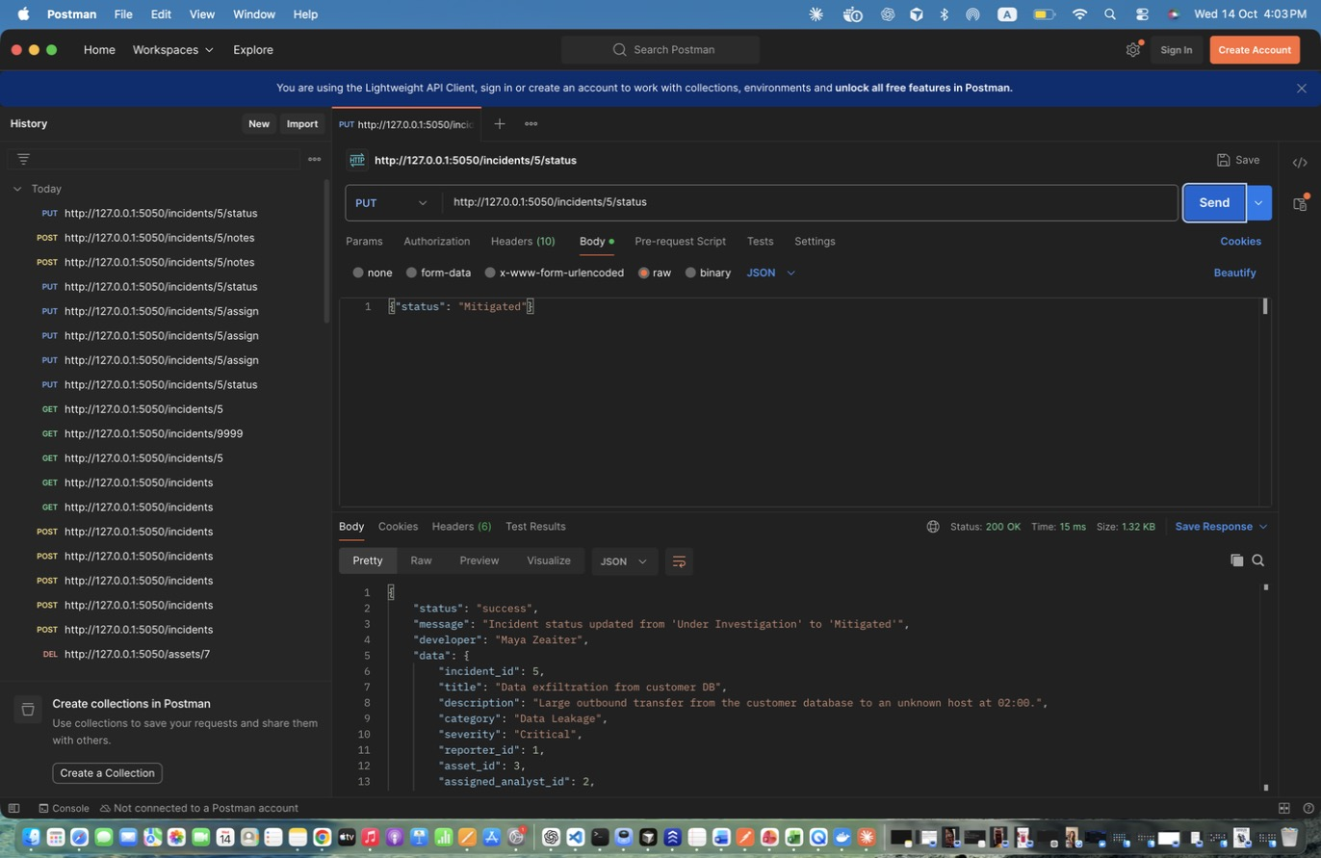
Figure 66: Maya Zeaiter – Status 2: Under Investigation -> Mitigated – Status 2: Under Investigation -> Mitigated
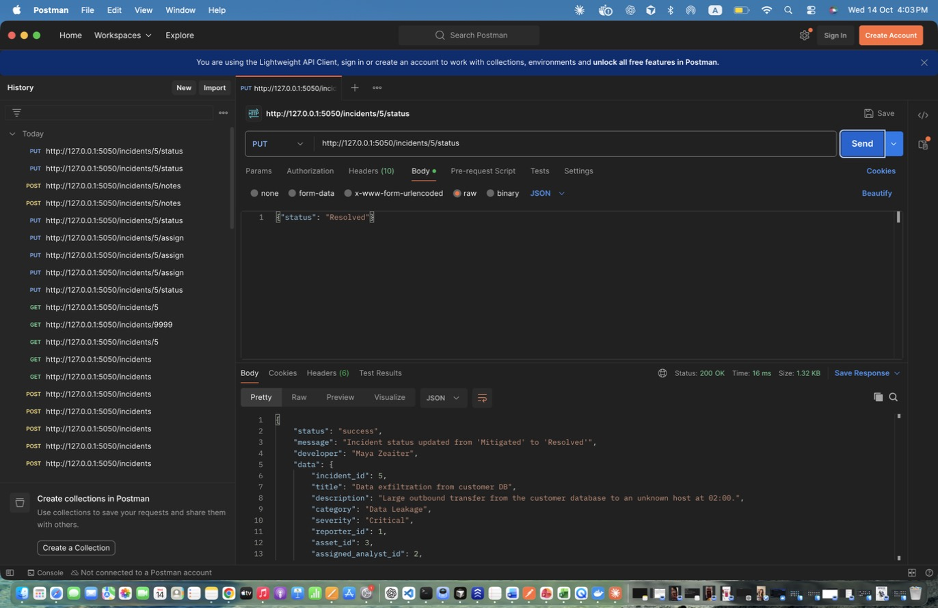
Figure 67: Maya Zeaiter – Status 3: Mitigated -> Resolved – Sets resolution_date.
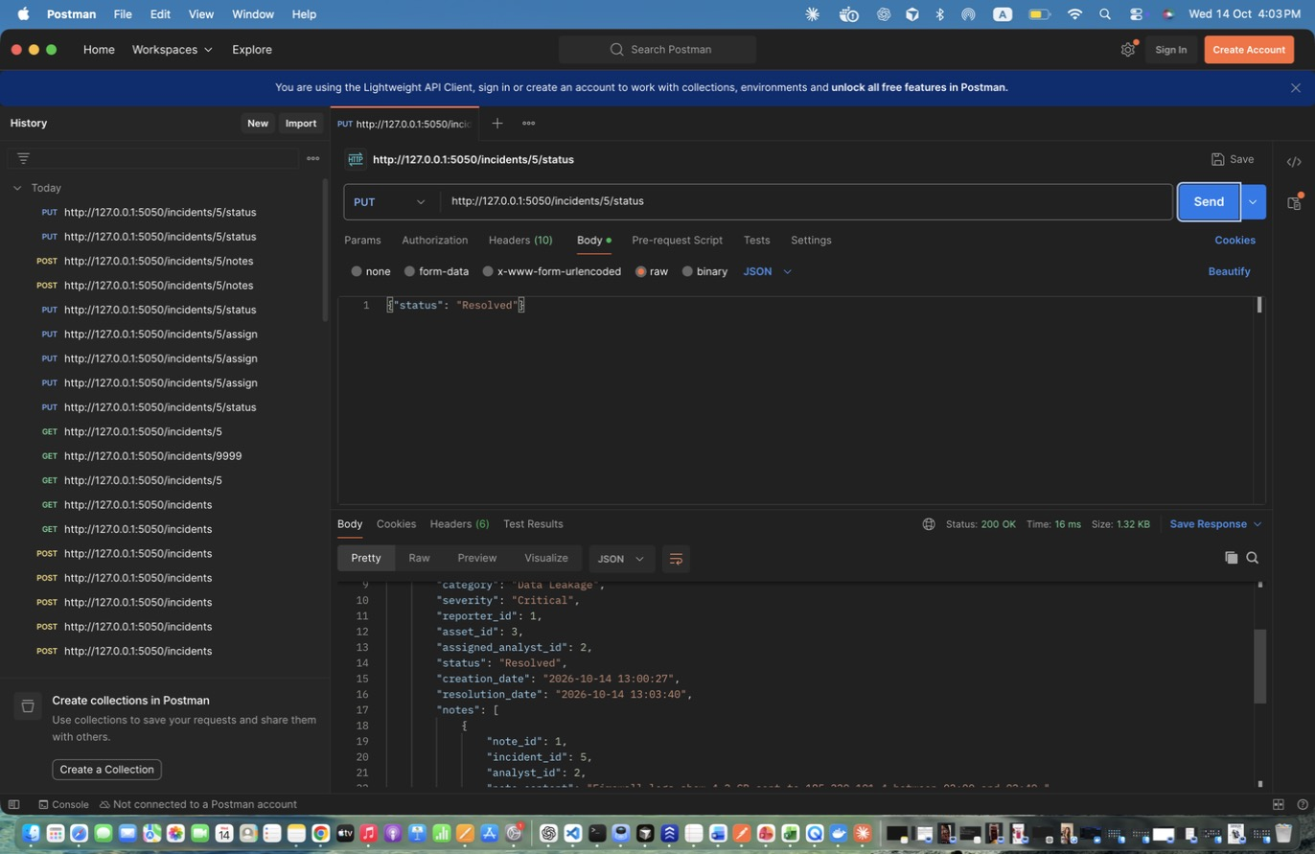
Figure 68: Maya Zeaiter – Status 3: Mitigated -> Resolved – Sets resolution_date. (response scrolled to show the rest)
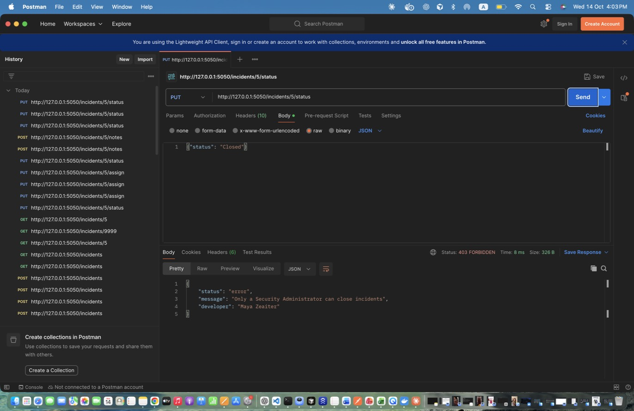
Figure 69: Maya Zeaiter – Status 4: Resolved -> Closed (analyst) DENIED – Only admins close incidents -> 403.
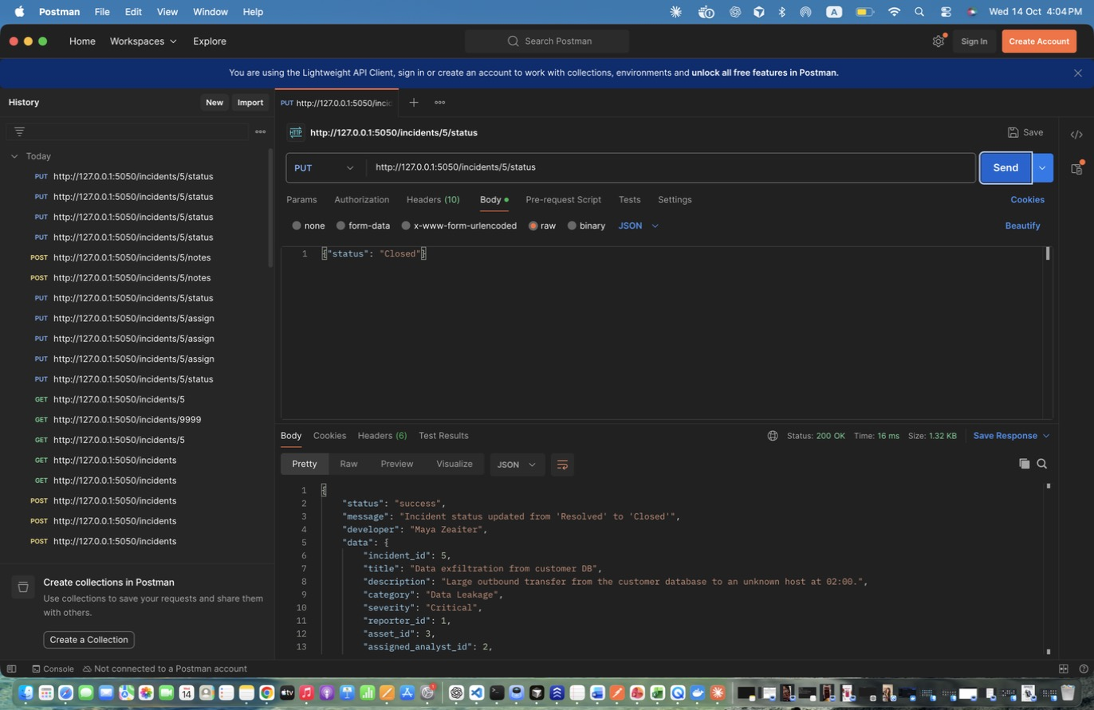
Figure 70: Maya Zeaiter – Status 4: Resolved -> Closed (admin) – Status 4: Resolved -> Closed (admin)
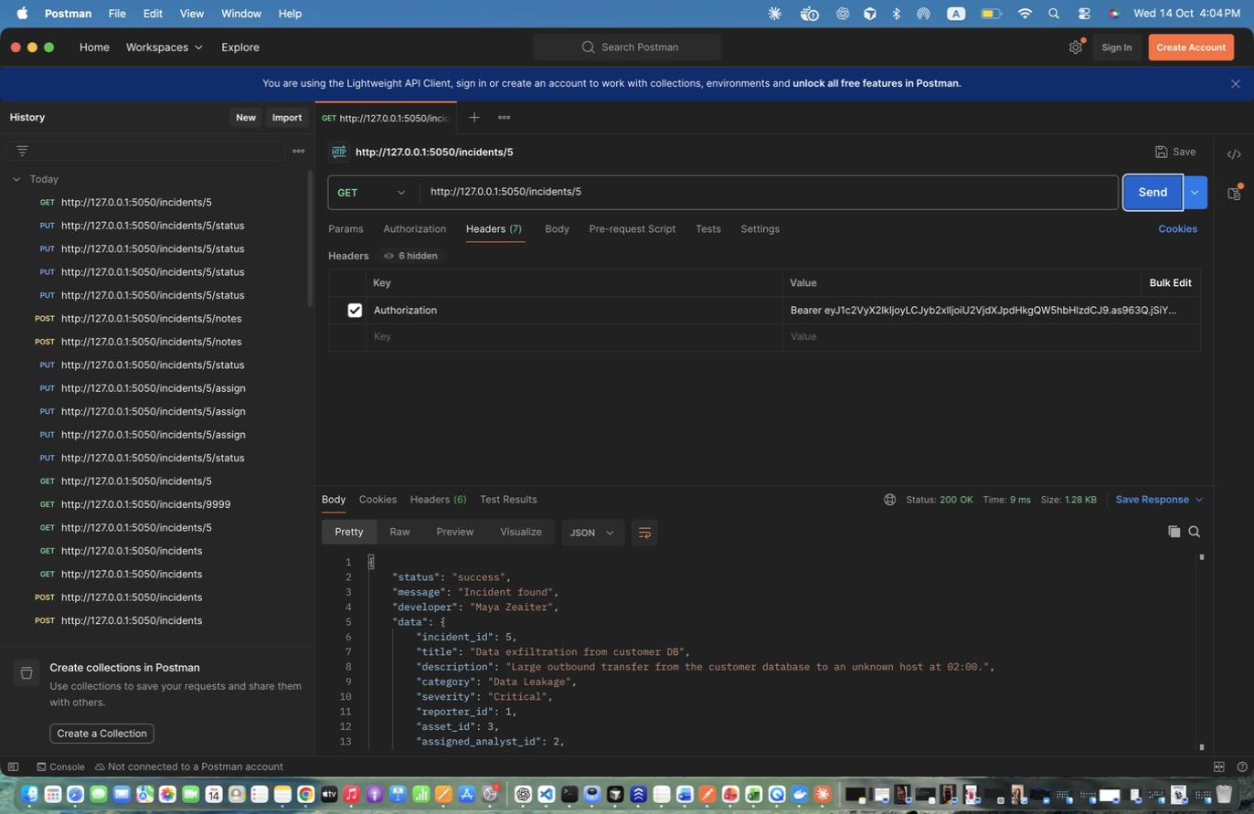
Figure 71: Maya Zeaiter – Retrieve Incident with notes – Shows the final state and both notes.
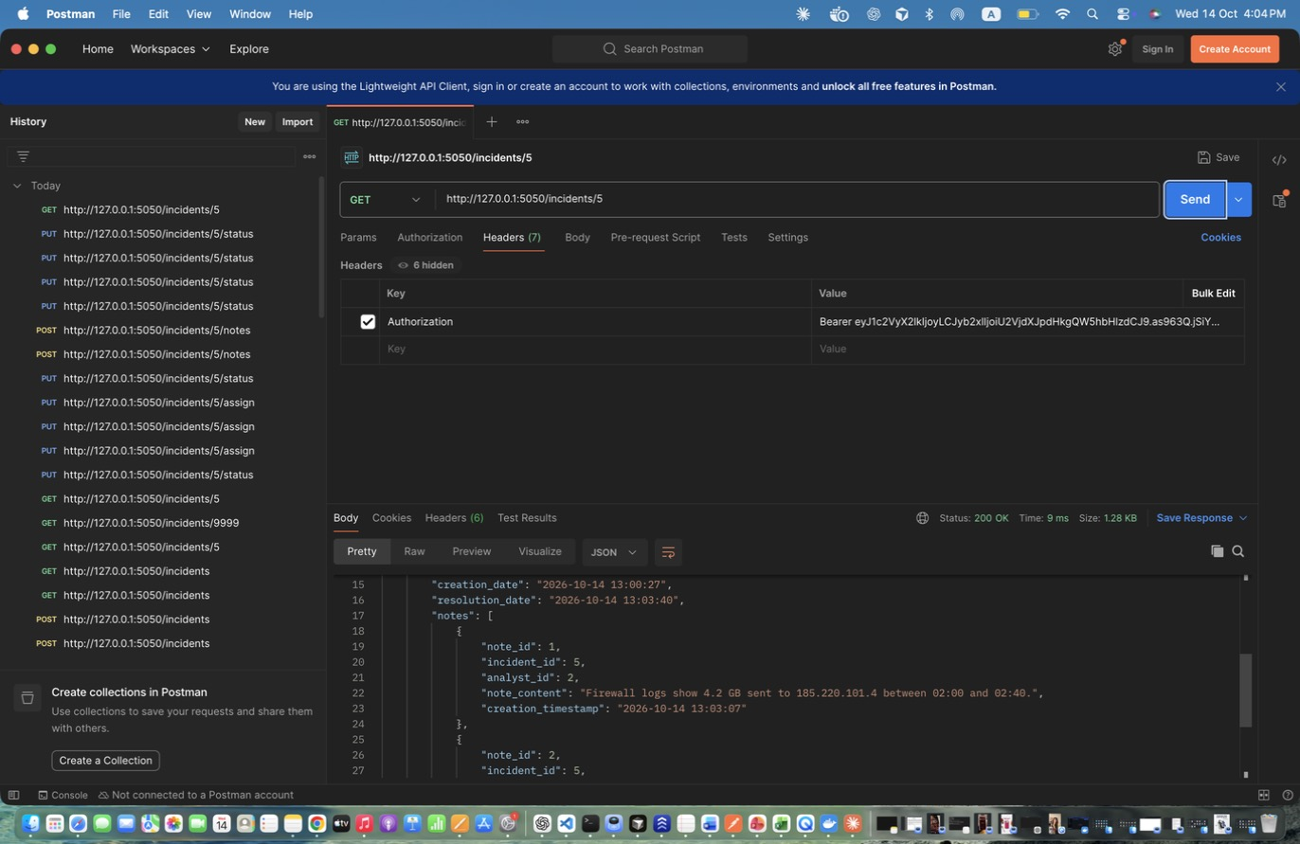
Figure 72: Maya Zeaiter – Retrieve Incident with notes – Shows the final state and both notes. (response scrolled to show the rest)

Database (Maya Zeaiter)
Output of the sqlite3 command-line tool on my project database (security_system.db), taken right after the Postman run above.
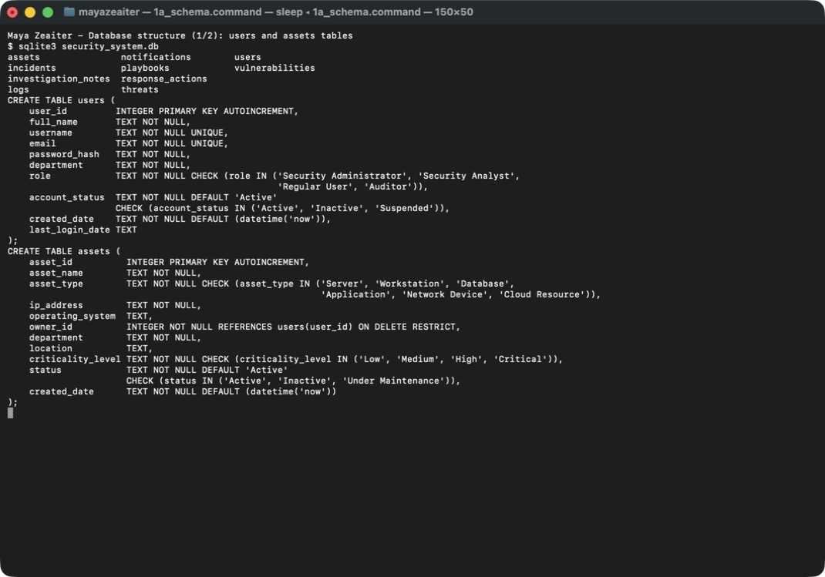
Figure 73: Maya Zeaiter – Database structure – users and assets tables (primary keys, UNIQUE, CHECK constraints, owner_id foreign key)
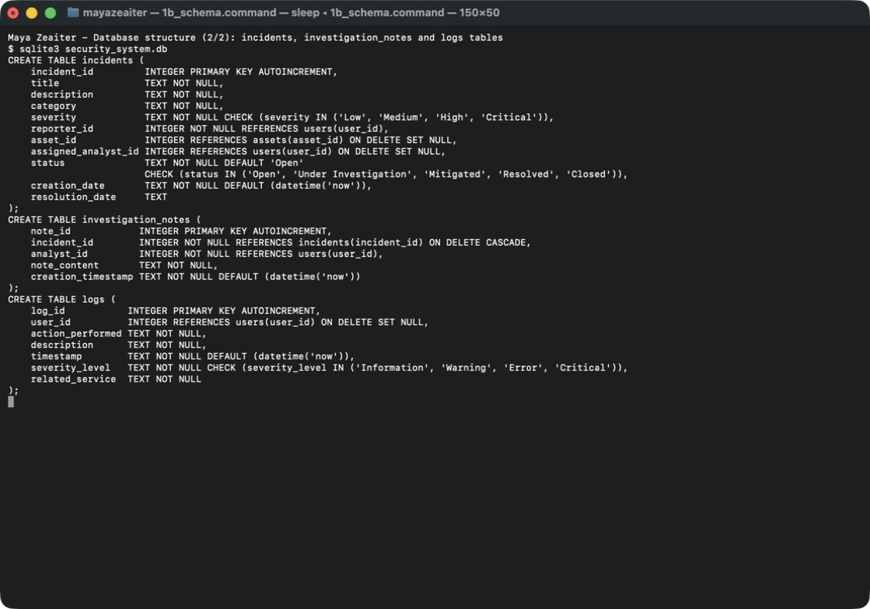
Figure 74: Maya Zeaiter – Database structure – incidents, investigation_notes and logs tables with their foreign keys
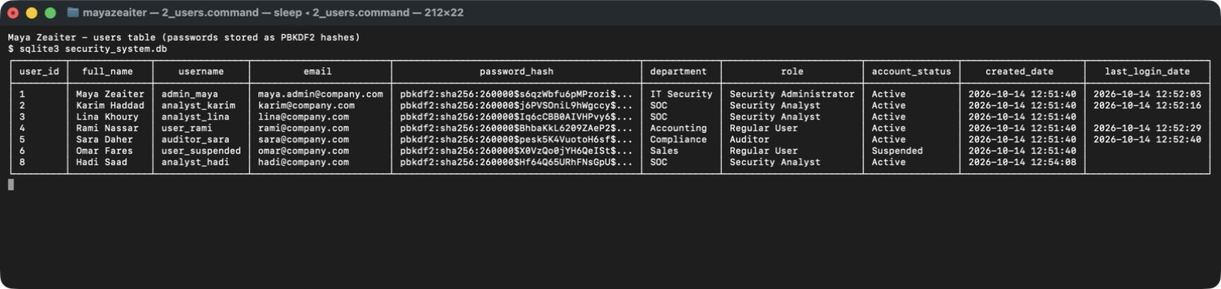
Figure 75: Maya Zeaiter – users table records – passwords are stored only as PBKDF2 hashes; Suspended account and the deleted user (id 7) are visible
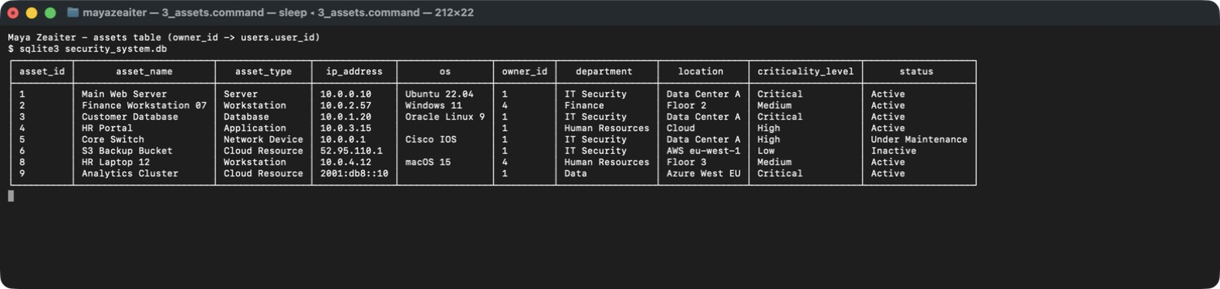
Figure 76: Maya Zeaiter – assets table records – criticality level and status stored as validated text values; asset 7 was deleted
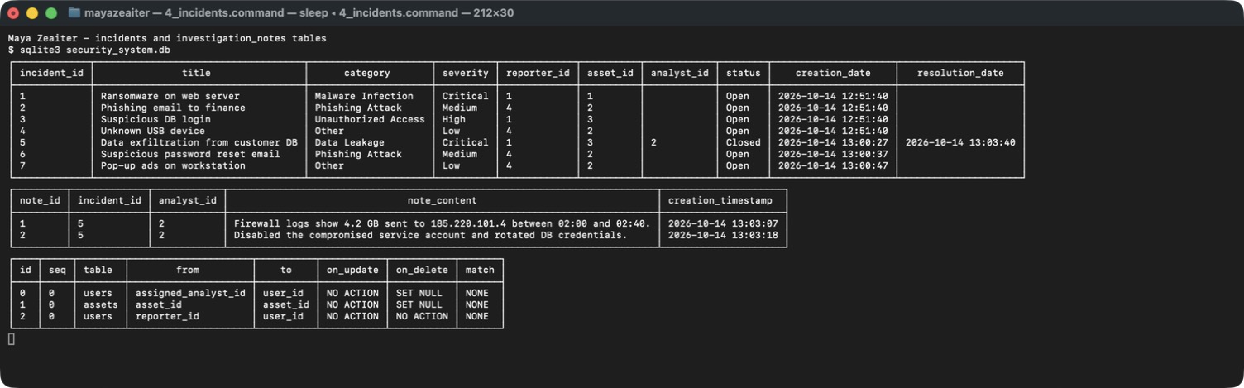
Figure 77: Maya Zeaiter – incidents and investigation_notes records – incident 5 closed with resolution date, two notes linked to it, and the incidents foreign keys
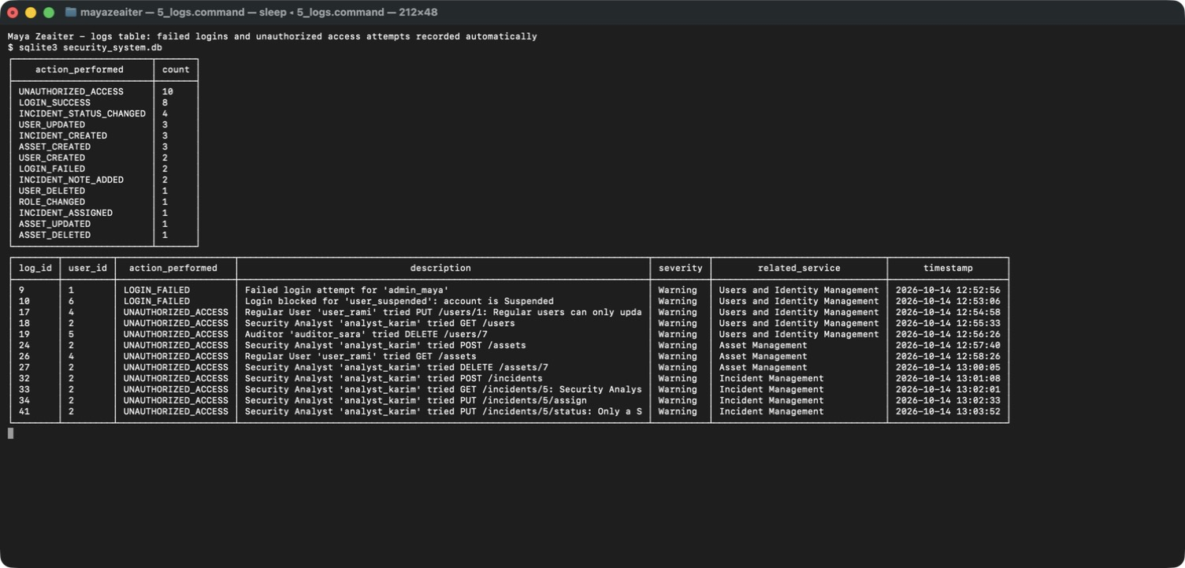
Figure 78: Maya Zeaiter – logs table – counts per action and the automatically recorded failed logins and unauthorized access attempts

GitHub (Maya Zeaiter)
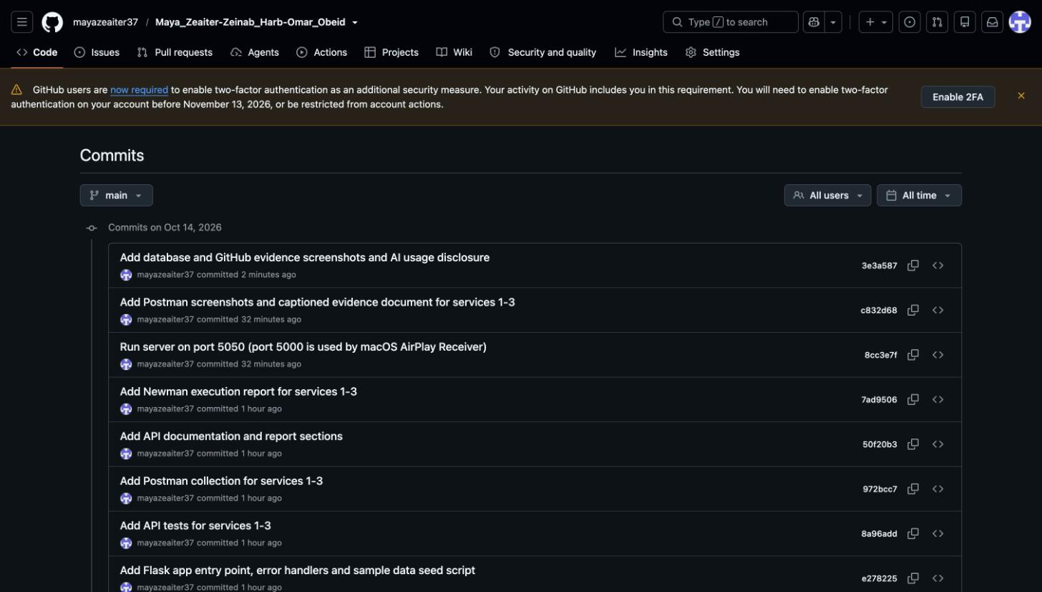
Figure 79: Maya Zeaiter – GitHub commit history (newest commits) – repository Maya_Zeaiter-Zeinab_Harb-Omar_Obeid
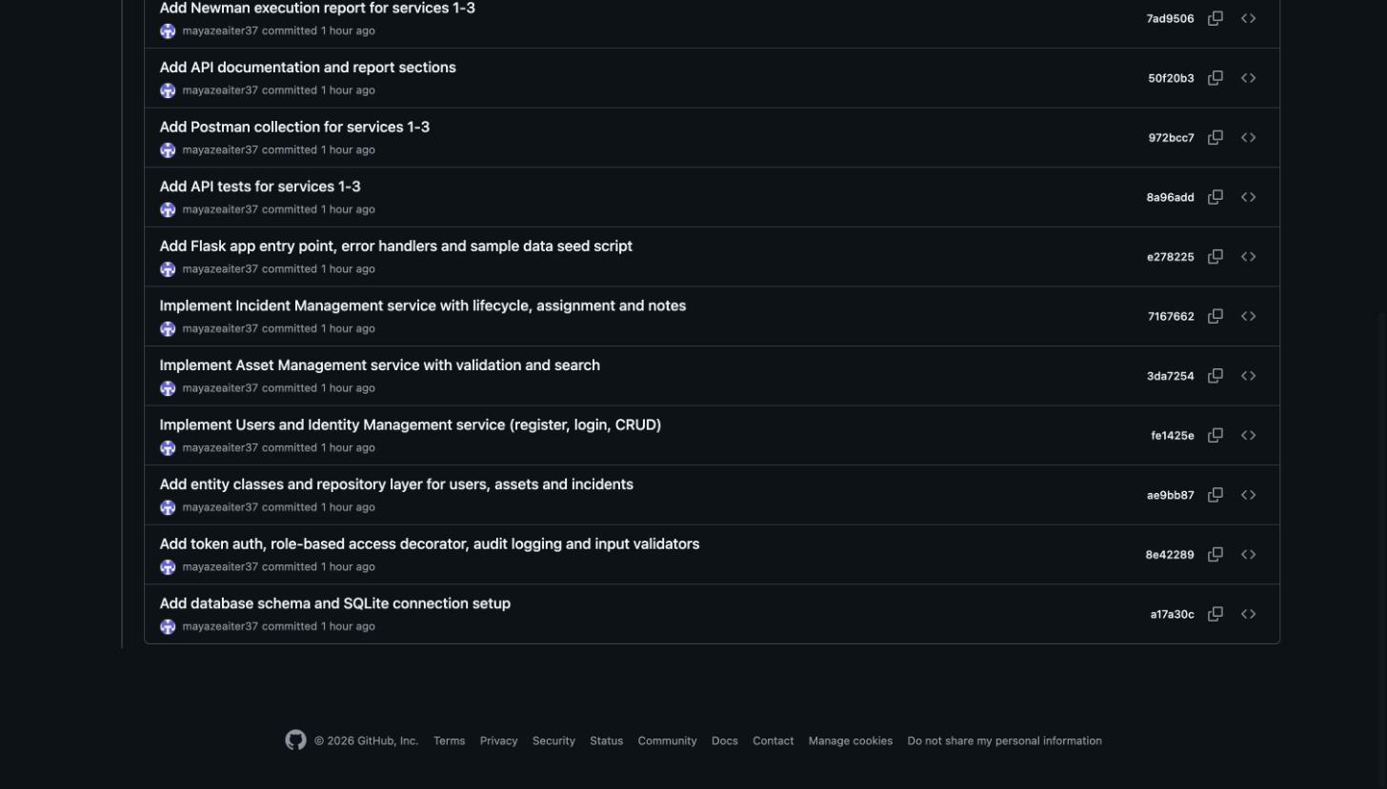
Figure 80: Maya Zeaiter – GitHub commit history (older commits) – one commit per implementation step
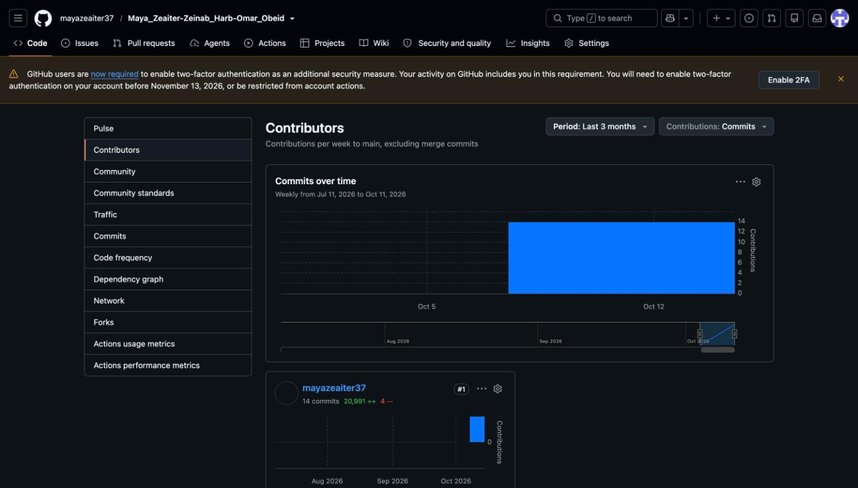
Figure 81: Maya Zeaiter – GitHub Contributors page – commits by mayazeaiter37 (Maya Zeaiter)

