Implementation Evidence – Services 4–6
Zeinab Harb
EECE 435L Final Project – Sprint I · Security Incident Detection and Response Management System
Services: Threat Intelligence (4), Security Audit Logging (5), Security Reports (6). All screenshots were taken from my own running system (Flask server on http://127.0.0.1:5050, Postman collection Zeinab_Harb_Services_4-6, and the security_system.db database in DB Browser for SQLite). Database timestamps are stored in UTC (Beirut is UTC+3).

1. Authentication (Zeinab Harb)
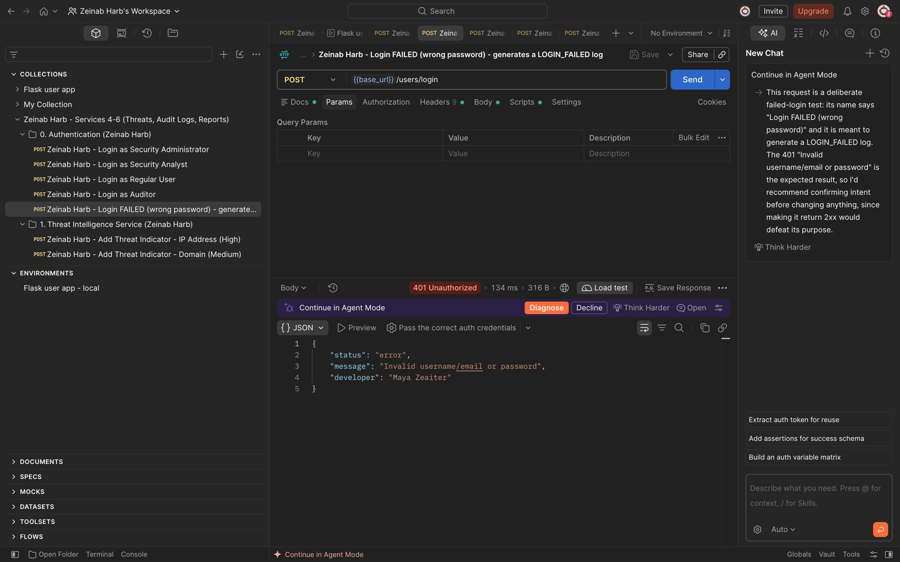
Figure 1: Zeinab Harb – User Login – failed login with a wrong password is rejected (401) and creates a LOGIN_FAILED audit log

2. Threat Intelligence Service (Service 4) (Zeinab Harb)
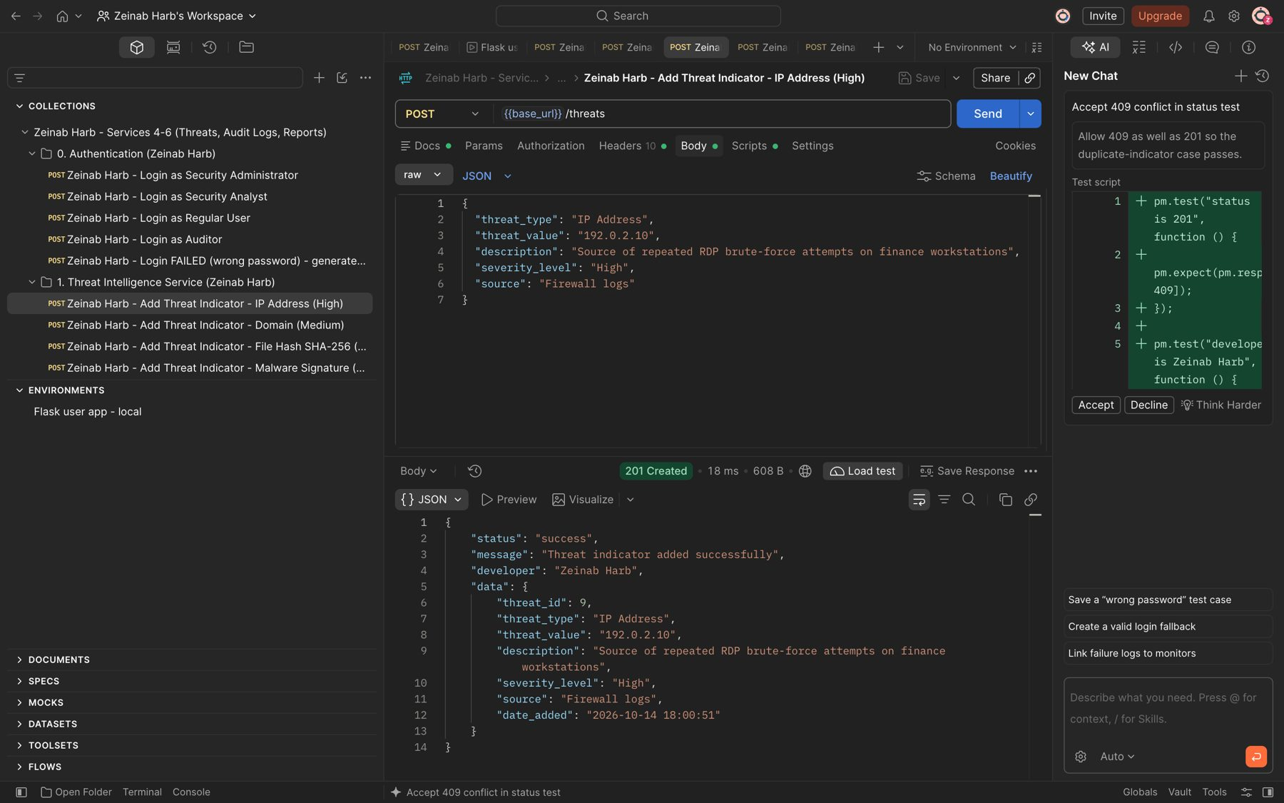
Figure 2: Zeinab Harb – Add Threat Indicator – adds a malicious IP address with severity High (201)
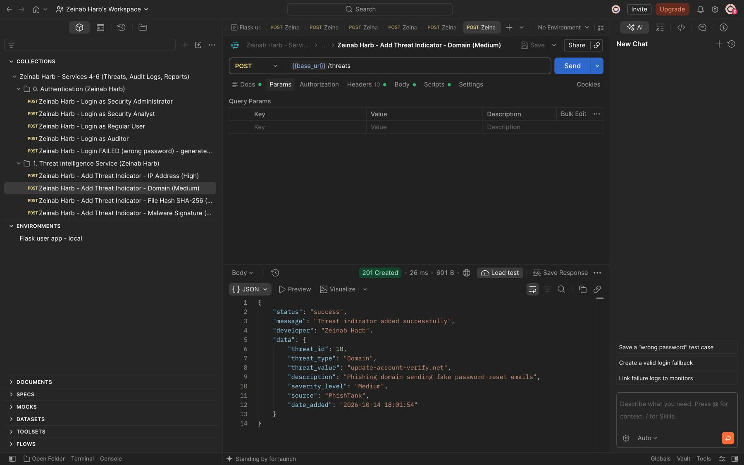
Figure 3: Zeinab Harb – Add Threat Indicator – adds a phishing domain with severity Medium; the domain is stored in lowercase (201)

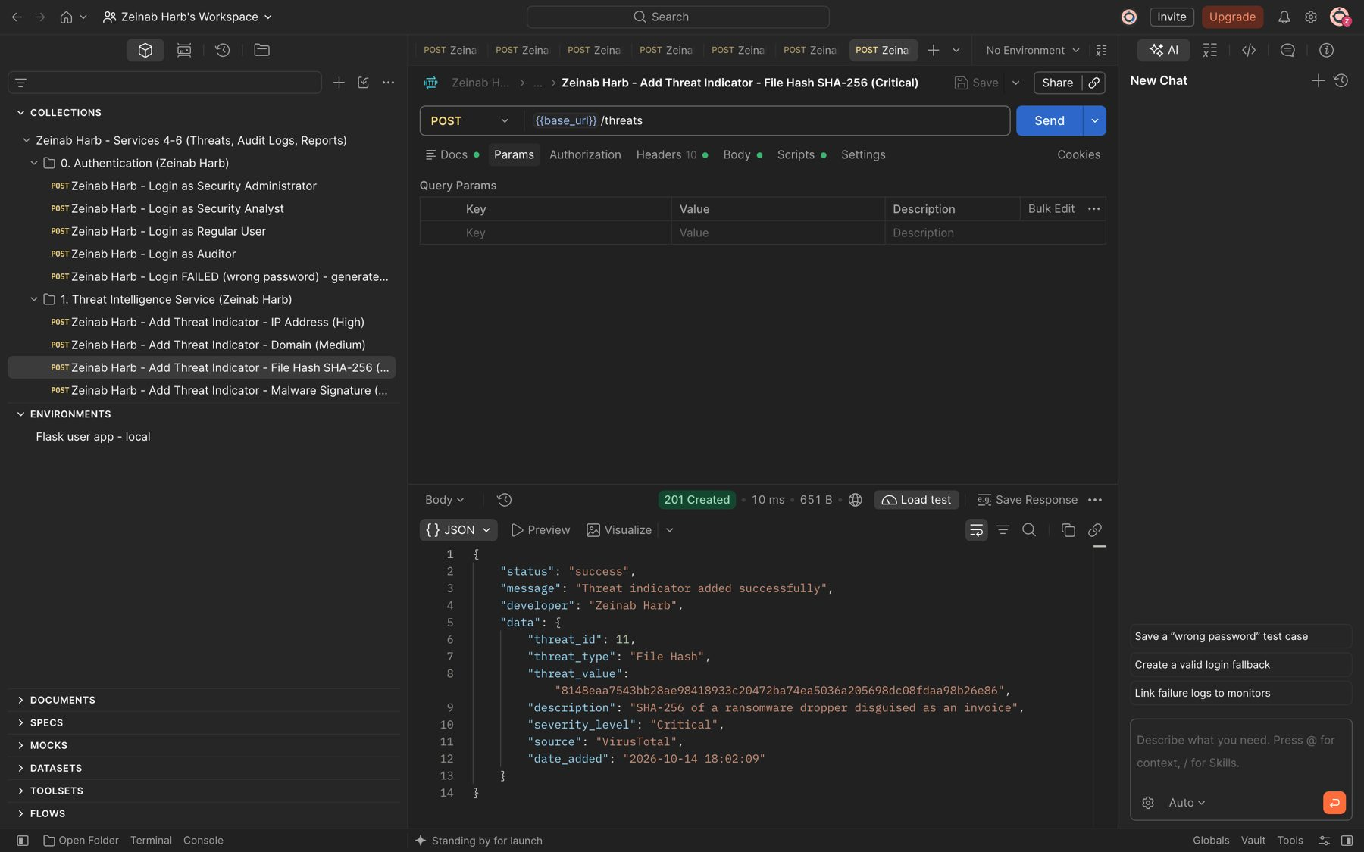
Figure 4: Zeinab Harb – Add Threat Indicator – adds a ransomware SHA-256 file hash with severity Critical (201)
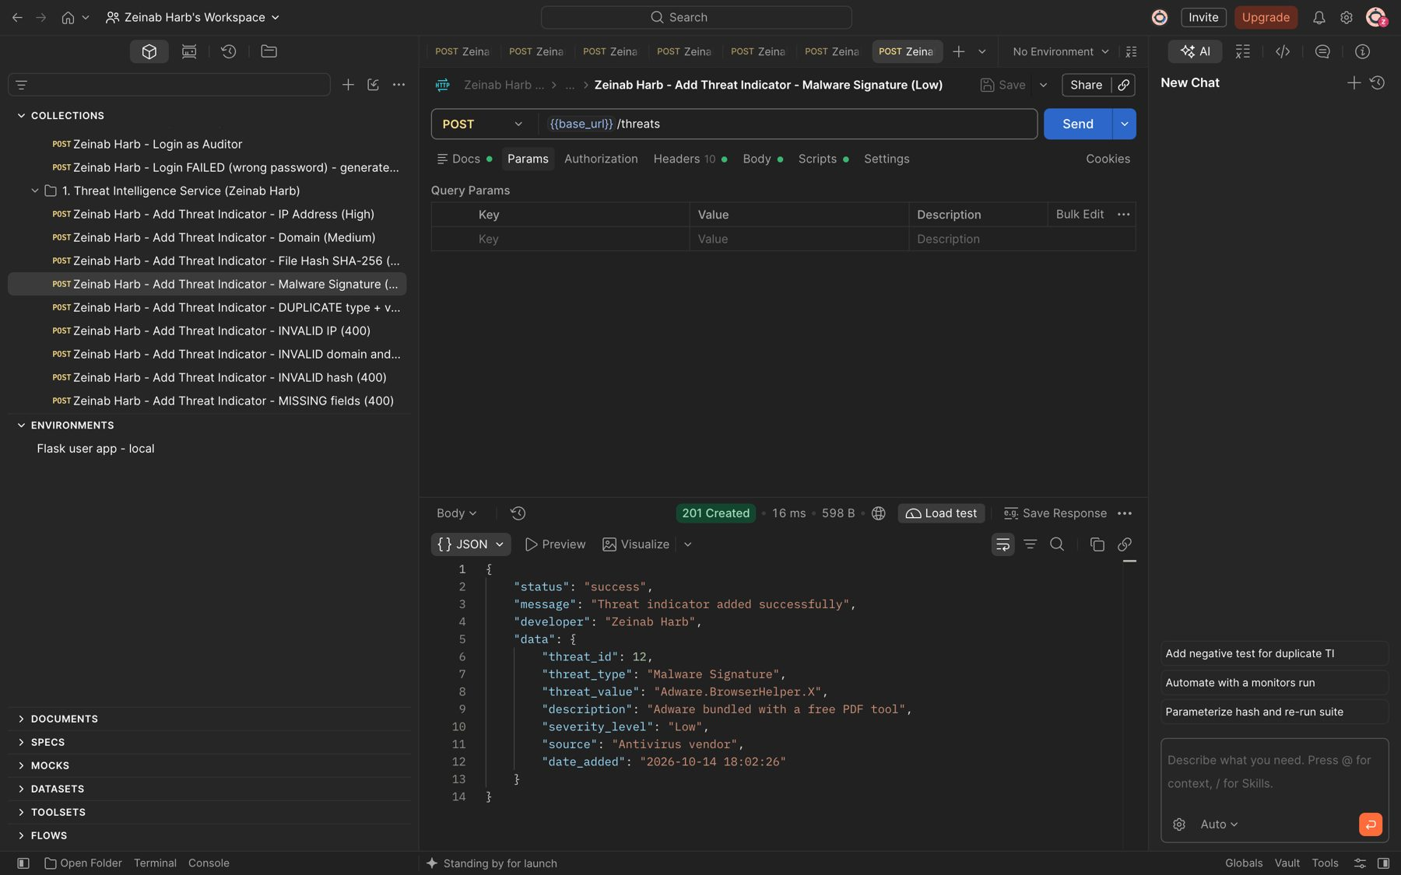
Figure 5: Zeinab Harb – Add Threat Indicator – adds an adware malware signature with severity Low (201)

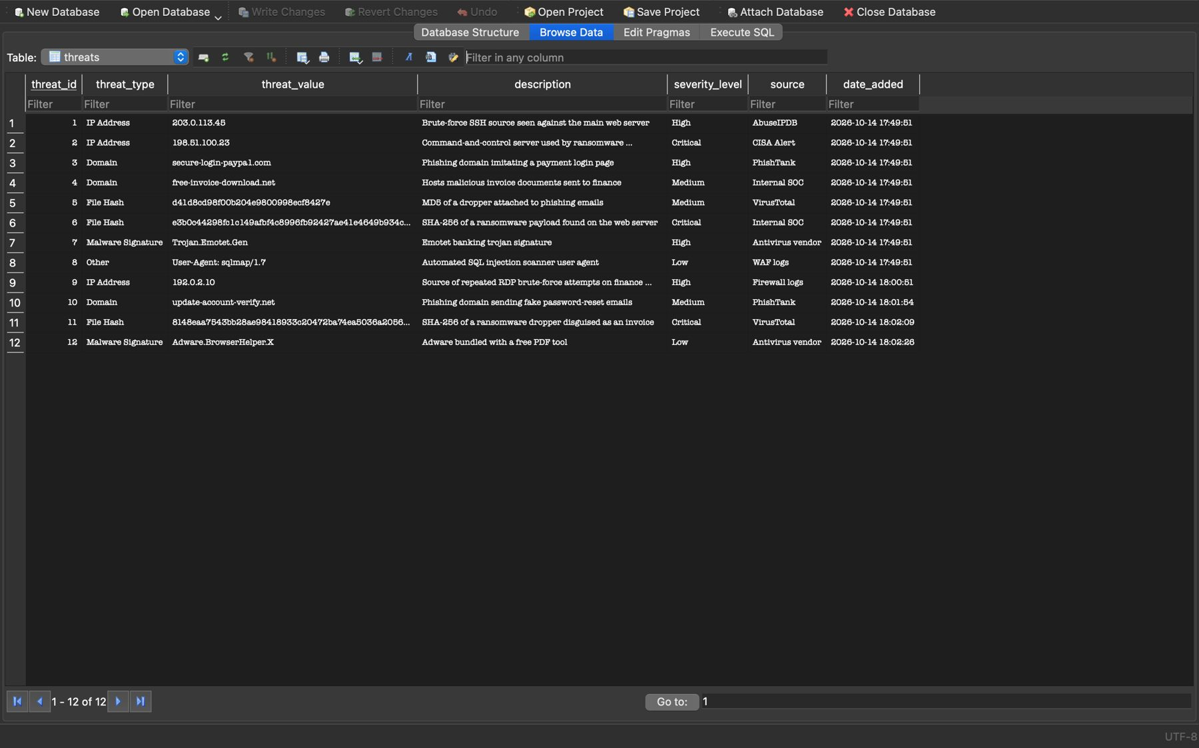
Figure 6: Zeinab Harb – Add Threat Indicator – stored threat records in the database (8 seeded + 4 added, ids 9–12)
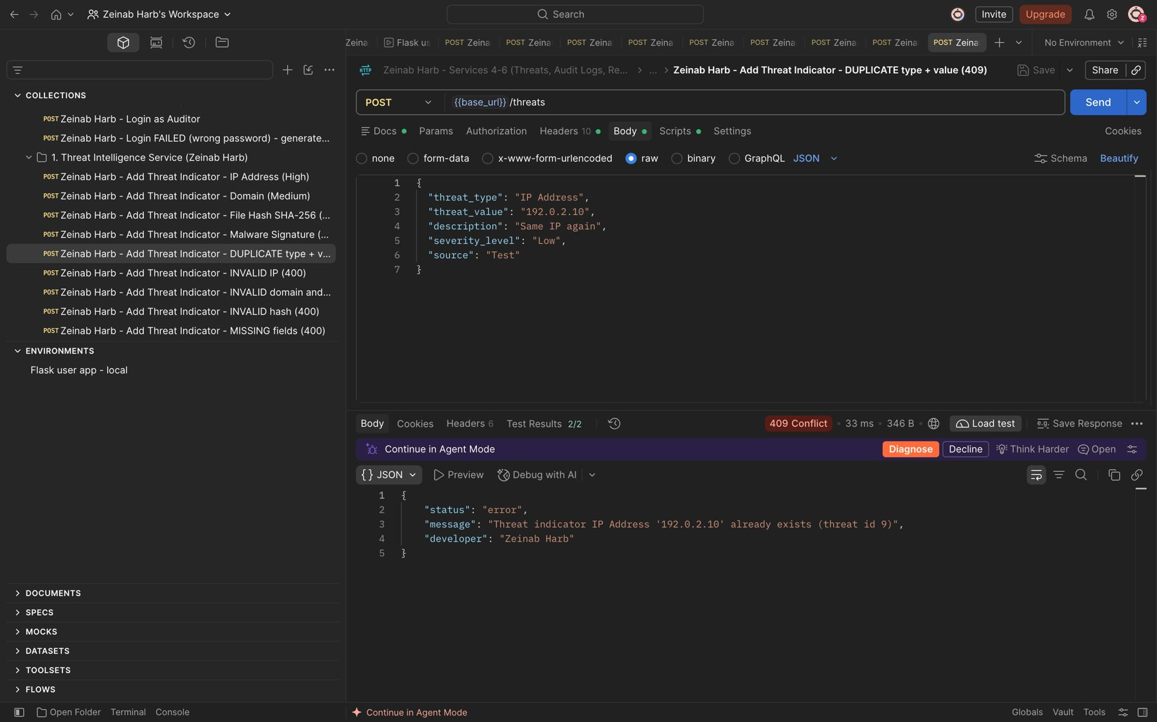
Figure 7: Zeinab Harb – Add Threat Indicator – duplicate threat type and value rejected (409)

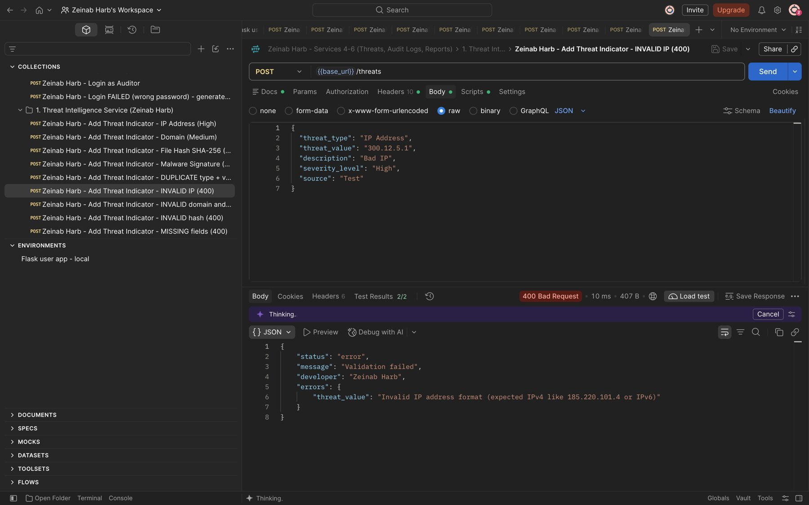
Figure 8: Zeinab Harb – Add Threat Indicator – invalid IP address format rejected (400)
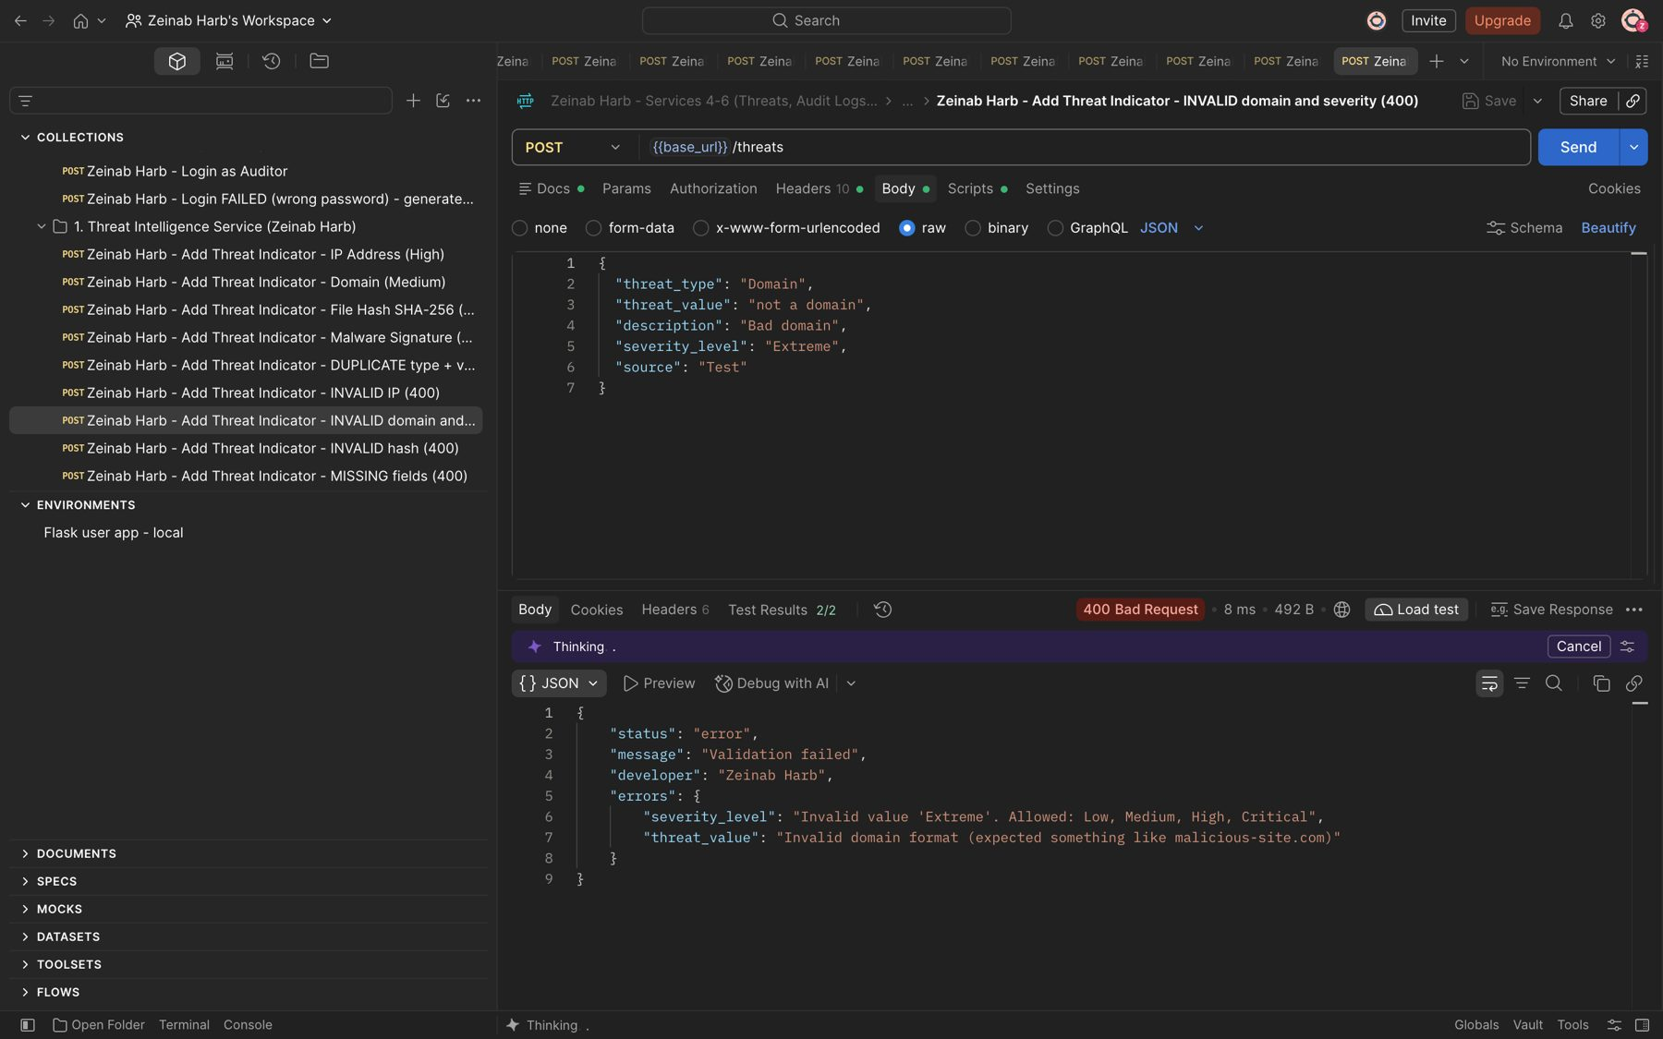
Figure 9: Zeinab Harb – Add Threat Indicator – invalid domain format and invalid severity rejected (400)

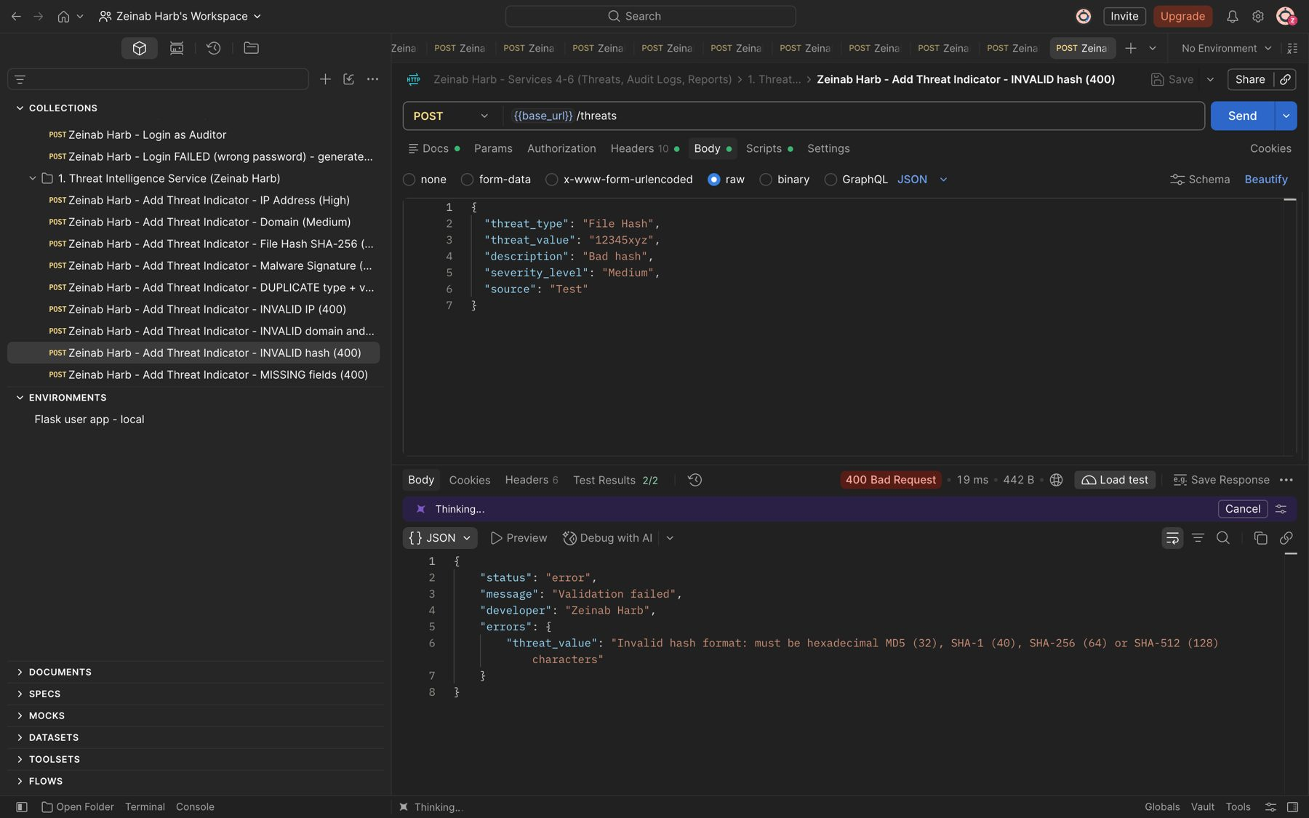
Figure 10: Zeinab Harb – Add Threat Indicator – invalid file hash format rejected (400)
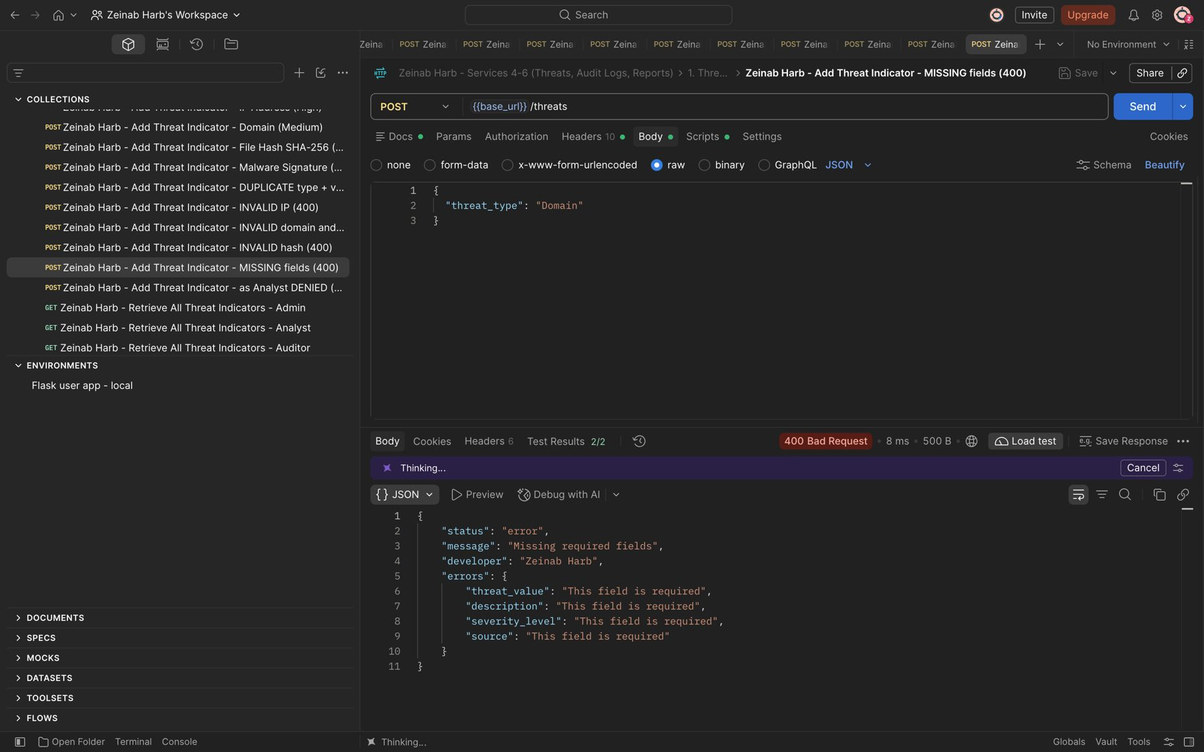
Figure 11: Zeinab Harb – Add Threat Indicator – missing required fields rejected (400)

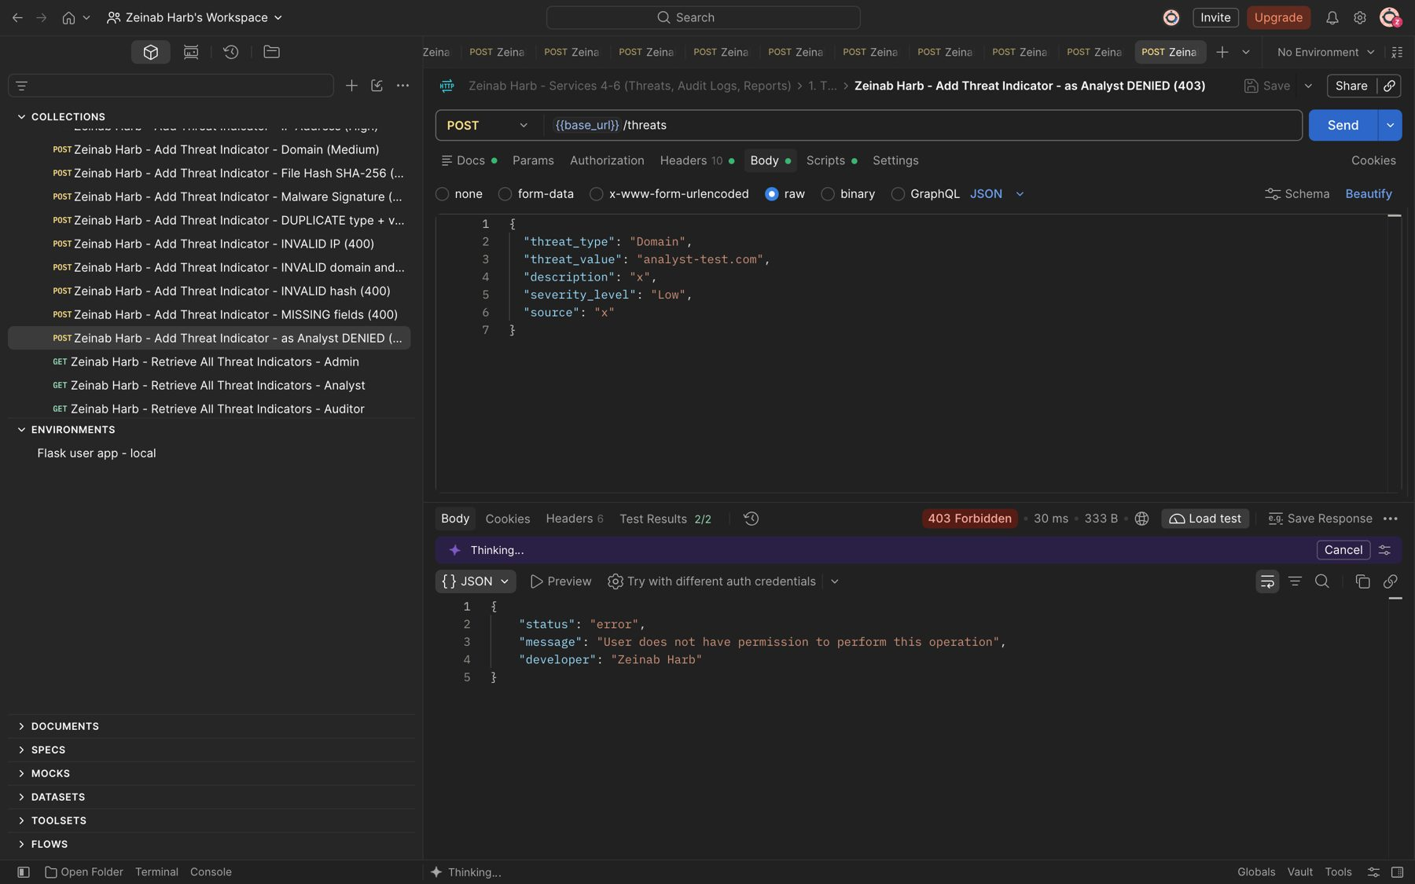
Figure 12: Zeinab Harb – Add Threat Indicator – Security Analyst is not allowed to add threats (403)
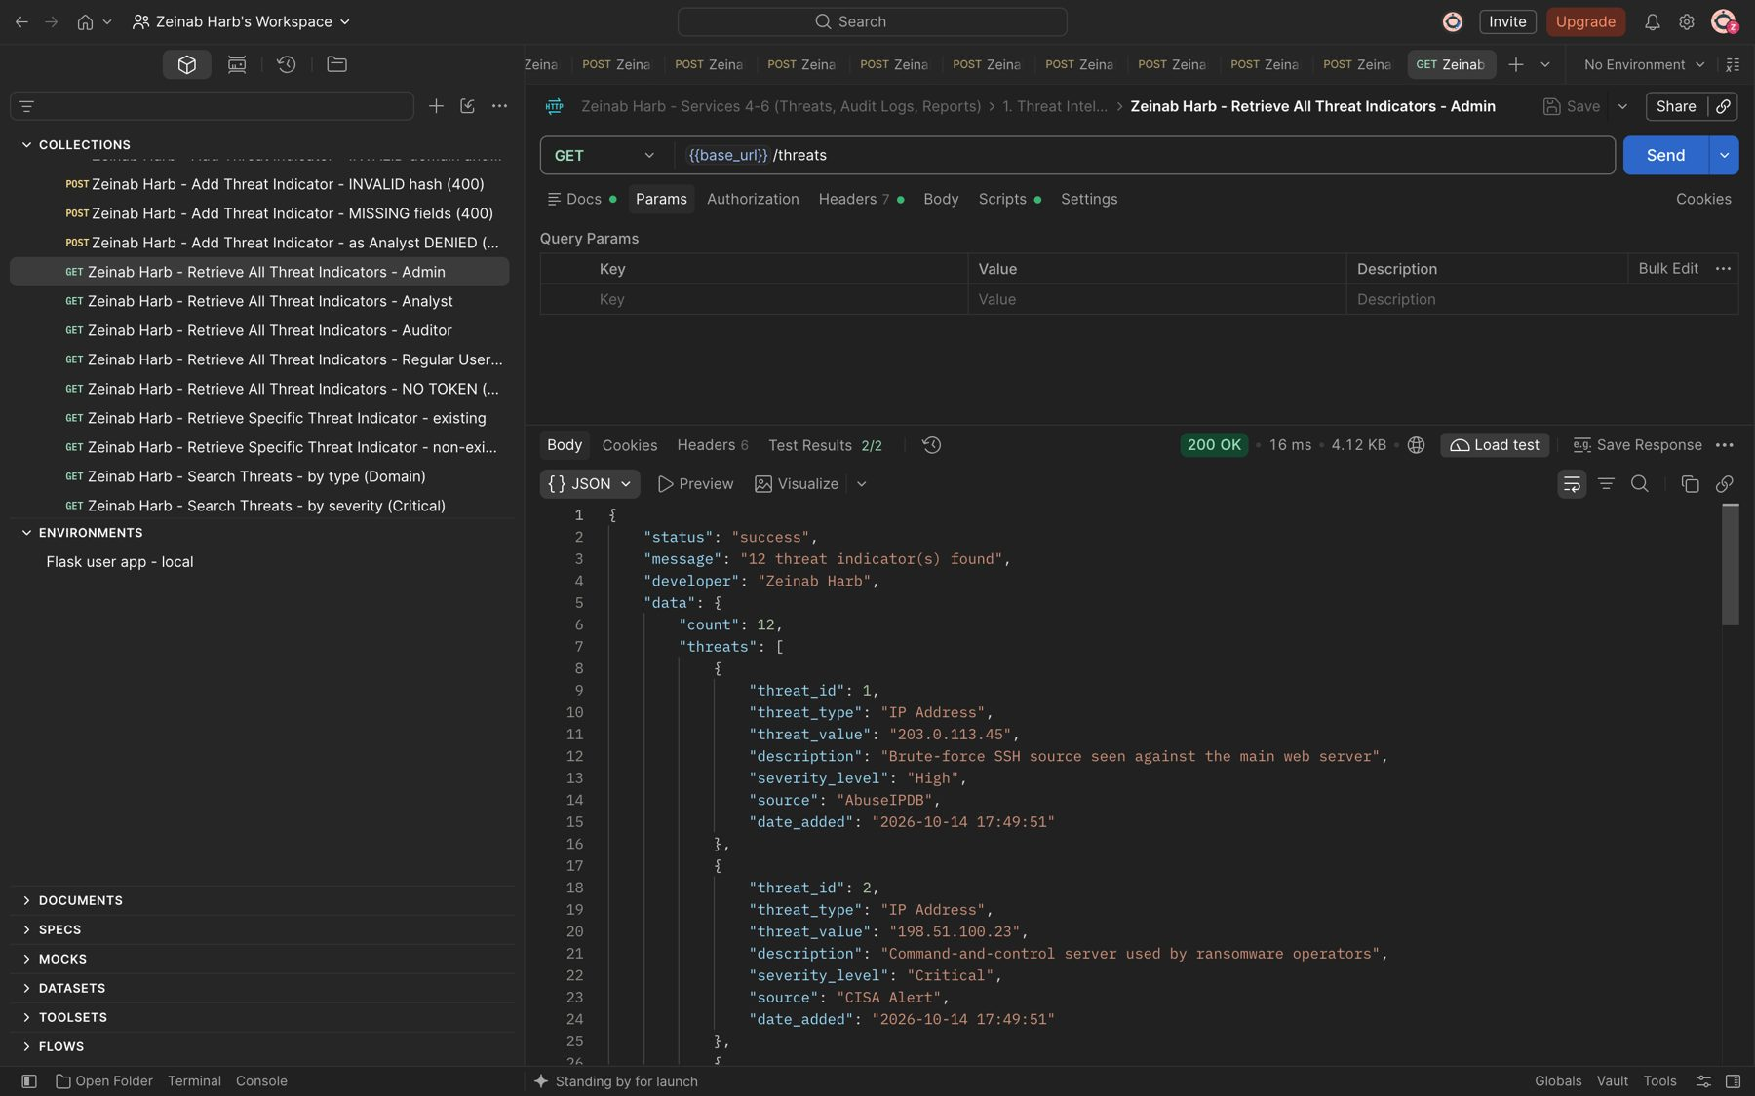
Figure 13: Zeinab Harb – Retrieve All Threat Indicators – returns every stored threat with severity, source and date added (200)

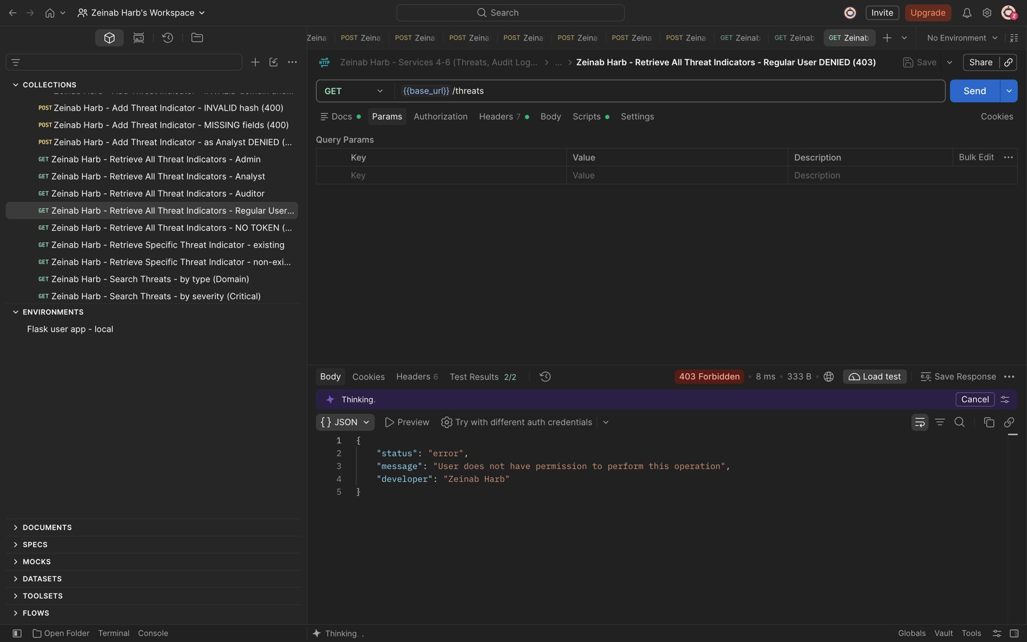
Figure 14: Zeinab Harb – Retrieve All Threat Indicators – Regular User denied (403)
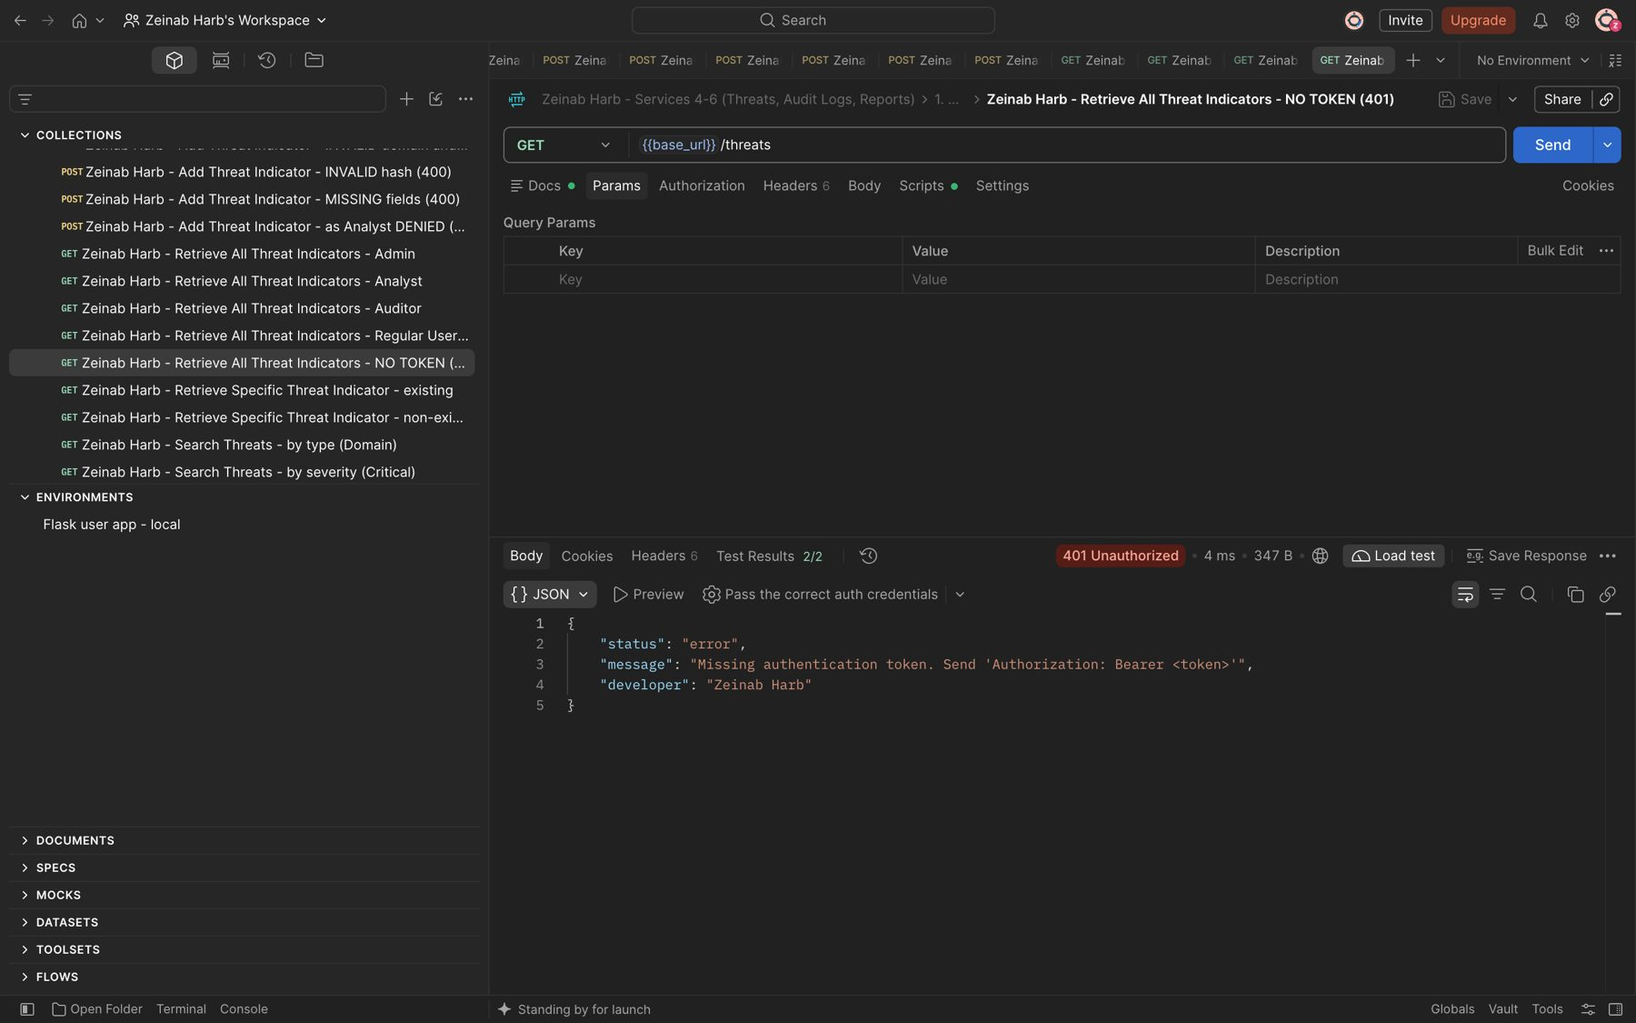
Figure 15: Zeinab Harb – Retrieve All Threat Indicators – request without a token rejected (401)

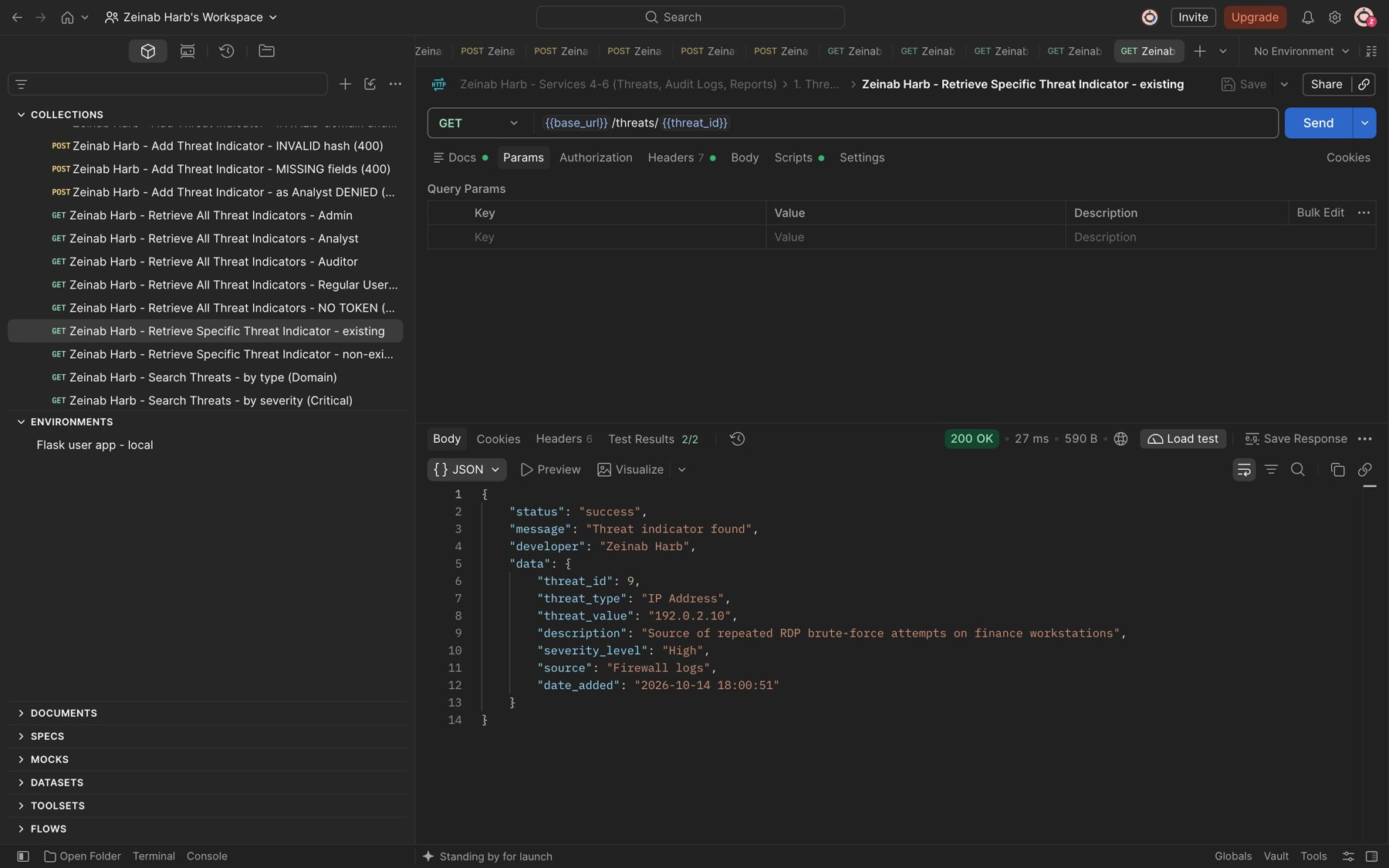
Figure 16: Zeinab Harb – Retrieve Specific Threat Indicator – returns an existing threat (200)
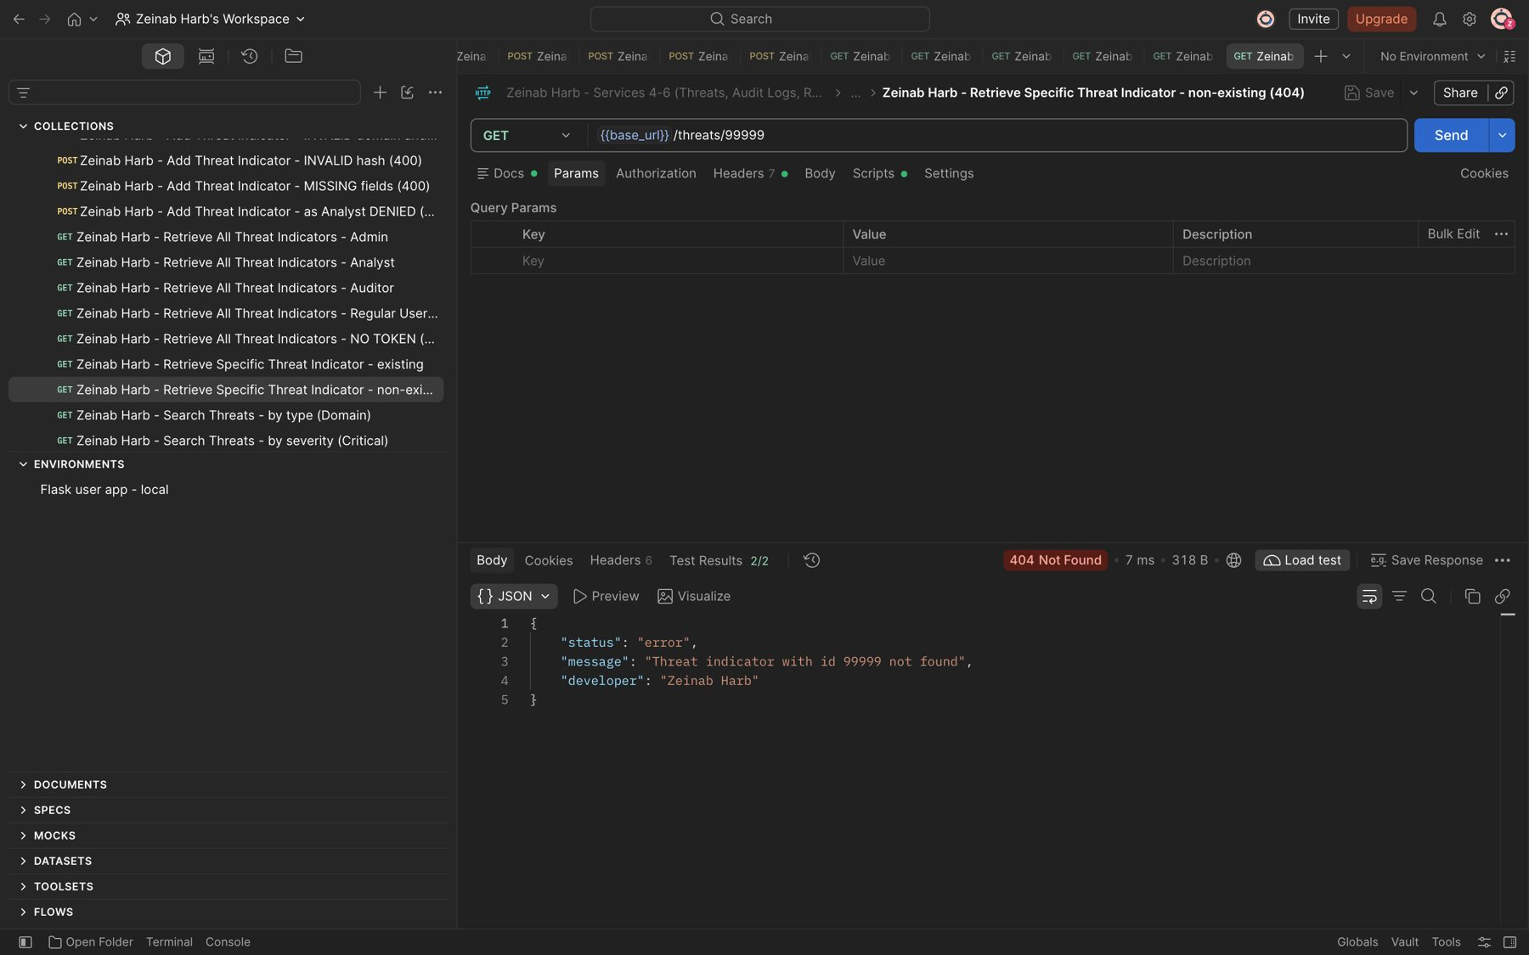
Figure 17: Zeinab Harb – Retrieve Specific Threat Indicator – non-existing threat id returns 404

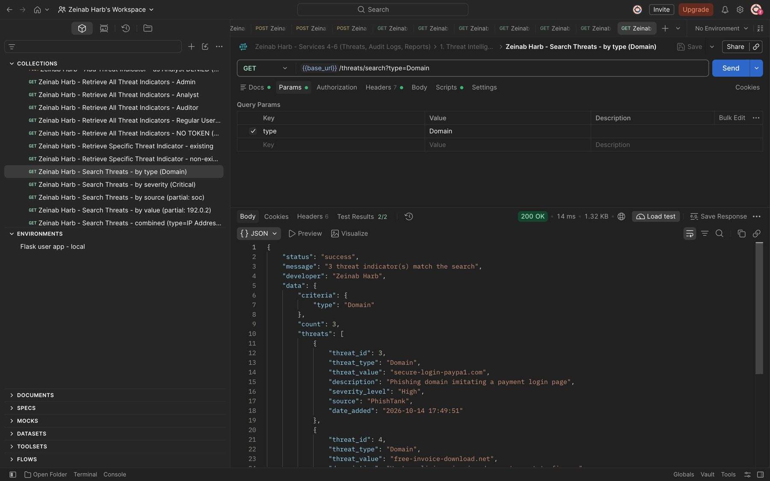
Figure 18: Zeinab Harb – Search Threat Indicators – search by type (Domain)
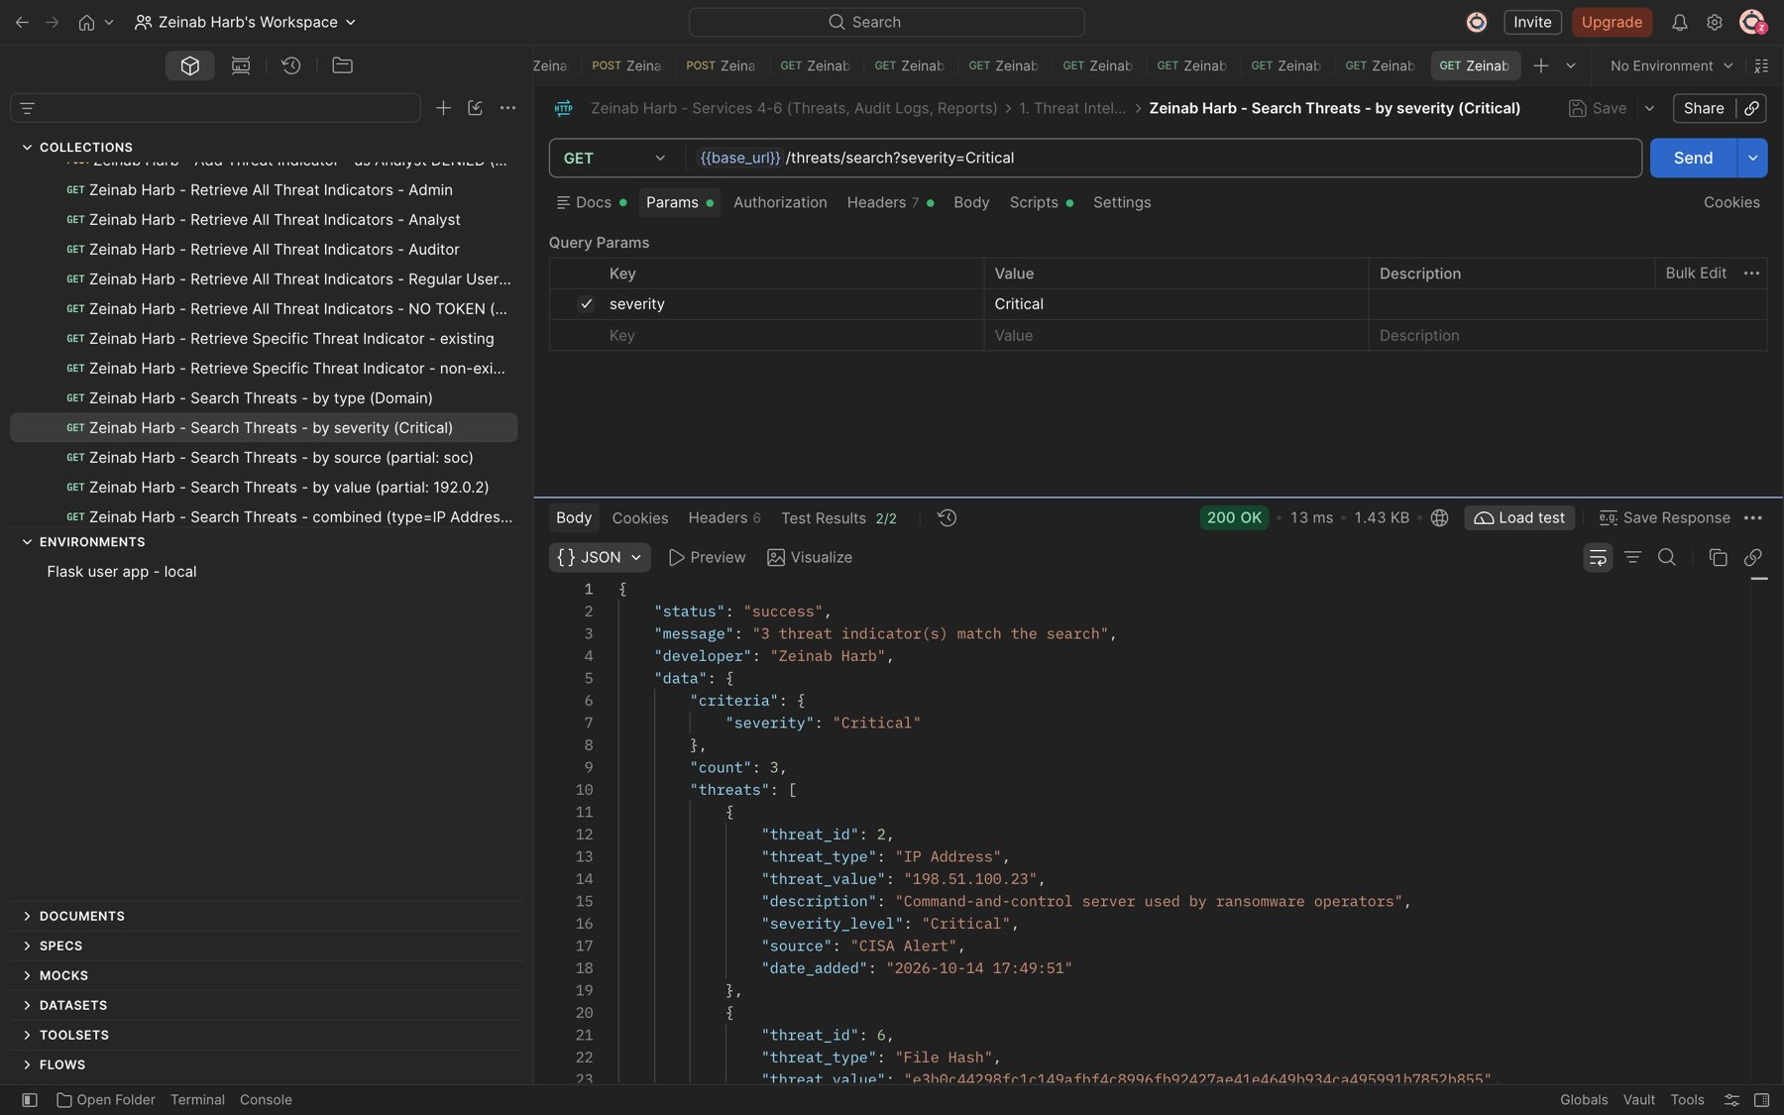
Figure 19: Zeinab Harb – Search Threat Indicators – search by severity (Critical)

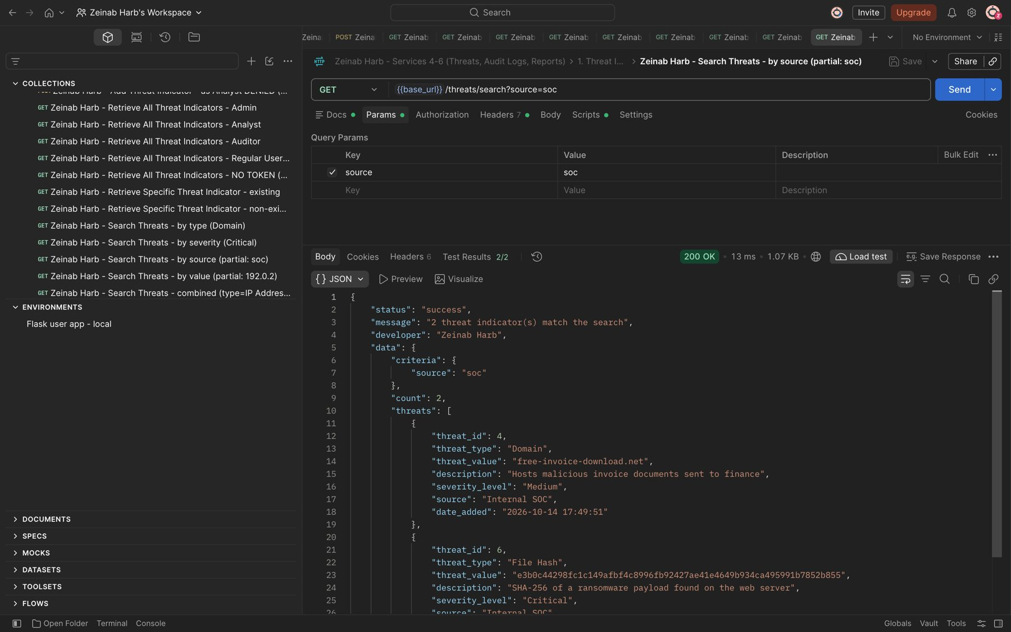
Figure 20: Zeinab Harb – Search Threat Indicators – partial search by source (soc)
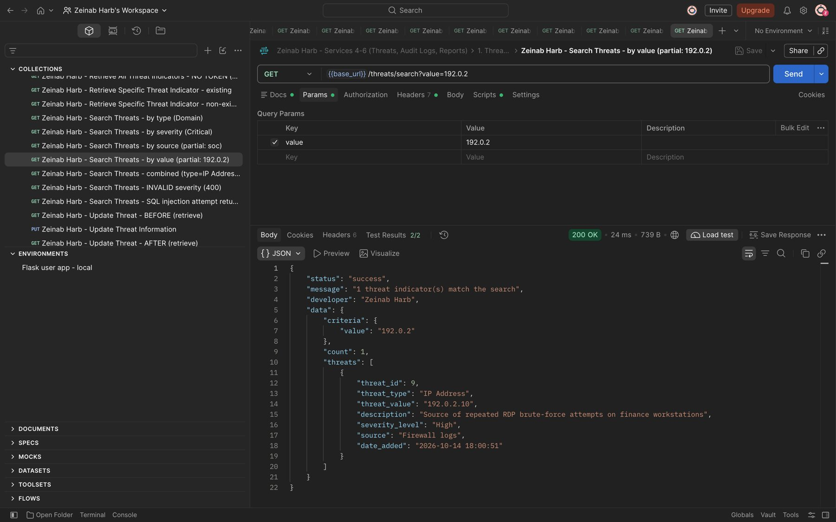
Figure 21: Zeinab Harb – Search Threat Indicators – partial search by threat value (192.0.2)

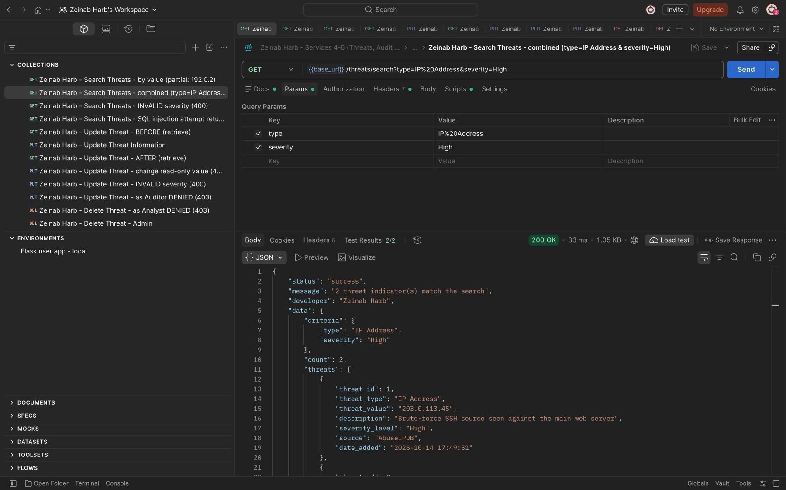
Figure 22: Zeinab Harb – Search Threat Indicators – combined search by type and severity
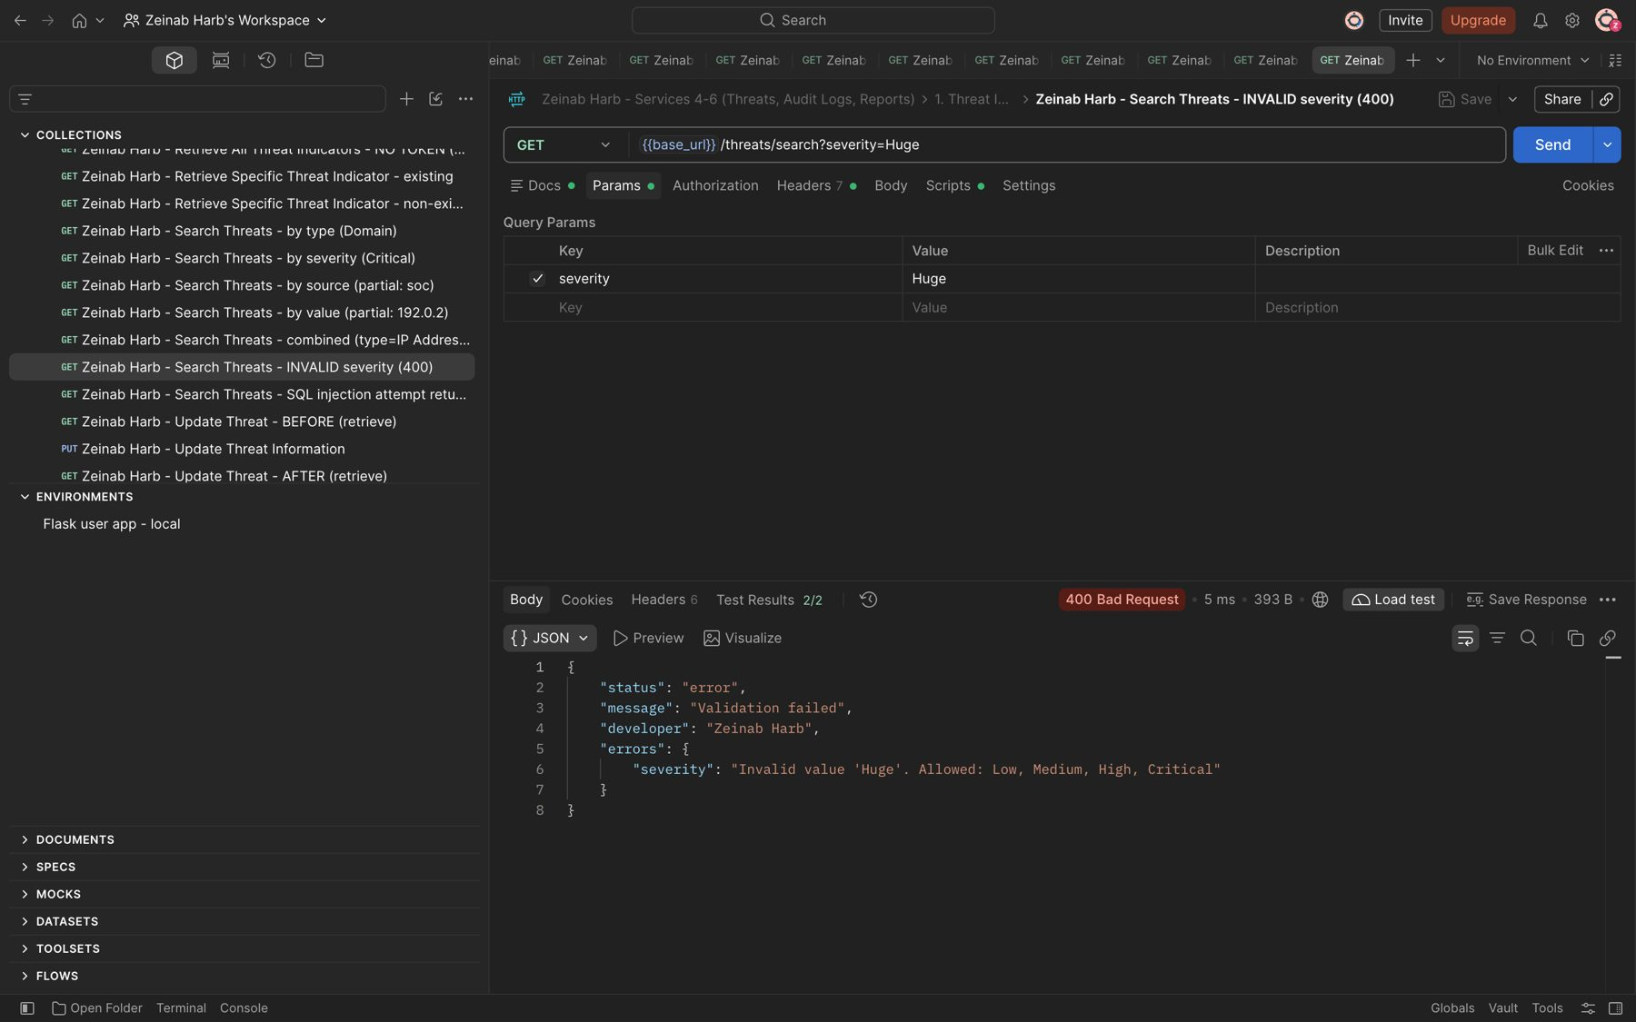
Figure 23: Zeinab Harb – Search Threat Indicators – invalid severity value rejected (400)

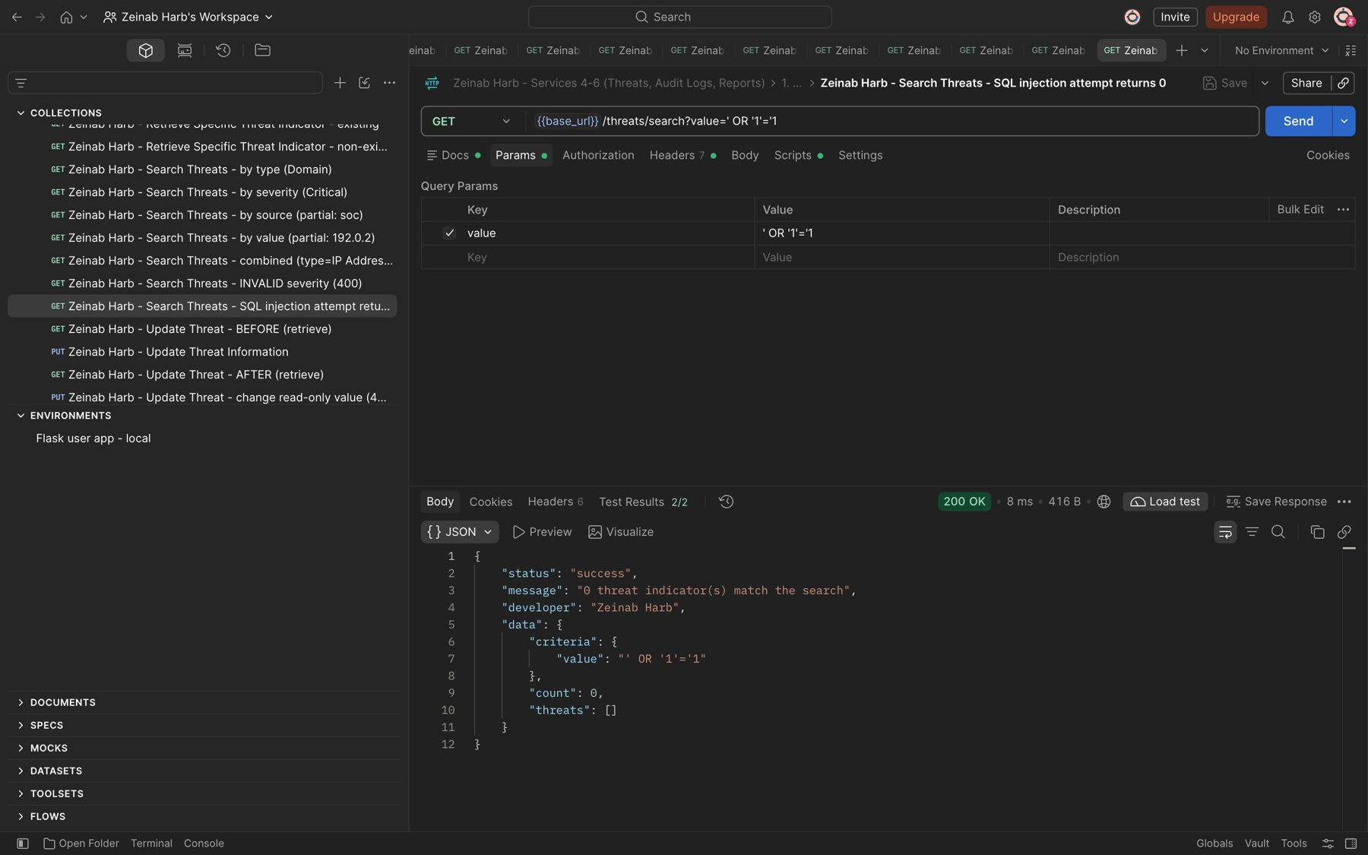
Figure 24: Zeinab Harb – Search Threat Indicators – SQL injection attempt is treated as text and returns 0 results
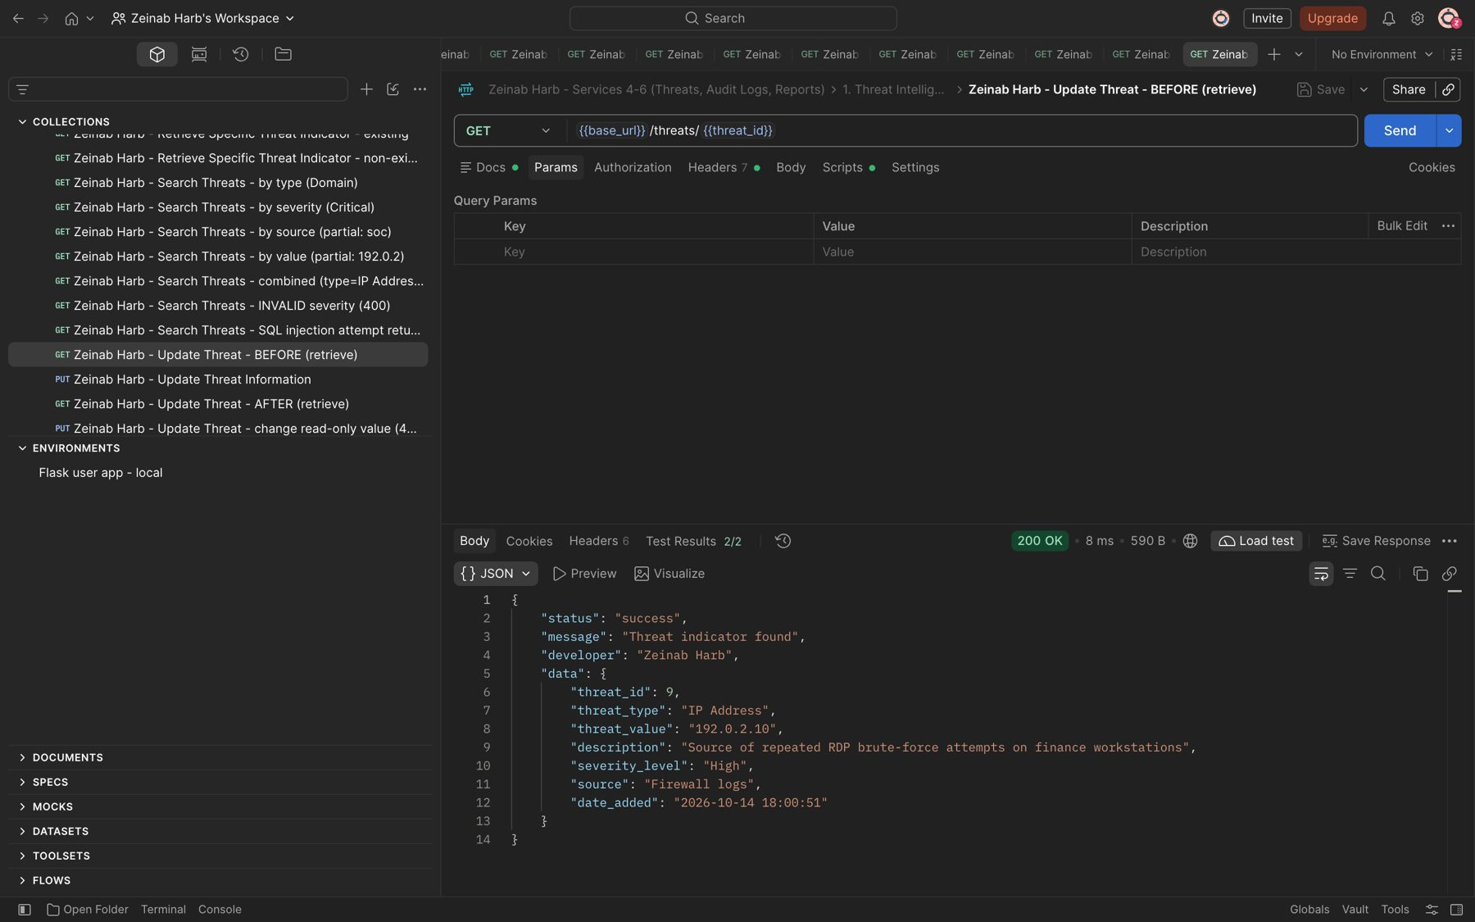
Figure 25: Zeinab Harb – Update Threat Information – threat before the update (severity High)

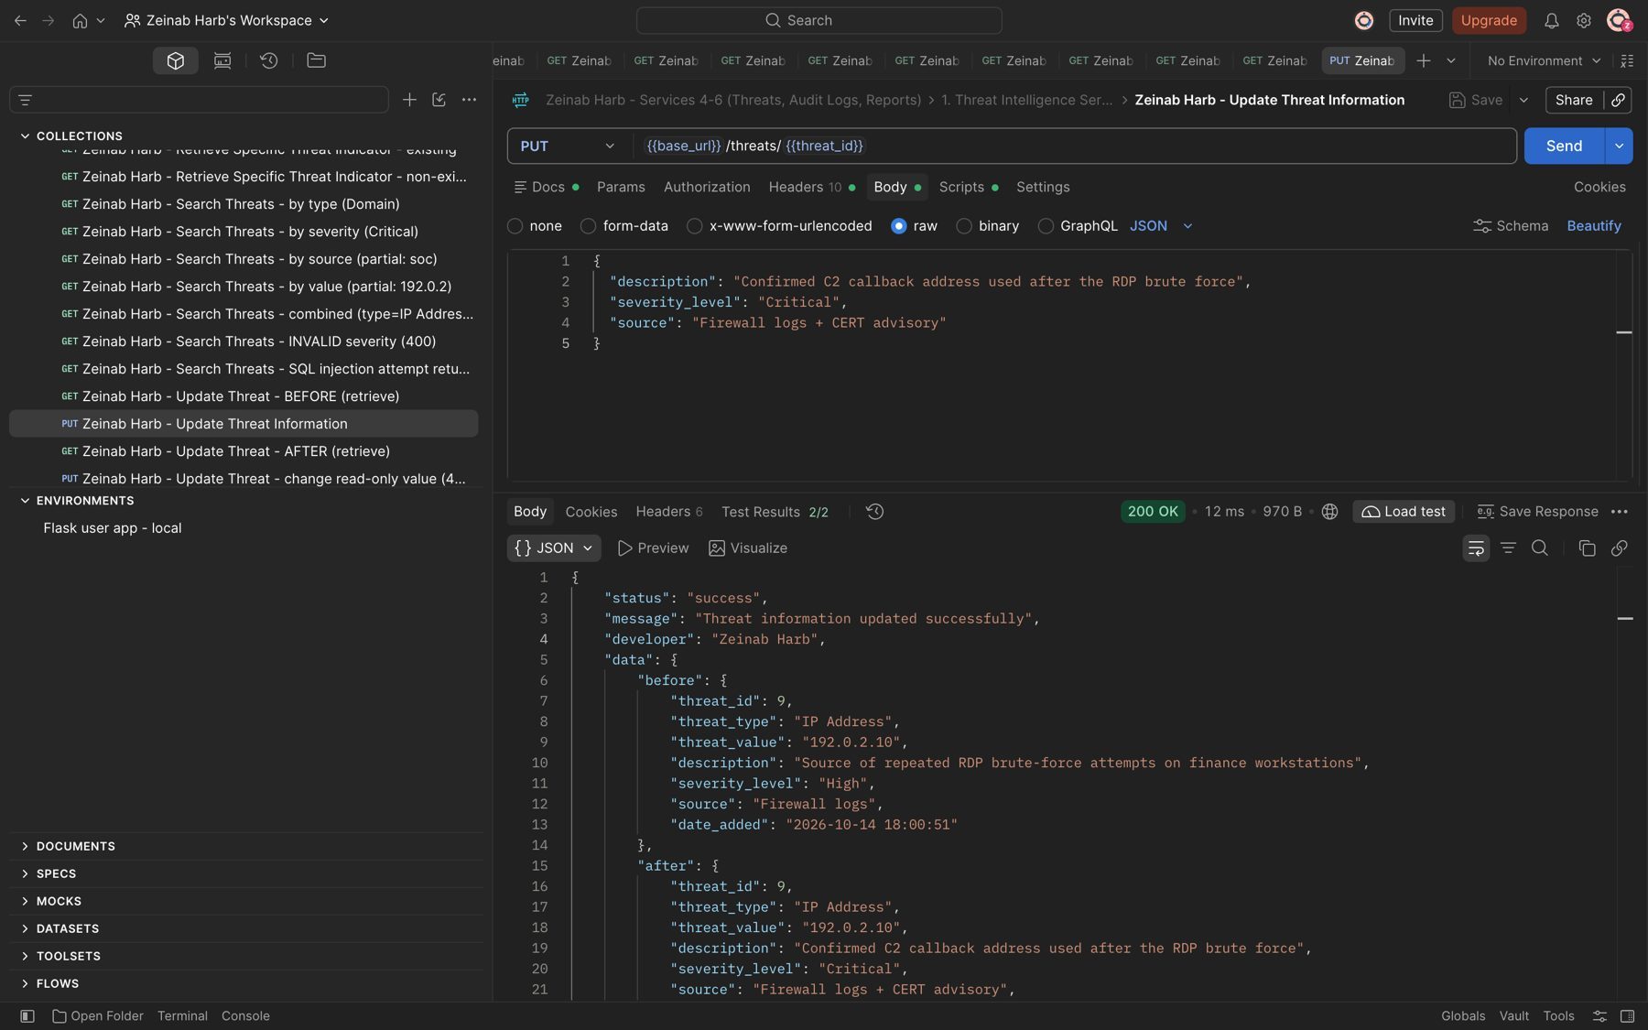
Figure 26: Zeinab Harb – Update Threat Information – updates description, severity and source; response shows before and after (200)
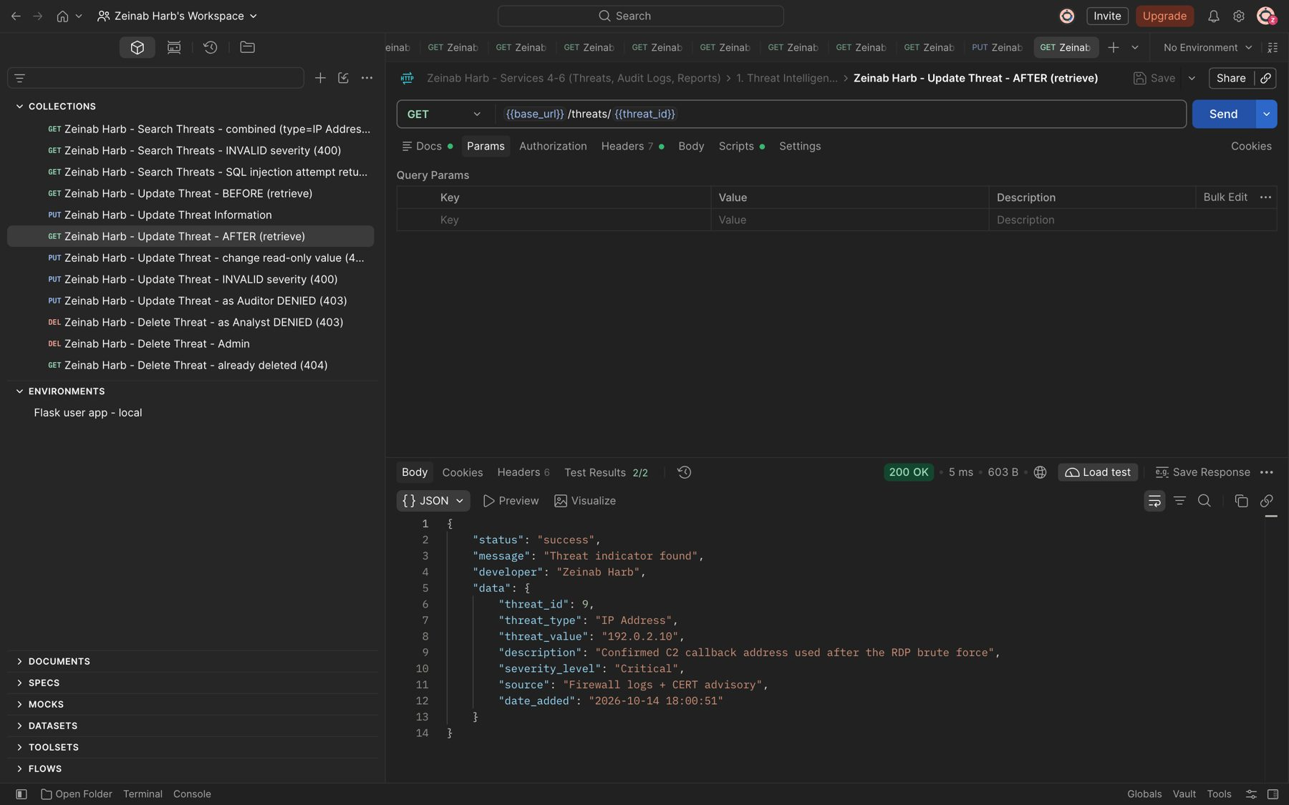
Figure 27: Zeinab Harb – Update Threat Information – threat after the update (severity Critical)

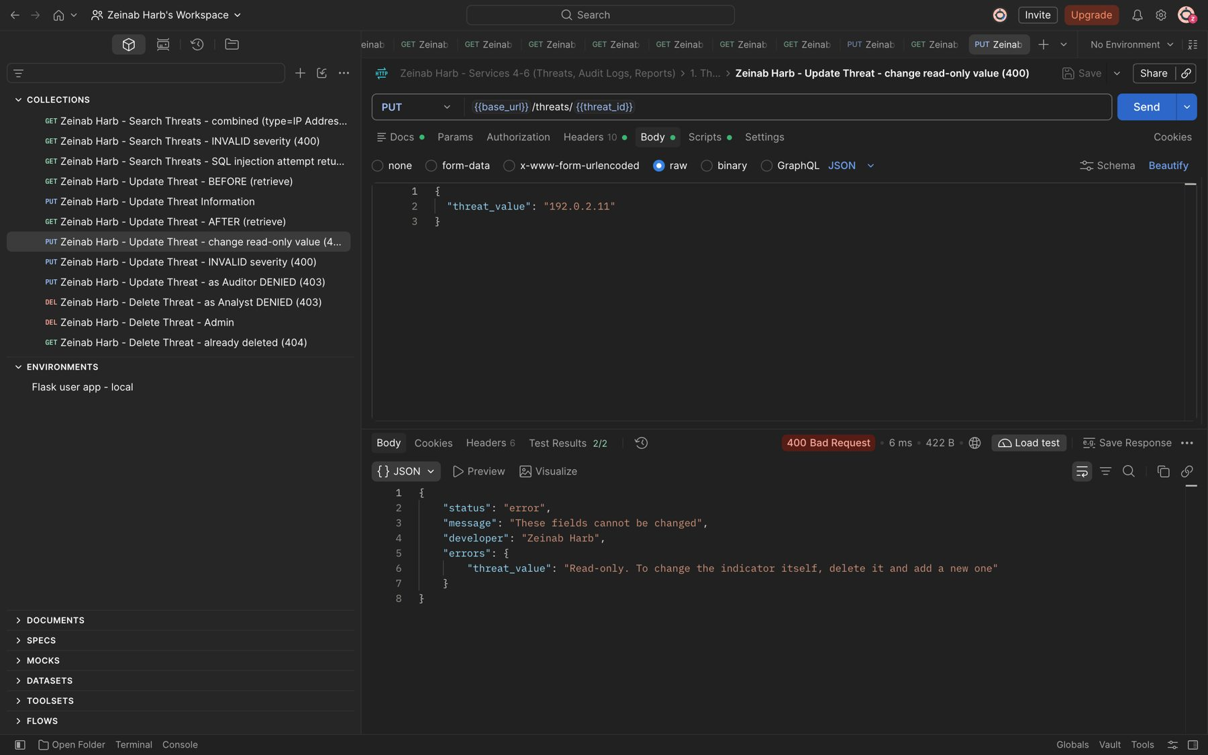
Figure 28: Zeinab Harb – Update Threat Information – changing the read-only threat value rejected (400)
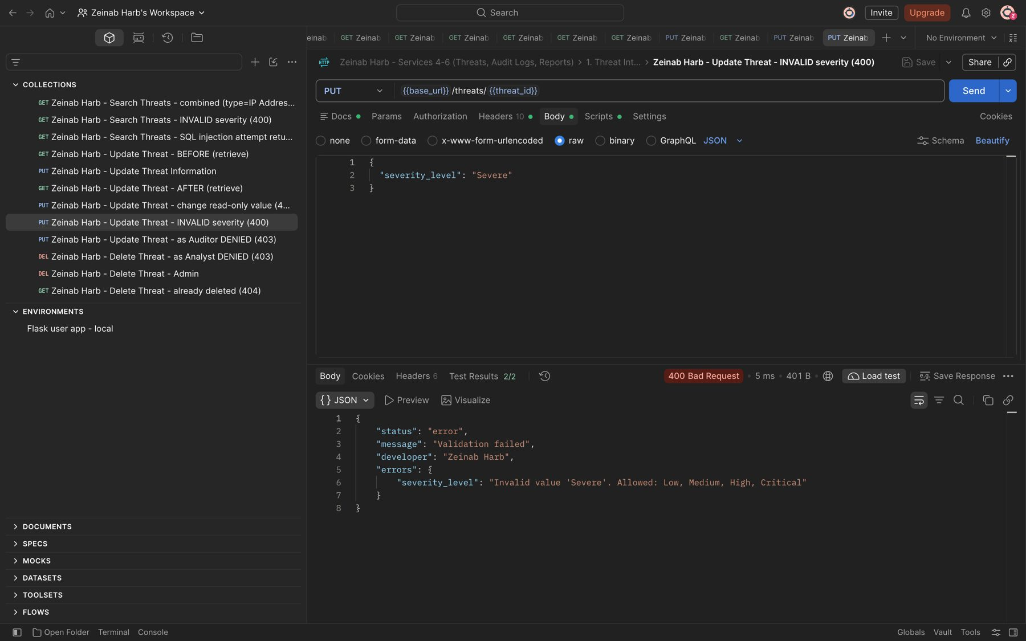
Figure 29: Zeinab Harb – Update Threat Information – invalid severity rejected (400)

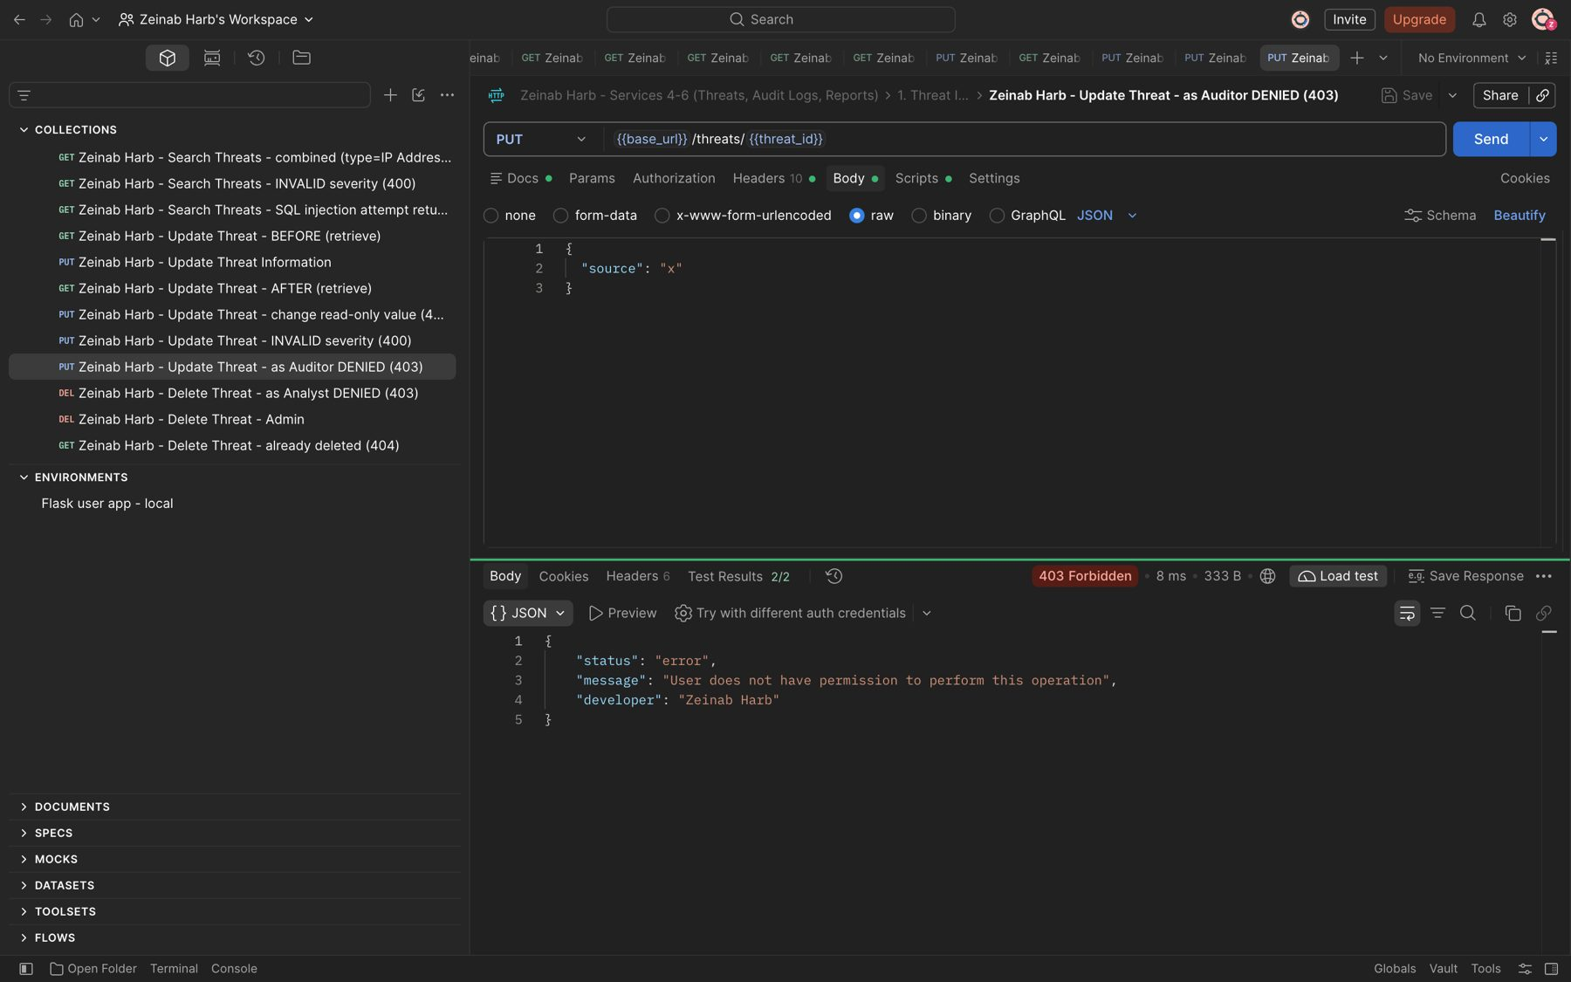
Figure 30: Zeinab Harb – Update Threat Information – Auditor not allowed to update threats (403)
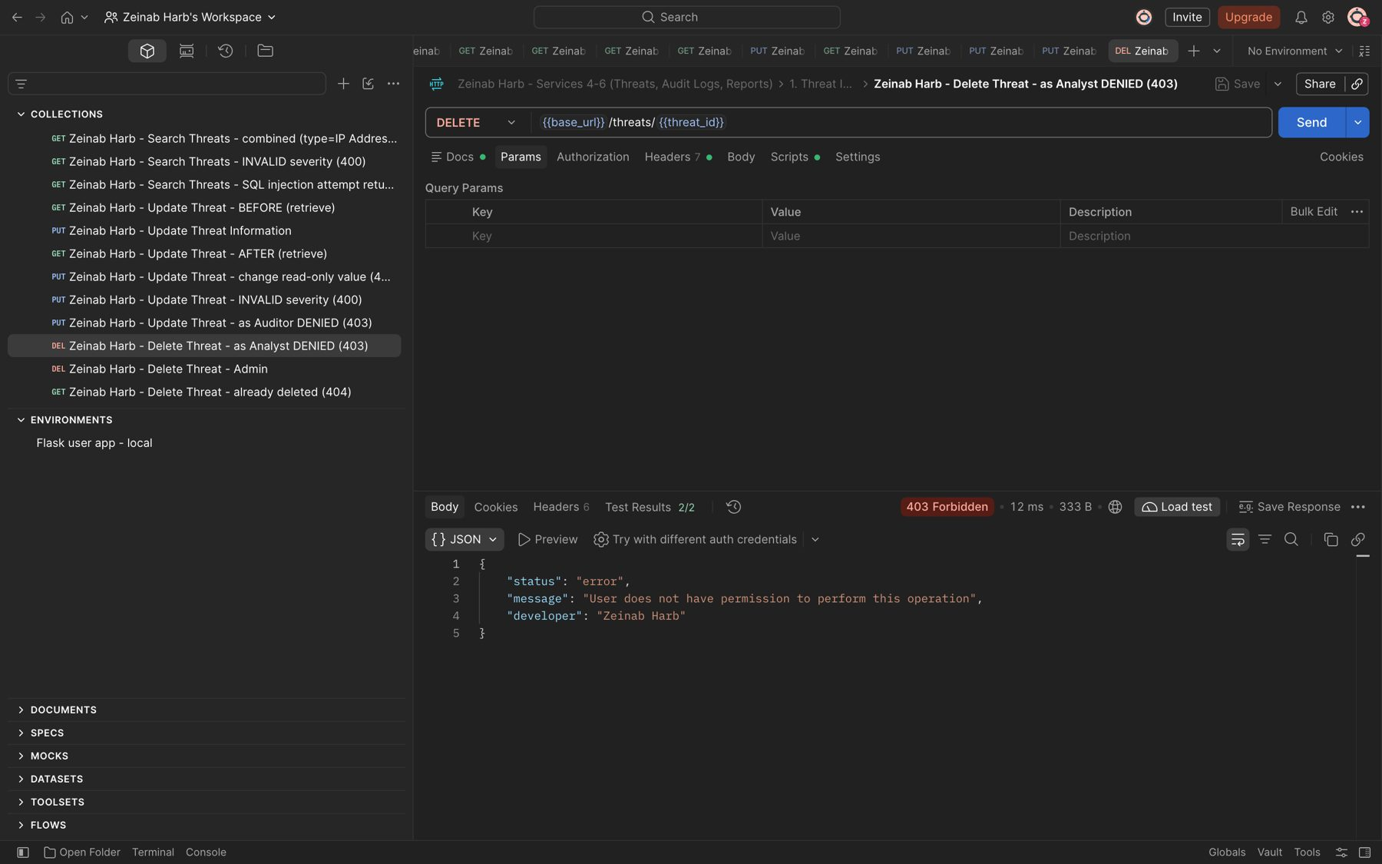
Figure 31: Zeinab Harb – Delete Threat Indicator – unauthorized deletion by a Security Analyst prevented (403)

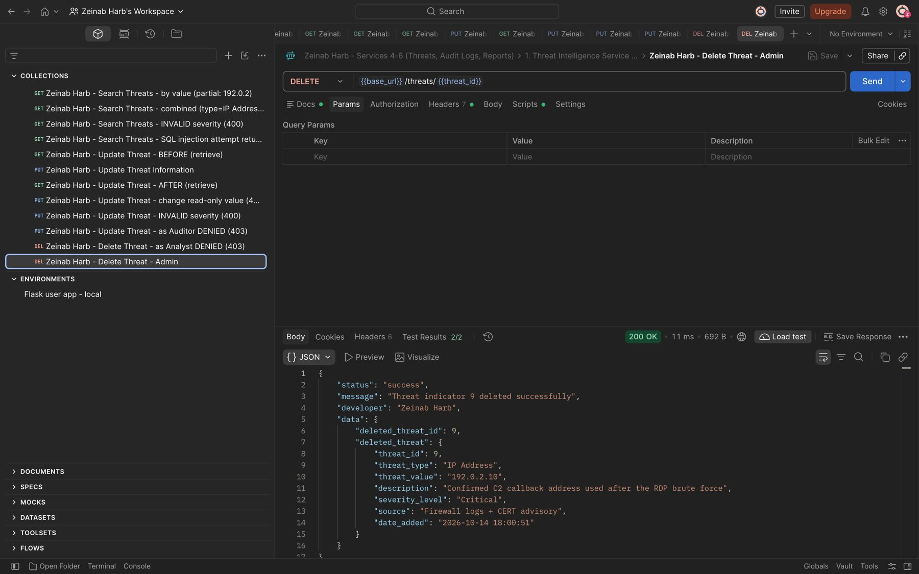
Figure 32: Zeinab Harb – Delete Threat Indicator – Security Administrator deletes a threat (200)
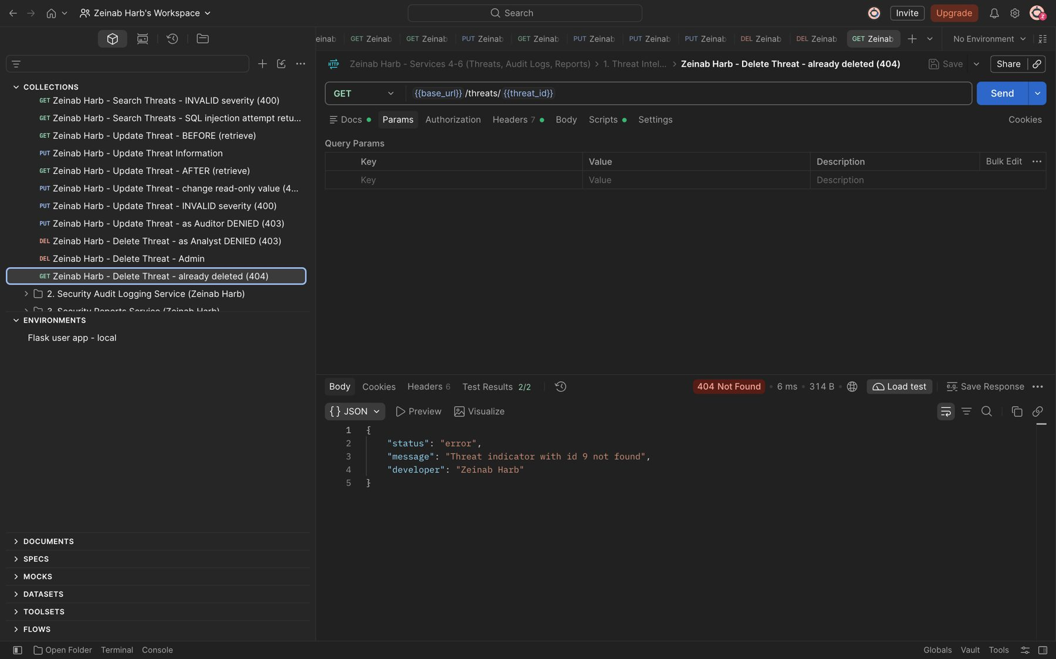
Figure 33: Zeinab Harb – Delete Threat Indicator – the deleted threat no longer exists (404)

3. Security Audit Logging Service (Service 5) (Zeinab Harb)
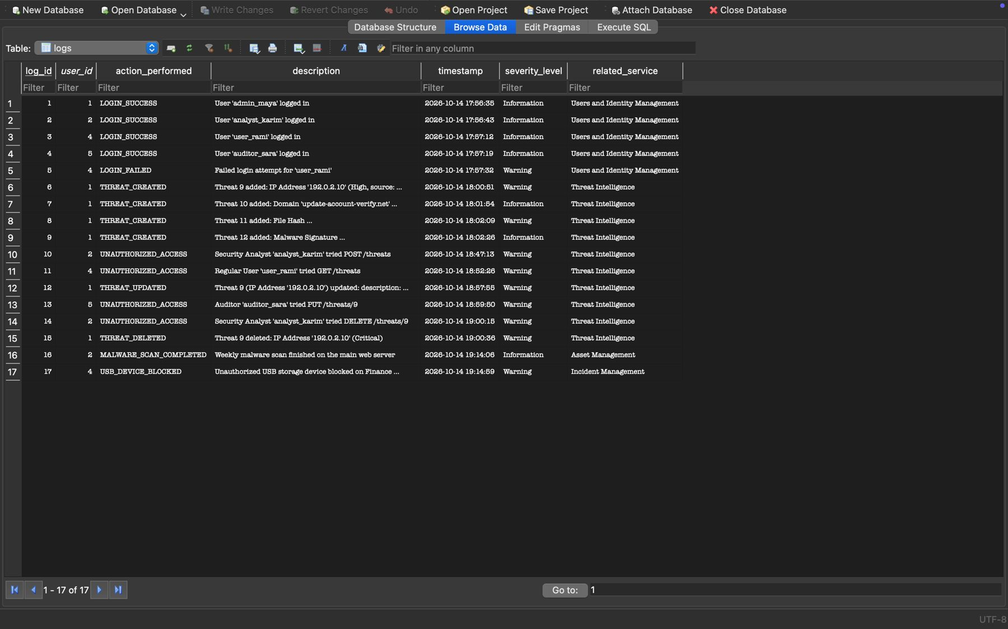
Figure 34: Zeinab Harb – Security Audit Logging – logs generated automatically by system activities (logins, failed login, threat changes, unauthorized access)
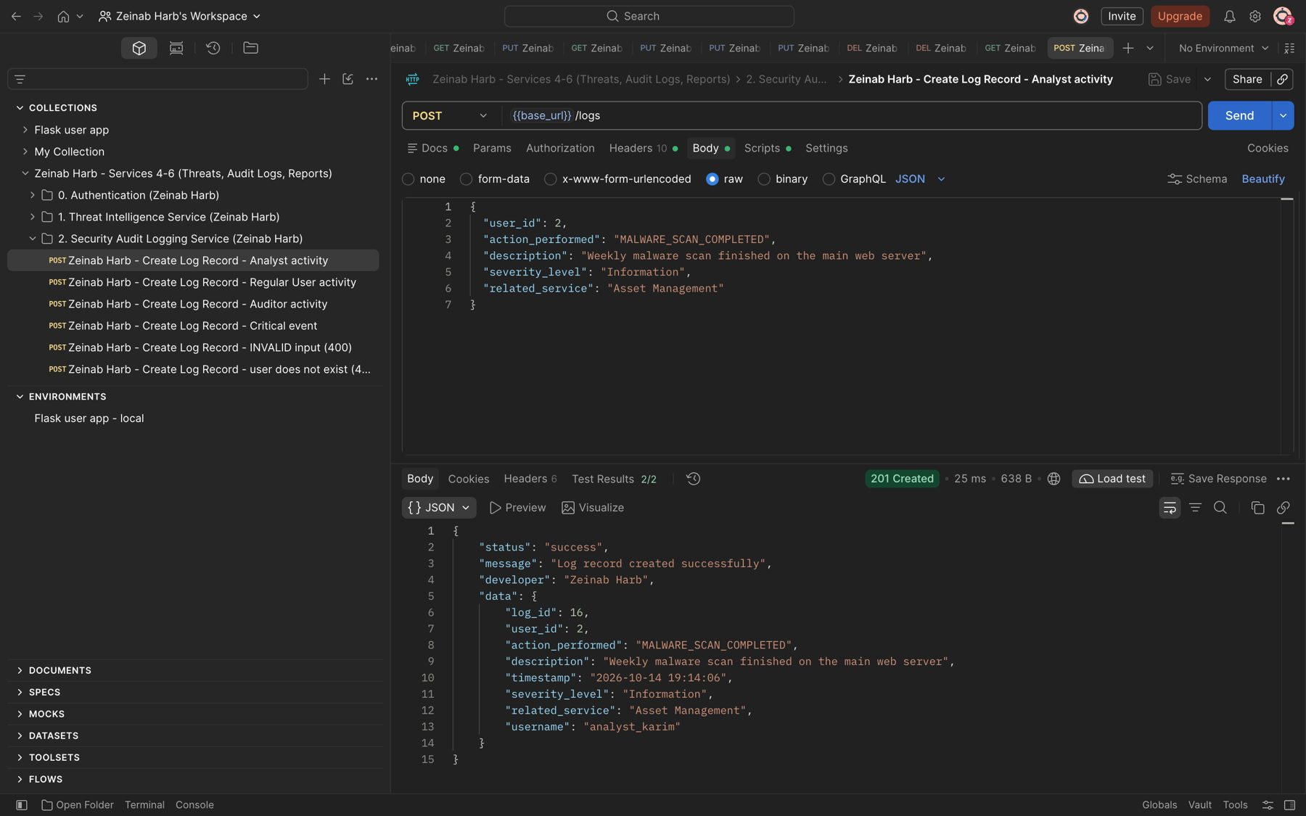
Figure 35: Zeinab Harb – Create Log Record – log record for a Security Analyst activity (201)

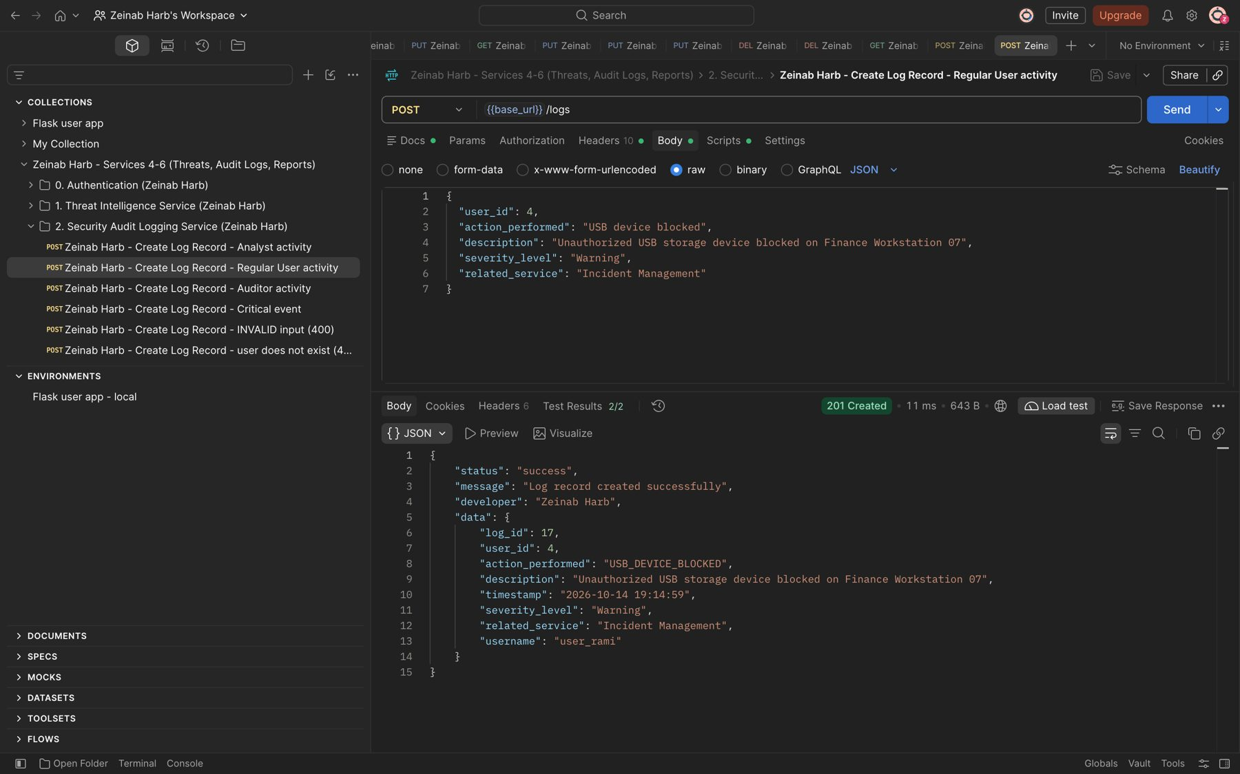
Figure 36: Zeinab Harb – Create Log Record – log record for a Regular User activity; the action is normalised to USB_DEVICE_BLOCKED (201)
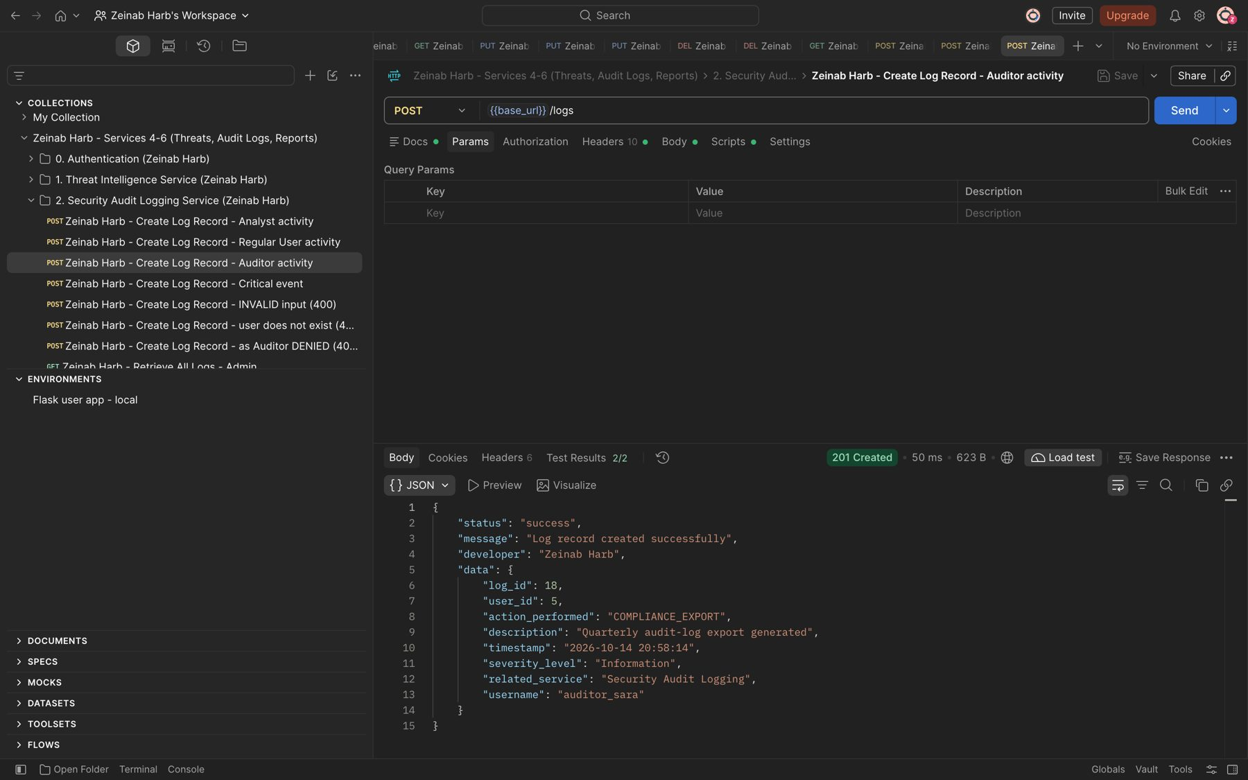
Figure 37: Zeinab Harb – Create Log Record – log record for an Auditor activity (201)

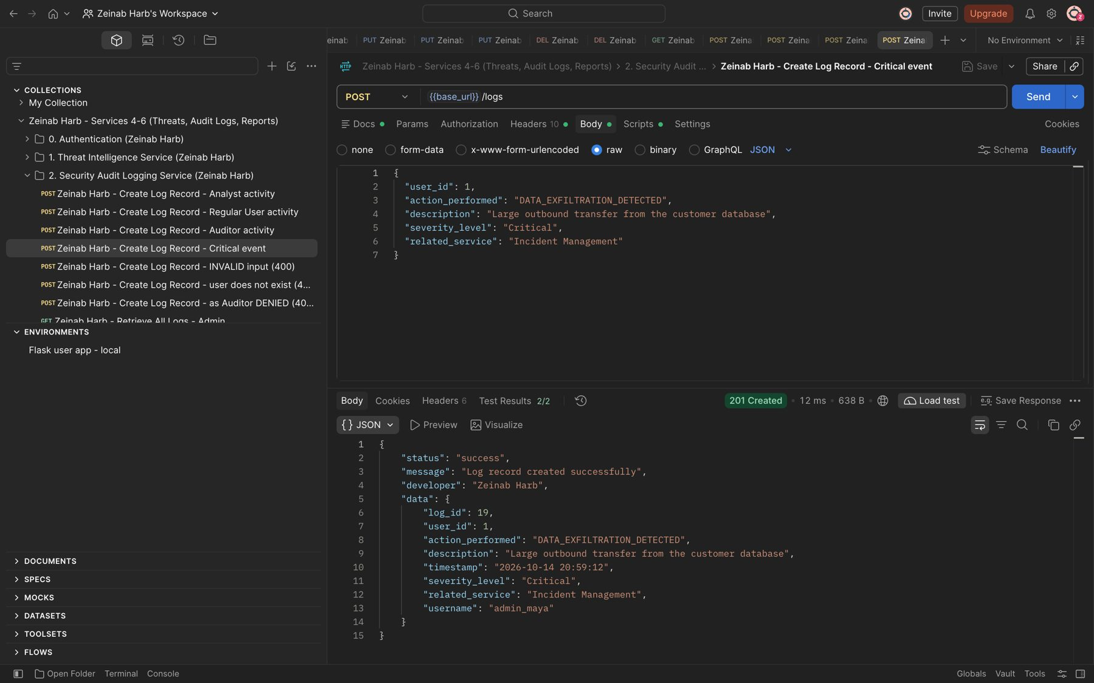
Figure 38: Zeinab Harb – Create Log Record – critical security event logged (201)
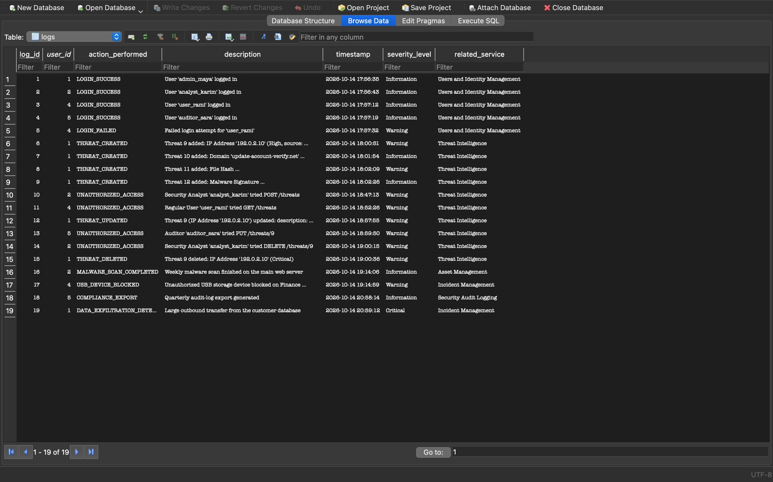
Figure 39: Zeinab Harb – Create Log Record – manually created log records stored in the database

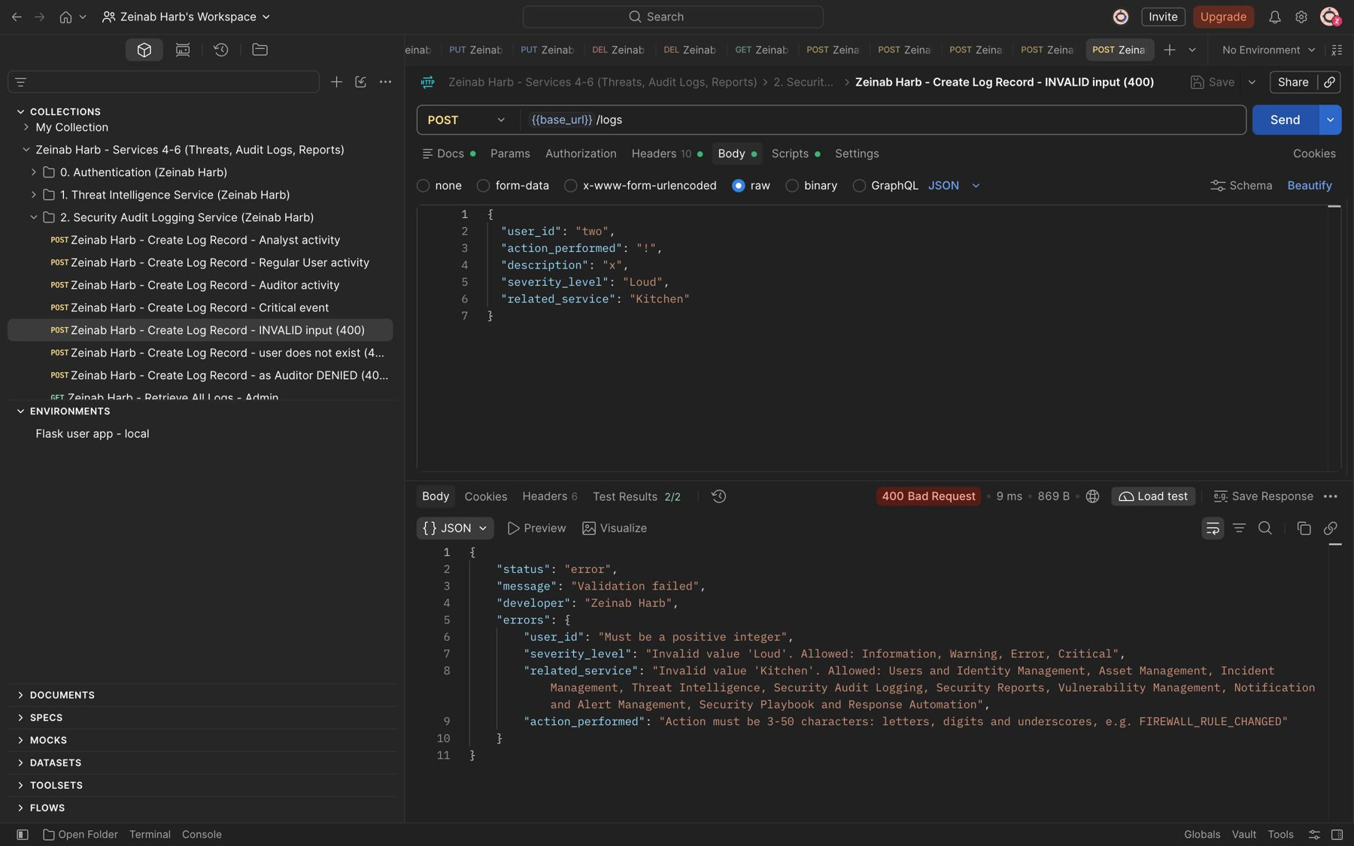
Figure 40: Zeinab Harb – Create Log Record – invalid input rejected with four validation errors (400)
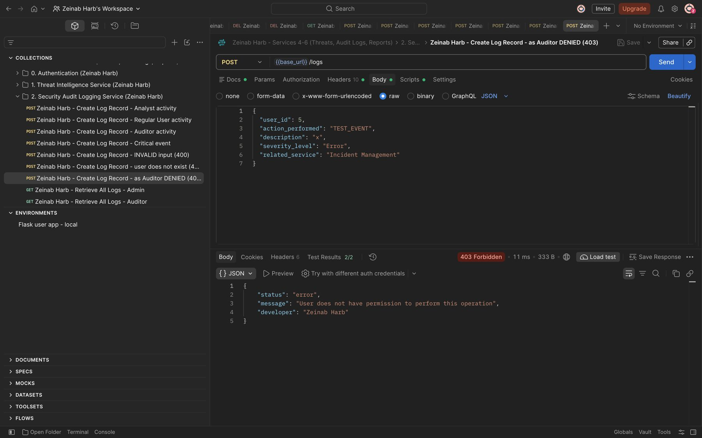
Figure 41: Zeinab Harb – Create Log Record – Auditor cannot create log records (403)

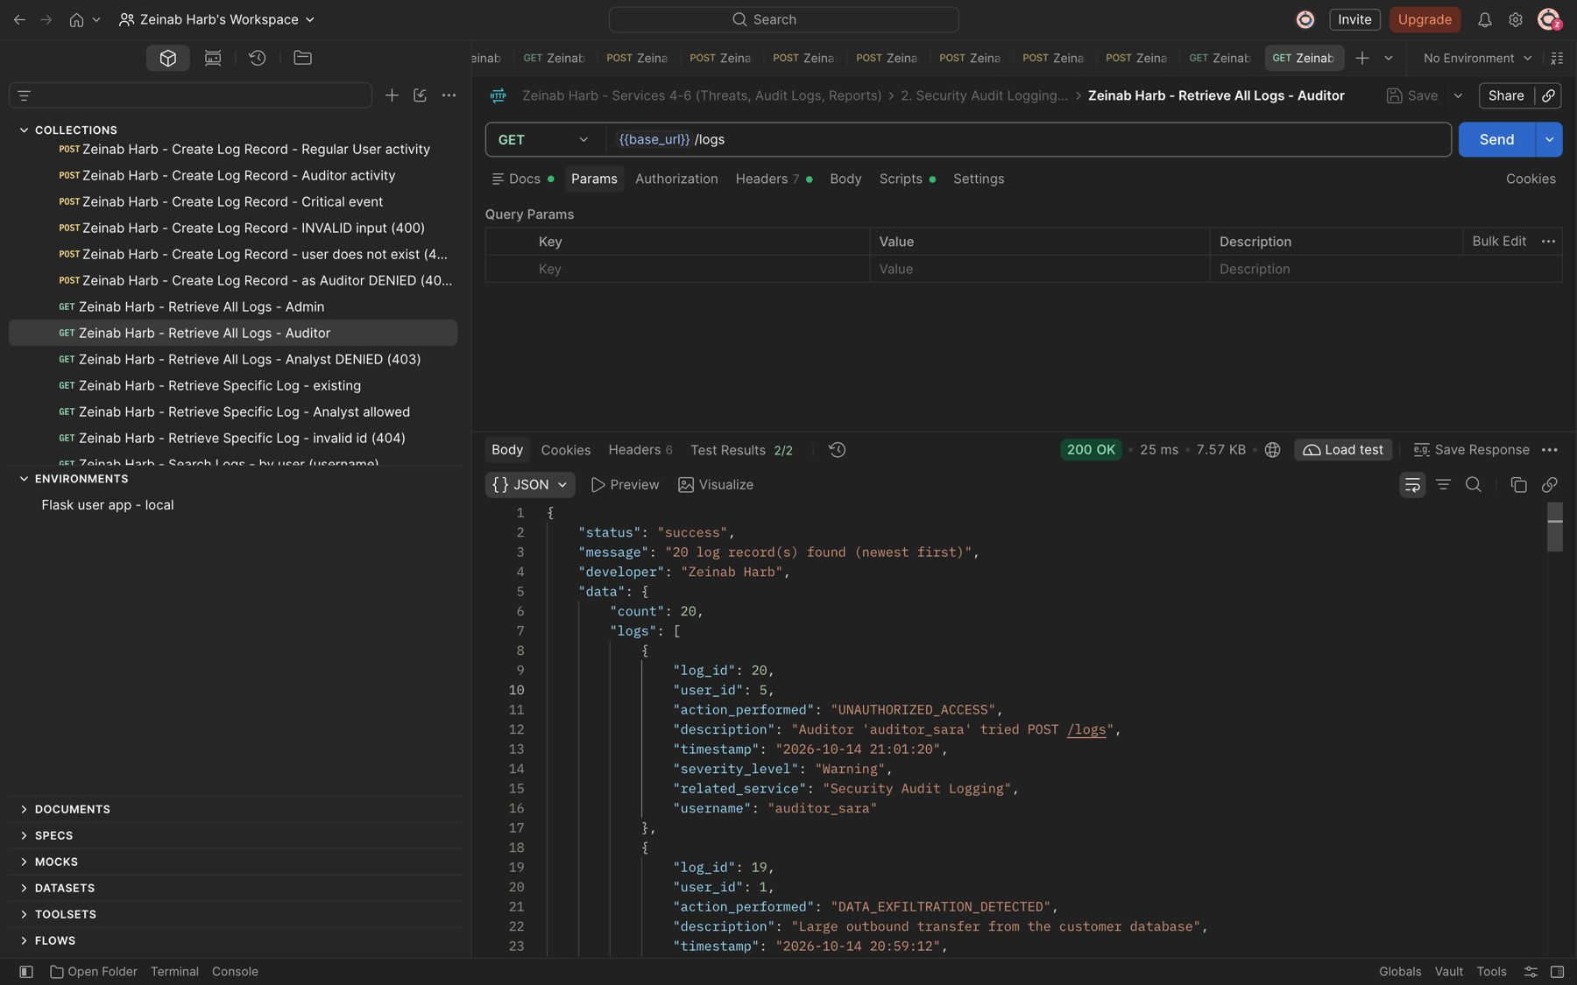
Figure 42: Zeinab Harb – Retrieve All Logs – Auditor views all audit records, newest first (200)
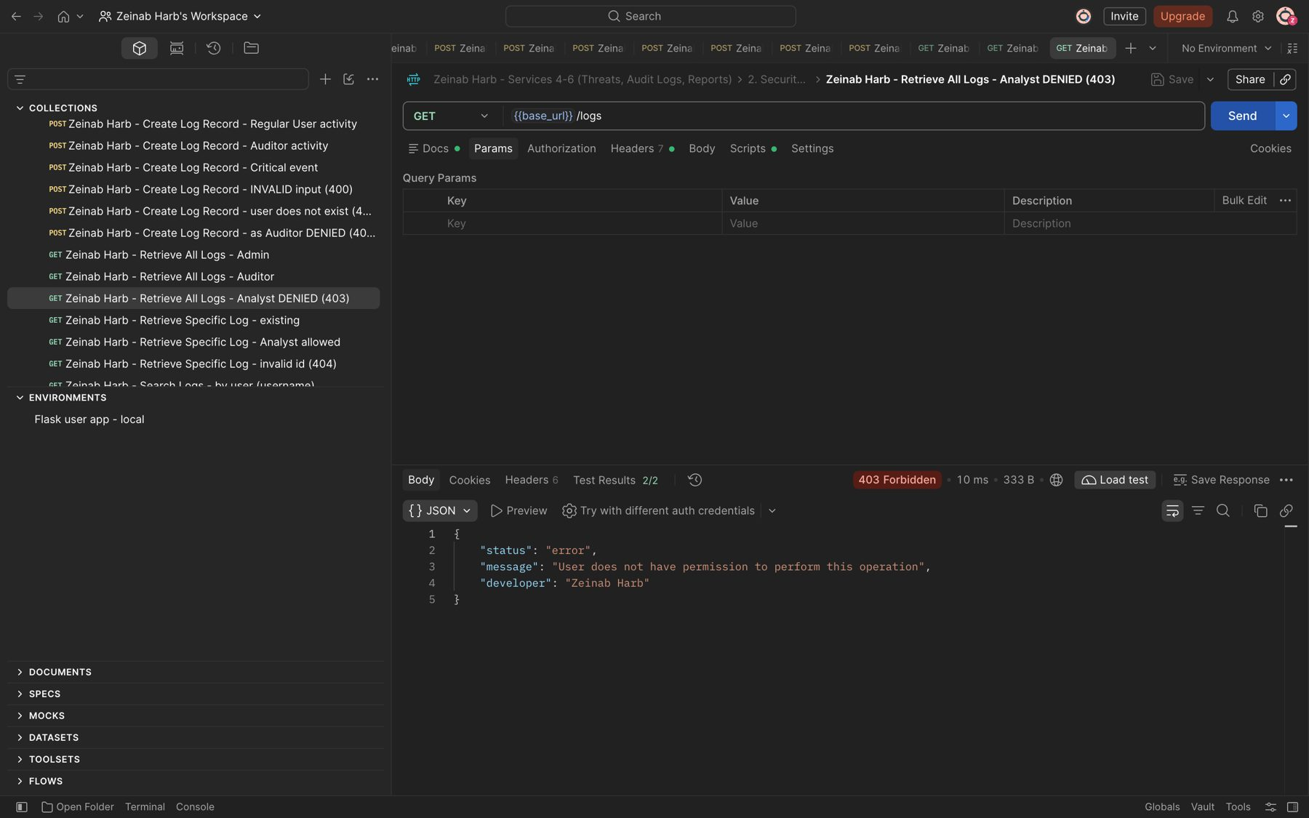
Figure 43: Zeinab Harb – Retrieve All Logs – Security Analyst denied (403)

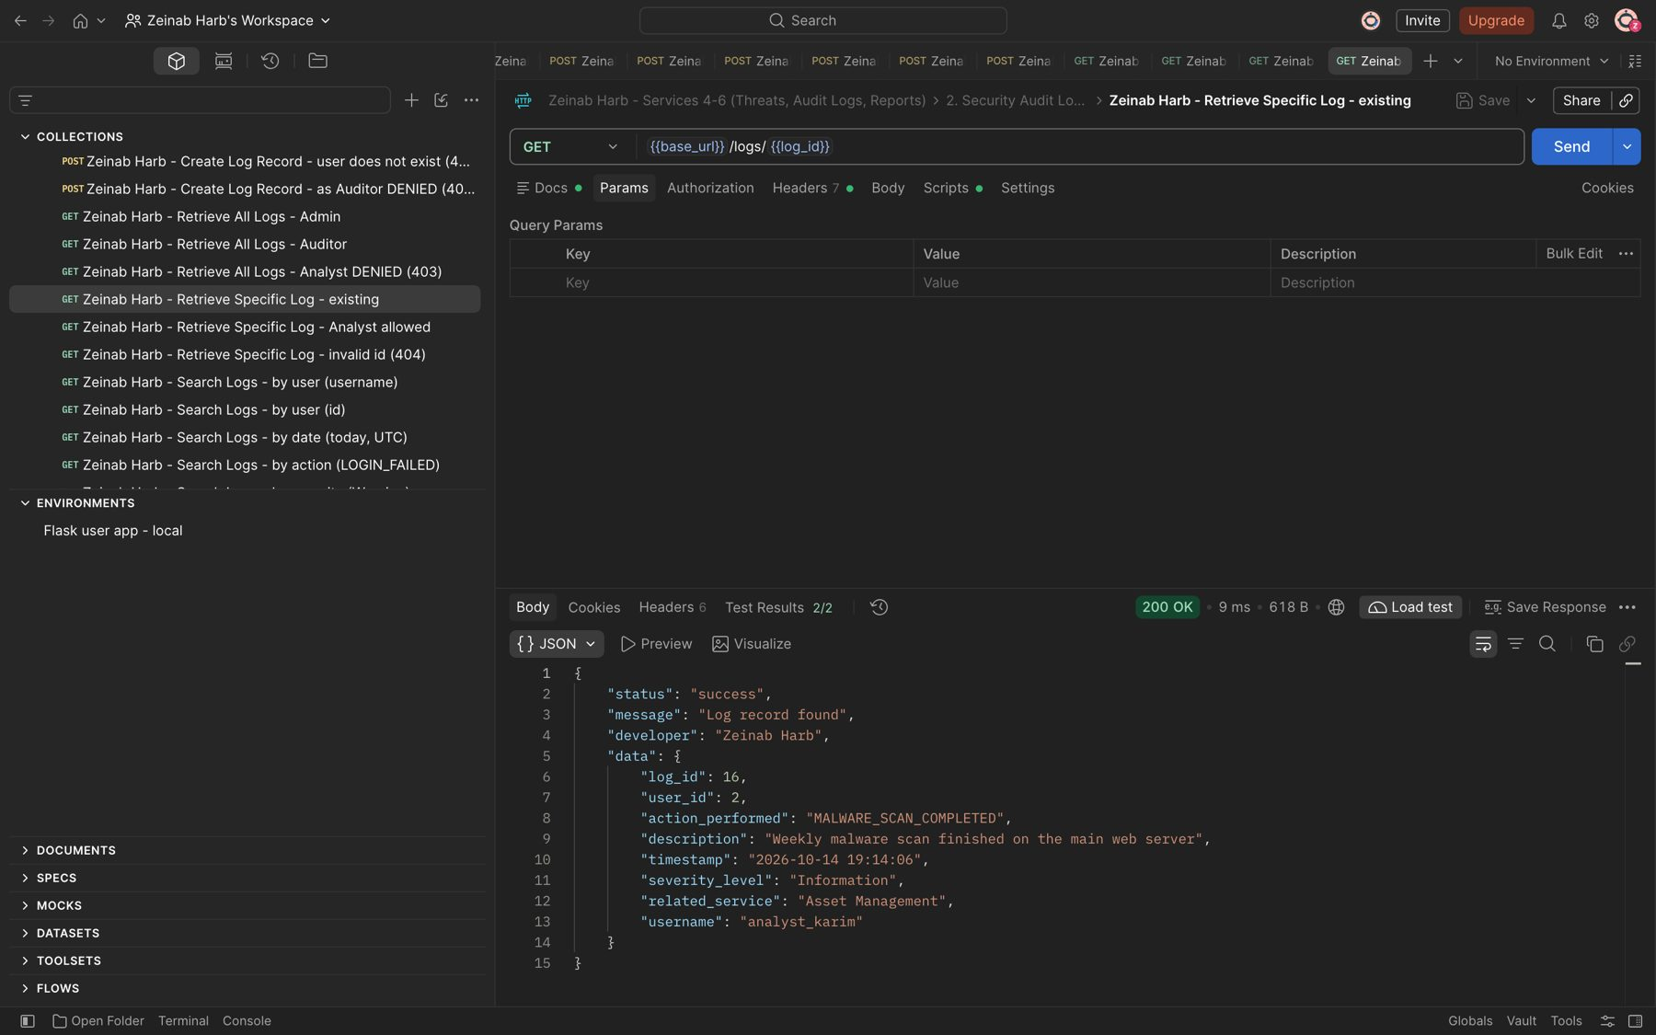
Figure 44: Zeinab Harb – Retrieve Specific Log – returns an existing log record (200)
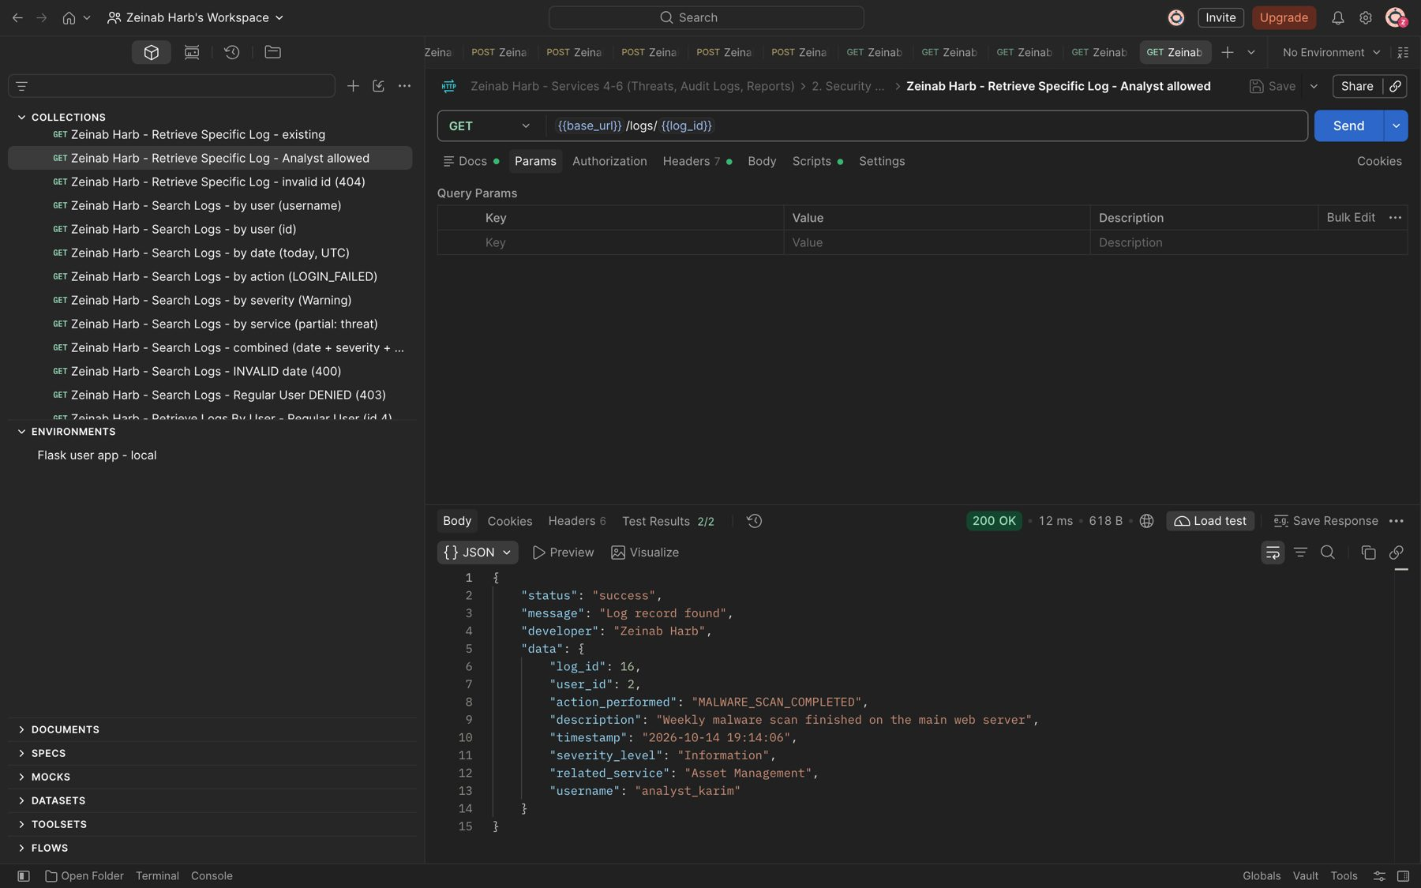
Figure 45: Zeinab Harb – Retrieve Specific Log – Security Analyst is allowed to view a specific log (200)

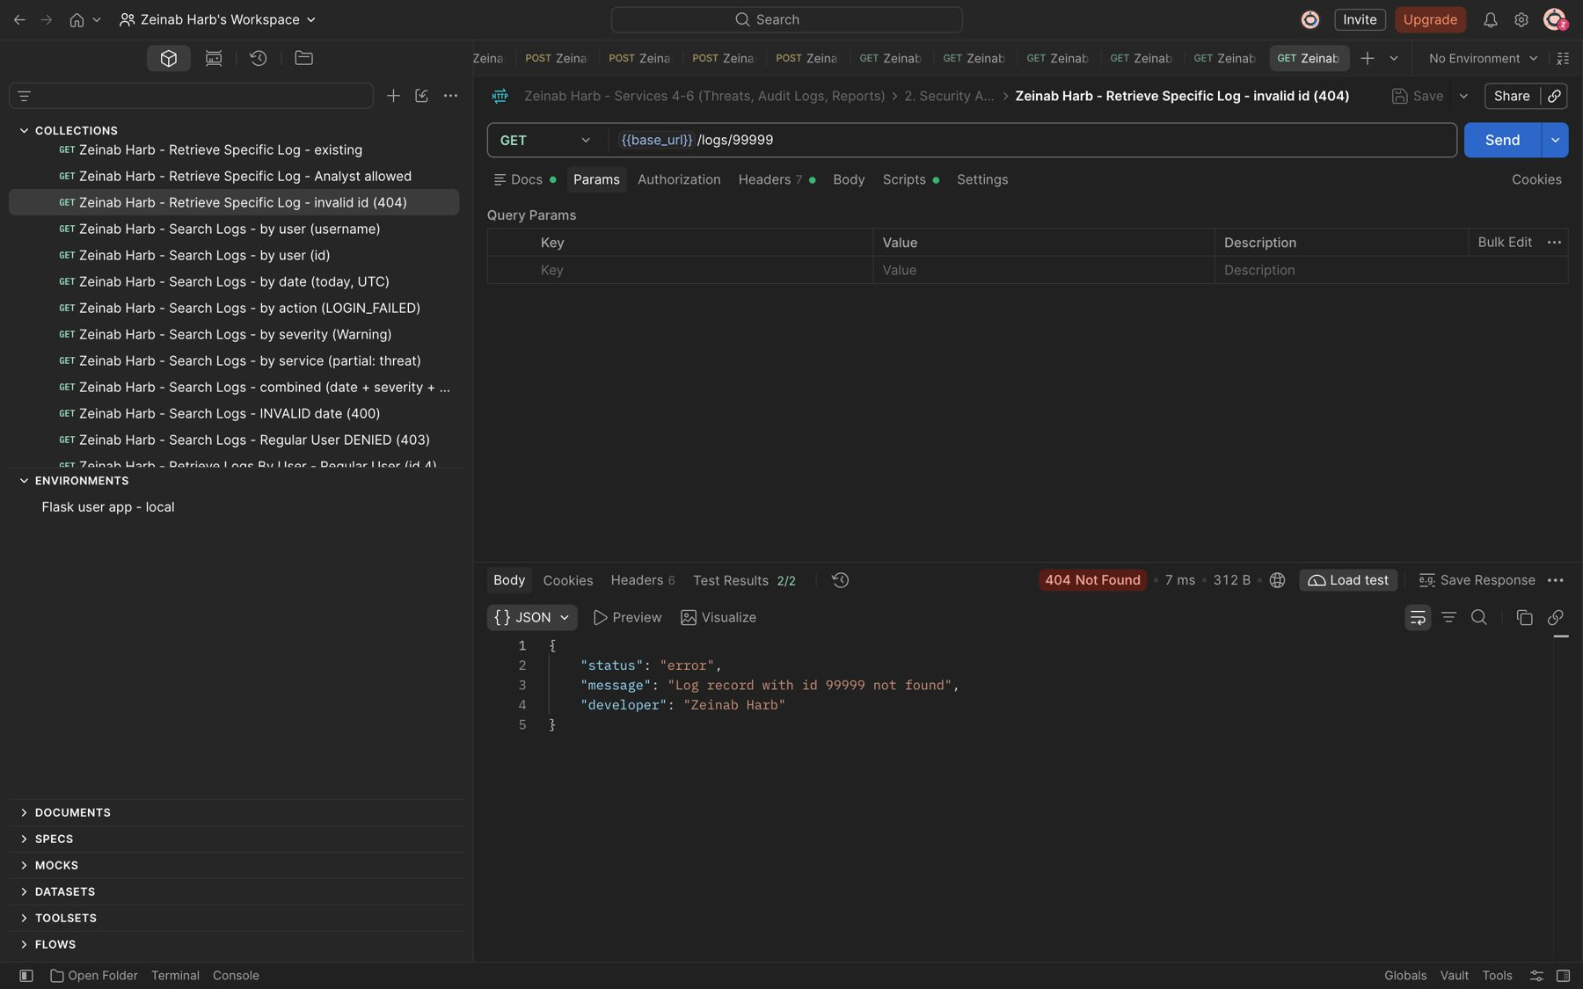
Figure 46: Zeinab Harb – Retrieve Specific Log – invalid log id returns 404
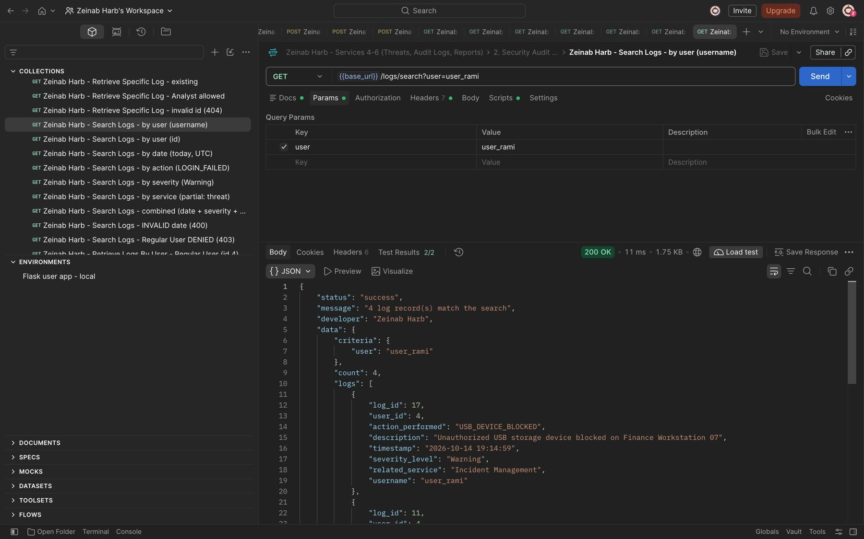
Figure 47: Zeinab Harb – Search Logs – filter by user (username)

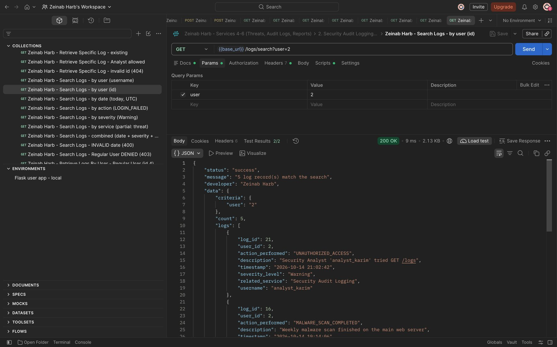
Figure 48: Zeinab Harb – Search Logs – filter by user (user id)
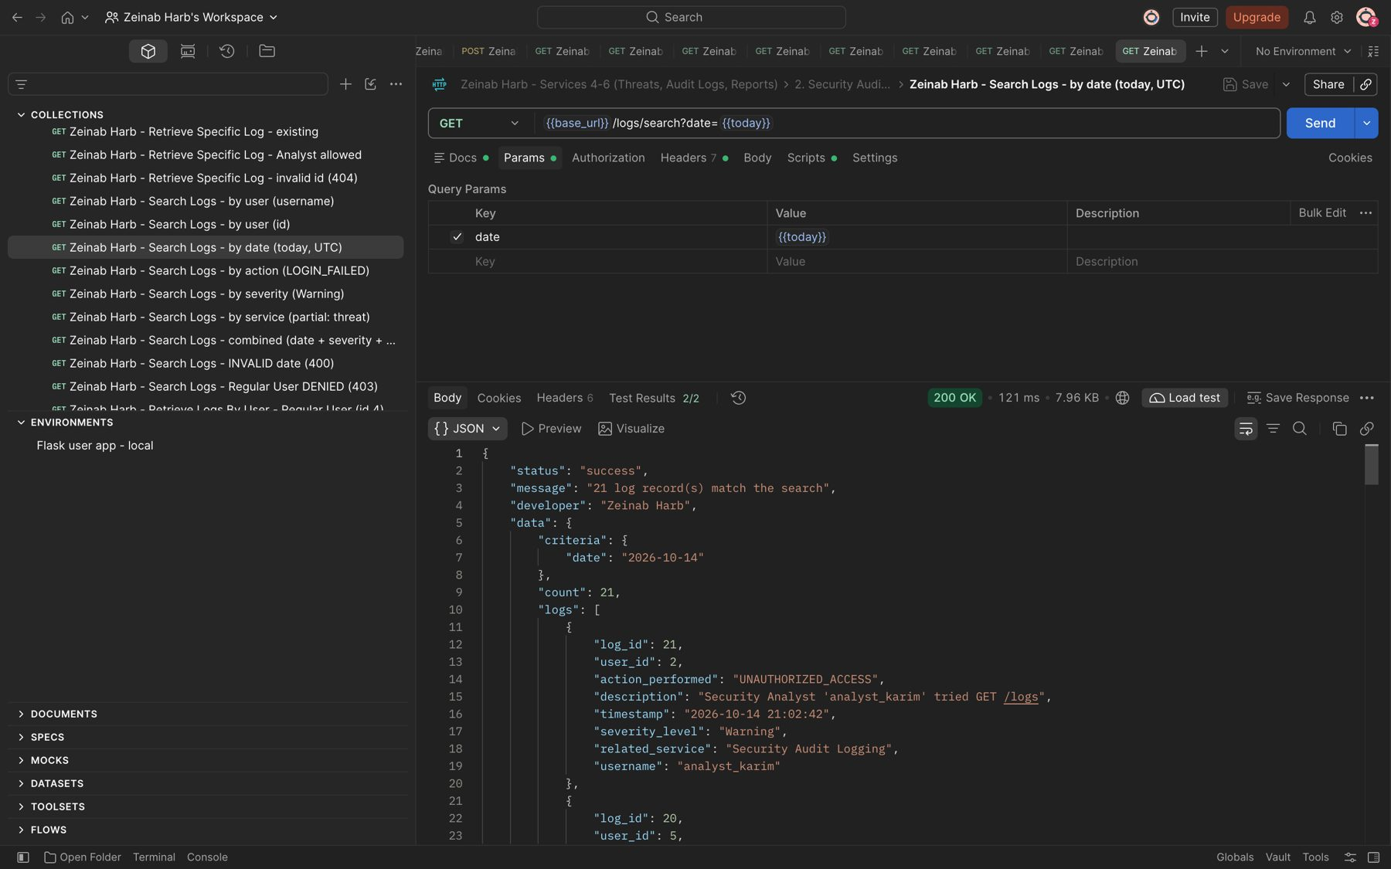
Figure 49: Zeinab Harb – Search Logs – filter by date

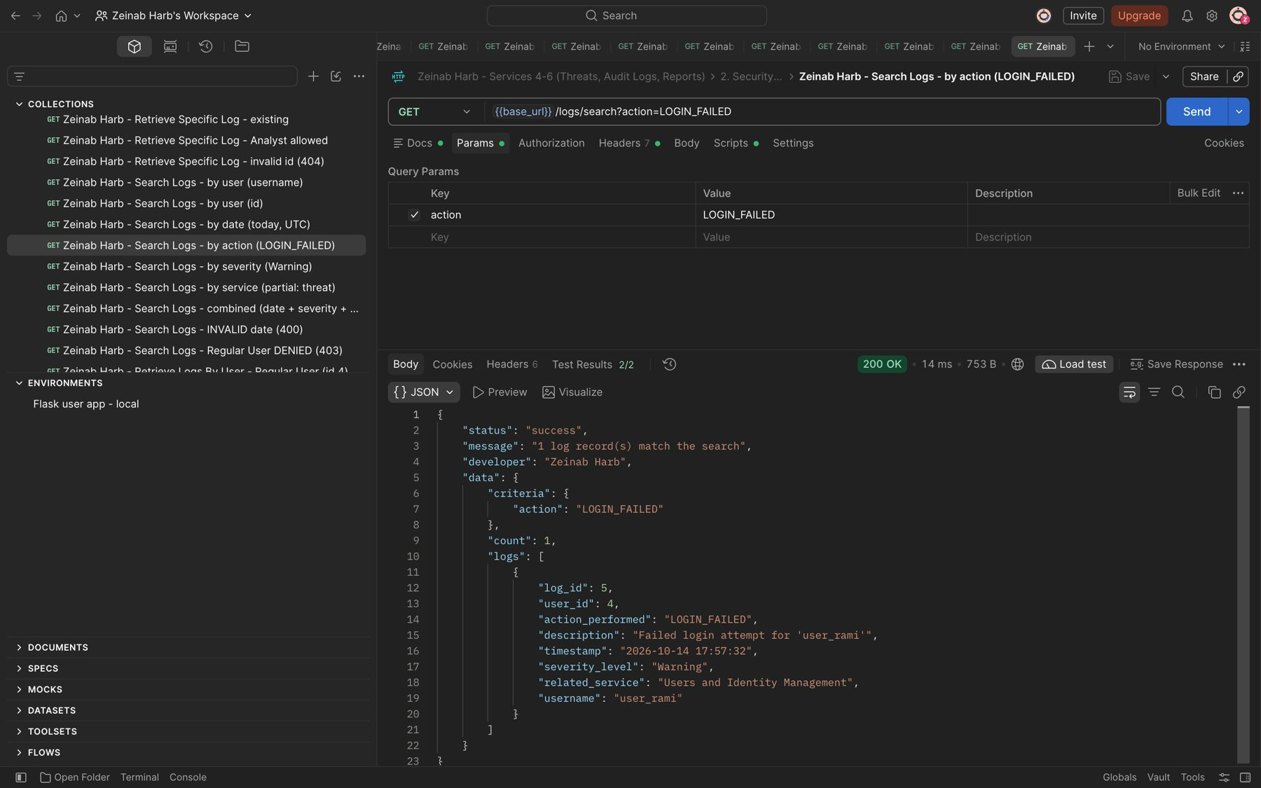
Figure 50: Zeinab Harb – Search Logs – filter by action (LOGIN_FAILED)
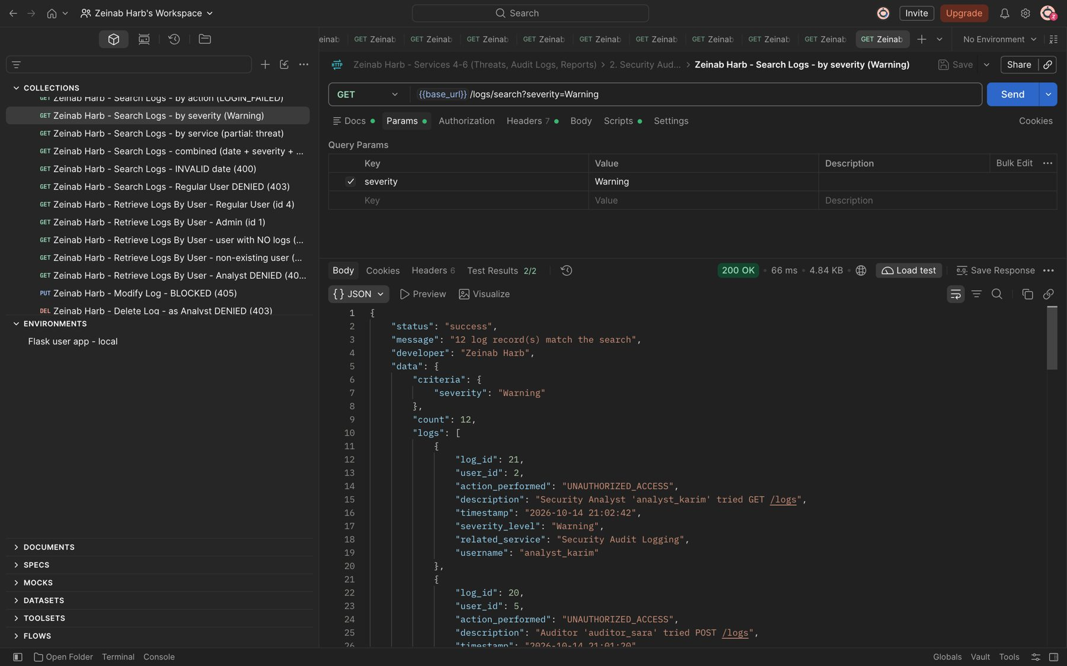
Figure 51: Zeinab Harb – Search Logs – filter by severity (Warning)

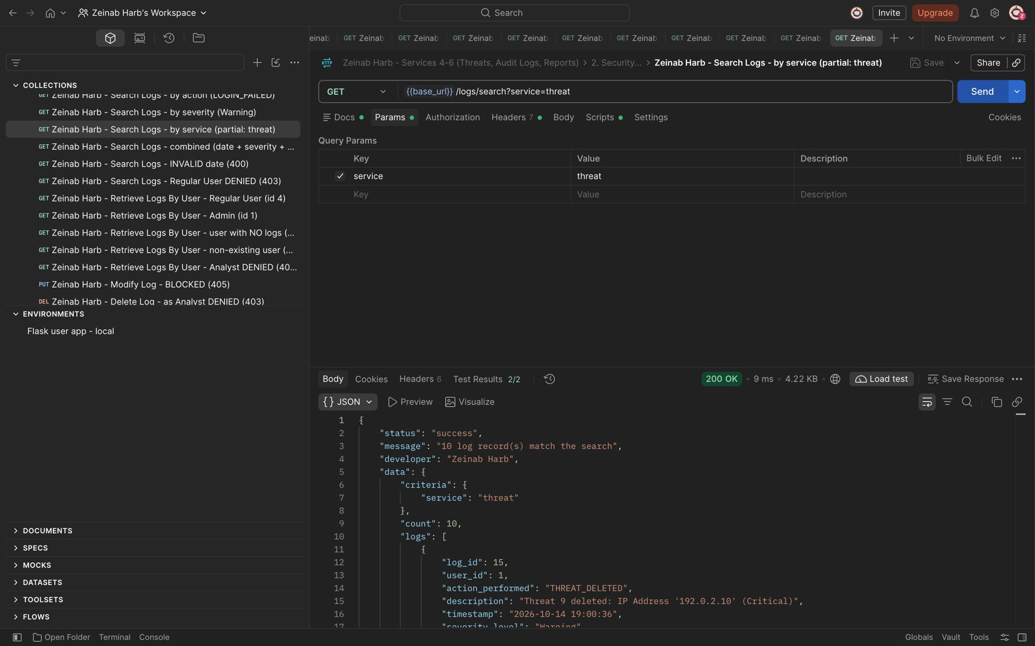
Figure 52: Zeinab Harb – Search Logs – partial filter by related service (threat)
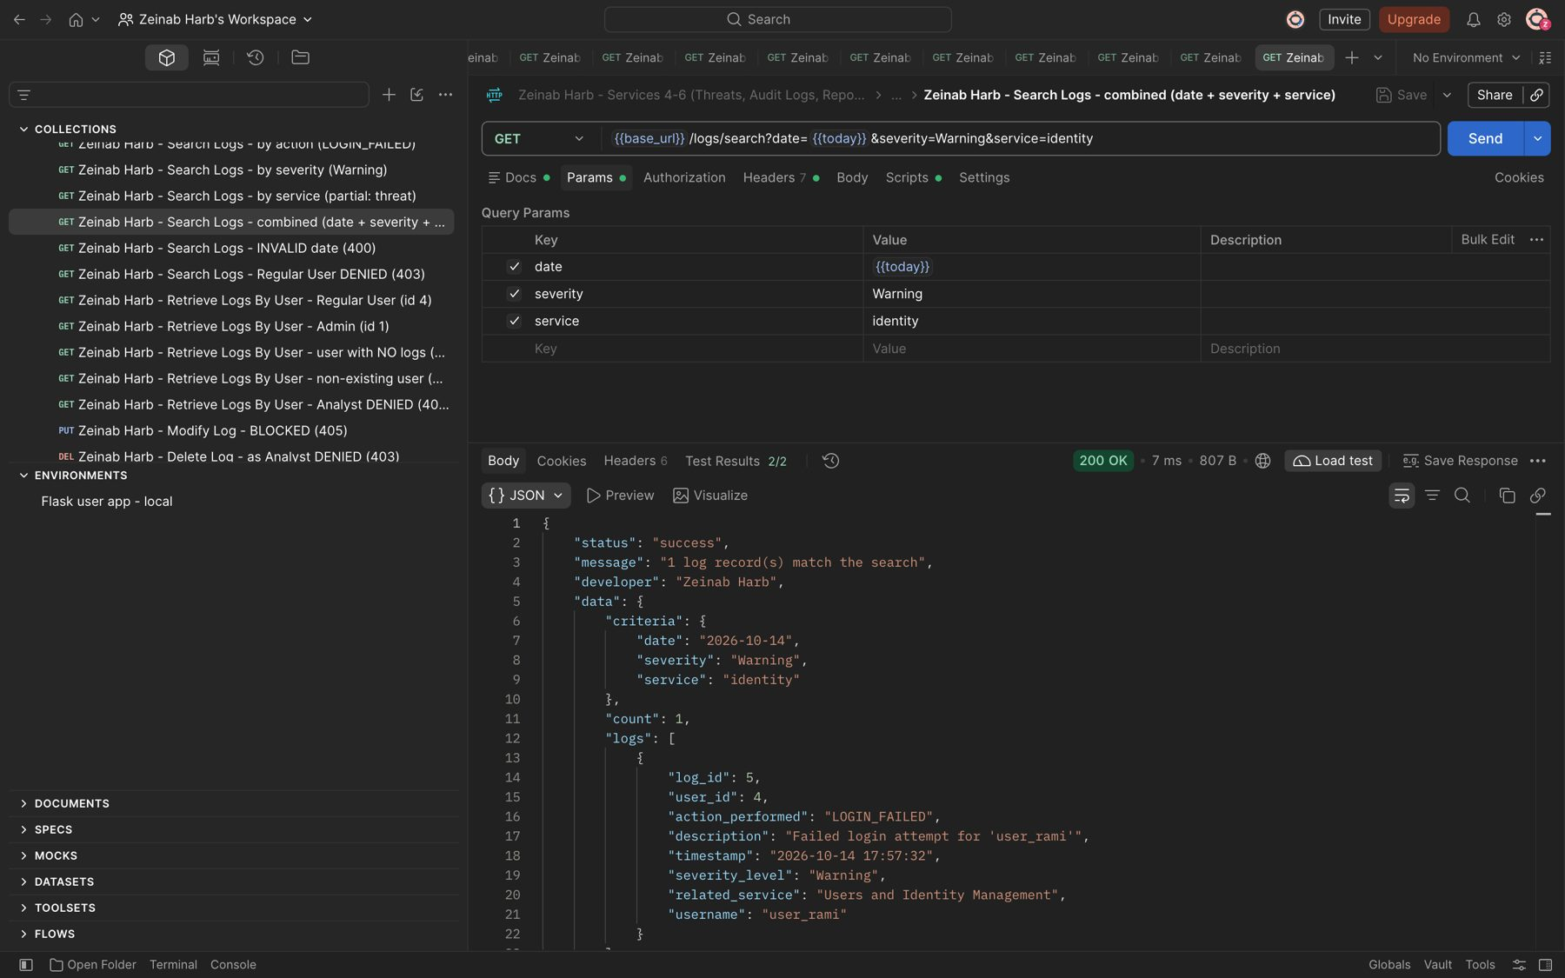
Figure 53: Zeinab Harb – Search Logs – combined date, severity and service filter

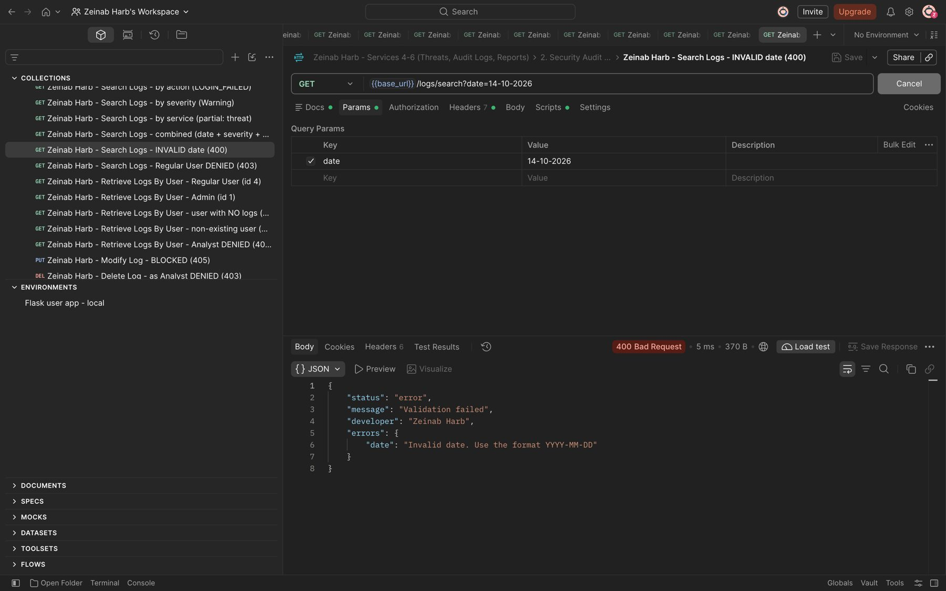
Figure 54: Zeinab Harb – Search Logs – invalid date format rejected (400)
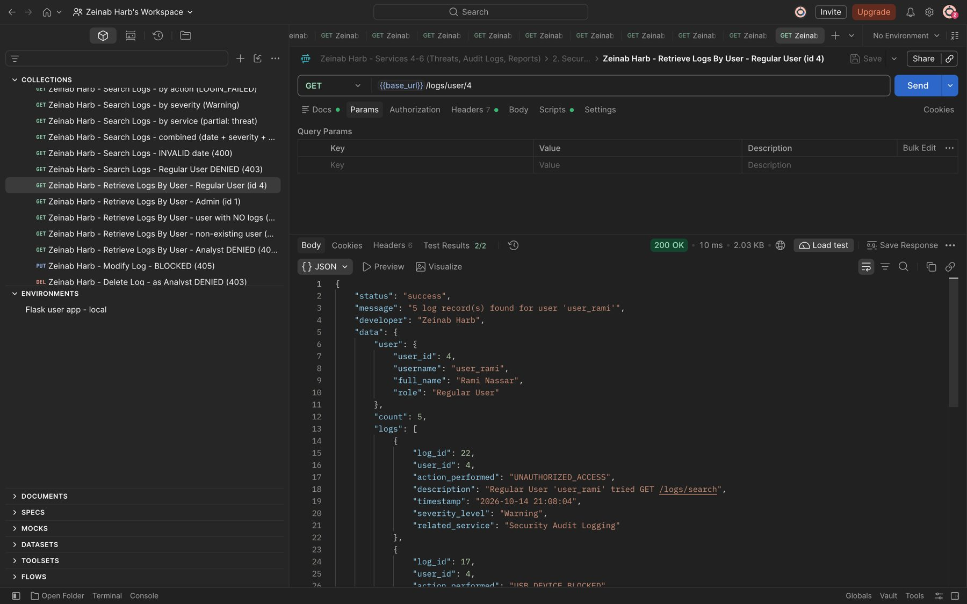
Figure 55: Zeinab Harb – Retrieve Logs By User – returns all logs of the selected user (user_rami, id 4)

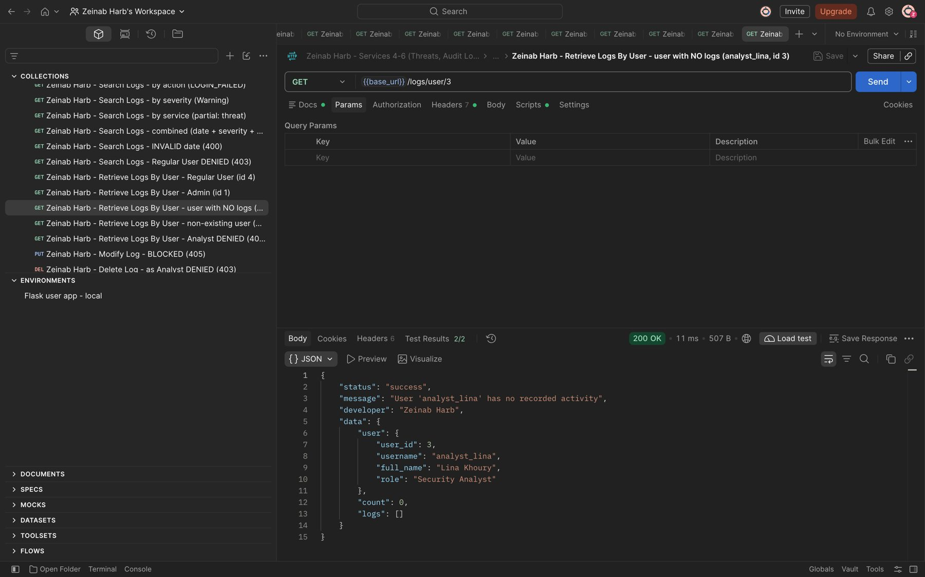
Figure 56: Zeinab Harb – Retrieve Logs By User – user with no logs returns an empty list (count 0)
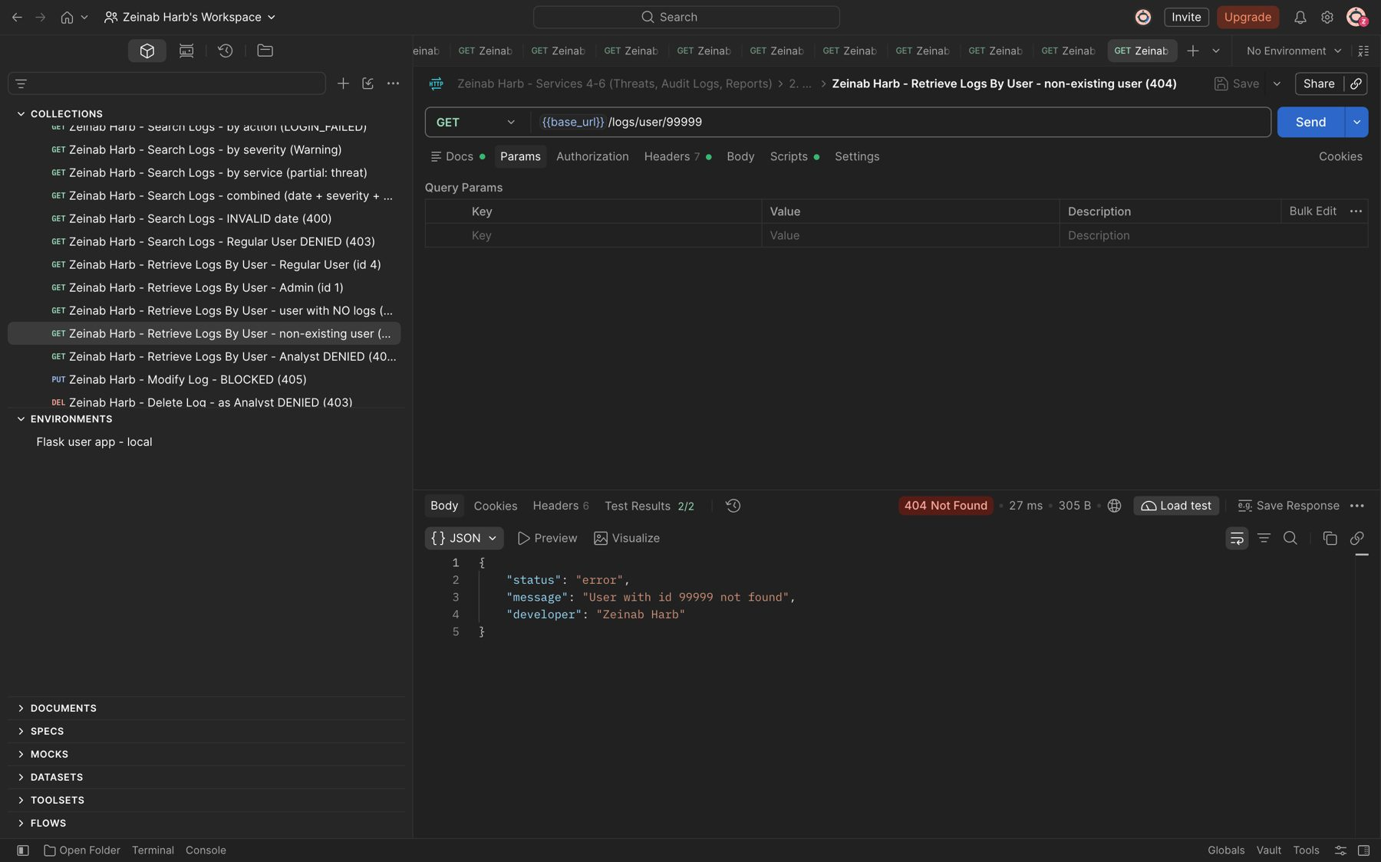
Figure 57: Zeinab Harb – Retrieve Logs By User – non-existing user returns 404

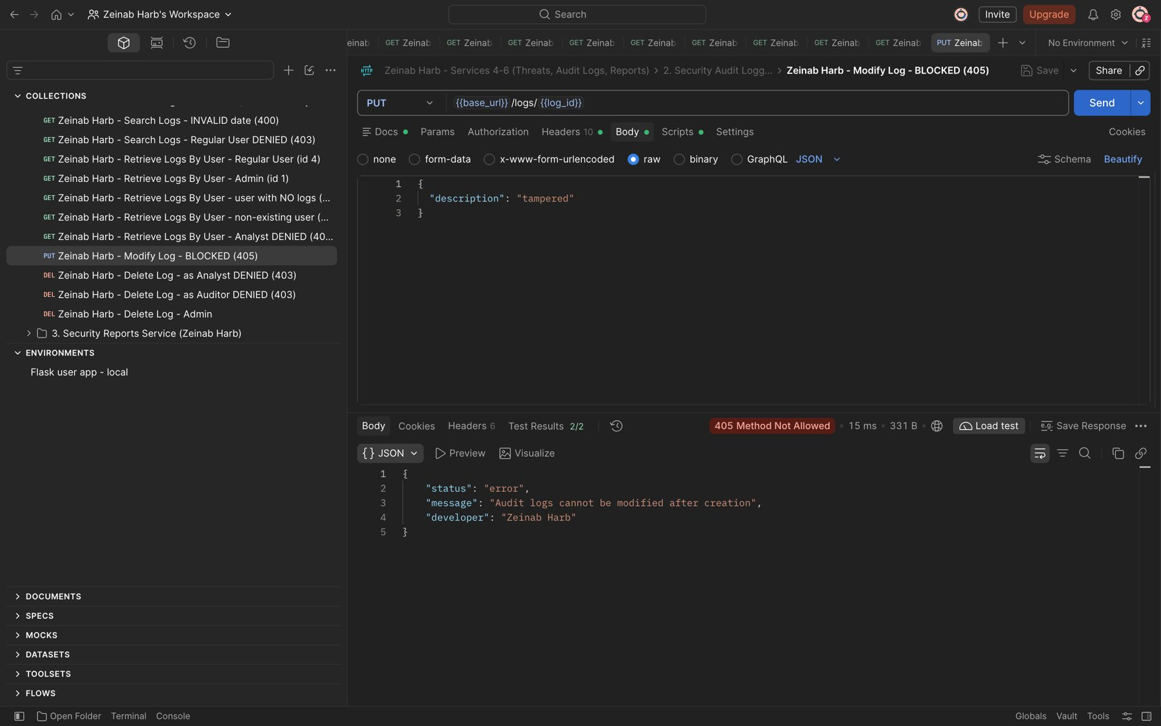
Figure 58: Zeinab Harb – Audit Log Protection – modifying a log record is blocked (405)
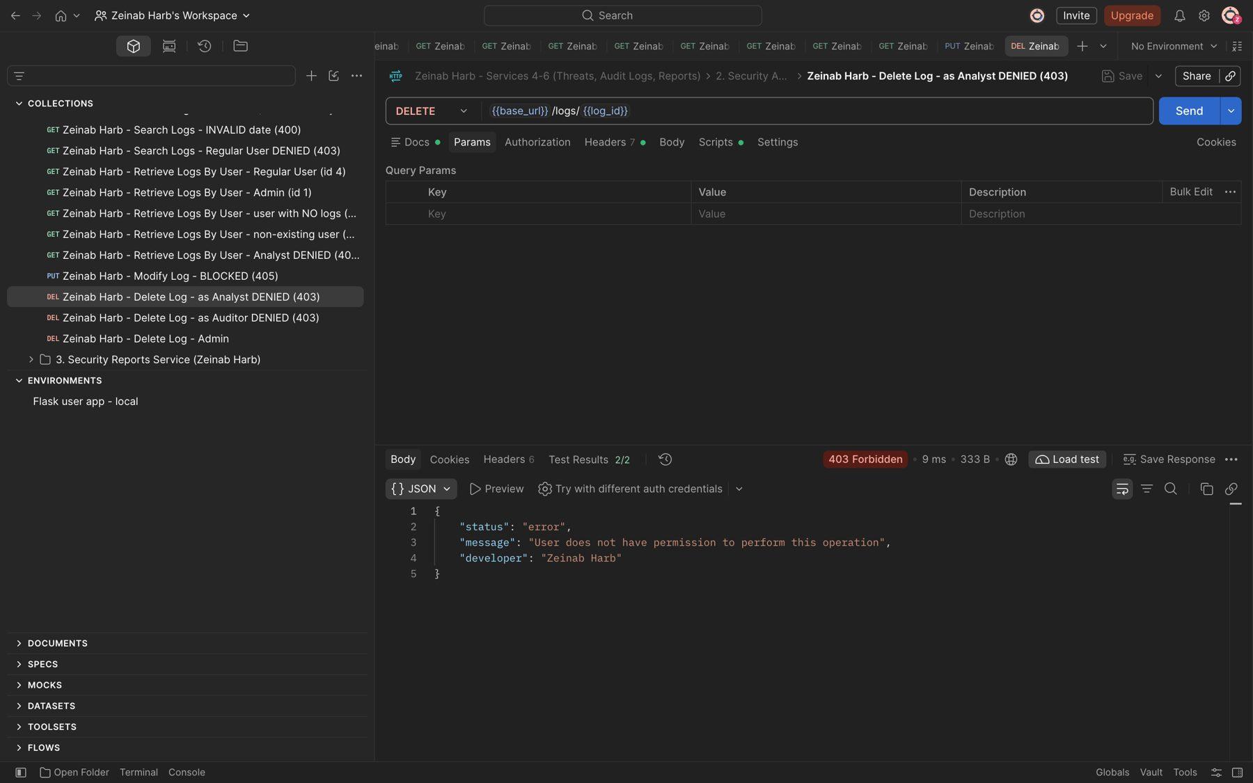
Figure 59: Zeinab Harb – Delete Logs – unauthorized deletion attempt by a Security Analyst denied (403)

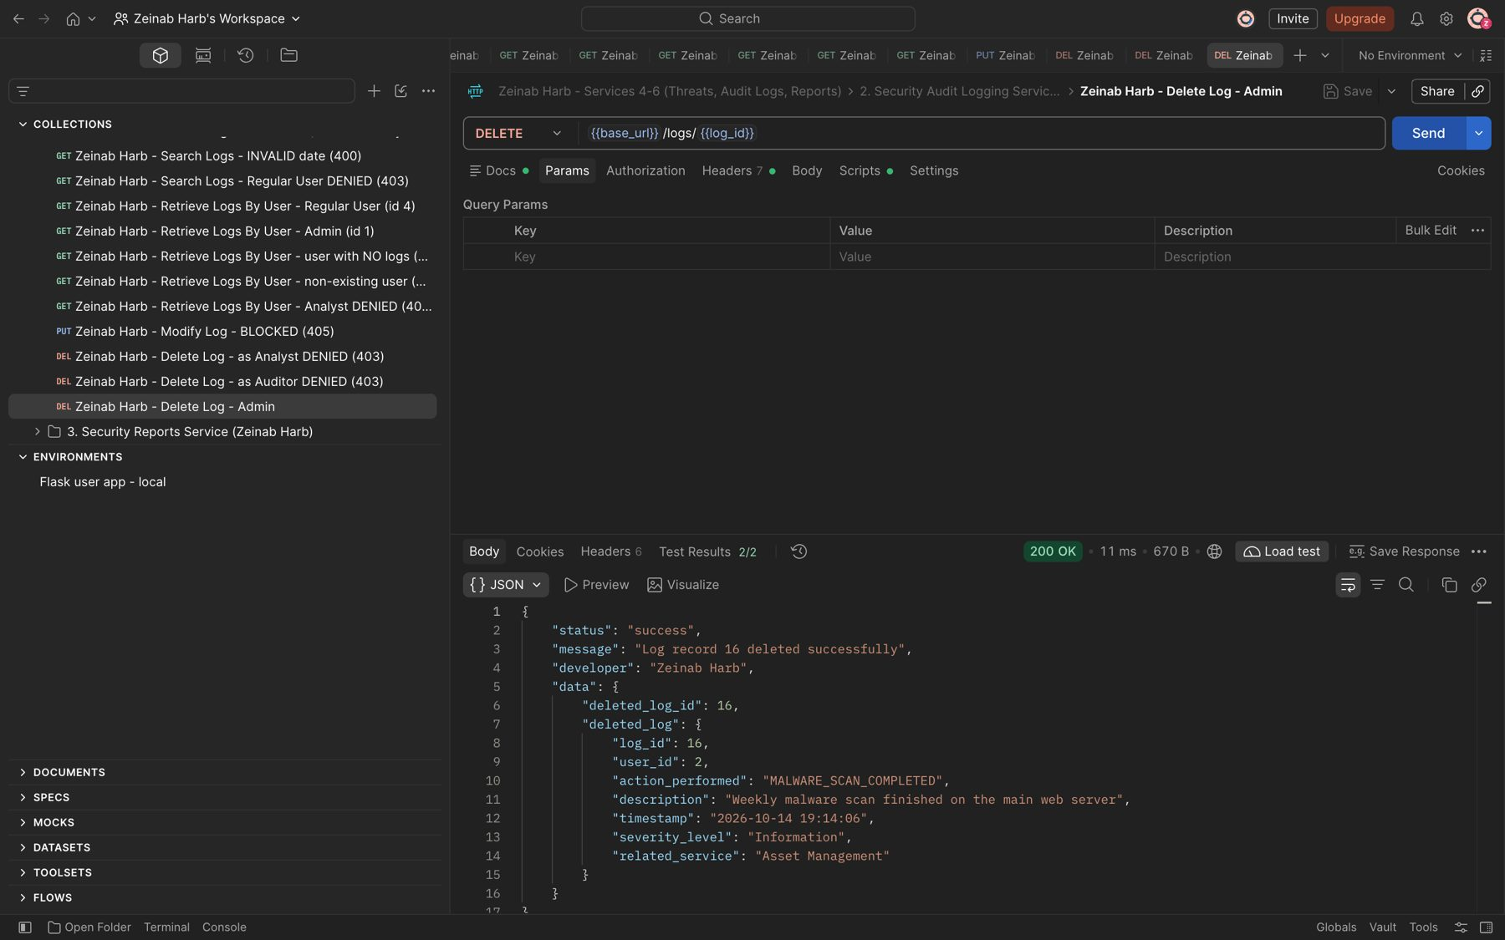
Figure 60: Zeinab Harb – Delete Logs – Security Administrator deletes a log record (200)
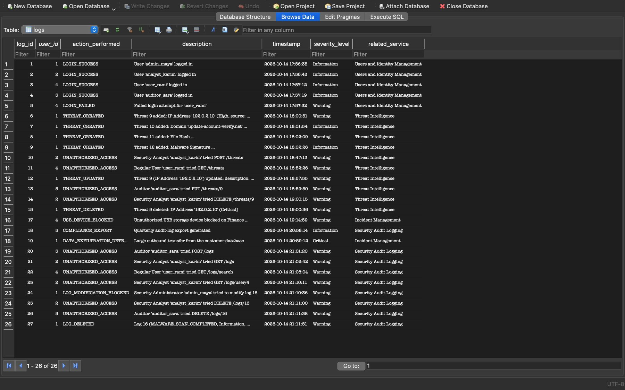
Figure 61: Zeinab Harb – Delete Logs – log 16 removed; LOG_MODIFICATION_BLOCKED and LOG_DELETED records stored in the database

4. Security Reports Service (Service 6) (Zeinab Harb)
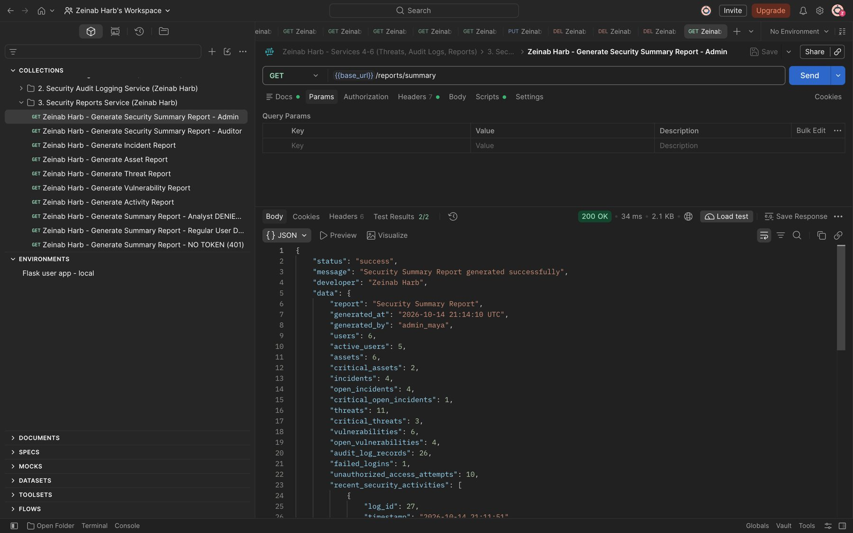
Figure 62: Zeinab Harb – Generate Security Summary Report – overview of the system's security status (200)
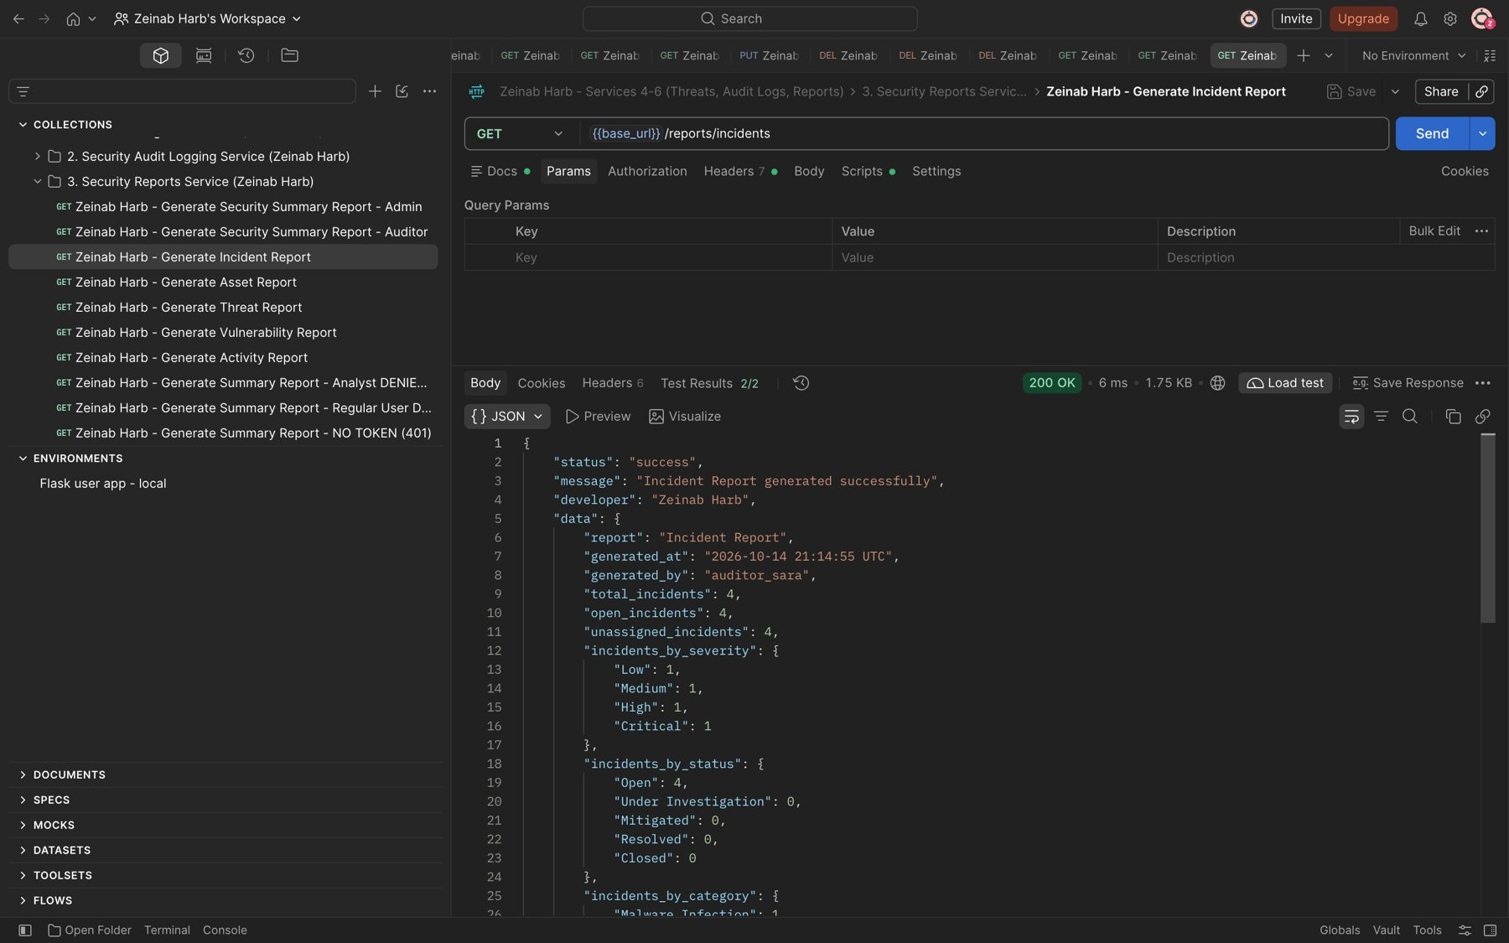
Figure 63: Zeinab Harb – Generate Incident Report – incidents by severity, status and category (200)

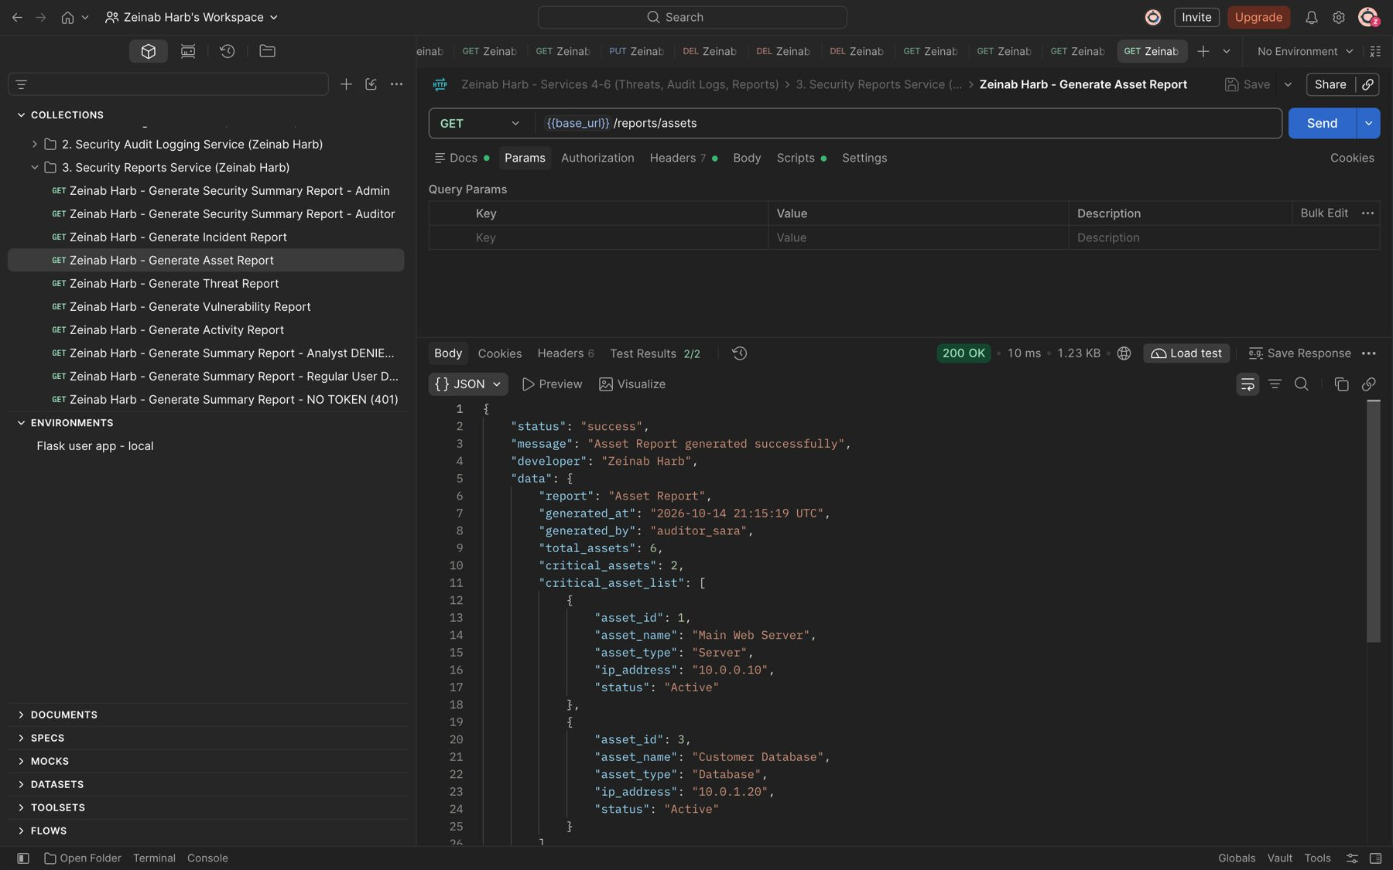
Figure 64: Zeinab Harb – Generate Asset Report – total, critical and by-type asset statistics (200)
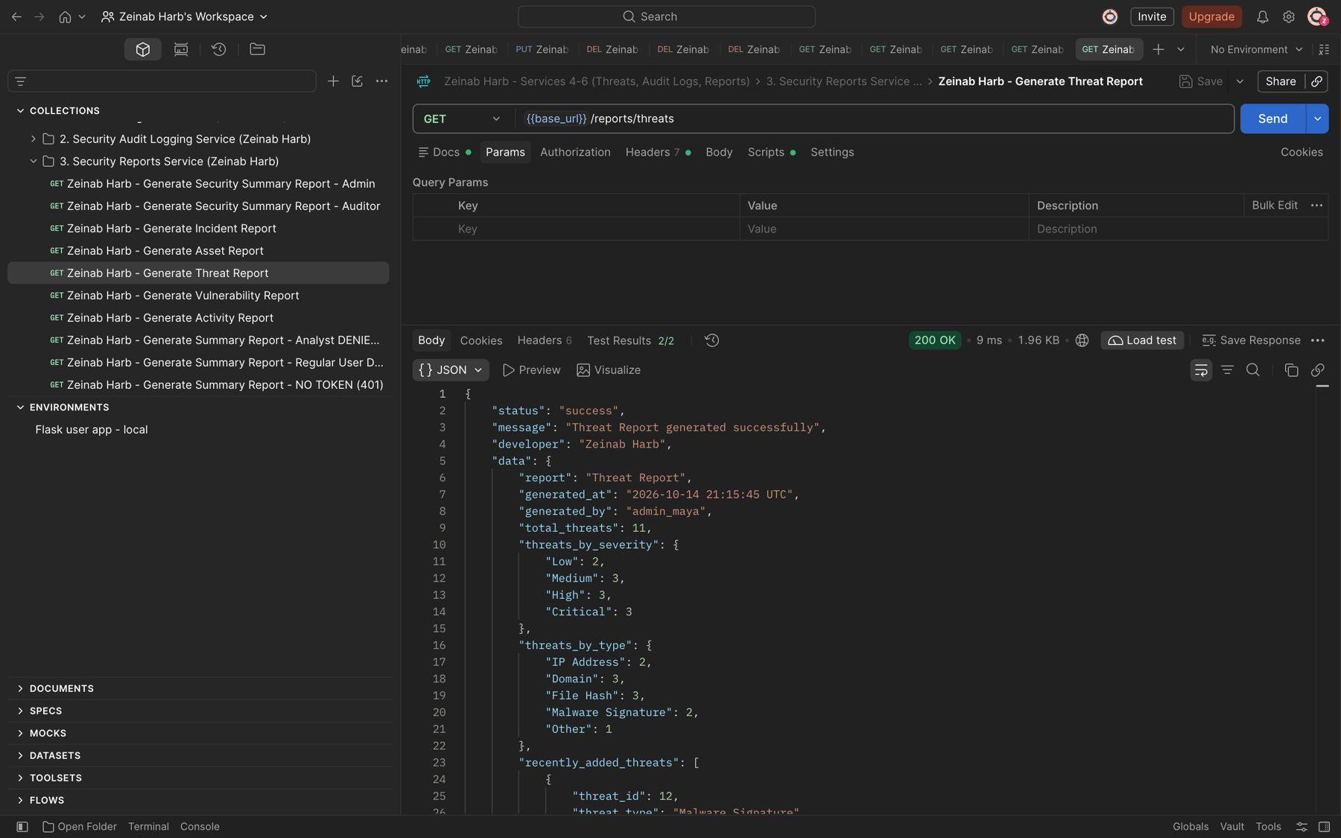
Figure 65: Zeinab Harb – Generate Threat Report – threats by severity and type and recently added threats (200)

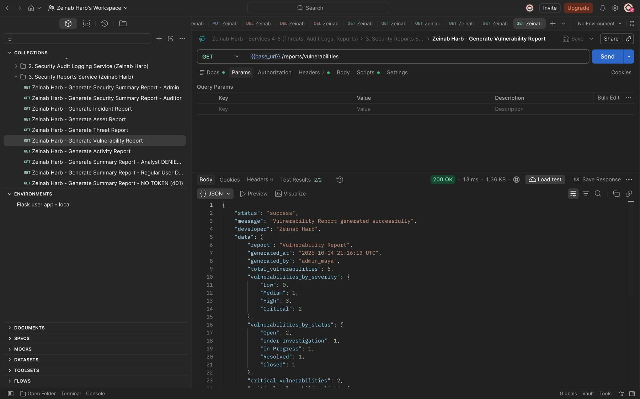
Figure 66: Zeinab Harb – Generate Vulnerability Report – vulnerabilities by severity and status and critical vulnerabilities (200)
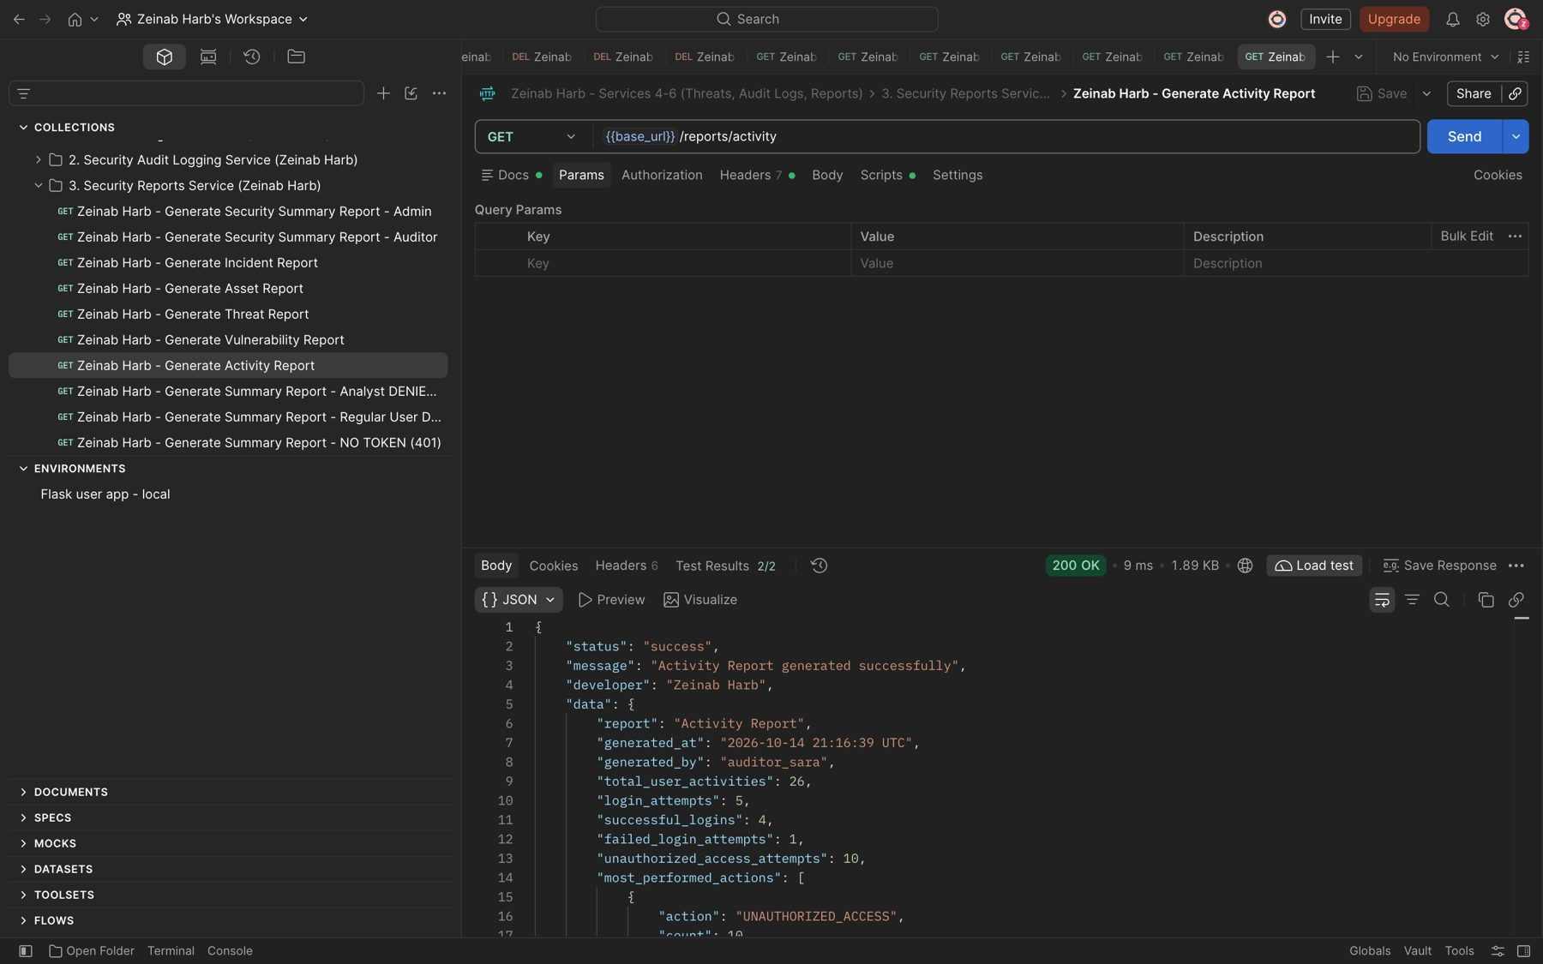
Figure 67: Zeinab Harb – Generate Activity Report – activities, login attempts, failed logins and most performed actions (200)

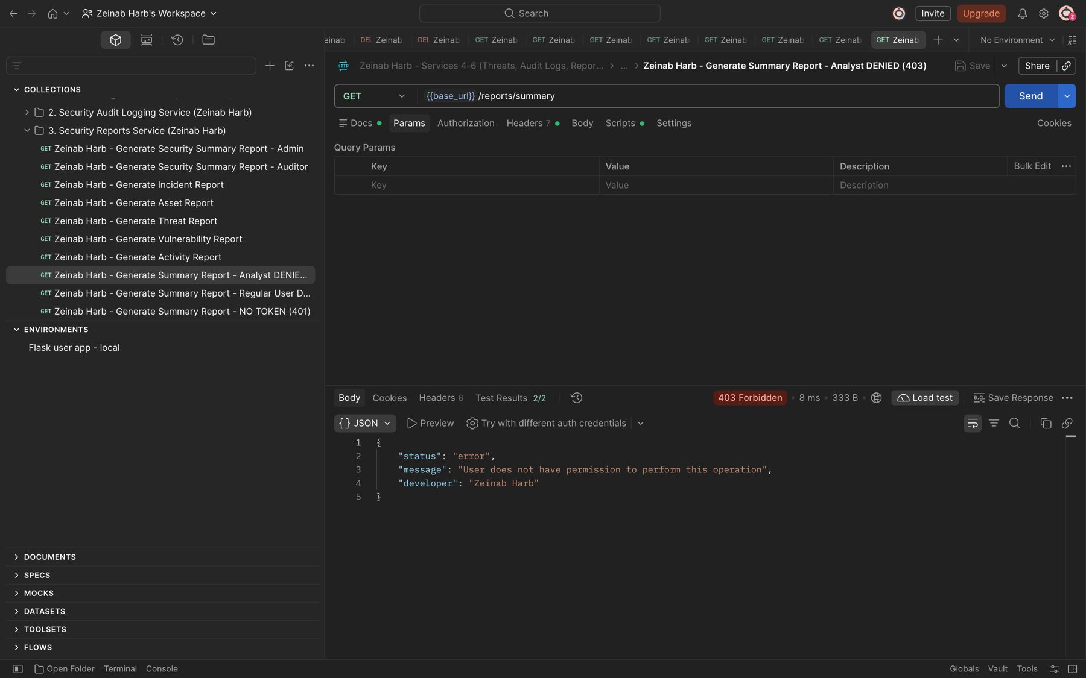
Figure 68: Zeinab Harb – Generate Security Summary Report – Security Analyst denied (403)
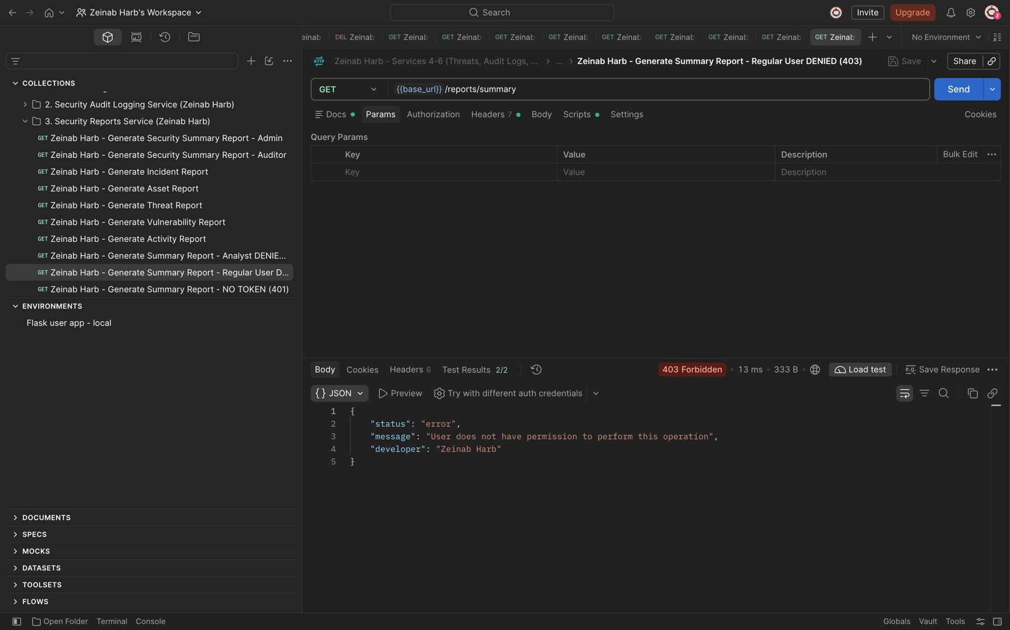
Figure 69: Zeinab Harb – Generate Security Summary Report – Regular User denied (403)

5. Database Design (Zeinab Harb)
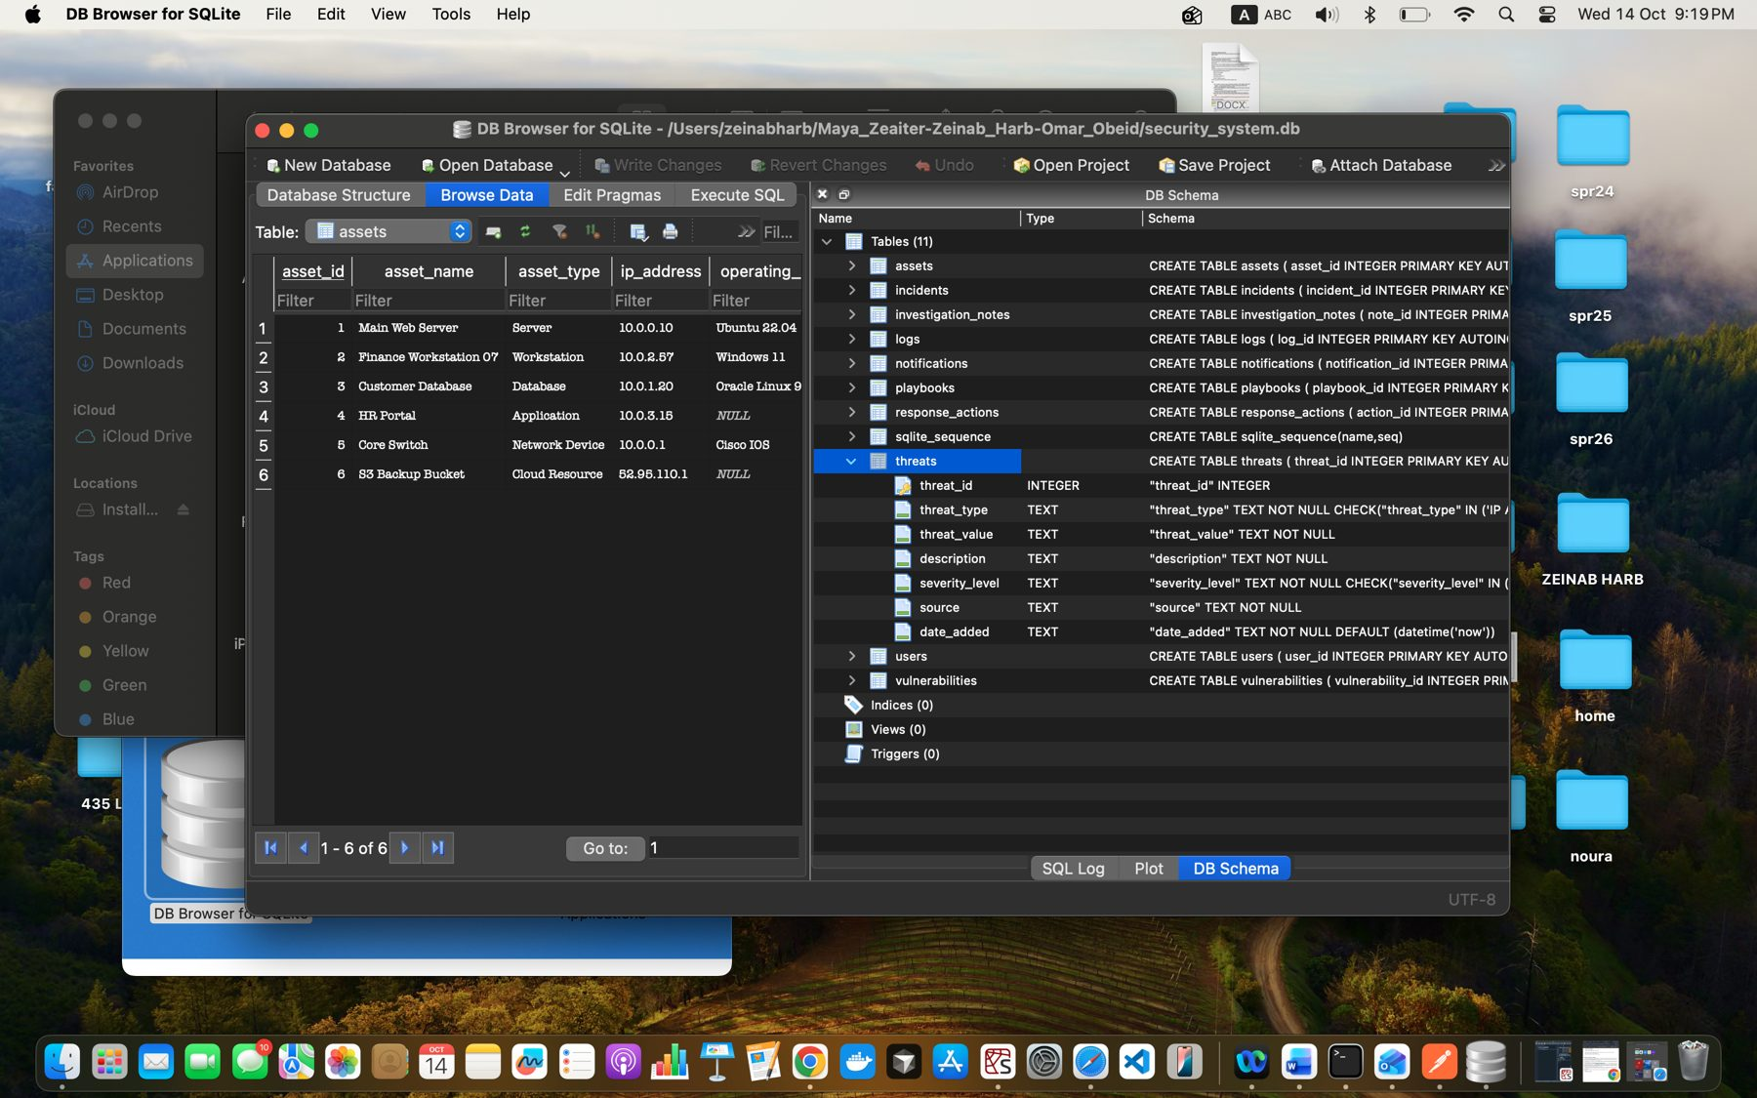
Figure 70: Zeinab Harb – Database Design – structure of the threats table (columns, types and CHECK constraints)
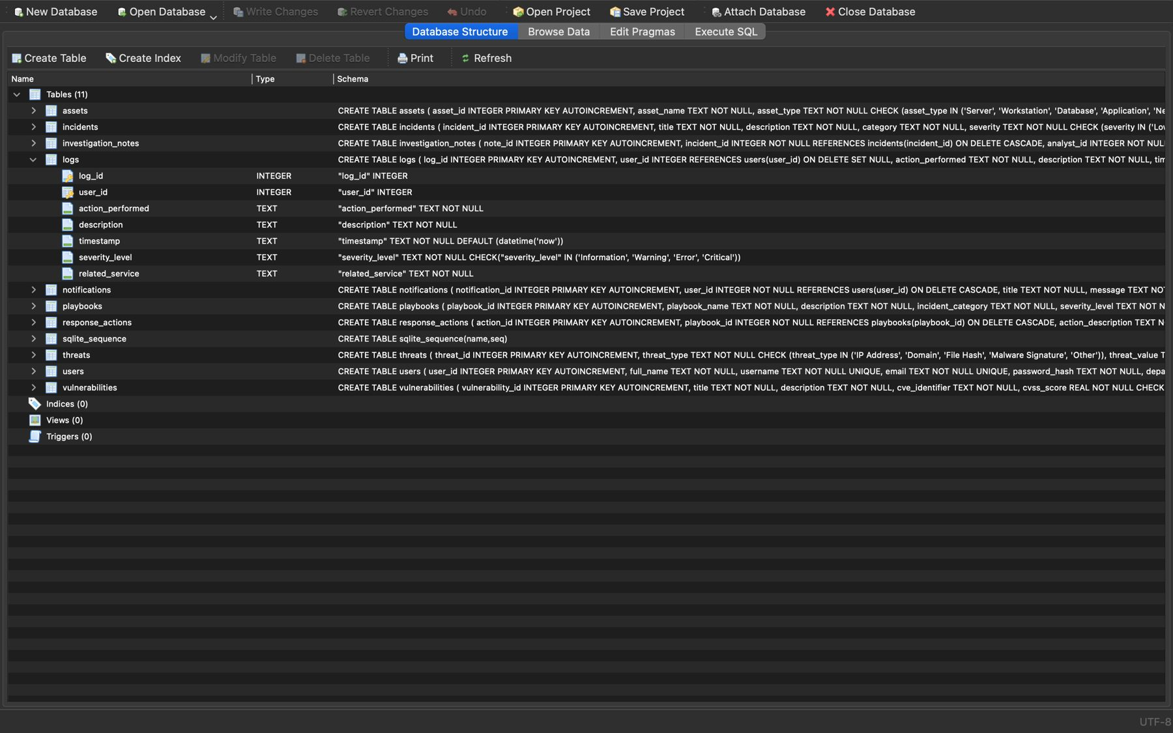
Figure 71: Zeinab Harb – Database Design – structure of the logs table (foreign key to users and severity CHECK constraint)

6. GitHub Version Control (Zeinab Harb)
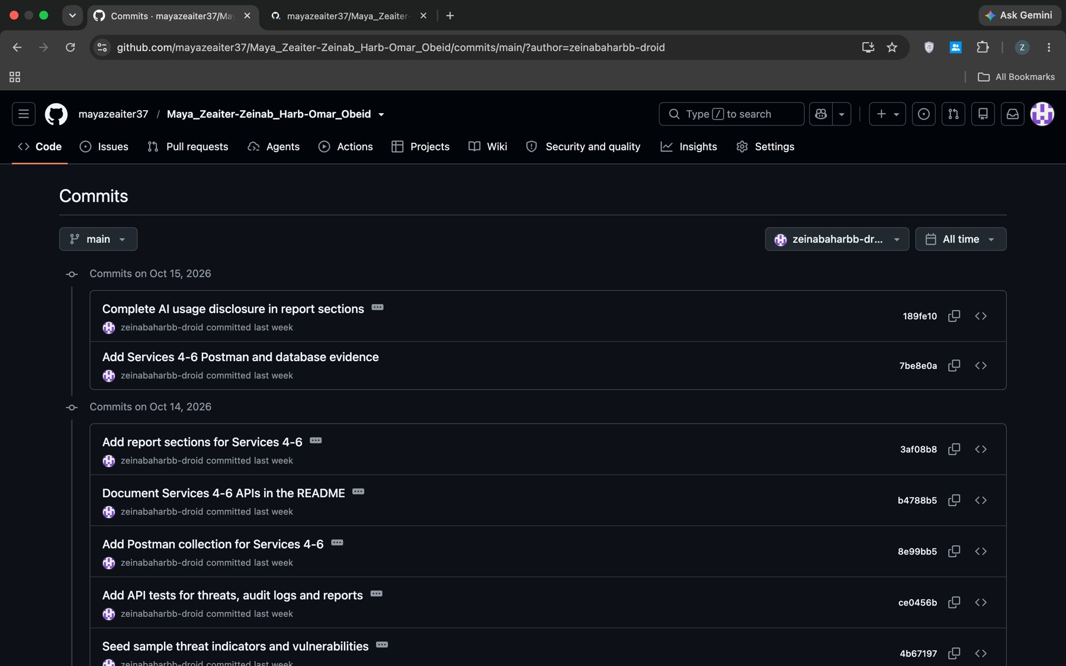
Figure 72: Zeinab Harb – GitHub – commit history of my Services 4–6 work
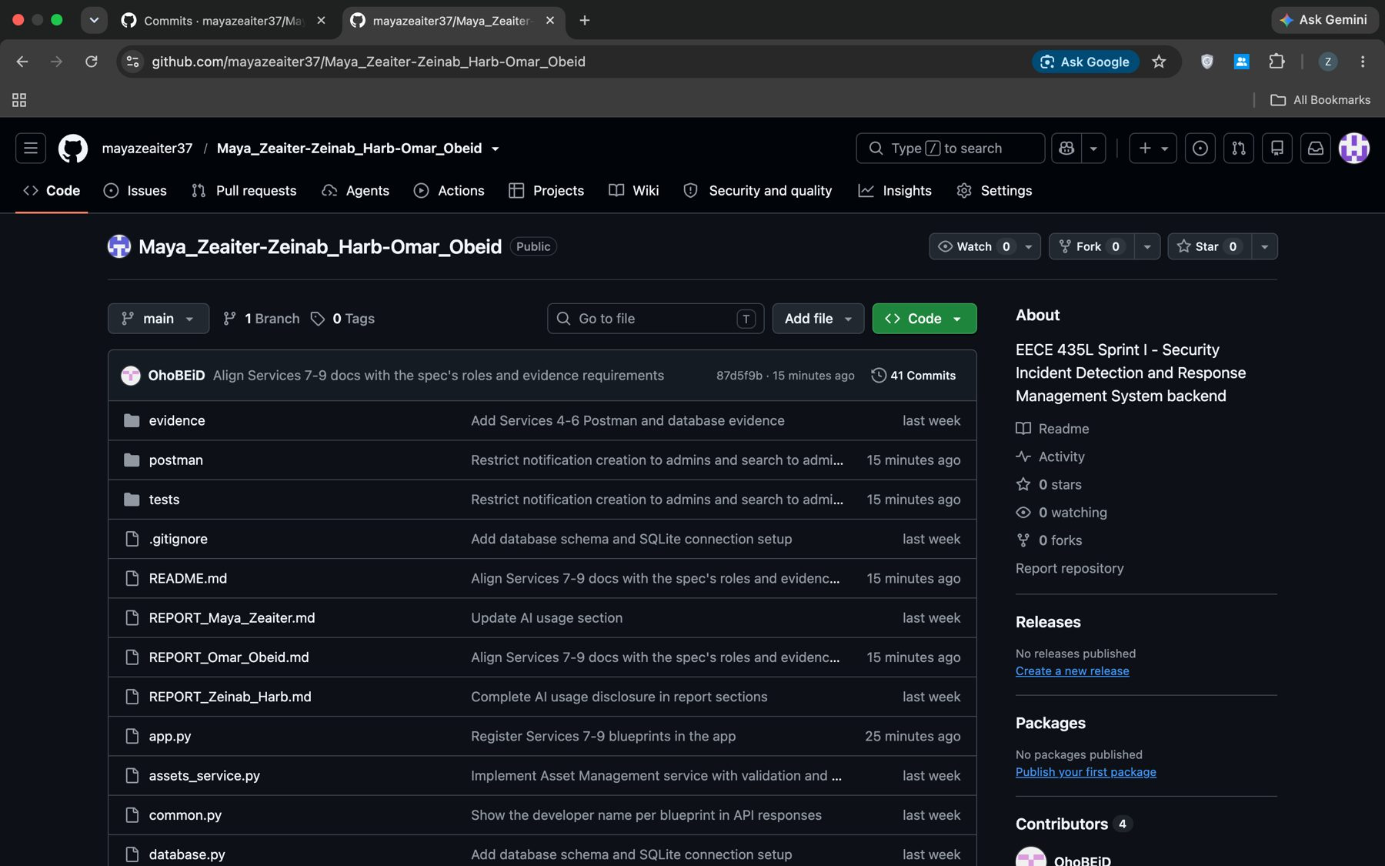
Figure 73: Zeinab Harb – GitHub – repository showing my Services 4–6 files

