# Abstract

Title: Causal Heterogeneity: Opportunities and Pitfalls in Experimental Data

All experimenters know that human and animal subjects show natural variability and do not respond to experimental treatments in a uniform way. It is common to view this causal heterogeneity as a source of error, and in traditional between-subjects designs it is often modeled in this way. In within-subjects designs, however, where causal inference involves comparing subjects to themselves, such heterogeneity can be examined directly and can yeild important theoretical and methodological insights. We argue that many existing datasets contain such untapped opportunities, and using datasets from cognitive and social psychology, we show how to avail of them. This guidance also applies to those planning to conduct such studies. We also show the potentially grave consequences of failing to take causal heterogeneity into account.

# Introduction

All organisms show intrinsic heterogeneity, that is, variation in their structure and function that cannot be simply attributed to measurement error. Within species in nature, there is heterogeneity in basic phenotypic features such as size, shape, color, symmety. This is true for microorganisms, plants, animals. Humans are no exception. It can be argued that this fact lies at the foundation of modern statistics. At least since the time of Galton, intra-specific variability has be recognized. In Fisher’s landmark book, Statisical Methods for Research Workers, heterogeneity is the background used for determining whether an experimental effect is likely to be real or not. His ANOVA model compares mean differences between treatments and control to what would be expected if that variation was similar to what one would be expected from background heterogeneity in experimental units.

It is typical practice in experimental psychology to viewing heterogeneity as unwanted noise in statistical models for experimental data. The focus is on the average not the variability. If that variability can be attributed to measurement error or process-irrelevant variability in experimental procedure or instrumentation, this approach makes sense. If, however, it captures heterogeneity in the causal process being investigated, then this approach leads to lost opportunities for (a) theory development, and (b) for methodological development for adequately testing theory. Furthermore, certain approaches to heterogeneity can result in overconfidence in findings or even spurious findings. In either case, the result is failures to replicate and distorted literatures.

In typical between-subjects experimental designs, where one observation is obtained on each subject, causal heterogeneity cannot be distinguished from measurement error and other process-irrelevant variability in responses. In within-subjects designs, however, where causal inference involves comparing subjects to themselves in other conditions, such heterogeneity can be examined directly and can yeild important theoretical and methodological insights. By examined directly, we mean that its existence and strength can be established without necessarily knowing the sources. Our goal in writing this paper is to show how this can be accomplished.

## Example of Opportunities and Pitfalls: Effects of Stimulus Valence on RT Dataset

Our first example dataset comes from a replication of Higgins et al. Study 3. The research question we are interesed in is whether there are reaction time differences in endorsed self-descriptions according to whether their valence is positive or negative. A straightforward prediction is that participants will be faster to endorse positive as opposed to negative self-descriptions. We chose this straightforward hypothesis not because of its scientific interest but because we wanted to examine heterogeneity in an effect that can be readily confirmed. Our intent in this section is to first show using standard software an adequate analysis of the data.

### Methods

### Recommended analysis

To examine this hypothesis, we will primarily work with a statistical model where stimulus valence is the single predictor and log reaction time is the outcome. This simple model can be used to develop the main points regarding heterogeneity of causal effects. Later we will consider the need to add additional information about the temporal ordering of the stimuli and allow for stimuli and temporal order to be treated as random effects. All datasets, together with syntax and code, are available at the following URL. We begin these analyses in SPSS and R. Later, as models become more complex, it will be necessary to proceed with analyses in R alone.

If we examine in Table 1 a portion of the data matrix we can see that each log RT observation for each subject is given a separate data line. Each line contains columns for the subject’s unique indentifier (ID number), the exact stimulus word used (such as “confident” and “anxious”), the valence of each word (coded -0.5 if negative and 0.5 if positive) and the temporal order in which each word was presented to this subject (e.g., 1st, 15th, etc.). As is usual, stimulus ordering was randomized and each subject encountered a different order.

Our model specifies that in the population, a person’s log reaction time can be different for positively valenced and negatively valenced traits, and it allows this difference to vary across persons. This model is parametrically identical to a standard repeated-measures model with replications (Kirk, Winer, Maxwell & Delaney). As we will see, when estimated using from current mixed-model software, the output of this model is much more informative about the existence and size of causal heterogeneity than the output of a traditional repeated-measures ANOVA model.

The model can be written as follows:









Some readers will recognize Eq. 1, 2, 3 as a multilevel model expressed in Bryk and Raudenbush’s (2000) notation. In Eq. 1, the logRT observed for subject j (1, 2, …67) for stimulus valence i (-0.5, 0.5) is a function of an overall level for subject j, , and an effect of valence, , that is specific to each subject j. In Eq. 2, between-subject variability in overall levels is composed of a level for the typcial subject, , and , each subject’s specific deviation (positive or negative) from that average. In Eq. 3, between-subject variability in the valence effect is composed of an effect for the typical subject, , and , each subject’s specific deviation (positive or negative) from that average. Finally, Eq. 4 is the same information presented in a single, mixed-model equation form. It is obtained by substituting Eqs. 2 and 3 into Eq. 1. We assume that the deviations of actual logRTs from their predicted values, the , are normally distributed with the same variance within valence condition. In addition, we assume that the subject-level random effects,  and  are normally distributed with mean zero, variances  and , and covariance . For a more elaborate introduction to these eqauations and their assumptions, see Bolger and Laurenceau (2013).

We will begin by estimating this model using mixed-model software in SPSS and R. The datasets are in the corresponding binary form. The syntax requred to estimate the model in SPSS is as follows:

MIXED logrt WITH valenceE

/FIXED=valenceE | SSTYPE(3)

/METHOD=REML

/PRINT=G SOLUTION TESTCOV

/RANDOM=INTERCEPT valenceE | SUBJECT(id) COVTYPE(UN).

For R, this syntax is:

Out1 <- (lmer(logrt ~ valenceE + (1 + valenceE| id), data=study1a))

summary(Out1)

Both produce essential identical results.

|  |  |  |  |  |  |  |  |
| --- | --- | --- | --- | --- | --- | --- | --- |
| **Estimates of Fixed Effects** | | | | | | | |
| Parameter | Estimate | Std. Error | df | t | Sig. | 95% Confidence Interval | |
| Lower Bound | Upper Bound |
| Intercept | 6.866321 | .022668 | 57.228 | 302.912 | .000 | 6.820934 | 6.911709 |
| valenceE | -.161572 | .022173 | 51.249 | -7.287 | .000 | -.206080 | -.117064 |
| a. Dependent Variable: logrt. | | | | | | | |
|  | | | | | | | |

|  |  |  |  |  |  |  |  |
| --- | --- | --- | --- | --- | --- | --- | --- |
| **Estimates of Covariance Parameters** | | | | | | | |
| Parameter | | Estimate | Std. Error | Wald Z | Sig. | 95% Confidence Interval | |
| Lower Bound | Upper Bound |
| Residual | | .058719 | .002407 | 24.391 | .000 | .054185 | .063632 |
| Intercept + valenceE [subject = id] | UN (1,1) | .027087 | .005659 | 4.786 | .000 | .017985 | .040793 |
| UN (2,1) | -.001932 | .004034 | -.479 | .632 | -.009839 | .005974 |
| UN (2,2) | .015636 | .005594 | 2.795 | .005 | .007755 | .031527 |
| a. Dependent Variable: logrt. | | | | | | | |

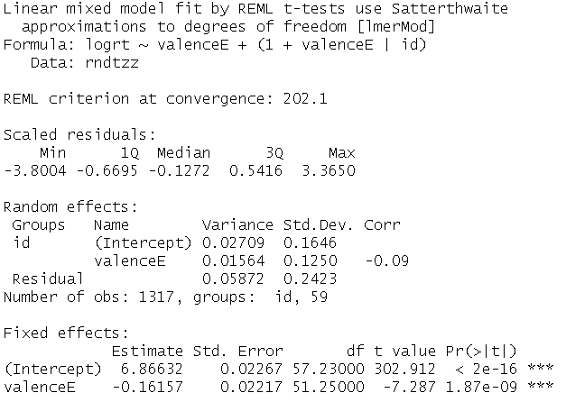

It seems natural to begin by examining the estimate of the valence effect for the typical person, usually called a fixed effect in the mixed models literature (McCulloch, Searle & Niewhuis, 2012). The typical person is .16 logRT units faster at responding to positively valenced words than to negatively valenced words. The 95% CI is [-0.21, -0.12]. This difference corresponds to approximately 140 ms. For some researchers, this might be the only important statistic to report. In traditional repeated-measures ANOVA software, this is the result that is emphasized. But an average or fixed effect such as this is potentially a very limited and sometimes misleading estimate of a causal effect.

Before examining the other parameter estimates, we will turn to a graphical display of the raw data. Figure 1 is a panel plot showing each subject’s data for logRT as a function of valence. The panels are ordered by the size of the valence difference for each subject. The reader can see that the valence effect is discernable for many subjects, but it varies in size: The subject (id 35) in the upper left-hand corner shows a difference that is approximately [three times] larger than the subject in the middle of the panels (id 12). Heterogeneity such as this is part of the phenomenon to be explained, and the model proposed earlier will allow us to do so..

First, the estimate of the SD of the valence random effect is allows us to predict where 95% of the subjects in the population are. That is -.16 plus or minus 2*0.125, which equals -0.41 to 0.09. This indicates that there are subjects at the 2.5% who have more than x times the average valence effect, and there are those at the 95% that have slightly reversed valence effects. This suggests that a one-size fits all view of valence effects that one gets from the fixed effect is quite misleading.

The model not only provides estimates of population parameters. It can also be used to predict the valence effect for each person in the sample. These are called Empirical-Bayes predictions of Best Linear Unbiased Predictions (BLUPs). We display these in three ways. First we show them as a spaghetti plot in Figure x. The thick dark line is the fixed effect and the thin dark lines are the individual-specific effect for members of the sample. This illustrates the substantial causal heterogeneity observed. The second way we display predictions on the same is as a stripchart, and again the heterogeneity is evident.The third way is to overlay the predictions on the observed paneled data in Figure x. Here we see that the model is capturing variation in the data quite well.

The reader will see the extra information contained in the results beyond the usual fixed effect estimates. These results call for some theory that can explain these differences and measures that can predict them. We will consider this later in the paper. But even in the absence of explanatory variables, the causal heterogeneity is fundamental to any accurate account of the experimental results.

### Why not repeated measures ANOVA?

Since we describe the model above as parameterically identical to a repeated-measures ANOVA, the reader may naturally wonder why we could not use traditional repeated-measures software. The answer is that we do not have a balanced design. We are examining RT to traits that subjects say are self-descriptive and as can be seen from Figure x, fewer negative traits than positive traits are chosen by most subjects. Had we not selected on self-descriptive traits, we could still be unable to use repeated-measures ANOVA because 18 of 62 participants had missing repeated measurements. This is not uncommon in designs with many repeated measurements and it is the main reason researchers researchers who use repeated-measures ANOVA tend to aggregate their data before analyzing them. This not only results in incorrect inferences it also makes it impossible to estimate heterogeneity of effects and examine their properties. We now turn to a consideration of that approach. will discuss this approach in the next section.

### The aggregation approach

As we noted, when datasets are unbalanced as is the case with Study 1, one common solution is to aggregate the data within each subject so that only cell means on the repeated factor are used. In this way, the data can be analyzed using standard repeated measures ANOVA. For Study 1 this would mean that we can use data from all but the two participants who chose no negatively-valenced traits.

The SPSS syntax to perform the aggregation is as follows: [have to figure this out]

In R it is: [copy relevant code]

To conduct a repeated-measures ANOVA on the aggregated data in SPSS, see the following input and output:

GLM rtneg rtpos

/WSFACTOR=valence 2

/METHOD=SSTYPE(3)

/WSDESIGN=valence.

|  |  |  |  |  |  |  |
| --- | --- | --- | --- | --- | --- | --- |
| **Tests of Within-Subjects Effects** | | | | | | |
| Measure: MEASURE_1 | | | | | | |
| Source | | Type III Sum of Squares | df | Mean Square | F | Sig. |
| valence | Sphericity Assumed | .845 | 1 | .845 | 46.276 | .000 |
| Greenhouse-Geisser | .845 | 1.000 | .845 | 46.276 | .000 |
| Huynh-Feldt | .845 | 1.000 | .845 | 46.276 | .000 |
| Lower-bound | .845 | 1.000 | .845 | 46.276 | .000 |
| Error(valence) | Sphericity Assumed | 1.059 | 58 | .018 |  |  |
| Greenhouse-Geisser | 1.059 | 58.000 | .018 |  |  |
| Huynh-Feldt | 1.059 | 58.000 | .018 |  |  |
| Lower-bound | 1.059 | 58.000 | .018 |  |  |

The R equivalent is:

aggs1aa.out = aov(logrt ~ valenceE + idcat, data=aggs1aa)

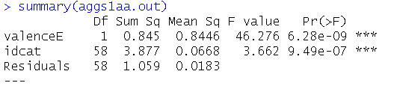

As we can see, aggregation over the stimuli within the negative and positive conditions has not changed the results appreciably. In fact, had the original data been balanced, the estimates and tests would have been identical. This follows because aggregation affects the signal and the noise in the ANOVA in the same way, leaving the ratio of the two unchanged. What has happened to the heterogeneity in this case? We define heterogeneity as the true differences between subjects in the trait-valence effect., It is still present in the data but it cannot be distinguished from error variance due to the specific stimuli in each valence condition. We see this as a major limitation of the aggregation approach.

### Failing to model the heterogeneity

Although using mixed-model software is essential to estimating and displaying heterogeneity in causal effects, it requires care. Some researchers have made the mistake of omitting heterogeneity in their models, the most notable in recent years has been a paper by Fisher et al. that was retracted from Psychological Science. Let us examine for our example dataset the consequences of omitting heterogeneity effects.

SPSS:

MIXED logrt WITH valenceE

/FIXED=valenceE | SSTYPE(3)

/METHOD=REML

/PRINT=G SOLUTION TESTCOV

/RANDOM=INTERCEPT | SUBJECT(id) COVTYPE(UN).

R:

mle3aa <- (lmer(logrt ~ valenceE + (1 + valenceE| id), data=rndtzz))

|  |  |  |  |  |  |  |  |
| --- | --- | --- | --- | --- | --- | --- | --- |
| **Estimates of Fixed Effectsa** | | | | | | | |
| Parameter | Estimate | Std. Error | df | t | Sig. | 95% Confidence Interval | |
| Lower Bound | Upper Bound |
| Intercept | 6.857012 | .022153 | 58.421 | 309.529 | .000 | 6.812674 | 6.901349 |
| valenceE | -.154034 | .014950 | 1285.127 | -10.303 | .000 | -.183364 | -.124705 |
| a. Dependent Variable: logrt. | | | | | | | |

|  |  |  |  |  |  |  |  |
| --- | --- | --- | --- | --- | --- | --- | --- |
| **Estimates of Covariance Parametersa** | | | | | | | |
| Parameter | | Estimate | Std. Error | Wald Z | Sig. | 95% Confidence Interval | |
| Lower Bound | Upper Bound |
| Residual | | .061994 | .002473 | 25.066 | .000 | .057331 | .067036 |
| Intercept [subject = id] | Variance | .025894 | .005356 | 4.834 | .000 | .017263 | .038839 |
| a. Dependent Variable: logrt. | | | | | | | |

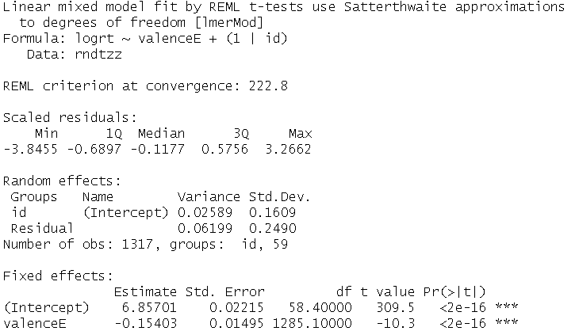

Again the results for SPSS and R are identical. What has changed in these results is the standard error and t value for the valence effect. In the random intercepts and slopes model, we found an SE of 0.022, and a t-value of 7.3. Now we observe an SE of .015 and a t-value of -10.3 This corresponds to a downward bias of almost one-third, i.e., the biased version is 66% as wide as the original. In the case of small effects, this difference in SE could lead to false conclusions about the exisitence of effects, and consequent failures to replicate.

### Summary

Summary table of the valence fixed (Est) and random (SD(Est)) effects for the various models. The first line of numbers are the effect estimates when the intercept is random but the valence effect is treated as zero. We see, as was shown earlier, the overly small standard error and the overly narrow CI. The second line are the estimates for the minimal model with both intercepts and slopes teated as random. The next line includes time as a fixed and random effect. This has no appreciable effect on the results. Finally, we have a model that also treats stimuli as random. Here we see an increase in the SE for the fixed effect, but essentially no effect on the random effect variance of CI.

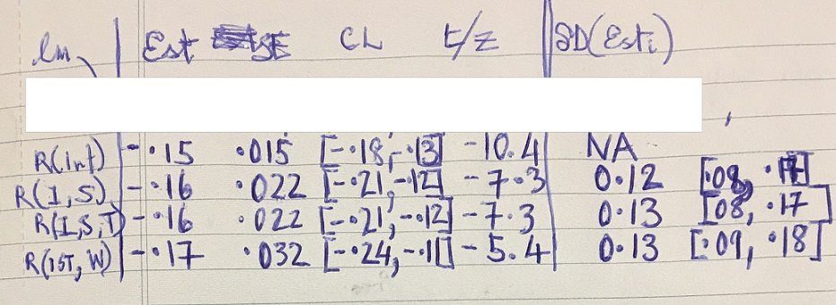

## Example of low heterogeneity dataset: Hassin et al., Experiment 7

## Example of high heterogeneity dataset: Hassin valence dataset

## Example of stability of random effects over time: Yuka dataset

## Benefits for Developing Theory and Methods

Heterogeneity can provide opportunities for theory development. For example, if a manipulation is inneffective for a third of participants in a sample, this suggests that covariates should be examined to determine if they help explain the variability in effectiveness. As far as opportunities for methodological development or improvement, heterogeneity can indicate systematic errors in experimental procedure. Some experimenters can put subjects at ease whereas others cannot. Some experimental procedures evoke heterogeneity. Knowing that this is the case, can lead to revisions of procedure. A final

Causal chains: What links show relative homogeneity/heterogeneity? Where in the causal chain to intervene experimentally?

## Four Pitfalls

### Models that fail to account for heterogeneity at all

### Models that rely on averaging over replications. These can provide valid tests of fixed effects, but they cannot examine hetergeneity.

### Models that correctly take account of heterogeneity but almost always neglect to estimate the size of the effect.

### Models that correctly reveal the heterogeneity but this heterogeneity is not interpreted or sometimes not even discussed.

# Discussion

## We saw that data from repeated measures experiments are much richer than can be seen from traditional analyses

## Opportunities for theory

### If there is heterogeneity, what does it tell us about the population being studied? Are there subpopulations for whom the process in distinct?

### Causal chains: What links show relative homogeneity/heterogeneity? Where in the causal chain to intervene experimentally?

## Opportunities for methods

### Can indicate systematic errors in experimental procedure: some testing sessions conducted in summer heat or winter cold. Some experimenters can put subjects at ease whereas others cannot. Some experimental procedures evoke heterogeneity. Knowing that this is the case, can lead to revisions of procedure.

### Heterogeneity can be used diagnostically to choose stimuli. If an investigator finds that participants vary greatly in their responses to a particular stimulus and are uniform in their response to a different stimulus, they could use this information in making choices between the two.

## Problems and pitfalls

### Precision of estimates; power to detect random effects

### Difference between in-sample predictions and population estimates

## Conclusions: To better understand causal processes

### Best to assume heterogeneity than the opposite

### Tests are misleading: too liberal if they are ignored, too conservative if commonly methods of aggregation are used.

### A more realistic picture of psychological processes

### A better basis for applying psychology too

# Extra

## Sources of heterogeneity: Math priming

### Irrelevant to causal process

#### Experimental procedure: experimenter is unintentionally rude to participant. S’s chair causes discomfort.

#### Subjects: S who comes to lab is tired, hungry, in bad mood

### Relevant to causal process

#### Educational level

#### Math training

#### Attitudes toward math

## Non-Sources: Math priming

### Stimulus heterogeneity: specific math calculations within congruency condition

### Measurement error, other sources of random error at the trial level: standard the model separate this error from subject level heterogeneity

## Sources: Valence of self-descriptions

### Relevant to causal process

#### Promotion/prevention focus

#### Self-worth

#### Western/Eastern culture

## Non-Sources: Valence of self-descriptions

### Stimulus heterogeneity: specific self-descriptions