https://world-nuclear-news.org/articles/kairos-doe-enhance-collaboration-on-advanced-reactor-design
23.02.2026

Kairos, DOE enhance collaboration on advanced reactor design
The US Department of Energy's Oak Ridge National Laboratory and Kairos Power have entered into a USD27 million strategic partnership to accelerate the technology needed to deploy a new generation of advanced nuclear reactors.
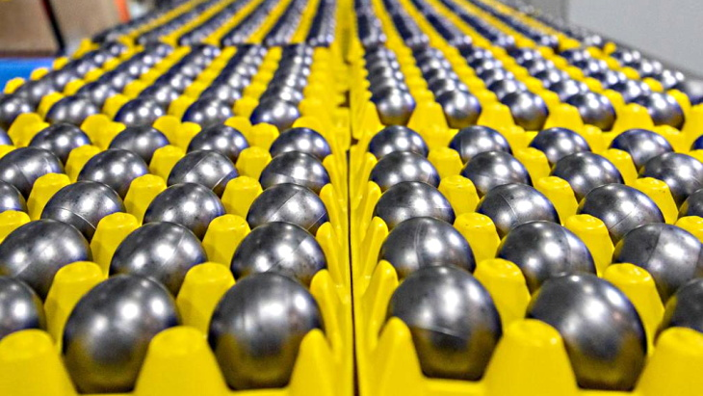TRISO fuel pebbles (Image: Kairos Power)
Under the partnership, over the next five years Oak Ridge National Laboratory (ORNL) will provide expertise and access to specialised facilities to review and evaluate various aspects of Kairos Power's novel fluoride salt-cooled high-temperature reactor design, which uses molten fluoride salt coolant with TRISO (tri-structural isotropic) fuel to generate reliable energy with robust inherent safety. ORNL will also manufacture components for reactor development and testing, and assess the performance of coated particle fuel following irradiation under conditions relevant to their planned reactor operation.
The scope of work includes: assessing fuel manufacturing and synthesis methods to evaluate product quality and production methods for TRISO fuel particles; understanding the properties of TRISO fuel pebbles to support a fabrication capability and quality control infrastructure; completing a comprehensive used fuel pebble management plan to include on-site cask storage, transportation and final disposition; producing components using advanced manufacturing techniques to better understand how materials that come into contact with the salt, such as ceramics, carbon composites, and metallic materials, perform in extremely high temperatures; and enabling remote maintenance systems capable of operating under high temperatures with simultaneous exposure to radiation and corrosive salts.
"Ultimately, the project's outcomes will support the design, construction and eventual operation of Kairos Power's planned Hermes demonstration reactors under construction in Oak Ridge, Tennessee, and subsequent commercialisation of its planned fluoride salt-cooled high-temperature reactor," ORNL said.
Kairos is building the Hermes Low-Power Demonstration Reactor - known as Hermes 1 - in Oak Ridge, Tennessee. Hermes 1, a scaled demonstration of Kairos's KP-FHR fluoride salt-cooled high-temperature reactor technology, is the first non-light-water reactor to be approved for construction by the US Nuclear Regulatory Commission. Kairos Power broke ground at the Hermes 1 site in Oak Ridge in July 2024 and began nuclear safety-related construction in May 2025. It will not produce electricity - Kairos's iterative development approach will see lessons learned from the project feeding into the Hermes 2 commercial-scale demonstration plant - a 50 MWe plant powered by a single commercial-scale reactor. Hermes 2 will include a power generation system.
DOE is investing up to USD303 million of risk reduction funding in Kairos Power's Hermes demonstration reactors under the Advanced Reactor Demonstration Program to mature the company’s molten salt reactor design. The latest project marks the fourth partnership between ORNL and Kairos Power since 2020.
"DOE's support has been instrumental in helping Kairos Power accelerate our path to technological maturity," said Ed Blandford, chief technology officer and co-founder of Kairos Power. "By collaborating with Oak Ridge National Laboratory, we gain access to decades of expertise and a unique set of capabilities that we couldn't find anywhere else. We are pleased to partner with the lab as we work to deploy safe, reliable advanced reactor technology that builds on Oak Ridge's nuclear legacy."
"Providing the scientific basis for new technology is what we do at Oak Ridge National Laboratory," said ORNL Director Stephen Streiffer. "With energy demand expected to increase substantially by 2050, our continued partnerships with US industry, including Kairos Power, are how we will bring more reliable, affordable energy to market."

