1. **Master**

Specifies that only the master thread should execute a section of the program.

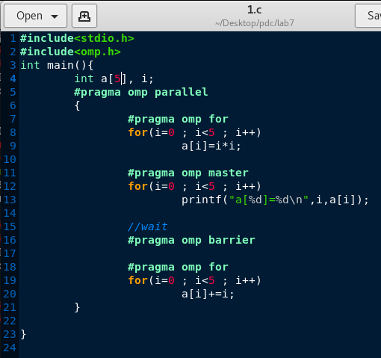

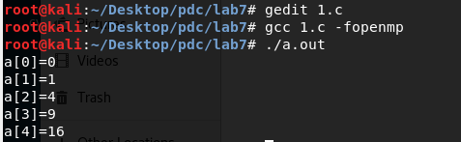

1. **Single and Critical**

Single: specifies that a section of code should be executed by single thread (not necessarily the master thread)

Critical: specifies that code is executed by one thread at a time

So single construct will be executed only once while the critical section will be executed as many times as there are of threads.

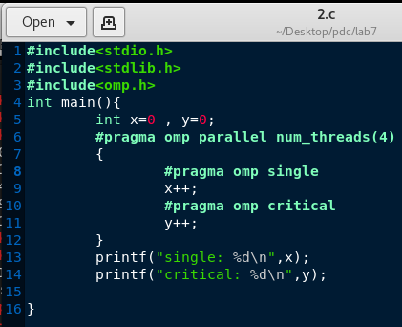

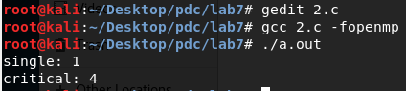

1. **Barrier**

A barrier defines a point in the code where all active threads will stop until all threads have arrived at that point. With this, you can guarantee that certain calculations are finished.

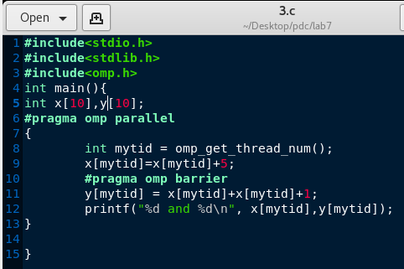

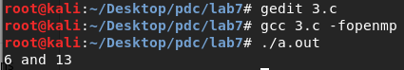

1. **Ordered**

Specifies that code under a parallelized for loop should be executed like a sequential loop.

The ordered directive must be within the dynamic extent of a for or parallel for construct with an ordered clause.

