Before analysis began, the three structured datasets (sentences, utterances, Q&A exchanges) underwent systematic sanity checks to confirm they could be trusted. Row counts were reconciled end-to-end, every sentence resolved to exactly one utterance, with no orphaned or duplicated rows, additionally, coverage was confirmed across all 16 quarters for both banks plus one non-routine event call.
Filler content was quantified rather than just flagged: 349 of 1,059 Q&A exchanges were classified as filler and the percentage sentences retained after filtering was measured directly. This scrutiny caught a genuine problem at scale: roughly 17% of exchanges initially marked “substantive” turned out to be closing remarks only, once analyst content itself was checked for filler rather than just the presence of a management reply.
Borderline cases were spot-checked by reading the actual flagged text. This stage exists to de-risk every later finding, topic and sentiments results are only trustworthy as the join and filters underneath them.

Category | Metric | Value
Data volume | Raw sentences | 19, 092
 | Raw utterances | 2,570
 | Raw metrics row | 1,021
Reconciliation | Structured sentences matched to a parent utterance | 19,092 (100%, 0 orphaned)
 | Structured sentences assigned a stable “utterance_id” | 2,570 (100%)
Coverage | Banks | JPM, UBS
 | Quarters | 16 (2022 Q1 – 2025 Q4)
 | Non-routine calls | 1 (JPM 2023-Q2, First Republic acquisition
Q & A exchange structuring | Total Q&A exchanges identified | 1,059
 | Substantive | 710 (67.0%)
 | Filler | 349 (33%)
 | Exchanges reclassified once analyst content (not just reply length) was checked. | ~17% of initially “substantive” exchanges
Filler-sentence detection | Additional filler sentences caught after the clause-level fix | 390
Table 1: Exploratory Data Analysis Summary Statistics

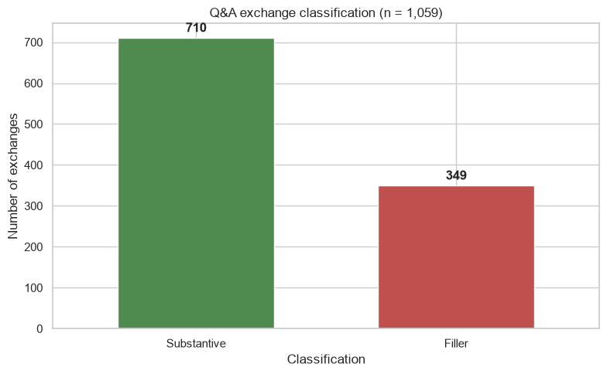
Figure 1:Number of exchanges by classification
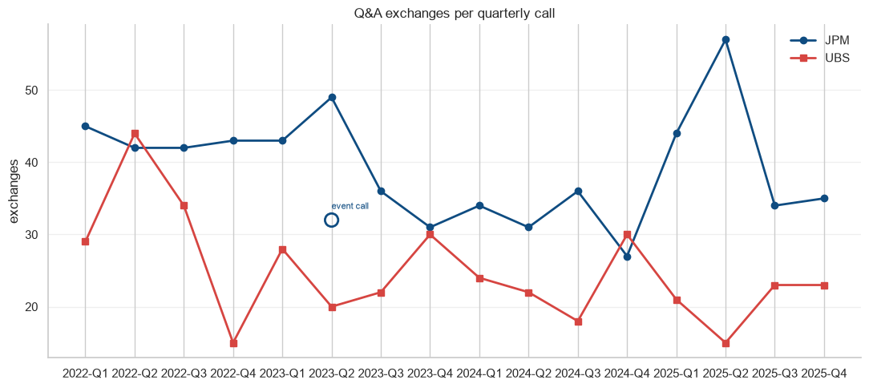
Figure 2: QA exchanges per quarterly call (JPM & UBS)

