Smart Campus Hub
Software Design Specification
Version 1.0
Prepared by
Muhammad Ibrahim – [24K-0649]
Muhammad Hasnain– [24K-0516]
Obaid Ullah– [24K-0793]

Course: Software Design and Analysis [CS-3004]
Supervisor / Instructor: Mr. Syed Ahmed Khan
FAST-NUCES
1/05/2026

Table of Contents

Chapter 1: Introduction 1
i. System Overview 1
ii. Problem Statement 1
iii. Scope 1
iv. Objectives 1
v. Users and Stakeholders 1
vi. System Requirements Summary 1
Functional Requirements 1
Non-Functional Requirements 1
vii. Software Process Model 1
Chapter 2: System Analysis and Modeling 1
i. Use Case Diagram 1
<<include>> Relationships 1
<<extend>> Relationships 1
Use Case Description Tables 1
ii. Class Diagram 1
Classes, Attributes, and Methods 1
Relationships 1
BCE (Boundary–Control–Entity) Model 1
iii. Activity Diagrams 1
Diagram 1 — Course Registration Workflow 1
Diagram 2 — Grade Submission Workflow 1
iv. Sequence Diagrams 1
Diagram 1 — Student Course Enrollment 1
Diagram 2 — Faculty Grade Submission with Audit 1
v. Component Diagram 1
vi. Deployment Diagram 1
vii. Timing Diagram 1
Chapter 5: Architectural View (4+1 Model) 1
i. Logical View 1
ii. Process View 1
iii. Development View 1
iv. Physical View 1
v. +1 Use Case View 1
References 1

Chapter 1: Introduction

i. System Overview
The Smart Campus Hub is a web-based academic management platform that unifies fragmented university operations into a single interface. It digitises student records, course registrations, attendance, grading, and faculty interactions, replacing standalone portals with one consistent system. Built on the Model-View-Controller (MVC) pattern over a normalised MySQL backend, the Hub delivers real-time data, role-based access, and reduced administrative effort for students, faculty, advisors, and administrators.

ii. Problem Statement
Modern universities operate multiple independent systems for registration, attendance, grading, and reporting. This fragmentation creates friction at every level. The Smart Campus Hub addresses five concrete problems:
Fragmented portals. Students and staff currently log into separate systems for registration, transcripts, attendance, and announcements. Each system has its own credentials, interface, and update cycle, increasing user effort and training cost. The Hub consolidates these workflows behind one authenticated entry point.
Data redundancy and synchronisation errors. When personal and academic data are duplicated across departmental databases, updates in one place rarely reach the others. A normalised single source of truth eliminates inconsistent records of the same student or course.
Registration bottlenecks. Peak-load registration with no central capacity check causes scheduling clashes and server overloads. The Hub uses transaction-controlled enrollment with section capacity limits enforced at the database layer, preventing overcommitment and double-booking.
Opaque communication. Grades, attendance, and announcements often reach students through informal channels with delays. The Hub exposes these through authenticated views updated immediately after faculty action, with audit trails ensuring accountability.
Lack of central oversight. Administrators struggle to see system-wide activity. Centralised reporting on enrollments, attendance trends, and grade distributions gives leadership the data needed for resource allocation and policy decisions.

iii. Scope
In scope. The Hub covers user authentication and role-based access; student academic profiles; faculty profiles; the course catalogue and per-semester course offerings (sections); enrollment with capacity and prerequisite control; attendance recording and reporting; grade submission, GPA computation, and transcripts; administrative configuration of users, semesters, and section assignments; institutional reporting; and full audit logging of grade and attendance changes.
Out of scope. The current version explicitly excludes: learning content delivery (lecture videos, online quizzes — handled by a separate LMS); financial banking integration and payment gateways; the Finance module (fee vouchers, payment verification, scholarships, financial holds) is reserved for a later release once its data model is finalised; alumni management; library systems; hostel management; transport tracking; and any mobile native application (the platform is browser-based).

iv. Objectives
Objective 01: Deliver a unified web platform replacing at least three legacy portals within one academic year of deployment.
Objective 02: Enforce zero duplicate enrollments per student-section pair through database-level uniqueness constraints.
Objective 03: Achieve sub-2-second response times on indexed queries (enrollment lookup, attendance retrieval, transcript view) at expected peak load.
Objective 04: Reduce registration-period support tickets by at least 40 percent compared to the legacy system.
Objective 05: Maintain full auditability of every grade and attendance change with no manual logging effort.
Objective 06: Compute end-of-semester GPAs for the entire student body within 30 minutes of grade submission cutoff.
Objective 07: Provide administrators with at least five standard institutional reports without external tooling.
Objective 08: Maintain 99.5 percent monthly uptime during active academic periods, supported by daily automated backups.

v. Users and Stakeholders
The system serves six actors, each interacting through a role-restricted interface.
Student. Primary end user. Registers for course sections, views attendance and grades, downloads vouchers, submits assignments, and applies for clearance. Has read access to personal records only.
Faculty. Records attendance, uploads and modifies grades, manages course materials, views the assigned timetable, creates assessments, and reviews anonymous course feedback. Acts only on assigned sections.
Academic Advisor / Head of Department. Approves student registrations, monitors academic progress, grants prerequisite overrides, and resolves timetable conflicts within their department.
Finance / Accounts Officer. Listed for completeness; the Finance module is out of scope for version 1.0 and will be addressed in a future release.
Administrator. Manages user accounts, configures semester windows and deadlines, assigns faculty to sections, allocates rooms, and generates institutional reports. Holds the highest privilege level.
System / Timer (Automated). A non-human actor representing scheduled processes — registration deadline locking, low-attendance alerts, batch GPA computation, and daily backups.

vi. System Requirements Summary

Functional Requirements
ID | Actor | Requirement
FR-01 | Student | The system shall allow a student to register for available course sections within the active registration window.
FR-02 | Student | The system shall display each student's transcript and current CGPA computed from grades.
FR-03 | Student | The system shall display daily attendance per enrolled section with status (present, absent, late).
FR-04 | Student | The system shall allow students to download semester fee vouchers as PDF (placeholder integration with the future Finance module).
FR-05 | Student | The system shall allow students to submit assignments to assigned sections before the deadline.
FR-06 | Student | The system shall display exam seating plans for the active semester.
FR-07 | Student | The system shall allow students to apply for final clearance and degree.
FR-08 | Student | The system shall allow a student to drop an enrolled section before the drop deadline, updating enrollment status to 'dropped'.
FR-09 | Faculty | The system shall allow faculty to record attendance for assigned sections on a per-class-date basis, rejecting future dates.
FR-10 | Faculty | The system shall allow faculty to upload and modify grades for students in their assigned sections, with all changes captured in the audit log.
FR-11 | Faculty | The system shall allow faculty to upload and manage course materials per section.
FR-12 | Faculty | The system shall display the faculty member's teaching timetable for the active semester.
FR-13 | Faculty | The system shall allow faculty to create assignments and quizzes.
FR-14 | Faculty | The system shall allow faculty to view anonymous course feedback aggregated by section.
FR-15 | Advisor | The system shall allow advisors to approve or reject student registration requests.
FR-16 | Advisor | The system shall allow advisors to grant prerequisite overrides on a per-student-per-section basis.
FR-17 | Advisor | The system shall display each advisee's academic progress including CGPA, completed credit hours, and pending requirements.
FR-18 | Admin | The system shall allow administrators to create, deactivate, and manage all user accounts with role assignment.
FR-19 | Admin | The system shall allow administrators to configure academic semesters with start dates, end dates, and registration deadlines.
FR-20 | Admin | The system shall allow administrators to assign faculty to course sections.
FR-21 | Admin | The system shall allow administrators to allocate classrooms and laboratories to sections.
FR-22 | Admin | The system shall generate institutional reports on enrollments, grade distribution, and attendance trends.
FR-23 | System | The system shall automatically lock course registration at the configured deadline.
FR-24 | System | The system shall trigger low-attendance email alerts when a student's attendance in any section drops below the configured threshold.
FR-25 | System | The system shall compute end-of-semester CGPAs in batch following grade submission cutoff.
FR-26 | System | The system shall execute a daily database backup at the configured off-peak time.
FR-27 | All Users | The system shall provide a secure password reset workflow via verified email link.

Non-Functional Requirements
ID | Category | Requirement
NFR-01 | Performance | Indexed queries (enrollment, attendance, audit lookups) shall respond within 2 seconds at expected peak load. Justified by performance indexes on enrollments, attendance, course_sections, and audit_log.
NFR-02 | Security | All user passwords shall be stored as bcrypt hashes; raw passwords shall never be logged or returned in any response.
NFR-03 | Data Integrity | Database CHECK and FOREIGN KEY constraints (e.g., end_date > start_date, marks_obtained ≤ total_marks, grade_points 0.00–4.00) shall reject all out-of-range data at insertion.
NFR-04 | Consistency | ENUM types on role, status, and action columns shall guarantee a closed value set across the lifetime of the system.
NFR-05 | Concurrency | Enrollment shall be transactional; concurrent registration into a section at capacity shall not exceed max_capacity under any race condition.
NFR-06 | Auditability | Every INSERT, UPDATE, and DELETE on grades and attendance shall be captured automatically in audit_log via database triggers, with no application-side responsibility.
NFR-07 | Availability | The platform shall maintain 99.5 percent monthly uptime during active academic periods, supported by automated daily backups.
NFR-08 | Scalability | The schema and indexing strategy shall support at least a fivefold increase in students and enrollments without redesign.
NFR-09 | Usability | All user-facing functions shall be accessible through a standard web browser without plugin installation.
NFR-10 | Maintainability | The MVC structure shall isolate presentation, business logic, and persistence so that changes in one layer do not require changes in others.

vii. Software Process Model
Adopted Model: Unified Process (UP) — an iterative, use-case-driven, architecture-centric, and risk-focused process tailored to object-oriented projects.
Justification. The Smart Campus Hub is fundamentally object-oriented: actors map to use cases, use cases drive class structure, and class structure drives the schema. The Unified Process is built around exactly this flow, making it a natural fit. UP's iterative nature suits an academic project where requirements evolve through review cycles, while its emphasis on UML modelling aligns with the OOAD deliverables required in this document. The four-phase structure also gives the team natural milestones for evaluation.
Phases:
Inception. Define vision, identify primary actors and use cases, and establish scope boundaries (in-scope and out-of-scope as documented in Chapter 1.iii).
Elaboration. Build the architectural baseline. Produce the use case, class, sequence, and activity diagrams; finalise the database schema; resolve major risks (capacity race conditions, audit integrity).
Construction. Implement the system iteratively module by module — auth, academic, attendance, grading, audit, admin — with continuous testing.
Transition. User acceptance testing, deployment, training, and handover. Finalise documentation and feedback channels.

Chapter 2: System Analysis and Modelling
  - All diagrams are also provided as pdf documents

i. Class Diagram
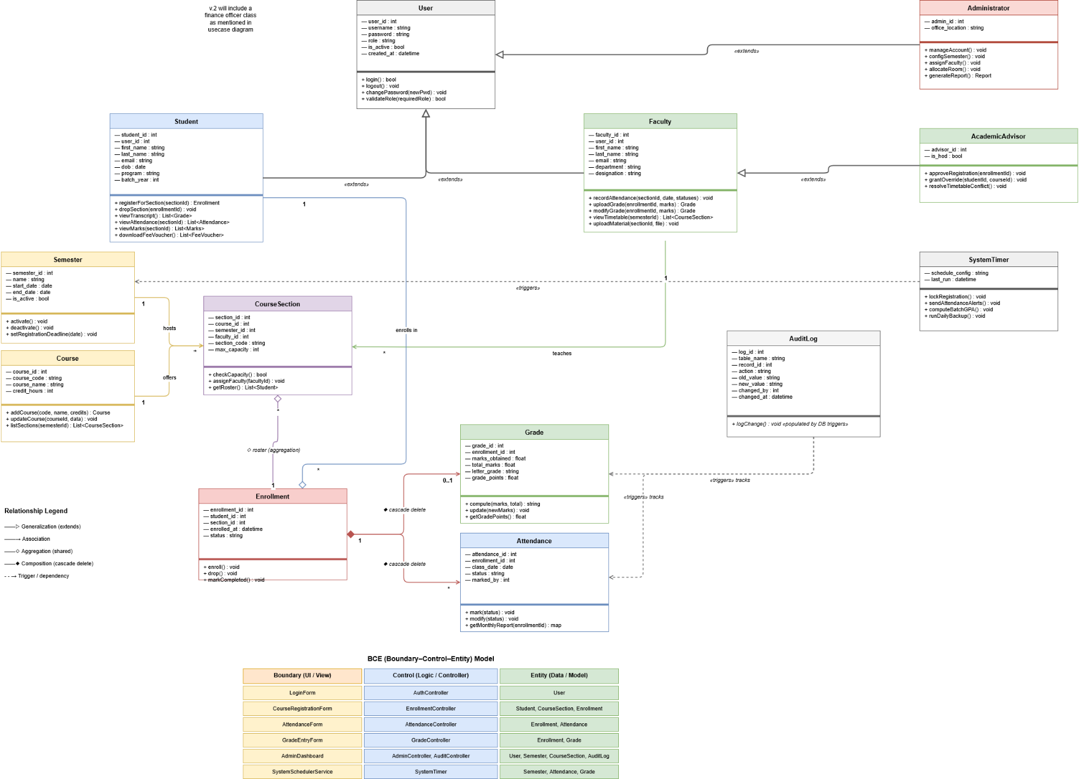
Diagram Type: Class Diagram – [Please refer to the pdf document to view the full diagram]
Description: Shows ten domain classes mapped one-to-one from the schema, with inheritance, composition, aggregation, and association relationships and their multiplicities.

Description. The class diagram captures the static structure of the system. Ten classes correspond directly to the ten schema tables, preserving the analysis-to-design traceability required by the Unified Process.

Classes, Attributes, and Methods
Class | Attributes | Key Methods
User | user_id, username, password (bcrypt), role, is_active, created_at | login(), logout(), changePassword(), validateRole()
Student (extends User) | student_id, user_id, first_name, last_name, email, dob, program, batch_year | registerForSection(), dropSection(), viewTranscript(), viewAttendance()
Faculty (extends User) | faculty_id, user_id, first_name, last_name, email, department, designation | recordAttendance(), uploadGrade(), viewTimetable(), uploadMaterial()
Course | course_id, course_code, course_name, credit_hours | addCourse(), updateCourse(), listSections()
Semester | semester_id, name, start_date, end_date, is_active | activate(), deactivate(), setRegistrationDeadline()
CourseSection | section_id, course_id, semester_id, faculty_id, section_code, max_capacity | checkCapacity(), assignFaculty(), getRoster()
Enrollment | enrollment_id, student_id, section_id, enrolled_at, status | enroll(), drop(), markCompleted()
Attendance | attendance_id, enrollment_id, class_date, status, marked_by | mark(), modify(), getMonthlyReport()
Grade | grade_id, enrollment_id, marks_obtained, total_marks, letter_grade, grade_points | compute(), update(), getGradePoints()
AuditLog | log_id, table_name, record_id, action, old_value, new_value, changed_by, changed_at | logChange() — populated by DB triggers

Relationships
- Generalization (inheritance): Student and Faculty inherit from User.
- Association: Faculty 1 — * CourseSection (a faculty member teaches many sections).
- Aggregation: CourseSection ◇— * Student via Enrollment (the section has a roster, but students exist independently).
- Composition: Enrollment ◆— * Attendance, Enrollment ◆— 0..1 Grade (cascade delete: removing the enrollment removes its attendance and grade).
- Association: Course 1 — * CourseSection (a course is offered in many sections across semesters).
- Association: Semester 1 — * CourseSection.

BCE (Boundary–Control–Entity) Model
Boundary (UI) | Control (Logic) | Entity (Data)
LoginForm | AuthController | User
CourseRegistrationForm | EnrollmentController | Student, CourseSection, Enrollment
AttendanceForm | AttendanceController | Enrollment, Attendance
GradeEntryForm | GradeController | Enrollment, Grade
AdminDashboard | AdminController, AuditController | User, Semester, CourseSection, AuditLog

ii. Use Case Diagram
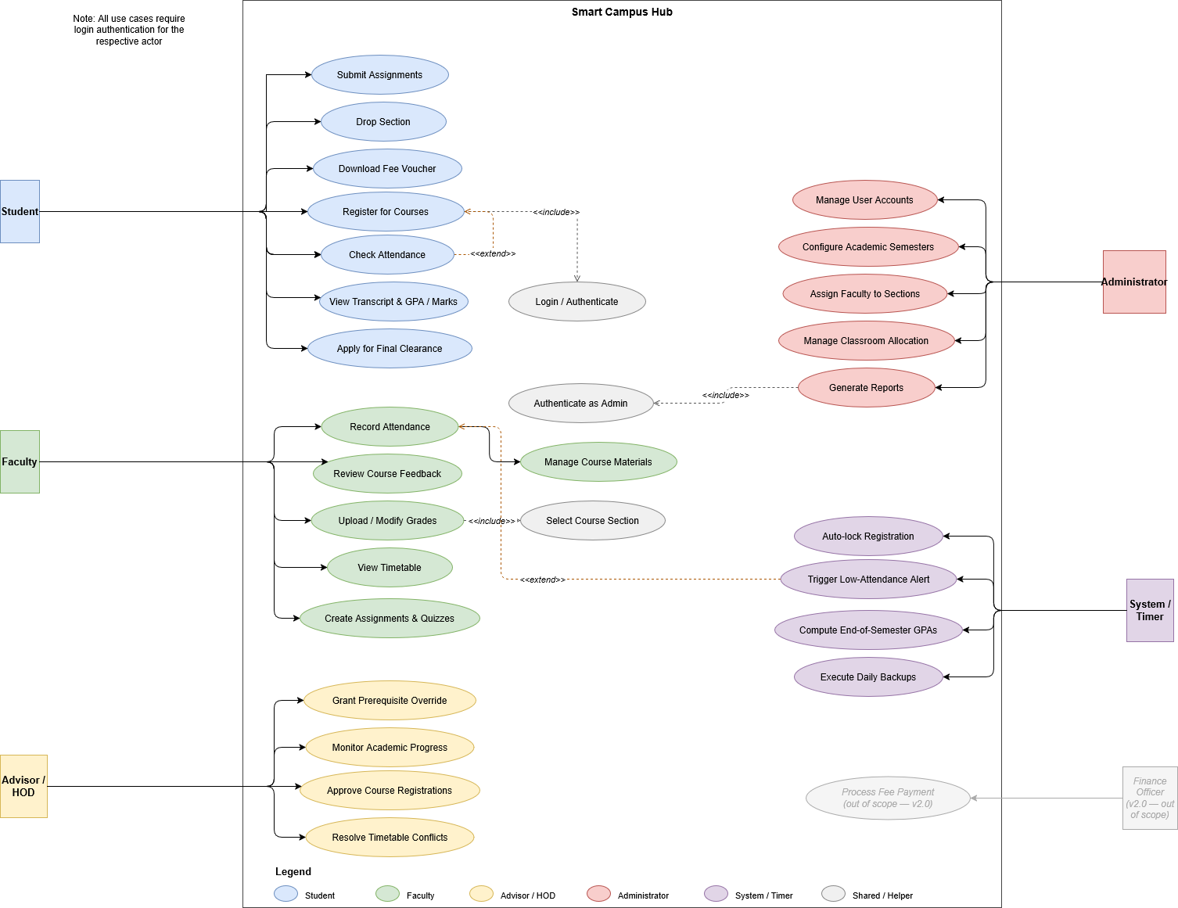
Diagram Type: Use Case Diagram
Description: Shows all six actors of the Smart Campus Hub and their use cases, along with <<include>> and <<extend>> relationships between use cases.

Description. The use case diagram captures the full set of behaviours visible to external actors. Six actors are connected to the use cases they initiate. The diagram makes explicit which actions are reused across use cases (via <<include>>) and which are conditional extensions (via <<extend>>).
Actors and their use cases:
Student: Register for Courses, Drop Section, View Transcript & GPA, Check Attendance, Download Fee Voucher, Submit Assignments, View Exam Seating Plans, Apply for Final Clearance.
Faculty: Record Attendance, Upload/Modify Grades, Manage Course Materials, View Timetable, Create Assignments & Quizzes, Review Course Feedback.
Advisor / HOD: Approve Course Registrations, Monitor Academic Progress, Grant Prerequisite Override, Resolve Timetable Conflicts.
Administrator: Manage User Accounts, Configure Academic Semesters, Assign Faculty to Sections, Manage Classroom Allocation, Generate Reports.
System / Timer: Auto-lock Registration, Trigger Low-Attendance Alerts, Compute End-of-Semester GPAs, Execute Daily Backups.
Finance Officer: Out of scope for version 1.0; included in the diagram in greyed-out form for completeness.

<<include>> Relationships
- Register for Courses <<include>> Login — every registration requires authenticated session.
- Upload Grades <<include>> Select Course Section — grades are always tied to a section.
- Generate Reports <<include>> Authenticate as Admin — reporting requires admin privilege.

<<extend>> Relationships
- Apply Prerequisite Override <<extend>> Register for Courses — only invoked when a prerequisite check fails.
- Trigger Low-Attendance Alert <<extend>> Record Attendance — only invoked when attendance crosses the configured threshold.

Use Case Description Tables
Use Case 1: Register for Courses
Field | Description
Use Case Name | Register for Courses
Actor | Student
Precondition | Student is authenticated, registration window is open, and student has no active financial hold.
Main Flow | 1. Student logs in. 2. Student browses available sections. 3. System checks section capacity and prerequisites. 4. Student confirms enrollment. 5. System creates an enrollments row inside a transaction. 6. System returns confirmation.
Postcondition | A new row exists in enrollments with status = 'active'; section capacity counter is incremented.
Exceptions | Capacity full → enrollment rejected; prerequisite missing → override required; duplicate enrollment → rejected by UNIQUE constraint.

Use Case 2: Record Attendance
Field | Description
Use Case Name | Record Attendance
Actor | Faculty
Precondition | Faculty is authenticated and assigned to the selected section.
Main Flow | 1. Faculty selects a section and class date. 2. System loads the enrolled student list. 3. Faculty marks each student as present, absent, or late. 4. System inserts attendance rows. 5. Confirmation displayed.
Postcondition | Attendance rows exist for all students for the chosen date; UNIQUE(enrollment_id, class_date) prevents duplicates.
Exceptions | Future date → trigger rejects insert; duplicate (enrollment_id, class_date) → rejected; faculty not assigned → access denied.

Use Case 3: Upload / Modify Grades
Field | Description
Use Case Name | Upload / Modify Grades
Actor | Faculty
Precondition | Faculty is authenticated and assigned to the section; grade entry window is open.
Main Flow | 1. Faculty selects a section. 2. System loads the enrolled roster. 3. Faculty enters marks_obtained and total_marks. 4. System computes letter_grade and grade_points. 5. INSERT or UPDATE on grades. 6. Trigger writes a row in audit_log. 7. Notification sent to student.
Postcondition | grades row reflects new marks; corresponding audit_log row exists.
Exceptions | Marks exceed total_marks → CHECK constraint rejects; faculty not assigned → access denied.

Use Case 4: Manage System User Accounts
Field | Description
Use Case Name | Manage System User Accounts
Actor | Administrator
Precondition | Administrator is authenticated with admin role.
Main Flow | 1. Admin opens user management. 2. Admin creates / edits / deactivates an account, assigning role. 3. System hashes any new password with bcrypt. 4. Persists row in users table. 5. Confirmation displayed.
Postcondition | users table reflects requested change; profile rows in students or faculty linked through user_id.
Exceptions | Username not unique → rejected; weak password → rejected; deactivating self → rejected.

Use Case 5: Auto-lock Registration at Deadline
Field | Description
Use Case Name | Auto-lock Course Registration at Deadline
Actor | System / Timer
Precondition | Active semester has a configured registration_deadline.
Main Flow | 1. Scheduler fires at deadline. 2. System sets a flag closing the registration window. 3. Subsequent enrollment attempts are rejected at the application layer. 4. Notification sent to students who started but did not complete registration.
Postcondition | Registration window closed; no new enrollments accepted for the semester.
Exceptions | Scheduler down → fallback manual close by administrator; transient lock failure → retried per configured policy.

iii. Activity Diagrams

Diagram 1 — Course Registration Workflow
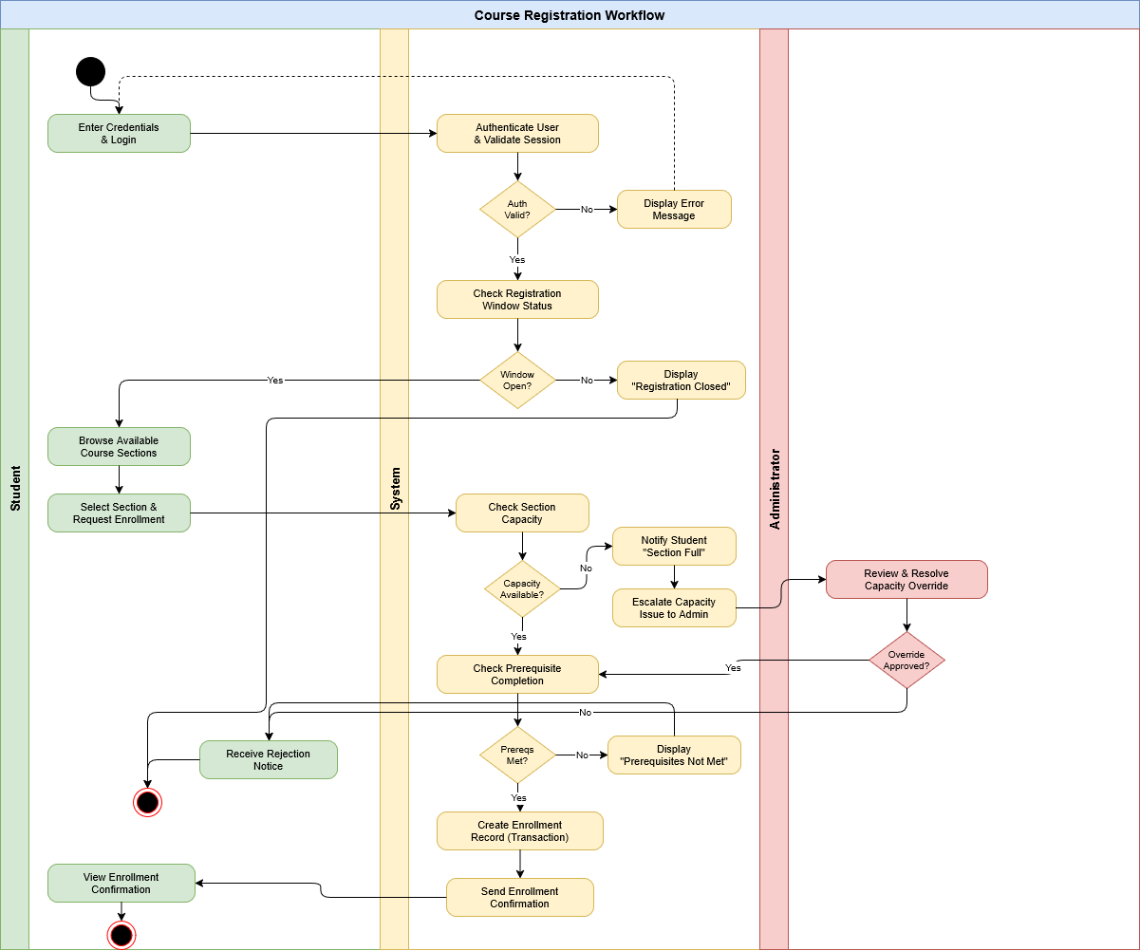
Diagram Type: Activity Diagram (Swimlanes)
Description: Swimlanes: Student | System | Administrator. Flow covers login, browsing sections, capacity and prerequisite checks, and enrollment confirmation.
Description. This swimlaned activity diagram traces a student's registration from authentication through final enrollment. The Student lane initiates and confirms; the System lane enforces capacity and prerequisite rules; the Administrator lane handles edge resolution. Decision diamonds gate flow on capacity availability and prerequisite satisfaction. The merge point delivers a final confirmation back to the student and writes to the enrollments table.

Diagram 2 — Grade Submission Workflow
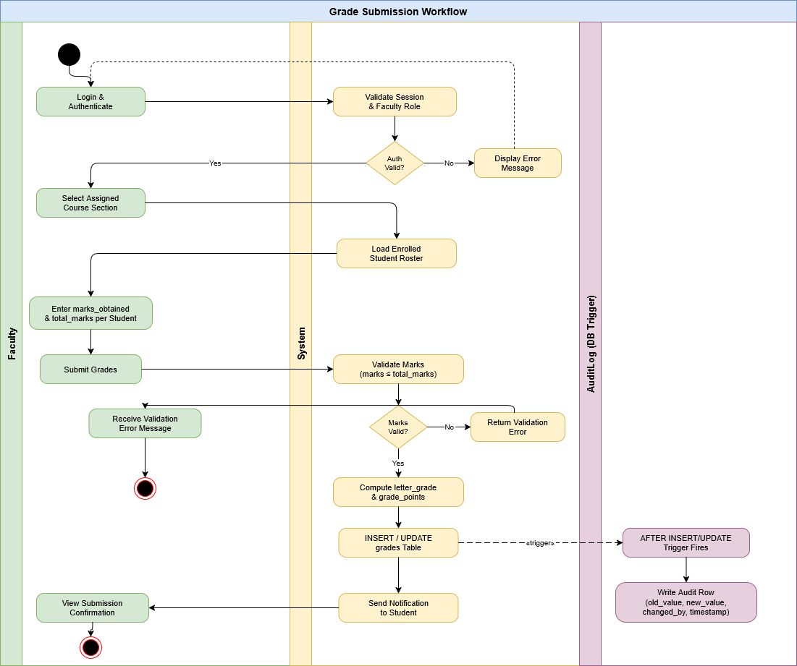
Diagram Type: Activity Diagram (Swimlanes)
Description: Swimlanes: Faculty | System | AuditLog. Flow covers section selection, marks entry, computation of letter_grade and grade_points, persistence in the grades table, automatic trigger insertion into audit_log, and student notification.

Description. This diagram captures the grade submission pipeline. The Faculty lane handles section selection and marks entry. The System lane computes the letter grade and grade points based on the institutional grading scale, then persists the grades row. The AuditLog lane is fed automatically by a database trigger on INSERT/UPDATE of the grades table — this enforces audit completeness without relying on application discipline.

iv. Sequence Diagrams

Diagram 1 — Student Course Enrollment
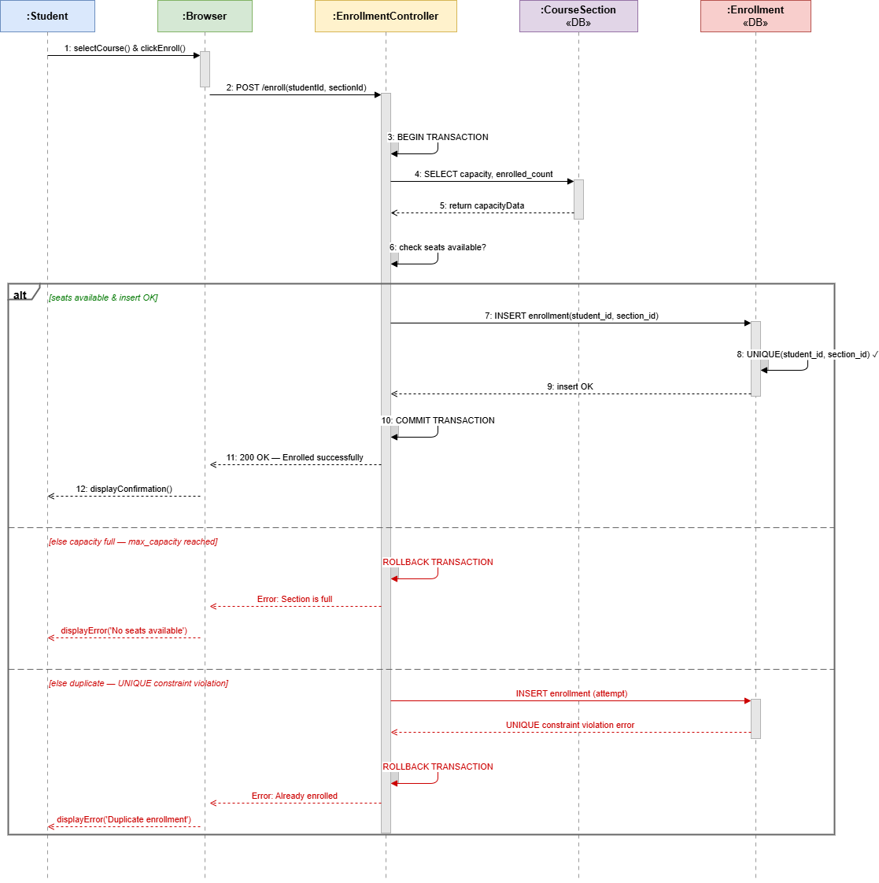
Diagram Type: Sequence Diagram
Description: Lifelines: Student, Browser, EnrollmentController, CourseSection (DB), Enrollment (DB). Messages cover capacity check, duplicate enrollment check via UNIQUE constraint, transaction begin/commit, and confirmation response.
Description. The student initiates enrollment through the browser. The EnrollmentController begins a transaction, queries CourseSection for current capacity, and attempts an INSERT into Enrollment. The UNIQUE(student_id, section_id) constraint blocks duplicate enrollments at the database. On success, the controller commits and returns confirmation; on capacity overflow or duplicate, it rolls back and returns an error message.
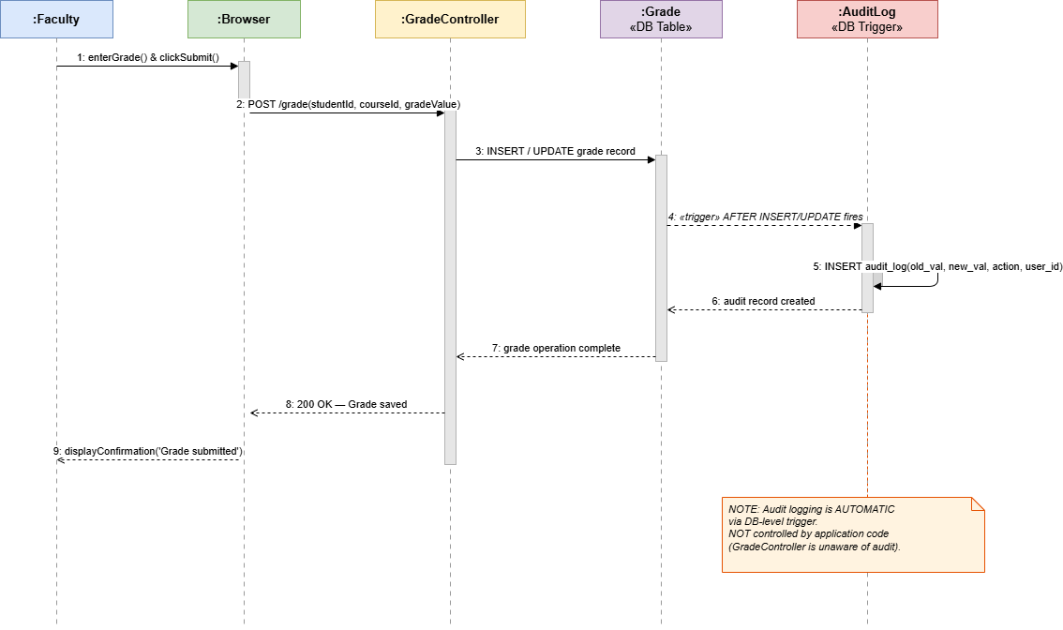
Diagram Type: Sequence Diagram
Description: Lifelines: Faculty, Browser, GradeController, Grade (DB), AuditLog (DB Trigger). Messages cover grade insert/update, trigger firing automatically, audit row creation, and response back to the faculty UI.

Diagram 2 — Faculty Grade Submission with Audit

Description. The faculty member submits a grade through the browser. The GradeController calls INSERT or UPDATE on the grades table. The database trigger then fires automatically, inserting a row into audit_log with the old and new values, the action type, and the changed_by user_id. The controller returns confirmation to the browser. Note that the audit step is invisible to the application, ensuring no developer can bypass it.

v. Component Diagram
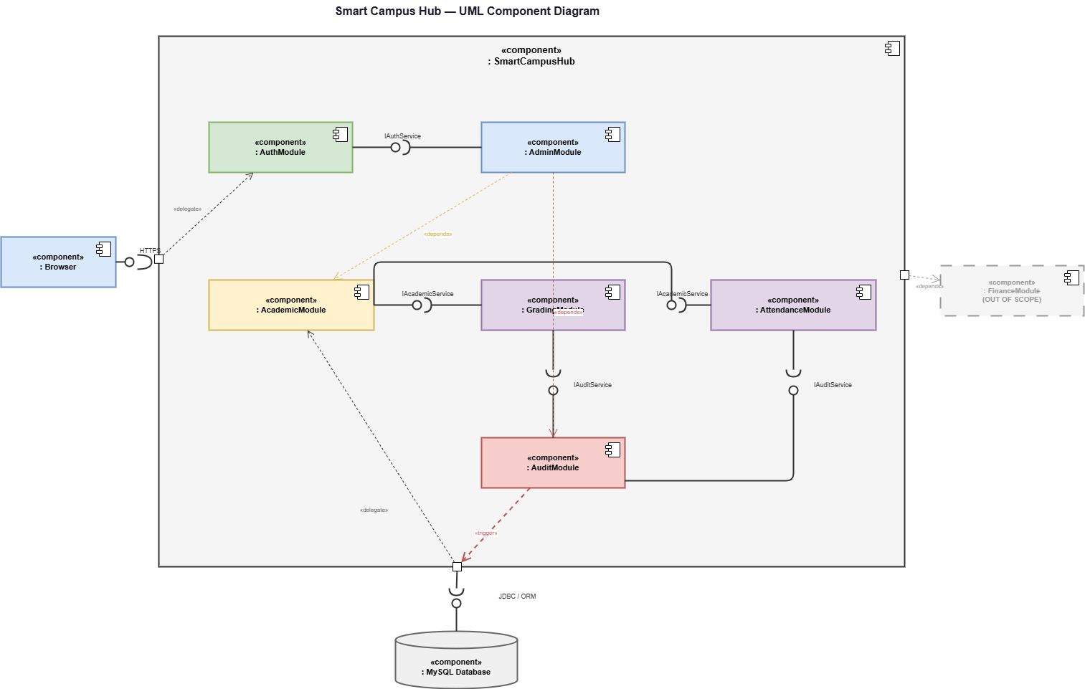

Diagram Type: Component Diagram
Description: Shows software components — AuthModule, AcademicModule, GradingModule, AttendanceModule, AuditModule, AdminModule, FinanceModule (out of scope, dashed) — and the dependencies between them.

Description. The Hub is decomposed into seven logical components, each owning a part of the schema and a set of use cases:
- AuthModule — owns users; provides authentication and session services consumed by every other module.
- AcademicModule — owns students, faculty, courses, semesters, course_sections, enrollments. Depends on AuthModule for identity.
- GradingModule — owns grades and the v_student_cgpa view. Depends on AcademicModule (enrollments) and AuditModule (every change is audited).
- AttendanceModule — owns attendance. Depends on AcademicModule and AuditModule.
- AuditModule — owns audit_log and the database triggers that populate it. Used implicitly by GradingModule and AttendanceModule via DB-level triggers, not API calls.
- AdminModule — provides administration UIs. Depends on AuthModule, AcademicModule, and AuditModule.
- FinanceModule — placeholder; reserved for a future release. Shown dashed in the diagram and unconnected to active flows.

vi. Deployment Diagram
[ DIAGRAM PLACEHOLDER ]
Diagram Type: Deployment Diagram
Description: Three-tier physical layout — Client Browser node, Application Server node (MVC framework), Database Server node (MySQL with smart_campus schema). Connections labelled with HTTPS and JDBC/ORM.
— Insert diagram image here —

Description. The platform is deployed across three tiers. The client tier is any modern browser running on a student, faculty, or administrator machine. The application tier hosts the MVC framework and business logic, accessed by clients over HTTPS. The data tier hosts MySQL with the smart_campus schema, accessed by the application tier over a JDBC or ORM connection within a secured network segment. Daily backup jobs run on the database tier.

vii. Timing Diagram
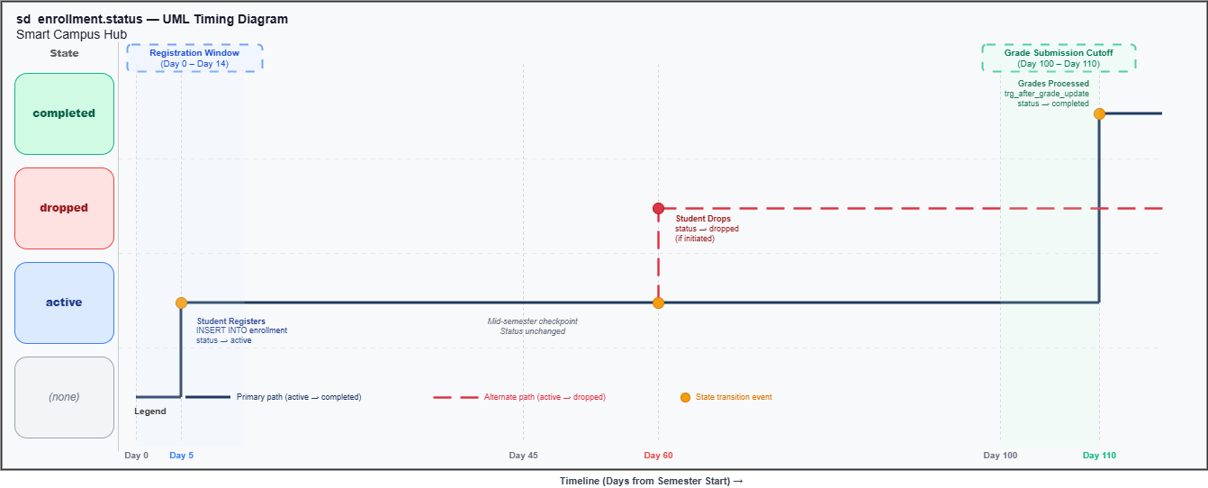
Diagram Type: Timing Diagram
Description: Shows state transitions of enrollment.status across a semester: 'active' from registration through the term, transitioning to 'dropped' (if drop occurs) or 'completed' (at semester end after grade submission).

Description. The timing diagram tracks the enrollment.status attribute across the semester timeline. After successful registration, the row begins in the 'active' state. If the student initiates a drop before the drop deadline, the state transitions to 'dropped'. Otherwise, after grade submission and end-of-semester processing, the System actor transitions the status to 'completed'. The diagram makes explicit that 'dropped' and 'completed' are terminal states for that enrollment.

Chapter 5: Architectural View (4+1 Model)
The 4+1 view model captures the system from five complementary angles. Each view targets a specific stakeholder concern.

i. Logical View
The logical view summarises the domain model. The User class is the root of the inheritance hierarchy, with Student and Faculty as concrete subclasses. The Enrollment class is the central junction connecting Student and CourseSection. CourseSection itself binds Course, Semester, and Faculty into a single offering. Grade and Attendance hang off Enrollment in a composition relationship — they cannot exist without their parent enrollment, and cascade-delete rules enforce this at the database. AuditLog is decoupled, recording every grade and attendance change without being referenced by any business object.

ii. Process View
The process view captures runtime concurrency and automation.
- Enrollment transactions. Each registration runs inside a database transaction with row-level locking on CourseSection capacity. This prevents two students from simultaneously occupying the last available seat.
- Scheduled processes. The System actor runs four scheduled jobs: registration deadline locking, low-attendance email alerts, end-of-semester GPA batch computation, and daily database backup.
- Database triggers. A BEFORE INSERT trigger on attendance rejects future-dated rows. AFTER INSERT/UPDATE/DELETE triggers on grades and attendance populate audit_log. These triggers run inside the same transaction as the originating change, so audit rows cannot be lost.
- Notification background workers. Low-attendance alerts and grade notifications are dispatched asynchronously to avoid blocking interactive requests.

iii. Development View
Source code is organised in packages mirroring the modules and the schema:
Package | Owns Tables | Primary Use Cases
com.smartcampus.auth | users | Login, password reset, role enforcement
com.smartcampus.academic | students, faculty, courses, semesters, course_sections, enrollments | Registration, profile management, section management
com.smartcampus.grading | grades, v_student_cgpa | Grade entry, transcript, GPA computation
com.smartcampus.attendance | attendance | Attendance recording, low-attendance alerts
com.smartcampus.audit | audit_log | Database triggers, audit reporting
com.smartcampus.admin | (uses all) | User management, semester configuration, reporting
com.smartcampus.finance | — (out of scope v1.0) | Reserved for future release

iv. Physical View
Hardware nodes:
- Client machines — any device running a modern browser; no installed client software.
- Application Server — runs the web server and the MVC framework hosting the controllers and views.
- Database Server — runs MySQL with the smart_campus schema, performance indexes, views, and triggers.
Communication channels:
- Client to Application Server — HTTPS, with bcrypt-protected credentials and signed sessions.
- Application Server to Database Server — JDBC or ORM over a private network segment.
- Database backup target — encrypted off-server storage refreshed daily by the System actor.

v. +1 Use Case View
The +1 view binds the other four views together by tracing how the most important use cases traverse the architecture.
Example: Student Course Registration. The student opens the registration form (View) hosted on the Application Server. Submission invokes the EnrollmentController (Controller). The controller begins a transaction and reads from course_sections (Model) on the Database Server. After capacity and prerequisite checks pass, the controller writes to enrollments. The transaction commits. The Model returns the new row to the controller, which renders the confirmation page back to the student.
Example: Faculty Grade Submission. Faculty submits grades via GradeEntryForm (View). The GradeController writes to grades (Model). A database trigger writes synchronously to audit_log. The controller returns a confirmation rendered as a View. Every layer in the architecture participated in fulfilling a single use case, and every column written is traceable back to the originating actor.

References
References are formatted in IEEE style.
[1] G. Booch, J. Rumbaugh, and I. Jacobson, The Unified Modeling Language User Guide, 2nd ed. Boston, MA, USA: Addison-Wesley, 2005.
[2] C. Larman, Applying UML and Patterns: An Introduction to Object-Oriented Analysis and Design and Iterative Development, 3rd ed. Upper Saddle River, NJ, USA: Prentice Hall, 2004.
[3] P. Kruchten, The Rational Unified Process: An Introduction, 3rd ed. Boston, MA, USA: Addison-Wesley, 2003.
[4] I. Jacobson, G. Booch, and J. Rumbaugh, The Unified Software Development Process. Reading, MA, USA: Addison-Wesley, 1999.
[5] Object Management Group, OMG Unified Modeling Language Specification, Version 2.5.1, Dec. 2017. [Online]. Available: https://www.omg.org/spec/UML/2.5.1
[6] Oracle Corporation, MySQL 8.0 Reference Manual, 2024. [Online]. Available: https://dev.mysql.com/doc/refman/8.0/en/
[7] R. Elmasri and S. B. Navathe, Fundamentals of Database Systems, 7th ed. Boston, MA, USA: Pearson, 2016.
[8] M. Fowler, Patterns of Enterprise Application Architecture. Boston, MA, USA: Addison-Wesley, 2002.
[9] P. Kruchten, “The 4+1 View Model of Architecture,” IEEE Software, vol. 12, no. 6, pp. 42–50, Nov. 1995.
[10] R. S. Pressman and B. R. Maxim, Software Engineering: A Practitioner’s Approach, 9th ed. New York, NY, USA: McGraw-Hill, 2020.

