COAL LAB-9 IN-LAB TASKS
[24K-0649]
Task 1:
INCLUDE Irvine32.inc

.data
marks DWORD 10 DUP(?)
inputMSG BYTE "Enter Student Marks: ",0
msg1 BYTE "Passed Students: ",0
msg2 BYTE "Failed Students: ",0
pass DWORD 0
fail DWORD 0

.code

main PROC
mov ecx, LENGTHOF marks
mov esi, OFFSET marks

inputLoop:
mov edx, OFFSET inputMSG
call WriteString
call ReadInt
mov [esi], eax
add esi, TYPE marks
loop inputLoop

call Count

mov edx, OFFSET msg1
call WriteString
mov eax, pass
call WriteDec
call CrLf

mov edx, OFFSET msg2
call WriteString
mov eax, fail
call WriteDec
call CrLf

exit
main ENDP

Count PROC
mov ecx, LENGTHOF marks
mov esi, OFFSET marks

nextMark:
mov eax, [esi]
cmp eax, 50
jl failed

mov eax, pass
inc eax
mov pass, eax
jmp continueLoop

failed:

mov eax, fail
inc eax
mov fail, eax

continueLoop:
add esi, TYPE marks
loop nextMark
ret
Count ENDP

END main

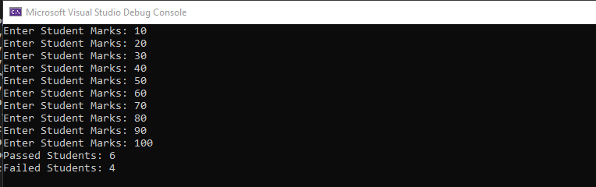
Task 2:
INCLUDE Irvine32.inc

.data
msg BYTE "Encrypted value: ",0
value BYTE ?

.code
main PROC

mov al, 01011101
rol al, 2
shr al, 1
mov value, al

mov edx, OFFSET msg
call WriteString
movzx eax, value
call WriteDec
call CrLf

exit
main ENDP
END main

