Employee Absenteeism Project

Madhurima Biswas

29 November 2018

Contents

I. Introduction 2

1.1 Problem Statement 2

1.2 Data 2

II. Methodology 4

2.1 Exploratory Data Analysis 4

2.1.1 Univariate Analysis 4

2.1.2 Bivariate Analysis 12

2.1.3 Fixing Data Anomalies 18

2.1.4 Missing Value Analysis 18

2.1.5 Outlier Analysis 19

2.1.6 Feature Selection 22

2.1.7 Feature Scaling 25

2.1.8 Data Sampling 26

2.2 Modeling 27

2.2.1 Model Selection 27

2.2.2 Decision tree Algorithm 27

2.2.3 Random Forest Algorithm 30

2.2.4 Multiple Linear Regression 31

2.2.5 KNN Algorithm 33

III. Conclusion 34

3.1 Model Evaluation 34

3.2 Final Model Selection 36

3.3 Solutions 36

Appendix A - Extra Figures 37

Appendix B - R Code 38

Appendix C - Python code 55

References 60

I. Introduction:

1.1. Problem Statement

Absenteeism is a serious workplace problem and an expensive occurrence for both employers and employees. Absenteeism of employees from work leads to back logs, piling of work and thus work delay. Human capital plays an important role in collection, transportation and delivery at XYZ Courier Company. The company is passing through genuine issue of Absenteeism. The aim of the project is to reduce the number of absenteeism amongst employees of company XYZ by bringing necessary changes accordingly. We would like to predict the losses that will occur every month if the same trend of absenteeism continues in the year 2011.

1.2. Data

The task is to build predictive regression models, which will predict the employees’ absenteeism, based on the various factors given in the data of the XYZ Courier Company.

Given below is a sample of the data set that we are using to predict the employee absenteeism:

Table 1.1: Absenteeism at work sample data (XYZ Company)

|  |  |  |  |  |  |  |  |  |  |
| --- | --- | --- | --- | --- | --- | --- | --- | --- | --- |
| ID | Reason for absence | Month of absence | Day of the week | Seasons | Transportation expense | Distance from Residence to Work | Service time | Age | Work load Average/day |
| 11 | 26 | 7 | 3 | 1 | 289 | 36 | 13 | 33 | 239,554 |
| 36 | 0 | 7 | 3 | 1 | 118 | 13 | 18 | 50 | 239,554 |
| 3 | 23 | 7 | 4 | 1 | 179 | 51 | 18 | 38 | 239,554 |
| 7 | 7 | 7 | 5 | 1 | 279 | 5 | 14 | 39 | 239,554 |
| 11 | 23 | 7 | 5 | 1 | 289 | 36 | 13 | 33 | 239,554 |

|  |  |  |  |  |  |  |  |  |  |  |
| --- | --- | --- | --- | --- | --- | --- | --- | --- | --- | --- |
| Hit target | Disciplinary failure | Education | Son | Social drinker | Social smoker | Pet | Weight | Height | Body mass index | Absenteeism time in hours |
| 97 | 0 | 1 | 2 | 1 | 0 | 1 | 90 | 172 | 30 | 4 |
| 97 | 1 | 1 | 1 | 1 | 0 | 0 | 98 | 178 | 31 | 0 |
| 97 | 0 | 1 | 0 | 1 | 0 | 0 | 89 | 170 | 31 | 2 |
| 97 | 0 | 1 | 2 | 1 | 1 | 0 | 68 | 168 | 24 | 4 |
| 97 | 0 | 1 | 2 | 1 | 0 | 1 | 90 | 172 | 30 | 2 |

Therefore, in the table below, we have the following 20 independent variables, using which we have to predict the employee Absenteeism:

Table 1.2: Predictor Variables

No. Independent Variables

1 ID

2 Reason for Absence

3 Month of Absence

4 Day of the week

5 Seasons

6 Transportation Expense

7 Distance from Residence to work

8 Service time

9 Age

10 Work load Average/ day

11 Hit target

12 Disciplinary failure

13 Education

14 Son

15 Social Drinker

16 Social Smoker

17 Pet

18 Weight

19 Height

20 Body Mass Index

We have 11 numerical and 9 categorical independent variables in this data.

II. Methodology

2.1. Exploratory Data Analysis:

The objective first is to study each feature available in the data and try to assess some patterns and understand the dimensions & properties of the data by exploring it visually. It helps us in understanding the nature of data in terms of distribution of the individual variables/features, finding missing values, relationship with other variables and many other things.

2.1.1. Univariate Analysis:

A. Dependent Target Variable: “Absenteeism time in hours”

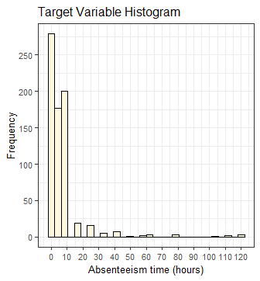

Since our target variable is continuous, we can visualize it by plotting its histogram.

Fig.2.1

Observation:

* Most of the employees have taken leave of short durations, but in the long run, it adds up to the absenteeism problem. It is a right (positively) skewed variable and can be transformed to treat its skewness using logarithmic, cube root or square root function.
* Removing outliers might help reduce the skewness in data as well.

B. Independent Numeric Variables:

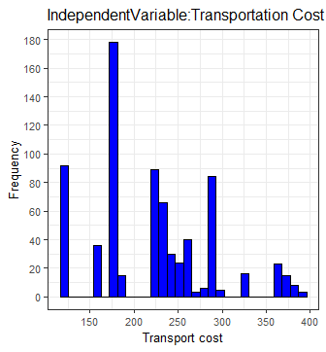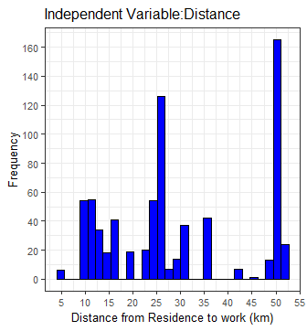

Fig.2.2

Observation:

* The mean transportation expense of the employees is 221.03 (rs.) and mean distance from residence to work is 29.67 km.
* There is no clear-cut pattern in “transportation Expense” & “Distance from residence to work” variable.

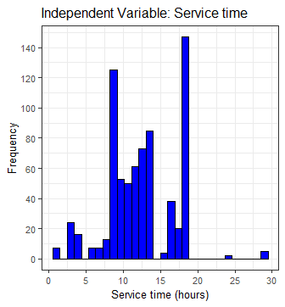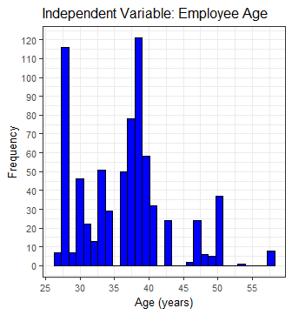

Fig.2.3

Observation:

* Most of the absentees have a “Service time” around the median hour of 13 hours and an average of 12.56 hours, i.e. employees with high or less service time have not taken much leaves comparatively.
* Most of the absentees are below the “Age” of 50, i.e. around the median of 37 years.

However, this could be because they hire less old employees working in this company as there is need for active members who can collect, transport & delivery courier and therefore, we have to look for more relations.

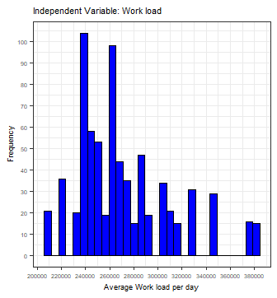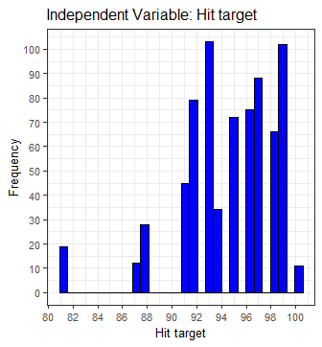

Fig.2.4

Observation:

* Employees with moderately low “Average work load per day” were absent having an average of 271188.8.
* It can be clearly seen that employees with high “Hit Target” were more absent from work comparatively. Hence, the employer can look into minimizing their employee’s targets.

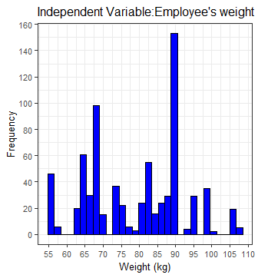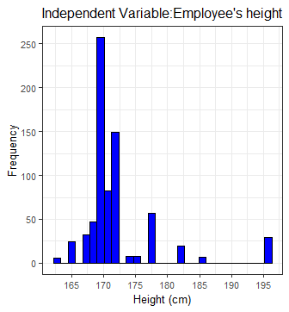

Fig.2.5

Observation:

* There is no clear-cut pattern in “Employee’s weight”.
* There is right skewness towards low heighted employees and this can be reduced by outlier analysis.

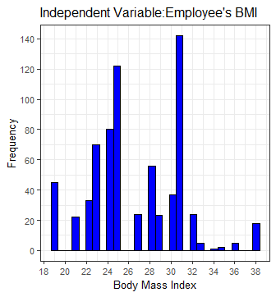 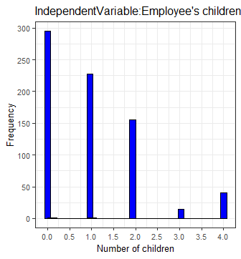

Figfig.2.6

Observation:

* Normal BMI is considered between 18.5 to 25. The average “BMI” for absentees is 26.7, which comes under the category of ‘slightly overweight’. The XYZ Company can therefore create some fitness awareness or routines for their employees.
* Most of the absentees have no “Son” or just one in number. The median of this variable is 1.

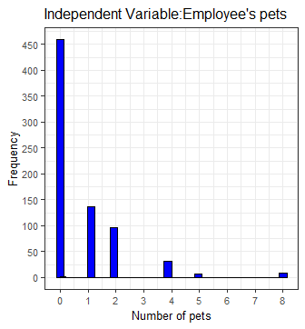fig.2.7

Observation:

* Most of the employees who were absent have no pet, median & mode being ‘0’. However, we cannot say that responsibility of a pet at home could be necessarily a generic reason of absence in this company.

C. Independent Categorical Variables:

Bar graphs for the categorical variables in the data as follows:

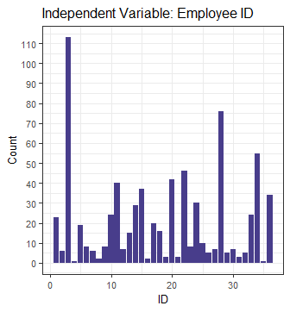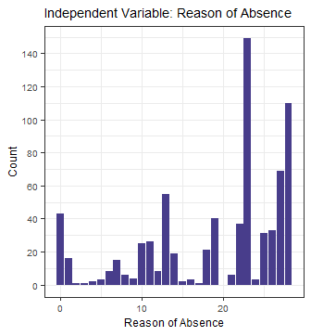

Fig.2.8

Observation:

* The bar graph for “ID” tells us about which employees were absent the most. Thus, recognizing the most frequent absentees and helping the company heads to micromanage them.
* The mode of “Reason of Absence” variable is ‘23: Medical Consultation’ and 2nd highest mode is ‘28: Dental Consultation’. So, if the company can arrange regular health checkups near or in their company premises, the losses due absenteeism can be reduced.
* In the “Reason of Absence” variable, there is a category ‘0’, which is an anomaly in data as it is not mentioned in either ICD reasons or without ICD ones.

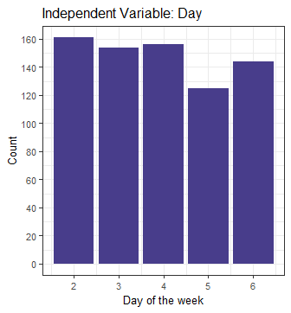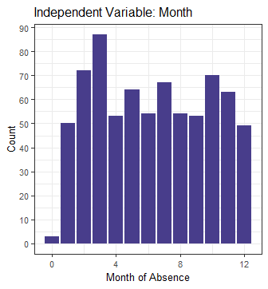

Fig.2.9

Observation:

* There is no clear-cut pattern in both “Day of the week” & “Month of Absence” variables.
* There is anomaly in the “Month of Absence” variable as ‘0’Th month is not a valid month.

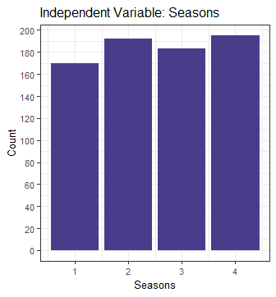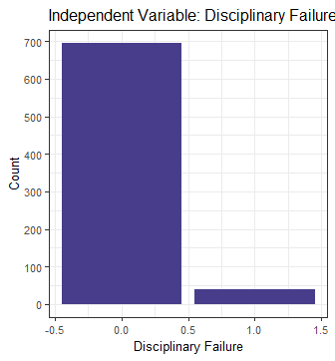

Fig.2.10

Observation:

* There is no clear-cut pattern in “Seasons” variable.
* There are very few absentees with disciplinary failure. This, in general, is a positive thing for the company, but this may or not be related to absenteeism issue. Let’s see further.

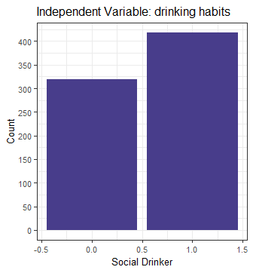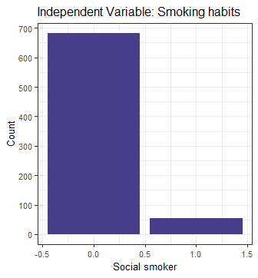

Fig.2.11

Observation:

* There is no clear-cut pattern in the “social drinker” variable.
* Most of the absentees are non-smokers.

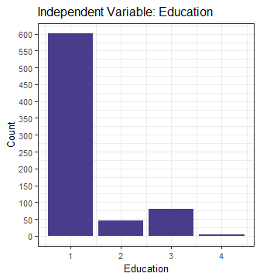

Observation:

* Most of the absentees are high school pass outs and very few amongst them have gone for higher studies.

Fig.2.12

2.1.2. Bivariate Analysis:

After looking features individually, let’s explore the independent variables with respect to the target variable using scatter plots to discover hidden relationships between the independent variable and the target variable and use those findings in missing data imputation and feature engineering.

A. Dependent target Variable Vs Independent Variables:

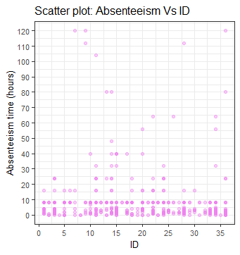 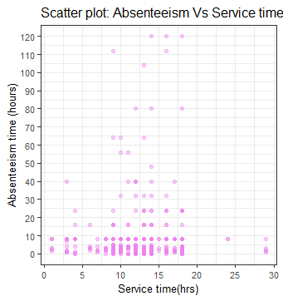

Fifig.2.13

Observation:

* “Absenteeism time in hours” target variable Vs “ID” can help the company to manage absentees who took a long period of leave at a time and to counsel or warn them, if needed.
* There are more & high absents observed in the mid-range of “Service time”.

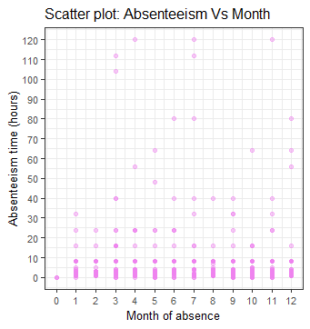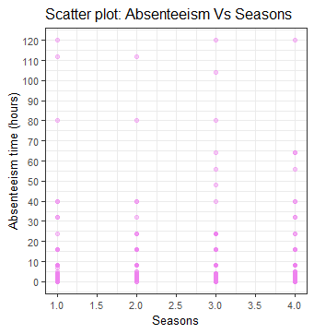

Observation:

* “Month of Absence” & “Seasons” are quite spread well across the entire range of the Absenteeism time without any obvious pattern.

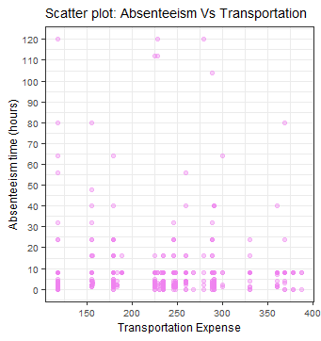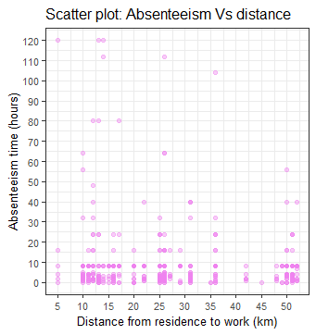

Observation:

* Intuitively, it is expected that the absenteeism will increase with the increase in “distance from work” and “transportation expense”, however, that is not the case for this company.

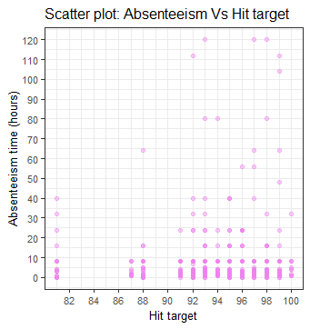 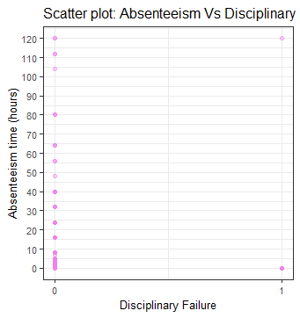

Observation:

* It can be noticed that absentees of this company have high hit targets, and therefore the employer might reconsider their individual targets for the future.
* Most of the absents are those having no disciplinary failure in their record.

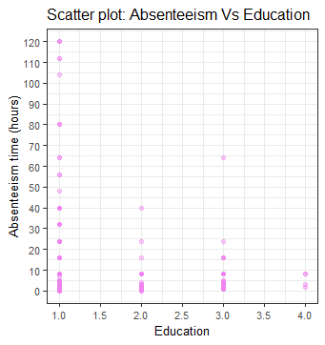 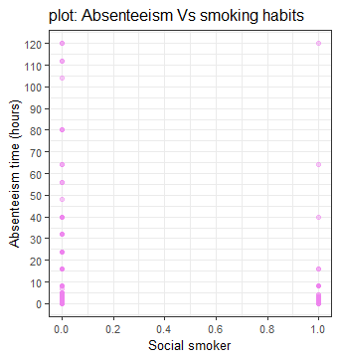

Observation:

* Most the absentees are high school graduates, whereas employees with higher education degrees tend to take less leaves in this company.
* There is a pattern in “social smoker” vs Absenteeism that non-smokers are more absent.

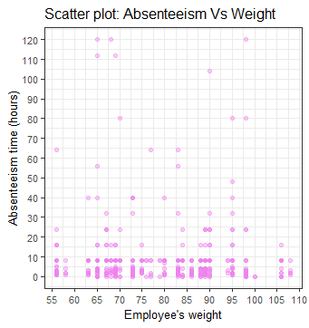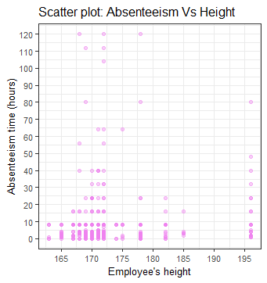

* There is no obvious pattern in “Weight” Vs Absenteeism time.
* We can see that more absentees are short to medium heighted. Heights above 190cm looks like outliers.

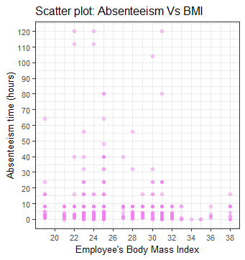 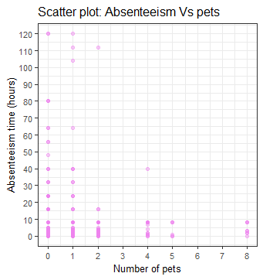

* ‘Body Mass Index” Vs “Absenteeism time” shows no such pattern except that most of the absentees have slightly obese BMI range.
* Most of the absentees have no or few pets at home.

B. Independent Variable Vs Independent Variable (Interdependencies):

Let’s explore the independent variables with respect to other independent variables using scatter plots to discover hidden relations or dependencies between them.

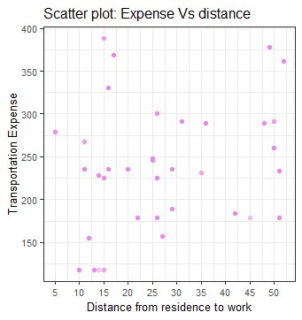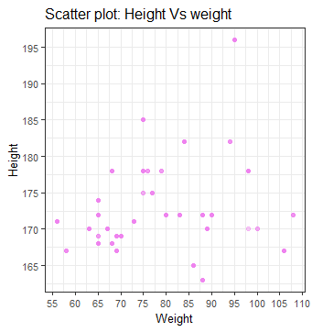

Observation:

* Intuitively, it is expected that Transportation expense will roughly increase with increasing distance, but that is not the case here. Probably, the employees have different modes of transport.
* ‘Height’ & ‘Weight’ do not seem correlated much.

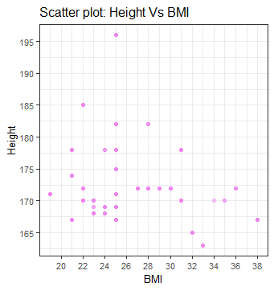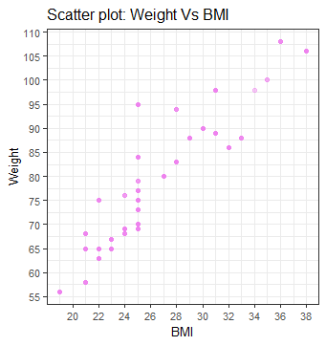

* Body Mass Index or BMI formula is proportional to body weight & inversely proportional to the square of height. There is a clear positive linear relationship between weight and BMI in this data and therefore they are redundant variables.
* On the other hand, it is hard to say anything about the pattern between height and BMI for this dataset.

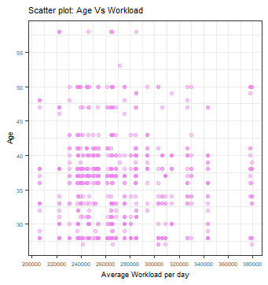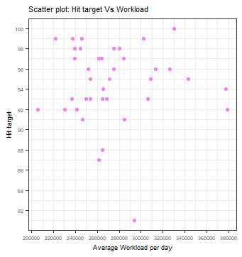

* Most absentees have a higher Hit Target, but low to medium Average workload per day comparatively.
* Comparatively, younger absentees with low-medium average workload/day are more.

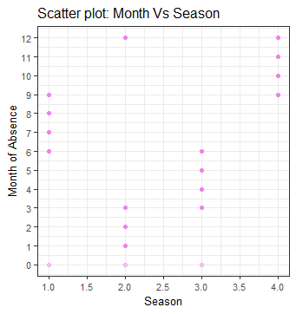

* The “Seasons” tend to stay for 4 months in a year, after which they disperse into a new season. This transition of season in a month is smoother and hence two seasons may overlap in a month. However, there is anomaly at 0th month where 3 seasons overlap. We need to fix this before data processing.

2.1.3. Fixing Data Anomalies:

Since all data are in numeric type, even the categorical ones, we do not need to convert it for data consolidation.

From the pre-processing and visualizing the variables, it has been found that two variables, i.e. “Reason of Absences” & “Month of Absence”, have invalid zero values in them, so we can treat them as missing values and them impute them further accordingly.

*zero_index = which(data$Reason.for.absence == 0)*

*for(i in zero_index){*

*data$Reason.for.absence[i]= NA*

*}*

*zero_index = which(data$Month.of.absence == 0)*

*for(i in zero_index){*

*data$Month.of.absence[i]= NA*

*}*

2.1.4. Missing Value Analysis:

Missing data can have a severe impact on building predictive models because the missing values might be contain some vital information, which could help in making better predictions. So, it becomes imperative to carry out missing data imputation.

The total missing values in the data are computed as follows:

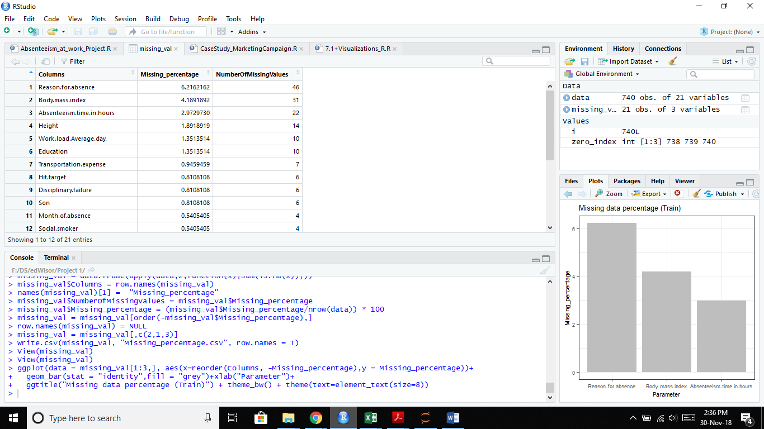

The highest missing value percentage is about 6%, which is less than 10% and therefore can be acceptably replaced with statistical approximations or using KNN imputation. To find the suitable method of imputation, a missing value is created and mean/median/KNN imputation methods applied to find the closest predicted value to the actual value.

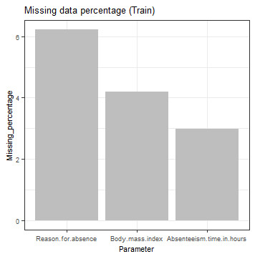

*##To test for the best method to find missing values for this dataset*

*data[6,6]=179*

*data[6,6]=NA*

*#By median method:*

*data$Transportation.expense[is.na(data$Transportation.expense)]=median(data$Transportation.expense, na.rm = T)*

*#data[6,6]=225 (median)*

*#By mean method:*

*#reupload data*

*data[6,6]=NA*

*data$Transportation.expense[is.na(data$Transportation.expense)]=mean(data$Transportation.expense, na.rm = T)*

*#data[6,6]=221.129 (mean)*

*#By KNN Imputation:*

*#reupload data*

*data[6,6]=NA*

*data=knnImputation(data, k=5)*

*#data[6,6]=179 (KNN) , which is the closest to 179 (actual value) and hence, we freeze this method.*

The missing data was successfully imputed in the features using KNN imputation.

2.1.5. Outlier Analysis:

By definition, outliers are points that are distant from remaining observations. As a result, they can potentially skew or bias any analysis performed on the dataset. It is therefore important to detect and adequately deal with outliers.

We draw box plots to check the distribution & outliers in the dataset.

Absenteeism time Box plots for Independent Variables (before Outlier removal):

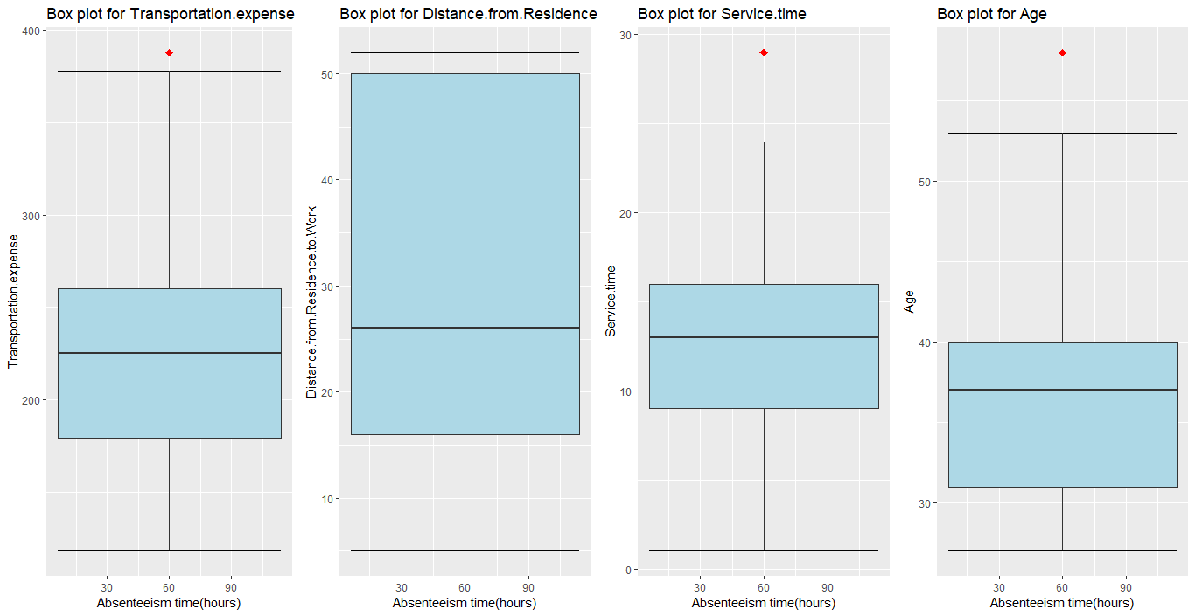

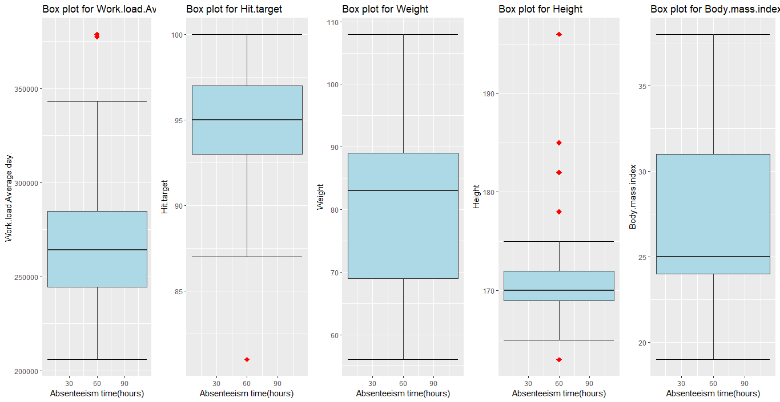

Outliers make sense only in numeric or continuous data for this dataset. The “Absenteeism time” variable consists of the labels to be used to train and test the predictive models and hence it should be left untouched by further manipulation by outlier analysis.

Box plots of the variables after Outlier removal:

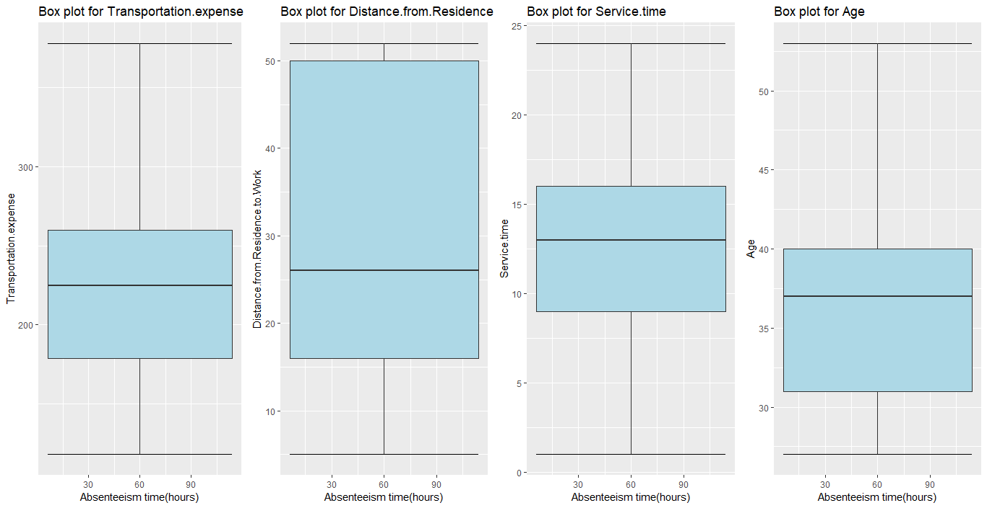

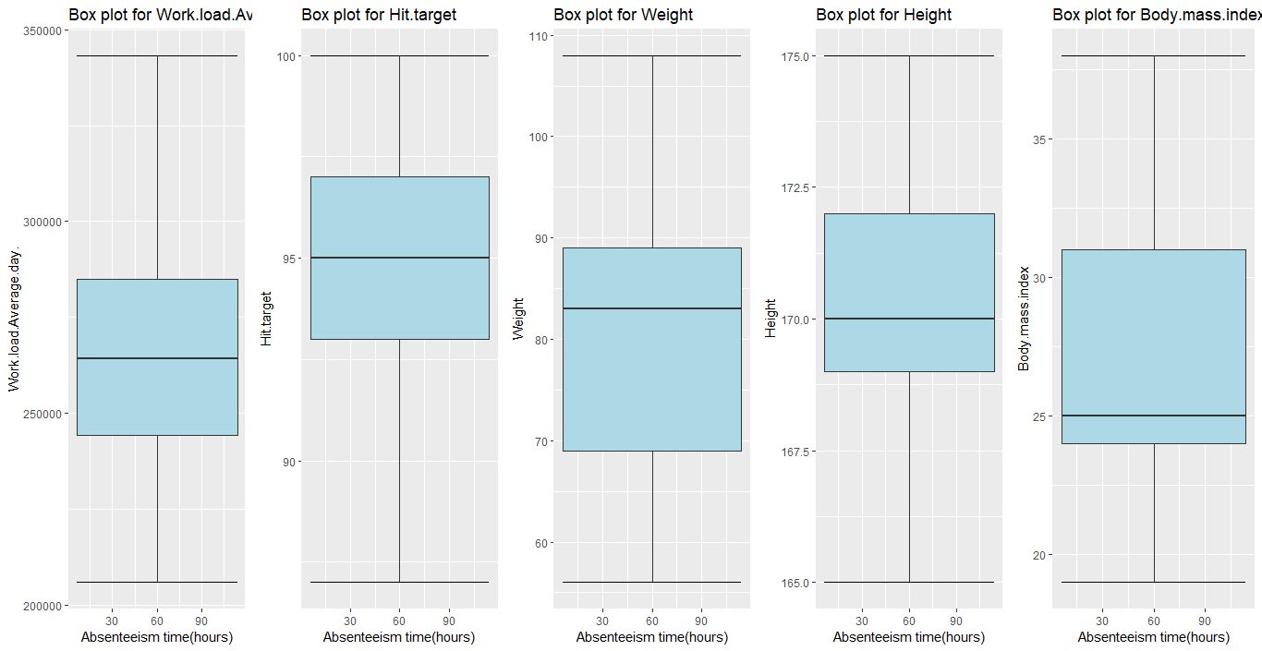

After performing outlier Analysis and removing outliers using Boxplot Method, Predictor vs Absenteeism boxplots is plotted again to compare the differences.

2.1.6. Feature Selection:

It is needed that we assess the importance of each predictor variable in our analysis, as there is a possibility that many variables in our analysis are not important at all to predict the ‘Absenteeism time’ values.

A. Using Correlation plots:

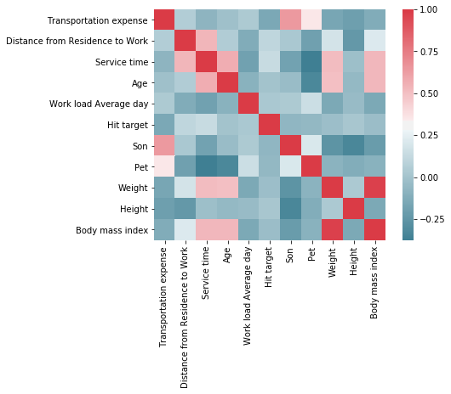

*corrgram(data, order = F, upper.panel=panel.pie, text.panel=panel.txt, main = "Correlation Plot", font.labels = 1)*

*mat = cor(data)*

*corrplot(as.matrix(mat),method= 'pie',type = "lower", tl.col = "black", tl.cex = 0.7)*

* If |r|>0.8 for two variables, those variables are considered redundant variables and one of them can be removed from the dataset.
* Output: "Weight" & "Body.Mass.Index" variables are highly positively correlated as expected after performing the pre-processing of the data.

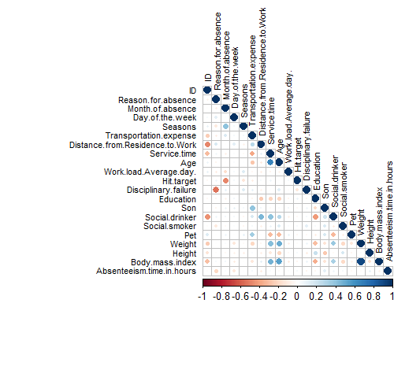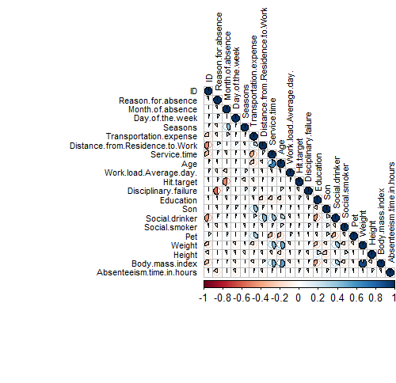

B. Using Chi-square test of Independence (relationship between categorical variables):

*n = c(1,2,3,4,5,12,13,15,16) #indices of the categorical variables*

*for(i in n){*

*print(names(data[i]))*

*print(chisq.test(table(data$Absenteeism.time.in.hours,data[,i])))*

*}*

* If p-value<0.05 (Reject Null Hypothesis) => Target variable depends on the independent variable.
* If p-value>0.05 (Do Not Reject Null Hypothesis) =>Target variable & independent variable are independent of each other.
* Output:

"ID": X-squared = 1577.1, df = 1330, p-value = 2.868e-06

"Reason.for.absence": X-squared = 6085.7, df = 2698, p-value < 2.2e-16

"Month.of.absence": X-squared = 576.12, df = 570, p-value = 0.4206

"Day.of.the.week": X-squared = 185.04, df = 152, p-value = 0.03512

"Seasons": X-squared = 178.62, df = 114, p-value = 0.000105

"Disciplinary.failure": X-squared = 615.77, df = 38, p-value < 2.2e-16

"Education": X-squared = 55.066, df = 114, p-value = 1

"Social.drinker": X-squared = 57.514, df = 38, p-value = 0.022

"Social.smoker": X-squared = 45.661, df = 38, p-value = 0.1837

* Target Variable "Absenteeism.time.in.hours" depends on all the categorical variables, except “month of absence”, "Education" & “Social.smoker” attributes.

C. Using Random Forest Algorithm:

*data.rf=randomForest(data$Absenteeism.time.in.hours~.,data = data, ntree=1000, keep.forest= F, importance= T)*

*importance(data.rf,type = 1)*

* Output:
* %IncMSE
* ID 10.6189921
* Reason.for.absence 13.9939070
* Month.of.absence 8.9653443
* Day.of.the.week 1.0176514
* Seasons 9.0015197
* Transportation.expense 4.4330720
* Distance.from.Residence.to.Work 5.8995292
* Service.time 9.8489478
* Age 11.7781713
* Work.load.Average.day. 2.2867752
* Hit.target 0.3832429
* Disciplinary.failure -0.8874999
* Education 3.0991756
* Son 8.3011303
* Social.drinker 5.3789409
* Social.smoker -1.2207280
* Pet 2.6435399
* Weight 7.2855691
* Height 14.4292822
* Body.mass.index 6.6481634
* "Hit Target", “Disciplinary.failure”, "Social Smoker" & "day of the week" have the least variable importance with 0-1% (approx.).

D. Dimensional Reduction:

We should remove those features that do not contribute to predicting the target variable as it will only lead to increase in the complexity of the model and incorrect prediction.

* From Correlation Plot --> We can drop "Weight" or "Body.Mass.Index" column. From RF variable importance output, we see that “weight” has higher importance, so we can drop “Body.Mass.Index” variable.
* From Chi square test & Random Forest --> We drop "Education" & “Social.smoker” variables.

2.1.7. Feature Scaling:

The dataset contains features that are highly varying in magnitudes, units and range. Feature Scaling (Normalization/Standardization) is a step of Data Pre-Processing, which is applied to independent variables or features of data. It helps to normalize the data within a particular range and sometimes helps in speeding up the calculations in distance-based algorithms.

Standardization works well if the data is normally distributed, otherwise we scale data by normalization method.

A. Normality Check:

* Q-Q Plot for continuous variables:

*qqnorm(data$Transportation.expense)*

*qqnorm(data$Height)*

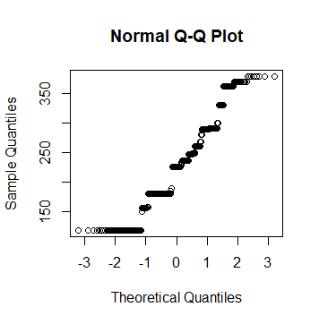 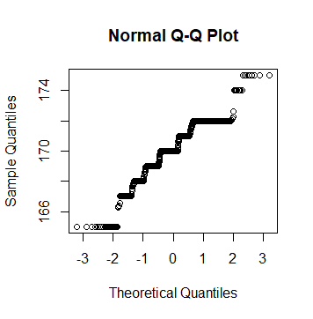

*qqnorm(data$Distance.from.residence.to.work)*

*qqnorm(data$Absenteeism.time.in.hours)*

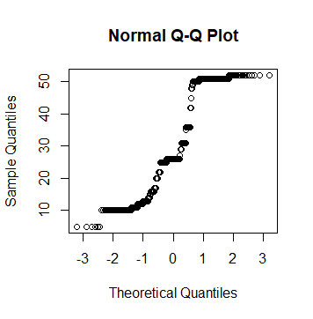 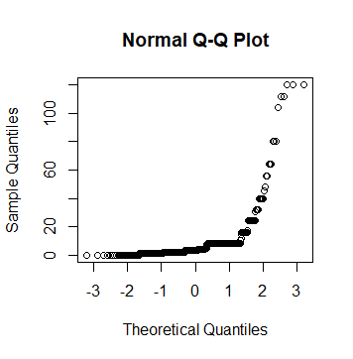

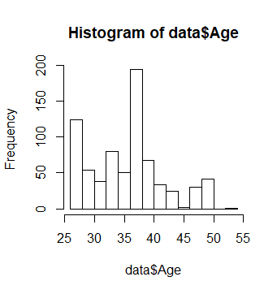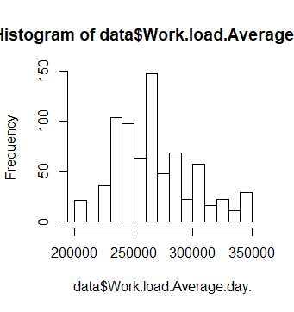

None of the continuous variables is normally distributed. So, we scale the data using Normalization method.

Normalization formula:

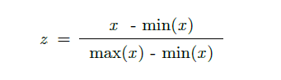

*#Only for continuous variables*

*for(i in OutCol){*

*print(i)*

*data[,i] = (data[,i] - min(data[,i]))/(max(data[,i]) - min(data[,i]))*

*}*

2.1.8. Data Sampling:

The whole dataset is divided into train and test split sets so that there is data from which the model can learn and there is a part of the data set using which we can do unbiased evaluation of the trained model.

Random sampling without replacement is used to split 80% of the data into training set and remaining 20% into test set.

*sample.index = sample(nrow(data), 0.8*nrow(data), replace = F)*

*train = data[sample.index,]*

*test = data[-sample.index,]*

2.2. Modeling

2.2.1. Model Selection:

The dataset of XYZ Company indicates that this is a supervised learning problem as there is the task of inferring a function or values from the labeled training data. Secondly, the dependent variable “Absenteeism time in hours” is of real valued or continuous type and therefore our prediction is of a quantity & it is a regression problem. Since we have many input variables, we shall perform a **multivariate regression analysis** on the given dataset.

2.2.2. Decision Tree Algorithm

*dt=rpart(Absenteeism.time.in.hours~.,data = train,method= "anova")*

*> summary(dt)*

*Call:*

*rpart(formula = Absenteeism.time.in.hours ~ ., data = train,*

*method = "anova")*

*n= 592*

*CP nsplit rel error xerror xstd*

*1 0.12020120 0 1.0000000 1.0064746 0.2705362*

*2 0.04928046 1 0.8797988 0.8915125 0.2404877*

*3 0.02205094 3 0.7812379 0.9141441 0.2155769*

*4 0.01065252 5 0.7371360 0.9371219 0.2190678*

*5 0.01054222 7 0.7158310 0.9627655 0.2255687*

*6 0.01000000 8 0.7052887 0.9626555 0.2255695*

*Variable importance*

*Reason.for.absence Age Son Transportation.expense*

*33 16 9 8*

*Distance.from.Residence.to.Work Height Weight Service.time*

*8 7 5 4*

*Work.load.Average.day Pet Social.drinker Hit.target*

*4 2 2 1*

*ID*

*1*

*Node number 1: 592 observations, complexity param=0.1202012*

*mean=6.991777, MSE=173.0504*

*left son=2 (378 obs) right son=3 (214 obs)*

*Primary splits:*

*Reason.for.absence < 19.10219 to the right, improve=0.12020120, (0 missing)*

*Son < 0.375 to the left, improve=0.03804571, (0 missing)*

*Height < 0.6174526 to the left, improve=0.02067571, (0 missing)*

*Distance.from.Residence.to.Work < 0.287234 to the right, improve=0.01763882, (0 missing)*

*Transportation.expense < 0.5980769 to the left, improve=0.01338666, (0 missing)*

*Surrogate splits:*

*Height < 0.7086694 to the left, agree=0.659, adj=0.056, (0 split)*

*Work.load.Average.day < 0.9519718 to the left, agree=0.655, adj=0.047, (0 split)*

*Transportation.expense < 0.9826923 to the left, agree=0.645, adj=0.019, (0 split)*

*Distance.from.Residence.to.Work < 0.05319149 to the right, agree=0.644, adj=0.014, (0 split)*

*Age < 0.8269231 to the left, agree=0.644, adj=0.014, (0 split)*

*Node number 2: 378 observations*

*mean=3.560138, MSE=9.371554*

*Node number 3: 214 observations, complexity param=0.04928046*

*mean=13.05327, MSE=404.6228*

*left son=6 (137 obs) right son=7 (77 obs)*

*Primary splits:*

*Son < 0.375 to the left, improve=0.04478752, (0 missing)*

*ID < 15.5 to the right, improve=0.02774764, (0 missing)*

*Service.time < 0.4565217 to the left, improve=0.02342015, (0 missing)*

*Distance.from.Residence.to.Work < 0.2021277 to the right, improve=0.02322409, (0 missing)*

*Social.drinker < 0.5 to the left, improve=0.01759270, (0 missing)*

*Surrogate splits:*

*Transportation.expense < 0.4961538 to the left, agree=0.748, adj=0.299, (0 split)*

*Height < 0.310058 to the right, agree=0.720, adj=0.221, (0 split)*

*Service.time < 0.4130435 to the left, agree=0.706, adj=0.182, (0 split)*

*Weight < 0.6442308 to the left, agree=0.696, adj=0.156, (0 split)*

*Reason.for.absence < 14.18197 to the left, agree=0.668, adj=0.078, (0 split)*

*Node number 6: 137 observations, complexity param=0.01065252*

*mean=9.861817, MSE=196.9078*

*left son=12 (101 obs) right son=13 (36 obs)*

*Primary splits:*

*Age < 0.4615385 to the left, improve=0.02954384, (0 missing)*

*Height < 0.5875101 to the left, improve=0.02574266, (0 missing)*

*Day.of.the.week < 4.5 to the right, improve=0.02398209, (0 missing)*

*Social.drinker < 0.5 to the left, improve=0.01599686, (0 missing)*

*Pet < 0.5853116 to the right, improve=0.01461495, (0 missing)*

*Surrogate splits:*

*Weight < 0.7211538 to the left, agree=0.847, adj=0.417, (0 split)*

*ID < 34.5 to the left, agree=0.825, adj=0.333, (0 split)*

*Height < 0.3980134 to the right, agree=0.788, adj=0.194, (0 split)*

*Service.time < 0.4347826 to the left, agree=0.774, adj=0.139, (0 split)*

*Node number 7: 77 observations, complexity param=0.04928046*

*mean=18.73158, MSE=723.8284*

*left son=14 (69 obs) right son=15 (8 obs)*

*Primary splits:*

*Age < 0.1757286 to the right, improve=0.11158270, (0 missing)*

*Day.of.the.week < 3.5 to the right, improve=0.08138058, (0 missing)*

*Distance.from.Residence.to.Work < 0.2021277 to the right, improve=0.08000780, (0 missing)*

*ID < 15 to the right, improve=0.05764600, (0 missing)*

*Work.load.Average.day < 0.2005483 to the right, improve=0.03857452, (0 missing)*

*Node number 12: 101 observations*

*mean=8.42184, MSE=102.3121*

*Node number 13: 36 observations, complexity param=0.01065252*

*mean=13.90175, MSE=440.163*

*left son=26 (23 obs) right son=27 (13 obs)*

*Primary splits:*

*Height < 0.5697937 to the left, improve=0.08744407, (0 missing)*

*Day.of.the.week < 4.5 to the right, improve=0.07850019, (0 missing)*

*Reason.for.absence < 13.11839 to the right, improve=0.06744882, (0 missing)*

*Social.drinker < 0.5 to the left, improve=0.04207122, (0 missing)*

*Work.load.Average.day < 0.244397 to the right, improve=0.03724410, (0 missing)*

*Surrogate splits:*

*Distance.from.Residence.to.Work < 0.4680851 to the left, agree=0.917, adj=0.769, (0 split)*

*Service.time < 0.6086957 to the right, agree=0.917, adj=0.769, (0 split)*

*Pet < 0.1234224 to the left, agree=0.917, adj=0.769, (0 split)*

*Transportation.expense < 0.575 to the left, agree=0.833, adj=0.538, (0 split)*

*Social.drinker < 0.5 to the right, agree=0.833, adj=0.538, (0 split)*

*Node number 14: 69 observations, complexity param=0.02205094*

*mean=15.67147, MSE=459.3171*

*left son=28 (54 obs) right son=29 (15 obs)*

*Primary splits:*

*Distance.from.Residence.to.Work < 0.1702128 to the right, improve=0.07076549, (0 missing)*

*Social.drinker < 0.5 to the left, improve=0.06729260, (0 missing)*

*Hit.target < 0.7307692 to the left, improve=0.06373516, (0 missing)*

*Seasons < 2.5 to the left, improve=0.05947428, (0 missing)*

*Reason.for.absence < 18.82234 to the left, improve=0.04594533, (0 missing)*

*Surrogate splits:*

*Transportation.expense < 0.1884615 to the right, agree=0.928, adj=0.667, (0 split)*

*Weight < 0.7403846 to the left, agree=0.928, adj=0.667, (0 split)*

*ID < 7.5 to the right, agree=0.797, adj=0.067, (0 split)*

*Node number 15: 8 observations*

*mean=45.125, MSE=2227.859*

*Node number 26: 23 observations*

*mean=9.237525, MSE=56.28467*

*Node number 27: 13 observations*

*mean=22.15385, MSE=1012.746*

*Node number 28: 54 observations, complexity param=0.02205094*

*mean=12.66667, MSE=313.4815*

*left son=56 (39 obs) right son=57 (15 obs)*

*Primary splits:*

*Reason.for.absence < 18.82234 to the left, improve=0.13441000, (0 missing)*

*Hit.target < 0.8846154 to the left, improve=0.07125832, (0 missing)*

*Day.of.the.week < 5.5 to the left, improve=0.06361566, (0 missing)*

*Month.of.absence < 5.5 to the right, improve=0.06091959, (0 missing)*

*Social.drinker < 0.5 to the left, improve=0.05751834, (0 missing)*

*Surrogate splits:*

*Hit.target < 0.8076923 to the left, agree=0.778, adj=0.2, (0 split)*

*Node number 29: 15 observations*

*mean=26.48875, MSE=834.8078*

*Node number 56: 39 observations, complexity param=0.01054222*

*mean=8.641026, MSE=70.94806*

*left son=112 (31 obs) right son=113 (8 obs)*

*Primary splits:*

*Work.load.Average.day < 0.8204879 to the left, improve=0.39032040, (0 missing)*

*Reason.for.absence < 13.5 to the right, improve=0.11775290, (0 missing)*

*ID < 21.5 to the right, improve=0.09704926, (0 missing)*

*Month.of.absence < 3.5 to the right, improve=0.08930142, (0 missing)*

*Transportation.expense < 0.6788462 to the right, improve=0.07056163, (0 missing)*

*Node number 57: 15 observations*

*mean=23.13333, MSE=792.3822*

*Node number 112: 31 observations*

*mean=5.967742, MSE=9.257024*

*Node number 113: 8 observations*

*mean=19, MSE=175*

Now, we predict for new test cases:

*predict.dt=predict(dt,test[,-18])*

2.2.3. Random Forest Algorithm

*rf = randomForest(Absenteeism.time.in.hours~., train, importance = TRUE, ntree = 500)*

*> summary(rf)*

*Length Class Mode*

*call 5 -none- call*

*type 1 -none- character*

*predicted 592 -none- numeric*

*mse 500 -none- numeric*

*rsq 500 -none- numeric*

*oob.times 592 -none- numeric*

*importance 34 -none- numeric*

*importanceSD 17 -none- numeric*

*localImportance 0 -none- NULL*

*proximity 0 -none- NULL*

*ntree 1 -none- numeric*

*mtry 1 -none- numeric*

*forest 11 -none- list*

*coefs 0 -none- NULL*

*y 592 -none- numeric*

*test 0 -none- NULL*

*inbag 0 -none- NULL*

*terms 3 terms call*

We predict for test set:

predict.rf <- data.frame(predict(rf, subset(test, select = -c(Absenteeism.time.in.hours))))

2.2.4. Multiple Linear Regression

Multicollinearity is when independent variables in a regression model are correlated. It tries to inflate or resist the variance of different strong regressors in the data. Therefore, we need to do a collinearity check before performing linear regression.

*> vif.data= vif(data[,-18])*

*> vifcor(data[,-18], th = 0.8)*

*No variable from the 17 input variables has collinearity problem.*

*The linear correlation coefficients ranges between:*

*min correlation ( Month.of.absence ~ ID ): -4.542897e-05*

*max correlation ( Age ~ Service.time ): 0.661807*

*---------- VIFs of the remained variables --------*

*Variables VIF*

*1 ID 2.509781*

*2 Reason.for.absence 1.102944*

*3 Month.of.absence 1.720037*

*4 Day.of.the.week 1.078431*

*5 Seasons 1.335310*

*6 Transportation.expense 2.458060*

*7 Distance.from.Residence.to.Work 1.841511*

*8 Service.time 3.445202*

*9 Age 3.134506*

*10 Work.load.Average.day 1.151894*

*11 Hit.target 1.355962*

*12 Disciplinary.failure 1.090212*

*13 Son 1.493890*

*14 Social.drinker 2.387001*

*15 Pet 1.689840*

*16 Weight 2.032082*

*17 Height 1.238693*

Now that multicollinearity is not an issue, we can build our regression model.

*lr = lm(Absenteeism.time.in.hours~., data = train)*

*> #summary of the model*

*> summary(lr)*

*Call:*

*lm(formula = Absenteeism.time.in.hours ~ ., data = train)*

*Residuals:*

*Min 1Q Median 3Q Max*

*-21.417 -4.351 -1.436 1.195 106.290*

*Coefficients:*

*Estimate Std. Error t value Pr(>|t|)*

*(Intercept) 14.82960 5.58499 2.655 0.008145 \*\**

*ID -0.05373 0.07170 -0.749 0.453955*

*Reason.for.absence -0.49346 0.07486 -6.592 9.86e-11 \*\*\**

*Month.of.absence 0.01028 0.19447 0.053 0.957861*

*Day.of.the.week -0.79728 0.36362 -2.193 0.028734 \**

*Seasons 0.27226 0.52728 0.516 0.605818*

*Transportation.expense 1.68389 3.10483 0.542 0.587791*

*Distance.from.Residence.to.Work -7.19587 2.16700 -3.321 0.000955 \*\*\**

*Service.time 8.01568 5.05313 1.586 0.113226*

*Age -4.91859 3.76004 -1.308 0.191356*

*Work.load.Average.day -1.47516 2.30282 -0.641 0.522045*

*Hit.target 3.67282 2.48753 1.476 0.140360*

*Disciplinary.failure -1.92652 2.39856 -0.803 0.422194*

*Son 6.74366 2.23318 3.020 0.002642 \*\**

*Social.drinker 3.67838 1.58240 2.325 0.020444 \**

*Pet -1.02093 1.82474 -0.559 0.576041*

*Weight -3.75747 2.86896 -1.310 0.190822*

*Height 5.97834 3.03563 1.969 0.049389 \**

*---*

*Signif. codes: 0 ‘***’ 0.001 ‘**’ 0.01 ‘*’ 0.05 ‘.’ 0.1 ‘ ’ 1*

*Residual standard error: 12.23 on 574 degrees of freedom*

*Multiple R-squared: 0.1621, Adjusted R-squared: 0.1373*

*F-statistic: 6.532 on 17 and 574 DF, p-value: 2.675e-14*

Then we predict for the test set:

*predict.lr=predict(lr, test[,-18])*

2.2.5. KNN Implementation

KNN is distance based non-parametric algorithm and it never stores patterns from the training data, but classifies for new test cases based on a similarity measure.

First, we need to check for the best no. of neighbors (k):

*#K=5:*

*> predict.knn = knn.reg(train = train[,-18],test = test[,-18],train$Absenteeism.time.in.hours, k= 5)*

*> regr.eval(test[,18], predict.knn$pred, stats = c("mae","mse","rmse","mape"))*

*mae mse rmse mape*

*6.712344 199.341057 14.118819 Inf*

*> #K=7:*

*> predict.knn = knn.reg(train = train[,-18],test = test[,-18],train$Absenteeism.time.in.hours, k= 7)*

*> regr.eval(test[,18], predict.knn$pred, stats = c("mae","mse","rmse","mape"))*

*mae mse rmse mape*

*6.418315 196.195775 14.006990 Inf*

*> #K=9:*

*> predict.knn = knn.reg(train = train[,-18],test = test[,-18],train$Absenteeism.time.in.hours, k= 9)*

*> regr.eval(test[,18], predict.knn$pred, stats = c("mae","mse","rmse","mape"))*

*mae mse rmse mape*

*6.167826 187.593597 13.696481 Inf*

*> #K=13:*

*> predict.knn = knn.reg(train = train[,-18],test = test[,-18],train$Absenteeism.time.in.hours, k= 13)*

*> regr.eval(test[,18], predict.knn$pred, stats = c("mae","mse","rmse","mape"))*

*mae mse rmse mape*

*6.039239 192.793157 13.884998 Inf*

*> #K=15:*

*> predict.knn = knn.reg(train = train[,-18],test = test[,-18],train$Absenteeism.time.in.hours, k= 15)*

*> regr.eval(test[,18], predict.knn$pred, stats = c("mae","mse","rmse","mape"))*

*mae mse rmse mape*

*6.081862 195.226633 13.972352 Inf*

*> #K=17:*

*> predict.knn = knn.reg(train = train[,-18],test = test[,-18],train$Absenteeism.time.in.hours, k= 17)*

*> regr.eval(test[,18], predict.knn$pred, stats = c("mae","mse","rmse","mape"))*

*mae mse rmse mape*

*5.944805 194.947266 13.962352 Inf*

*> #K=19:*

*> predict.knn = knn.reg(train = train[,-18],test = test[,-18],train$Absenteeism.time.in.hours, k= 19)*

*> regr.eval(test[,18], predict.knn$pred, stats = c("mae","mse","rmse","mape"))*

*mae mse rmse mape*

*5.853058 193.726139 13.918554 Inf*

*> #K=21:*

*> predict.knn = knn.reg(train = train[,-18],test = test[,-18],train$Absenteeism.time.in.hours, k= 21)*

*> regr.eval(test[,18], predict.knn$pred, stats = c("mae","mse","rmse","mape"))*

*mae mse rmse mape*

*5.855254 194.307576 13.939425 Inf*

Another way to check best k value:

*model <- train(Absenteeism.time.in.hours~., data = train, method = "knn",*

*+ trControl = trainControl("cv", number = 10),*

*+ tuneLength = 20)*

*> model$bestTune*

*k*

*18 39*

*> plot(model)*

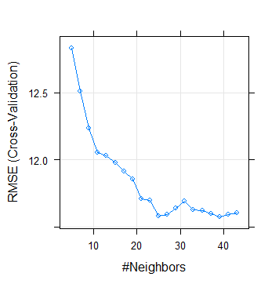

After checking both methods, it is best to choose k=19 as it gives us the least prediction error.

III. Conclusion

3.1 Model Evaluation:

Now that we have a few models for predicting the target variable, we need to decide which one to choose. Several criterias exist for evaluating and comparing models; here we can compare the models by using assessing the ‘Predictive Performance’ of the models. Predictive performance can be measured by comparing Predictions of the models with real values of the target variables, and calculating some average error measure like MAE, MSE, RMSE or MAPE.

*> #Error metric for Decision Tree:*

*> regr.eval(test[,18], predict.dt, stats = c("mae","mse","rmse","mape"))*

*mae mse rmse mape*

*5.753875 180.407076 13.431570 Inf*

*> #Output:*

*> #mae mse rmse mape*

*> #5.753875 180.407076 13.431570 Inf*

*> postResample(predict.dt,test[,18])*

*RMSE Rsquared MAE*

*13.4315701 0.1213995 5.7538750*

*> #Error metric for Random Forest:*

*> regr.eval(test[,18], predict.rf, stats = c("mae","mse","rmse","mape"))*

*mae mse rmse mape*

*5.295667 153.418298 12.386214 Inf*

*> #Output:*

*> #mae mse rmse mape*

*> #5.295667 153.418298 12.386214 Inf*

*> postResample(predict.rf,test[,18])*

*RMSE Rsquared MAE*

*12.3862140 0.2561696 5.2956666*

*> #Error metric for Multiple Linear Regression:*

*> regr.eval(test[,18], predict.lr, stats = c("mae","mse","rmse","mape"))*

*mae mse rmse mape*

*6.527533 188.009158 13.711643 Inf*

*> #Output:*

*> #mae mse rmse mape*

*> #6.527533 188.009158 13.711643 Inf*

*> postResample(predict.lr,test[,18])*

*RMSE Rsquared MAE*

*13.71164317 0.08126101 6.52753308*

*> #Error metric for KNN Implementation:*

*> regr.eval(test[,18], predict.knn$pred, stats = c("mae","mse","rmse","mape"))*

*mae mse rmse mape*

*5.853058 193.726139 13.918554 Inf*

*> #Output:*

*> #mae mse rmse mape*

*> #5.853058 193.726139 13.918554 Inf*

*> postResample(predict.knn$pred,test[,18])*

*RMSE Rsquared MAE*

*13.91855378 0.05935665 5.85305761*

MAPE (mean absolute percentage error) values come infinity because the denominator of the MAPE formula has actual values of the target variable which is ‘0 hours’ too and it is obvious that MAPE won’t work for this dataset. Therefore, we compare the predictive models using MAE, MSE and RMSE.

3.2 Final Model Selection:

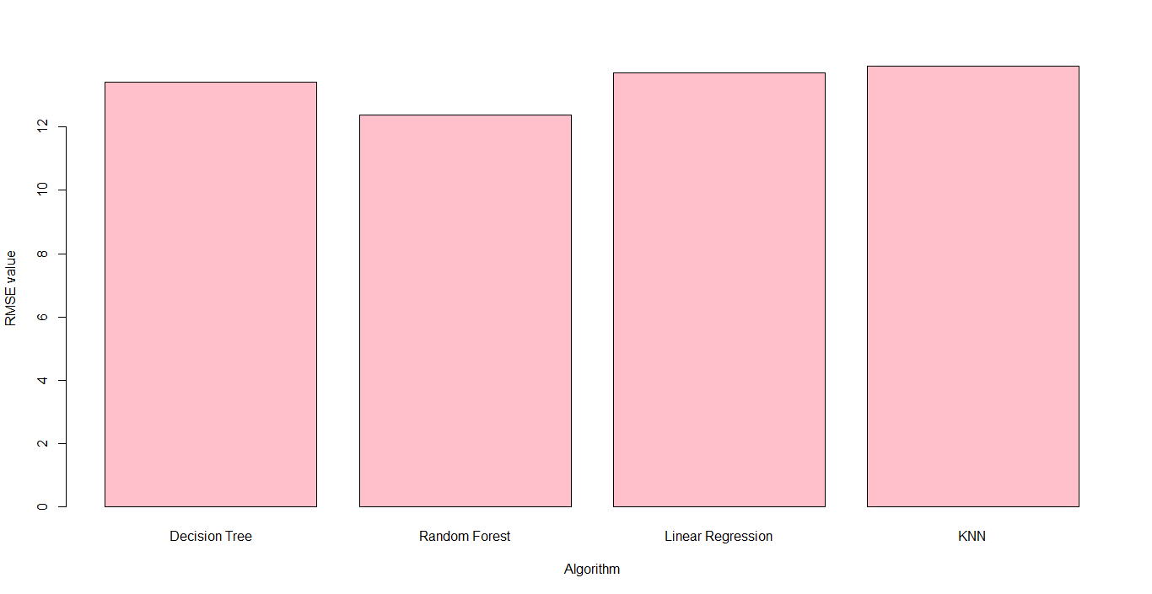

As we can observe that “Random Forest” algorithm produces the least error or RMSE (Root mean Square Error), we can freeze this algorithm as the model for analysis of new data or test cases of Absenteeism time of Company XYZ.

3.3 Solutions:

* A better model can be developed if there is more data available. More variables that are relevant can be added as the input variables and the dependent variable are less correlated and we can also see that R squared values are very low, i.e. the variance of target variable is not explained by the independent variables much.
* The employer can look into optimizing their employees’ targets as more absentees have higher hit targets.
* Employer can consider hiring highly educated employees as according to the data, they seem to take less leaves.
* The company can arrange regular health checkups near or in their company premises, the losses due absenteeism for doctor consultation can be reduced.
* Some absentees were spending more money for less distance from work; therefore, the company should provide a common mode of transport for all employees, if reasonable.

Appendix A: Extra plots

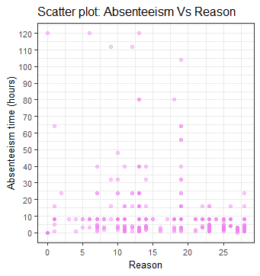 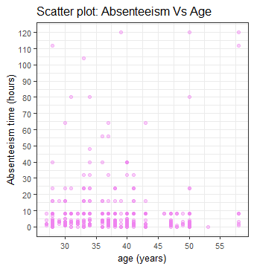 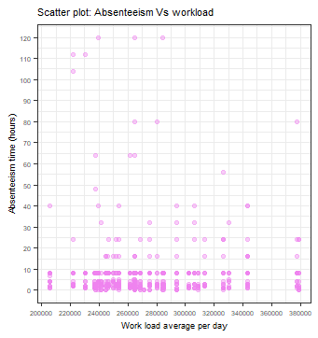 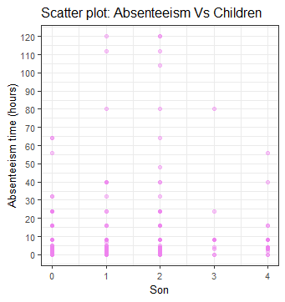

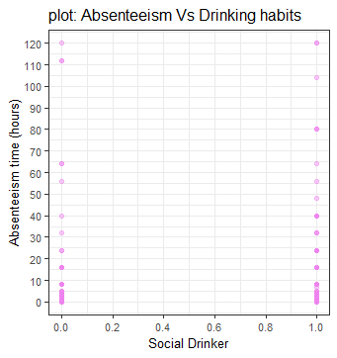 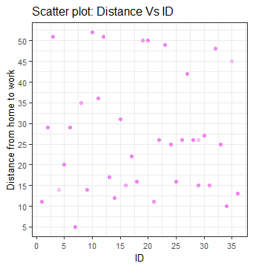

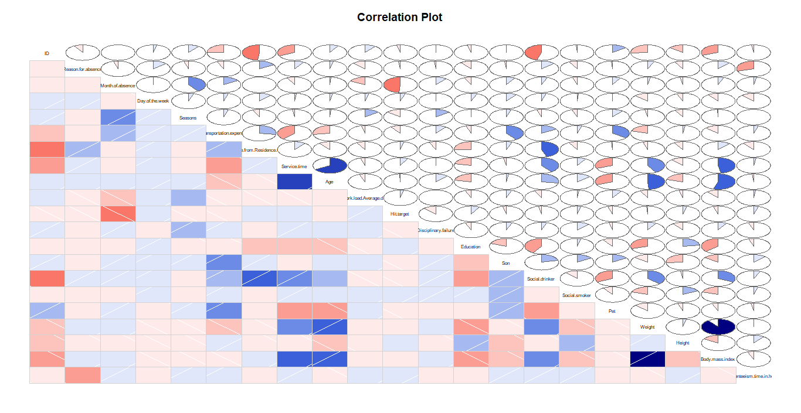

Appendix B: R code

#To clear the R environment of any predefined objects

rm(list=ls())

#To set working directory

setwd("F:/DS/edWisor/Project 1")

getwd()

#To load required libraries

library(xlsx)

library(dplyr) # used for data manipulation and joining

library(ggplot2) # used for ploting

library(caret) # used for modeling

library(corrgram)

library(corrplot) # used for making correlation plot

library(DMwR)

library(randomForest)

library(class)

library(FNN)

library(scales)

#To load the data

data = read.xlsx("Absenteeism_at_work_Project.xls",sheetIndex = 1, header = T)

data[data == " " | data == "" | data == "NA"] = NA

############Data Exploration#############

str(data)

dim(data)

#Data has 9 categorical variables & 12 numeric variables

#Target variable is continuous in nature

###Univariate Analysis

#Since all data are in numeric type, we don't need to convert it for data consolidation

#Histogram for Target variable (continuous variable)

ggplot(data, aes_string(x = data$Absenteeism.time.in.hours)) +

geom_histogram(fill="cornsilk", colour = "black") + geom_density() +

scale_y_continuous(breaks=pretty_breaks(n=10)) +

scale_x_continuous(breaks=pretty_breaks(n=10))+

theme_bw() + xlab("Absenteeism time (hours)") + ylab("Frequency") + ggtitle("Target Variable Histogram") +

theme(text=element_text(size=10))

#Histogram for Independent Continuous Variables

ggplot(data, aes_string(x = data$Transportation.expense)) +

geom_histogram(fill="blue", colour = "black") + geom_density() +

scale_y_continuous(breaks=pretty_breaks(n=10)) +

scale_x_continuous(breaks=pretty_breaks(n=10))+

theme_bw() + xlab("Transport cost") + ylab("Frequency") + ggtitle("IndependentVariable:Transportation Cost") +

theme(text=element_text(size=10))

ggplot(data, aes_string(x = data$Distance.from.Residence.to.Work)) +

geom_histogram(fill="blue", colour = "black") + geom_density() +

scale_y_continuous(breaks=pretty_breaks(n=10)) +

scale_x_continuous(breaks=pretty_breaks(n=10))+

theme_bw() + xlab("Distance from Residence to work (km)") + ylab("Frequency") + ggtitle("Independent Variable:Distance") +

theme(text=element_text(size=10))

ggplot(data, aes_string(x = data$Service.time)) +

geom_histogram(fill="blue", colour = "black") + geom_density() +

scale_y_continuous(breaks=pretty_breaks(n=10)) +

scale_x_continuous(breaks=pretty_breaks(n=10))+

theme_bw() + xlab("Service time (hours)") + ylab("Frequency") + ggtitle("Independent Variable: Service time") +

theme(text=element_text(size=10))

ggplot(data, aes_string(x = data$Age)) +

geom_histogram(fill="blue", colour = "black") + geom_density() +

scale_y_continuous(breaks=pretty_breaks(n=10)) +

scale_x_continuous(breaks=pretty_breaks(n=10))+

theme_bw() + xlab("Age (years)") + ylab("Frequency") + ggtitle("Independent Variable: Employee Age") +

theme(text=element_text(size=10))

ggplot(data, aes_string(x = data$Work.load.Average.day.)) +

geom_histogram(fill="blue", colour = "black") + geom_density() +

scale_y_continuous(breaks=pretty_breaks(n=10)) +

scale_x_continuous(breaks=pretty_breaks(n=10))+

theme_bw() + xlab("Average Work load per day") + ylab("Frequency") + ggtitle("Independent Variable: Work load") +

theme(text=element_text(size=7))

ggplot(data, aes_string(x = data$Hit.target)) +

geom_histogram(fill="blue", colour = "black") + geom_density() +

scale_y_continuous(breaks=pretty_breaks(n=10)) +

scale_x_continuous(breaks=pretty_breaks(n=10))+

theme_bw() + xlab("Hit target") + ylab("Frequency") + ggtitle("Independent Variable: Hit target") +

theme(text=element_text(size=10))

ggplot(data, aes_string(x = data$Son)) +

geom_histogram(fill="blue", colour = "black") + geom_density() +

scale_y_continuous(breaks=pretty_breaks(n=10)) +

scale_x_continuous(breaks=pretty_breaks(n=10))+

theme_bw() + xlab("Number of children") + ylab("Frequency") + ggtitle("Independent Variable:Employee's children") +

theme(text=element_text(size=10))

ggplot(data, aes_string(x = data$Weight)) +

geom_histogram(fill="blue", colour = "black") + geom_density() +

scale_y_continuous(breaks=pretty_breaks(n=10)) +

scale_x_continuous(breaks=pretty_breaks(n=10))+

theme_bw() + xlab("Weight (kg)") + ylab("Frequency") + ggtitle("Independent Variable:Employee's weight") +

theme(text=element_text(size=10))

ggplot(data, aes_string(x = data$Height)) +

geom_histogram(fill="blue", colour = "black") + geom_density() +

scale_y_continuous(breaks=pretty_breaks(n=10)) +

scale_x_continuous(breaks=pretty_breaks(n=10))+

theme_bw() + xlab("Height (cm)") + ylab("Frequency") + ggtitle("Independent Variable:Employee's height") +

theme(text=element_text(size=10))

ggplot(data, aes_string(x = data$Body.mass.index)) +

geom_histogram(fill="blue", colour = "black") + geom_density() +

scale_y_continuous(breaks=pretty_breaks(n=10)) +

scale_x_continuous(breaks=pretty_breaks(n=10))+

theme_bw() + xlab("Body Mass Index") + ylab("Frequency") + ggtitle("Independent Variable:Employee's BMI") +

theme(text=element_text(size=10))

ggplot(data, aes_string(x = data$Pet)) +

geom_histogram(fill="blue", colour = "black") + geom_density() +

scale_y_continuous(breaks=pretty_breaks(n=10)) +

scale_x_continuous(breaks=pretty_breaks(n=10))+

theme_bw() + xlab("Number of pets") + ylab("Frequency") + ggtitle("Independent Variable:Employee's pets") +

theme(text=element_text(size=10))

#Bar graph for Independent Categorical Variables

ggplot(data, aes_string(x = data$ID)) +

geom_bar(stat="count",fill = "DarkSlateBlue") + theme_bw() +

xlab("ID") + ylab('Count') + scale_y_continuous(breaks=pretty_breaks(n=10)) +

ggtitle("Independent Variable: Employee ID ") + theme(text=element_text(size=10))

ggplot(data, aes_string(x = data$Reason.for.absence)) +

geom_bar(stat="count",fill = "DarkSlateBlue") + theme_bw() +

xlab("Reason of Absence") + ylab('Count') + scale_y_continuous(breaks=pretty_breaks(n=10)) +

ggtitle("Independent Variable: Reason of Absence ") + theme(text=element_text(size=9))

ggplot(data, aes_string(x = data$Month.of.absence)) +

geom_bar(stat="count",fill = "DarkSlateBlue") + theme_bw() +

xlab("Month of Absence") + ylab('Count') + scale_y_continuous(breaks=pretty_breaks(n=10)) +

ggtitle("Independent Variable: Month ") + theme(text=element_text(size=10))

ggplot(data, aes_string(x = data$Day.of.the.week)) +

geom_bar(stat="count",fill = "DarkSlateBlue") + theme_bw() +

xlab("Day of the week") + ylab('Count') + scale_y_continuous(breaks=pretty_breaks(n=10)) +

ggtitle("Independent Variable: Day ") + theme(text=element_text(size=10))

ggplot(data, aes_string(x = data$Seasons)) +

geom_bar(stat="count",fill = "DarkSlateBlue") + theme_bw() +

xlab("Seasons") + ylab('Count') + scale_y_continuous(breaks=pretty_breaks(n=10)) +

ggtitle("Independent Variable: Seasons ") + theme(text=element_text(size=10))

ggplot(data, aes_string(x = data$Disciplinary.failure)) +

geom_bar(stat="count",fill = "DarkSlateBlue") + theme_bw() +

xlab("Disciplinary Failure") + ylab('Count') + scale_y_continuous(breaks=pretty_breaks(n=10)) +

ggtitle("Independent Variable: Disciplinary Failure ") + theme(text=element_text(size=10))

ggplot(data, aes_string(x = data$Social.drinker)) +

geom_bar(stat="count",fill = "DarkSlateBlue") + theme_bw() +

xlab("Social Drinker") + ylab('Count') + scale_y_continuous(breaks=pretty_breaks(n=10)) +

ggtitle("Independent Variable: drinking habits ") + theme(text=element_text(size=10))

ggplot(data, aes_string(x = data$Social.smoker)) +

geom_bar(stat="count",fill = "DarkSlateBlue") + theme_bw() +

xlab("Social smoker") + ylab('Count') + scale_y_continuous(breaks=pretty_breaks(n=10)) +

ggtitle("Independent Variable: Smoking habits ") + theme(text=element_text(size=10))

ggplot(data, aes_string(x = data$Education)) +

geom_bar(stat="count",fill = "DarkSlateBlue") + theme_bw() +

xlab("Education") + ylab('Count') + scale_y_continuous(breaks=pretty_breaks(n=10)) +

ggtitle("Independent Variable: Education ") + theme(text=element_text(size=10))

###Bivariate Analysis

##Target Variable Vs Independent Categorical Variables

length(unique(data$ID))

#1.Absenteeism time Vs ID

ggplot(data) +

geom_point(aes(data$ID, data$Absenteeism.time.in.hours),colour = "violet", alpha = 0.4) +

theme_bw()+ ylab("Absenteeism time (hours)") + xlab("ID") + ggtitle("Scatter plot: Absenteeism Vs ID") +

theme(text=element_text(size=10)) +

scale_x_continuous(breaks=pretty_breaks(n=10)) +

scale_y_continuous(breaks=pretty_breaks(n=10))

#2.Absenteeism time Vs Reason of Absence

ggplot(data) +

geom_point(aes(data$Reason.for.absence, data$Absenteeism.time.in.hours),colour = "violet", alpha = 0.4) +

theme_bw()+ ylab("Absenteeism time (hours)") + xlab("Reason") + ggtitle("Scatter plot: Absenteeism Vs Reason") +

theme(text=element_text(size=10)) +

scale_x_continuous(breaks=pretty_breaks(n=10)) +

scale_y_continuous(breaks=pretty_breaks(n=10))

#3.Absenteeism time Vs Month of Absence

ggplot(data) +

geom_point(aes(data$Month.of.absence, data$Absenteeism.time.in.hours),colour = "violet", alpha = 0.4) +

theme_bw()+ ylab("Absenteeism time (hours)") + xlab("Month of absence") + ggtitle("Scatter plot: Absenteeism Vs Month") +

theme(text=element_text(size=10)) +

scale_x_continuous(breaks=pretty_breaks(n=10)) +

scale_y_continuous(breaks=pretty_breaks(n=10))

#4.Absenteeism time Vs Month of Absence

ggplot(data) +

geom_point(aes(data$Seasons , data$Absenteeism.time.in.hours),colour = "violet", alpha = 0.4) +

theme_bw()+ ylab("Absenteeism time (hours)") + xlab("Seasons") + ggtitle("Scatter plot: Absenteeism Vs Seasons") +

theme(text=element_text(size=10)) +

scale_x_continuous(breaks=pretty_breaks(n=10)) +

scale_y_continuous(breaks=pretty_breaks(n=10))

#5.Absenteeism time Vs Transportation Expense

ggplot(data) +

geom_point(aes(data$Transportation.expense , data$Absenteeism.time.in.hours),colour = "violet", alpha = 0.4) +

theme_bw()+ ylab("Absenteeism time (hours)") + xlab("Transportation Expense") + ggtitle("Scatter plot: Absenteeism Vs Transportation") +

theme(text=element_text(size=9)) +

scale_x_continuous(breaks=pretty_breaks(n=10)) +

scale_y_continuous(breaks=pretty_breaks(n=10))

#6.Absenteeism time Vs Distance from residence to work

ggplot(data) +

geom_point(aes(data$Distance.from.Residence.to.Work , data$Absenteeism.time.in.hours),colour = "violet", alpha = 0.4) +

theme_bw()+ ylab("Absenteeism time (hours)") + xlab("Distance from residence to work (km)") + ggtitle("Scatter plot: Absenteeism Vs distance") +

theme(text=element_text(size=10)) +

scale_x_continuous(breaks=pretty_breaks(n=10)) +

scale_y_continuous(breaks=pretty_breaks(n=10))

#7.Absenteeism time Vs Service time

ggplot(data) +

geom_point(aes(data$Service.time , data$Absenteeism.time.in.hours),colour = "violet", alpha = 0.4) +

theme_bw()+ ylab("Absenteeism time (hours)") + xlab("Service time(hrs)") + ggtitle("Scatter plot: Absenteeism Vs Service time") +

theme(text=element_text(size=10)) +

scale_x_continuous(breaks=pretty_breaks(n=10)) +

scale_y_continuous(breaks=pretty_breaks(n=10))

#8.Absenteeism time Vs Age

ggplot(data) +

geom_point(aes(data$Age , data$Absenteeism.time.in.hours),colour = "violet", alpha = 0.4) +

theme_bw()+ ylab("Absenteeism time (hours)") + xlab("age (years)") + ggtitle("Scatter plot: Absenteeism Vs Age") +

theme(text=element_text(size=10)) +

scale_x_continuous(breaks=pretty_breaks(n=10)) +

scale_y_continuous(breaks=pretty_breaks(n=10))

#9.Absenteeism time Vs workload

ggplot(data) +

geom_point(aes(data$Work.load.Average.day. , data$Absenteeism.time.in.hours),colour = "violet", alpha = 0.4) +

theme_bw()+ ylab("Absenteeism time (hours)") + xlab("Work load average per day") + ggtitle("Scatter plot: Absenteeism Vs workload") +

theme(text=element_text(size=7)) +

scale_x_continuous(breaks=pretty_breaks(n=10)) +

scale_y_continuous(breaks=pretty_breaks(n=10))

#And so on. The graphs are plotted and recorded in the project report.

##########Fixing Data Anomalies##########

#Treating the 0's in 'Reason of absences' & 'Month of absence' as missing values

zero_index = which(data$Reason.for.absence == 0)

for(i in zero_index){

data$Reason.for.absence[i]= NA

}

zero_index = which(data$Month.of.absence == 0)

for(i in zero_index){

data$Month.of.absence[i]= NA

}

##################Missing Value Analysis##################

missing_val = data.frame(apply(data,2,function(x){sum(is.na(x))}))

missing_val$Columns = row.names(missing_val)

names(missing_val)[1] = "Missing_percentage"

missing_val$NumberOfMissingValues = missing_val$Missing_percentage

missing_val$Missing_percentage = (missing_val$Missing_percentage/nrow(data)) * 100

missing_val = missing_val[order(-missing_val$Missing_percentage),]

row.names(missing_val) = NULL

missing_val = missing_val[,c(2,1,3)]

write.csv(missing_val, "Missing_percentage.csv", row.names = T)

ggplot(data = missing_val[1:3,], aes(x=reorder(Columns, -Missing_percentage),y = Missing_percentage))+

geom_bar(stat = "identity",fill = "grey")+xlab("Parameter")+

ggtitle("Missing data percentage (Train)") + theme_bw() + theme(text=element_text(size=8))

##To test for the best method to find missing values for this dataset

#data[6,6]=179 (actual)

data[6,6]=NA

#By median method:

data$Transportation.expense[is.na(data$Transportation.expense)]=median(data$Transportation.expense, na.rm = T)

data[6,6]

#data[6,6]= 225 (median)

#reupload data again

rm(list = ls())

data = read.xlsx("Absenteeism_at_work_Project.xls",sheetIndex = 1, header = T)

data[data == " " | data == "" | data == "NA"] = NA

zero_index = which(data$Reason.for.absence == 0)

for(i in zero_index){

data$Reason.for.absence[i]= NA

}

zero_index = which(data$Month.of.absence == 0)

for(i in zero_index){

data$Month.of.absence[i]= NA

}

#By mean method:

data[6,6]=NA

data$Transportation.expense[is.na(data$Transportation.expense)]=mean(data$Transportation.expense, na.rm = T)

data[6,6]

#data[6,6]= 221.0929 (mean)

#reupload data again

rm(list = ls())

data = read.xlsx("Absenteeism_at_work_Project.xls",sheetIndex = 1, header = T)

data[data == " " | data == "" | data == "NA"] = NA

zero_index = which(data$Reason.for.absence == 0)

for(i in zero_index){

data$Reason.for.absence[i]= NA

}

zero_index = which(data$Month.of.absence == 0)

for(i in zero_index){

data$Month.of.absence[i]= NA

}

#By KNN Imputation:

data[6,6]=NA

data=knnImputation(data, k=5)

data[6,6]

#data[6,6]= 179 (KNN), which is the closest to 179 and hence, we freeze this method.

#reload the data & replace the missing values

rm(list = ls())

data = read.xlsx("Absenteeism_at_work_Project.xls",sheetIndex = 1, header = T)

data[data == " " | data == "" | data == "NA"] = NA

zero_index = which(data$Reason.for.absence == 0)

for(i in zero_index){

data$Reason.for.absence[i]= NA

}

zero_index = which(data$Month.of.absence == 0)

for(i in zero_index){

data$Month.of.absence[i]= NA

}

data = knnImputation(data, k=5) #KNN

sum(is.na(data)) #To verify

write.csv(data, 'data_Missing.csv', row.names = F)

####################Outlier Analysis########################

####Box Plot distribution & outlier check####

#str(data)

#since all the variables are numeric data type, we don't need to change data type here

cnames = colnames(data)

for(i in 1:length(cnames)){

assign(paste0("gn",i), ggplot(aes_string(y = (cnames[i]), x = data$Absenteeism.time.in.hours), data = subset(data))+

stat_boxplot(geom = "errorbar", width = 0.5) +

geom_boxplot(outlier.colour="red", fill = "light blue",outlier.shape=18,outlier.size=3, notch=FALSE) +

theme(legend.position="bottom")+

labs(y=cnames[i],x="Absenteeism time(hours)")+

ggtitle(paste("Box plot for",cnames[i])))

}

#Plotting plots together

gridExtra::grid.arrange(gn2,gn3,gn4,gn5,ncol=4)

gridExtra::grid.arrange(gn6,gn7,gn8,gn9,ncol=4)

gridExtra::grid.arrange(gn10,gn11,gn18,gn19, gn20,ncol=5)

#Replace all outliers with NA and impute using KNN:

#for(i in cnames){

# val = data[,i][data[,i] %in% boxplot.stats(data[,i])$out]

# print(length(val))

# data[,i][data[,i] %in% val] = NA

#}

#sum(is.na(data)) #To verify

#No. of NAs(outliers in whole dataset)= 501, which is high.

OutCol = colnames(data)

#We don't want some categorical columns to manipulated for outliers, like ID (Employee's ID is unique and can't be an outlier).

#also, Target variable shouldn't be manipulated much.

OutCol = OutCol[c(-1,-2,-3,-4,-5,-12,-13,-15,-16,-21)] #OutCol contains only continuous variables now

for(i in OutCol){

val = data[,i][data[,i] %in% boxplot.stats(data[,i])$out]

print(length(val))

data[,i][data[,i] %in% val] = NA

}

sum(is.na(data)) #To verify

#No. of NAs(outliers in numeric variables)= 231 (without categorical variables)

#highest no. of outliers found in "height" column, i.e. 119 NA in that column now

#119/740*100 = 16% > 10%, the part of the data to be manipulated.

#We fill in the NAs using KNN imputation.

data = knnImputation(data, k=5)

sum(is.na(data)) #to verify

write.csv(data, 'data_without Outliers.csv', row.names = F)

############################Feature Selection############################

#Correlation Plot

corrgram(data, order = F,

upper.panel=panel.pie, text.panel=panel.txt, main = "Correlation Plot", font.labels = 1)

mat = cor(data)

corrplot(as.matrix(mat),method= 'pie',type = "lower", tl.col = "black", tl.cex = 0.7)

#If |r|>0.8, those two variables are redundant variables.

#Output: "Weight"&"Body.Mass.Index" are highly positively correlated.

#Chi-square Test of Independence

n = c(1,2,3,4,5,12,13,15,16) #indices of the categorical variables

for(i in n){

print(names(data[i]))

print(chisq.test(table(data$Absenteeism.time.in.hours,data[,i])))

}

#If p-value<0.05 (Reject Null Hypothesis) => Target variable depends on the independent variable.

#If p-value>0.05 (Do Not Reject Null Hypothesis) =>Target variable & independent variable are independent of each other.

#Using Random Forest Algorithm:

data.rf=randomForest(data$Absenteeism.time.in.hours~.,data = data, ntree=1000, keep.forest= F, importance= T)

importance(data.rf,type = 1)

###################Dimensional Reduction######################

#From Correlation Plot --> We can drop "Weight" or "Body.Mass.Index" column.

#From Chi square test --> We drop "Education" & "Social.smoker"

data= subset(data, select= -c(Body.mass.index,Education,Social.smoker))

if("Body.mass.index" %in% OutCol) OutCol = OutCol[ - which(OutCol == "Body.mass.index")]

if("Education" %in% OutCol) OutCol = OutCol[ - which(OutCol == "Education")]

if("Social.smoker" %in% OutCol) OutCol = OutCol[ - which(OutCol == "Social.smoker")]

################################Feature Scaling##################################

#Only for continuous variables

#Normality check

qqnorm(data$Absenteeism.time.in.hours)

qqnorm(data$Transportation.expense)

qqnorm(data$Distance.from.Residence.to.Work)

qqnorm(data$Service.time)

qqnorm(data$Height)

qqnorm(data$Weight)

#None of the continuous variables have a normal distribution.

hist(data$Age)

hist(data$Work.load.Average.day.)

#We go for "Normalization", instead of standardization

data1 = data

for(i in OutCol){

print(i)

data[,i] = (data[,i] - min(data[,i]))/(max(data[,i]) - min(data[,i]))

}

##############################Sampling#################################

set.seed(1234)

sample.index = sample(nrow(data), 0.8*nrow(data), replace = F) #80% data -->Train set, 20%--> Test set

##################################Model Development###################################

rm(list= ls()[!(ls() %in% c('data','sample.index','data1'))])

train = data[sample.index,]

test = data[-sample.index,]

dim(train)

dim(test)

######1.Decision Tree######

library(rpart)

dt=rpart(Absenteeism.time.in.hours~.,data = train,method= "anova")

summary(dt)

#Predict for new test cases

predict.dt=predict(dt,test[,-18])

#Error metric:

regr.eval(test[,18], predict.dt, stats = c("mae","mse","rmse","mape"))

#Output:

#mae mse rmse mape

#5.753875 180.407076 13.431570 Inf

postResample(predict.dt,test[,18])

#RMSE Rsquared MAE

#13.4315701 0.1213995 5.7538750

#MAPE is Inf as some actual values of target variable is 0 hours.

#MAPE is not usually used as a measure in case of time-series Analysis.

rms.dt = RMSE(predict.dt, test[,18], na.rm = F)

#######2.Random Forest Algorithm#######

rf = randomForest(Absenteeism.time.in.hours~., train, importance = TRUE, ntree = 500)

summary(rf)

#Predict for test case:

predict.rf <- data.frame(predict(rf, subset(test, select = -c(Absenteeism.time.in.hours))))

#Error metric:

regr.eval(test[,18], predict.rf, stats = c("mae","mse","rmse","mape"))

#Output:

#mae mse rmse mape

#5.295667 153.418298 12.386214 Inf

postResample(predict.rf,test[,18])

#RMSE Rsquared MAE

#12.3862140 0.2561696 5.2956666

#MAPE is Inf as some actual values of target variable is 0 hours.

#Errors did decrease.

rms.rf = RMSE(predict.rf, test[,18], na.rm = F)

########3.Multiple Linear Regression########

#Check Multicollinearity

library(usdm)

vif.data= vif(data[,-18])

vifcor(data[,-18], th = 0.8)

#Output:

#No variable from the 17 input variables has collinearity problem.

#To run regression model

lr = lm(Absenteeism.time.in.hours~., data = train)

#summary of the model

summary(lr)

#Predict for test case:

predict.lr=predict(lr, test[,-18])

#Error metric:

regr.eval(test[,18], predict.lr, stats = c("mae","mse","rmse","mape"))

#Output:

#mae mse rmse mape

#6.527533 188.009158 13.711643 Inf

postResample(predict.lr,test[,18])

#RMSE Rsquared MAE

#13.71164317 0.08126101 6.52753308

#Random Forest Algorithm got better result than Linear Regression.

rms.lr = RMSE(predict.lr, test[,18], na.rm = F)

##############4.KNN Implementation##############

#Predict for test data:

#K=5:

#predict.knn = knn.reg(train = train[,-18],test = test[,-18],train$Absenteeism.time.in.hours, k= 5)

#regr.eval(test[,18], predict.knn$pred, stats = c("mae","mse","rmse","mape"))

#Output:

#mae mse rmse mape

#6.712344 199.341057 14.118819 Inf

#K=7:

#predict.knn = knn.reg(train = train[,-18],test = test[,-18],train$Absenteeism.time.in.hours, k= 7)

#regr.eval(test[,18], predict.knn$pred, stats = c("mae","mse","rmse","mape"))

#Output:

#mae mse rmse mape

#6.418315 196.195775 14.006990 Inf

#K=9:

#predict.knn = knn.reg(train = train[,-18],test = test[,-18],train$Absenteeism.time.in.hours, k= 9)

#regr.eval(test[,18], predict.knn$pred, stats = c("mae","mse","rmse","mape"))

#Output:

#mae mse rmse mape

#6.167826 187.593597 13.696481 Inf

#K=11:

#predict.knn = knn.reg(train = train[,-18],test = test[,-18],train$Absenteeism.time.in.hours, k= 11)

#regr.eval(test[,18], predict.knn$pred, stats = c("mae","mse","rmse","mape"))

#Output:

#mae mse rmse mape

#6.136897 192.691006 13.881319 Inf

#K=13:

#predict.knn = knn.reg(train = train[,-18],test = test[,-18],train$Absenteeism.time.in.hours, k= 13)

#regr.eval(test[,18], predict.knn$pred, stats = c("mae","mse","rmse","mape"))

#Output:

#mae mse rmse mape

#6.039239 192.793157 13.884998 Inf

#K=15:

#predict.knn = knn.reg(train = train[,-18],test = test[,-18],train$Absenteeism.time.in.hours, k= 15)

#regr.eval(test[,18], predict.knn$pred, stats = c("mae","mse","rmse","mape"))

#Output:

#mae mse rmse mape

#6.081862 195.226633 13.972352 Inf

#K=17:

#predict.knn = knn.reg(train = train[,-18],test = test[,-18],train$Absenteeism.time.in.hours, k= 17)

#regr.eval(test[,18], predict.knn$pred, stats = c("mae","mse","rmse","mape"))

#Output:

#mae mse rmse mape

#5.944805 194.947266 13.962352 Inf

#K=19:

predict.knn = knn.reg(train = train[,-18],test = test[,-18],train$Absenteeism.time.in.hours, k= 19)

print(predict.knn)

#Error metric:

regr.eval(test[,18], predict.knn$pred, stats = c("mae","mse","rmse","mape"))

#Output:

#mae mse rmse mape

#5.853058 193.726139 13.918554 Inf

postResample(predict.knn$pred,test[,18])

#RMSE Rsquared MAE

#13.91855378 0.05935665 5.85305761

#K=21:

#predict.knn = knn.reg(train = train[,-18],test = test[,-18],train$Absenteeism.time.in.hours, k= 21)

#regr.eval(test[,18], predict.knn$pred, stats = c("mae","mse","rmse","mape"))

#mae mse rmse mape

#5.855254 194.307576 13.939425 Inf

#To check for best k value:

model <- train(Absenteeism.time.in.hours~., data = train, method = "knn",

trControl = trainControl("cv", number = 10),

tuneLength = 20)

model$bestTune

plot(model)

rms.knn = RMSE(predict.knn$pred, test[,18], na.rm = F)

#A new dataframe to store results

algorithm <- c('Decision Tree','Random Forest','Linear Regression','KNN')

RMSE_val <- c(rms.dt,rms.rf,rms.lr,rms.knn)

results <- data.frame(algorithm, RMSE_val)

print(results)

barplot(results$RMSE_val, width = 1, names.arg = results$algorithm,

ylab="RMSE value", xlab = "Algorithm",col='pink')

Appendix C: Python code

#Set working directory

import os

os.chdir("F:/DS/edWisor/Project 1")

os.getcwd()

Load libraries

import pandas as pd

import matplotlib.pyplot as plt

import numpy as np

import seaborn as sns

from sklearn.model_selection import train_test_split

from random import randrange, uniform

from scipy.stats import chi2_contingency

from fancyimpute import KNN

from ggplot import *

#Load the data

data = pd.read_excel("Absenteeism_at_work_Project.xls")

data.shape

data.head(10)

Data Exploration

#Histogram for Target Variable

ggplot(data, aes(x = 'Absenteeism time in hours')) + geom_histogram(fill="DarkSlateBlue", colour = "black") +\

geom_density() +\

theme_bw() + xlab("Absenteeism time (hours)") + ylab("Frequency") + ggtitle("Target Variable Analysis") +\

theme(text=element_text(size=20))

#fixing data anomalies

data['Reason for absence'] = data['Reason for absence'].replace(0.0,np.nan)

data['Month of absence'] = data['Month of absence'].replace(0.0,np.nan)

Missing Value Analysis

#create dataframe with missing percentage

missing_val=pd.DataFrame(data.isnull().sum())

missing_val=missing_val.reset_index()

missing_val=missing_val.rename(columns={'index':'variables',0: 'Missing %'})

missing_val['Missing %']=(missing_val['Missing %']/len(data))*100

missing_val=missing_val.sort_values('Missing %',ascending=False).reset_index(drop=True)

missing_val.to_csv('Missing_%.csv',index=False)

missing_val

#imputation method

data['Height'].loc[129]

#Actual value = 171

#create missing value

data['Height'].loc[129]=np.nan

#impute with mean

data['Height'] = data['Height'].fillna(data['Height'].mean())

data['Height'].loc[129]

#mean value = 172.154

#reload data

data = pd.read_excel("Absenteeism_at_work_Project.xls")

data['Reason for absence'] = data['Reason for absence'].replace(0.0,np.nan)

data['Month of absence'] = data['Month of absence'].replace(0.0,np.nan)

#impute with median

data['Height'].loc[129]=np.nan

data['Height'] = data['Height'].fillna(data['Height'].median())

data['Height'].loc[129]

#median value = 170.0

#reload data

data = pd.read_excel("Absenteeism_at_work_Project.xls")

data['Reason for absence'] = data['Reason for absence'].replace(0.0,np.nan)

data['Month of absence'] = data['Month of absence'].replace(0.0,np.nan)

#impute with KNN

#since we have all data in numeric, we can apply KNN.

data.dtypes

data['Height'].loc[129]=np.nan

data = pd.DataFrame(KNN(21).fit_transform(data),columns=data.columns)

#KNN value = 170.73 , closest to 171. so we freeze this method.

#to verify

pd.DataFrame(data.isnull().sum())

Outlier Analysis

#Plot boxplot to visualize Outliers

%matplotlib inline

plt.boxplot(data['Absenteeism time in hours'])

#save numeric names

cnames = ["Transportation expense", "Distance from Residence to Work", "Service time", "Age", "Work load Average day", "Hit target","Son", "Pet", "Weight", "Height", "Body mass index"]

#Detect and delete outliers from data

for i in cnames:

print(i)

q75, q25 = np.percentile(data.loc[:,i], [75 ,25])

iqr = q75 - q25

min = q25 - (iqr*1.5)

max = q75 + (iqr*1.5)

print(min)

print(max)

#Replace with NA

data.loc[data[i] < min,:i] = np.nan

data.loc[data[i] > max,:i] = np.nan

#Calculate missing value

pd.DataFrame(data.isnull().sum())

#Impute with KNN

data = pd.DataFrame(KNN(21).fit_transform(data), columns = data.columns)

Feature Selection

##Correlation analysis

#Correlation plot

df_corr = data.loc[:,cnames]

#Set the width and height of the plot

f, ax = plt.subplots(figsize=(7, 5))

#Generate correlation matrix

corr = df_corr.corr()

#Plot using seaborn library

sns.heatmap(corr, mask=np.zeros_like(corr, dtype=np.bool), cmap=sns.diverging_palette(220, 10, as_cmap=True),

square=True, ax=ax)

#Chisquare test of independence

#Save categorical variables

cat_names = ['ID', 'Reason for absence', 'Month of absence', 'Day of the week',

'Seasons','Disciplinary failure', 'Education','Social drinker',

'Social smoker']

#loop for chi square values

for i in cat_names:

print(i)

chi2, p, dof, ex = chi2_contingency(pd.crosstab(data['Absenteeism time in hours'], data[i]))

print(p)

data = data.drop(['Body mass index'], axis=1)

Feature Scaling

#Normality check

%matplotlib inline

plt.hist(data['Height'], bins='auto')

cnames = ["Transportation expense", "Distance from Residence to Work", "Service time", "Age", "Work load Average day",

"Hit target","Son", "Pet", "Weight", "Height"]

#Nomalisation

for i in cnames:

print(i)

data[i] = (data[i] - data[i].min())/(data[i].max() - data[i].min())

Model Development

#Data Sampling

nrow= len(data.index)

train, test = train_test_split(data, test_size = 0.2)

train.shape

test.shape

#####Decision Tree Algortithm

from sklearn.tree import DecisionTreeRegressor

fit_dt= DecisionTreeRegressor(max_depth=2).fit(train.iloc[:,0:19],train.iloc[:,19])

fit_dt

predict_dt= fit_dt.predict(test.iloc[:,0:19])

#Calculate RMSE

def RMSE(actual, pred):

return np.sqrt(((pred - actual) ** 2).mean())

RMSE(test.iloc[:,19],predict_dt)

#output = 13.009041545395686

######Random Forest Algorithm

from sklearn.ensemble import RandomForestRegressor

fit_rf = RandomForestRegressor(n_estimators = 100, random_state = 99).fit(train.iloc[:,0:19],train.iloc[:,19])

fit_rf

predict_rf= fit_rf.predict(test.iloc[:,0:19])

RMSE(test.iloc[:,19],predict_rf)

#output = 10.168282568103772

######Multiple Linear Regression

import statsmodels.api as sm

fit_lr = sm.OLS(train.iloc[:,19],train.iloc[:,0:19]).fit()

fit_lr.summary()

predict_lr = fit_lr.predict(test.iloc[:,0:19])

RMSE(test.iloc[:,19],predict_lr)

#output = 13.350487470207554

######KNN Implementation

from sklearn import neighbors

rmse_val = [] #to store rmse values for different k

for K in range(30):

K = K+1

fit_knn = neighbors.KNeighborsRegressor(n_neighbors = K)

fit_knn.fit(train.iloc[:,0:19], train.iloc[:,19]) #fit the model

predict_knn = fit_knn.predict(test.iloc[:,0:19]) #make prediction on test set

error = RMSE(test.iloc[:,19] , predict_knn) #calculate rmse

rmse_val.append(error) #store rmse values

print('RMSE value for k= ' , K , 'is:', error)

#plotting the rmse values against k values

curve = pd.DataFrame(rmse_val)

curve.plot()

#K=12 is the value of neighbors for least RMSE.

#For K=12:

fit_knn = neighbors.KNeighborsRegressor(n_neighbors = 12)

fit_knn.fit(train.iloc[:,0:19], train.iloc[:,19]) #fit the model

predict_knn = fit_knn.predict(test.iloc[:,0:19]) #make prediction on test set

RMSE(test.iloc[:,19] , predict_knn)

#Thus, we find the "Random Forest Algorithm" gives us the best result with the least RMSE for this dataset.

References

*Mitchell, T. (1997). Machine Learning. McGraw Hill. p. 2*

*Brieman, Friedman, Olshen and Stone, Classification and Regression Trees, 1984*