- Use the Regression tree learning scheme (weka.classifiers.M5') to analyze the CPU.arff. Experiment with the available parameters to understand their significance and discuss how they influence the model?
In this dataset, all 7 attributes, including the class attribute, are numeric, and it is an interesting dataset for exploring regression trees.
For this exercise, in the Classify tab of WEKA I selected M5P. One of the options in the GenericObjectEditor allows toggling between:
buildRegressionTree = false ➔ Generates a model tree/rule.
buildRegressionTree = true ➔ Generates a regression tree/rule.
I played with all other different options, but my focus was on comparing Model Tree versus Regression Tree so to get more familiar with both of them. Regarding this comparison, the main feature I have noticed is that (1) the Model Tree offers a simpler global model (2) while yielding a higher performance:
- At default values with 10-folds cross-validation, the Model Tree generates 5 rules while the Regression Tree generates 10 rules.
Also, in both Regression Tree and Model Tree, CHMIN (min channels) appears as the root attribute. However, in the Model Tree, MYCT (cycles), MMIN (min main memory), and CHMAX (max channels) are excluded from the model, while the Regression Tree only excludes MMIN from the model.
- The Model Tree yields sensibly higher correlation coefficient and lower error values than the Regression Tree.
REGRESSION TREE | MODEL TREE
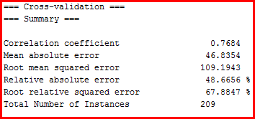 | 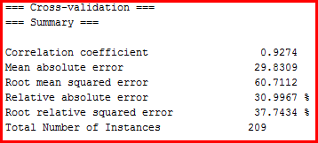
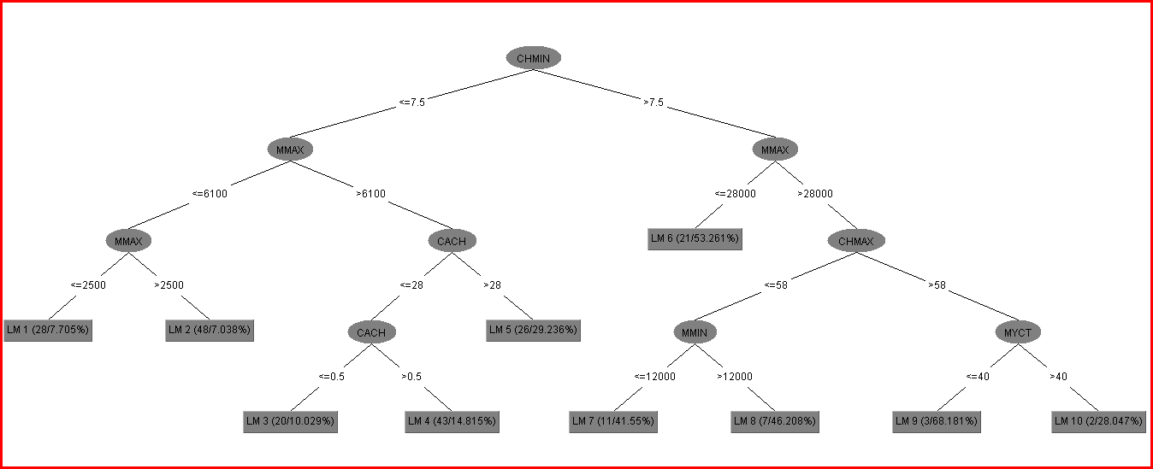 | 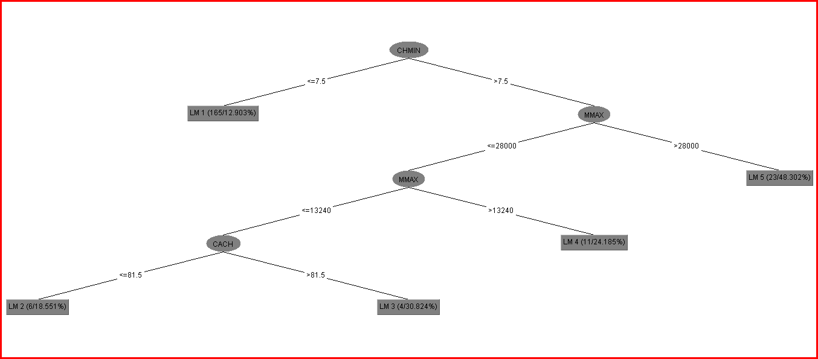

It is also interesting to note that, although -- following the expected pattern described in (1) above -- we can observe a more simplified tree in several areas of the Model Tree, this scheme unexpectedly generates greater specificity or branching (than the Regression Tree) for CHMIN > 7.5 and MMAX <= 28,000.

