- Produce a hierarchical clustering (COBWEB) model for iris data. How many clusters did it produce? Why? Does it make sense? What did you expect? Change the acuity and cutoff parameters in order to produce a model that clusters major Iris types together. Use the classes to cluster evaluation. Examine your findings/understanding of the produced results.
I will address all these questions throughout my answer below as I need to go back and forth through different system settings to explore the dataset.
I run the model against the Iris dataset at default values for this model. Initially, I did not remove the class attribute, so the system generated 4 clusters, one of them being the root node (that includes the 150 instances in the Iris dataset) and the other three are the leaves (which contain 50 instances each).
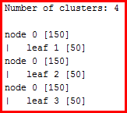 | 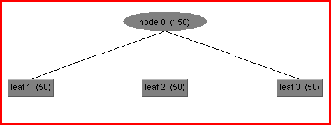
Changing acuity and cutoff parameters while the class attribute is included will still keep the system trying to cluster around those three Iris types.
Then I run the system after removing the class attribute – so Cobweb can do its own thing. I set saveInstanceData = True (to allow visualization) but leave at default value acuity and cutoff:
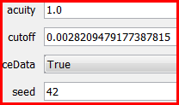 | 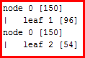
Selecting Classes to clusters we can see that Iris-setosa gets correctly clustered while most of Iris-versicolor gets clustered together with the Iris-virginica.
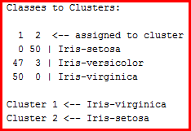
Based on the exploration we have done in previous labs with this dataset, it is not a surprise that the Iris-setosa is clearly clustered as a unit while there is some confusion mingling Iris-virginica and Iris-versicolor when clustering using all 4 flower measurement attributes. For this reason, I also experimented with using only the Petal Width for clustering, and after adjusting the acuity I could obtain a pretty nice clustering division.
Now, going back to using all 4 flower measurement attributes: I experimented with acuity and cutoff values to get better results. As the default of acuity was 1.0, I played with both much smaller and larger values. For the cutoff value, the default value is very small, so I mostly tried larger values.
Leaving all other values at default:
- A larger acuity, such as acuity = 2, will make the system too forgiving of variance, producing a result where there is a single cluster that includes all instances.
- A smaller acuity, such as acuity = 0.5, will make the system more sensible to variance, generating some results that start making more sense:
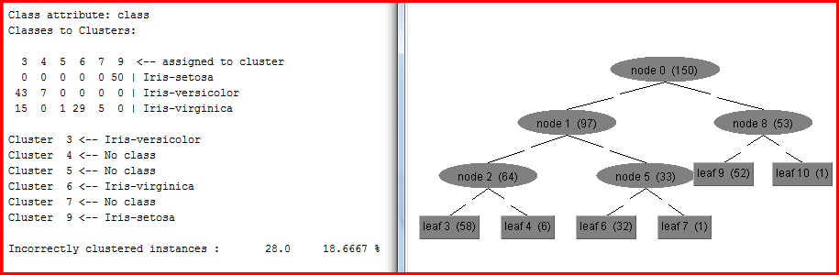
- If we decrease acuity too much, we would end up with a system too prone to over-fitting, eventually with a leaf per instance.
- Conversely, if we leave untouched all other parameters and increase cutoff to a large enough value, we will end up with a single cluster. That is why we might need to play with both acuity and cutoff parameters until finding a combination that most appropriately deals with the specific characteristics of this dataset attributes. For instances, the parameter combination below (first column in table below) gives a very good cluster outcome were the three clusters generated at the leaves are nicely covering the three different Iris types (results including classes to cluster evaluation also pasted in table below):
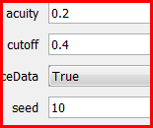 | 