- Design networks of McCuloogh-Pitts neurons that implement logical NOT and logical AND gate. Draw each network and label the weight and threshold value. In what way would XOR be more difficult to implement?
To draw these circuits I will use the following symbols:
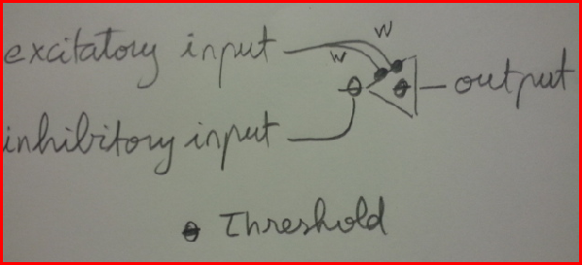
Where output (Vout) is:
1 ➔ if the summation of each excitatory input x its weight (all weights have same value) is equal or greater than the threshold AND there is no inhibition.
0 ➔ otherwise.
In truth tables below, 0 = FALSE, and 1 = TRUE.
NOT GATE
Vin | Vout  -----+------  1 | 0  0 | 1 | When W = 1 and threshold = 2, we get the truth table for the logical NOT by using this circuit:  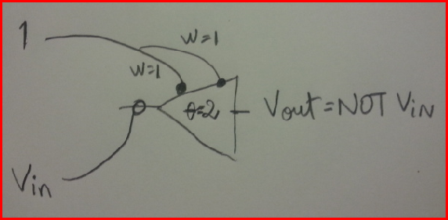

If Vin = 1 ➔ Vout = 0
Else (Vin = 0), as the total excitatory input = 2, which is = to the threshold (also 2) ➔ Vout = 1
AND GATE
V1 | V2 | AND  ---+----+----+----  0 | 0 | 0  0 | 1 | 0  1 | 0 | 0  1 | 1 | 1 | When W = 1 and threshold = 3, we get the truth table for the logical AND by using this circuit: 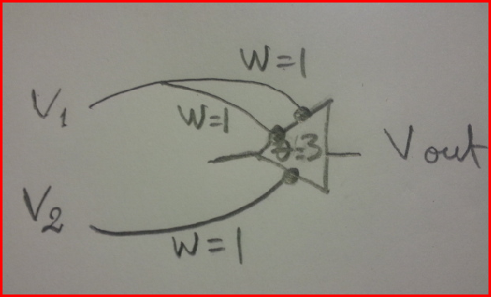
If V1 = 0 and V2 = 0, then total input = (0 * 2) + (0 * 1) = 0 < Threshold (3) ➔ Vout = 0
If V1 = 0 and V2 = 1, then total input = (0 * 2) + (1 * 1) = 1 < Threshold (3) ➔ Vout = 0
If V1 = 1 and V2 = 0, then total input = (1 * 2) + (0 * 1) = 2 < Threshold (3) ➔ Vout = 0
If V1 = 1 and V2 = 1, then total input = (1 * 2) + (1 * 1) = 3 = Threshold (3) ➔ Vout = 1
XOR GATE
Logical functions such as Boolean AND, OR, and NOT operators are linearly separable. Therefore, they can be performed using a single MCP neuron. However, not all logic operators are linearly separable (i.e., in a true table). This is the case of the XOR operator, for which is impossible to divide the regions containing either 1 or 0. This challenge can be overcome by using more than one neuron arranged in feedforward network -- in the case of the XOR operator, with a NOT function and either an OR or an AND.

V1 | V2 | XOR
---+----+----
0 | 0 | 0 Last neuron receives 0 excitatory and no inhibitory ➔ 0 final output
0 | 1 | 1 Last neuron receives 2 excitatory and no inhibitory ➔ 1 final output
1 | 0 | 1 Last neuron receives 2 excitatory and no inhibitory ➔ 1 final output
1 | 1 | 0 Last neuron receives 2 excitatory and the inhibitory ➔ 0 final output
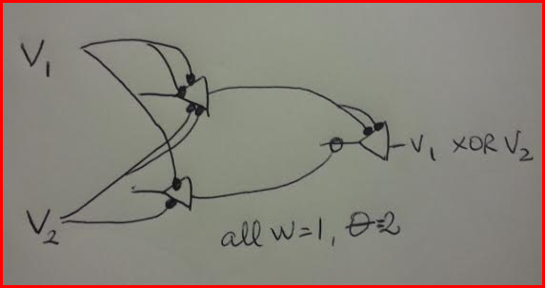
- Read a short tutorial at: http://lcn.epfl.ch/tutorial/english/index.html. What is the main difference between McCullogh-Pitts neuron and general artificial neuron?
The main difference between the McCullogh-Pitts neuron and the Artificial Neuron model is the use of absolute inhibitory input.
GENERAL ARTIFICIAL NEURON | McCULLOGH-PITTS NEURON
Inputs can be discrete values from a set, such as {0,1}, or real-valued numbers. | Inputs are binary (exclusively ones or zeros).  Excitatory inputs  Inhibitory inputs
Has a set of weights (real-valued numbers that determine the contribution of each input). | There are no weights.
The threshold is a real number | The threshold is an integer (it could be any real number, but there is no point in this).
The activation function for artificial neuron model has been expanded to include other functions besides the unit step function, such as the sigmoid, piecewise linear, and Gaussian. | The activation function is always the unit step function.

- Which of the 2-input binary logical functions can be computed with a McCulloch-Pitts
• neuron? → AND, OR (as well as NOT operator)
• network? → AND, OR, XOR (as well as NOT operator)

Only logical functions that are linearly separable can be performed using a single MCP neuron. The XOR operator is not linearly separable and cannot be achieved with a single MCP neuron. However, it can be implemented by using more than one MCP neuron arranged in a feedforward network.

- Read through the tutorial at: http://heart.cbl.utoronto.ca/~berj/ann.html. Fill in the table at the end of the tutorial’s exercise part.

V1 input | V2 input | Target (desired output)  (for binary OR) | Weighted Sum  (V1*W31)+(V2*W32)+(1*theta3)  W31, W32, and theta3  = 0 for the initial row | Perceptron Output  step function f(u3)  u_3<0➔0  u_3>=0➔1 | t3-V3 | (0.5*delta3*V1) + previous W31 | (0.5*delta3*V2) + previous W32 | (0.5*delta3*1) + previous theta3
V1 | V2 | t3 | u3 | V3 | delta3 | new  W31 | new  W32 | new  theta3
0 | 0 | 0 | 0 | 1 | -1 | 0 | 0 | -0.5
0 | 1 | 1 | -0.5 | 0 | 1 | 0 | 0.5 | 0
1 | 0 | 1 | 0 | 1 | 0 | 0 | 0.5 | 0
1 | 1 | 1 | 0.5 | 1 | 0 | 0 | 0.5 | 0
0 | 0 | 0 | 0 | 1 | -1 | 0 | 0.5 | -0.5
0 | 1 | 1 | 0 | 1 | 0 | 0 | 0.5 | -0.5
1 | 0 | 1 | -0.5 | 0 | 1 | 0.5 | 0.5 | 0
1 | 1 | 1 | 1 | 1 | 0 | 0.5 | 0.5 | 0
0 | 0 | 0 | 0 | 1 | -1 | 0.5 | 0.5 | -0.5
0 | 1 | 1 | 0 | 1 | 0 | 0.5 | 0.5 | -0.5
1 | 0 | 1 | 0 | 1 | 0 | 0.5 | 0.5 | -0.5
1 | 1 | 1 | 0.5 | 1 | 0 | 0.5 | 0.5 | -0.5
0 | 0 | 0 | -0.5 | 0 | 0 | 0.5 | 0.5 | -0.5
0 | 1 | 1 | 0 | 1 | 0 | 0.5 | 0.5 | -0.5
1 | 0 | 1 | 0 | 1 | 0 | 0.5 | 0.5 | -0.5
1 | 1 | 1 | 0.5 | 1 | 0 | 0.5 | 0.5 | -0.5

- Using the unit step activation function for the artificial neuron, determine a set of weights (and threshold value) that will produce the following classification:

x1 x2 output
-0.2 0.5 0
0.2 -0.5 0
0.8 -0.8 1
0.8 0.8 1

Try to do this by hand first, and then check your answer with the applet. You can use any applet available on the Internet (please include the link to the applet used)
Here is a set of weights and threshold values that will produce the above classification:

W1 = 1.5
W2 = 0.5
Threshold = 0.5

Below I am running those values using the Artificial Neuron applet in this link:

http://lcn.epfl.ch/tutorial/english/aneuron/html/index.html

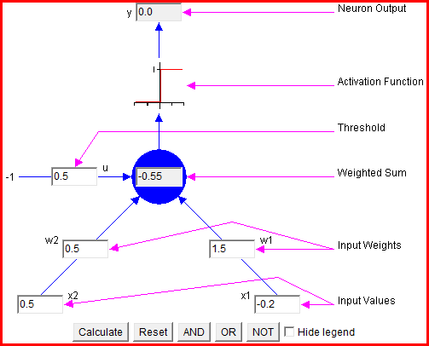 | 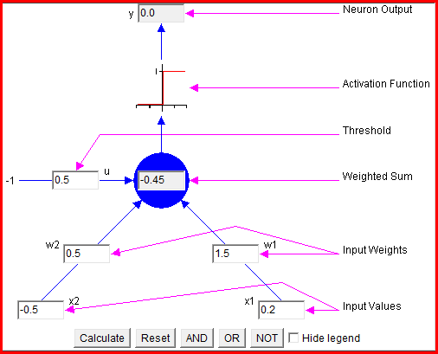
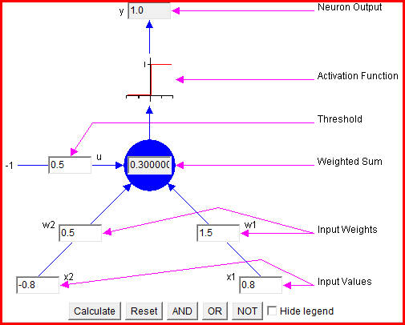 | 