Ward Visit Map
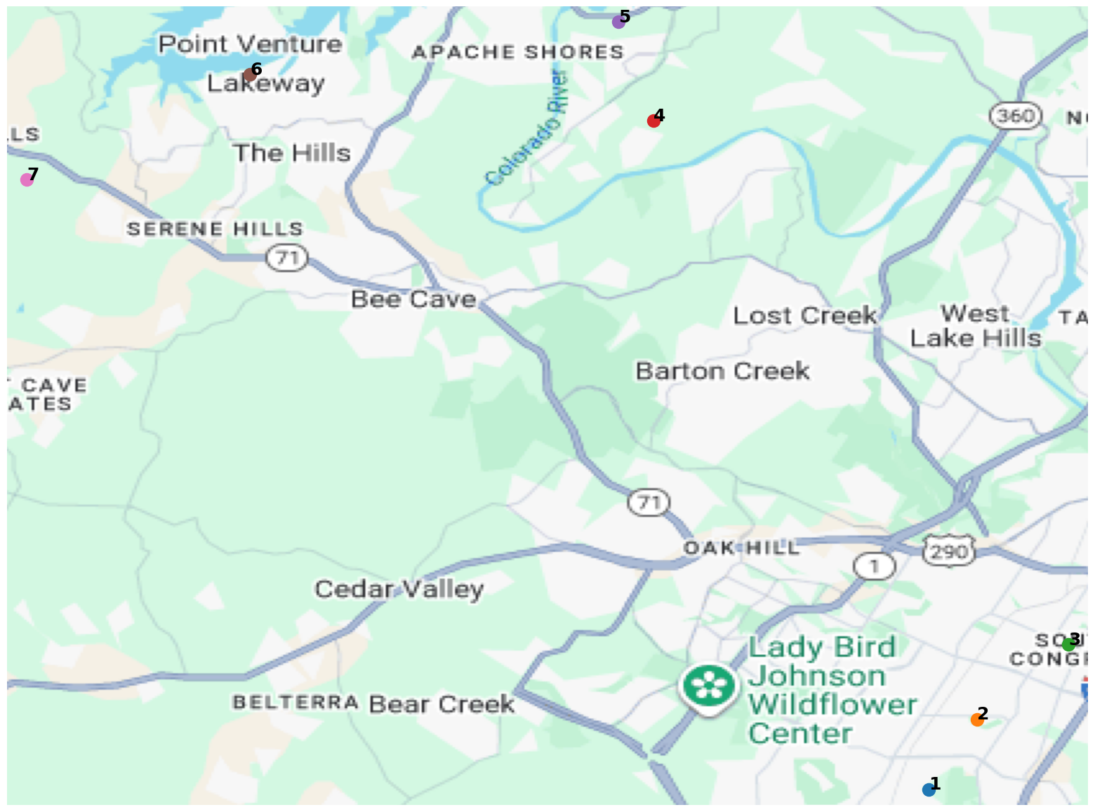

Legend
# | Ward Last | Address
1 | Luna | 2406 Monarch Dr., Austin, TX. 7874.8
2 | Cas | 2404 Roehampton Dr., Austin, TX
3 | Jaimes | Austin, Texas 78745
4 | Dennis | 11508 shoreview Overlook, Austin TX 78732
5 | Mosonye | 12834 Texas Sage Court, Austin, TX
6 | Hall | 2. Prestonwood Circle, Lakeway, TX 78734
7 | Taylor | 6416 e Llano Stage Tr 1, Austin, TX 78738

