## horizontal line



Functionality Specification Document

----------------------------------------------------------------------------------------------------------------------------

**Document Version 1.0**

**Latest updated:- 20-Nov–2020**

**Author : Omkar S Mayekar**

**Flyaway**

**Content**

**1 . About this Document………………………………........2**

**1.1 How this Document is organized ……………………………………………………….. 2**

**1.2 Contact Information..……………………………………………………………………. 3**

**2 . Introduction……………………………………………....4**

**2.1 Objectives…………………………………………………………………….………........ 4**

**3. Flow chart………………………………......................... .5**

**3.1 Flow chart diagram…….…………………………………………………………………… 5**

**4. Sprint Trello kanban board…………………………… 6**

**4.1 Sprint 1…………………………………………………………………….………...............6**

**``` 4.2 Sprint 2…………………………………………………………………….………...............7**

**5 . Solution Overview………………………………………..8**

**5.1 User Interfaces …………………………………………………………………………. … 8**

**6 . Github link……………………………………………....14**



1. **About this Document**

**This functional and integration (FIS) document will enable you to understand the proposed solution of Flyaway.com**

**The content of the document will have a solution and its configuration details as it will be available for our client.**

**1.1  How this Document is organized**

**This document is organized into following chapters:**

**Chapter 2 - "Introduction" provides solution scope to be delivered to our Client.**

**Chapter 3 - "Flow chart" provides how the user is interacting with the application.**

**Chapter 4 - "Sprint Planning" provides how the application was developed in each sprint .**

**Chapter 5 - "Solution Overview" provides information on Company Lockers Pvt. Ltd. ,**

**Components and Interfaces in system.**

**Chapter 6 - “Open Items” provide information about the software enhancement**

**still to be done.**

**Chapter 7- “Github link” provides the information where the project is located.**

**1.2    Contact Information**

**Flyaway  welcomes your comments and suggestions on the quality and usefulness of this document. For any questions, comments, or suggestions on the documentation, you can contact us at the following address:**

|  |
| --- |
| **For India Enquiry              .**  **Omkar Mayekar**  **Flyaway.com India**  **Tel: +91 (742) 081 5182**  **contact_us@flyaway.com** |



**2 .   Introduction**

**This document describes the implementation of *Flyaway*  and how its users can interact with the application.**

***FlyAway is a ticket-booking portal that lets people book flights on their website*.**

**2.1    Objectives**

**The objective of this document is to describe how the solution of *Flyaway* will integrate with User.**

**This document also provides information on end to end workflow flow so that business users can understand the features and functionalities of the *Flyaway an online booking portal*.**

**The workflow mainly involves the following important aspects,**

1. **A search form in the homepage that allows user to enter travel details like the date of travel, source, destination and the number of persons.**
2. **Based on the travel details entered, it will show the available flights with their ticket prices.**

**3.  Once a person selects a flight to book, they will be taken to a login page where they must fill in their user details.**

**4. If he/she is not a user they will be taken to the registration page.**

**5. In the next page, they are shown the flight details of the flight that they have booked and the payment is done via a dummy payment gateway.**

**6. On completion of the payment, they are shown a confirmation page with the details of the flight they have booked.**



**3 . Flow chart**

**3.1 The objective of this session if to show how the user interacts with the flow of the**

***Company Lockers Pvt. Ltd.***

Start

User is asked to enter the booking details like source & destination, etc.

Based on the entered booking details the available flights are shown to the user to book

**­­­**

NO

Register First

IF

Registered User

Login page

YES

Confirmed Booking Details

Dummy Payment Gateway



**END**

**4. Sprint planning**

**4.1 This section tells how the workload was sliced into smaller part and was completed.**

**For effective pace and efficiency a trello board was managed as shown below.**

**It was divided into three parts**

* 1. **Task to do.**
  2. **In Progress**
  3. **Completed in Sprint 1**

**The timebox for each sprint i.e sprint 1 and sprint 2 was 1 week .**

**Sprint 1**

**The sprint 1 overall working flow of the application was done.**

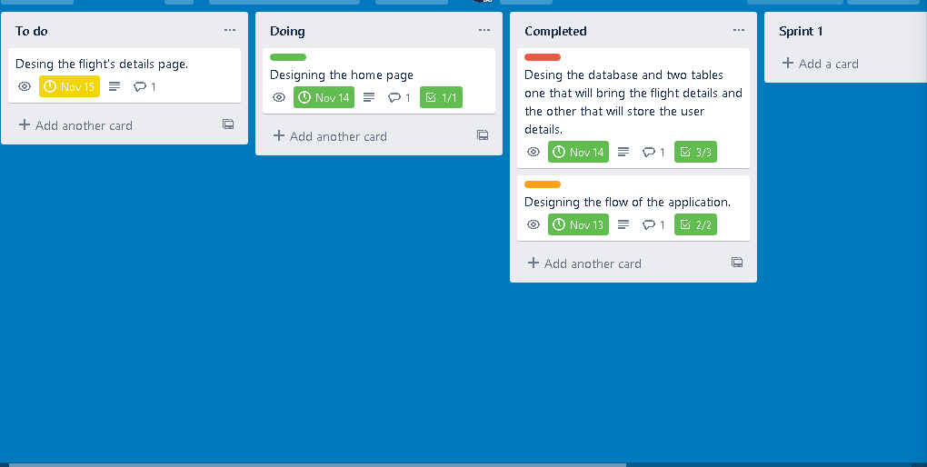**==========================================================================**

**Sprint 2**

**In sprint 2 the entire workflow with enhacement is completed.**

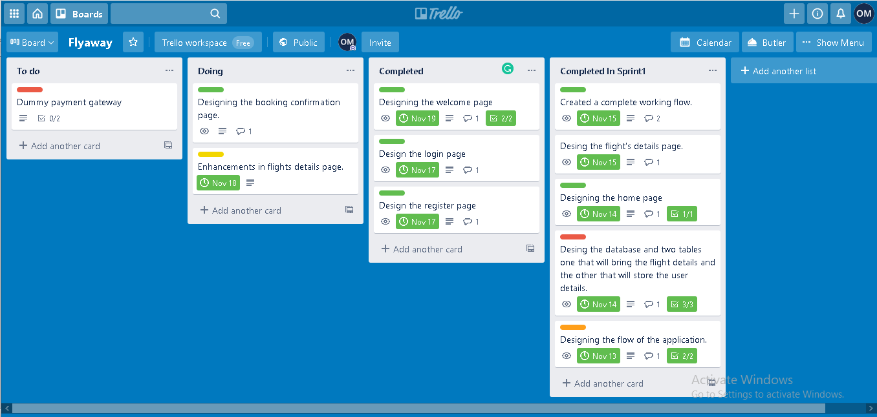

**The complete activity of the sprint can be seen from the below link.**

**Click here: -** <https://trello.com/b/J6m7hb9s/flyaway>



**5 Solution Overview**

**Platform requirement**

**The platform used for this project is the eclipse IDE, Tomcat, My sql workbench**

**Below is the welcome page of the application**

**=====================================================================**

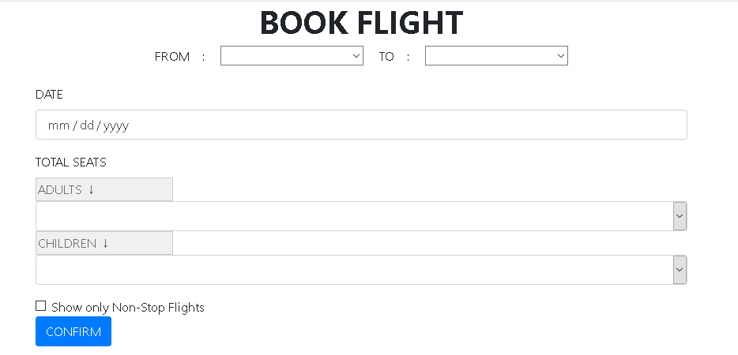

**=====================================================================**

**Step 1  - User is allowed to  search flights available for a specific date, source, destination and the number of seats.**

**Once the user  submits, the application takes him to display the available flights:**

**----------------------------------------------------------------------------------------------------------------------------**

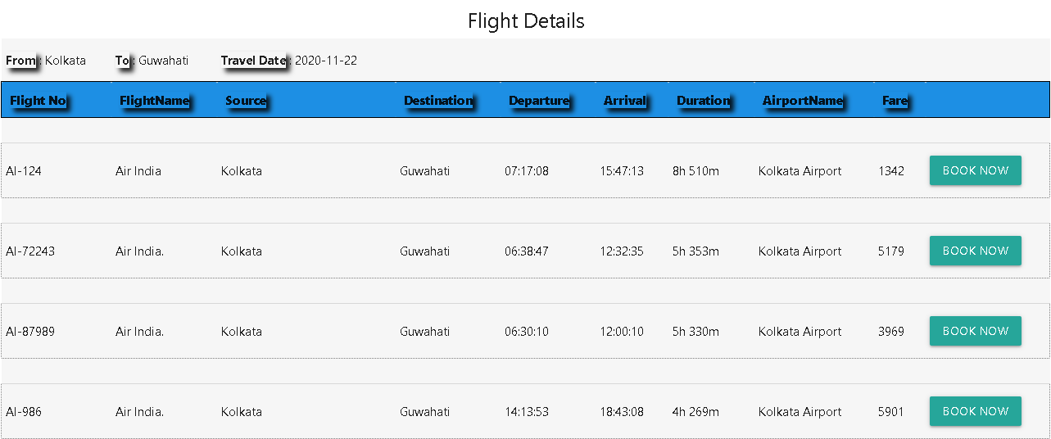

**=====================================================================**

**Step 2  - The user is allowed to book the flight of  his choice.**

**=====================================================================**

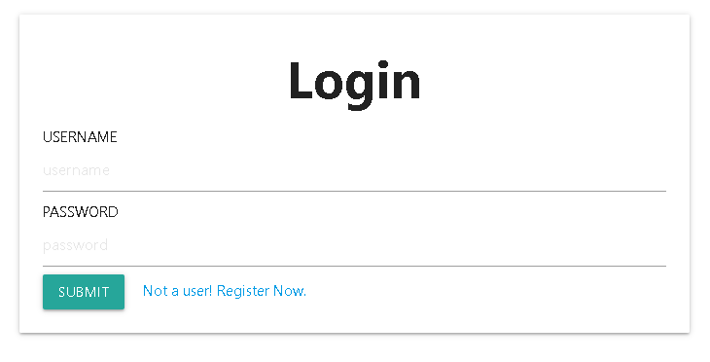

**=====================================================================**

**User is taken to the login page where he is allowed to fill his valid login credentials. If he is not a valid user he must register first.**

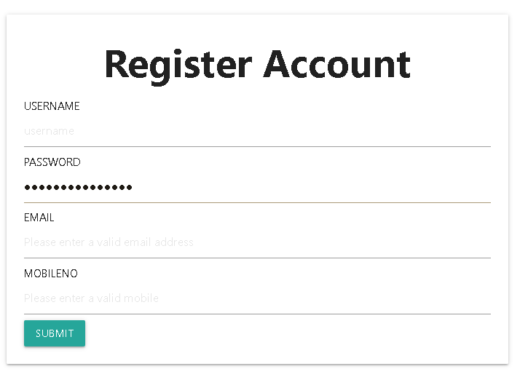

**=====================================================================**

**Step 3 - Once the user is validated he/she will be redirected to the payment page where the user needs to enter the valid payment credentials.**

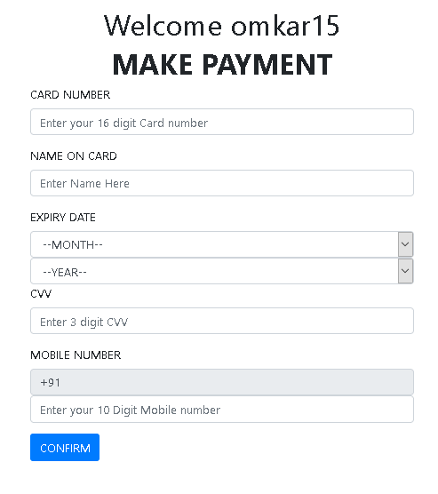

**On completion of the payment, they are shown a confirmation page with the details of the flight they have booked.**

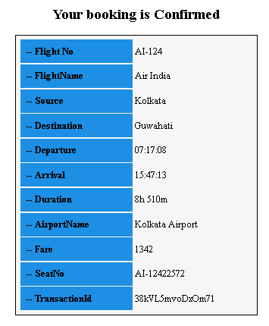**=============================================================**  
  
Database :-

**In order to store the data of the flights and users there is a master datatbase.**

There are 3 tables created to store the data.

1. Bookingdetails : - all the confirmed booking details goes here.
2. Flight_detials :- all the flights data i.e source, destination, etc.
3. Userdetails :- all the registered users data go here.

**The Backend (DATABASE)**

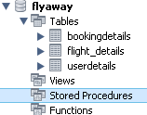

**Table 1:-**

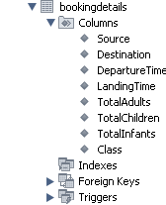

**Table 2:-**

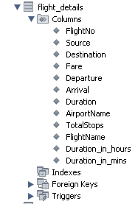

**Table 3:-**

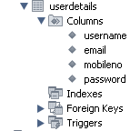



**6. Github link**

**This section lists where the source code is located and from where the user can download and use it.**

<https://github.com/mayekaromkar15/Phase2-Project>