## horizontal line



Functionality Specification Document

----------------------------------------------------------------------------------------------------------------------------

**Document Version 1.0**

**28 - Feb - 2021**

**Author : Omkar S Mayekar**

**Sportyshoes.com**

**Content**

**1 . About this Document…………………………….........2**

**1.1 How this Document is organized ……………………………………………………. 2**

**1.2 Contact Information ………………………………………………………………….3**

**2 . Introduction…………………………………………….4**

**2.1 Objectives…………………………………………………………………….……….... 4**

**3. Flows…………………………………………………….5**

**3.1 User Flow…………………………………………………………………………………. 5**

**3.2 Admin Flow………………………………………………………………………………..5**

**4. Sprint Planning………………………………………....7**

**5 . Solution Overview……………………………………....9**

**5.1. UI for User………………………………………………………………………………...9**

**5.2 UI for Admin……………………………………………………………………………...14**

**6 . Github link……………………………………………..15**



1. **About this Document**

**This functional and integration (FIS) document will enable you to understand the proposed solution of Sportyshoes.com**

**The content of the document will have a solution and its configuration details as it will be available for our client.**

**1.1 How this Document is organized**

**This document is organized into the following chapters:**

**Chapter 2 - "Introduction" provides solution scope to be delivered to our Client.**

**Chapter 3 - "Flows" provides information on how Sporty shoes flow is across the entire webapp.**

**Chapter 4 - "Sprint Planning" provides how the product was divided into 2 sprints in order to build a webapp.**

**.**

**Chapter 5 - “UI screen for Users and Admins” provide information about the software looks at every stage.**

**Chapter 6- “Github link” provides the information on where the project is located.**

**1.2 Contact Information**

**Sportyshoes welcomes your comments and suggestions on the quality and usefulness of this document. For any questions, comments, or suggestions on the documentation, you can contact us at the following address:**

|  |
| --- |
| **For India Enquiry.**  **Omkar Mayekar**  **Sportyshoes.com India**  **Tel: +91 (742) 081 5182**  **contact_us@sportyshoes.com** |



**2 . Introduction**

**This document describes the implementation of *Sportyshoes.com* and how its users can interact with the application.**

***Sports shoes are a ticket-booking portal that lets people book flights on their website*.**

**2.1 Objectives**

**The objective of this document is to describe how the solution of *Sportyshoes* will integrate with the User.**

**This document also provides information on end-to-end workflow flow so that business users can understand the features and functionalities of the *Sportyshoes an online booking portal*.**

**The workflow mainly involves the following important aspects,**

1. **Manage the products in the store including categorizing them**
2. **Browse the list of users who have signed up and be able to search users**
3. **See purchase reports filtered by date and category**



**3 . Flow chart User**

**3.1 User Flow Chart**

***.***

Start

HomePage is displayed for any user with login option on the same page.

**­­­**

NO

Register First

IF

Registered User

Login page

YES

The User is taken to homepage with add to cart option.

END

Further pages with options like checkout, payment gateway and payment confirmation.

**3.1 Admin Flow Chart**

Start

LOGIN

The Admin is taken to homepage with options like:

**­­**

Setup Product Categories

Browse Members

Purchase Report

Change Password

Setup Products

Admin can change password from here and redirect to dashboard

Registered users can be seen here

Users report can be seen here

Admin can add categories form here

Admin can add products form here

END



**4. Sprint planning**

**4.1 This section tells how the workload was sliced into smaller part and was completed.**

**For effective pace and efficiency a trello board was managed as shown below.**

**It was divided into three parts**

* 1. **Task to do.**
  2. **In Progress**
  3. **Completed in Sprint 1**

**The timebox for each sprint i.e sprint 1 and sprint 2 was 1 week .**

**Sprint 1**

**The sprint 1 overall working flow of the application was done.**

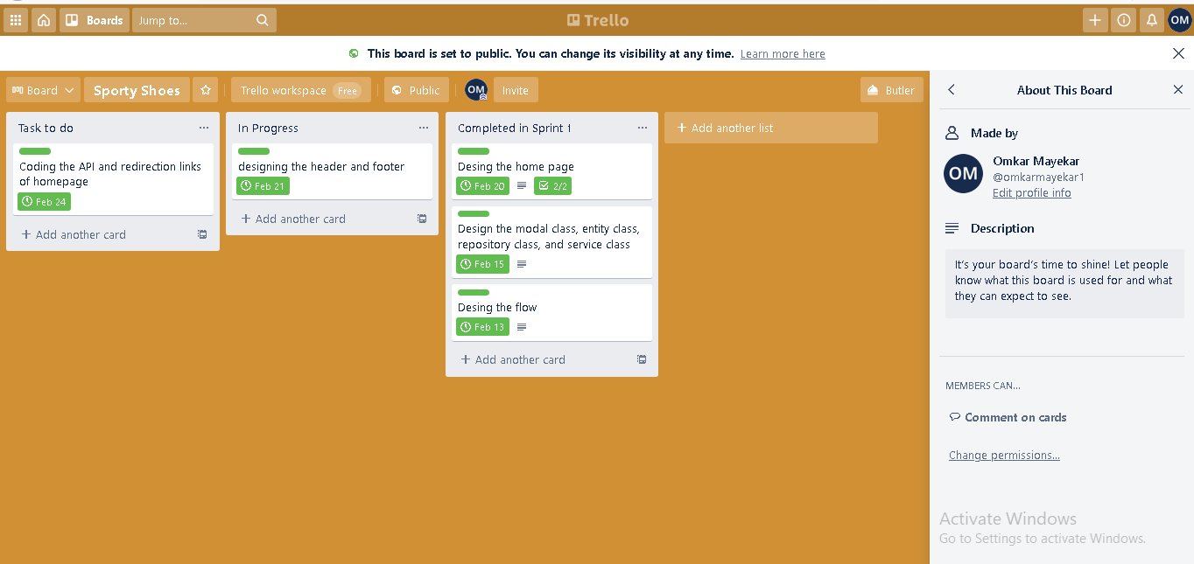

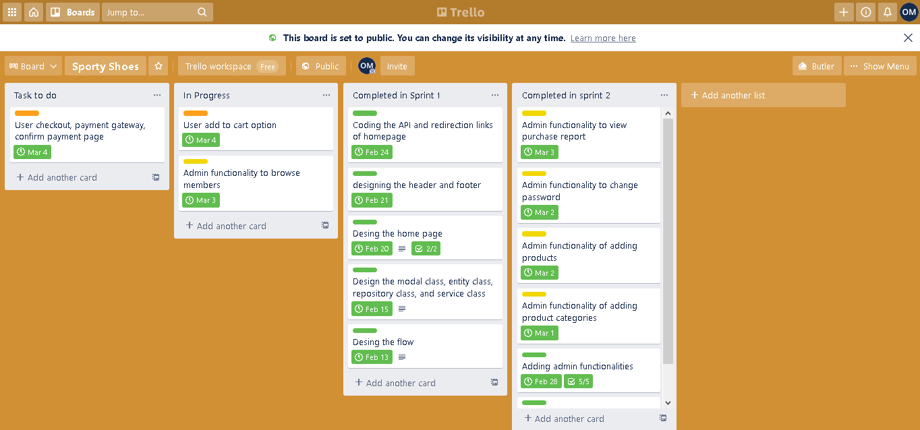**==========================================================================**

**Sprint 2**

**In sprint 2 the entire workflow with enhacement is completed.**

**The complete activity of the sprint can be seen from the below link.**

**Click here: -** <https://trello.com/b/CFXp43pd/sporty-shoes>



**5 Solution Overview**

**Platform requirement**

**The platform used for this project is the eclipse IDE, Tomcat, My sql workbench**

**5.1. UI for User:-**

***USER UI***

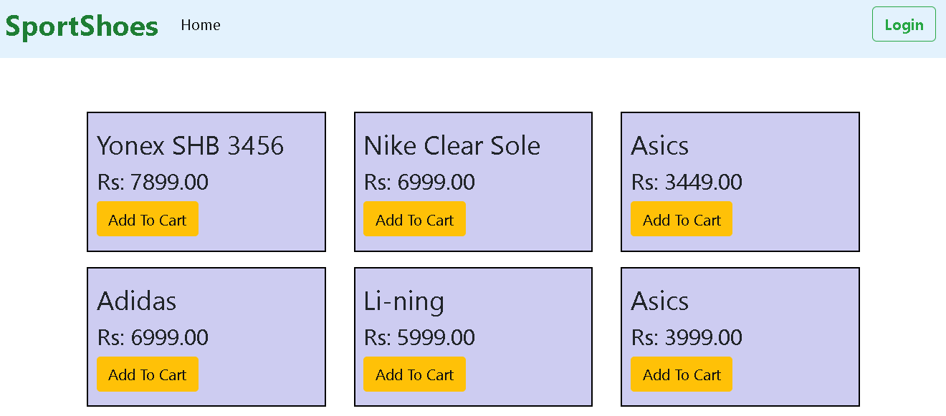

**=====================================================================**

**Step 1 - This is the homepage of the User.**

**The user must be registered in order to make the purchases.**

**----------------------------------------------------------------------------------------------------------------------------**

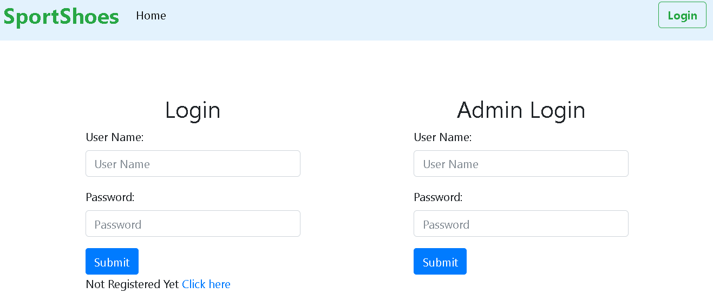

**Step 2 - The login page is as shown as above.**

**=====================================================================**

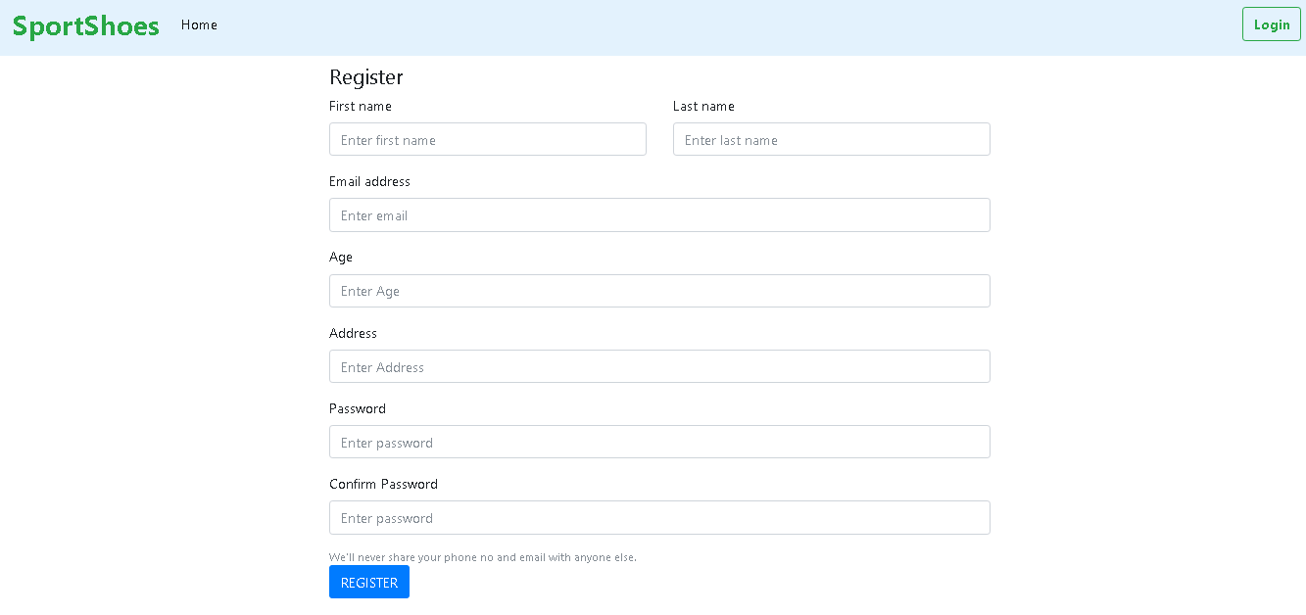

**Step 3 - User is taken to the login page where he is allowed to fill his valid login credentials. If he is not a valid user he must register first.**

**========================================================================**

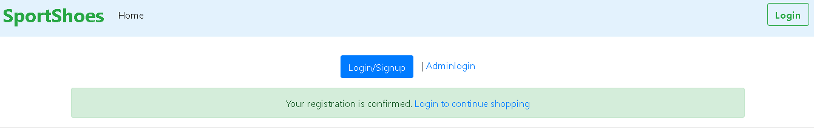

**Step 4 - Once the user is registered he gets an acknowledgement screen saying he is registered and he can now be able to login.**

**=========================================================================**

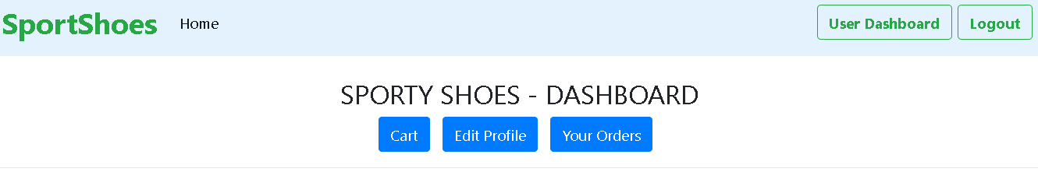

**Step 4 - Once the user is logged in he/she is redirect to this page.**

1. **Here user can view his cart.**
2. **Edit their profile.**
3. **And also their orders.**

**==========================================================================**

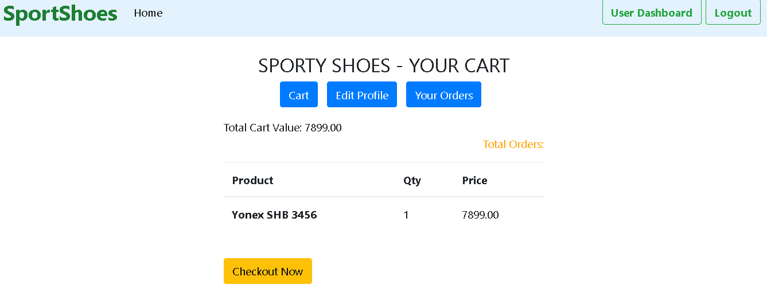

**Step 5 - User can checkout product of his choice and they will be redirected here.**

**==========================================================================**

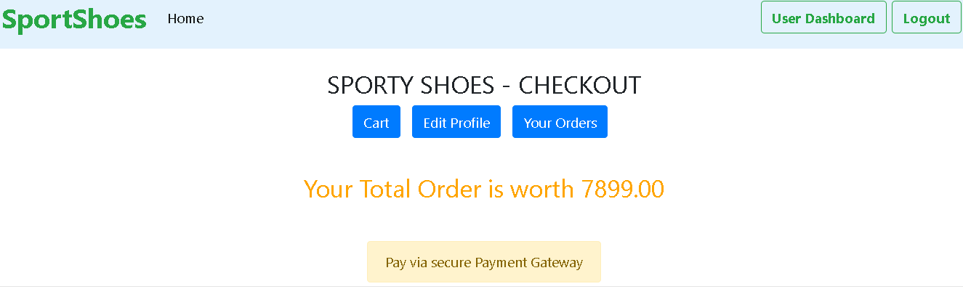

**Step 6 - The checkout page looks as above.**

**==========================================================================**

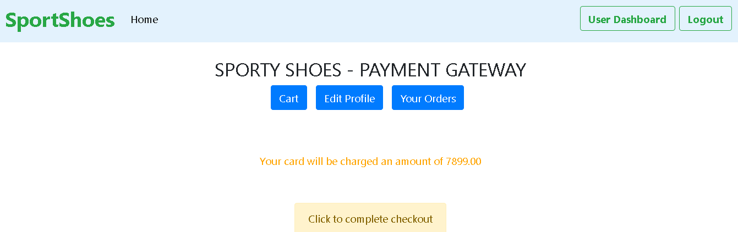

**Step 7 - The payment gateway looks as above.**

**==========================================================================**

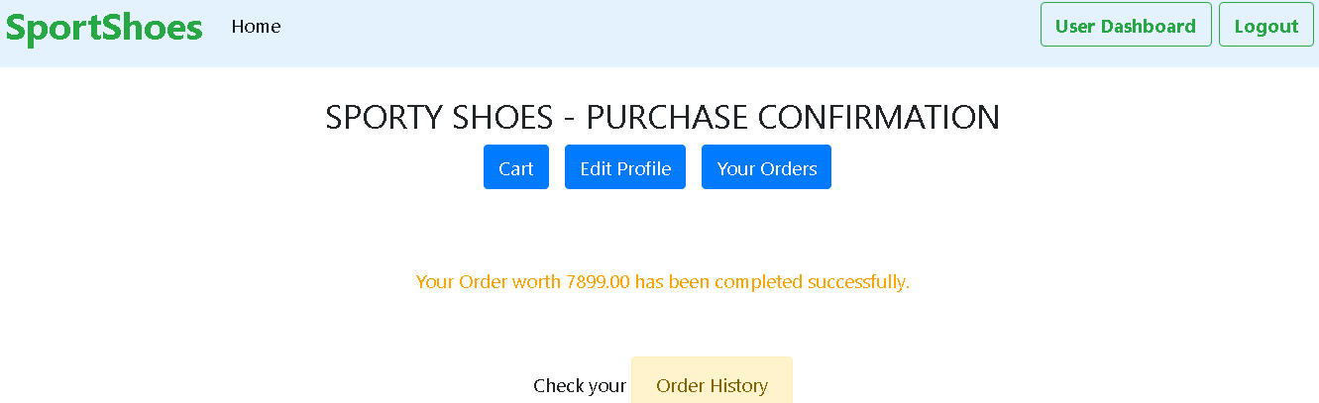

**Step 8 - The purchase confirmation page looks as above.**

**==========================================================================**

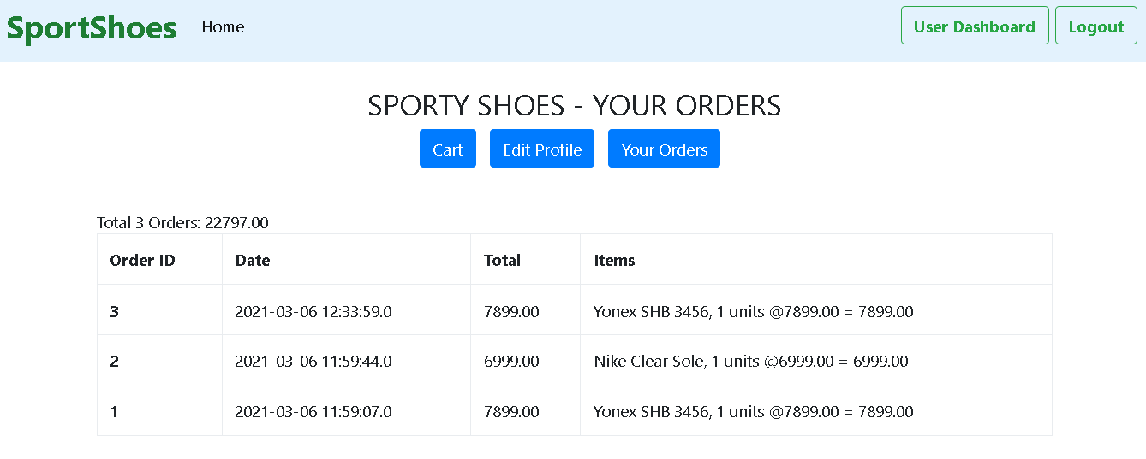

**The user can also view their order history.**

**==========================================================================**

**5.2. UI for User:-**

***ADMIN UI***

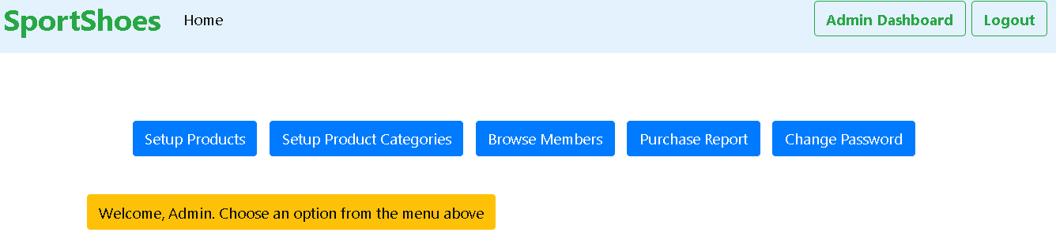

**The Admin Dashboard looks as above.**

**==========================================================================**

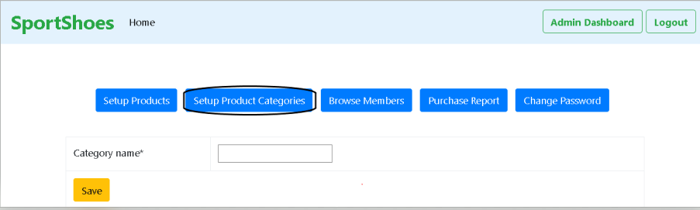

**Admin is able to set up product categories from above highlighted option..**

**==========================================================================**

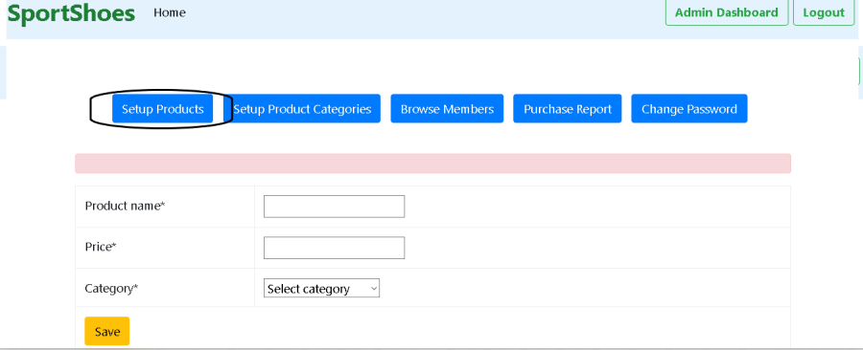**The admin is able to setup product from above highlighted option.**

**==========================================================================**

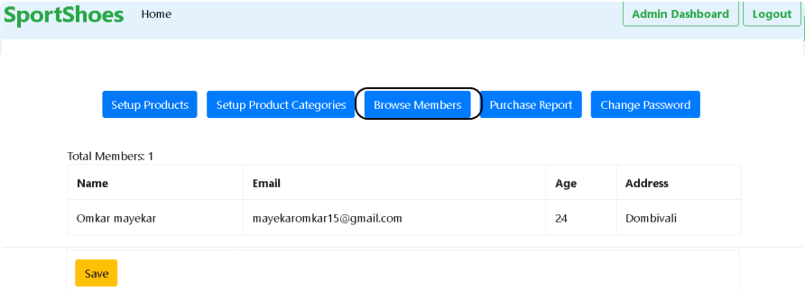

**The admin can access all the member details.**

**==========================================================================**

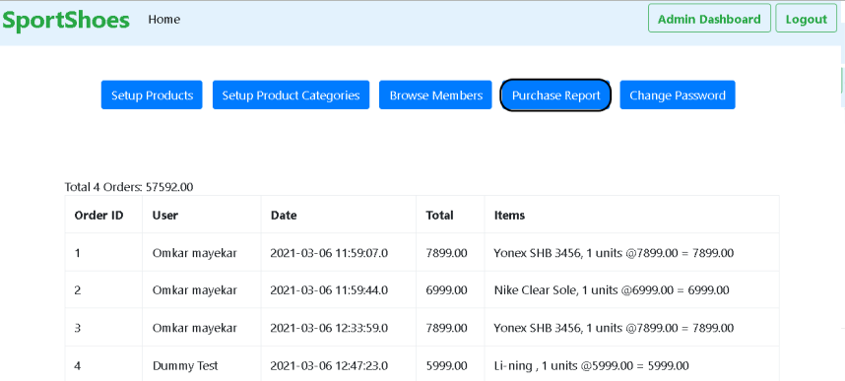

**The admin can view the purchase report from here.**

**==========================================================================**

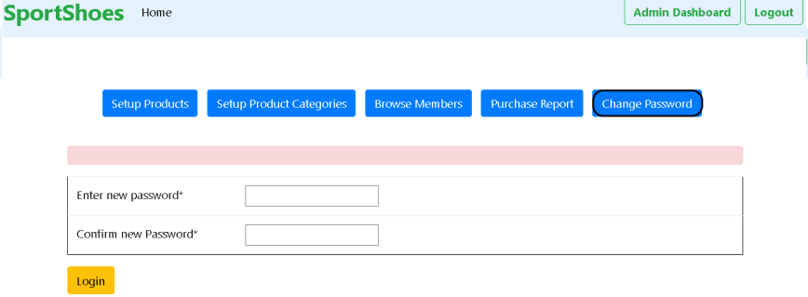

**The admin is able to change the password from here**

**==========================================================================**

**The Backend (DATABASE)**

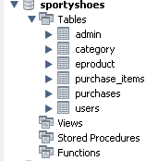

1. **Table 1:-**

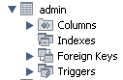

1. **Table 2:-**

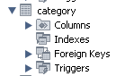

1. **Table 3:-**

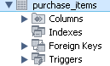

1. **Table 4:-**

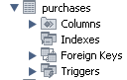

1. **Table 5:-**

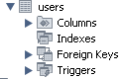



**6. Github link**

**This section lists where the source code is located and from where the user can download and use it.**

<https://github.com/mayekaromkar15/Project-Sporty_shoes>