**Simplilearn Phase 1 project Screenshots by Omkar Mayekar**

* **This is how the welcome page looks like**

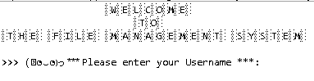

* **Once a valid user enter the following page is displayed**

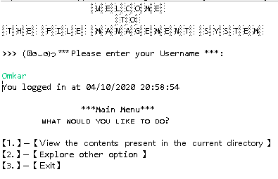

1. **Once the user selects option 1 from the main menu**

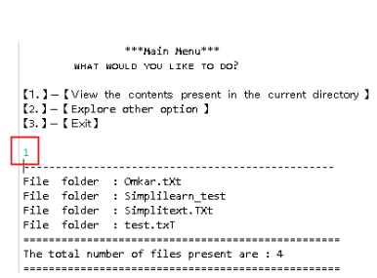

**2.Once the user selects the option 2**

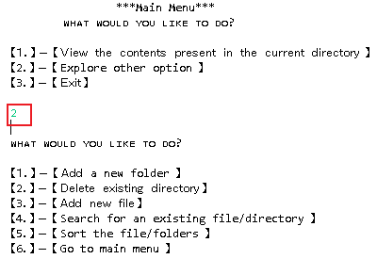

**1.1 In the submenus if the user selects option 1**

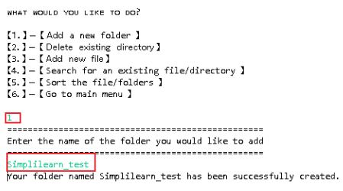

**1.2 In the submenus if the user selects option 2**

**1.2.1 If the user select 1st option from prompt**

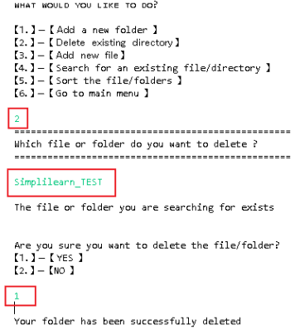

**1.2.2 If the user select 2nd option from prompt**

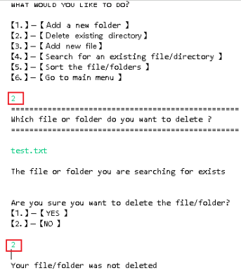

**1.3 In the submenus if the user selects option 3**

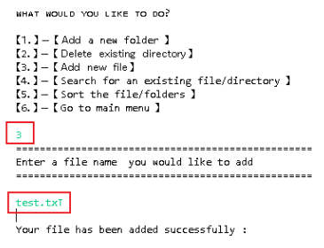

**1.4 In the submenus if the user selects option 4**

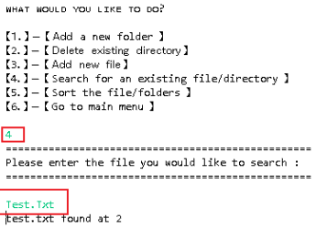

* 1. **In the submenus if the user selects option 5**

**1.5.1Ascending**

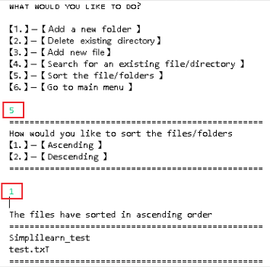

* + 1. **Descending**

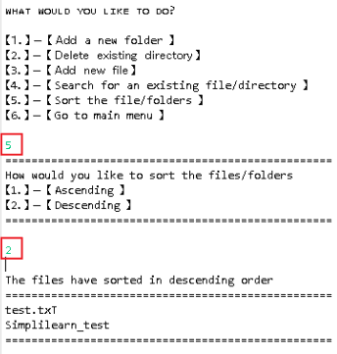

* 1. **In the submenus if the user selects option 6**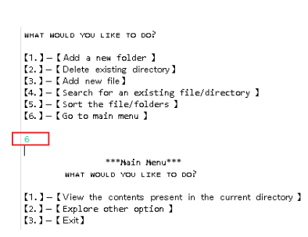

**3.Once the user selects option 3 from the main menu**

