## ANOVA Table

Table 1 ANOVA of cultivation, organic versus conventional nutrient management, sampling time, and year effects on trace global warming gases, soil biological activity, and soil properties in 2014 and 2015.

|  |  |  |  |  |  |  |  |  |
| --- | --- | --- | --- | --- | --- | --- | --- | --- |
|  | N2O | CO2 | NMN | MBC | MBN | DOC | N | H2O |
| Cultivation (C) |  |  |  | . | * | * | ** |  |
| Nutrient (N) |  | *** | . | *** | *** | *** | *** | . |
| Sampling (S) | *** | *** | *** |  | ** |  | *** | *** |
| Year (Y) | *** |  | *** | * | *** | ** | *** |  |
| C:N | *** | *** |  |  |  |  | *** | * |
| C:S |  | ** |  |  |  |  | ** |  |
| C:Y |  |  |  |  |  |  | ** |  |
| N:S |  | . |  |  |  | . | *** |  |
| N:Y | * | *** | . |  |  | * | *** |  |
| S:Y |  | *** | *** | ** | *** |  | *** | *** |
| C:N:S |  |  |  |  | . |  | ** |  |
| C:N:Y |  | * |  |  |  |  | *** |  |
| C:S:Y |  | . |  |  |  |  |  |  |
| N:S:Y |  |  | * |  |  |  | *** |  |
| C:N:S:Y |  | * | . |  | . |  | * |  |

CO2, Incubation Respiration; H2O, gravimetric water content; MBC, microbial biomass C; DOC, dissolved organic C; N, mineral NO3-+NH4+-N; N2O, Incubation N2O emissions; NMN, net mineralizable N

## Means separation table for significant main effects

There were no significant main effects without higher-order interactions for CO2, H2O, NMN, or N

|  |  |  |  |  |  |
| --- | --- | --- | --- | --- | --- |
|  |  | N2O | MBC | DOC | MBN |
| Cultivation | CT | 1.1(0.41) | 200(12) | **60a(1.6)** | **48ab(3.4)** |
|  | LR | 0.49(0.1) | 230(13) | **59a(2.1)** | **51a (2.4)** |
|  | RT | 0.44(0.11) | 200(10) | **54b(1.7)** | **43b (2.5)** |
| Nutrient | CON | 0.77(0.27) | **190b(10)** | **54b(1.5)** | **40b(2)** |
|  | ORG | 0.58(0.1) | **230a(9)** | **61a(1.4)** | **54a(2.3)** |
| Sampling | Pre-Term | **0.096c(0.011)** | 220(18) | 58(2.3) | 52(3.8) |
|  | Post-Term | **0.47b(0.09)** | 210(13) | 56(2.1) | 53(3.3) |
|  | Midseason | **1.8a(0.53)** | 200(13) | 58(2.1) | 41(3.3) |
|  | Harvest | **0.34b(0.11)** | 210(12) | 58(2) | 44(2.2) |
| Year | 2014 | **0.27b(0.061)** | 230(8.2) | **55b(1.4)** | 40(1.3) |
|  | 2015 | **1.1a(0.28)** | 200(11) | **60a(1.6)** | 55(2.8) |

## Figures for significant interaction effects

### CO2

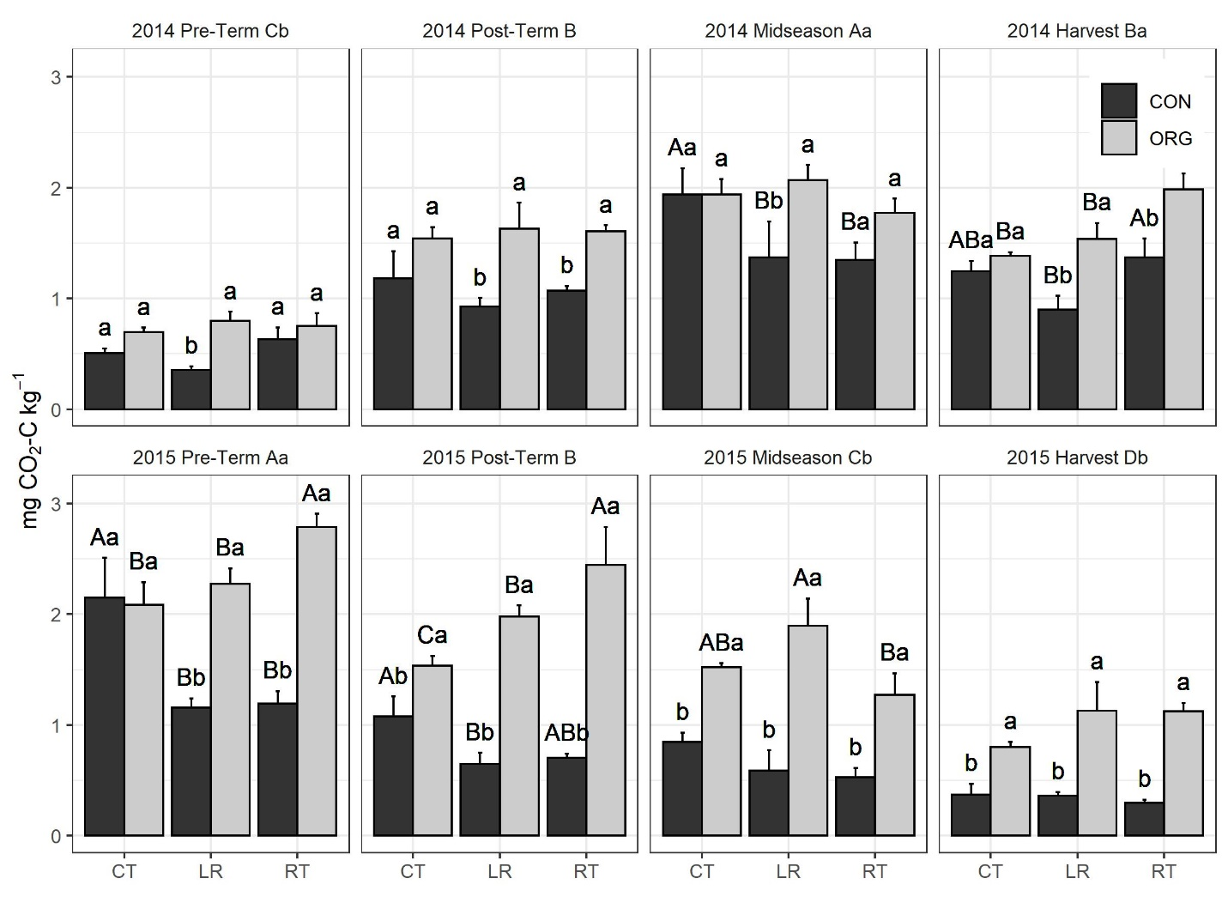

#On bars, read the uppercase letters WITHIN A FERTILIZER treatment

#On bars, read the lowercase letters WITHIN A CULTIVATION TREATMENT

#On each panel, read the uppercase letters WITHIN A YEAR

#On each panel, read the lowercase letters WITHIN A SAMPLING TIME ACROSS YEARS (ie 2014 midseason a > 2015 midseason b)

C:/Users/.../NCSU/Studies/LabileC/Presentable/MBC Plots/2020Redo_soil_extrns/pub/final/msp_co2a_d_yearXsampcltXnut_all_and_msp_co2a_d_yearXsampcltXnut_all_and_msp_co2a_d_yearXsampXnutXclt_all.jpeg

### N2O

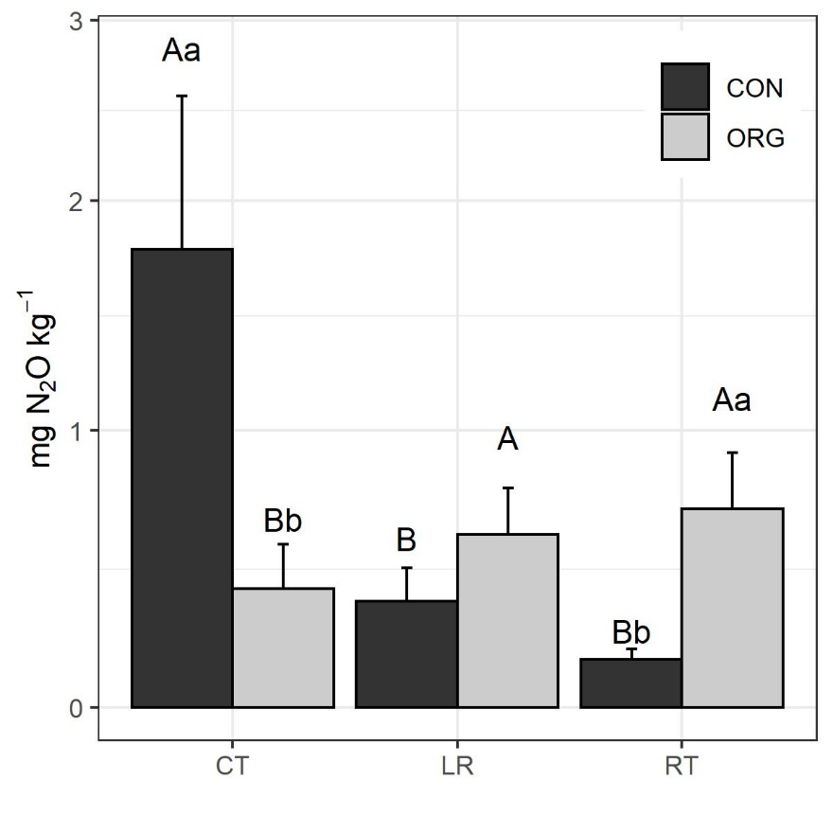

#Read the uppercase letters WITHIN A FERTILIZER treatment

#Read the lowercase letters WITHIN A CULTIVATION TREATMENT (Ie no difference between org and conv within LR b/c no lowercase letters)

### Gravimetric water content

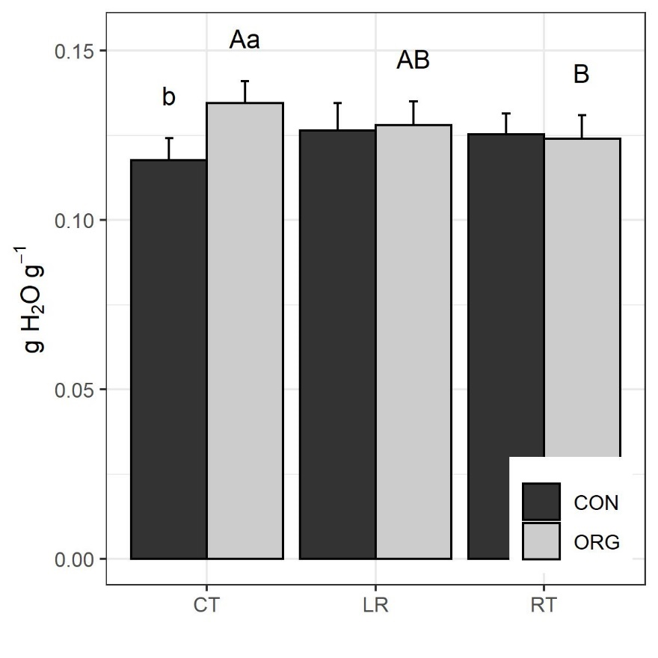

#Read the uppercase letters WITHIN A FERTILIZER treatment

#Read the lowercase letters WITHIN A CULTIVATION TREATMENT (Ie no difference between org and conv within LR or RT bc no letters)

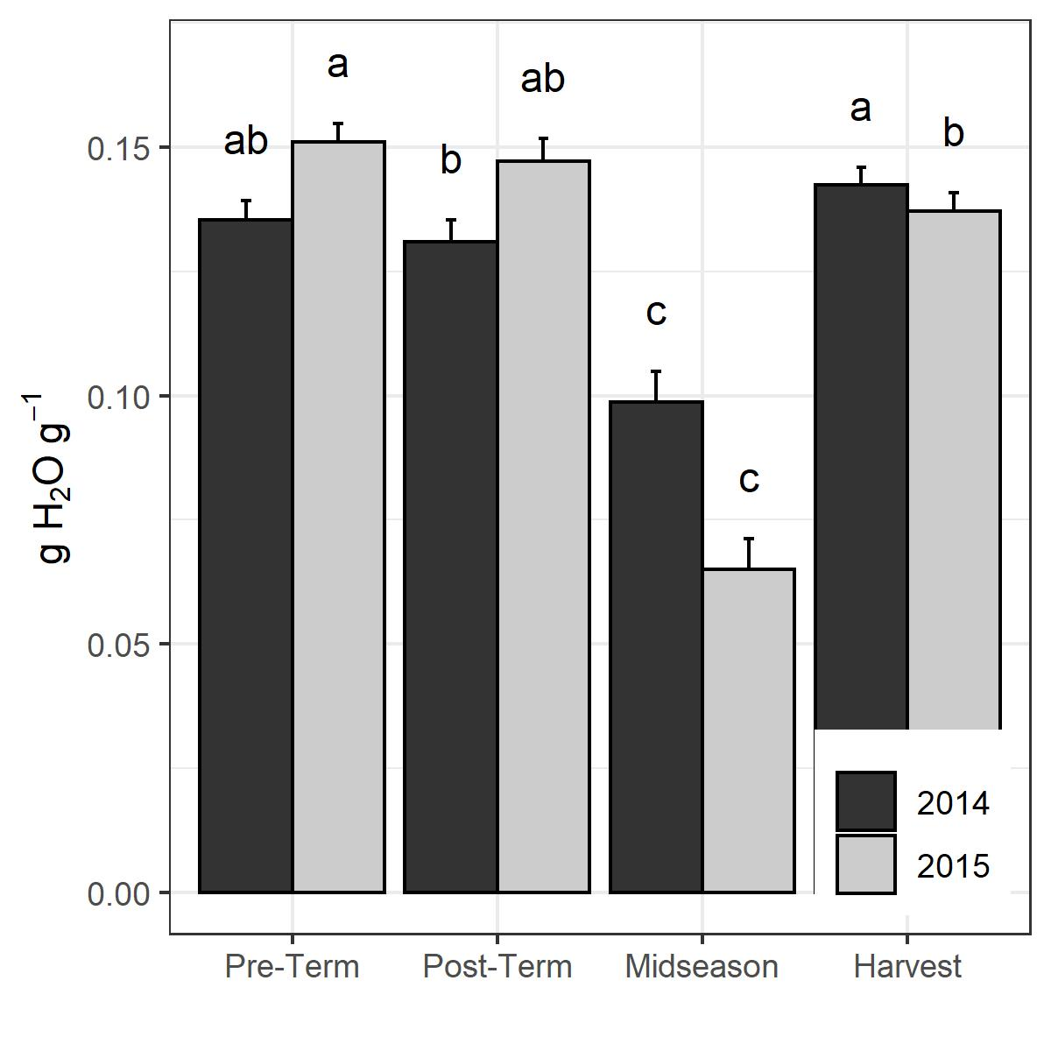

#ggsave(filename="C:/Users/.../NCSU/Studies/LabileC/Presentable/MBC Plots/2020Redo_soil_extrns/pub/final/msp_grvwat_yearXsamp_all.jpeg", width = 4, height = 4, plot=a)

#Read the lowercase letters WITHIN A YEAR (ie in both years midseason is lower than harvest)

### DOC

No interactions except year*nut, and that is only magnitude interaction not direction interaction (i.e. main effects still are accurate that org>conv overall, 2015>2014 overall, just by different degrees).

These main effects are in the table.

### MBC

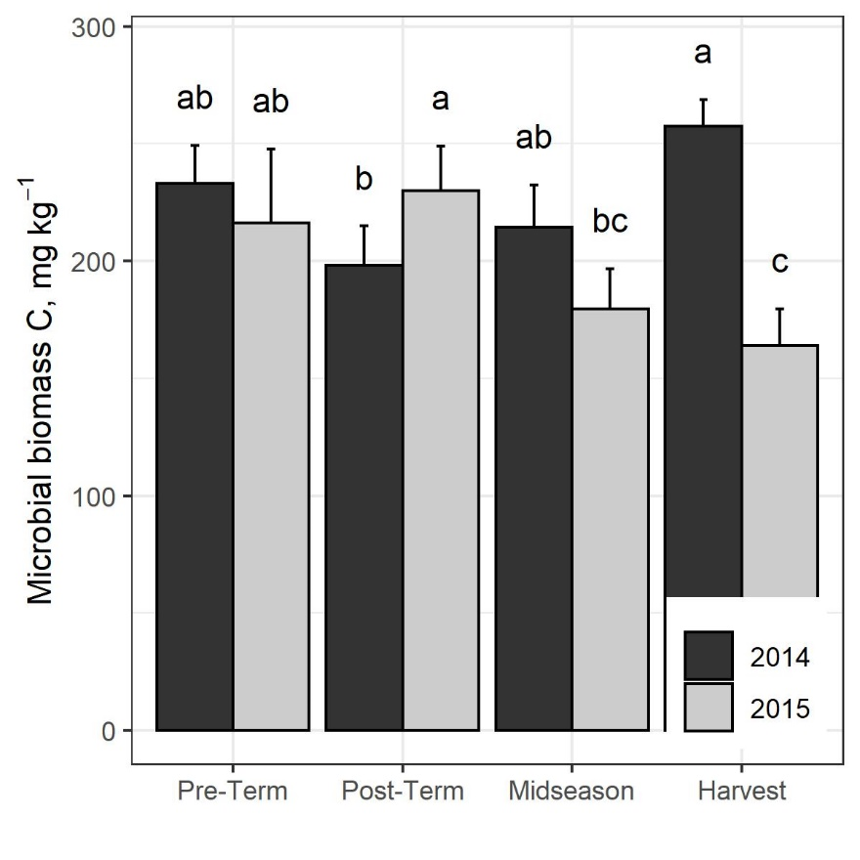

#ggsave(filename="C:/Users/.../NCSU/Studies/LabileC/Presentable/MBC Plots/2020Redo_soil_extrns/pub/final/msp_mbc_mgkg_yearXsamp_all.jpeg", width = 4, height = 4, plot=a)

#Read the lowercase letters WITHIN A YEAR (ie harvest is lower than postterm in 2015)

### MBN

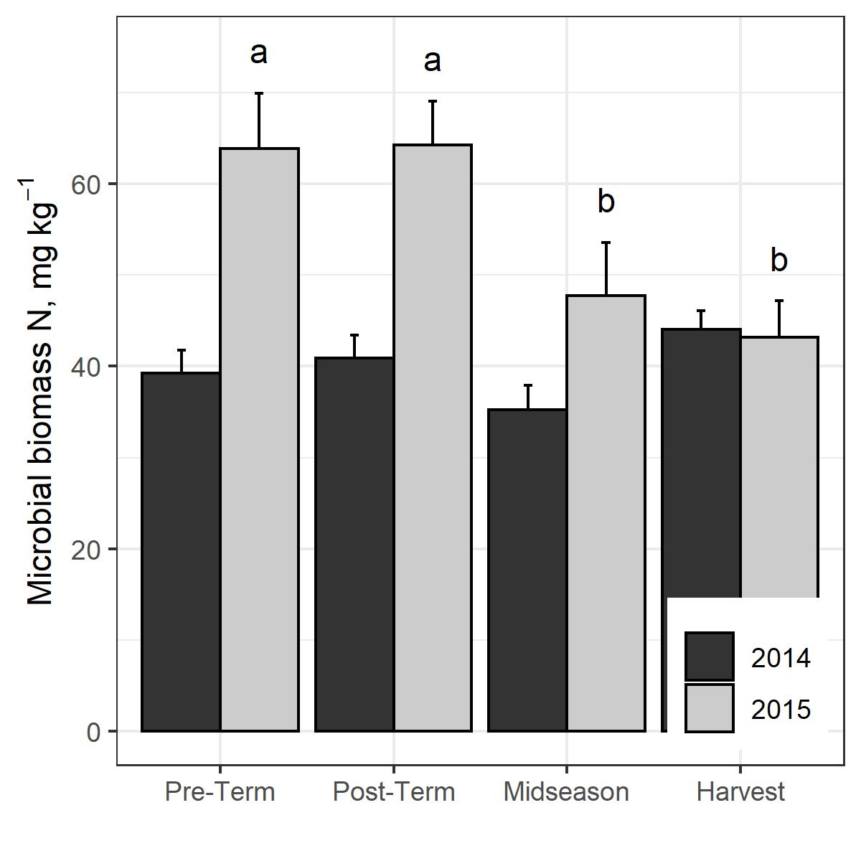

#ggsave(filename="C:/Users/.../NCSU/Studies/LabileC/Presentable/MBC Plots/2020Redo_soil_extrns/pub/final/msp_mbn_yearXsamp_all.jpeg", width = 4, height = 4, plot=a)

#Read the lowercase letters WITHIN A YEAR (ie no differences in 2014)

### Mineralizable N

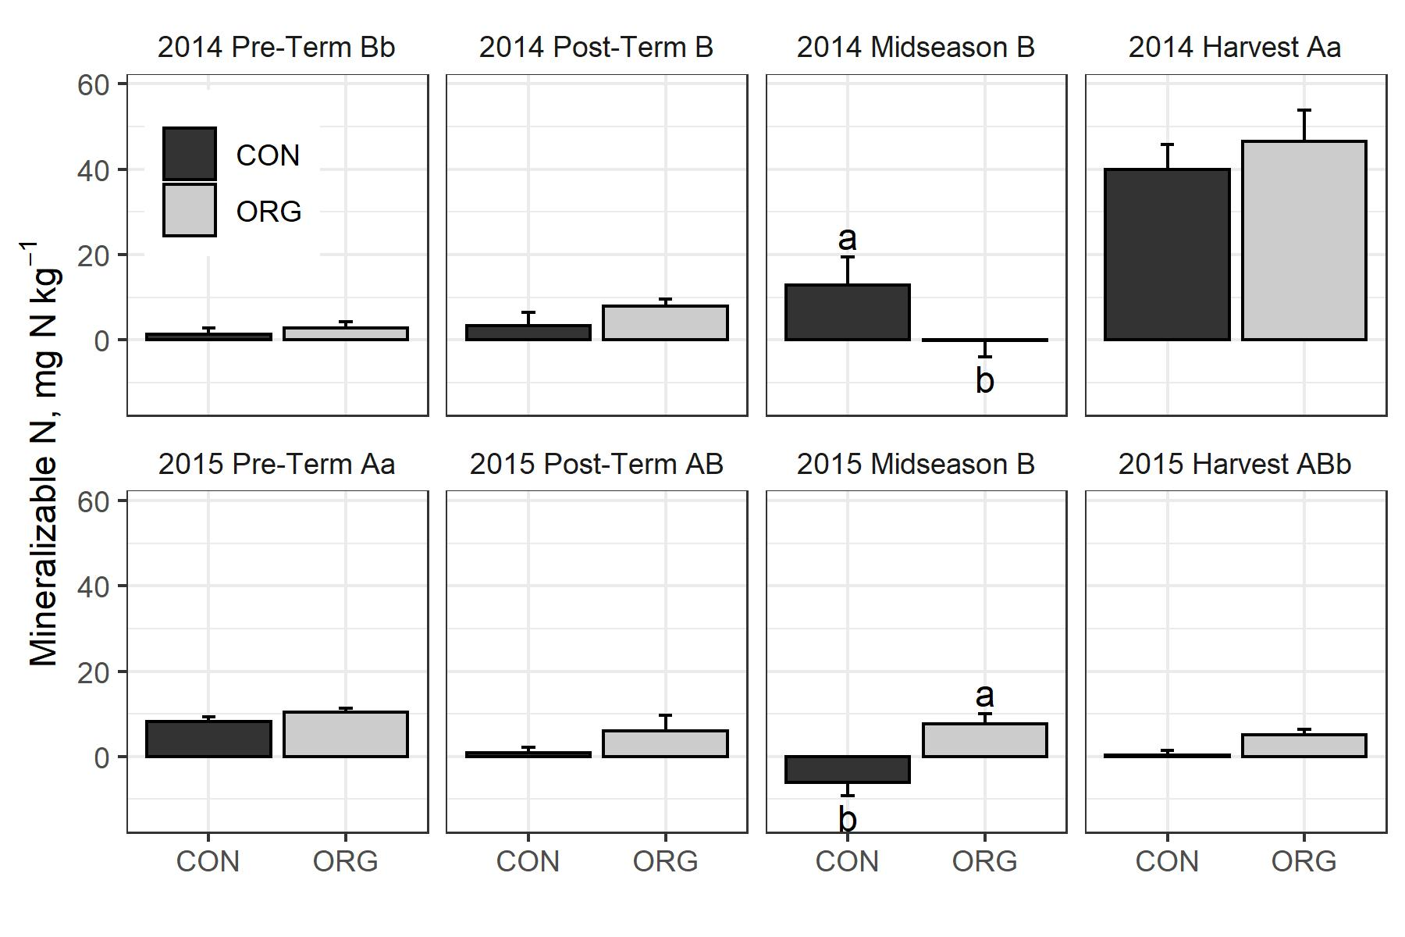

C:/Users/seanb/Documents/words/…/Studies/LabileC/Presentable/MBC Plots/2020Redo_soil_extrns/pub/final/msp_nmn_yearXsampXnut_all_and_msp_nmn_yearXsamp_all.jpeg

#On each panel, read the uppercase letters WITHIN A YEAR

#On each panel, read the lowercase letters WITHIN A SAMPLING TIME ACROSS YEARS (ie 2014 harvest > 2015 harvest)

### Mineral N

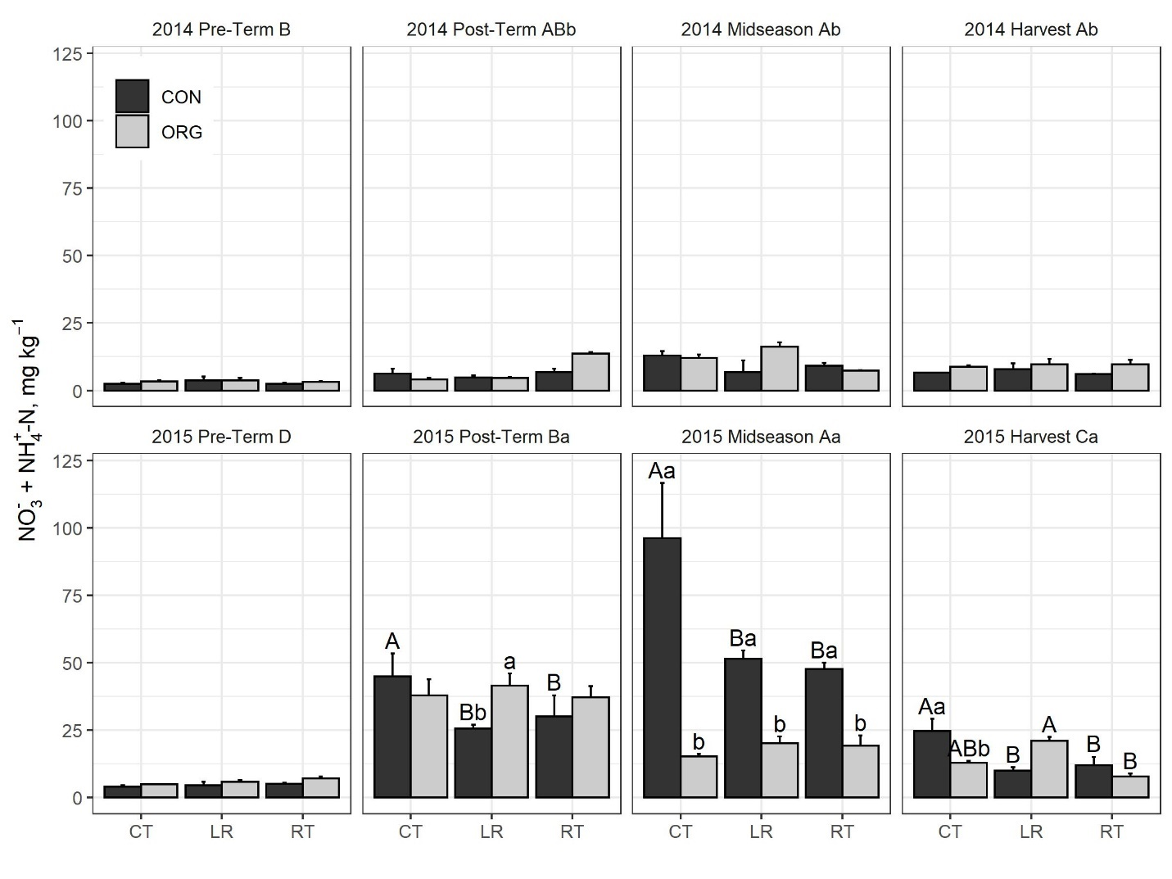

C:/Users/.../NCSU/Studies/LabileC/Presentable/MBC Plots/2020Redo_soil_extrns/pub/final/msp_min_yearXsampcltXnut_all_and_msp_min_yearXsampcltXnut_all_and_msp_min_yearXsampXnutXclt_all.jpeg

#On bars, read the uppercase letters WITHIN A FERTILIZER treatment

#On bars, read the lowercase letters WITHIN A CULTIVATION TREATMENT

#On each panel, read the uppercase letters WITHIN A YEAR

#On each panel, read the lowercase letters WITHIN A SAMPLING TIME ACROSS YEARS (ie 2014 midseason < 2015 midseason)

## Addition experiment N2O Emissions

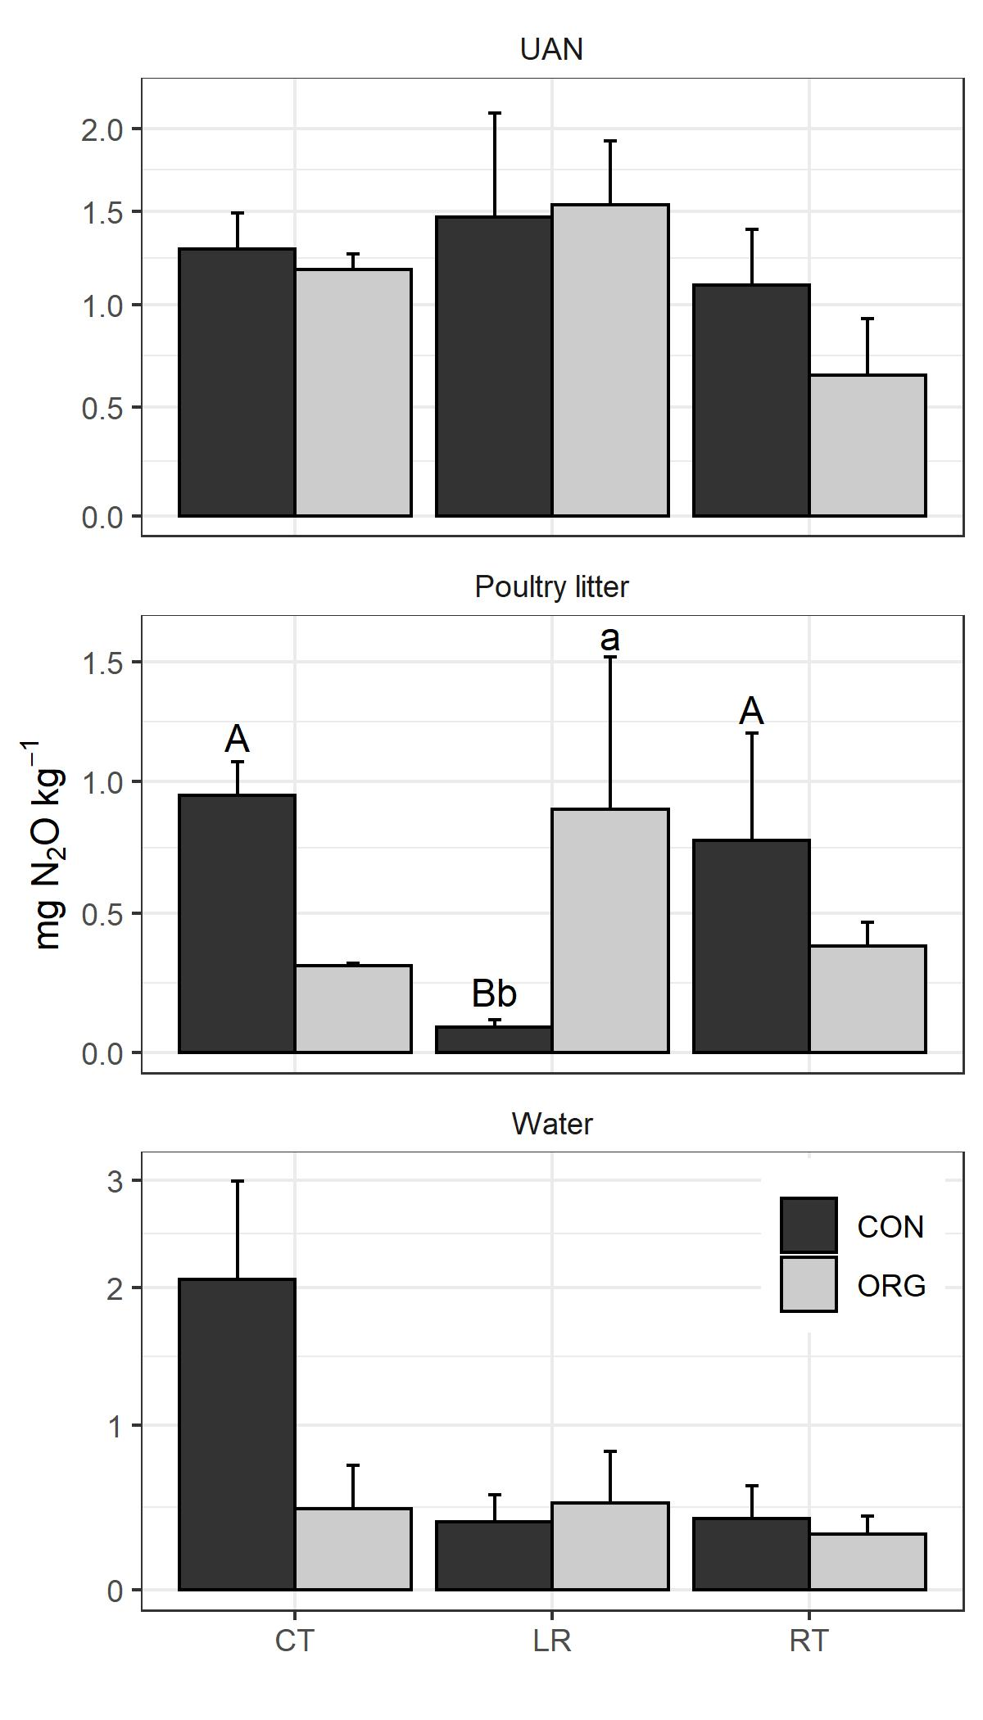

"C:/Users/…/NCSU/Studies/LabileC/Presentable/MBC Plots/2020Redo_soil_extrns/pub/final/msp_n2ol_nutXclt_org_and_msp_n2ol_cltXnut_org.jpeg”

#Read the uppercase letters WITHIN A FERTILIZER treatment

#Read the lowercase letters WITHIN A CULTIVATION TREATMENT

16mg N added per 100g soil (same for UAN and 3-2-3 (% N - %P2O5 - %K2O) litter experiments), to simulate a 168 kg ha-1 field fertilizer addition.