|  |  |  |  |  |  |  |  |  |
| --- | --- | --- | --- | --- | --- | --- | --- | --- |
|  |  |  | CON | | | ORG | | |
|  | Date | Action | CT | LR | RT | CT | LR | RT |
| 2013 | 10/25 | Disking old corn field | x |  |  | x | x | x |
| 10/22 | CC - Drill planting (Wheat, 120 lb/A, Pioneer 26R12) | x | x | x |  |  |  |
| 10/30 | CC - Drill planting (Abruzzi rye, 110lbs/ac) |  |  |  | x | x | x |
| 2014 | 4/4 | Pre-Term Soil sampling | x | x | x | x | x | x |
| 4/10 | CC - Biomass sampling | x | x | x | x | x |  |
| 4/21 | CC - Flail mowing | x |  |  | x | x |  |
| 4/22 | CC - 1st Disking (Tandem wheel disc) | x |  |  | x | x |  |
| 4/23 | CC - Spraying glyphosate (24 oz/a) |  | x | x |  |  |  |
| 5/6 | CC - Biomass sampling |  |  |  |  |  | x |
| 5/8 | Post-Term Soil sampling | x | x | x | x | x |  |
| 5/9 | CC - 2nd Disking (Tandem wheel disc) | x |  |  | x | x |  |
| 5/20 | CC - Roller-crimping |  |  |  |  |  | x |
| 5/21 | CC - 3rd Disking (Tandem wheel disc) | x |  |  | x | x |  |
| 5/27 | Soybean planting (CON: Pioneer 96M; ORG: Hutchinson; 30" centers; 175,000 seeds/A with a JD Planter) | x | x | x | x | x | x |
| 5/29 | Herbicide application (Valor SX 2 oz/A) | x | x | x |  |  |  |
| 6/4 | Midseason and N addition experiment soil sampling | x | x | x | x | x | x |
| 6/16 | Cultivation (Rotary hoe) |  |  |  | x | x |  |
| 6/26 | Applied herbicide (Roundup, 32 oz/A; Warrant , Pos, 3 Pts/A) | x | x | x |  |  |  |
| 7/15 | Cultivation (Field cultivator) |  |  |  | x | x |  |
| 10/21 | Harvest Soil sampling | x | x | x | x | x | x |
| 10/29 | Disking (Tandem wheel disc) |  |  |  | x | x | x |
| 11/4 | CC - Drill planting (10 lb crimson clover + 20 lb hairy vetch/A; additional 30 lb rye /A in RT) |  |  |  | x | x | x |
| 12/15 | Harvest | x | x | x |  |  |  |
| 12/18 | CC - Overseed planting (Wheat, 150lb/A, broadcast speader) | x | x | x |  |  |  |
|  | 4/1 | Pre-Term Soil sampling | x | x | x | x | x | x |
| 2015 | 4/1 | CC - Sprayng glyphosate (24 oz/a) | x | x | x |  |  |  |
| 4/6 | CC - Biomass sampling |  | x | x |  |  |  |
| 4/9 | CC - 1st Disking (Tandem wheel disc) | x |  |  | x | x |  |
| 4/23 | CC - Biomass sampling |  |  |  |  |  | x |
| 4/23 | CC - Roller-crimping |  |  |  |  |  | x |
| 4/23 | Apply poultry litter |  |  |  | x | x | x |
| 4/23 | CC - 2nd Disking (Tandem wheel disc) | x |  |  | x | x |  |
| 4/24 | Applied Bicep II Magnum (2.1 qt/A, S-metolachlor + Atrazine) | x | x | x |  |  |  |
| 4/24 | Corn planting 30" rows (CON: Dekalb DKC 64-69, 28,000 seeds/A with John Deere E-106 planter; ORG: Augusta A 5565; 30,000 seeds/A with John Deere 7200 MaxEmerge 2 Drawn Four Row) | x | x | x | x | x | x |
| 4/28 | Apply N (75 lb/A) | x | x | x |  |  |  |
| 5/4 | Post-Term Soil sampling | x | x | x | x | x | x |
| 5/8 | Cultivation (Rotary hoe) |  |  |  | x | x |  |
| 5/22 | Cultivation (Tine cultivator) |  |  |  | x | x |  |
| 6/2 | Apply herbicide | x | x | x |  |  |  |
| 6/2 | Apply N (87.75 lb /A) | x | x | x |  |  |  |
| 6/4 | Apply K (150 lb /A of 0-0-50 + 18 % S) | x | x | x |  |  |  |
| 6/11 | Midseason Soil sampling | x | x | x | x | x | x |
| 8/17 | Harvest | x | x | x | x | x | x |
|  | 9/8 | Harvest Soil sampling | x | x | x | x | x | x |

## ANOVA

Table 1 ANOVA of cultivation, organic versus conventional nutrient management, sampling time, and year effects on trace global warming gases, soil biological activity, and soil properties in 2014 and 2015.

|  |  |  |  |  |  |  |  |  |  |  |
| --- | --- | --- | --- | --- | --- | --- | --- | --- | --- | --- |
|  | N2O | CO2 | NMN | MBC | MBN | DOC | N | H2O | TC | TN |
| Cultivation (C) |  |  |  |  |  |  | . |  |  |  |
| Nutrient (N) |  | *** |  | . | ** | * | ** |  | * |  |
| Sampling (S) | *** | *** | *** |  | *** |  | *** | *** | - | - |
| Year (Y) | *** |  | *** | ** | *** | ** | *** |  | - | - |
| C:N | * | ** |  |  |  |  | ** |  |  |  |
| C:S |  | ** |  | . |  |  | ** |  | - | - |
| C:Y |  |  |  |  |  |  | ** |  | - | - |
| N:S |  | . |  |  |  | * | *** |  | - | - |
| N:Y | ** | *** | * |  |  | * | *** | * | - | - |
| S:Y | . | *** | *** | *** | *** |  | *** | *** | - | - |
| C:N:S |  |  |  |  | * |  | ** |  | - | - |
| C:N:Y |  | * |  |  |  |  | *** |  | - | - |
| C:S:Y |  | . |  |  |  |  |  |  | - | - |
| N:S:Y |  |  | ** | . |  |  | *** |  | - | - |
| C:N:S:Y |  | * | * |  | * |  | ** |  | - | - |

## Means separation table for significant main effects

There were no significant main effects without higher-order interactions for CO2, H2O, NMN, MBN, MBC, or N

|  |  |  |  |  |
| --- | --- | --- | --- | --- |
|  |  | N2O | DOC | TC |
| Cultivation | CT | 1.1(0.41) | 60(1.6) | 1.1(0.015) |
|  | LR | 0.49(0.1) | 59(2.1) | 1.1(0.04) |
|  | RT | 0.44(0.11) | 54(1.7) | 1.1(0.031) |
| Nutrient | CON | 0.77(0.27) | **54b(1.5)** | **0.98b(0.021)** |
|  | ORG | 0.58(0.1) | **61a(1.4)** | **1.2a(0.021)** |
| Sampling | Pre-Term | **0.096d(0.011)** | 58(2.3) | - |
|  | Post-Term | **0.47b(0.09)** | 56(2.1) | - |
|  | Midseason | **1.8a(0.53)** | 58(2.1) | - |
|  | Harvest | **0.34c(0.11)** | 58(2) | - |
| Year | 2014 | **0.27b(0.061)** | **55b(1.4)** | **-** |
|  | 2015 | **1.1a(0.28)** | **60a(1.6)** | **-** |

write.csv("./Studies/LabileC/Presentable/Results/2020_redo_means_and_anovas/means/lbc_meanssep_maineffects_only_table_for_pub_tc_only.csv")

and

write.csv("C:/Users/seanb/Documents/words/My Career/NCSU/Studies/LabileC/Presentable/Results/2020_redo_means_and_anovas/means/lbc_meanssep_maineffects_only_table_for_pub.csv")

## Table 2 N2O emissions in relation to soil variables (N=144)

|  |  |  |  |  |  |  |  |
| --- | --- | --- | --- | --- | --- | --- | --- |
|  | Pearson's r | | | | β | *b* | SE |
|  | H2O | N | CO2 | log(N2O) |
| H2O |  | -0.309*** | 0.097 | -0.587*** | -0.472 | -8.717*** | 1.095 |
| N |  |  | -0.094 | 0.567*** | 0.442 | 0.015*** | 0.002 |
| CO2 |  |  |  | 0.132 | 0.220 | 0.211*** | 0.054 |
| Mean | 0.126 | 15.8 | 1.28 | -0.693 | Intercept = -0.101 | | |
| SD | 0.034 | 18.3 | 0.647 | 0.620 | Adj.*R*2 *=* 0.548*** | | |

H2O soil gravimetric moisture; N soil NH4++NO3--N; CO2 mineralizable C; β standardized regression slope coefficients in standard deviations from the centered variable; *b* unstandardized regression slope coefficients; SE standard error of the unstandardized slopes; *** sigificant at *p* < 0.001

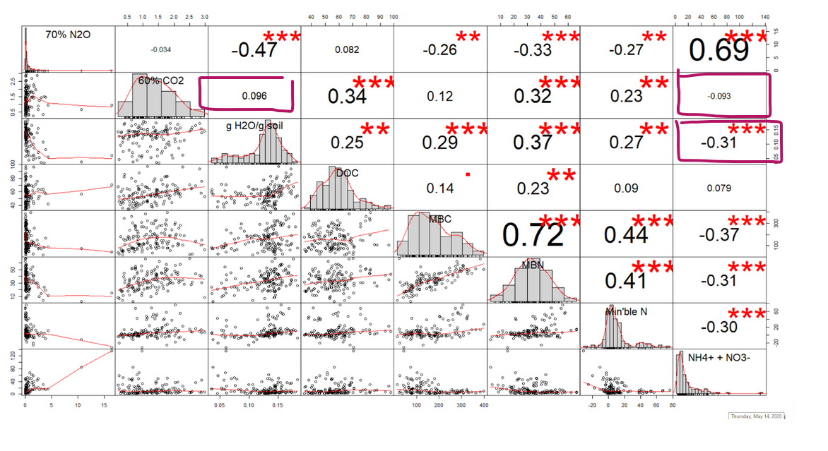

## N2O

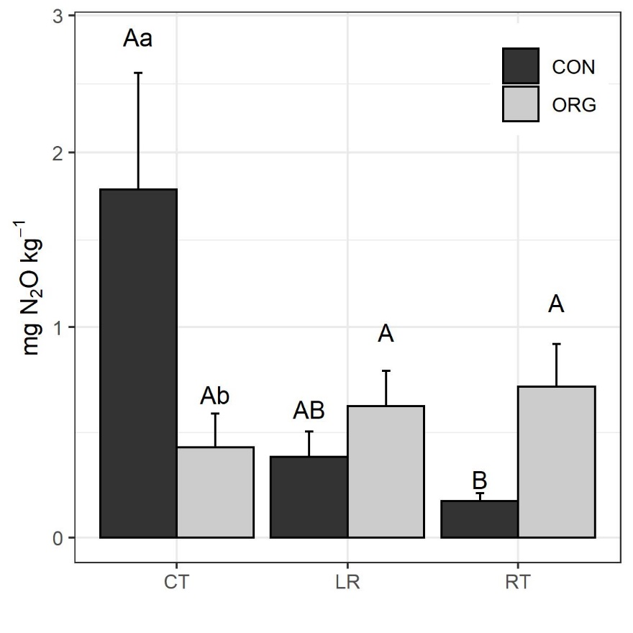

#Read the uppercase letters WITHIN A FERTILIZER treatment

#Read the lowercase letters WITHIN A CULTIVATION TREATMENT (Ie no difference between org and conv within LR bc no letters)

## CO2

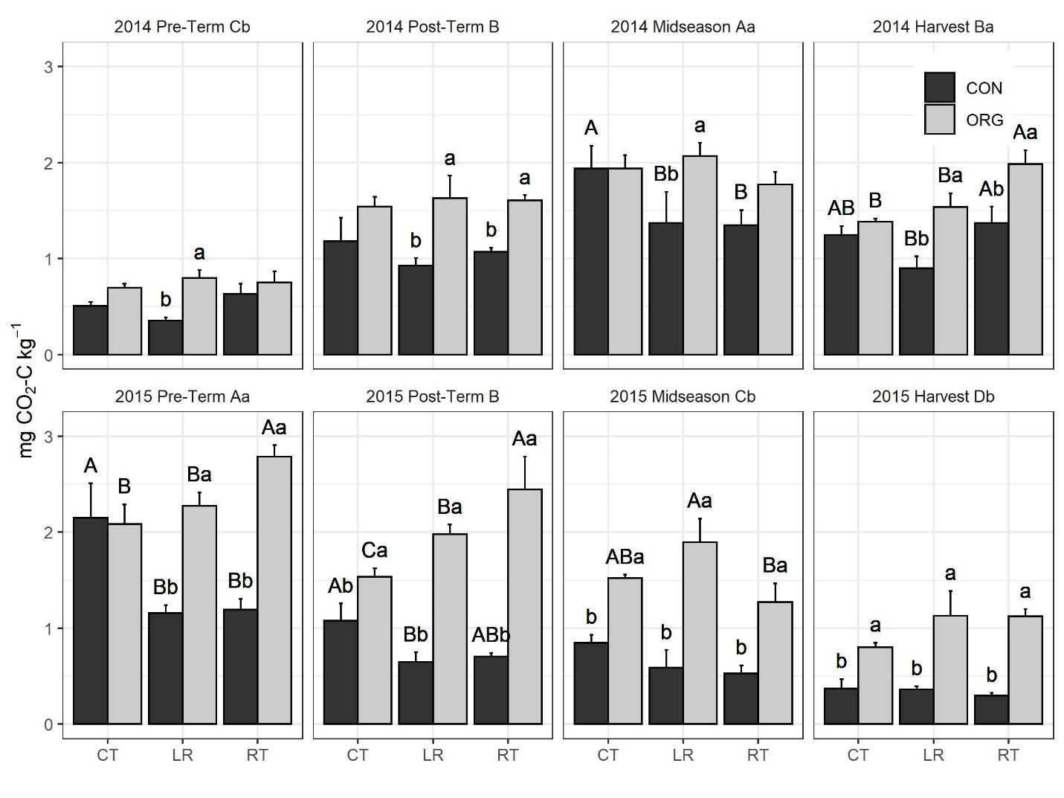

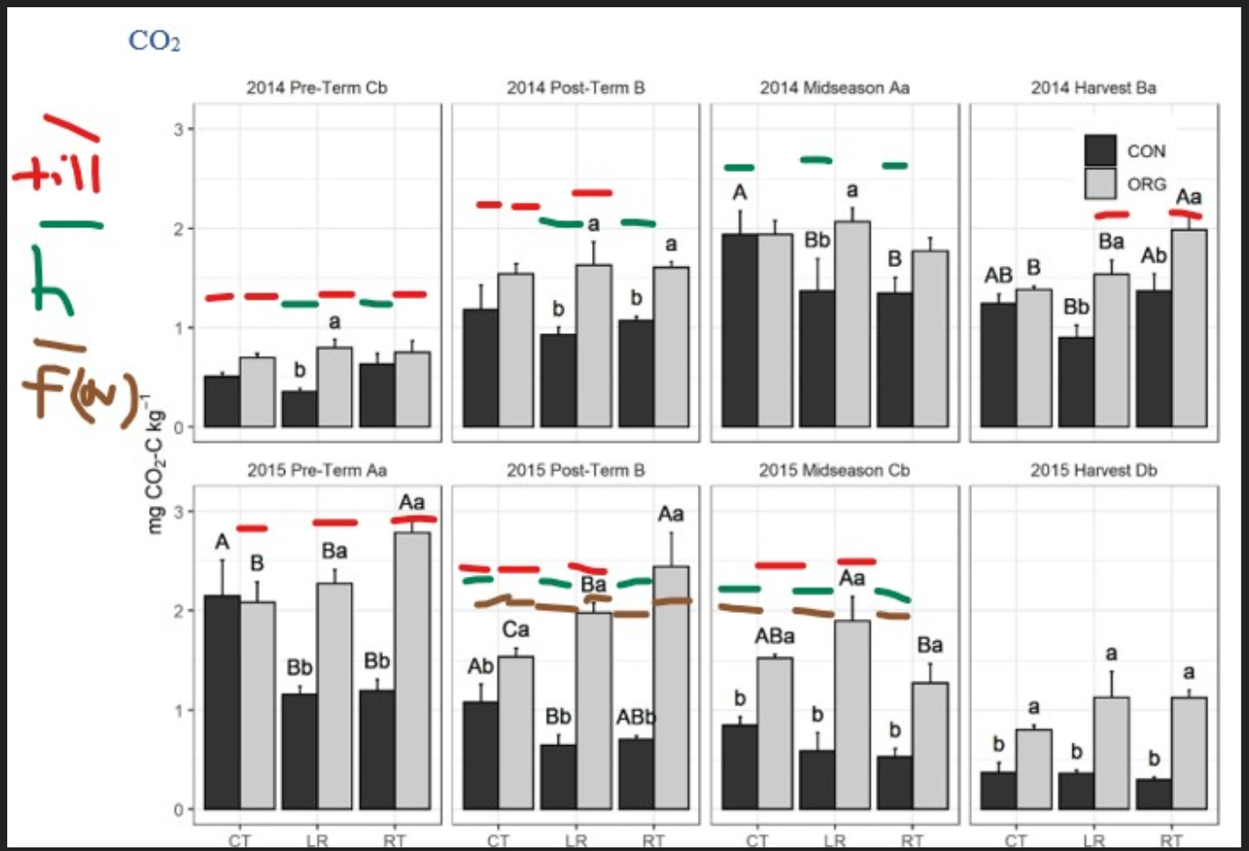

"C:\Users\seanb\Documents\words\My Career\NCSU\Studies\LabileC\Presentable\MBC Plots\2020Redo_soil_extrns\pub\final\msp_co2a_d_yearXsampcltXnut_all_and_msp_co2a_d_yearXsampcltXnut_all_and_msp_co2a_d_yearXsampXnutXclt_all.jpeg"

#On bars, read the uppercase letters WITHIN A FERTILIZER treatment

#On bars, read the lowercase letters WITHIN A CULTIVATION TREATMENT

#On each panel, read the uppercase letters WITHIN A YEAR

#On each panel, read the lowercase letters WITHIN A SAMPLING TIME ACROSS YEARS (ie 2014 midseason > 2015 midseason)

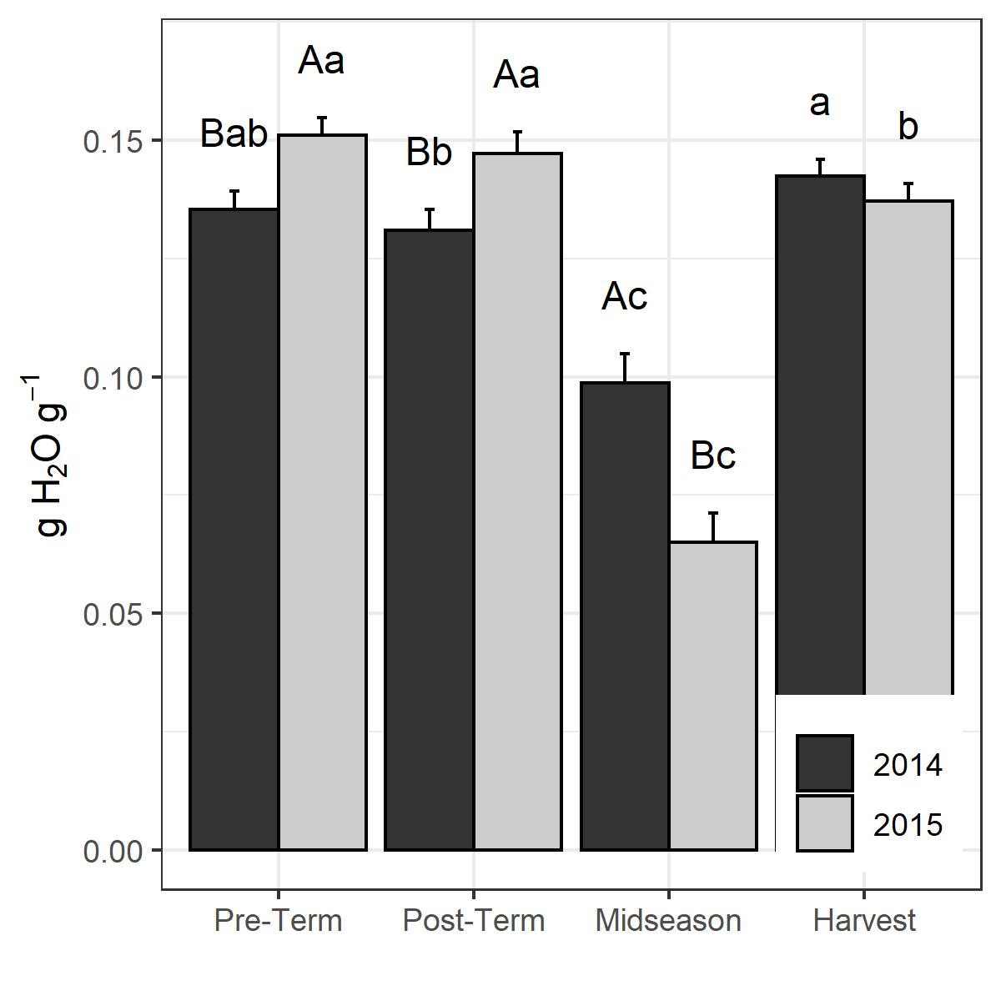

#ggsave(filename="C:/Users/.../NCSU/Studies/LabileC/Presentable/MBC Plots/2020Redo_soil_extrns/pub/final/msp_grvwat_yearXsamp_all.jpeg", width = 4, height = 4, plot=a)

#Read the lowercase letters WITHIN A YEAR (ie in both years midseason is lower than harvest)

#Read the uppercase within a SAMPLING

Note there is that N*Y interaction but it means that 2015 was drier than 2014 in organic while 15 and 14 were the same in conventional. Boring.

## DOC

No interactions except year*nut, and that is only magnitude interaction not direction interaction (i.e. main effects still are accurate that org>conv overall, 2015>2014 overall, just by different degrees).

These main effects are in the table.

## MBC

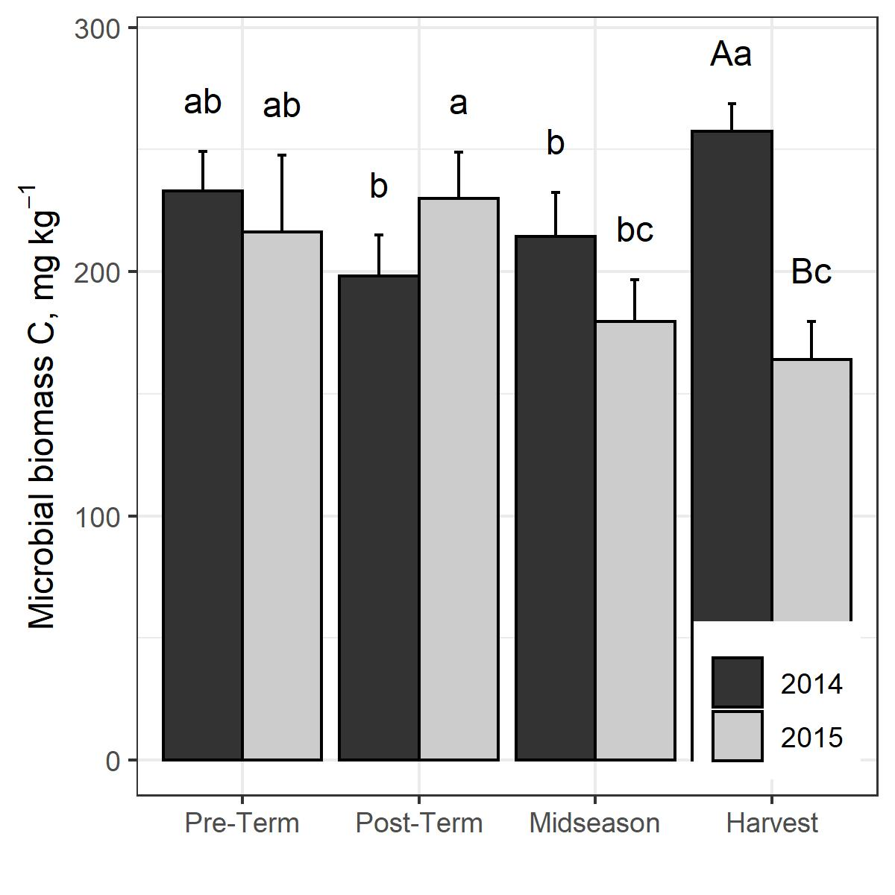

C:/Users/seanb/Documents/words/My Career/NCSU/Studies/LabileC/Presentable/MBC Plots/2020Redo_soil_extrns/pub/final/msp_mbc_mgkg_yearXsamp_all.jpeg

#Read the lowercase letters WITHIN A YEAR

#Read the uppercase within a SAMPLING

## MBN

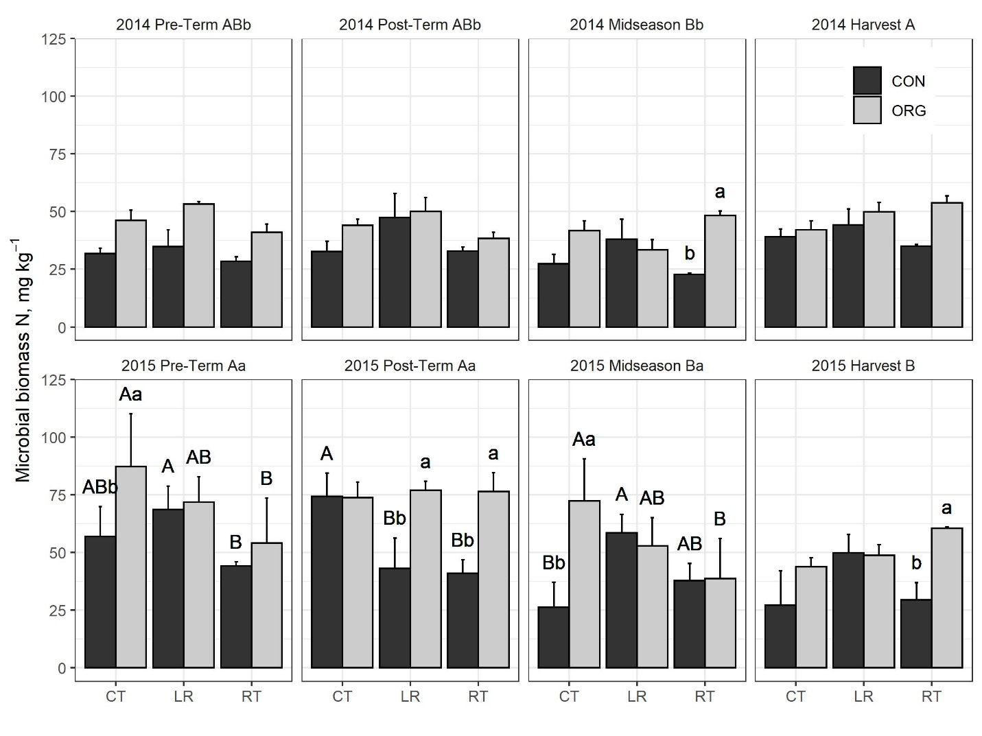

ggsave(filename="C:/Users/seanb/Documents/words/My Career/NCSU/Studies/LabileC/Presentable/MBC Plots/2020Redo_soil_extrns/pub/final/msp_mbn_yearXsampcltXnut_all_and_msp_mbn_yearXsampcltXnut_all_and_msp_mbn_yearXsampXnutXclt_all.jpeg", width = 8, height = 6, plot=a)

#On bars, read the uppercase letters WITHIN A FERTILIZER treatment

#On bars, read the lowercase letters WITHIN A CULTIVATION TREATMENT

#On each panel, read the uppercase letters WITHIN A YEAR

#On each panel, read the lowercase letters WITHIN A SAMPLING TIME ACROSS YEARS (ie 2014 midseason > 2015 midseason)

## NMN

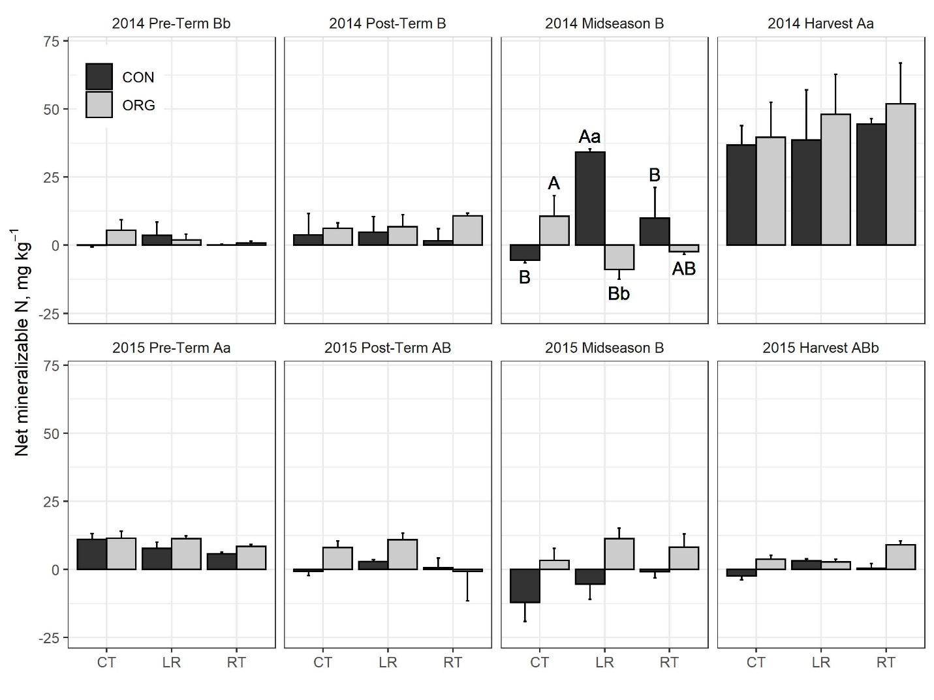

#ggsave(filename="C:/Users/seanb/Documents/words/My Career/NCSU/Studies/LabileC/Presentable/MBC Plots/2020Redo_soil_extrns/pub/final/msp_nmn_yearXsampcltXnut_all_and_msp_nmn_yearXsampcltXnut_all_and_msp_nmn_yearXsampXnutXclt_all.jpeg", width = 8, height = 6, plot=a)

#On bars, read the uppercase letters WITHIN A FERTILIZER treatment

#On bars, read the lowercase letters WITHIN A CULTIVATION TREATMENT

#On each panel, read the uppercase letters WITHIN A YEAR

#On each panel, read the lowercase letters WITHIN A SAMPLING TIME ACROSS YEARS

## MIN

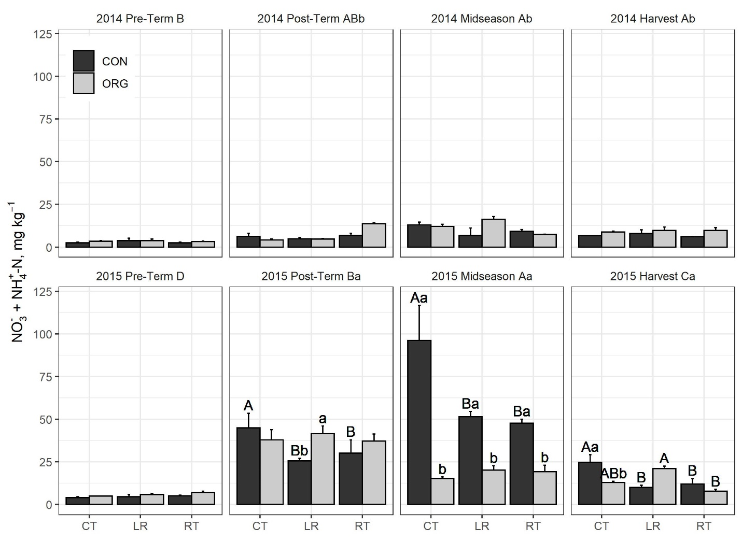

#ggsave(filename="C:/Users/seanb/Documents/words/My Career/NCSU/Studies/LabileC/Presentable/MBC Plots/2020Redo_soil_extrns/pub/final/msp_min_yearXsampcltXnut_all_and_msp_min_yearXsampcltXnut_all_and_msp_min_yearXsampXnutXclt_all.jpeg", width = 8, height = 6, plot=a)

#On bars, read the uppercase letters WITHIN A FERTILIZER treatment

#On bars, read the lowercase letters WITHIN A CULTIVATION TREATMENT

#On each panel, read the uppercase letters WITHIN A YEAR

#On each panel, read the lowercase letters WITHIN A SAMPLING TIME ACROSS YEARS

## N addition experiment

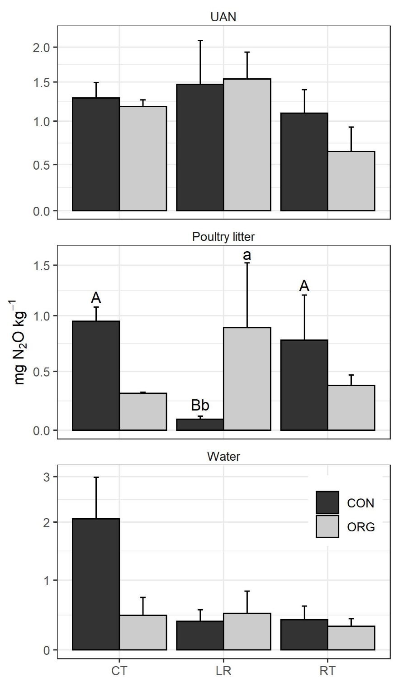

#Read the uppercase letters WITHIN A FERTILIZER treatment

#Read the lowercase letters WITHIN A CULTIVATION TREATMENT

In addition, mineral N > water only = organic N (a> b=b) in another ANOVA of a model with the actual amendment type as a factor. (C:/Users/seanb/Documents/words/My Career/NCSU/Studies/LabileC/Presentable/Results/2020_redo_means_and_anovas/means/gas/n2o/means_n2o_2014-xxxx_24-204h_cum_70WFPS_labtrXcltXblock.txt)