**PHASE – 5: DEVELOPMENT PART 3**

**INTRODUCTION:**

**The objective of the provided PHP script can be summarized as follows**:

**1. Retrieve Data:**

Retrieve the most recent water level data from a database table named 'level-log.'

**2. Calculate Water Level:**

Determine the remaining water level in a tank by subtracting the retrieved data from the total tank height.

**3. Calculate Volume:**

Calculate the volume of water in the tank based on the tank's dimensions (diameter and height) and the calculated water level.

**4. Real-time Monitoring:**

Implement a system that enables real-time tracking and monitoring of water consumption in homes, public places, and industries.

**5. Web Application:**

You've developed a web application that is hosted on a remote server.

The web application fetches data from the remote database to update its user interface.

These objectives serve as a guide for the development and implementation of the IoT water consumption monitoring system, addressing the critical issues of water conservation and responsible water usage.

This is an IOT project implemented using Raspberry Pi and custom Web Application. I have revamped the Web Application code for better understanding.

an ultrasonic sensor is fitted on top of the water tank. The sensor is connected to Raspberry Pi, which measures water level in the tank every minute. The water level reading is fed to a remote database. A Web Application running in the remote host makes use of this data to update the water level animation and the thin bar line graph.

**SCHEMATICS DIAGRAM:**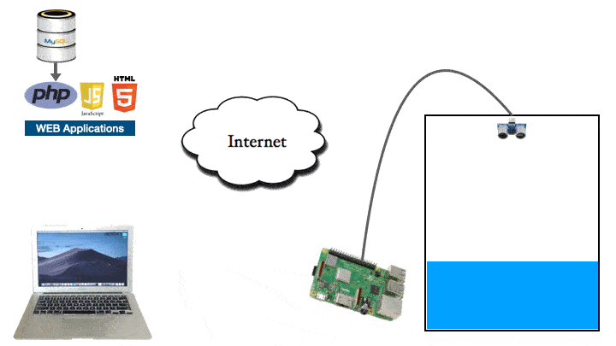

**DEVELOPMENT CODE WITH EXPLANATION:**

<!Doctype html>

<html lang="en">

<head>

<script type="text/javascript" src="https://cdn.fusioncharts.com/fusioncharts/latest/fusioncharts.js"></script>

<script type="text/javascript" src="https://cdn.fusioncharts.com/fusioncharts/latest/themes/fusioncharts.theme.fusion.js"></script>

<script type="text/javascript" src="tank_animation.js"></script>

</head>

<body>

<div style='border:0px solid green;'>

<div id='chart-container'>Reload Page if you don't see animation</div>

</div>

</body>

</html>

The components of Smart Water Tank

**The key components of this project are as follows:-**

1. **Web Application**.  The web application is created using PHP, HTML & Javascript as frontend and MySQL as backend.

2. **Webserver**. To run the web application, you will need a webserver. You can host the web application locally on a webserver on your LAN or you can host it on a webserver provided by any hosting provider accessible through a public IP address.

For Local host. You can use widely popular XAMPP to install a webserver  on a PC. The package installs Apache Webserver, PHP and MySQL database server on your PC.

For Remote host. You need to buy a web hosting plan from any of the hosting provider like Godaddy, Speedhost etc.

3. **Raspberry Pi**.  Raspberry Pi has a built in Wifi which makes it easier to connect to internet through home wifi router. Also, it has GPIO pins for external hardware / sensor interface. So basically we can program it to measure a sensor’s data and send it to a remote / local server through wifi ethernet network. It is not necessary to use a Raspberry Pi for this project, you can use other modern microcontrollers such as ESP32 which are much cheaper and have built in wifi. I chose Raspberry Pi as it supports Python and has good community support.

4. **Ultrasonic Sensor**. HCSR-04 ultrasonic sensor is used for measuring distance. It works on the basic principle of sound wave relfection from an object and time taken by the echo to calculate the distance. The sound wave emitted by this sensor are reflected back by water surface just as good as they would reflect back from a wall. So the idea is to mount this sensor on top of the water tank to get the sound wave reflection from the surface of water. This sensor is controlled by a Python script running on the Raspberry Pi.

Installing the code in your webserver

I recommend that you download the code from github and refer to it as you read the article.

Extract the zip file and place the ‘water-tank’ folder in the public directory of your webserver. It is ‘htdocs’ if you have used the XAMPP. it is also named as ‘www’ if you use different installer. In my macbook this is where the folder is located:-

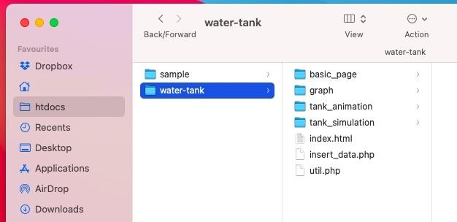

Inside the ‘water-tank’ folder you should find a file called ‘water_level.sql’. This contains the sample database.  Using the PHPmyadmin interface create a database called ‘water_level’ and import this sql file. Post successful import, you should see the table named ‘level_log’ is created as shown in picture below.

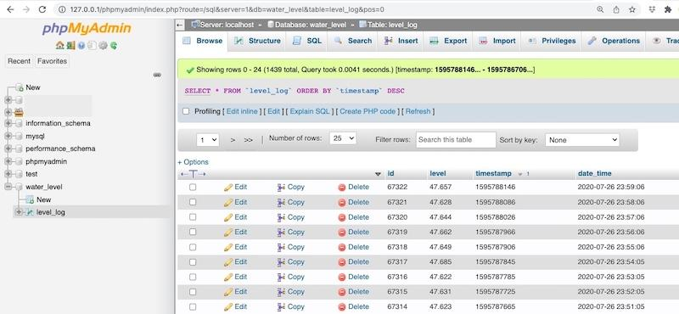

This table is used for storing the readings arriving from the remote sensor. Do not forget to provide the database connection parameters in the beginning of 'util.php' file. Also, enter the physical dimensions of your tank as shown below. They are required for the purpose of calculating volume of the liquid present in the tank.

<?php

**global** $db_server, $db_username, $db_pwd,$db_name;

$db_server='localhost';

$db_username='root';

$db_pwd='';

$db_name='water_level';

//-------------------------------

**global** $dia, $height;

$dia=104; //cm

$height=116; //cm

Now, open a browser and type ‘127.0.0.1/water-tank’ in address bar. Replace ‘127.0.0.1’ with the IP address of the webserver if you are accessing the web application from a some other PC connected to the same LAN.

You should see the following page:-

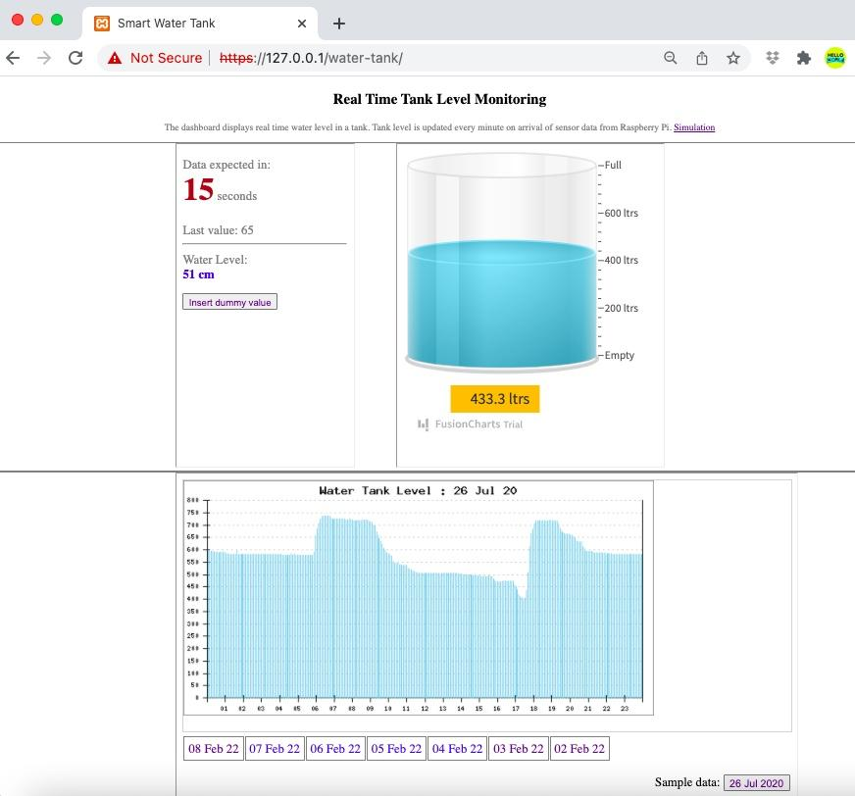

Let me describe each section of the web page in detail.

The Web Application

As you can see in the picture above, the page has 3 major sections. The information on the left side of tank (section 1), the animated tank (section 2) and the graph (section 3). Each of these sections is a different web page in itself containing a particular functionality. They are all rendered together using <iframe> tags in ‘water-tank/index.html’ file.

**Section 1 : The basic page**

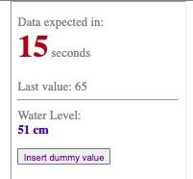

The page is rendered through 'index.html' file inside  'basic_page' folder. The task of javascript embedded in this page is to fetch the html code from the server every 2 seconds and place it in the tag with id 'info'. The javascript function get_data() which is the essence of its core functionality, does this task.

**function** **data_request_timer**(){

window.setInterval(get_data, 2000); //timer for running get_data() function every 2 seconds

}

**function** **get_data**(){

console.**log**("fetching data from server");

$.**get**("read_data1.php",

**function**(data, status){

       document.**getElementById**("info").innerHTML = data;

   });

}

As seen in the code above, using jQuery $.get() method, we make ajax call to the server looking for response from “read_data1.php” file. The php file, when triggered through ajax request, queries the database to fetch the latest entry in the ‘level_log’ table. Based on the timestamp of the entry, it calculates how old the entry is and dynamically generates the html code.

$html="<**div** style='$style'>

       $msg $img

<**br**><**br**>

Last value: $x_cm <**br**>$ago

<**hr**>

Water Level:<**br**> <**b** style='color:blue'>$water_level cm</**b**><**br**>

     </**div**>”;

echo”$html”;

This html code is sent back to the client (basic_page/index.html) as ajax response. The response is displayed by the element with id ‘info’ inside the ‘index.html’ file.

**Section 2 : The Tank Animation page**

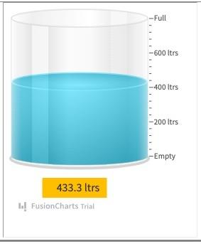

The code for this section is placed inside ‘tank_animation’ folder. The animated tank is rendered at element with id ‘chart-container’ inside the ‘index.html’ file. The code responsible for generation of the animated tank is present inside ‘tank_animation.js’, provided by a website called Fusion chart. The appearance and behaviour of this tank can be adjusted by tweaking the parameters in ‘tank_animation.js’ file. Important points to note

*line 5*: renderAt: 'chart-container' (the id of html element where the tank is rendered)

*line 14*: "upperLimit": "800" (set upper limit of the tank, all the markers adjust automatically. In this case it denotes volume of liquid)

*line 21*: "dataStreamUrl": "read_data2.php" (The server file which feeds the data to tank)

*line 30*: "value": "700" (maximum value (volume of liquid) expected, should be less than the upper limit)

This JS file expects data from server in a certain format every 2000 milliseconds (or 2 seconds, line 63). The format must begin with keyword ‘&value=’ followed by the data value (line 62). This data is generated and provided by ‘read_data2.php’ file in the server. The path of this PHP file is entered at line 21. You can have a look at the code of ‘read_data2.php’ file and notice that this file also queries the database to fetch the latest entry. Then it calculates the volume of the water available in the tank and finally outputs a string which begins with keyword ‘&value=’ followed by the volume. This process happens every 02 seconds as defined in line 63 of ‘tank_animation.js’ file.

$x_cm=$row['level']; //latest depth value in database

**global** $dia, $height;

$water_level= $height-$x_cm;

$water_level= round($water_level,1);

$volume=calculate_volume($dia,$water_level);

$str="&value=".$volume; //prepare the string format expected by the tank_animation.js file

**echo**"$str"; //send the data back to the client via ajax request

You can play around with other parameters also to understand the working of the animation. Do not forget to clear the browser cache whenever you tweak the ‘tank_animation.js file’.

**Section 3 : The Graph**

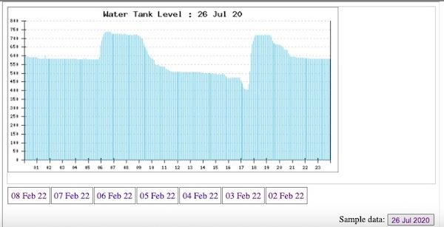

I found a nice php graph library known as PHplot. This library provides multiple types of graphs to choose from. You can read the documentation provided [here](http://phplot.sourceforge.net/phplotdocs/). I chose the [thinbar line](http://phplot.sourceforge.net/phplotdocs/ex-thinbarline1.html)graph to plot the readings of tank level in a day. These graphs are easy to use, however, they expect you to feed the data in a certain manner. That is where the whole coding effort is needed.

The code for plotting this graph lies in the folder ‘graph’. The ‘index.php’ file renders the graph by invoking graph.php file inside an <iframe>. It also generates the hyperlinks of previous 7 dates.

The file ‘graph.php’ is all about reading the ‘level’ values from the database for a given date and preprocess them to form a data structure (a two dimensional array) that is expected as input by the thin bar line graph.

Once the two dimensional array is ready, pass it to PHplot function to plot the graph.

**function** **draw_graph**($arr2d){

    $plot = **new** PHPlot(600, 300); //size of graph

    $plot->SetImageBorderType('plain');

    $plot->SetPlotType('thinbarline');

    $plot->SetDataType('text-data');

    $plot->SetNumXTicks(24);

    $plot->SetDataValues($arr2d); //this 2-d array is generated and passed here to plot the data

    # Main plot title:

    $dt_graph=$_GET["date"];

    $dt= date('d M y', strtotime($dt_graph));

    $title='Water Tank Level : '.$dt;

    $plot->SetTitle($title);

    $plot->DrawGraph();

}

The code is well commented, have a closer look if you want to understand it. So, when you press a date button, the data corresponding to that date is fetched from the database and structured in a 2-d array which can be consumed by the thinbar line graph of PHplot library.

Raspberry Pi and HCSR-04 Hardware Connection

The hardware connection to interface Ultrasonic distance sensor with Raspberry Pi are as shown in pic below

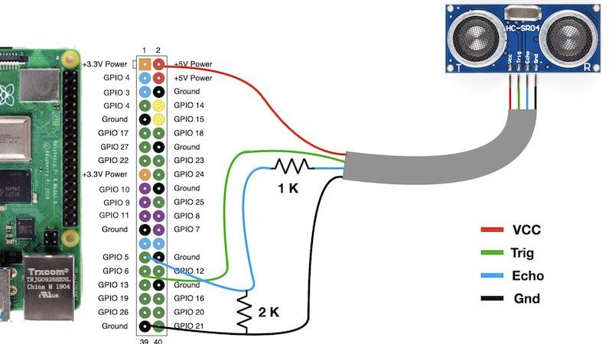

Raspberry Pi Configuration

The Python Code for Raspberry Pi is located in the 'raspberry-pi' folder. Simply copy this folder to any location in Raspberry Pi. I have placed it in 'Downloads' as seen in picture below.

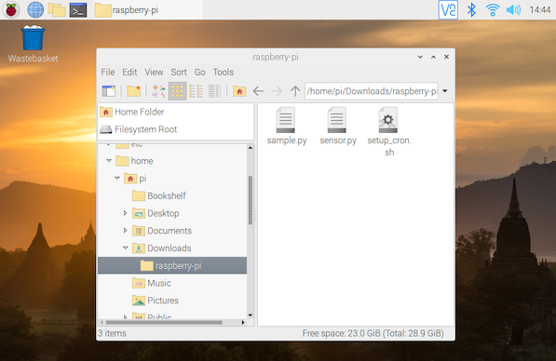

The 'sample.py' is a minimalistic file that can be used to test communication with the Web Application. This file generates a random value and sends it to the server. Open the terminal and run this file. You will notice that it makes a web request to the server as shown below.

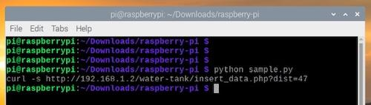

Now, connect the ultrasonic sensor to Raspberry Pi as per connection diagram and run the main file 'sensor.py'. It contains the code to generate distance data through ultrasonic sensor and sends it to the server.

Finally, set up a cron task to run the 'sensor.py' automatically every one minute. You can do it using the 'crontab -e' command and create the entry manually. Otherwise, simply run the 'setup_cron.sh' bash file. It ensures that the cron task in created correctly.

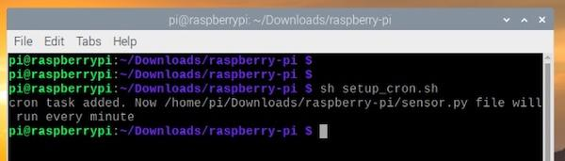

You can check the cron entry by using 'crontab -l' command as shown below

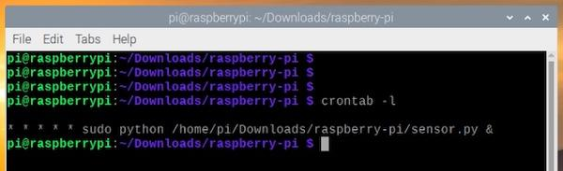

Thats it, you have successfully implemented this project.

**Conclusion:**

The Smart Water Tank project is a successful implementation of an IoT (Internet of Things) system that monitors and manages water levels in a tank. The project combines hardware, software, and web technology to provide real-time and historical insights into water levels.