**Project name**:Form Creation and validation

**Software needed** : Xampp

**Database**: Mysql

**Database name**: wiredelta

**Short description about the module**

* This is module for creating the dynamic form elements using drag and drop format.
* Client side validation is available on this.
* In this i save the created form in mysql database.
* The saved templates has been displayed on the bottom of the page as link while click the click in popup the saved html has been displayed out

**Screenshots:**

1. **Home page:**

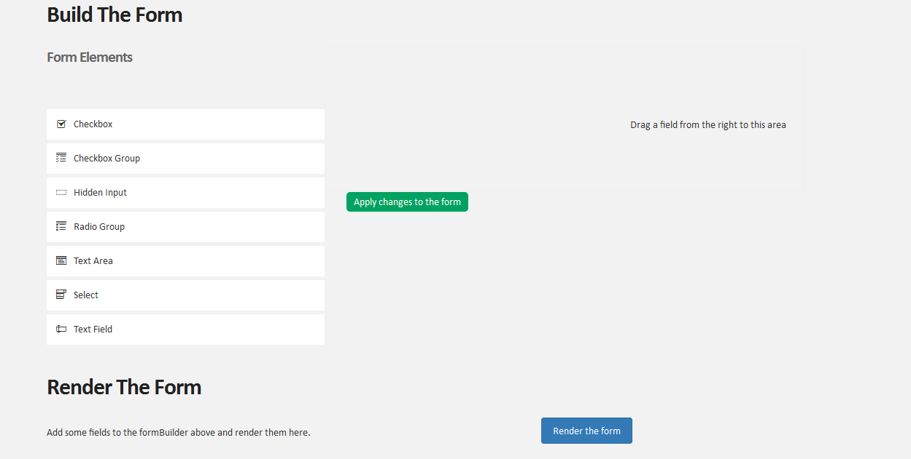

2.**Drag and drop**



In this we can drag the html elements from right side to the left. There are seven set of elements here on that text fields have four inner types .

3.**Element edit and Validation**

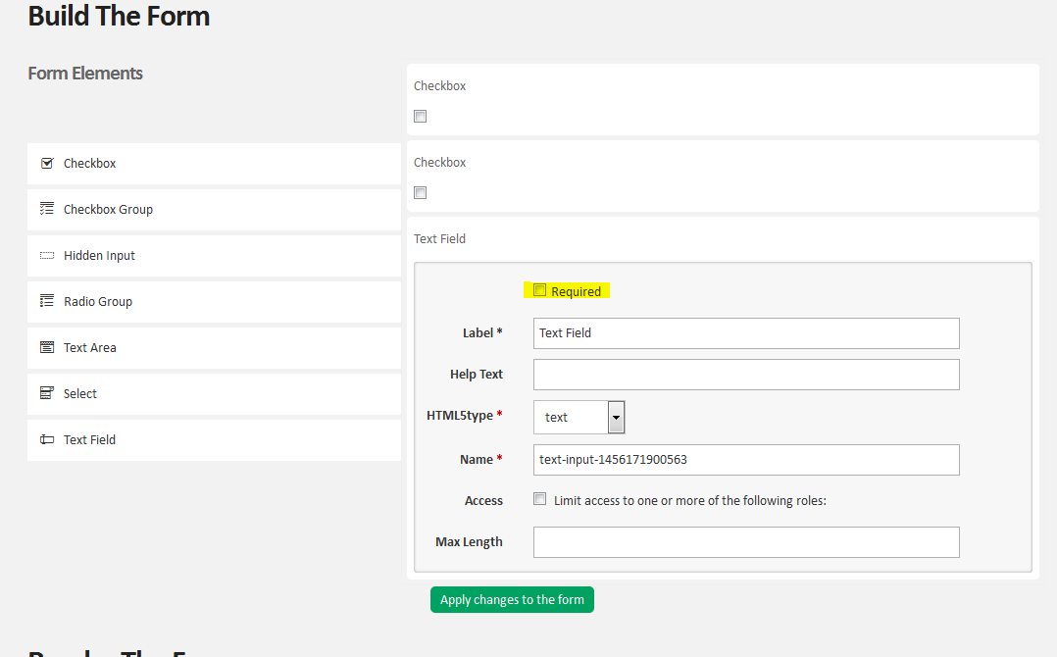

In there was an edit icon which will appear when we hover it mouse its near to the label name. After that there was a checkbox called REQUIRED while we check the element will became a mandatory one.

4. **Text box types and maxlength**

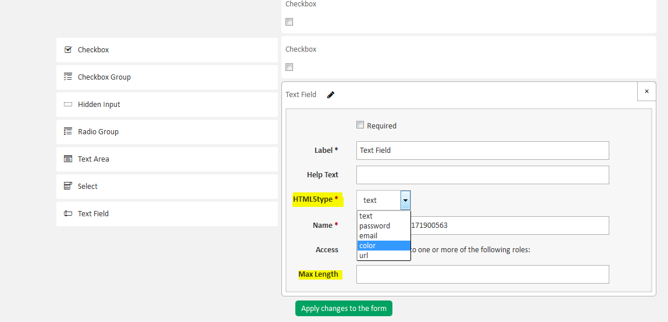

It will appears when we drag the text field in the HTML5type there were five options while select that the element will change appropriately.

The maxlength field which is used for to control the length of input characters .

5.**Apply the changes to the form**   
  
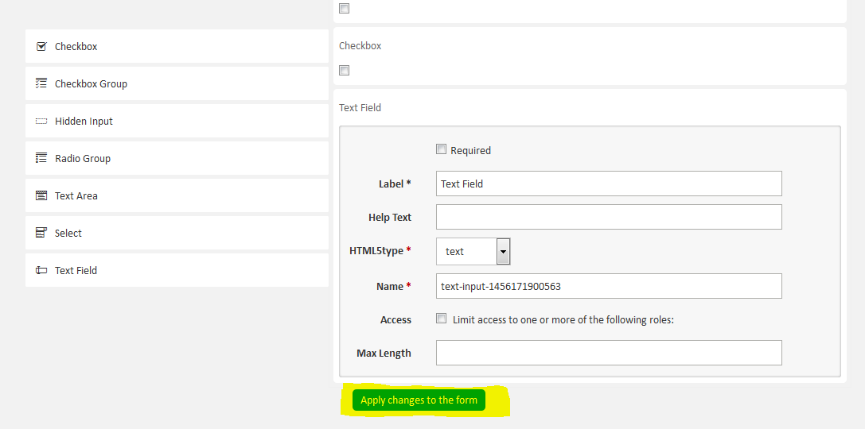

In this after the all the changes done when we click the Apply changes to the form . The code for to create the form will be structured.

**For every changes we have to click this button**

**6.** **Render the form**

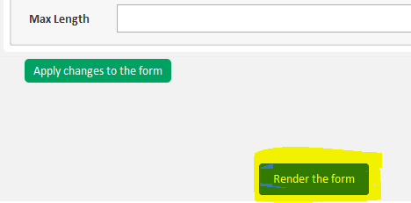

While click the Rendered the form the form will be generated and the generated form will be shown on the left side of the button .  
  
At the same time the generated form will be stored on the database.

After this when we refresh the page the generated template list is showing on the bottom