How this affects the sound of the ouput?

The effect of this change is to produce multiple echoes rather than one echo in the output signal and the amplitude of the each echo is smaller than the echoes appear before it.

Given: b0=1, G=0.8, N=800

The **difference equation** is:

y(n)=b0*x(n)+G*y(n-N) = x(n) + G*y(n-800)

The **transfer function** is:

y(n) = x(n) + 0.8y(n-800)

y(z) = x(z) + 0.8y(z)z-800

(1-0.8z-800)y(z) = x(z)

y(z) = x(z) / (1-0.8z-800)

By definitione: H(z) = y(z)/x(z) = x(z) / (1-0.8z-800) * (1/x(z)) = 1/ (1-0.8z-800)

Therefore,

$$H(Z)= \frac{1}{1 - 0.8Z^{-800}}$$

The **Impulse response** of the filter is:

$h(n) ={ 0.8 }^{\frac{n}{800}}U(\frac{n}{800})$

Because the it defined in discrete time, when n/800 is and integer and n>=0,

$$h(n) ={ 0.8 }^{\frac{n}{800}}U(\frac{n}{800})$$

Otherwise,

$h(n) =0$

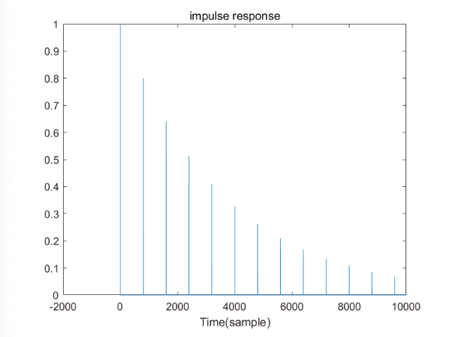

What happens when the gain for the delayed value is greater than 1?

If the delayed gain is greater than 1, the value of the delayed part will increase continuously, the output becomes blurred and obvious. We cannot recognize the words in the output signal.