The content for this project is stored at .\csse477FinalProject\edu.rosehulman.sws\Reports

1. Architecture Diagram

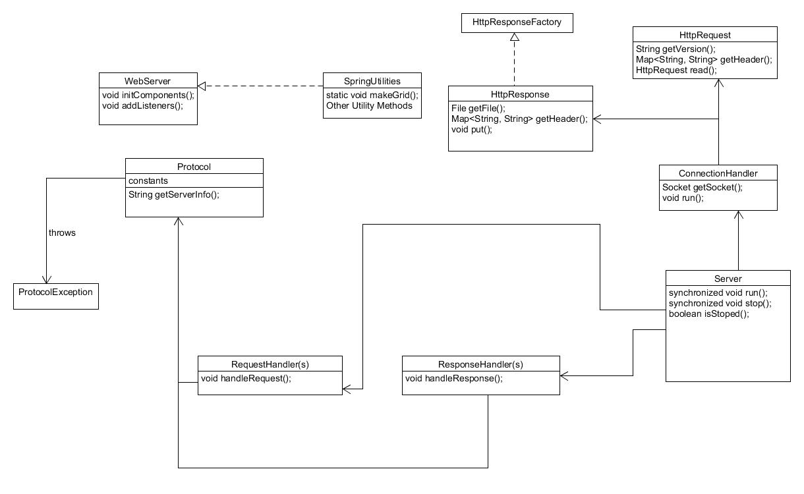

1. List of Patterns

The main pattern that is used so far is the Strategy pattern. The factory pattern is also used for HttpResponse(s).

1. How could we improve the design?

The greatest weakness that currently exists is that multiple clients connect directly to the same server. For this approach, the client needs to know a lot of information about the remote server to be able to connect to it. And this isn’t always the best for expanding systems. The server may also care what kind of device is connecting to it and need to worry about that. In this way, a server/client relationship can start to take on too much burden. The best way of improving the design would be to add in a Broker pattern or something like it.

1. Test Report (on the next page)

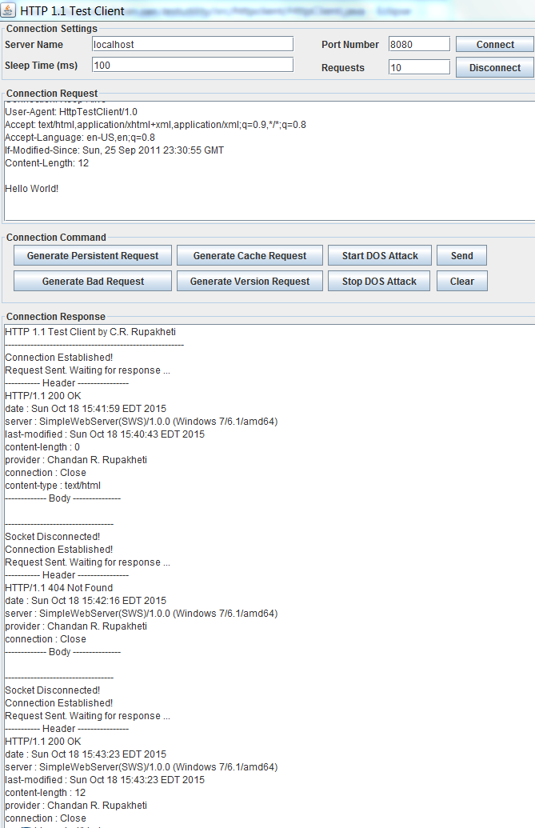

Above is a shot of the client (browser). The log file for this scenario lives in the main project at csse477FinalProject\edu.rosehulman.sws\Reports

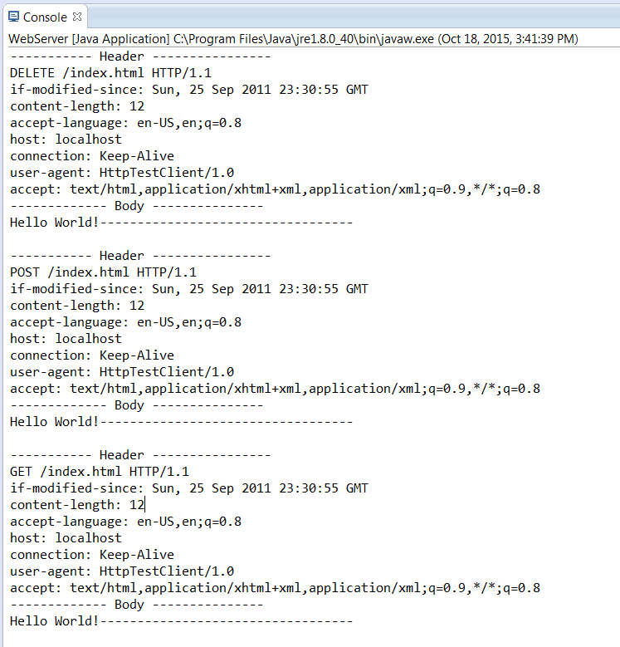

Above is a shot of the server. The log file for this scenario lives in the main project at csse477FinalProject\edu.rosehulman.sws\Reports

1. The project has been bundled and turned in. This report lives in it.