The content is stored at .\csse477FinalProject\edu.rosehulman.sws\Reports\Milestone<X>

**Change History**

10/18/2015 Version 1.0: Original Document for Milestone 1

* Original UML Diagram
* Explanation of design patterns used
* Potential Design Improvements
* Test Report for Milestone 1

10/25/2015 Version 2.0: Expanded for Milestone 2

* Creation of Change History
* Updated UML Diagram and UML Description
* Updated Architecture Diagram
* Potential Improvements
* Test Report for Milestone 2
* Created Milestone 2 Feature Listing

XX/XX/2015 Version 3.0: Expanded for Milestone 3

* Updates to Change History

**Design**

1. Detailed Design\Architecture Diagram

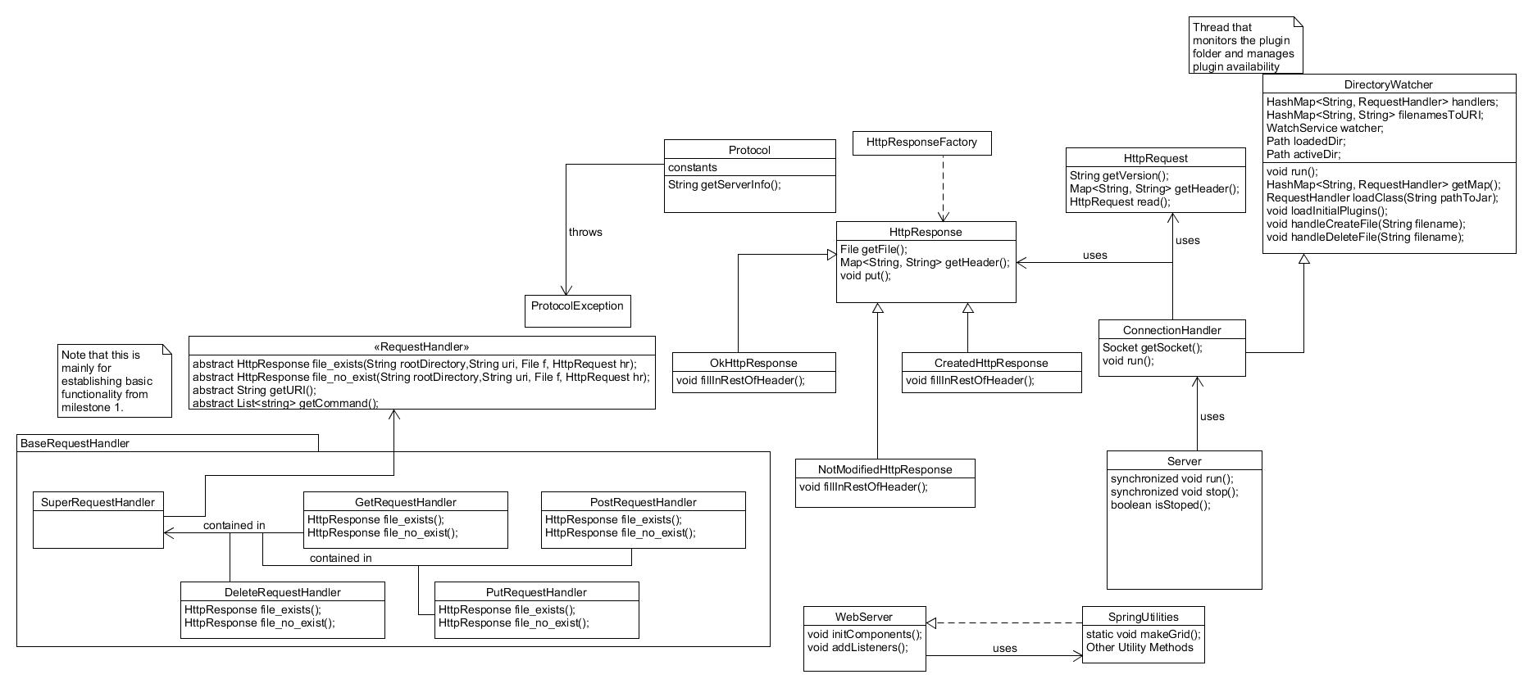

For this milestone we used plug-in architecture to attach the RequestHandler(s) into a SuperRequestHandler. We used the DirectoryWatcher class to dynamically track changes to the plug-in folder.

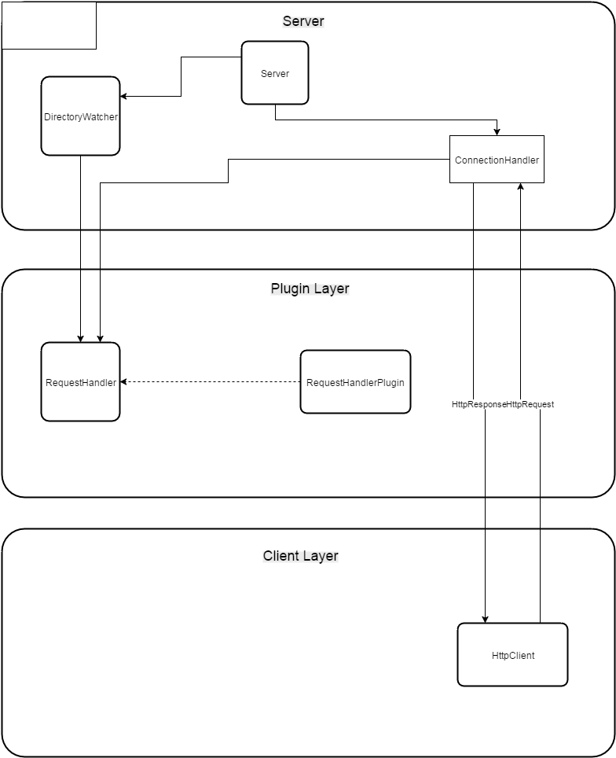

**Milestone 1**

1. List of Patterns

The main pattern that is used so far is the Strategy pattern. The factory pattern is also used for HttpResponse(s).

1. How could we improve the design?

The greatest weakness that currently exists is that multiple clients connect directly to the same server. For this approach, the client needs to know a lot of information about the remote server to be able to connect to it. And this isn’t always the best for expanding systems. The server may also care what kind of device is connecting to it and need to worry about that. In this way, a server/client relationship can start to take on too much burden. The best way of improving the design would be to add in a Broker pattern or something like it.

1. Milestone 1 Test Report (on the next page)

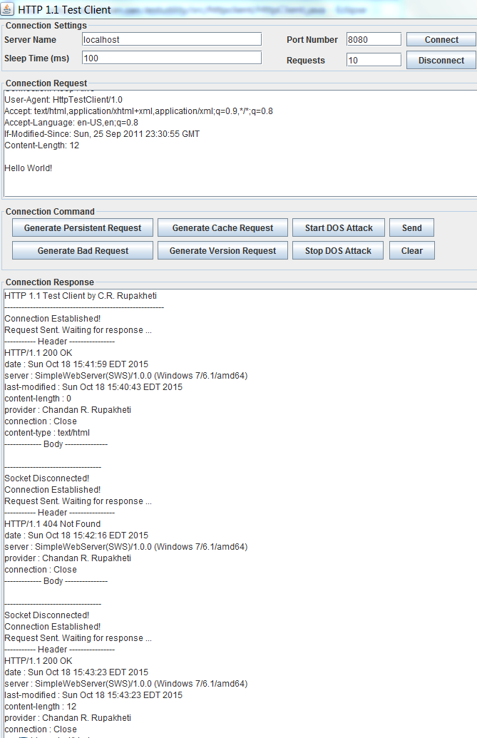

Above is a shot of the client (browser). The log file for this scenario lives in the main project at .\csse477FinalProject\edu.rosehulman.sws\Reports\Milestone1

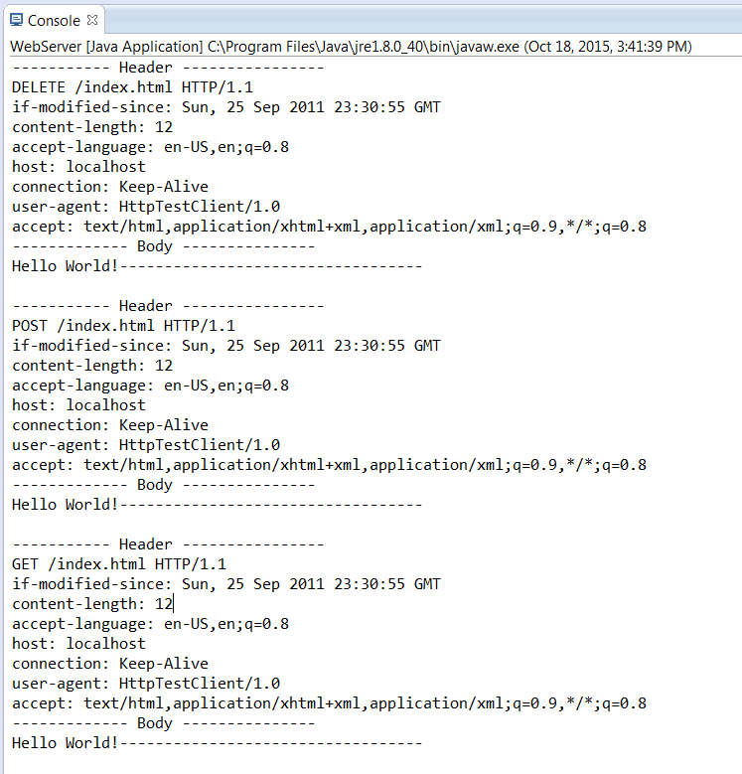

Above is a shot of the server. The log file for this scenario lives in the main project at .\csse477FinalProject\edu.rosehulman.sws\Reports\Milestone1

**Milestone 2**

**Milestone 2 Report**

The first screenshot shows that we were able to dynamically unload the jar file for the testing handler. It successfully performed the get request, and then failed after we unloaded it. The other ones are other examples of it working through the jar files. (Next Page)

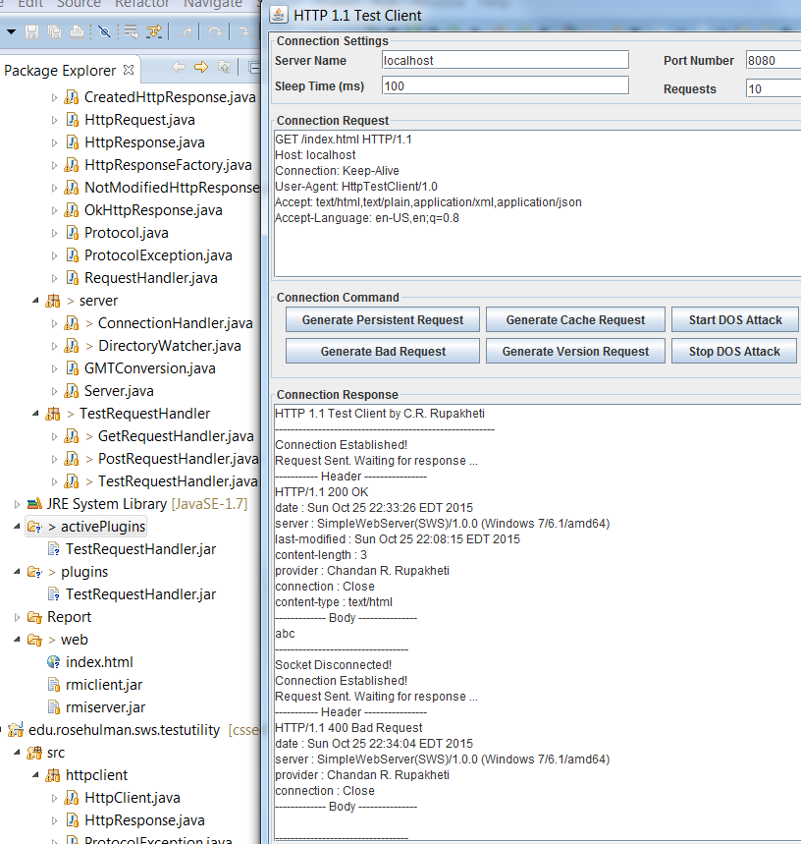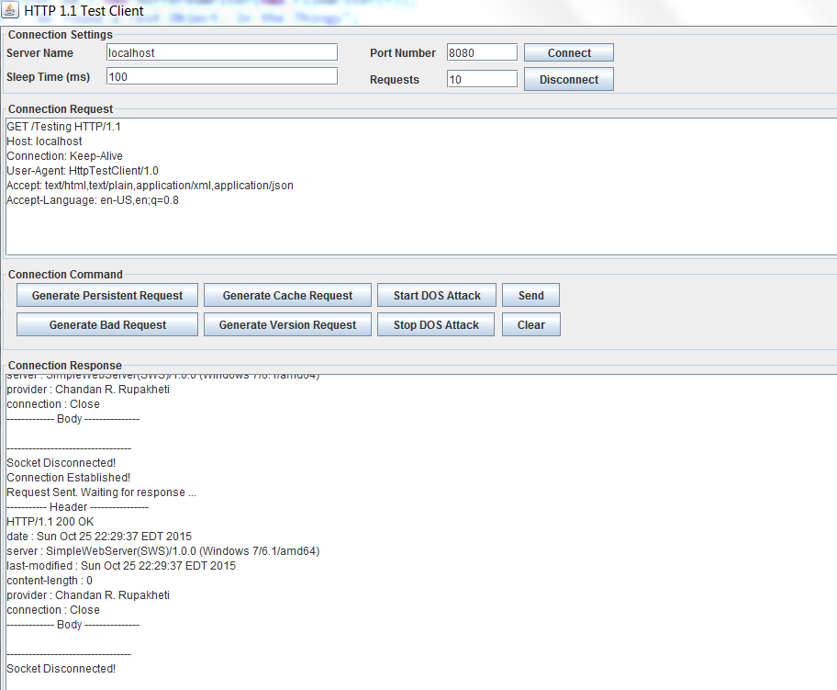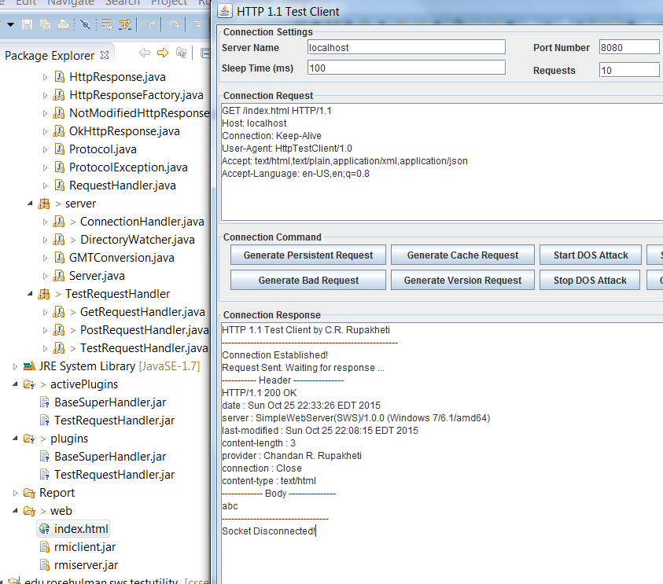

HTTP 1.1 Test Client by C.R. Rupakheti

--------------------------------------------------------

Connection Established!

Request Sent. Waiting for response ...

----------- Header ----------------

HTTP/1.1 200 OK

date : Sun Oct 18 15:41:59 EDT 2015

server : SimpleWebServer(SWS)/1.0.0 (Windows 7/6.1/amd64)

last-modified : Sun Oct 18 15:40:43 EDT 2015

content-length : 0

provider : Chandan R. Rupakheti

connection : Close

content-type : text/html

------------- Body ---------------

----------------------------------

Socket Disconnected!

Connection Established!

Request Sent. Waiting for response ...

----------- Header ----------------

HTTP/1.1 404 Not Found

date : Sun Oct 18 15:42:16 EDT 2015

server : SimpleWebServer(SWS)/1.0.0 (Windows 7/6.1/amd64)

provider : Chandan R. Rupakheti

connection : Close

------------- Body ---------------

----------------------------------

Socket Disconnected!

Connection Established!

Request Sent. Waiting for response ...

----------- Header ----------------

HTTP/1.1 200 OK

date : Sun Oct 18 15:43:23 EDT 2015

server : SimpleWebServer(SWS)/1.0.0 (Windows 7/6.1/amd64)

last-modified : Sun Oct 18 15:43:23 EDT 2015

content-length : 12

provider : Chandan R. Rupakheti

connection : Close

content-type : text/html

------------- Body ---------------

Hello World!

----------------------------------

Socket Disconnected!

Connection Established!

Request Sent. Waiting for response ...

----------- Header ----------------

HTTP/1.1 200 OK

date : Sun Oct 18 15:43:36 EDT 2015

server : SimpleWebServer(SWS)/1.0.0 (Windows 7/6.1/amd64)

last-modified : Sun Oct 18 15:43:36 EDT 2015

content-length : 24

provider : Chandan R. Rupakheti

connection : Close

content-type : text/html

------------- Body ---------------

Hello World!Hello World!

----------------------------------

Socket Disconnected!

Connection Established!

Request Sent. Waiting for response ...

----------- Header ----------------

HTTP/1.1 204 No Content

date : Sun Oct 18 15:43:46 EDT 2015

server : SimpleWebServer(SWS)/1.0.0 (Windows 7/6.1/amd64)

provider : Chandan R. Rupakheti

connection : Close

------------- Body ---------------

----------------------------------

Socket Disconnected!

Connection Established!

Request Sent. Waiting for response ...

----------- Header ----------------

HTTP/1.1 201 Created

date : Sun Oct 18 15:43:52 EDT 2015

server : SimpleWebServer(SWS)/1.0.0 (Windows 7/6.1/amd64)

provider : Chandan R. Rupakheti

etag : index.html

connection : Close

------------- Body ---------------

----------------------------------

Socket Disconnected!

Connection Established!

Request Sent. Waiting for response ...

----------- Header ----------------

HTTP/1.1 200 OK

date : Sun Oct 18 15:44:04 EDT 2015

server : SimpleWebServer(SWS)/1.0.0 (Windows 7/6.1/amd64)

last-modified : Sun Oct 18 15:43:52 EDT 2015

content-length : 12

provider : Chandan R. Rupakheti

connection : Close

content-type : text/html

------------- Body ---------------

Hello World!

----------------------------------

Socket Disconnected!

*The browser log file for this scenario is above*

----------- Header ----------------

GET /index.html HTTP/1.1

if-modified-since: Sun, 25 Sep 2011 23:30:55 GMT

accept-language: en-US,en;q=0.8

host: localhost

connection: Keep-Alive

user-agent: HttpTestClient/1.0

accept: text/html,application/xhtml+xml,application/xml;q=0.9,*/*;q=0.8

------------- Body ---------------

----------------------------------

----------- Header ----------------

GET /web/index.html HTTP/1.1

if-modified-since: Sun, 25 Sep 2011 23:30:55 GMT

accept-language: en-US,en;q=0.8

host: localhost

connection: Keep-Alive

user-agent: HttpTestClient/1.0

accept: text/html,application/xhtml+xml,application/xml;q=0.9,*/*;q=0.8

------------- Body ---------------

----------------------------------

----------- Header ----------------

PUT /index.html HTTP/1.1

if-modified-since: Sun, 25 Sep 2011 23:30:55 GMT

content-length: 12

accept-language: en-US,en;q=0.8

host: localhost

connection: Keep-Alive

user-agent: HttpTestClient/1.0

accept: text/html,application/xhtml+xml,application/xml;q=0.9,*/*;q=0.8

------------- Body ---------------

Hello World!----------------------------------

----------- Header ----------------

POST /index.html HTTP/1.1

if-modified-since: Sun, 25 Sep 2011 23:30:55 GMT

content-length: 12

accept-language: en-US,en;q=0.8

host: localhost

connection: Keep-Alive

user-agent: HttpTestClient/1.0

accept: text/html,application/xhtml+xml,application/xml;q=0.9,*/*;q=0.8

------------- Body ---------------

Hello World!----------------------------------

----------- Header ----------------

DELETE /index.html HTTP/1.1

if-modified-since: Sun, 25 Sep 2011 23:30:55 GMT

content-length: 12

accept-language: en-US,en;q=0.8

host: localhost

connection: Keep-Alive

user-agent: HttpTestClient/1.0

accept: text/html,application/xhtml+xml,application/xml;q=0.9,*/*;q=0.8

------------- Body ---------------

Hello World!----------------------------------

----------- Header ----------------

POST /index.html HTTP/1.1

if-modified-since: Sun, 25 Sep 2011 23:30:55 GMT

content-length: 12

accept-language: en-US,en;q=0.8

host: localhost

connection: Keep-Alive

user-agent: HttpTestClient/1.0

accept: text/html,application/xhtml+xml,application/xml;q=0.9,*/*;q=0.8

------------- Body ---------------

Hello World!----------------------------------

----------- Header ----------------

GET /index.html HTTP/1.1

if-modified-since: Sun, 25 Sep 2011 23:30:55 GMT

content-length: 12

accept-language: en-US,en;q=0.8

host: localhost

connection: Keep-Alive

user-agent: HttpTestClient/1.0

accept: text/html,application/xhtml+xml,application/xml;q=0.9,*/*;q=0.8

------------- Body ---------------

Hello World!----------------------------------

*The server log file for this scenario is above*

**Milestone 2 Feature Listing**

1. DirectoryWatcher Implementation: Austin May
2. Plug-in Architecture Implementation: Jonathan Taylor/Zach Haloski
3. Updates to Report Implementation: Team

**Milestone 2 Potential Future Improvements**

Handle having two plug-ins with the same URI if they implement different methods.

**Milestone 3**