Availability Scenario 1

1. Source: File System

Stimulus: Exception

Environment: Normal operation

Artifact: File System

Response: System handles the fault without failing

Response Measurement: System doesn’t crash when an exception occurs during a file operation

1. Test Plan

Delete a file. This will cause an exception as the connection is using the file at the time it tries to be deleted. Test to see if the server is still available after the fault

1. Baseline

100%. Despite the faults, the server remains available.

1. Scalability

Scaling from one server to two, using a load balancer.

1. Results

Our server remained at 100% availability.

Performance Scenario 1

1. Source: People/Connections

Stimulus: Large amount of connections

Environment: Overloaded operation

Artifact: Server

Response: Server latency remains under 100 ms.

Response Measurement: Measuring of the latency for the responses in the overloaded state

1. Test Plan

Use a mouse clicker to press the get request button 1000 times on our web page and measure the response rate.

1. Baseline

With our initial setup below is the connections per second that we serviced:

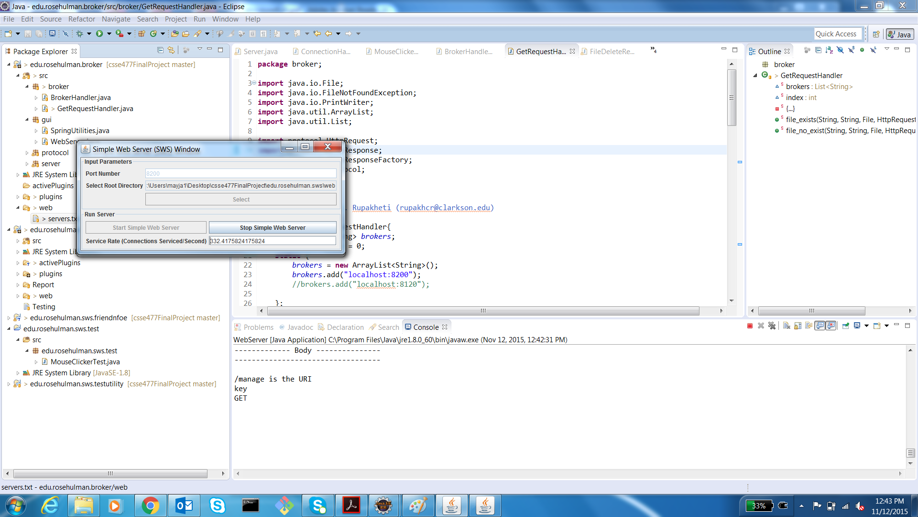

This is 332 connections per second.

1. Scaling

We scaled from one server to two servers using a load balancer

1. Results

Using two servers, below is our measured latency:

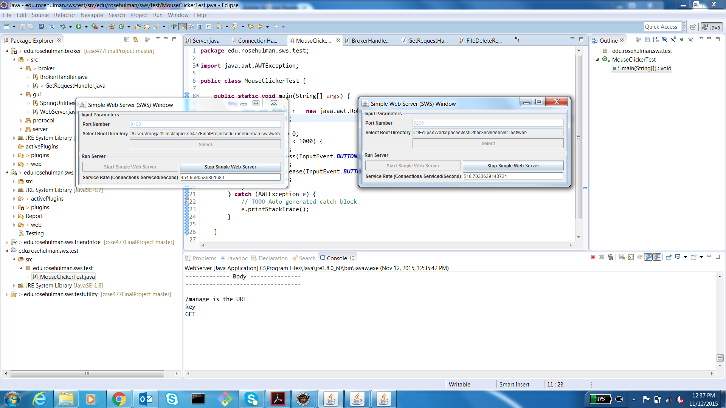

This is 454 connections per second for one of our servers and 510 connections per second for our other server, which is an improvement over the baseline.

Security Scenario 1

1. Source: File System

Stimulus: Delete request

Environment: normal operation

Artifact: files.txt file

Response: Though files.txt is deleted, server responds by recreating the file

Response Measurement: System doesn’t fail as a result of the files.txt file being deleted

1. Test Plan

Our delete mechanism allows the users to delete the files from the server. If the user deletes the files.txt file, this removes functionality from our server. Our server should respond by recreating the file.

1. Baseline

Server recreated the files.txt when it was deleted.

1. Scaling

We will scale from one server to two.

1. Results

Both servers were able to recreate the files.txt even when it was deleted.