Artificial Intelligence
& OpenAI

March 2026
Part 1: What Is Artificial Intelligence (AI)?

Artificial Intelligence, or AI, is technology that allows computers and machines to think, learn, and solve problems — much like a human brain does. Instead of following a fixed list of rules, an AI system learns from examples and gets better over time.
Simple Definition
AI = Teaching machines to learn from data and make smart decisions, just like humans do — but much faster and at a much bigger scale.


A good way to understand AI is to compare it to learning to ride a bike: the more you practice, the better you get. AI works the same way — the more data it processes, the smarter it becomes.

1.1 How Does AI Work?
AI works through a process called Machine Learning. Here are the basic steps:
- Input: Engineers feed the AI huge amounts of data — text, images, audio, etc.
- Processing: The AI analyzes the data and looks for patterns.
- Output: It makes a prediction or generates a result.
- Learning: If it makes a mistake, it adjusts and improves for next time.

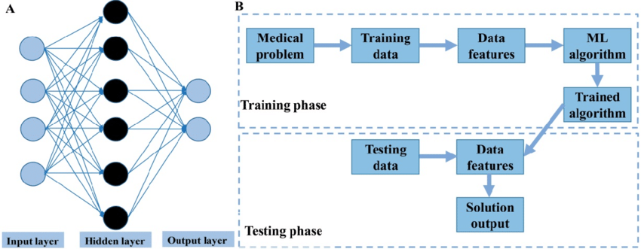

1.2 Types of AI
There are two main types of AI:

Type | Description
Narrow AI (ANI) (weak AI) | Designed to do ONE specific task very well. Example: Siri, Google Maps, spam filters.
General AI (AGI) (strong AI) | A hypothetical AI that can do ANYTHING a human can do. Still theoretical — does not exist yet.

1.3 AI in Your Daily Life
You already use AI every day, even if you don't realize it:
- Netflix & Spotify — AI recommends movies and music based on your taste.
- Google Search — AI finds the most relevant results for your queries.
- Voice Assistants — Siri, Alexa, and Google Assistant understand and respond to your voice.
- Email Spam Filters — AI detects and blocks unwanted emails.
- Face Recognition — Your phone uses AI to unlock with your face.
- Medical Diagnosis — AI helps doctors detect diseases from scans and X-rays.

1.4 Benefits and Risks of AI
AI is a powerful tool — but it comes with both opportunities and challenges.

Benefits | Risks & Challenges
✓ Saves time on repetitive tasks | ! Job displacement in some sectors
✓ Improves medical diagnosis accuracy | ! Privacy concerns and data collection
✓ Personalizes learning & experiences | ! AI can generate false information
✓ Available 24/7 without fatigue | ! Risk of bias in decision-making



Part 2: What Is OpenAI?

OpenAI is one of the most important and well-known AI companies in the world. It created ChatGPT, the AI chatbot that took the internet by storm in 2022 and introduced millions of people to the power of AI.

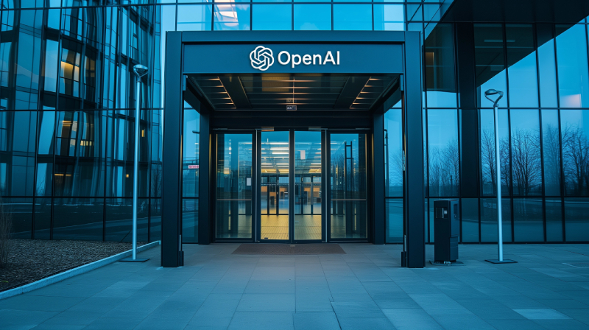

2.1 The Story of OpenAI
- Founded in 2015 by Sam Altman, Greg Brockman, Ilya Sutskever, and Elon Musk.
- Started as a non-profit research lab with the goal of building AI safely for the benefit of all humanity.
- Later became a 'capped-profit' company to raise the money needed for large-scale AI development.
- In 2025, it officially became a Public Benefit Corporation (PBC), still guided by its founding mission.

OpenAI's Mission
To ensure that artificial general intelligence (AGI) benefits all of humanity — not just a few people or companies.

2.2 OpenAI's Key Products
OpenAI has built several groundbreaking AI tools. Here are the most important ones:

ChatGPT | A conversational AI chatbot. You type a question or task, and it responds in human-like language. It can write essays, answer questions, help with code, brainstorm ideas, and much more.

GPT Models (GPT-3, GPT-4, GPT-5) | These are the powerful AI 'brains' behind ChatGPT. Each new version is smarter, faster, and more capable. GPT-5 was released in 2025 and is currently the most advanced model.

DALL-E | An AI system that creates images from text descriptions. You write 'a sunset over the ocean in the style of Van Gogh' and DALL-E generates the image.

Whisper | An AI tool that listens to audio and converts it to text (speech-to-text). Very useful for transcribing meetings, podcasts, and voice recordings.

Codex / GitHub Copilot | An AI that reads and writes computer code. Developers use it to write programs faster and with fewer errors.

Sora | A video generation AI released in 2024. You describe a scene in words, and Sora creates a realistic video from it.

2.3 ChatGPT: The Game Changer
ChatGPT was launched in November 2022 and became the fastest-growing app in internet history, reaching 100 million users in just two months. By 2026, it has over 900 million weekly active users worldwide.

What makes ChatGPT special? It uses a Large Language Model (LLM) — a type of AI trained on billions of pages of text from the internet, books, and other sources. This allows it to:
- Answer almost any question in a clear, conversational way
- Write emails, essays, summaries, and creative stories
- Translate text between languages
- Explain complex topics simply
- Help debug computer code
- Assist with research and brainstorming

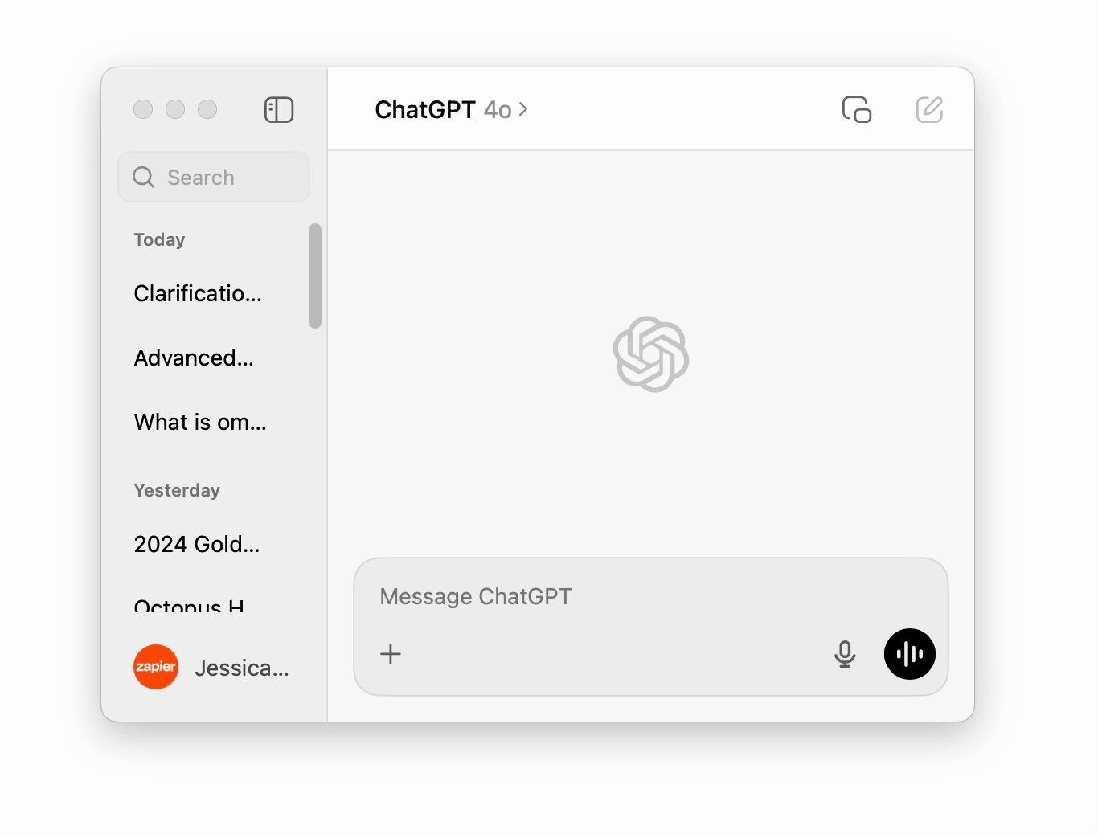

2.4 OpenAI Timeline — Key Milestones

2015 | OpenAI founded by Sam Altman, Elon Musk, and others as a non-profit AI lab.
2019 | Releases GPT-2. Shifts to a 'capped-profit' model to fund bigger research.
2020 | GPT-3 released — one of the most powerful language models at the time.
2021 | DALL-E launched — AI can now generate images from text.
2022 | ChatGPT launched (Nov). Becomes a global sensation overnight.
2023 | GPT-4 released with multimodal abilities (text + images). 100M+ users.
2024 | GPT-4o, Sora video generator, and SearchGPT released. Partnership with Apple.
2025 | GPT-5 released. OpenAI becomes a Public Benefit Corporation. 800M+ users.
2026 | ChatGPT reaches 900 million weekly active users. Valued at $730 billion.

Part 3: Key AI Concepts — Simply Explained

Here is a quick reference guide to the most common AI terms you will encounter:

Machine Learning (ML) | A type of AI where the computer learns from examples and data, without being explicitly programmed for every task.

Deep Learning | A more advanced form of machine learning that uses 'neural networks' — layers of connected nodes inspired by the human brain.

Neural Network | A computer system modeled after the structure of the human brain. It processes information in layers and is great at recognizing patterns.

Large Language Model (LLM) | A very large AI trained on massive amounts of text. It learns to understand and generate human language. ChatGPT is powered by an LLM.

Generative AI | AI that can CREATE new content — text, images, music, code, and video. ChatGPT and DALL-E are examples of generative AI.

Prompt | The instruction or question you type into an AI chatbot. The quality of your prompt affects the quality of the AI's response.

Hallucination | When an AI confidently states something that is incorrect or made up. This is a known challenge — always verify important AI-generated information.

AGI (Artificial General Intelligence) | A theoretical future AI that could perform any intellectual task a human can. We do not have this yet.

Conclusion

Artificial Intelligence is no longer science fiction — it is a real, everyday technology that is transforming how we work, learn, communicate, and live. From the GPS that guides your car to the chatbot that answers your questions, AI is everywhere.

OpenAI, through products like ChatGPT, DALL-E, and GPT-5, has been at the forefront of this revolution. Its tools have made powerful AI accessible to anyone with an internet connection — students, business owners, doctors, teachers, and curious individuals around the world.

The Bottom Line
AI is a tool — like a calculator or the internet. The more you understand it, the better you can use it responsibly and effectively. Stay curious, keep learning, and always think critically about the information AI provides.

Ghofrane gadhgadhi - IT 11

