# AGM - Arcade Game Maker Pedagogical Product Line

# Descrição Geral

A linha de produto (LP) Arcade Game Maker (AGM) produz uma série de jogos arcade. Cada jogo é jogado por um único jogador que controla, parcialmente, os objetos que se movem. O objetivo é marcar pontos acertando obstáculos estáticos. Os jogos vão desde aqueles com obstáculos baixos até obstáculos altos e estão disponíveis para uma variedade de diferentes plataformas.

# Similaridades e Variabilidades

## Similaridades

* todo jogo possui um conjunto de Sprites (seção 2.3);
* todo jogo possui um conjunto de Rules (seção 2.3);
* todos os jogos envolvem movimentação.

## Variabilidades

* **Tipos de Regras**: é a maior diferença entre os jogos. Algumas regras estão relacionadas às leis da física (gravidade, colisões, etc) e podem ser aplicáveis a múltiplos jogos. Outras regras estão especificamente relacionadas a um jogo e podem ser usadas em todas as implementações do jogo, mas não se aplicam a outros jogos;
* **Tipos de Movimentação**: em alguns jogos a movimentação é inerente à operação do jogo. Isto acontece periodicamente e é orientada pelo tempo. Em outros jogos, o jogador escolhe e inicia a movimentação, sendo ações dirigidas pelo ator.

## Conceitos importantes

**Sprite**: são os elementos do jogo que os jogadores vêem e com os quais eles interagem.

**Rule**: são as regras que regem as ações dos jogos. Por exemplo, um jogo pode ter uma regra em que um objeto em movimento ao colidir com um objeto estático deve obedecer às leis da física.

# Requisitos

## Cenários dos Casos de Uso

### Play Selected Game

|  |  |
| --- | --- |
| **Use Case Name:** | Play Selected Game |
| **Use Case ID:** | AGM001 |
| **Use Case Level:** | Abstract |
| **Actor:** | GamePlayer or GameInstaller |
| **Preconditions:** | AGM011: Install game has completed successfully. |
| **Postconditions:** | Actor has won/lost/tied and the game is ready to play again. |
| **Detailed Description** | |
| **Trigger:** | Actor selects game executable and initiates execution. |
| |  |  | | --- | --- | | **Actor** | **System Response** | | Selects PLAY from the menu | Initializes the game and displays the gameboard | | Left-clicks to begin play | Starts game action | | Left-clicks or uses keyboard to enter commands | Responds to the command in the expected manner | | Responds to Won/Lost/Tied dialog box with left-click | Returns the gameboard to its initialized, ready-to-play state | | |
| **Alternative Courses of Action** | |
| **No. 1:** | |
| |  |  | | --- | --- | | **Actor** | **System Response** | | At any time, may select EXIT from the menu | See AGM002: Exit game | | |
| **Extensions** | |
| **List:** | |
| |  |  | | --- | --- | | **Actor** | **System Response** | | See AGM006: Play Brickles |  | | See AGM007: Play Pong |  | | See AGM008: Play Bowling |  | | |
| **Exceptions** | |
| **List:** | |
| |  |  | | --- | --- | | **Actor** | **System Response** | | N/A | N/A | | |
| **Concurrent Uses:** | N/A |
| **Related Use Cases:** | AGM002: Exit game |
| **Decision Support** | |
| **Frequency:** | On Demand |
| **Criticality:** | High |
| **Risk:** | Low |

### Exit Game

|  |  |
| --- | --- |
| **Use Case Name:** | Exit Game |
| **Use Case ID:** | AGM002 |
| **Use Case Level:** | System end-to-end |
| **Actor:** | GamePlayer or GameInstaller |
| **Preconditions:** | Game system is running. |
| **Postconditions:** | Game system is terminated. |
| **Detailed Description** | |
| **Trigger:** |  |
| |  |  | | --- | --- | | **Actor** | **System Response** | | Selects EXIT from system menu | Prompts actor to save or exit the game | | Saves game | Saves the game and exits the program | | |
| **Alternative Courses of Action** | |
| **No. 1:** | |
| |  |  | | --- | --- | | **Actor** | **System Response** | | Cancels the EXIT action | Returns to suspended action | | |
| **No. 2:** | |
| |  |  | | --- | --- | | **Actor** | **System Response** | | May initiate EXIT by left-clicking the upper right-hand corner of the game window | Prompts actor to save or exit the game | | Saves game | Saves the game and exits the program | | |
| **Extensions** | |
| **List:** | |
| |  |  | | --- | --- | | **Actor** | **System Response** | | N/A | N/A | | |
| **Exceptions** | |
| **List:** | |
| |  |  | | --- | --- | | **Actor** | **System Response** | | N/A | N/A | | |
| **Concurrent Uses:** | N/A |
| **Related Use Cases:** | AGM001: Play selected game |
| **Decision Support** | |
| **Frequency:** | Low - only once per game start-up |
| **Criticality:** | Low |
| **Risk:** | Low |

### Save Game

|  |  |
| --- | --- |
| **Use Case Name:** | Save Game |
| **Use Case ID:** | AGM003 |
| **Use Case Level:** | System end-to-end |
| **Actor:** | GamePlayer or GameInstaller |
| **Preconditions:** | Game executable is running, and a game has been started. |
| **Postconditions:** | Current state of the game has been written to the specified file OR action has been cancelled. |
| **Detailed Description** | |
| **Trigger:** |  |
| |  |  | | --- | --- | | **Actor** | **System Response** | | Selects the SAVE option in the system menu | Allows the actor to specify a filename | | Writes game data to the file | | Returns to the game's pre-SAVE status | | |
| **Alternative Courses of Action** | |
| **No. 1:** | |
| |  |  | | --- | --- | | **Actor** | **System Response** | | Selects the EXIT menu option | See AGM002: Exit game | | |
| **Extensions** | |
| **List:** | |
| |  |  | | --- | --- | | **Actor** | **System Response** | | N/A | N/A | | |
| **Exceptions** | |
| **List:** | |
| |  |  | | --- | --- | | **Actor** | **System Response** | | Selects the SAVE option in the system menu | Prompts the actor to specify a filename | | Raises exception because the disk is full | | Selects a different disk | Attempts to save again | | Identifies an existing file with the same name as specified in the Save dialog | | Raises ExistingFileException | | Chooses a different name OR  Agrees to overwrite the existing file | Writes the file | | |
| **Concurrent Uses:** | N/A |
| **Related Use Cases:** | AGM002: Exit game |
| **Decision Support** | |
| **Frequency:** | On demand |
| **Criticality:** | Medium |
| **Risk:** | Medium - other files might be corrupted. |

### Save Score

|  |  |
| --- | --- |
| **Use Case Name:** | Save Score |
| **Use Case ID:** | AGM004 |
| **Use Case Level:** | System end-to-end |
| **Actor:** | GamePlayer |
| **Preconditions:** | Game system is running and a game is in progress |
| **Postconditions:** | File has been written, or action has been cancelled |
| **Detailed Description** | |
| **Trigger:** |  |
| |  |  | | --- | --- | | **Actor** | **System Response** | | Selects SAVE SCORE from system menu | Prompts actor to specify a filename | | If the file does not exist, creates new file | | Writes score to the file | | Returns to the game's pre-SAVE status | | |
| **Alternative Courses of Action** | |
| **No. 1:** | |
| |  |  | | --- | --- | | **Actor** | **System Response** | | Selects SAVE SCORE from system menu | Prompts actor to specify a filename | | If the file exists, overwrites existing score  Else creates new file and writes score | | |
| **Extensions** | |
| **List:** | |
| |  |  | | --- | --- | | **Actor** | **System Response** | | N/A | N/A | | |
| **Exceptions** | |
| **List:** | |
| |  |  | | --- | --- | | **Actor** | **System Response** | | Selects the SAVE SCORE option in the system menu | Prompts actor to specify a filename | | Raises exception because the disk is full | | Selects a different disk, if available | Attempts to save again | | |
| **Concurrent Uses:** | N/A |
| **Related Use Cases:** | AGM005: Check previous best score |
| **Decision Support** | |
| **Frequency:** | On demand |
| **Criticality:** | Medium |
| **Risk:** | Low |

### Check Previous Best Score

|  |  |
| --- | --- |
| **Use Case Name:** | Check Previous Best Score |
| **Use Case ID:** | AGM005 |
| **Use Case Level:** | System end-to-end |
| **Actor:** | GamePlayer |
| **Preconditions:** | Game system is running. |
| **Postconditions:** | Stored score has been shown to actor. |
| **Detailed Description** | |
| **Trigger:** |  |
| |  |  | | --- | --- | | **Actor** | **System Response** | | Selects Check Previous Best Score | Prompts actor to specify a filename | | Reads the file and returns score in a dialog box | | Selects OK on dialog box to continue | Returns to state before select | | |
| **Alternative Courses of Action** | |
| **No. 1:** | |
| |  |  | | --- | --- | | **Actor** | **System Response** | | N/A | N/A | | |
| **Extensions** | |
| **List:** | |
| |  |  | | --- | --- | | **Actor** | **System Response** | | N/A | N/A | | |
| **Exceptions** | |
| **List:** | |
| |  |  | | --- | --- | | **Actor** | **System Response** | | Selects Check Previous Best Score | Prompts actor to specify a filename | | Finds that file does not exist | | Selects OK on dialog box to continue | Returns to state before select | | |
| **Concurrent Uses:** | N/A |
| **Related Use Cases:** | AGM004: Save score |
| **Decision Support** | |
| **Frequency:** | On demand |
| **Criticality:** | Medium |
| **Risk:** | Low |

### Play Brickles

|  |  |
| --- | --- |
| **Use Case Name:** | Play Brickles |
| **Use Case ID:** | AGM006 |
| **Use Case Level:** | System end-to-end |
| **Actor:** | GamePlayer or GameInstaller |
| **Preconditions:** | AGM011: Install game has completed successfully. |
| **Postconditions:** | Game has been played. |
| **Detailed Description** | |
| **Trigger:** |  |
| |  |  | | --- | --- | | **Actor** | **System Response** | | Selects PLAY from the menu | Initializes the game and displays the gameboard | | Left-clicks to begin play | Starts game action | | Left-clicks or uses the keyboard to enter commands | Moves the paddle horizontally to follow the mouse track  After each movement of the puck, system checks for a collision with another object.  If puck collides with the ceiling, it is reflected back into the playing area.  If the puck collides with a wall, it is reflected back into the playing area.  If the puck collides with the floor, it ceases to exist. If the maximum number of pucks has not been reached, requests and provides a new puck. If the maximum has been reached, the Lost dialog is presented.  If the puck collides with a brick, defines action by the type of brick. When the puck collides with the last brick, the Won dialog is presented. | | Responds to Won/Lost dialog box with left-click | Returns the gameboard to its initialized, ready-to-play state | | |
| **Alternative Courses of Action** | |
| **No. 1:** | |
| |  |  | | --- | --- | | **Actor** | **System Response** | | N/A | N/A | | |
| **Extensions** | |
| **List:** | |
| |  |  | | --- | --- | | **Actor** | **System Response** | | N/A | N/A | | |
| **Exceptions** | |
| **List:** | |
| |  |  | | --- | --- | | **Actor** | **System Response** | | N/A | N/A | | |
| **Concurrent Uses:** | N/A |
| **Related Use Cases:** | N/A |
| **Decision Support** | |
| **Frequency:** | On demand |
| **Criticality:** | High |
| **Risk:** | Low |

### Play Pong

|  |  |
| --- | --- |
| **Use Case Name:** | Play Pong |
| **Use Case ID:** | AGM007 |
| **Use Case Level:** | System end-to-end |
| **Actor:** | GamePlayer or GameInstaller |
| **Preconditions:** | AGM011: Install game has completed successfully. |
| **Postconditions:** | Game has been played. |
| **Detailed Description** | |
| **Trigger:** |  |
| |  |  | | --- | --- | | **Actor** | **System Response** | | Selects PLAY from the menu | Initializes the game and displays the gameboard | | Left-clicks to begin play | Starts game action | | |
| **Alternative Courses of Action** | |
| **No. 1:** | |
| |  |  | | --- | --- | | **Actor** | **System Response** | | N/A | N/A | | |
| **Extensions** | |
| **List:** | |
| |  |  | | --- | --- | | **Actor** | **System Response** | | N/A | N/A | | |
| **Exceptions** | |
| **List:** | |
| |  |  | | --- | --- | | **Actor** | **System Response** | | N/A | N/A | | |
| **Concurrent Uses:** | N/A |
| **Related Use Cases:** | N/A |
| **Decision Support** | |
| **Frequency:** | On demand |
| **Criticality:** | High |
| **Risk:** | Low |

### Play Bowling

|  |  |
| --- | --- |
| **Use Case Name:** | Play Bowling |
| **Use Case ID:** | AGM008 |
| **Use Case Level:** | System end-to-end |
| **Actor:** | GamePlayer or GameInstaller |
| **Preconditions:** | AGM011: Install game has completed successfully. |
| **Postconditions:** | Game has been played. |
| **Detailed Description** | |
| **Trigger:** |  |
| |  |  | | --- | --- | | **Actor** | **System Response** | | Selects PLAY from the menu | Initializes the game and displays the gameboard | | Left-clicks to begin play | Starts game action | | Repeat the following for 10 frames plus a bonus throw | | | Positions the mouse and left-clicks to send ball down alley | Moves the ball down the alley using a randomly selected algorithm. If collisions result when the ball reaches the pins, moves pins as determined by the physics of the collision. | | Counts number of pins knocked down | | Positions the mouse and left-clicks to send ball down alley | Moves the ball down the alley using a randomly selected algorithm. If collisions result when the ball reaches the pins, moves pins as determined by the physics of the collision | | Computes score | | |
| **Alternative Courses of Action** | |
| **No. 1:** | |
| |  |  | | --- | --- | | **Actor** | **System Response** | | N/A | N/A | | |
| **Extensions** | |
| **List:** | |
| |  |  | | --- | --- | | **Actor** | **System Response** | | N/A | N/A | | |
| **Exceptions** | |
| **List:** | |
| |  |  | | --- | --- | | **Actor** | **System Response** | | N/A | N/A | | |
| **Concurrent Uses:** | N/A |
| **Related Use Cases:** | N/A |
| **Decision Support** | |
| **Frequency:** | On demand |
| **Criticality:** | High |
| **Risk:** | Low |

### Initialization

|  |  |
| --- | --- |
| **Use Case Name:** | Initialization |
| **Use Case ID:** | AGM009 |
| **Use Case Level:** | Function sub-use case |
| **Actor:** | N/A |
| **Preconditions:** | AGM006: Play Brickles, AGM007: Play Pong, or AGM008: Play Bowling has begun operation. |
| **Postconditions:** | Game is ready to operate. |
| **Detailed Description** | |
| **Trigger:** |  |
| |  |  | | --- | --- | | **Actor** | **System Response** | |  | Creates the standard instances of the required classes | | Enters the READY state | | |
| **Alternative Courses of Action** | |
| **No. 1:** | |
| |  |  | | --- | --- | | **Actor** | **System Response** | | N/A | N/A | | |
| **Extensions** | |
| **List:** | |
| |  |  | | --- | --- | | **Actor** | **System Response** | | Selects Load Game from the menu | Presents a file chooser box | | Opens the file that is indicated | | Reads and constructs the game objects | | |
| **Exceptions** | |
| **List:** | |
| |  |  | | --- | --- | | **Actor** | **System Response** | |  | Runs out of memory while creating objects | | Displays the Error dialog box | | Destroys objects already created | | |
| **Concurrent Uses:** | N/A |
| **Related Use Cases:** | N/A |
| **Decision Support** | |
| **Frequency:** | Once per game start-up |
| **Criticality:** | High |
| **Risk:** | Medium |

### Animation Loop

|  |  |
| --- | --- |
| **Use Case Name:** | Animation Loop |
| **Use Case ID:** | AGM010 |
| **Use Case Level:** | Function sub-use case |
| **Actor:** | N/A |
| **Preconditions:** | AGM009: Initialization has operated successfully and the user has left-clicked. |
| **Postconditions:** | Game is completed. |
| **Detailed Description** | |
| **Trigger:** |  |
| |  |  | | --- | --- | | **Actor** | **System Response** | |  | Generates periodic signals and sends them to the game | | Moves all objects one step according to their movement algorithm | | Checks for collisions and executes the collision algorithms of the objects | | |
| **Alternative Courses of Action** | |
| **No. 1:** | |
| |  |  | | --- | --- | | **Actor** | **System Response** | | Holds down the left mouse button | Pauses the movement of the game | | |
| **Extensions** | |
| **List:** | |
| |  |  | | --- | --- | | **Actor** | **System Response** | | N/A | N/A | | |
| **Exceptions** | |
| **List:** | |
| |  |  | | --- | --- | | **Actor** | **System Response** | | N/A | N/A | | |
| **Concurrent Uses:** | N/A |
| **Related Use Cases:** | N/A |
| **Decision Support** | |
| **Frequency:** | Once for every playing of the game |
| **Criticality:** | High |
| **Risk:** | Medium |

### Install Game

|  |  |
| --- | --- |
| **Use Case Name:** | Install Game |
| **Use Case ID:** | AGM011 |
| **Use Case Level:** | System end-to-end |
| **Actor:** | GameInstaller |
| **Preconditions:** | N/A |
| **Postconditions:** | Game is installed. |
| **Detailed Description** | |
| **Trigger:** |  |
| |  |  | | --- | --- | | **Actor** | **System Response** | | Selects the installer executable to execute | Presents a file chooser to allow selection of a directory in which to place the game files | | Selects a directory | Places game files in the directory | | |
| **Alternative Courses of Action** | |
| **No. 1:** | |
| |  |  | | --- | --- | | **Actor** | **System Response** | | N/A | N/A | | |
| **Extensions** | |
| **List:** | |
| |  |  | | --- | --- | | **Actor** | **System Response** | | N/A | N/A | | |
| **Exceptions** | |
| **List:** | |
| |  |  | | --- | --- | | **Actor** | **System Response** | |  | Finds insufficient space to which to write files | | Displays the Out of Space dialog box | | Left-clicks on OK button | Exits the program | | |
| **Concurrent Uses:** | N/A |
| **Related Use Cases:** | AGM012: Uninstall Game |
| **Decision Support** | |
| **Frequency:** | Very seldom |
| **Criticality:** | High |
| **Risk:** | Low |

### Uninstall Game

|  |  |
| --- | --- |
| **Use Case Name:** | Uninstall Game |
| **Use Case ID:** | AGM012 |
| **Use Case Level:** | System end-to-end |
| **Actor:** | GameInstaller |
| **Preconditions:** | AGM011: Install game completed successfully. |
| **Postconditions:** | All disk space taken up by the game is reclaimed. |
| **Detailed Description** | |
| **Trigger:** |  |
| |  |  | | --- | --- | | **Actor** | **System Response** | | Selects UNINSTALL from the system menu | Presents a file chooser to the actor | | Selects directory where game is stored | Erases files in the directory | | Presents the Uninstall Completed dialog box | | Selects the OK button in the dialog box | Closes dialog box | | |
| **Alternative Courses of Action** | |
| **No. 1:** | |
| |  |  | | --- | --- | | **Actor** | **System Response** | | N/A | N/A | | |
| **Extensions** | |
| **List:** | |
| |  |  | | --- | --- | | **Actor** | **System Response** | | N/A | N/A | | |
| **Exceptions** | |
| **List:** | |
| |  |  | | --- | --- | | **Actor** | **System Response** | | N/A | N/A | | |
| **Concurrent Uses:** | N/A |
| **Related Use Cases:** | AGM011: Install game |
| **Decision Support** | |
| **Frequency:** | Very seldom |
| **Criticality:** | Low - can be done manually |
| **Risk:** | Medium - might erase the wrong files |
|  |  |

## Perfil dos Atores

### GamePlayer

**Abstract**: No

**Description**: Usual, frequent user of game

**Skill Level**: Medium

|  |  |  |  |
| --- | --- | --- | --- |
| **Actor's Perspective on Use Cases** | | | |
| **Use Case** | **Importance[1]** | **Personality[2]** | **Relative Frequency[3]** |
| AGM001: Play selected game | Primary | Initiator | High |
| AGM002: Exit game | Secondary | Initiator | Low |
| AGM003: Save game | Secondary | Initiator | Medium |
| AGM004: Save score | Secondary | Initiator | Low |
| AGM005: Check previous best score | Secondary | Initiator | Low |
| AGM006: Play Brickles | Secondary | Initiator | High |
| AGM007: Play Pong | Secondary | Initiator | High |
| AGM008: Play Bowling | Secondary | Initiator | High |

## GameInstaller

**Abstract**: No

**Description**: Installer of game, infrequent user

**Skill Level**: high

|  |  |  |  |
| --- | --- | --- | --- |
| **Actor's Perspective on Use Cases** | | | |
| **Use Case** | **Importance1** | **Personality2** | **Relative Frequency3** |
| AGM002: Exit game | Secondary | Initiator | Low |
| AGM003: Save game | Secondary | Initiator | Low |
| AGM004: Save score | Secondary | Initiator | Low |
| AGM005: Check previous best score | Secondary | Initiator | Low |
| AGM006: Play Brickles | Secondary | Initiator | Low |
| AGM007: Play Pong | Secondary | Initiator | Low |
| AGM008: Play Bowling | Secondary | Initiator | Low |
| AGM011: Install game | Primary | Initiator | Low |
| AGM012: Uninstall game | Primary | Initiator | Low |

## Modelo de Caso de Uso

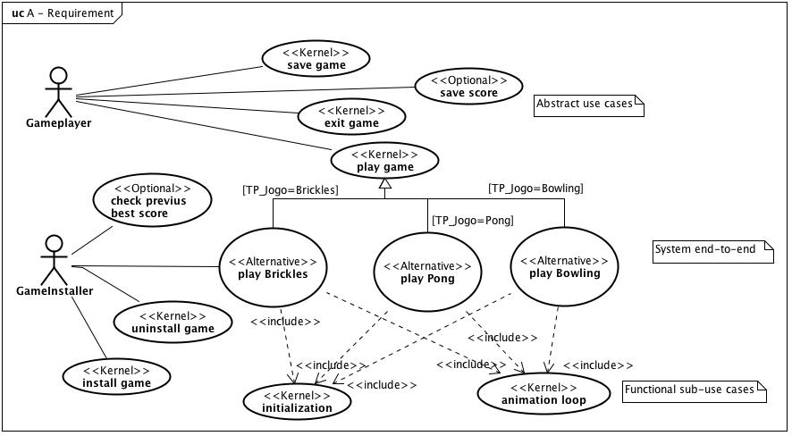

## Modelo de Domínio

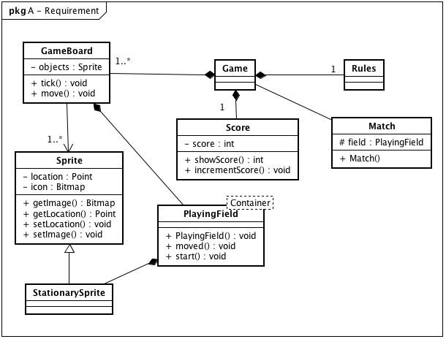

## Tabela de Conceitos

|  |  |  |  |  |  |  |
| --- | --- | --- | --- | --- | --- | --- |
| Concept | I | U | E | Q | Observation | Cross References |
| Game | X | X | X | X |  | AGM001, AGM002, AGM003, AGM011, AGM012 |
| Bowling | X | X | X | X |  | AGM008 |
| Brickles | X | X | X | X |  | AGM006 |
| Pong | X | X | X | X |  | AGM007 |
| Score |  | X |  | X |  | AGM004, AGM005 |

## Protótipo de interface

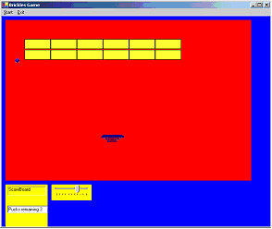 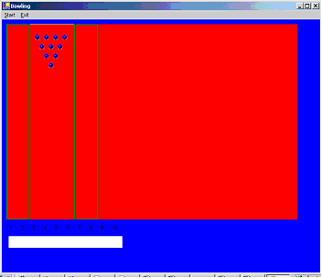

Brickles Game Bowling Game

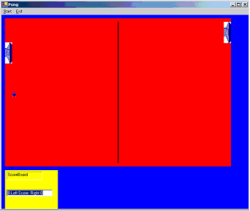

Pong Game

## Arquitetura Inicial

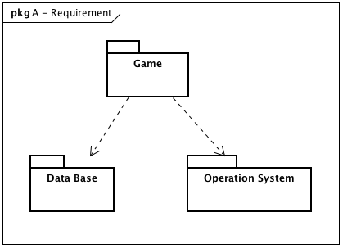

## Glossário

|  |  |
| --- | --- |
| **ACB** | Architecture Control Board |
| **AGM** | Arcade Game Maker |
| **application engineering** | Discipline of constructing a product using the product line architecture and selecting from the inventory of available product line components based on the production plan |
| **ATAM** | Architecture Tradeoff Analysis Method® |
| **CCB** | Configuration Change Board |
| **CEO** | Chief executive officer |
| **CLR** | Common language runtime |
| **core asset** | Reusable artifacts and resources that form the basis for the software product line |
| **CM** | Configuration management |
| **DHR** | Director of human resources |
| **domain engineering** | Discipline of creating, acquiring, and managing the resources needed to build a set of products |
| **FODA** | Feature-oriented domain analysis |
| **IDE** | Integrated development environment |
| **IEEE** | Institute of Electrical and Electronics Engineers |
| **MVC** | Model-view-controller |
| **MIDP** | Mobile Information Device Profile |
| **PLM** | Product line manager |
| **product** | Any saleable or usable output produced from the product line core assets |
| **RUP** | Rational Unified Process |
| **software product line** | Group of products sharing a common, managed set of features that satisfy specific needs of a selected market or mission and that are developed from a common set of core assets in a prescribed way |
| **TE** | Test effectiveness |
| **UML** | Unified Modeling Language |
| **VC** | Version control |
| **WAP** | wireless access protocol |

### Modelo de Características

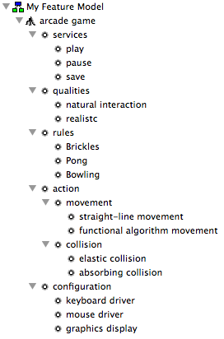

### Modelo de Características X Variabilidades

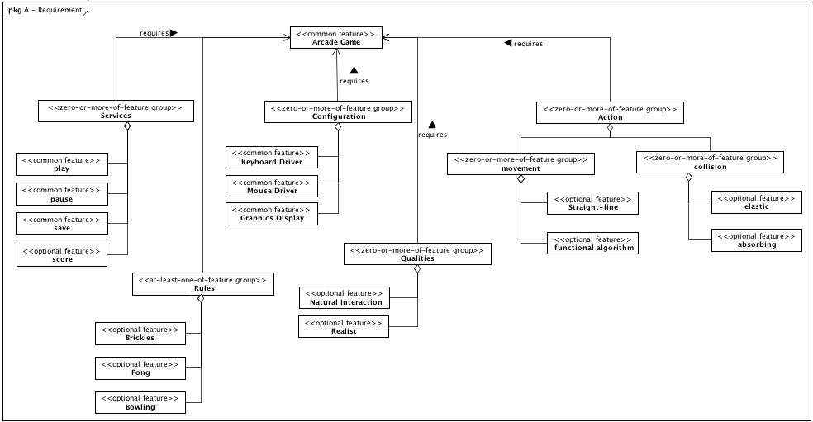

# Análise

# Projeto

# Implementação

1. Importance is primary or secondary.
2. Personality is initiator, server, receiver, or facilitator.
3. Relative Frequency is high, medium, or low.