Portfolio Project: Part 2

Maynard Peralta
Colorado State University Global
CSC450-1: Programming III
Instructor: Russell Frith
Due Date: 11/08/2026 Submitted: 11/08/2026

Concurrency Concepts: Java and C++ Implementation Analysis
Our final portfolio project asks us to demonstrate an understanding of the various concepts discussed in each module. For this second part of our portfolio project, we are to create a Java program that demonstrates concurrency concepts. The application will create two threads that will act as counters. The first thread will count from 0 to 20. Once that thread has finished, a second thread will count down from 20 to 0.
Java Application Design and Implementation
The Main class contains two methods: countUp() and countDown(). The first method contains a for loop that counts from 0 to 20. The second method contains a for loop that counts backwards from 20 to 0. Both methods display their progress in the console.
Two threads are created using Java’s Thread class and use the start() method to begin execution (Eck, 2022). The join() method ensures that the first thread completes before the second thread begins. This maintains the required execution sequence and prevents the counting operations from overlapping. The application also includes exception handling for InterruptedException to address potential interruptions while waiting for a thread to finish.
Performance Issues with Concurrency
Concurrency can introduce performance overhead through thread creation, context switching, and resource management. For applications with small workloads, these costs may outweigh the benefits of using multiple threads. In this project, each thread performs only twenty-one counting iterations for a minimal computational workload.
The two counting operations execute sequentially because the main program waits for the first thread to finish before creating the second. Therefore, the application demonstrates multithreading and thread coordination rather than parallel processing. The console output also introduces additional processing overhead because each counting operation displays its result.
String Vulnerabilities
Java strings are immutable, meaning their contents cannot be changed after creation. This helps prevent unexpected modifications but does not eliminate security concerns. Sensitive information stored in String objects may remain in memory until the objects are reclaimed.
Oracle (2025) emphasizes protecting confidential information, validating input, and following secure coding practices. The existing C++ application uses predefined string literals rather than dynamically managed character buffers. Therefore, it does not currently demonstrate a buffer overflow vulnerability. However, unsafe character-array operations in expanded C++ applications could introduce memory-related security risks.
Neither application is set up to accept user input, but additional validation and secure string handling would be necessary if the functionality were to be added.
Security of Data Types
Both applications use integer variables to perform their counting operations. Java uses a 32-bit signed int, while the width of C++ int depends on the implementation. Both are appropriate for the small counting ranges used in this project.
Larger applications must account for integer overflow and validate numerical inputs. Java provides automatic memory management, static type checking, and runtime array bounds checking. C++ offers greater control over memory allocation but requires developers to manage resources carefully to avoid memory-related errors.
Oracle (2025) identifies Java’s built-in protections as important safeguards against common programming vulnerabilities. However, neither language is completely secure without appropriate programming practices.
Java and C++ Performance and Security Comparison
The Java and C++ applications developed for this project demonstrate similar approaches to thread creation and management. Both programs use two separate threads: one to count from zero to twenty and another to count down from twenty to zero. Although they produce similar results, differences in their programming languages and execution environments affect performance, memory management, and security.
The source code for both applications is included in Appendix (Figure 1-1).
Thread Creation and Execution Performance
The C++ application uses the standard library’s std::thread class to create and manage threads. The thread constructor starts the specified counting function, while the join() method causes the main thread to wait for completion. Similarly, Java uses the Thread class, with start() beginning execution and join() coordinating thread completion (Eck, 2022).
Both applications execute the counting operations sequentially because the program waits for the first thread to finish before starting the second thread. Although both programs create and use multiple threads, they do not perform simultaneous execution of the counting operations. Instead, they demonstrate multithreading, thread coordination, and controlled execution.
Thread creation introduces overhead because the operating system must allocate resources, schedule execution, and manage each thread. Since each counting operation performs only twenty-one iterations, the overhead may exceed the time required to complete the actual calculations. Multithreading is generally more beneficial for applications with larger workloads that can execute independently.
The results of both applications running successfully are included in Appendix (Figure 1-2).
Runtime and Memory Management
The applications also differ in their execution environments. C++ programs are generally compiled into native machine code, allowing them to execute directly on the operating system. Java programs are compiled into bytecode and executed through the Java Virtual Machine (JVM). The JVM can use just-in-time compilation to optimize frequently executed code, although its startup and runtime management may introduce additional overhead.
Console output can also affect performance. C++ uses std::cout with std::endl, which inserts a newline and flushes the output stream. Repeated flushing can create additional overhead. Java uses System.out.println() to display output, which does not have precisely the same flushing behavior.
Memory management represents another important distinction. Java provides automatic garbage collection, reducing the need for developers to manually release memory. It also includes runtime protections, such as array bounds checking, that help prevent certain memory-related errors. C++ provides greater control over memory allocation and object lifetimes, which can support efficient resource utilization. However, developers must manage resources carefully to avoid problems such as memory leaks, dangling pointers, and improper memory access.
For these applications, memory requirements are minimal because both programs use only a few variables and two threads. Consequently, the differences in memory management are more significant when considering larger applications than their current execution.
String Handling and Security Vulnerabilities
Java uses the String class to represent text. Java strings are immutable, meaning their contents cannot be changed after creation. This reduces the possibility of unexpected modifications to existing string values. However, immutability does not eliminate every security concern. Sensitive information stored in ordinary String objects may remain in memory until garbage collection occurs.
The C++ application uses predefined string literals with std::cout and does not perform complex string manipulation. Therefore, the current program does not demonstrate an actual buffer overflow vulnerability. However, C++ applications that improperly manage character arrays or perform unsafe string operations may experience buffer overflows and memory corruption. These vulnerabilities can cause unexpected application behavior and potentially create security risks.
Both languages require developers to follow secure coding practices, particularly when handling confidential information and external input. Oracle (2025) emphasizes the importance of protecting sensitive information and applying appropriate security controls. Neither language’s built-in protections eliminate the need for careful programming.
Data Types and Overall Security Comparison
Both applications use integer variables for their counting operations. Java uses a 32-bit signed int, while the width of C++ int depends on the implementation. Both are appropriate for counting between zero and twenty. However, integer overflow can become a security concern when applications process larger values. Java defines integer overflow behavior, while signed integer overflow in C++ results in undefined behavior. Developers should validate numerical inputs and ensure calculations remain within supported limits.
Overall, Java provides stronger default protections against certain memory-safety vulnerabilities through automatic garbage collection, runtime checks, and restrictions on direct memory access. C++ offers greater control and flexibility but requires developers to take additional responsibility for memory management and safe programming practices.
Neither language is completely secure. Java applications can still experience vulnerabilities involving improper input validation, confidential information exposure, and resource exhaustion. Similarly, C++ applications can be developed securely when programmers use appropriate memory-management techniques and validate inputs.
For the applications developed in this project, neither implementation demonstrates a significant security vulnerability. Both use simple integer counters, predefined output messages, and sequential thread execution. The differences become more important when considering future applications that process external input, share data, or perform more complex operations.
Ultimately, Java provides a more protective default environment for reducing memory-management errors, while C++ offers greater control over system resources and performance. The appropriate language depends on application requirements, developer experience, and the security practices used during development.
Git Repositories
The source code for each program has each been uploaded to a Git repository where they can be viewed along with their commit history. The repositories can be accessed using the following links:
C++ program: https://github.com/maynperalta/CSC450Module7.git
Java program: https://github.com/maynperalta/CSC450Module8.git

Conclusion
The Java and C++ applications demonstrate thread creation and coordination through two sequential counting operations. Both successfully use thread-joining mechanisms to ensure the required execution order. Although multithreading introduces additional overhead, it can improve performance for more demanding workloads that benefit from simultaneous execution.
Java provides additional memory-safety protections through automatic memory management and runtime checks, while C++ offers greater control over memory and system resources. Both languages require careful handling of strings, data types, and application resources to minimize security vulnerabilities.

References
Eck, D. J. (2022). Introduction to programming using Java (Version 9.0). Hobart and William Smith Colleges. https://math.hws.edu/javanotes/index.html
Oracle. (2025). Secure coding guidelines for Java SE (Version 11.0). https://www.oracle.com/java/technologies/javase/seccodeguide.html

Appendix

Figure 1-1 Source code for C++ Program (Left) and Java Program (Right)

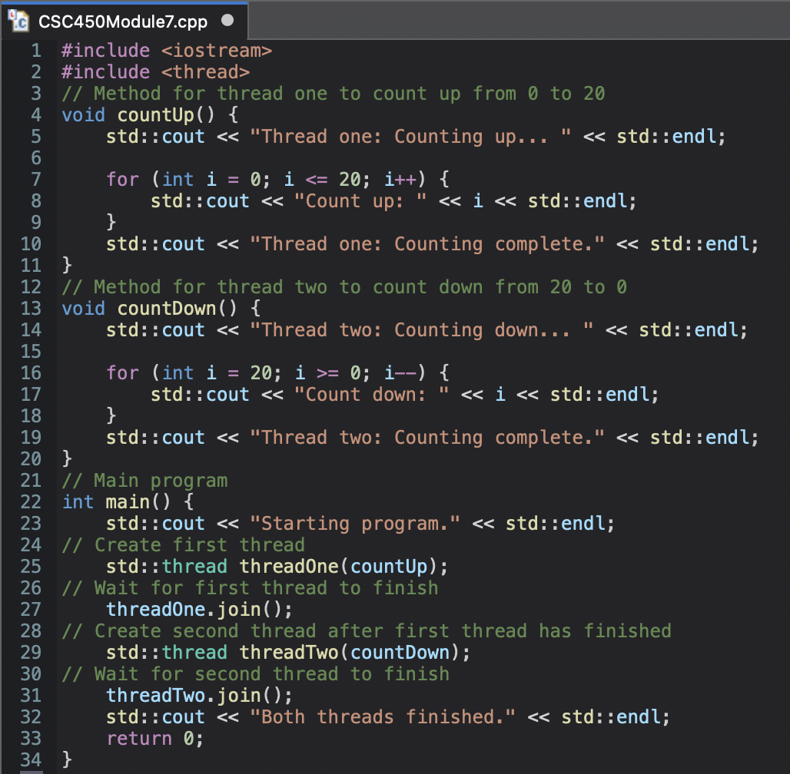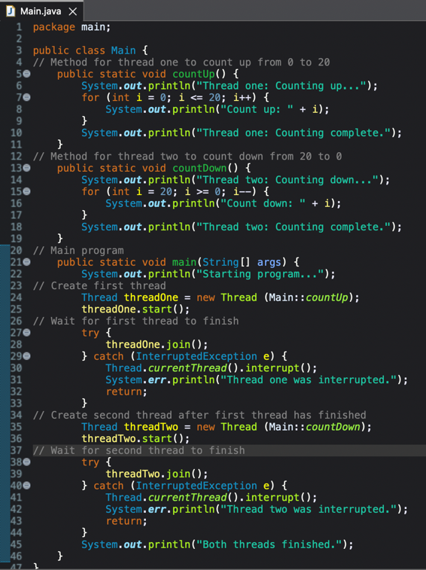

Figure 1-2 Results of Programs Running Successfully for C++ (Left) and Java (Right)



