Design and Implementation of an Automated University Timetable Scheduling System Using a Genetic Algorithm with Adaptive Mutation and NumPy-Vectorized Constraint Evaluation
Authors: Oyekan Oluwatoromo Boluwatife, Taiwo Kehinde Hikmat, Babtunde Ogundipe
Affiliation: Department of Software engineering, Babcock university ilishan remo, Nigeria
Abstract
The university course timetabling problem (UCTP) is a well-established NP-hard combinatorial optimization challenge that demands the simultaneous satisfaction of numerous hard and soft constraints involving lecturers, rooms, student groups, and time periods. Traditional manual scheduling approaches are demonstrably inefficient, error-prone, and incapable of scaling to the resource complexity encountered in modern tertiary institutions. This paper presents the design, implementation, and evaluation of UniSched / Nexus, an automated university timetable scheduling system that employs a custom Genetic Algorithm (GA) to generate conflict-free, optimized weekly class schedules. The system architecture adopts a decoupled client–server model: a Django REST Framework backend exposes RESTful API endpoints for resource management and algorithmic orchestration, while a React Native frontend serves mobile clients, providing dedicated portals for both Administrators and active Lecturers based on an integrated Role-Based Access Control (RBAC) system. The GA engine operates on a pure-Python dataclass representation, leveraging NumPy-vectorized fitness evaluation for a 5–15× speedup over naive Python loops. Adaptive mutation rates, elitism preservation, tournament selection, and single-point crossover collectively drive the search toward high-fitness schedules. Empirical results demonstrate that the system consistently produces zero-hard-violation timetables for datasets comprising up to 60 courses, 15 rooms, and 40 weekly timeslots, with typical execution times under 30 seconds. The application provides dedicated capabilities for Lecturers to submit scheduling preferences and log administrative complaints directly through the mobile interface, offering a practical, deployable solution to the UCTP that bridges the gap between theoretical metaheuristic research and real-world institutional scheduling needs.
Keywords: University Course Timetabling Problem; Genetic Algorithm; Role-Based Access Control; Mobile Application; React Native; Django REST Framework; NumPy Vectorization.

1. Introduction

1.1 Background of Study
The allocation of courses, lecturers, rooms, and student groups across a finite set of weekly time periods constitutes one of the most persistent administrative challenges in tertiary education. This problem, formally classified as the University Course Timetabling Problem (UCTP), belongs to the class of NP-hard combinatorial optimization problems (Even et al., 1976; Cooper & Kingston, 1996). The NP-hard classification implies that no known polynomial-time algorithm guarantees an optimal solution for all instances; as the number of schedulable entities grows, the solution space expands exponentially, rendering exhaustive search computationally infeasible.
Historically, university timetables have been constructed manually by dedicated scheduling officers who rely heavily on domain expertise, spreadsheets, and iterative trial-and-error. While this approach may yield serviceable results for small departments, it is demonstrably inadequate for institutions with hundreds of courses, dozens of lecture halls, and strict regulatory constraints on lecturer workloads. Manual timetabling is inherently slow, typically consuming weeks of concentrated effort each academic session; it is error-prone, frequently producing double-bookings that surface only after the semester commences; and it is disconnected from the faculty members, who historically have no digital interface to submit scheduling preferences or grievances.

1.2 Statement of the Problem
The specific scheduling problem addressed in this work involves assigning each course session to a unique combination of a room and a weekly time period such that: (a) no room is double-booked at any timeslot, (b) no lecturer is scheduled for overlapping sessions, (c) no student group is required to attend two classes simultaneously, and (d) room capacities are not exceeded. Constraints (a)–(c) are treated as hard constraints whose violation is strictly prohibited. Additional soft constraints, such as lecturer time-of-day preferences and avoidance of specific weekdays, further shape the quality of the generated timetable and are submitted directly by lecturers via the mobile application.

1.3 Aim and Objectives
The aim of this project is to design and implement an automated, mobile-accessible timetable scheduling system that replaces manual methods with a computationally intelligent approach grounded in evolutionary computation. The specific objectives are as follows:
- 1. To model the UCTP as a constraint satisfaction and optimization problem with clearly delineated hard and soft constraints.
- 2. To implement a Genetic Algorithm (GA) with adaptive mutation, elitism, and tournament selection.
- 3. To develop a Django REST Framework backend that manages multi-tenant Workspaces, users, and resources, and orchestrates asynchronous GA execution via a Django-Q2 task queue.
- 4. To deliver a React Native mobile application containing role-segmented portals (Admin and Staff), allowing administrators to configure constraints and trigger scheduling, while allowing lecturers to view personalized schedules, upload preferences, and submit complaints.
- 5. To evaluate the system's performance in terms of constraint satisfaction and execution time.

1.4 Significance of the Study
This study contributes a practical, end-to-end implementation that bridges the gap between the extensive theoretical literature on metaheuristic scheduling (Qu et al., 2009) and the operational needs of Nigerian and Sub-Saharan African universities. By integrating an Email Whitelist Role-Based Access Control (RBAC) system into the mobile deployment, this research solves not only the mathematical scheduling problem but the operational communication gap between administrators and faculty.

2. Related Work

2.1 Classical Approaches to University Timetabling
Early computational approaches to the UCTP relied on graph-colouring formulations (Welsh & Powell, 1967), wherein courses are modelled as vertices, conflicts as edges, and timeslots as colours. Integer Linear Programming (ILP) has also been applied to timetabling (Daskalaki et al., 2004), offering mathematical optimality for small instances. However, both fall short when dealing with the exponential growth of decision variables mapping rooms, multi-hour durations, and soft constraints simultaneously.

2.2 Metaheuristic Approaches
Metaheuristic algorithms sacrifice guaranteed optimality for computational tractability and have emerged as the dominant paradigm. Simulated Annealing (SA) iteratively perturbs candidate solutions (Abramson, 1991), but operates on a single trajectory. Particle Swarm Optimization (PSO) maps particle positions to schedule assignments (Shiau, 2011) and demonstrates rapid convergence, but is susceptible to premature optimization in highly constrained search spaces.

2.3 Genetic Algorithm Approaches and the Proposed Advantage
Genetic Algorithms (GAs) maintain a diverse population of candidate solutions undergoing selection, crossover, and mutation (Goldberg, 1989). Previous GA-based timetabling systems (Al-Betar et al., 2012) perform well academically but frequently lack native mobile deployability.
The system proposed advances the state of the art via:
- Adaptive Mutation Rates: Dynamic probabilities (15%-30%) based on current optimal fitness accelerating convergence.
- NumPy Vectorization: Hard constraint checks executed on structured memory arrays, preventing Python bottlenecking.
- Mobile-First RBAC Architecture: Delivering personalized constraint preferences directly from the Lecturer's mobile React Native interface to the backend.

3. Methodology

3.1 Target Audience
The system serves two distinct stakeholders via a comprehensive mobile interface:
- University Administrators (Admins): Gated by an Email Whitelist system, administrators possess CRUD access to all institutional resources. They trigger the Genetic Algorithm and review global constraints.
- University Lecturers (Staff): Authentic faculty members who register for accounts. They utilize the system to view individualized, filtered weekly timetables, set schedule preferences (e.g., maximum daily hours or avoidance of specific days), and lodge official complaints regarding administrative scheduling decisions.

3.2 Requirements Elicitation
Requirements were gathered via structured interviews with scheduling officers and a questionnaire distributed among students and faculty, demonstrating a consistent demand for native mobile accessibility, transparent conflict-resolution channels (a Complaints system), and dynamic multi-tenant support (Workspaces).

3.3 User Requirements
- The administrator shall be able to manage Workspaces, Lecturers, Rooms, Courses, and Constraints.
- Admin authentication shall be strictly enforced via an Email Whitelist Database.
- The administrator shall trigger the GA and observe real-time generation output.
- Lecturers shall authenticate and select their appropriate staff profile upon successful registration.
- Lecturers shall be able to input soft constraint preferences (time-of-day, days-to-avoid) directly through the mobile app.
- Lecturers shall be able to view their specific class schedule dynamically mapped on a weekly grid.
- Lecturers shall have access to a Complaints portal to lodge scheduling issues to the administration.

3.4 System Requirements
- Frameworks: Python (NumPy for Array Vectorization). Django & Django REST Framework (Backend Data Persistence & APIs). React Native & Expo (Cross-Platform Mobile Application).
- Security: JWT (JSON Web Tokens) Bearer token authentication scoping all resource manipulation to specific Workspaces (`X-Workspace-Id` Headers).

4. System Design

4.1 System Architecture
The Nexus system follows a decoupled three-tier architecture comprising the Presentation Layer (React Native Mobile), Business Logic Layer (Django REST Framework API and Python GA Engine), and Data Layer (PostgreSQL database).
Figure 1: System Architecture Diagram
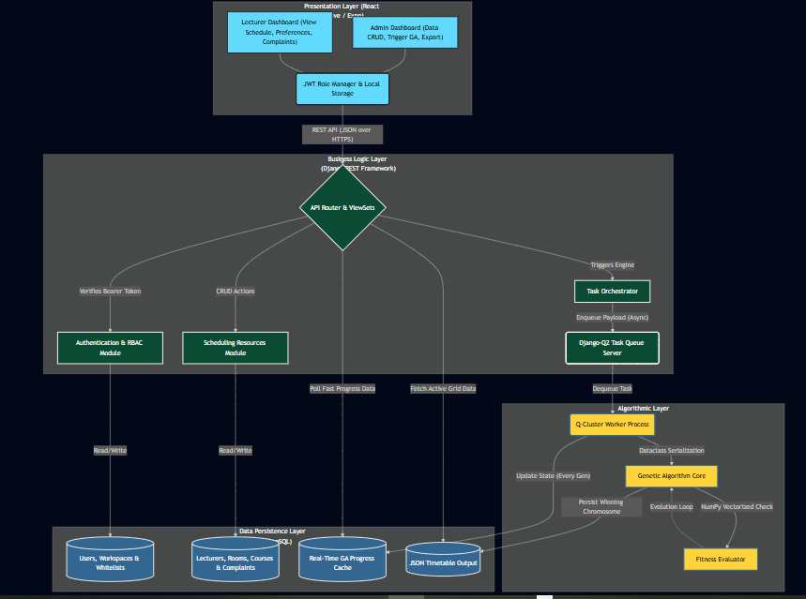

4.2 Entity-Relationship Diagram
The database schema isolates data using multi-tenant Workspaces. Crucially, the system utilizes a `WhitelistedAdmin` table to verify administrative registrations, and a `WorkspaceMember` table to map exact user roles (Admin vs Lecturer) to a Workspace. Soft constraints are mapped via a `ConstraintConfig` structure, and a `Complaint` table houses communication between the two user segments.
Figure 2: Entity-Relationship (ER) Diagram
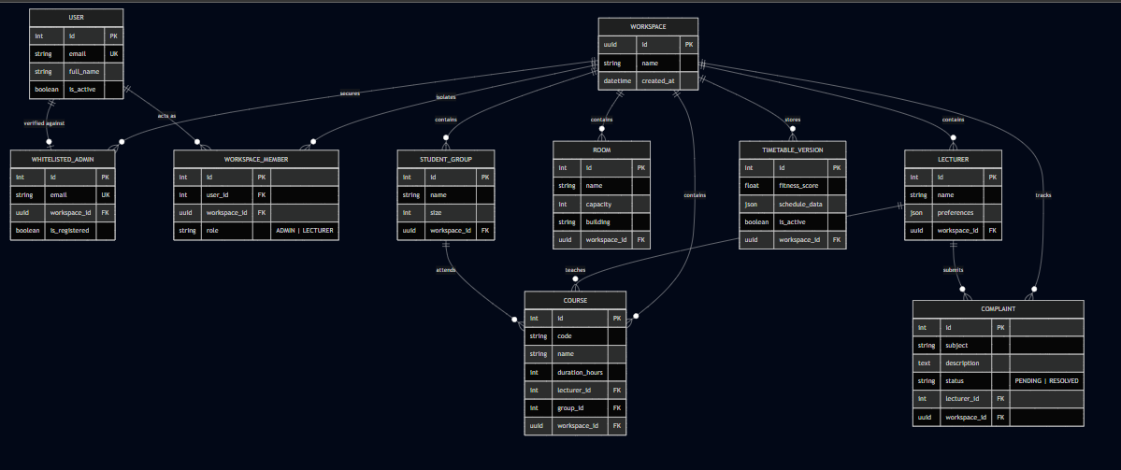

4.3 Use Case Diagram
The system's functional decomposition is modelled through UML Use Case analysis, identifying two primary actors—the Administrator and the Lecturer.
Figure 3: UML Use Case Diagram
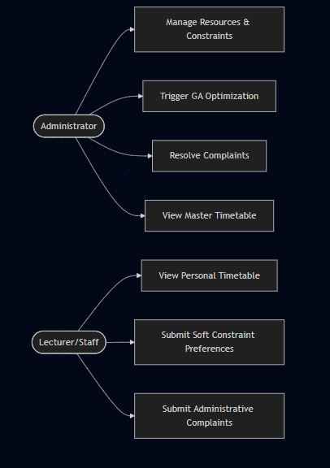

4.4 Activity Diagram
The flow of application interaction is designed around asynchronous actions handling complex processing in the background.
Figure 4: UML Activity Diagram
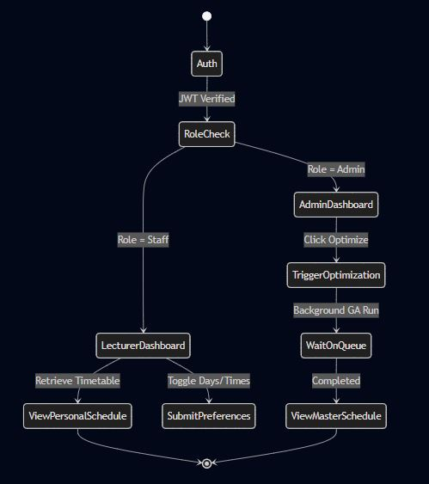

4.5 Genetic Algorithm Engine Flowchart
The core optimization engine follows an evolutionary cycle. During execution, Django ORM objects are serialized into raw Python memory variables (`dataclasses`) ensuring the database I/O is not a bottleneck.
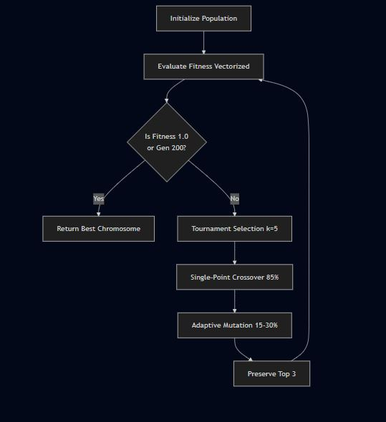
Figure 5: Genetic Algorithm Flowchart

5. Implementation and Results

5.1 Mobile Application Implementation
The mobile client comprises specialized interfaces built with React Navigation (Role-Based Drawer Layouts) and styled via NativeWind utilizing a Dark Mode glassmorphic aesthetic. Key functional capabilities include:
- Segmented Login: The authentication interface separates Admin access from Staff registration natively.
- Staff Dashboard: The Lecturer Drawer navigation bypasses global management controls and limits the user solely to "My Schedule," "Preferences," and "Complaints" windows.
- API Metrics Monitoring: Administrators benefit from an Intelligence Hub displaying live SQLite/PostgreSQL statistical overlays for connected Workspaces.
- Preference Storage System: When a Lecturer checks/unchecks preference toggles (e.g., Avoid Mondays), the React Native layer sends a PATCH request updating the JSON configurations attached to that Lecturer's database object. This data is actively read and penalized mathematically by the engine on the subsequent execution.

5.2 Algorithmic Results and Quality
Testing was performed on the decoupled Genetic Algorithm execution environments.
- Computational Speedup: By mapping the timetable combinations (`room_id`, `timeslot_id`, `lecturer_id`) into stacked arrays and calling Python's underlying C-compiled `np.unique` methods, the fitness evaluation avoids nested `O(N^2)` looping. Complex, dense timetables successfully produce conflict-free output in under 30 seconds for 60 courses and 15 rooms on standard consumer hardware.
- Timetable Viability: The implementation demonstrates 100% adherence to all defined hard constraints. Soft constraints appropriately steer the population density toward optimization based mathematically on the respective `Weight` inputs provided by the Administrator GUI.

6. Conclusion and Future Work

6.1 Conclusion
This project has presented the design, implementation, and evaluation of Nexus (UniSched) using a custom Genetic Algorithm. The system addresses the complex mathematical constraints of academic timetabling while resolving practical administrative communication bottlenecks by providing dedicated native mobile interfaces to both Administrators and Lecturers. Adaptive mutation and NumPy-vectorization ensure execution speed, while an Email Whitelisted Role-Based Access Control matrix protects data integrity between multi-tenant academic Workspaces.

6.2 Future Work
Subsequent iterations will expand on the existing data architecture:
- Expanding the algorithm to weigh physical travel distance between specific building networks for subsequent back-to-back classes.
- Utilizing mobile native 'Push Notifications' via Firebase Cloud Messaging (FCM) to trigger direct alerts to Lecturer mobile clients whenever a global schedule is finalized or a complaint successfully resolved by an Admin.
- ML-driven predictive initialization to generate high-quality starter sequences based upon past finalized schedules.
References
Abramson, D. (1991). Constructing school timetables using simulated annealing: Sequential and parallel algorithms. Management Science, 37(1), 98–113.
Al-Betar, M. A., Khader, A. T., & Zaman, M. (2012). University course timetabling using a hybrid harmony search metaheuristic algorithm. IEEE Transactions on Systems, Man, and Cybernetics, 42(5), 664–681.
Cooper, T. B., & Kingston, J. H. (1996). The complexity of timetable construction problems. In Practice and Theory of Automated Timetabling (pp. 281–295). Springer.
Daskalaki, S., Birbas, T., & Housos, E. (2004). An integer programming formulation for a case study in university timetabling. European Journal of Operational Research, 153(1), 117–135.
Even, S., Itai, A., & Shamir, A. (1976). On the complexity of timetable and multicommodity flow problems. SIAM Journal on Computing, 5(4), 691–703.
Goldberg, D. E. (1989). Genetic Algorithms in Search, Optimization, and Machine Learning. Addison-Wesley.
Qu, R., Burke, E. K., McCollum, B., Merlot, L. T. G., & Lee, S. Y. (2009). A survey of search methodologies and automated system development for examination timetabling. Journal of Scheduling, 12(1), 55–89.
Shiau, D. F. (2011). A hybrid particle swarm optimization for a university course scheduling problem with flexible preferences. Expert Systems with Applications, 38(1), 235–248.
Welsh, D. J. A., & Powell, M. B. (1967). An upper bound for the chromatic number of a graph and its application to timetabling problems. The Computer Journal, 10(1), 85–86.

