Housekeeping

Overview of the Proposed Software
- Background & Objectives: The Housekeeping module is a subsystem of the Hotel Operations & Services Integrated System (HOSIS). It is designed to manage room status, cleaning tasks, room inspections, housekeeping schedules, guest housekeeping requests, lost and found items, and maintenance reports raised by housekeeping staff. Its main objective is to keep room readiness information accurate and to improve coordination between Housekeeping, Front Office, and Engineering.
The target users are authorized housekeeping personnel (room attendants, floor supervisors/inspectors, and the executive housekeeper) and other hotel staff permitted to view room readiness information.
- Development & Hardware Platform:
  - OS / Platform Requirements: The system will be developed as a web-based application accessible through a compatible web browser. The initial system does not include a dedicated Android or iOS application.
  - Hardware Specifications: The system can be accessed using a desktop computer, laptop, or tablet with a compatible web browser and a stable network connection. Specific minimum CPU, RAM, and storage requirements have not yet been defined.
- Core Functions & Storage: The module allows authorized users to view and update room status, create and assign cleaning tasks, record room inspections, manage staff schedules, record guest requests, log found items and process claims, and report maintenance issues. Housekeeping information is stored in the centralized HOSIS database.
- Database & Environment: The project uses React and Vite for the web interface, Node.js with Express for the REST API, and PostgreSQL as the centralized HOSIS database. JWT authentication and role-based access control protect subsystem functions.
- Scope & Limitations: The module is intended for a single hotel establishment and forms part of the HOSIS web application. Its initial scope excludes direct integration with physical hotel hardware such as electronic door locks, IoT room sensors, and automated HVAC systems, as well as a dedicated native mobile application. Inventory tracking of linens and cleaning supplies is not part of the current data model.

Description of the Software
- Detailed Purpose: The Housekeeping module aims to improve room turnaround and guest service by organizing room status updates, assigning cleaning work, recording inspection results, and centralizing lost and found and guest request records. It supports operational efficiency by making the current state of every room visible to authorized personnel.
The module follows the access permissions and operational procedures defined for HOSIS. Specific regulatory compliance requirements have not yet been identified in the project scope.
- System Architecture Overview: The module follows the HOSIS modular architecture, meaning Housekeeping operates as part of one integrated application rather than as an independent system. The general architecture is:
User → React Frontend → REST API → Backend Server → HOSIS Database
The module shares information with other HOSIS subsystems. When a guest checks out, Front Office can trigger a DIRTY room status for Housekeeping. After cleaning and inspection, the room is marked CLEAN or INSPECTED and made visible to Front Office. If Housekeeping finds a maintenance issue, a maintenance request is created for Engineering, and the room may remain OUT OF ORDER until the repair is completed.
- Core Components:
  - Room Status Management — Allows authorized users to view rooms, select a room, and update its status (OCCUPIED, DIRTY, CLEAN, INSPECTED, or OUT OF ORDER). Every change is recorded in the room status log and Front Office is notified of room availability.
  - Cleaning Task Management — Allows supervisors to create or update cleaning tasks, assign a housekeeper, and track progress until cleaning is completed.
  - Inspection — Allows inspectors to record the result of an inspection; rooms that fail are returned for re-cleaning, and rooms that pass are marked CLEAN / INSPECTED.
  - Schedule Management — Maintains staff shifts, workloads, and assigned areas.
  - Guest Request Management — Records guest housekeeping requests, assigns staff to process them, and tracks completion.
  - Lost & Found Management — Records found items, stores and labels them, supports record search, and releases items when a valid claim is confirmed.
  - Maintenance Reporting — Allows housekeeping staff to report maintenance issues to Engineering and set the room OUT OF ORDER when needed.
  - User Interface and Access Control — Provides the Housekeeping dashboard and function pages according to the user’s assigned role and permissions; unauthorized login attempts are denied.
The module does not currently specify barcode scanning, QR-code scanning, or optical capture mechanisms as required features. These should not be treated as existing functions unless they are approved as additional project requirements.

Features of the Software
Table 1.1: Room Operations Features
Feature Name | Core Functionality | UI Elements / Components | Translators & Outputs
Room Status (HK-001 – HK-003) | View, select, and update the status of a room | Room list/grid, room selector, status dropdown, Save button | Updated room status; room status log entry; availability notice to Front Office
Cleaning Tasks (HK-004 – HK-006) | Create/update tasks, assign a housekeeper, perform cleaning | Task form, housekeeper selector, task status controls | Cleaning task record with start and completion time
Room Inspection (HK-007) | Inspect a cleaned room and record pass or fail | Inspection form, result selector, remarks field | Inspection record; room marked CLEAN/INSPECTED, or returned for re-cleaning
Housekeeping Schedule (HK-008 – HK-009) | View and create/update staff shifts and workloads | Schedule table/calendar, shift form, area selector | Schedule entries per staff member and date
Table 1.2: Guest Service and Support Features
Feature Name | Core Functionality | Interface / Hardware Requirements | Operations & Processing
Guest Requests (HK-013 – HK-014) | Record, assign, process, and complete guest requests | Web form, request list, status controls; desktop, laptop, or tablet browser | Request validated and saved; staff assigned; completion time recorded
Lost & Found (HK-010 – HK-012) | Record found items, store/label, search records, release valid claims | Item form, search box, claim form; desktop or laptop browser | Item and claim records; claim validated before item is released
Maintenance Reporting (HK-015) | Report an issue to Engineering and set the room OUT OF ORDER | Maintenance request form with category, description, and priority | Maintenance request created; room status updated; cleaning task created after repair
Login & Access Control | Authenticate housekeeping staff and show only permitted functions | Login form, dashboard, role-based menu | Credentials verified; access denied if not authorized

Software Development Team & Methodology

Software Development Team Structure
- Figure 1.1 Housekeeping Subsystem Development Team Structure
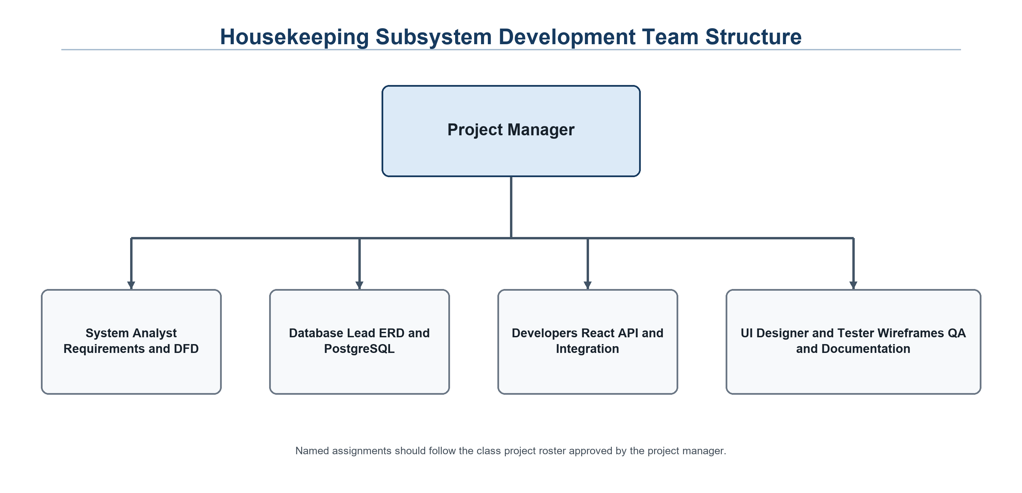

SDLC Model Selection
- Model Choice: Agile iterative development
- Rationale: Agile supports repeated review of shared room-status rules, database relationships, interface wireframes, and integration behavior with Front Office and Engineering. Each iteration can be tested and refined before the next feature set is added.

Software Planning

Gantt Chart
- Figure 1.2 Housekeeping Subsystem Development Gantt Chart
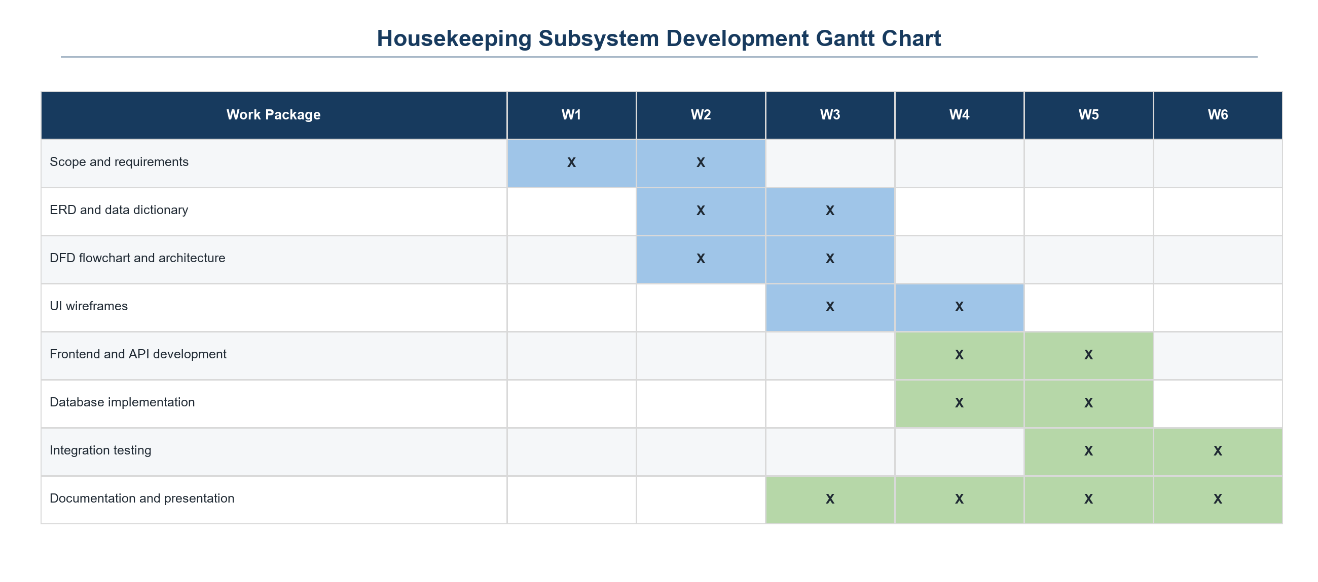

Development Timeline & Phases
- Week 1: Planning Phase (Scheduling, initial functional requirements analysis).
- Week 2: Actual Functional Analysis & Detailed Requirements Evaluation.
- Week 3: System Architecture & Design (Logical and physical design modeling, ERD, and flowcharts).
- Week 4: Program Development & Implementation (Coding and interface implementation).
- Week 5: Software Testing & Debugging (Defect logging, test executions, deployment planning).
- Week 6: Final System Evaluation & Project Finalization.

Software Analysis
- Requirements Elicitation: Requirements were gathered from the HOSIS system documentation (System Scope, Users and Roles, Functional and Non-Functional Requirements) and from the Housekeeping Department flowchart. Housekeeping functions were identified per role and each was given a reference code (HK-001 to HK-015) to avoid scope ambiguity.
- Documentation Strategy: Functional requirements are tracked against flowchart references, while non-functional requirements (security, usability, reliability, data integrity, maintainability, and performance) are tracked as categories with measurable criteria.
- Analysis Scope: The analysis defines what the Housekeeping module must do and the constraints it operates under (single hotel, web-based, integrated with Front Office and Engineering) rather than implementation details.

Specifications
- Software Specification: The Housekeeping subsystem runs in a current supported version of Chrome, Edge, or Firefox on Windows, macOS, or Linux. The frontend uses React and Vite, while the backend uses Node.js and Express.
- Hardware Specification:
  - Client Minimum Specifications: A desktop, laptop, or tablet capable of running a modern browser, with a stable network connection and sufficient memory for normal browser operation. No dedicated client installation is required.
  - Operational Metrics: Standard pages and room-status updates should respond within about three seconds under normal single-hotel workload. Authentication and permission checks are applied before protected actions are processed.
  - Deployment Flow: The web application is served from the HOSIS deployment environment. Users open the system URL in a supported browser and sign in with an authorized staff account; no separate desktop installation is required.

Requirements Specifications

Functional Requirements
Table 1.3: Functional Requirements List
Requirement No. | Description
FR 1 | The system shall authenticate housekeeping staff at login and deny access to unauthorized users.
FR 2 | The system shall display a Housekeeping Dashboard and the functions available to the user’s role.
FR 3 | The system shall allow authorized users to view room status (HK-001) and select a room (HK-002).
FR 4 | The system shall allow authorized users to update a room’s status to OCCUPIED, DIRTY, CLEAN, INSPECTED, or OUT OF ORDER (HK-003) and record each change in the room status log.
FR 5 | The system shall notify Front Office when a room becomes available.
FR 6 | The system shall allow supervisors to create or update cleaning tasks (HK-004).
FR 7 | The system shall allow supervisors to assign a housekeeper to a cleaning task (HK-005).
FR 8 | The system shall allow housekeepers to perform cleaning and update task progress, including start and completion time (HK-006).
FR 9 | The system shall allow inspectors to inspect a cleaned room and record the result (HK-007).
FR 10 | The system shall return a room for re-cleaning when it fails inspection, and mark it CLEAN / INSPECTED when it passes.
FR 11 | The system shall allow authorized users to view staff schedules (HK-008) and create or update schedules, workloads, and shifts (HK-009).
FR 12 | The system shall allow staff to record found items (HK-010), store and label them, and search or view lost and found records (HK-011).
FR 13 | The system shall release an item and update its record only when a claim is confirmed valid (HK-012).
FR 14 | The system shall record guest requests (HK-013), assign and process them, and mark them complete (HK-014).
FR 15 | The system shall allow housekeeping staff to create a maintenance request for Engineering (HK-015) and set the affected room OUT OF ORDER.
FR 16 | The system shall update the room status and create a cleaning task once Engineering completes the repair.

- Functional Workflow Summary: A user logs in and, if authorized, reaches the Housekeeping Dashboard and selects a function. Room status changes, cleaning tasks, inspections, schedules, guest requests, found items, and maintenance reports are submitted through the frontend to the backend through the REST API and stored in the HOSIS database. A checkout marks the room DIRTY; a task is assigned and cleaned; an inspection either returns the room for re-cleaning or marks it CLEAN / INSPECTED and notifies Front Office. Maintenance reports move the room to OUT OF ORDER until Engineering completes the repair, after which a new cleaning task is created. After each task the user may perform another task or end the session.

Non-Functional Requirements
Table 1.4: Non-Functional Requirements List
Category | Metric / Specification
Speed | Standard pages and room status updates should respond within about 3 seconds under normal single-hotel workload.
Availability | The system should be available during hotel operating hours, including all housekeeping shifts, subject to scheduled maintenance and the deployment environment.
Capacity | The system should support the room inventory and daily task, request, inspection, and status-log volume of one hotel property.
Reliability | Room status and task data must remain consistent; every status change is logged and failed saves display a clear error.
Security | Credentials are verified at login; passwords are stored as hashes; functions are restricted by role.
Data Integrity | Records are linked by primary and foreign keys so tasks, inspections, claims, and logs always refer to valid rooms, staff, and guests.
Usability | Interfaces use clear labels, consistent navigation, and visible status values so that housekeeping staff can work with minimal training.
Maintainability | Frontend, backend, and database are kept in separate areas of the project to support future changes.

- Non-Functional Impact Summary: These requirements govern how fast, secure, and dependable the module feels to users without changing its primary business logic. Numeric targets will be validated during testing.

Software Design

Logical & Physical Architecture
- Figure 1.3: Housekeeping Department Flowchart (Logical Diagram of System Workflow)
  - Narrative: The process begins when housekeeping staff log in. If not authorized, access is denied; otherwise the Housekeeping Dashboard opens. The user selects one of six functions — Manage Room Status, Manage Cleaning Tasks, Manage Housekeeping Schedules, Manage Lost & Found, Manage Guest Requests, or Report Maintenance Issue — and completes its steps. Decision points include Cleaning Completed?, Inspection Passed?, and Valid Claim?. The user then chooses Perform Another Task? to return to the dashboard or ends the session.
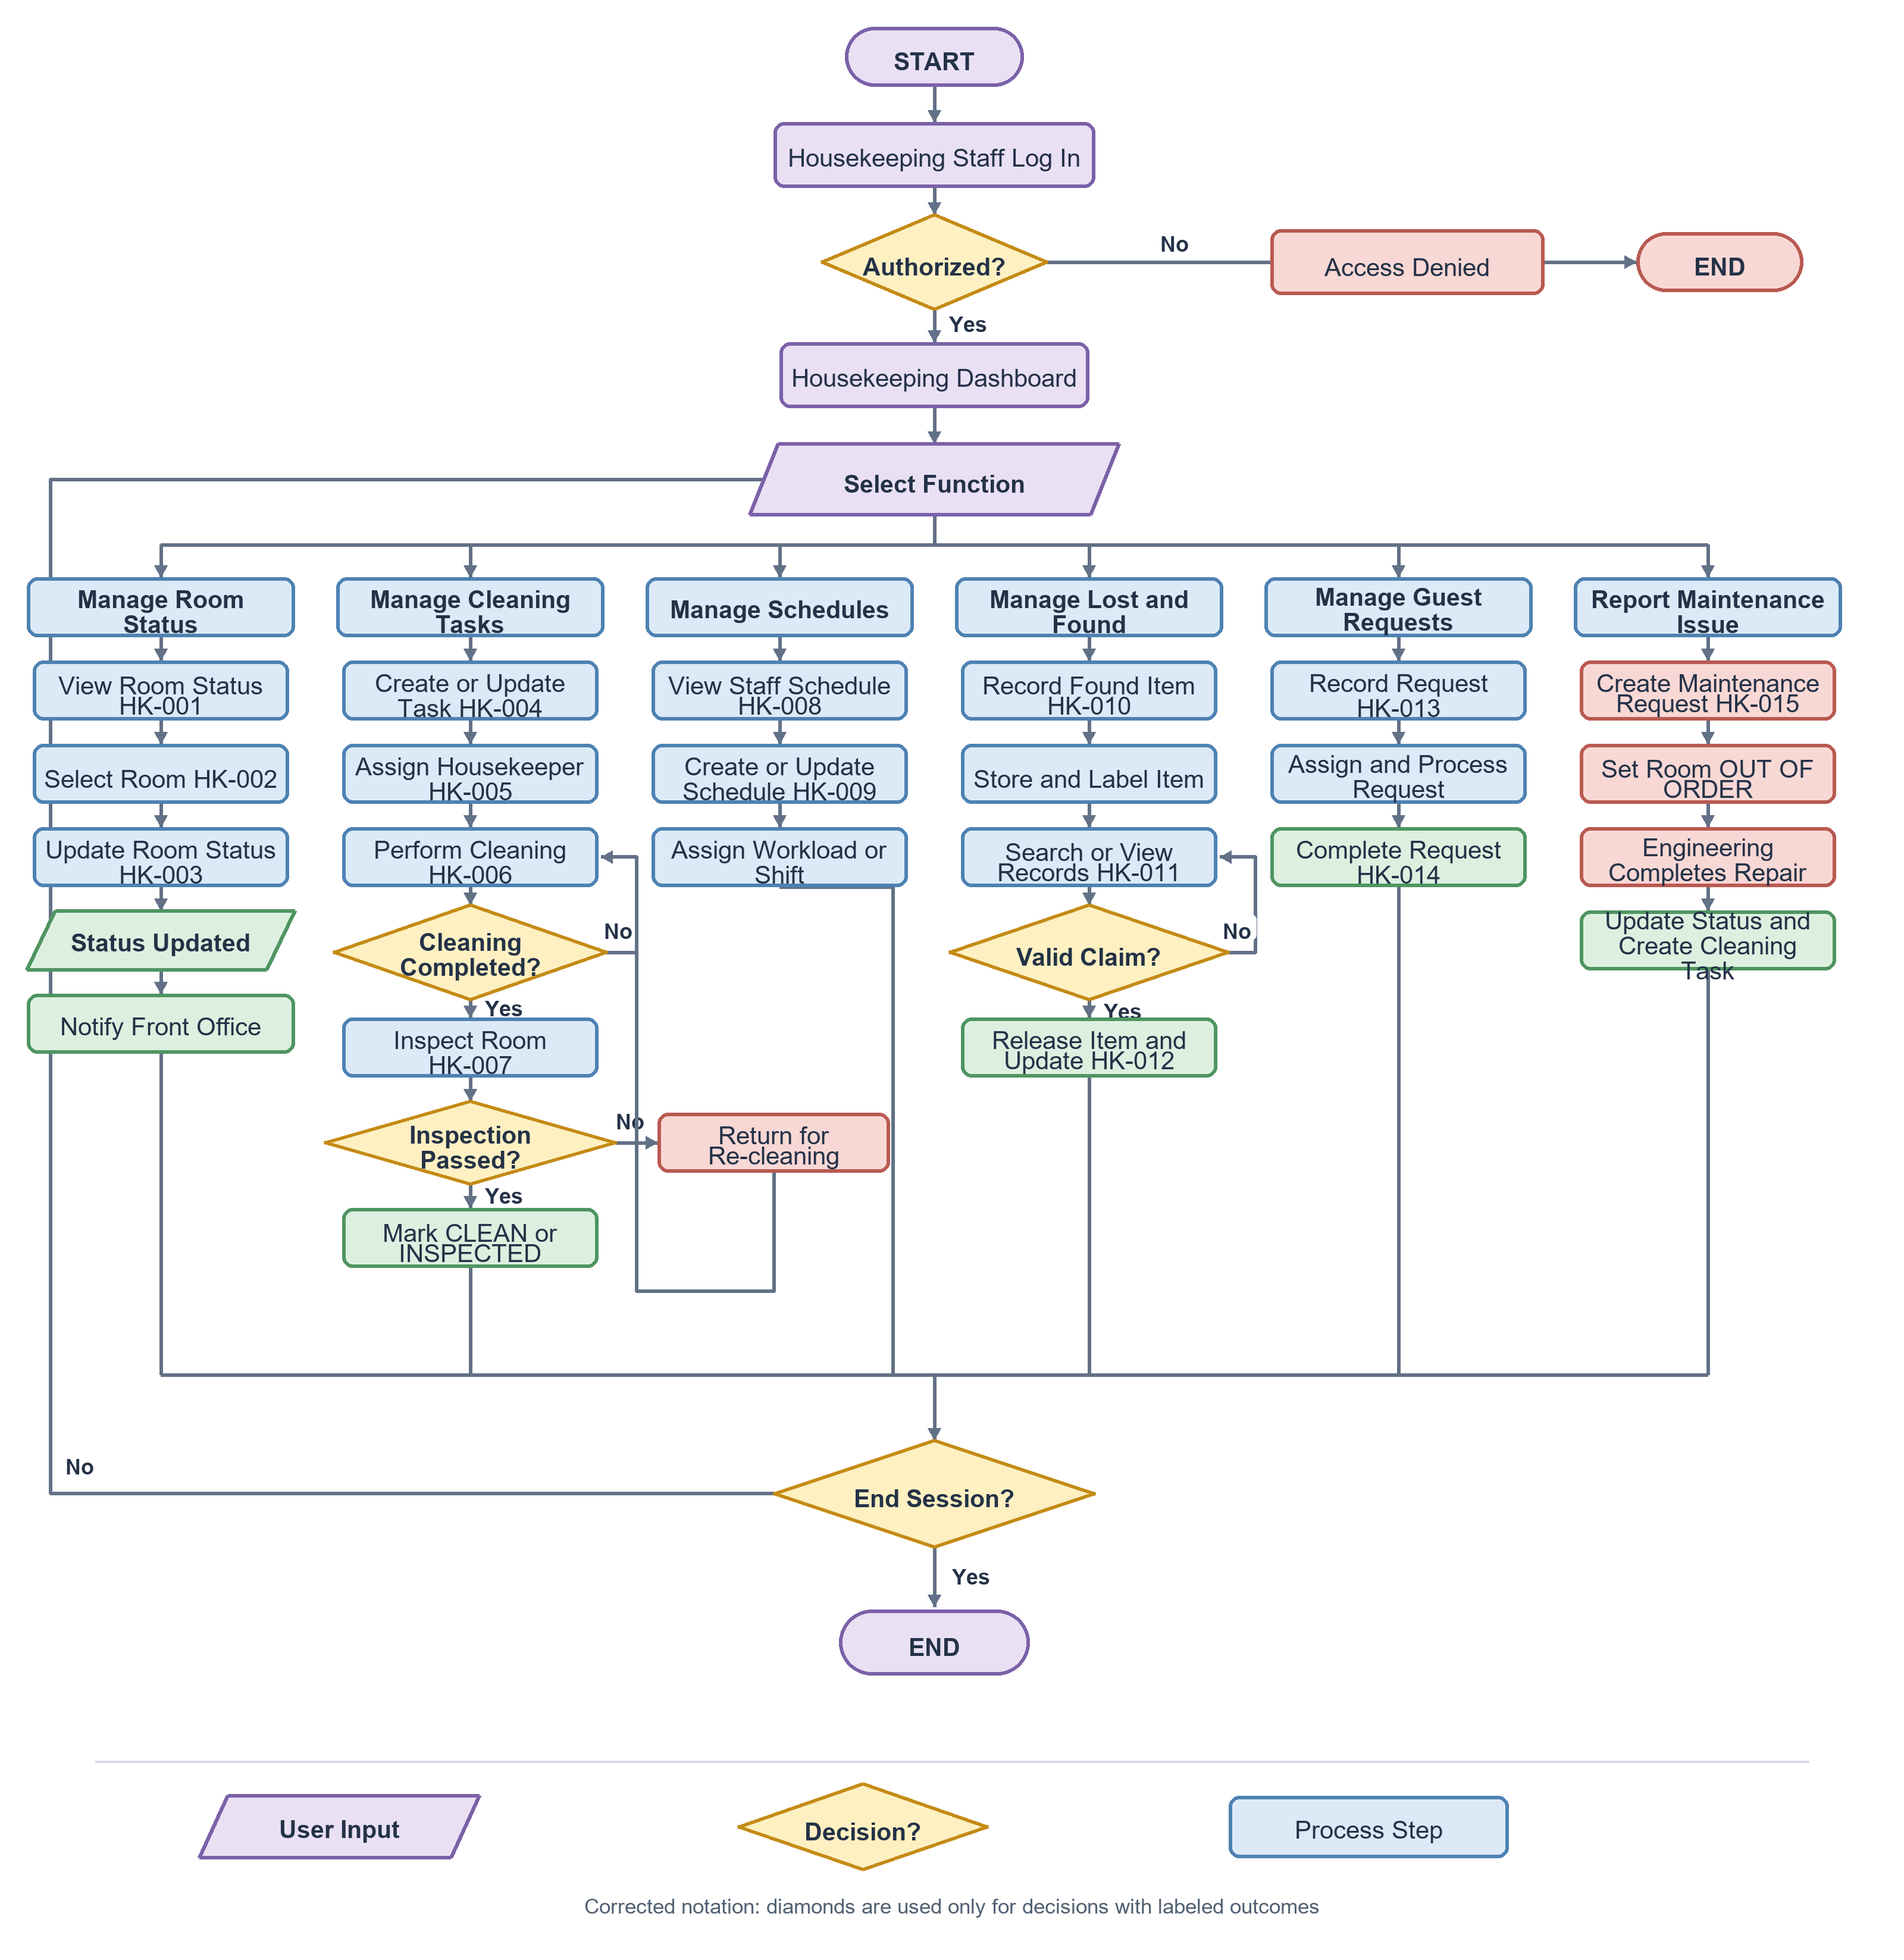
Figure 1.3: Housekeeping Department Flowchart
- Figure 1.4 HOSIS Housekeeping Physical Architecture
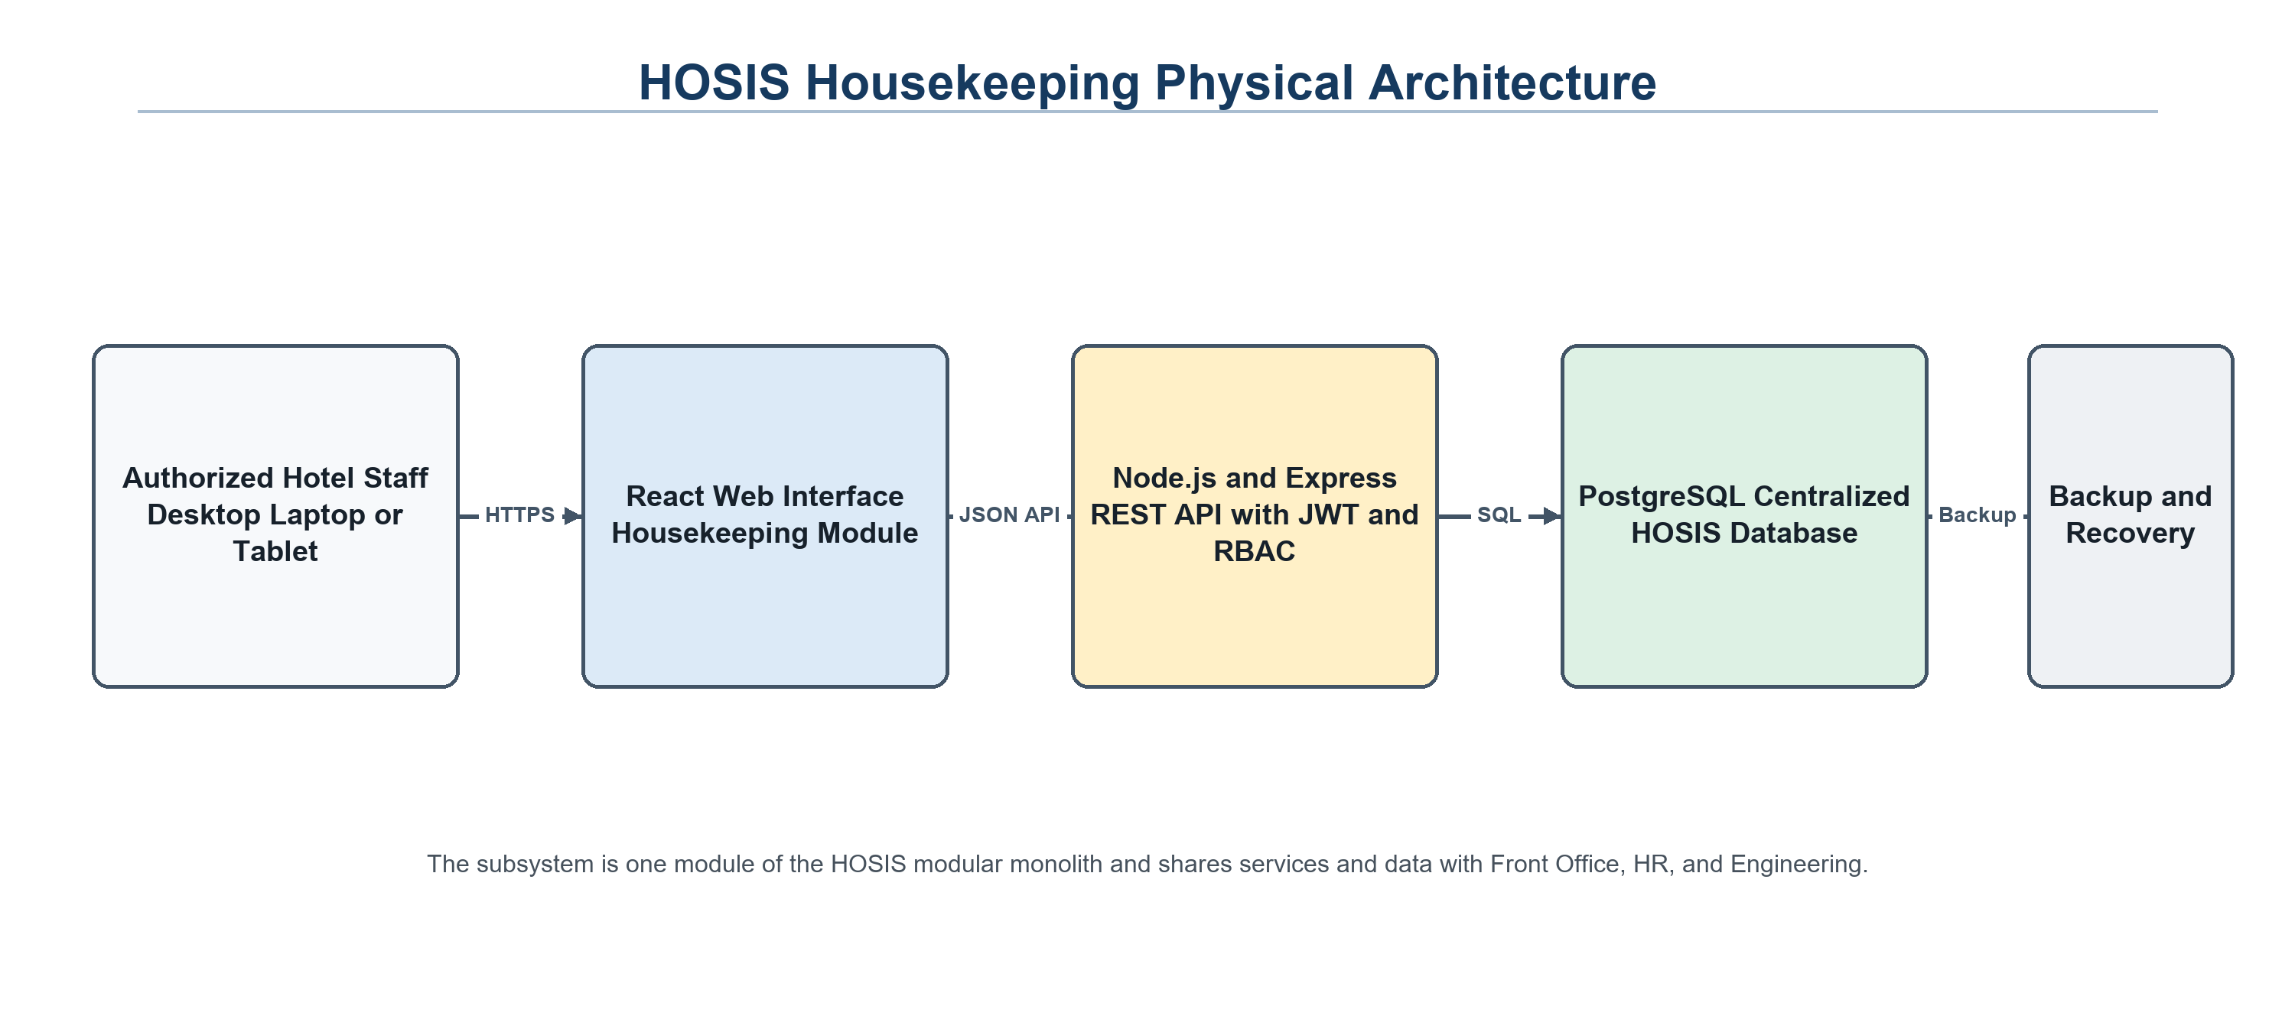
Housekeeping users access the React interface through a browser. The Node.js and Express API applies JWT authentication and role-based permissions before updating the centralized PostgreSQL database.
  - Narrative: Staff devices connect through the hotel network to the HOSIS web application. Browser requests reach the React interface and Node.js or Express REST API, which validates JWT credentials and role permissions before accessing PostgreSQL.

System Identity & Branding
- Figure 1.5 HOSIS Housekeeping System Identity
The subsystem uses the approved HOSIS name and institutional branding already shown in the document header. Housekeeping screens retain the shared HOSIS navigation, typography, status colors, and role-based interface patterns.

User Interface Specifications

Actual HOSIS Housekeeping Figma Prototype
- Figure 1.6 HOSIS Housekeeping UI Prototype Overview
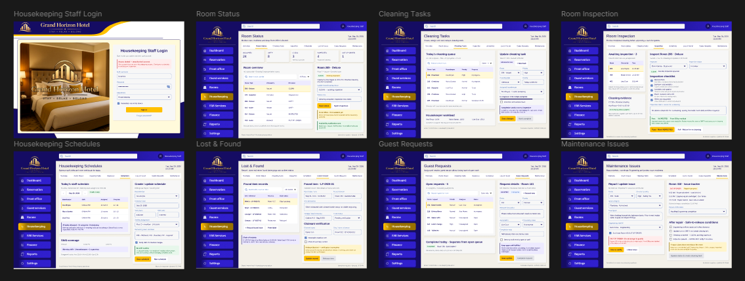
The following figures come from the HOSIS UI HOUSEKEEPING UI Figma file supplied by the project group. They are the group's actual interface prototypes, not screenshots of a deployed application. The names, room numbers, dates, task details, and status values shown in the prototype are illustrative test data.
Figure 1.7 Housekeeping Staff Login
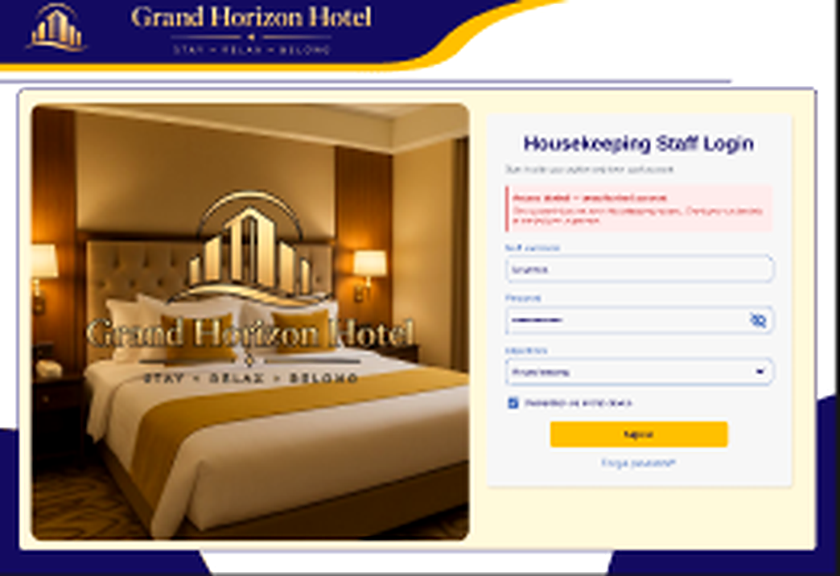
Login screen for authorized housekeeping staff using the Grand Horizon Hotel HOSIS interface.
Figure 1.8 Room Status
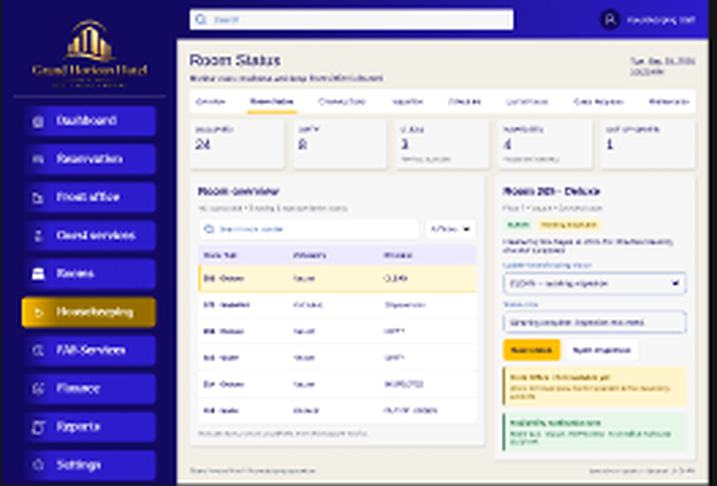
Room status workspace for reviewing room conditions, priorities, and operational notes.
Figure 1.9 Cleaning Tasks
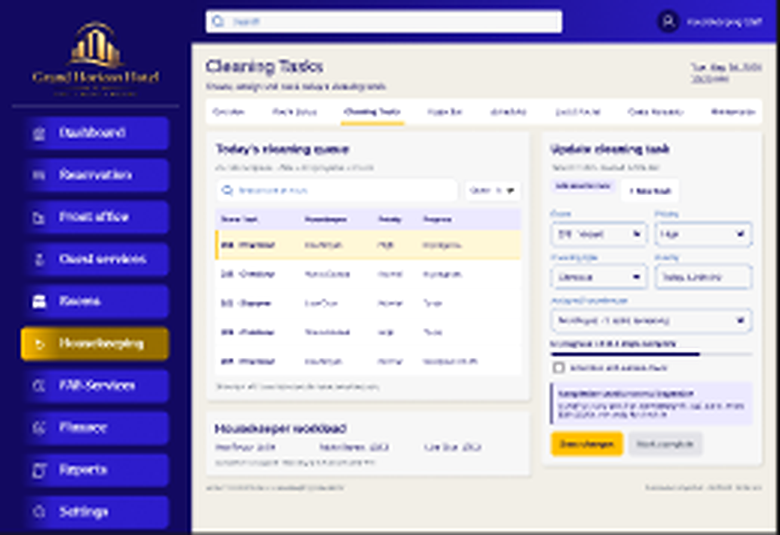
Cleaning task workspace for assignments, task details, updates, and attendant workload.
- UI Design Rationale: The actual prototype uses Grand Horizon Hotel branding, a blue and purple navigation system, a gold Housekeeping indicator, white work areas, compact tables, and color-coded operational feedback.

Supervisor and Inspector Interface
- Figure 2.0 Room Inspection
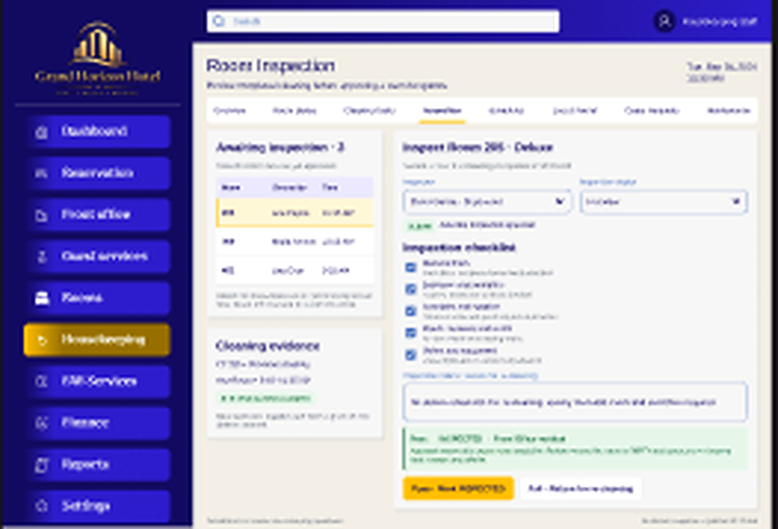
Inspection workspace for reviewing room readiness, checklist results, and follow-up action.
Figure 2.1 Housekeeping Schedules
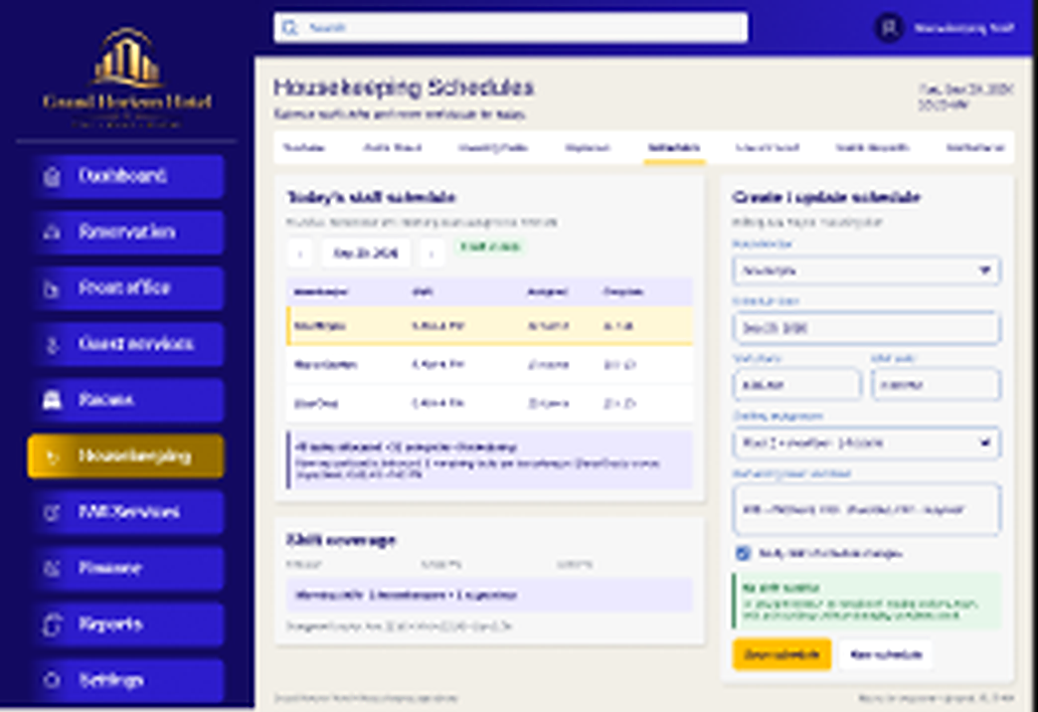
Scheduling workspace for shift assignments, coverage, staff availability, and workload planning.
- Operational UI Rationale: Supervisors can coordinate schedules, assign work, inspect cleaned rooms, and monitor status changes through the same Housekeeping navigation structure.

Guest Service Lost and Found and Maintenance Interface
- Figure 2.2 Guest Requests
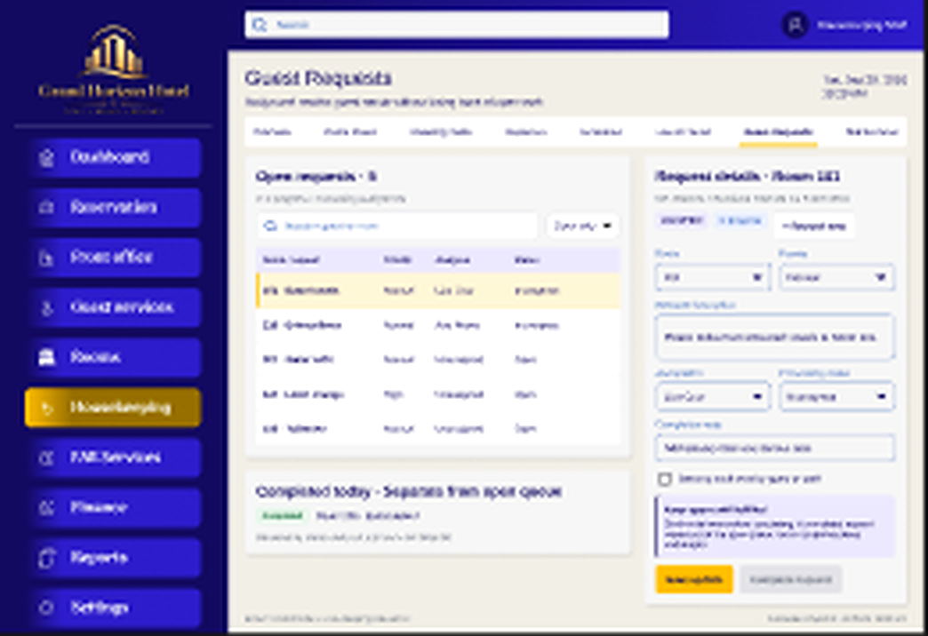
Guest request workspace for recording, assigning, tracking, and completing housekeeping service requests.
Figure 2.3 Lost and Found
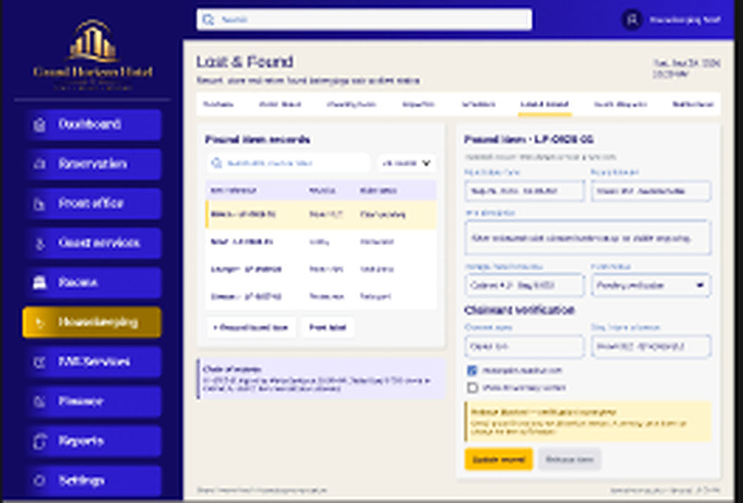
Lost and Found workspace for recording found items, storage details, claim status, and claimant verification.
Figure 2.4 Maintenance Issues
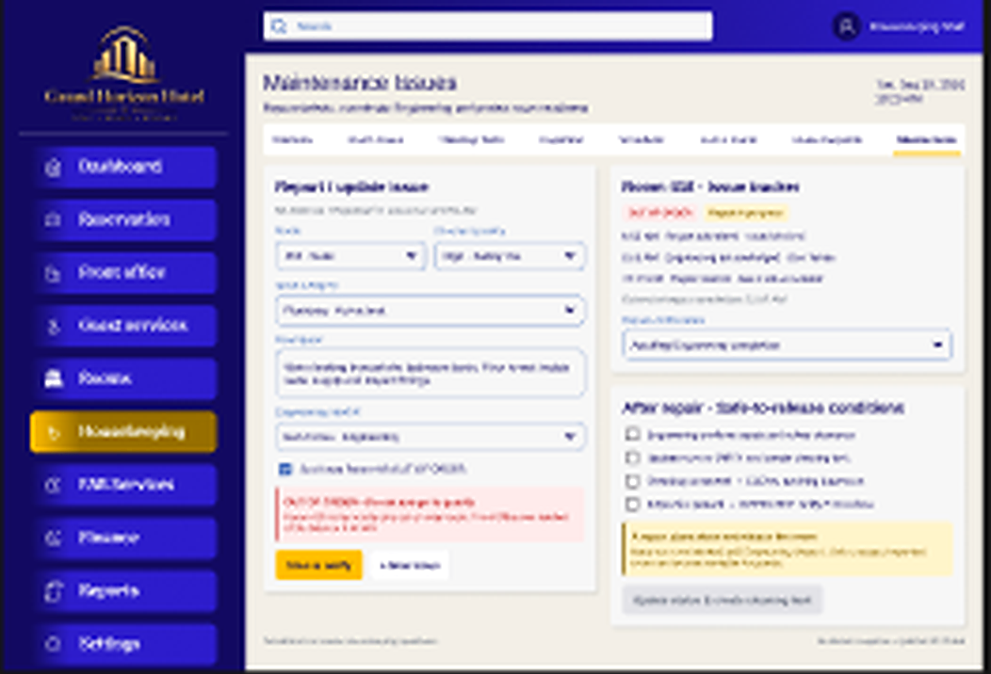
Maintenance issue workspace for reporting room defects, setting urgency, and monitoring repair follow-up.

Prototype Coverage

Only the eight Housekeeping screens visible in the supplied Figma file are presented here: Staff Login, Room Status, Cleaning Tasks, Room Inspection, Housekeeping Schedules, Lost and Found, Guest Requests, and Maintenance Issues. Other required functions remain documented in the workflow, DFD, and ERD but are not represented as completed UI frames in this figure set.
- Interface Rationale: The documented controls and descriptions are limited to the group's supplied prototype so the documentation remains consistent with the actual HOSIS Housekeeping design presented by the team.

Flow Diagrams & Architecture Models

Role Activity Diagram
- Figure 4.8 Housekeeping Role Activity Diagram
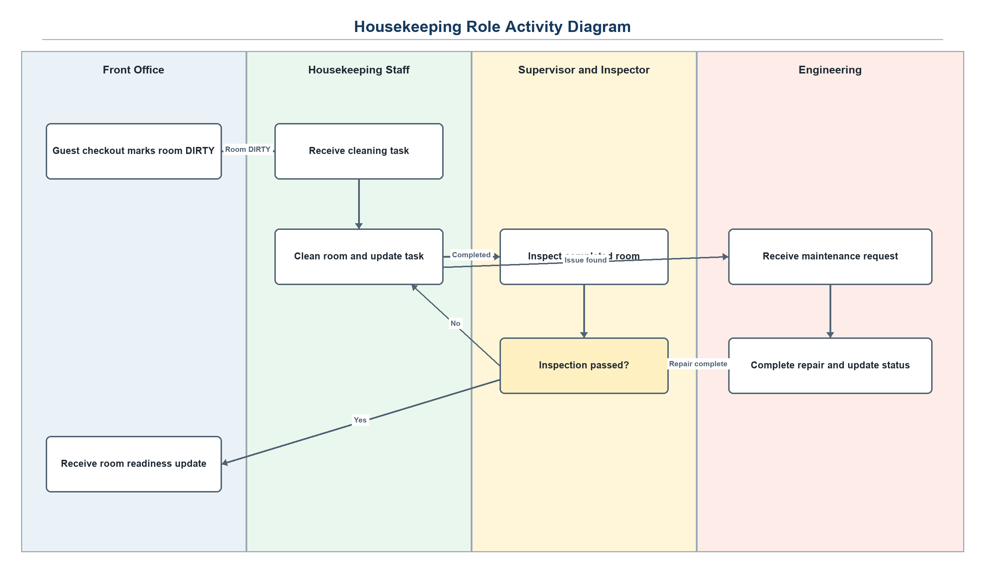
The diagram assigns checkout and availability actions to Front Office, cleaning work to Housekeeping, approval decisions to the Supervisor or Inspector, and repairs to Engineering.
- Narrative Breakdown: Housekeepers perform cleaning and report issues; supervisors assign tasks, inspect rooms, and manage schedules; Front Office receives room availability and triggers DIRTY status on checkout; Engineering resolves maintenance requests.

Technology Stack & Environment
- Frontend Framework: React with Vite
- Backend Runtime: Node.js
- Database Management System: PostgreSQL is the centralized HOSIS database used by the modular Housekeeping subsystem and its shared room, guest, staff, and maintenance records.

System Data Flow Diagrams (DFD) & Entity Relationship Diagrams (ERD)
- Figure 4.9 Housekeeping Login and Authorization DFD
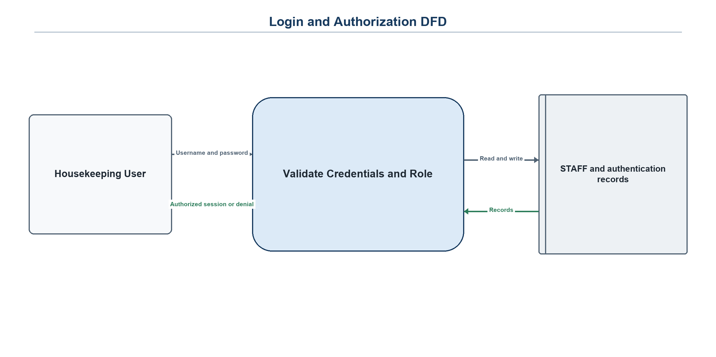
- Figure 5.0 Room Status and Cleaning Task DFD
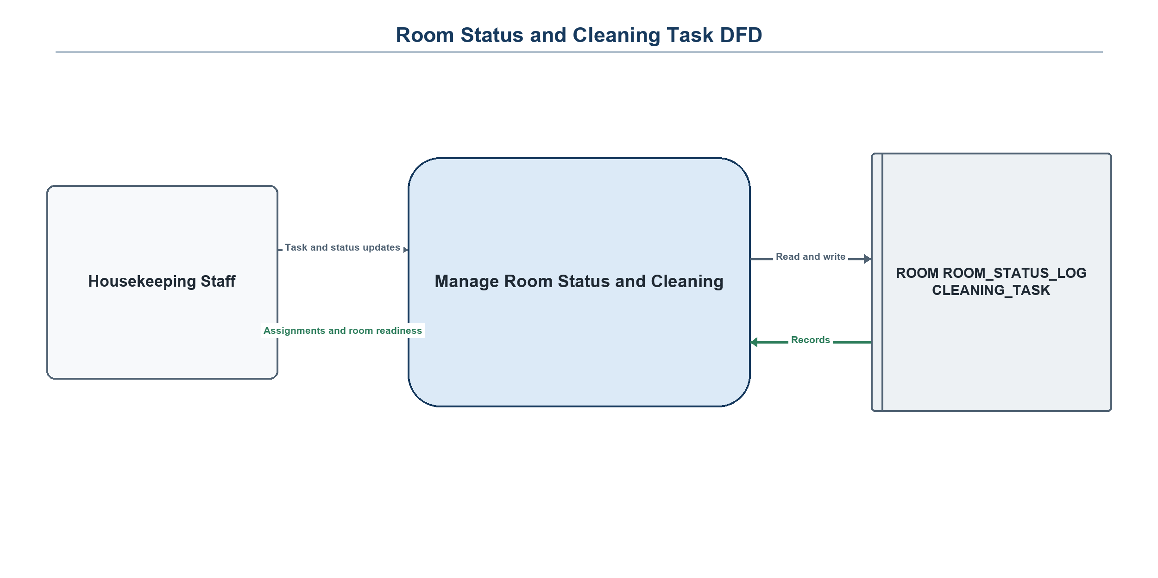
- Figure 5.1 Inspection and Re-cleaning DFD
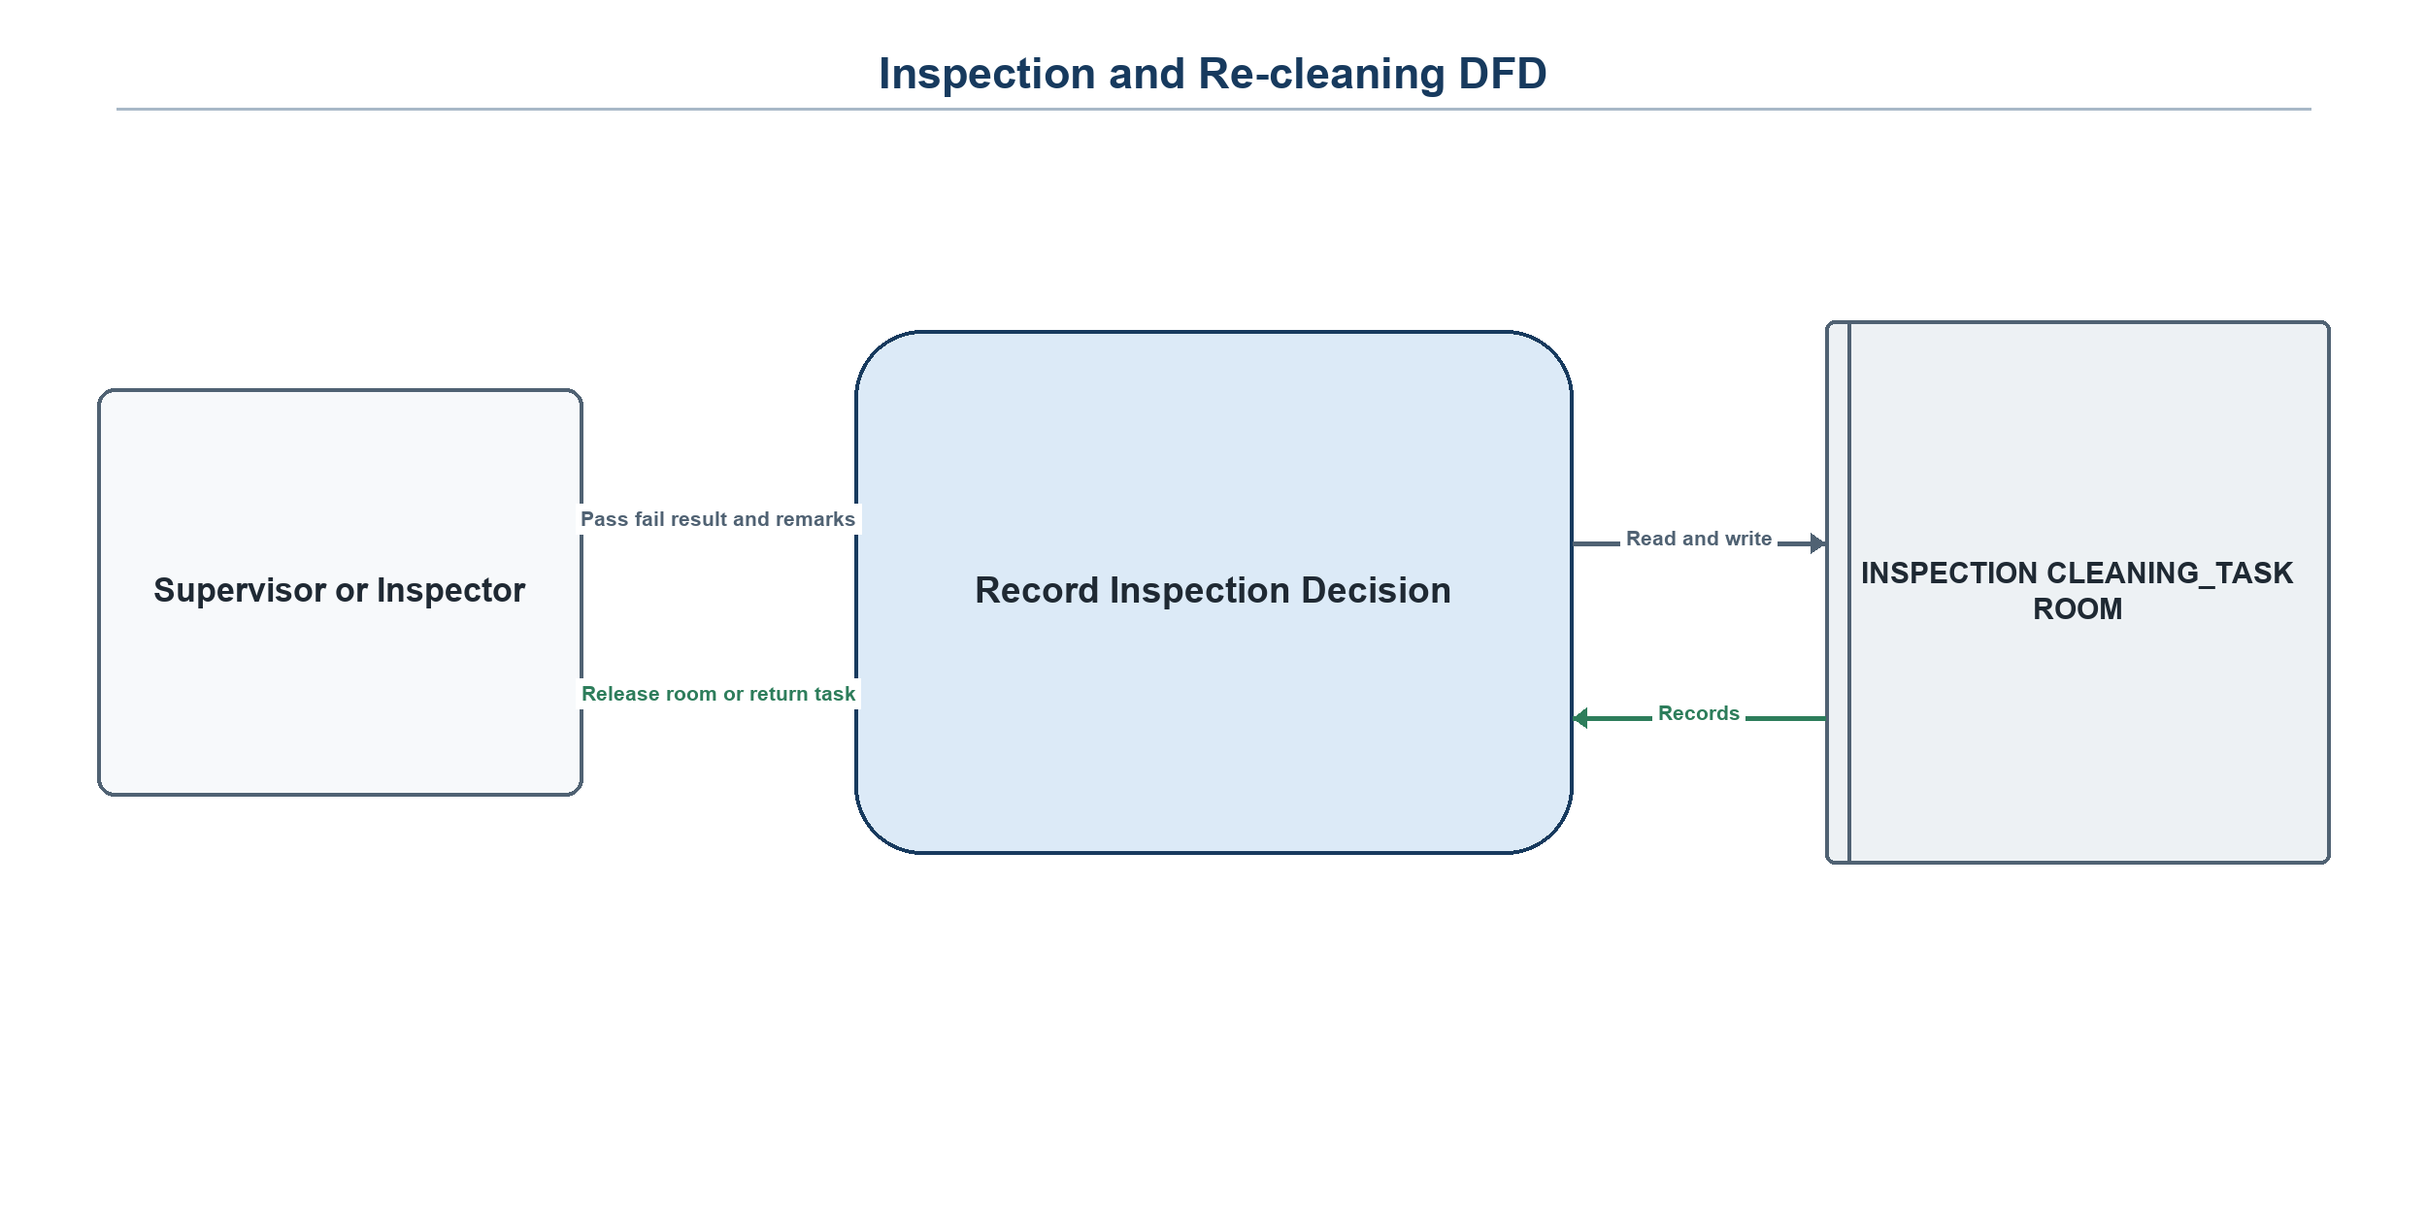
- Figure 5.2 Lost and Found and Guest Request DFD
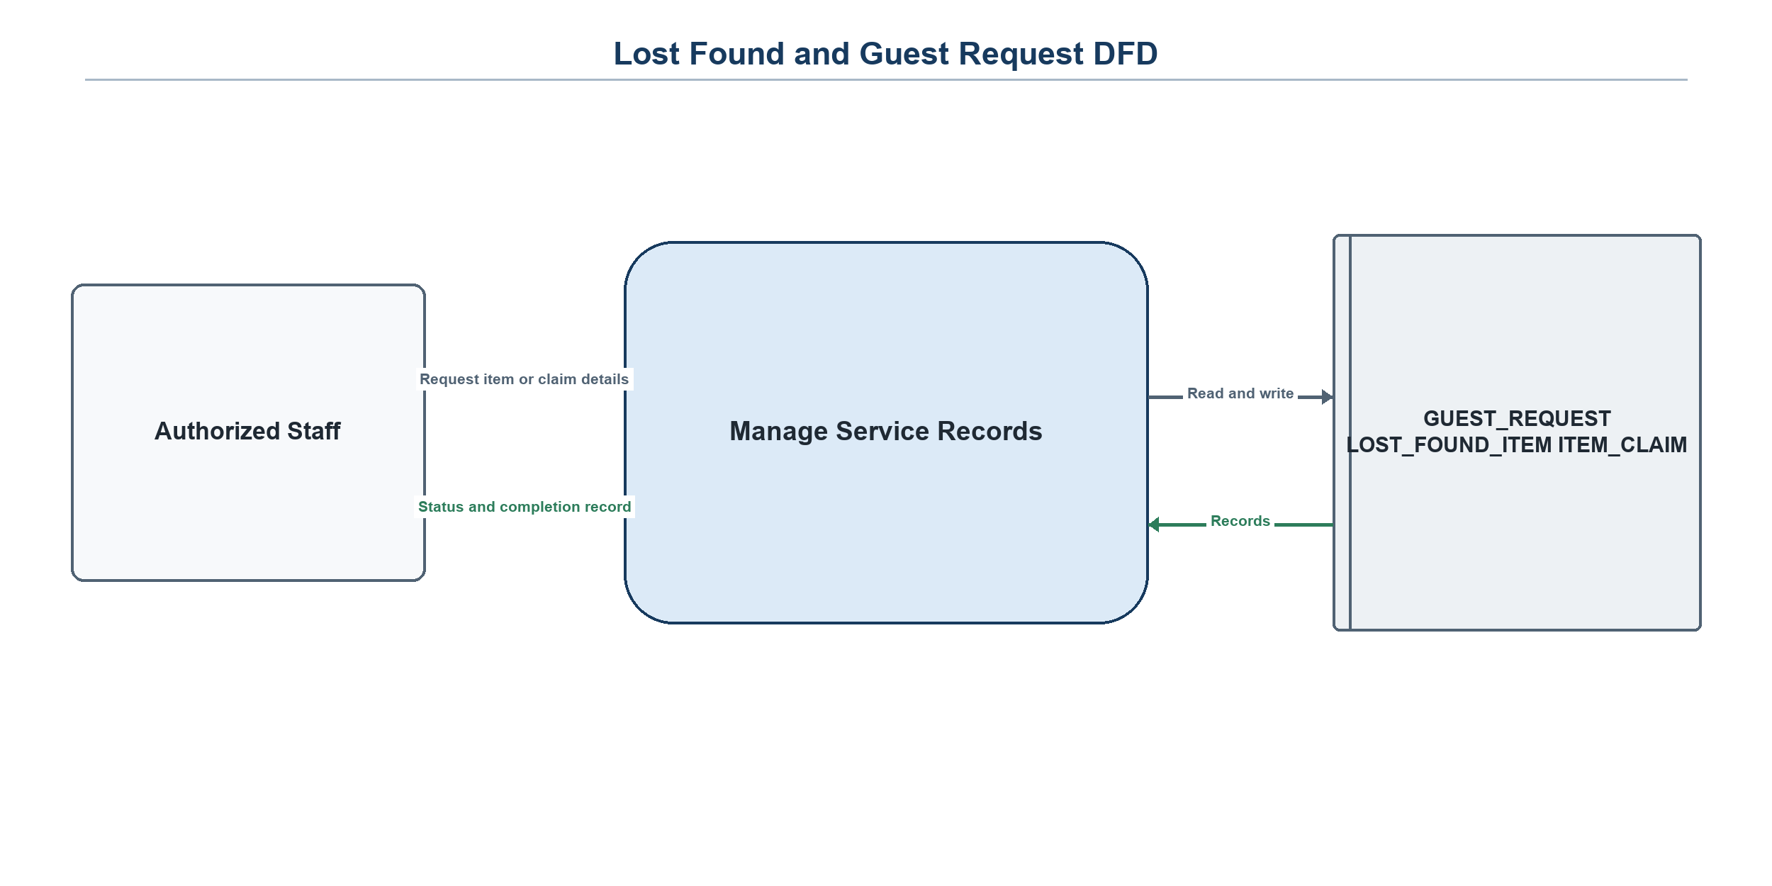
- Figure 5.3: Housekeeping Entity Relationship Diagram (ERD) — see below
- Figure 5.4 Housekeeping System Level DFD
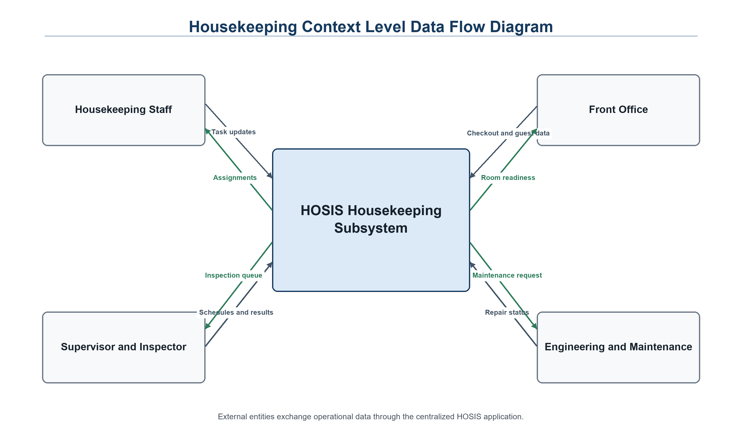
The system-level view shows the operational exchanges between Housekeeping, Front Office, Engineering, and the centralized HOSIS data stores.
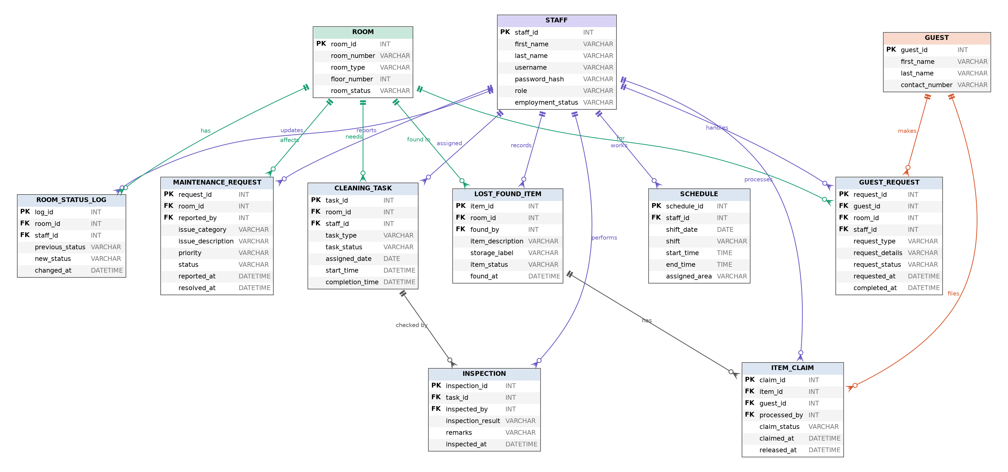
Figure 5.3: Housekeeping Entity Relationship Diagram (11 entities)
Notation: PK = primary key, FK = foreign key. Each relationship is one-to-many (1:N), with the foreign key on the “many” side. There are no many-to-many relationships, so no junction tables are needed.

Entities
Table 1.9: Entity Descriptions
Entity | Description
STAFF | Housekeeping personnel (housekeepers, inspectors, supervisors) who log in, perform cleaning, inspections, and updates.
ROOM | A hotel room and its current status (OCCUPIED, DIRTY, CLEAN, INSPECTED, OUT OF ORDER).
ROOM_STATUS_LOG | History of every room status change, including who changed it and when.
CLEANING_TASK | A cleaning assignment for a room, given to a housekeeper, with progress and times.
INSPECTION | The result of an inspection of a cleaning task; a task may be inspected again after re-cleaning.
SCHEDULE | Shift and work area entries for staff members.
GUEST | A guest who makes housekeeping requests or item claims.
GUEST_REQUEST | A housekeeping request from a guest for a room, handled by a staff member.
LOST_FOUND_ITEM | An item found in a room, with storage label and status.
ITEM_CLAIM | A guest’s claim for a found item, processed by staff until released or rejected.
MAINTENANCE_REQUEST | An issue reported for a room that needs Engineering attention.

Data Dictionary
STAFF
Attribute | Type | Key | Description
staff_id | INT | PK | Unique staff identifier
first_name | VARCHAR |  | Staff first name
last_name | VARCHAR |  | Staff last name
username | VARCHAR |  | Login username
password_hash | VARCHAR |  | Hashed password (never stored in plain text)
role | VARCHAR |  | Staff role used for access control
employment_status | VARCHAR |  | Employment state of the staff member
ROOM
Attribute | Type | Key | Description
room_id | INT | PK | Unique room identifier
room_number | VARCHAR |  | Room number
room_type | VARCHAR |  | Type of room
floor_number | INT |  | Floor where the room is located
room_status | VARCHAR |  | OCCUPIED, DIRTY, CLEAN, INSPECTED, or OUT OF ORDER
ROOM_STATUS_LOG
Attribute | Type | Key | Description
log_id | INT | PK | Unique log entry identifier
room_id | INT | FK | Room whose status changed
staff_id | INT | FK | Staff member who made the change
previous_status | VARCHAR |  | Status before the change
new_status | VARCHAR |  | Status after the change
changed_at | DATETIME |  | Date and time of the change
CLEANING_TASK
Attribute | Type | Key | Description
task_id | INT | PK | Unique task identifier
room_id | INT | FK | Room to be cleaned
staff_id | INT | FK | Assigned housekeeper
task_type | VARCHAR |  | Kind of cleaning work
task_status | VARCHAR |  | Progress of the task
assigned_date | DATE |  | Date the task was assigned
start_time | DATETIME |  | When cleaning started
completion_time | DATETIME |  | When cleaning finished
INSPECTION
Attribute | Type | Key | Description
inspection_id | INT | PK | Unique inspection identifier
task_id | INT | FK | Cleaning task being inspected
inspected_by | INT | FK | Inspector (staff member)
inspection_result | VARCHAR |  | Pass or fail result
remarks | VARCHAR |  | Inspector notes
inspected_at | DATETIME |  | Date and time of inspection
SCHEDULE
Attribute | Type | Key | Description
schedule_id | INT | PK | Unique schedule identifier
staff_id | INT | FK | Scheduled staff member
shift_date | DATE |  | Date of the shift
shift | VARCHAR |  | Shift name
start_time | TIME |  | Shift start time
end_time | TIME |  | Shift end time
assigned_area | VARCHAR |  | Floor or area assigned
GUEST
Attribute | Type | Key | Description
guest_id | INT | PK | Unique guest identifier
first_name | VARCHAR |  | Guest first name
last_name | VARCHAR |  | Guest last name
contact_number | VARCHAR |  | Guest contact number
GUEST_REQUEST
Attribute | Type | Key | Description
request_id | INT | PK | Unique request identifier
guest_id | INT | FK | Guest who made the request
room_id | INT | FK | Room concerned
staff_id | INT | FK | Staff member handling the request
request_type | VARCHAR |  | Kind of request
request_details | VARCHAR |  | Details of the request
request_status | VARCHAR |  | Progress of the request
requested_at | DATETIME |  | When the request was made
completed_at | DATETIME |  | When the request was completed
LOST_FOUND_ITEM
Attribute | Type | Key | Description
item_id | INT | PK | Unique item identifier
room_id | INT | FK | Room where the item was found
found_by | INT | FK | Staff member who found the item
item_description | VARCHAR |  | Description of the item
storage_label | VARCHAR |  | Storage location or label
item_status | VARCHAR |  | Stored, claimed, or released status
found_at | DATETIME |  | When the item was found
ITEM_CLAIM
Attribute | Type | Key | Description
claim_id | INT | PK | Unique claim identifier
item_id | INT | FK | Item being claimed
guest_id | INT | FK | Guest who filed the claim
processed_by | INT | FK | Staff member who processed the claim
claim_status | VARCHAR |  | Valid, rejected, or pending status
claimed_at | DATETIME |  | When the claim was filed
released_at | DATETIME |  | When the item was released
MAINTENANCE_REQUEST
Attribute | Type | Key | Description
request_id | INT | PK | Unique request identifier
room_id | INT | FK | Room affected
reported_by | INT | FK | Staff member who reported the issue
issue_category | VARCHAR |  | Type of problem
issue_description | VARCHAR |  | Description of the problem
priority | VARCHAR |  | Urgency level
status | VARCHAR |  | Progress of the repair request
reported_at | DATETIME |  | When the issue was reported
resolved_at | DATETIME |  | When the issue was resolved

Relationships
Table 2.0: Entity Relationships (all 1 : N)
# | Relationship | Meaning | Foreign Key
1 | STAFF assigned CLEANING_TASK | A housekeeper is assigned many tasks; each task has one housekeeper | CLEANING_TASK.staff_id
2 | ROOM needs CLEANING_TASK | A room can have many cleaning tasks over time | CLEANING_TASK.room_id
3 | CLEANING_TASK checked_by INSPECTION | A task can be inspected more than once if returned for re-cleaning | INSPECTION.task_id
4 | STAFF performs INSPECTION | An inspector does many inspections | INSPECTION.inspected_by
5 | STAFF works SCHEDULE | A staff member has many schedule entries | SCHEDULE.staff_id
6 | ROOM has ROOM_STATUS_LOG | A room has many status changes recorded | ROOM_STATUS_LOG.room_id
7 | STAFF updates ROOM_STATUS_LOG | A staff member makes many status updates | ROOM_STATUS_LOG.staff_id
8 | GUEST makes GUEST_REQUEST | A guest can make many requests | GUEST_REQUEST.guest_id
9 | ROOM for GUEST_REQUEST | A room can have many guest requests | GUEST_REQUEST.room_id
10 | STAFF handles GUEST_REQUEST | A staff member processes many requests | GUEST_REQUEST.staff_id
11 | ROOM found_in LOST_FOUND_ITEM | Many items can be found in one room | LOST_FOUND_ITEM.room_id
12 | STAFF records LOST_FOUND_ITEM | A staff member records many found items | LOST_FOUND_ITEM.found_by
13 | LOST_FOUND_ITEM has ITEM_CLAIM | An item can have many claims (e.g., one rejected, then one valid) | ITEM_CLAIM.item_id
14 | GUEST files ITEM_CLAIM | A guest can file many claims | ITEM_CLAIM.guest_id
15 | STAFF processes ITEM_CLAIM | A staff member processes many claims | ITEM_CLAIM.processed_by
16 | ROOM affects MAINTENANCE_REQUEST | A room can have many maintenance requests | MAINTENANCE_REQUEST.room_id
17 | STAFF reports MAINTENANCE_REQUEST | A staff member reports many maintenance issues | MAINTENANCE_REQUEST.reported_by

Survey & Evaluation Tool

Questionnaire Template
- Target Respondent Groups: Housekeepers, supervisors or inspectors, Front Office staff, and authorized administrators who interact with room-readiness workflows.
- Evaluation Dimensions:
  - Accessibility: Website accessibility, ease of signing in and finding functions.
  - Information Collection: Form readability and input clarity.
  - Processing Performance: Speed of room status updates, task assignment, and record searches.
  - Workflow Accuracy: Correctness of room status, inspection, and claim handling.
  - Interface Design: UI clarity, button guidance, aesthetic appeal.
- Open Feedback: Recommendations and improvement suggestions section.

Software Testing & Quality Assurance

Test Plan
Table 1.5: Test Case Types
Category | Focus Area | Test Procedure
Functionality | Input limits and core feature execution | Validate required fields and the major workflows: room status update, task assignment, inspection, claim release.
Security Protection | Verification of user credentials and access layers | Test login authentication, credential verification, and role-based route guards.
Database | Data persistence and record accuracy | Input test records and verify database storage, retrieval, and foreign key links.
Usability | Interactive elements and link integrity | Audit interface links, buttons, and transitions across screens.
Performance | System stability under varying loads | Conduct multi-record entry and measure processing times.
Table 1.6: Test Deliverables
No. | Deliverable Name | Author | Reviewer / Approver
1 | Test Plan | Software Tester | Project Manager
2 | Functional Test Cases | Software Tester | Project Manager
3 | Defect Log | Software Tester | Lead Developer
4 | Periodic Status Reports | Software Tester | Project Manager
5 | Test Closure Report | Software Tester | Project Manager
Table 1.7: Severity Matrix
Severity Level | Classification | Impact Description
1 | Critical | System crash, data corruption, total unresponsiveness requiring reboot.
2 | High | Loss of critical function without an immediate system crash.
3 | Medium | Quality degradation; core task achievable via workaround.
4 | Low | Minor cosmetic issues or unclear non-blocking error messages.
5 | Pass / No Error | System behaves strictly as intended.
Table 1.8: Test Execution Matrix & Traceability
Test Condition | Identified Risk / Problem | Severity Level | Prevention / Resolution Plan | Expected Results & Remarks | Lead Role
Functionality - Login | Unauthorized user reaches the dashboard | 1 | Verify credential check and role guards | Unauthorized users see Access Denied | Tester
Functionality - Room Status | Status saved without a log entry | 2 | Test that every update writes to ROOM_STATUS_LOG | Status and log stay consistent | Tester
Functionality - Inspection | Failed room not returned for re-cleaning | 2 | Test fail path and pass path separately | Fail returns room to cleaning; pass marks CLEAN/INSPECTED | Tester
Functionality - Lost & Found | Item released without a valid claim | 2 | Validate claim status before release | Item released only for valid claims | Tester
Functionality - Inputs | Invalid character handling | 2 | Implement input validation rules and error alerts | Invalid input is rejected with a clear message | Tester
Security - Authentication | Malformed or unverified credentials | 4 | Add validation rules and password checks | Invalid attempts blocked with clear alert | Tester
Database - Record View | Data rendering errors | 3 | Validate DB responses and backend routes | Database accurately outputs UI records | Project Manager
Usability - Interface | Screen element overlap | 3 | Audit layout across screen sizes | Layout remains clear across screens | UI Designer
Performance - Platform | Browser or OS incompatibility | 2 | Execute tests across browsers and operating systems | Stable performance across targets | Project Manager

Test Data & Iterative Design Refinements (Fixtures)
- Design Iteration 1 Login Interface: The final login screen adds clear credentials fields, role context, required-field feedback, invalid-login messaging, and access-denied handling.
- Design Iteration 2 Input Forms: Task, request, claim, and maintenance forms use labeled required fields, constrained status choices, and visible confirmation or validation messages.
- Design Iteration 3 Room and Task Views: The room-status and cleaning-task screens add filters, priority indicators, staff ownership, timing, and consistent status colors for faster scanning.
- Design Iteration 4 Inspection Confirmation: The inspection screen separates checklist results, pass or re-clean decisions, remarks, and room-release confirmation.
- Design Iteration 5 Lost and Found Output: Item records show photographs, custody history, storage labels, match status, claimant evidence, and release state in one workflow.

Project Lifecycle Management

1. Planning and Design
- Problem identification: manual tracking of room status, cleaning, inspection, and lost and found records.
- System scope, users and roles, requirements, HOSIS flowchart, Housekeeping flowchart, and ERD were prepared.
- Visual hierarchy, typography, and status color-coding for quick reading of room readiness.

2. Software Construction
- Project folder structure with separate frontend, backend, database, and documentation areas.
- Coding environment set up with React, Vite, and Node.js and verified for further implementation.
- Relational database schema based on the 11-entity ERD.

3. Monitoring and Controlling
- Scope validation and progress tracking against the HK-001 to HK-015 function list.
- Change control for schedule and requirement updates.
- Deliverable acceptance criteria verification.

4. Testing & QA Strategy
- Unit testing, manual end-user test scenarios, functional test suites, and User Acceptance Testing (UAT).

5. Maintenance Plan
- Corrective, adaptive, perfective, and preventive maintenance strategies after deployment.

Results, Conclusions, & Recommendations

Results and Discussion
- Functionality Review: The requirements, ERD, DFDs, corrected flowchart, and wireframes provide traceable coverage for room status, cleaning tasks, inspections, schedules, lost and found, guest requests, and maintenance reporting.
- Security Review: The design requires JWT authentication, backend role checks, password hashing, restricted navigation, and access-denied responses for unauthorized operations.
- Performance and Data Review: Referential integrity, indexed identifiers, validation rules, and the three-second response target will guide implementation and user acceptance testing across supported browsers.

Summary
- The Housekeeping module of HOSIS covers room status, cleaning tasks, inspections, schedules, guest requests, lost and found, and maintenance reporting, supported by an 11-entity database design and an integrated flow with Front Office and Engineering.

Conclusion
- Conclusion: The Housekeeping subsystem design is ready to guide database, API, and frontend implementation. Final operational readiness will be confirmed through integration testing and user acceptance testing with the approved HOSIS roles.

Recommendations
- Enhanced security controls (role-based access management, encryption protocols).
- Feature expansion, such as linen and supply inventory and notification alerts.
- UI/UX refinements and themes.
- Latency optimization for large datasets.
- Automated system maintenance and logging features.
- Expanded system specifications and broader device compatibility, including a mobile app for housekeepers.

User Manual Appendix

Housekeeping Staff User Manual
- Step 1: Log In (open the HOSIS URL and enter your username and password; unauthorized accounts see Access Denied).
- Step 2: Open the Housekeeping Dashboard and select a function.
- Step 3: View Room Status (see which rooms are DIRTY, CLEAN, INSPECTED, OCCUPIED, or OUT OF ORDER).
- Step 4: Perform Assigned Cleaning (open your cleaning task, start it, and mark it complete).
- Step 5: Record Found Items or Guest Requests (fill in the form and save).
- Step 6: Report a Maintenance Issue (select the room, describe the problem, and submit; the room is set OUT OF ORDER).
- Step 7: Choose another task or log out.

Supervisor / Inspector User Manual
- Step 1: Log In and open the Housekeeping Dashboard.
- Step 2: Create or Update Cleaning Tasks (choose the room and task type).
- Step 3: Assign a Housekeeper to each task.
- Step 4: Inspect Completed Rooms (record Pass or Fail with remarks).
- Step 5: Handle Inspection Results (failed rooms return for re-cleaning; passed rooms are marked CLEAN / INSPECTED and Front Office is notified).
- Step 6: Manage Schedules (view and update shifts, workloads, and areas).
- Step 7: Process Lost & Found Claims (search records, confirm a valid claim, and release the item).

