Name : Jolayemi Samuel

Course Code: CSC 411

Matric No: 0590

Question

1. Explain the structural layer of the programming languages and their possible errors

The structural layer of a programming language refers to the basic building blocks and syntax used to create programs. It consists of elements like statements, expressions, variables, data types, and control structures. Statements and Expressions:

Statements are individual instructions that perform a specific action.

Expressions are combinations of variables, operators, and values that evaluate to a single value.

1.Variables and Data Types:

Variables are used to store data values.

Data types define the type of data that can be stored in a variable, such as integers, floatingpoint numbers, strings.

2.Control Structures:

These determine the flow of execution in a program. Examples include loops (for, while), conditional statements (if-else), and functions.

Possible Errors:

1.Syntax Errors: These occur due to incorrect syntax in the code, like missing semicolons, mismatched parentheses, or misspelled keywords.

2.Type Errors: These happen when operations are performed on incompatible data types, such as trying to add a string and an integer.

3.Logic Errors: The code runs without crashing, but produces incorrect results due to flawed logic or algorithms.

4.Runtime Errors: These occur while the program is running, like dividing by zero or accessing an out-of-bounds array index.

5.Semantic Errors: These are harder to spot as the code compiles and runs without errors, but the program doesn't behave as expected due to incorrect understanding of what the code should do.

2.Explain with diagram the language implementation methods and highlight their advantages and disadvantages

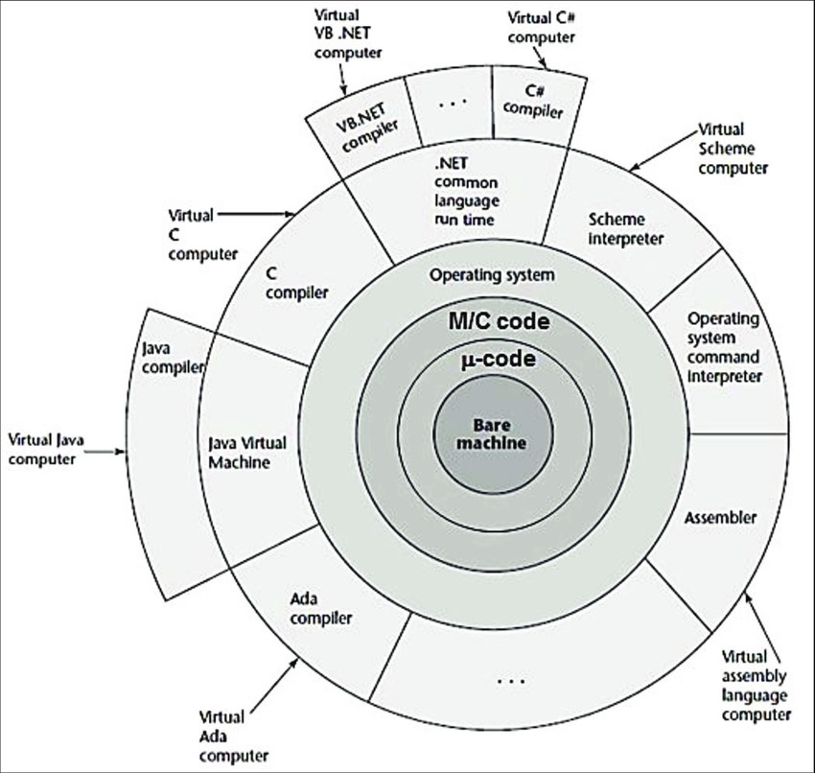

1. Interpreted Languages

Explanation:

In interpreted languages, source code is directly executed line-by-line by an interpreter without prior compilation.

Advantages:

Ease of Debugging: Errors can be identified easily as the interpreter goes through the code lineby-line.

Portability: Interpreted languages are generally more portable since the same code can run on any platform with the interpreter.

Disadvantages:

Slower Execution: Interpreted languages typically run slower because code is translated at runtime.

Less Optimization: Interpreters may not optimize code as efficiently as compilers.

2. Compiled Languages

Explanation:

In compiled languages, source code is translated into machine code by a compiler before execution.

Advantages:

Faster Execution: Compiled languages often run faster because the code is pre-translated into machine code.

Strong Optimization: Compilers can apply extensive optimizations to improve performance.

Disadvantages:

Platform Specific: Compiled programs are generally tied to a specific platform or architecture.

Longer Development Cycle: The compilation step can add time to the development process. 3. Just-In-Time (JIT) Compilation

Explanation:

JIT compilation combines both interpretation and compilation. Code is initially interpreted and then compiled into machine code during execution.

Advantages:

Performance and Flexibility: Offers a balance between the speed of compiled languages and the flexibility of interpreted languages.

Dynamic Optimization: Can optimize code during runtime based on execution patterns.

Disadvantages:

Overhead: JIT compilation can introduce overhead during the initial execution.

Complexity: Implementing a JIT system can be complex and require more resources.

4. Bytecode Compilation

Explanation:

Bytecode compilation involves translating source code into bytecode, which is a lower-level, platform-independent representation of the code. Bytecode is then executed by an interpreter or JIT compiler.

Advantages:

Portability: Bytecode can be executed on any platform that has an interpreter or JIT compiler for that bytecode.

Security: Bytecode can be verified before execution, enhancing security.

Disadvantages:

Performance Overhead: Bytecode still requires interpretation or JIT compilation, which can introduce performance overhead.

Less Optimization: Bytecode is generally less optimized compared to native machine code.

Each method has its own strengths and weaknesses, and the choice often depends on the specific requirements of the project, such as performance needs, platform compatibility, and development time.

3.Give a brief write up about your evaluation of BASIC,FORTRAN,C and JAVA Programming language noting the different in their paradigm and differences in their criteria

Brief evaluation of BASIC, FORTRAN, C, and JAVA programming languages:

BASIC (Beginner's All-purpose Symbolic Instruction Code)

Paradigm: Procedural

Criteria:

Simplicity: Designed for beginners, easy to learn.

Interactivity: Supports immediate feedback, often used in early personal computing.

Flexibility: Offers various versions and dialects, ranging from simple to more complex.

FORTRAN (Formula Translation)

Paradigm: Procedural, with some features of imperative and object-oriented programming.

Criteria:

Performance: Historically known for scientific and engineering calculations.

Legacy: One of the oldest high-level languages, with a long-standing history in academia and research.

Syntax: Initially criticized for its verbosity, but modern versions have improved readability.

C

Paradigm: Procedural, imperative, structured.

Criteria:

Efficiency: Low-level features allow for direct memory manipulation and high performance.

Portability: Widely used across platforms, forms the basis for many other languages.

Versatility: Can be used for system programming, embedded systems, and application development.

JAVA

Paradigm: Object-oriented, with support for imperative and functional programming.

Criteria:

Platform Independence: Runs on the Java Virtual Machine (JVM), making it highly portable.

Security: Built-in features like bytecode verification enhance security.

Ecosystem: Rich standard library and extensive third-party libraries/frameworks available.

Concurrency: Built-in support for multi-threading and synchronization.

Differences in Paradigms:

Procedural: Focuses on procedures or routines that operate on data.Object-oriented: Organizes code around objects and data, promoting modularity and reusability.

Imperative: Directly specifies how a program should perform computations.

Functional: Emphasizes the evaluation of expressions rather than execution of commands.