3.1.1 DC and DR Infrastructure Sizing / IP Address Requirements
The following section provides the proposed Data Centre (DC) and Disaster Recovery (DR) infrastructure details for the Kuwait deployment, including server roles, IP address requirements, management interfaces, private cluster communication, storage partitions, RAID configuration, and NAS replication requirements.
DC Environment
- OS LAN IP requirements
- iDRAC / management IP requirements
- Cluster IPs
- Server/NAS table
- SyncIQ replication note

DR Environment
- OS LAN IP requirements
- iDRAC / management IP requirements
- Cluster IPs
- Server/NAS table
- SyncIQ replication note

Replication Note
SyncIQ replication should be enabled between the DC and DR NAS platforms to support resilient data replication across both sites.

Kuwait Network Diagram
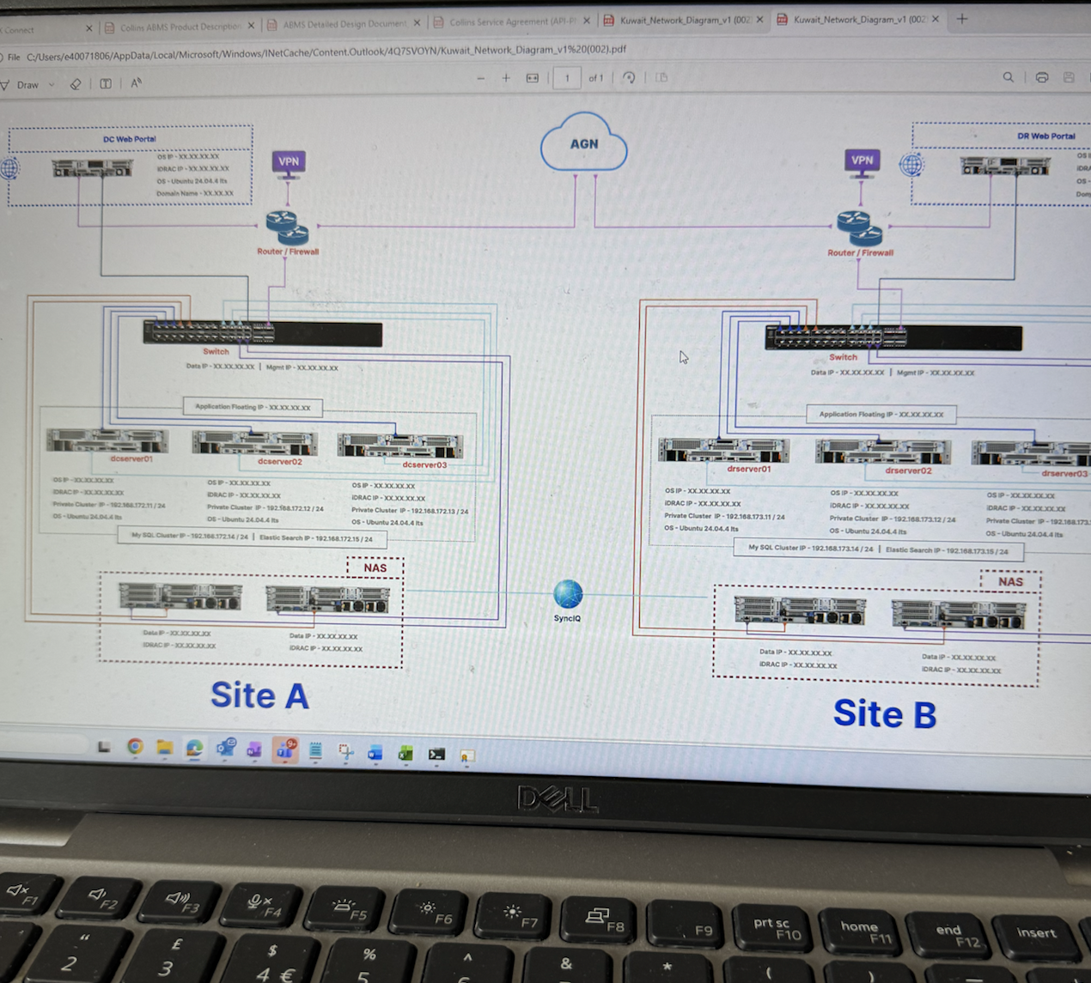
Figure 1. Kuwait DC/DR network architecture overview.

Kuwait Infinity Server Configuration
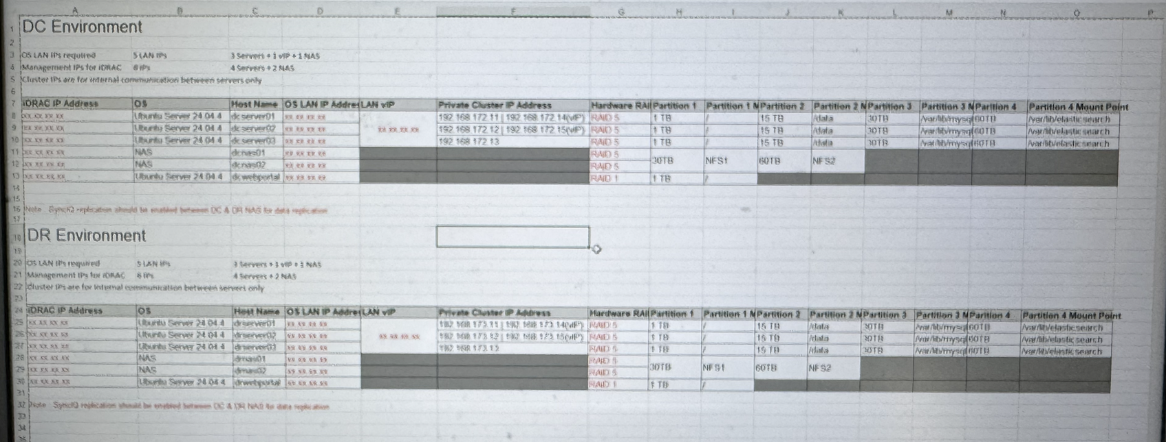
Figure 2. DC and DR server / NAS configuration capture.

