AWS Cloud Environment Design for Development Teams
Project Name: Cloud Enablement for Engineering Teams
Author: Abraham Mayowa Hezekiah
Date: 01/03/2024
Sprint Task: [Link to Jira Card]

Objective
To design and implement a secure, scalable, and maintainable AWS cloud environment for the development and engineering teams at Data Lake Limited, integrating with the corporate network and existing Microsoft Active Directory.

Architecture Overview
Key Components:
- - AWS Organizations with multiple accounts: Management, Shared Services, Dev Team 1, Dev Team 2
- - VPCs in each account with public and private subnets
- - VPN Connectivity between on-prem Data Center (Preston) and AWS using Site-to-Site VPN with IKEv2/IPSec and dual redundant tunnels
- - AWS Directory Service (Enterprise or AD Connector) integrated with on-prem AD (duu.local and blue.net)
- - SSO Integration via IAM Identity Center
- - Secure developer access (RDP/SSH) to EC2 resources
- - Region: AWS London (eu-west-2)

Security Considerations
- - End-to-end IPSec encryption on VPN tunnels
- - SSO using existing Active Directory credentials
- - MFA handled on endpoint devices (no additional MFA in AWS)
- - Use of IAM roles tied to AD groups
- - EC2 instances protected via Security Groups and NACLs
- - Optional: Use AWS Systems Manager for secure, portless session access

Networking Diagram
[Insert link or image of the diagram uploaded to Draw.io or Confluence]
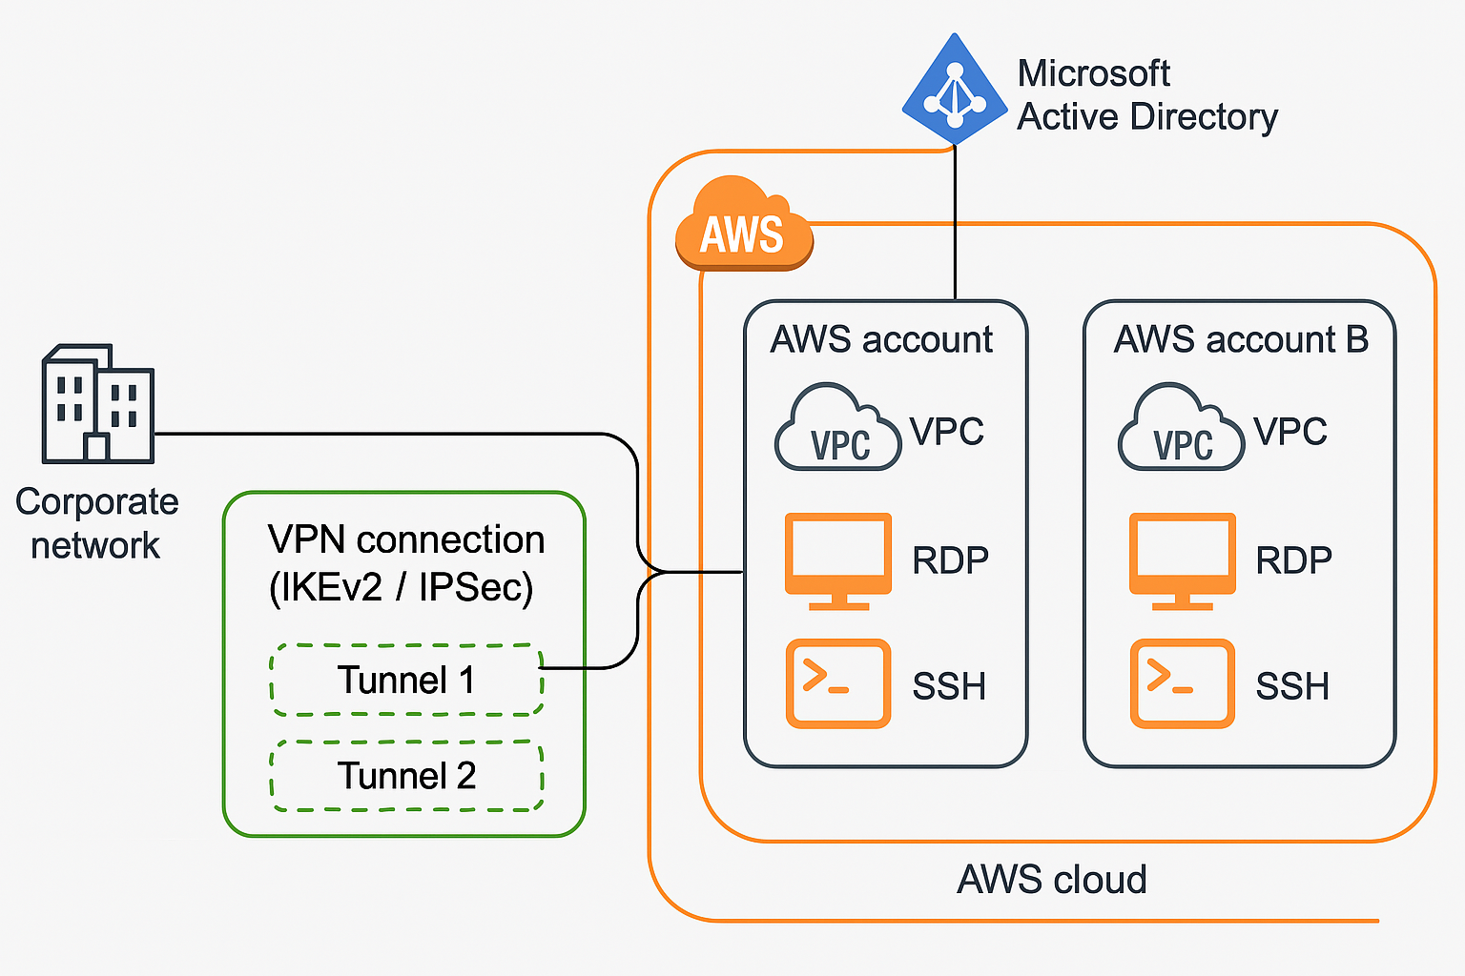

Implementation Plan
Step | Task | Owner | Status
1 | Create AWS Organization and accounts | Cloud Team | ☐
2 | Setup VPCs in each account | Cloud Team | ☐
3 | Deploy VPN Gateway, configure Site-to-Site VPN | Network Team | ☐
4 | Deploy AWS Directory Service or AD Connector | Cloud Team | ☐
5 | Integrate SSO with Microsoft AD | IAM Admin | ☐
6 | Configure EC2 access (RDP/SSH) | Cloud Team | ☐
7 | Review with Enterprise Architecture Team | Cloud Architect | ☐
8 | Submit for InfoSec Approval | Cloud Architect | ☐
9 | Begin environment build with Cloud Engineers | Cloud Team | ☐

Review & Approvals
- - Enterprise Architecture Team – Alignment on account strategy and connectivity
- - Information Security Team (InfoSec) – Approval of VPN, AD, and access control model

