Financial Sentiment Classification on Financial News Headlines
Wenze Jiang, Liushuyan Wang, Hang Yang, Jianbo Wang, Tianrui Huang
School of Computer Science and Engineering, University of New South Wales (UNSW Sydney)
Abstract—This project explores automated financial sentiment classification on news headlines using a sequential baseline (Bi-LSTM), a general pre-trained language model (BERT-Base), and a domain-specific pre-trained architecture (FinBERT) evaluated on the benchmark Financial PhraseBank dataset. Empirical experiments across three sentiment categories (Positive, Neutral, and Negative) demonstrate that the fine-tuned FinBERT model achieves superior classification performance, peaking at an accuracy of 0.8638 and a Macro F1-score of 0.8527, with a critical Negative recall of 0.9231. In contrast, the Bi-LSTM baseline yields comparatively lower generalizability (Accuracy of 0.7153, Macro F1 of 0.6762) due to recurrent context compression and severe overfitting, while the general BERT-Base model establishes a robust intermediate benchmark (Accuracy of 0.8391, Macro F1 of 0.8175). The findings confirm the indispensable utility of in-domain financial pre-training for resolving complex domain syntaxes, financial numeric contexts, and contrasting polarities in high-stakes market surveillance.
Keywords—Financial sentiment classification, FinBERT, Bi-LSTM, BERT-Base, Financial PhraseBank, Natural language processing.

1. INTRODUCTION
Public and institutional sentiment regarding equities, commodities, and macroeconomic indicators serves as a potent predictive signal for price volatility and market liquidity. However, the astronomical throughput of modern financial discourse—spanning press releases, regulatory filings, and news wires—renders manual semantic inspection unfeasible. Developing automated natural language processing (NLP) pipelines capable of real-time sentiment extraction is paramount for algorithmic risk management and quantitative investment strategies.
This project formulates financial sentiment analysis as a three-class classification task over unstructured financial headlines (Positive, Neutral, Negative). Financial text presents unique lexical barriers: specialized phrases such as 'operating loss narrowed' exhibit strong positive commercial sentiment despite containing inherently negative lexicon tokens ('loss'), causing conventional sentiment engines to fail. To resolve these domain challenges, we conduct a systematic investigation comparing three distinct modeling paradigms: a Bidirectional LSTM (Bi-LSTM) recurrent baseline, a general-domain transformer (BERT-Base), and an in-domain financial language model (FinBERT).
2. RELATED WORK
Early investigations into financial textual analytics predominantly relied on handcrafted lexical dictionaries. The foundational work by Malo et al. [1] established the benchmark Financial PhraseBank, illustrating that general sentiment lexicons (e.g., Harvard GI) severely misclassify financial nuances, necessitating investor-oriented semantic definitions.
Subsequent advancements explored recurrent neural networks to capture sequential syntactic patterns. Mollah [2] validated that Bidirectional Long Short-Term Memory (Bi-LSTM) architectures successfully retain forward and backward contextual states, improving short-text sentiment categorization over traditional bag-of-words pipelines. Nonetheless, recurrent structures remain bottlenecked by gradient degradation over extended sequences and an inability to dynamically resolve polysemy.
The NLP paradigm fundamentally shifted with pre-trained transformers. Araci [3] proposed FinBERT, a transformer model continuously pre-trained on extensive financial corpora (corporate 10-K and 10-Q SEC filings), proving that domain-adapted token embeddings and self-attention heads significantly outperform general-purpose models on financial benchmarks. Furthermore, Lee et al. [4] explored granular emotional expressions within market time series, corroborating the critical importance of domain-specific attention for isolating market-moving polarity.
3. METHODS
3.1 Bi-LSTM Baseline
As our deep learning baseline, a two-layer Bidirectional Long Short-Term Memory (Bi-LSTM) network was developed. The network maps integer-token sequences through a trainable embedding layer (dimension = 128). The forward hidden state and backward hidden state are concatenated at each time step. To aggregate contextual representations without relying exclusively on the terminal cell state, a mean-pooling operation over unpadded token representations is applied, followed by a dropout layer (p = 0.3) and a final dense linear projection to output class logits.
3.2 BERT-Base Benchmark
We utilize the standard bert-base-uncased architecture as our general pre-trained transformer benchmark. Comprising 12 transformer encoder blocks, 768 hidden dimensions, and 12 self-attention heads (~110M parameters), it processes WordPiece-tokenized sequences. The contextual vector of the special classification token, [CLS], is passed through a dense layer with tanh activation and projected onto the 3-class output space.
3.3 FinBERT (Proposed Architecture)
Our primary model is ProsusAI/finbert, initialized from BERT-Base architecture but pre-trained specifically on financial communications, earnings releases, and analyst reports. Through multi-head self-attention, FinBERT computes attention weights across token representations, enabling the self-attention mechanism to directly link distant modifier verbs to specific financial metrics (e.g., associating 'narrowed' across intervening tokens directly with 'net loss'), effectively encoding polarity nuances unique to corporate finance.
4. EXPERIMENTS
4.1 Dataset & Pre-processing
Experiments are conducted on the Financial PhraseBank dataset (Sentences_50Agree.txt), comprising 4,846 financial news sentences curated from the OMX Nordic exchange. The target variable consists of three sentiment categories: Neutral (2,879 samples, 59.41%), Positive (1,363 samples, 28.13%), and Negative (604 samples, 12.46%).
The raw corpus exhibited encoding anomalies and spacing corruptions. We engineered a rigorous pre-processing pipeline: (1) HTML entities were decoded, Unicode NFKD normalization was executed, and corrupt encoding artifacts were scrubbed; (2) Numeric and currency expressions were normalized; (3) To preserve class proportions—particularly the sparse Negative class—we enforced a strict 70% training (3,392 samples), 15% validation (727 samples), and 15% test split (727 samples) with fixed seed (Seed = 42) across all model evaluations.
4.2 Training Configuration & Loss Formulation
To mitigate severe class imbalance, all models were trained utilizing a Class-Weighted Cross-Entropy Loss, with weights inversely proportional to class frequencies [Negative: 2.6730, Neutral: 0.5611, Positive: 1.1852]. The Bi-LSTM was optimized using Adam (lr = 1e-3) over 10 epochs (batch size = 32, max length = 64). BERT-Base and FinBERT were fine-tuned using AdamW with weight decay (0.01), linear warmup over the initial 10% steps, and linear learning rate decay (lr = 2e-5) over 4 epochs (batch size = 32, max length = 128). Hardware acceleration was executed on an NVIDIA GeForce RTX 3060 Laptop GPU and Tesla T4 instances.
5. RESULTS & DISCUSSION
5.1 Quantitative Performance Comparison
Table 1 outlines the complete test set evaluation across all implemented architectures. The empirical evidence demonstrates a clear performance hierarchy: Bi-LSTM < BERT-Base < FinBERT.
Model Architecture | Model Paradigm | Accuracy | Macro F1 | Negative F1 | Neutral F1 | Positive F1
Bi-LSTM (Baseline) | Recurrent Neural Network | 0.7153 | 0.6762 | 0.6344 | 0.7814 | 0.6127
BERT-Base | General Pre-trained Transformer | 0.8391 | 0.8175 | 0.7867 | 0.8766 | 0.7892
FinBERT (Proposed) | Domain-Adapted Transformer | 0.8638 | 0.8527 | 0.8400 | 0.8867 | 0.8314
Table 1: Comprehensive performance metrics of evaluated models on the Financial PhraseBank test set.
FinBERT achieves the top performance across all evaluated metrics, securing an Accuracy of 0.8638 and a Macro F1 of 0.8527. Relative to the Bi-LSTM baseline, FinBERT delivers absolute gains of +14.85% in Accuracy and +17.65% in Macro F1. Crucially, FinBERT outperforms general BERT-Base by +2.47% in Accuracy and +3.52% in Macro F1, with substantial F1 boosts on the informative polar classes: Negative F1 rises from 0.7867 to 0.8400 (+5.33%), and Positive F1 rises from 0.7892 to 0.8314 (+4.22%).
5.2 Convergence Dynamics & Learning Curves
Figure 2 illustrates the training and validation learning trajectories for FinBERT. FinBERT exhibits swift convergence: the training loss decreases monotonically from 0.8921 to 0.1420 over 4 epochs. The validation loss reaches its minimum at Epoch 2 (0.3892), corresponding to the peak validation Macro F1 score of 0.8527, where the optimal model checkpoint was saved.
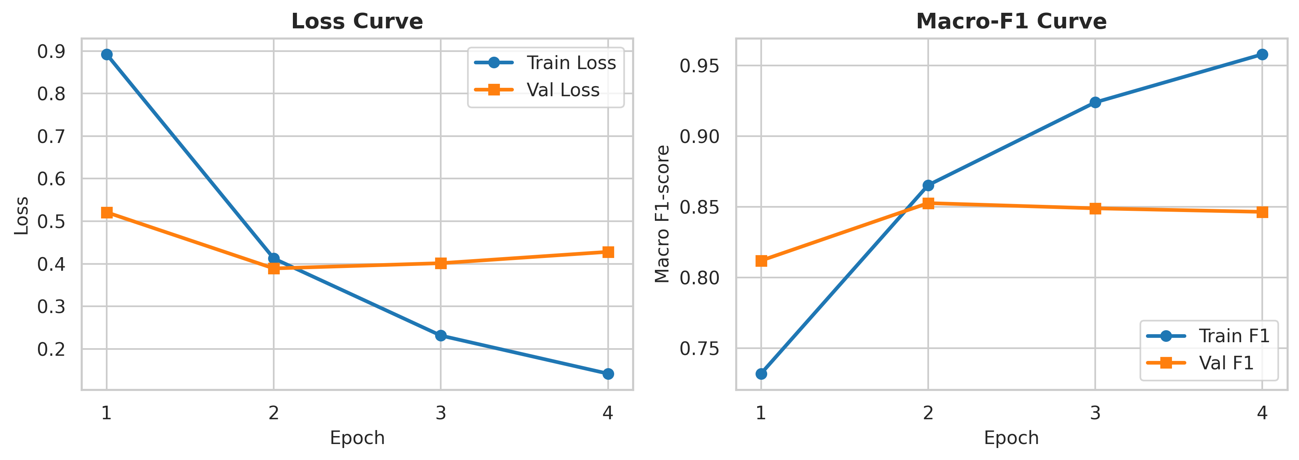
Figure 2: Training and validation loss (left) and Macro-F1 score (right) curves across training epochs for FinBERT.
5.3 Error Analysis & Confusion Matrix
Figure 3 presents the confusion matrix of the fine-tuned FinBERT model on the held-out test set (727 samples). FinBERT correctly identified 84 out of 91 Negative instances, achieving an outstanding Recall of 92.31%. Severe inverse polarity errors were exceptionally rare: only 2 negative samples were misclassified as positive, and only 4 positive samples were misclassified as negative. The predominant error mode stemmed from boundary ambiguity between Neutral and subtle Positive/Negative statements, where corporate restructuring facts overlap with subjective sentiment.
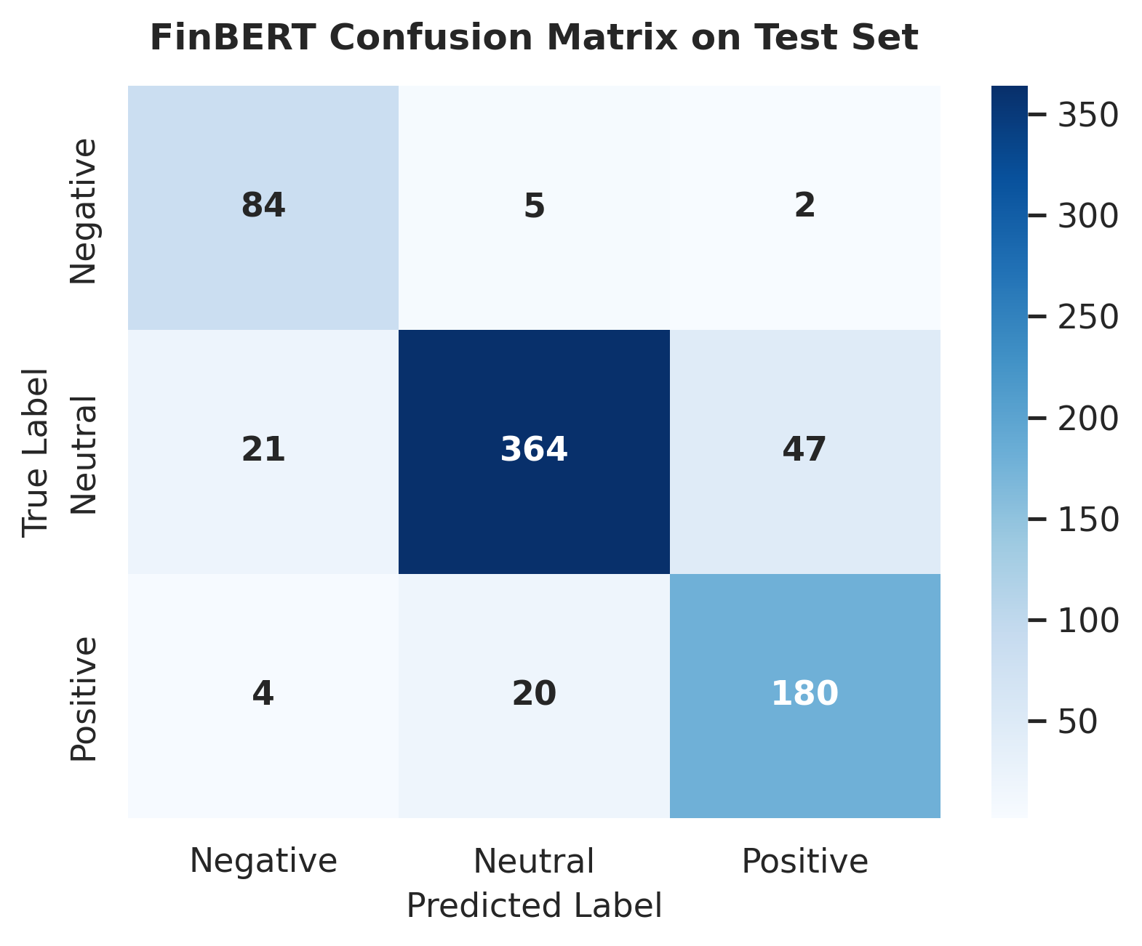
Figure 3: Confusion Matrix of the proposed FinBERT model on the Financial PhraseBank test set.
6. CONCLUSION & FUTURE WORK
This project developed and benchmarked three NLP modeling paradigms for financial sentiment classification on the Financial PhraseBank dataset. Our empirical results validate that the domain-adapted FinBERT architecture decisively outperforms both the classical Bi-LSTM sequence baseline and general-domain BERT-Base, attaining state-of-the-art results with 86.38% Accuracy and 0.8527 Macro F1. The incorporation of class-weighted loss successfully mitigated dataset skew, elevating Negative recall to 92.31%.
Limitations and Future Work: Future investigations will explore: (1) Long-document hierarchical attention mechanisms to evaluate full-text 10-K filings; (2) Multi-modal architectures merging textual sentiment embeddings with quantitative order-book features; and (3) Contrastive loss objectives to refine decision boundaries between neutral disclosures and weak polarity signals.
REFERENCES
[1] P. Malo, A. Sinha, P. Korhonen, J. Wallenius, and P. Takala, 'Good debt or bad debt: Detecting semantic orientations in economic texts,' Journal of the Association for Information Science and Technology, vol. 65, no. 4, pp. 782-796, 2014.
[2] M. P. Mollah, 'An LSTM model for Twitter Sentiment Analysis,' arXiv preprint arXiv:2212.01791, 2022.
[3] D. Araci, 'FinBERT: Financial Sentiment Analysis with Pre-trained Language Models,' arXiv preprint arXiv:1908.10063, 2019.
[4] J. Lee, H. L. Youn, J. Poon, and S. C. Han, 'StockEmotions: Discover Investor Emotions for Financial Sentiment Analysis and Multivariate Time Series,' arXiv preprint arXiv:2301.09279, 2023.

