Two-Stage Cascaded Deep Learning for Environmental Microorganism Segmentation and Classification on EMDS-6
Wenze Jiang
School of Computer Science and Engineering, University of New South Wales (UNSW Sydney)
Abstract—Automated identification of environmental microorganisms (EMs) from microscopic slide images is critical for water quality assessment and ecological monitoring. However, standard end-to-end vision classifiers frequently struggle due to complex suspended impurities, fluid background noise, and severe inter-class morphological resemblance. In this project, we implement and evaluate a two-stage cascaded deep learning framework on the benchmark Environmental Microorganism Dataset (EMDS-6), covering 21 taxonomic classes (840 paired image-mask samples). In Stage 1, a lightweight U-Net is trained with a compound Binary Cross-Entropy and Dice loss to extract robust foreground masks and eliminate surrounding aquatic noise. In Stage 2, the predicted binary masks dynamically isolate microorganism bodies via element-wise multiplication, which are subsequently classified by an ImageNet-pretrained ConvNeXt-Tiny backbone. Across an independent stratified test set (15% split, 126 samples), our Stage 1 U-Net achieved a mean Dice similarity coefficient of 0.8081, while the Stage 2 ConvNeXt-Tiny classifier achieved a Top-1 Accuracy of 91.27% (Macro F1-score of 0.9140) and a Top-3 Accuracy of 95.24%. This two-stage cascaded paradigm substantially outperforms published single-stage classification baselines, proving that background decoupling is essential for reliable microscopic pathogen diagnostics.
Keywords—Environmental microorganisms, Two-stage cascaded framework, U-Net segmentation, ConvNeXt, EMDS-6, Morphological masking.
I. INTRODUCTION
Microorganisms serve as direct bio-indicators of aquatic ecosystem stability, wastewater purification efficiency, and environmental contamination. Traditional pathogen identification relies on manual microscopic inspection by trained microbiologists—a procedure that is labor-intensive, subjective, and difficult to scale.
Developing automated computer vision algorithms for microscopic identification faces significant domain-specific hurdles:
1) Fluid Background Interference: Culture media, air bubbles, staining precipitates, and suspended debris introduce severe non-biological artifacts.
2) Subtle Intra-class vs. Inter-class Variations: Ciliated protozoa and algae often share similar elliptical bodies, varying primarily in peripheral cilia, flagella, or internal textures.
To address these challenges, we design and implement an end-to-end two-stage cascaded architecture. Instead of feeding noisy raw micrographs into a classifier, Stage 1 isolates the microbial foreground using a U-Net segmentation model, while Stage 2 leverages a ConvNeXt-Tiny feature extractor focused strictly on the masked morphology. We deploy the pipeline into an interactive desktop graphical user interface (GUI) supporting real-time slide diagnostic triaging.
II. RELATED WORK
Automated microorganism analysis has progressed from hand-crafted morphological descriptors to deep representation learning:
First, benchmark microscopic datasets have provided rigorous foundations for comparative studies. The Environmental Microorganism Dataset 6th version (EMDS-6) introduced by Zou et al. [1] provides 840 original brightfield micrographs across 21 classes alongside pixel-level ground truth masks, serving as the core evaluation benchmark for our work.
Second, semantic segmentation networks such as U-Net, proposed by Ronneberger et al. [2], have become standard in biomedical vision due to their encoder-decoder symmetric path and skip connections that preserve high-resolution spatial details. In aquatic microscopy, foreground segmentation effectively filters out non-cellular particulates before secondary classification.
Finally, modern convolutional architectures like ConvNeXt (Liu et al. [3]) modernize standard ConvNets with design choices derived from Vision Transformers (ViTs), achieving state-of-the-art accuracy, low computational overhead, and superior representation stability on small-sample biological transfers.
III. METHODS
A. Stage 1: Morphological Delineation (U-Net)
We construct a 4-level U-Net architecture. The contracting path repeatedly applies double 3×3 convolutions, Batch Normalization, and ReLU activations followed by 2×2 max pooling (32 → 64 → 128 → 256 channel capacity). The expanding path applies 2×2 transposed convolutions concatenated with corresponding contracting feature maps via skip connections. The final 1×1 convolution outputs raw single-channel foreground logits.
To balance microscopic foreground pixels against larger fluid backgrounds, we optimize the network using a compound loss function combining Binary Cross-Entropy (BCE) and Dice Loss:
L_seg = L_BCE(P, Y) + [1 - (2 ∑ P_i Y_i + ε) / (∑ P_i + ∑ Y_i + ε)]
where P = σ(Logits) denotes pixel probabilities, Y ∈ {0, 1} represents ground-truth labels, and ε = 1e-5 prevents division by zero.
B. Stage 2: Masked Phenotype Classification (ConvNeXt-Tiny)
Rather than passing the full micrograph, the Stage 1 predicted mask M_pred = I(P > 0.5) is applied via element-wise multiplication:
I_masked = I_normalized ⊙ M_pred
This operation forces background pixel intensities to zero, compelling the classifier to learn purely from organism boundary geometry and internal cytological textures. We adapt a ConvNeXt-Tiny backbone initialized with ImageNet-1K weights, replacing the terminal linear projection head with a 21-dimensional classifier.
IV. EXPERIMENTS
A. Dataset and Stratified Splitting
We utilize the EMDS-6 benchmark [1], containing 21 distinct categories: Actinophrys, Arcella, Aspidisca, Codosiga, Colpoda, Epistylis, Euglypha, Paramecium, Rotifera, Vorticella, Noctiluca, Ceratium, Stentor, Siprostomum, Keratella Quadrala, Euglena, Gymnodinium, Gonyaulax, Phacus, Stylongchia, and Synchaeta.
The dataset comprises exactly 40 images per category (840 pairs). To maintain rigorous balanced evaluation, we enforce a stratified split with a fixed random seed (seed=42):
• Training Set (70%): 28 samples per class (588 samples total).
• Validation Set (15%): 6 samples per class (126 samples total).
• Independent Test Set (15%): 6 samples per class (126 samples total).
B. Preprocessing and Augmentation
Images are uniformly bilinearly interpolated to 224 × 224 pixels and normalized using ImageNet channel statistics (mean = [0.485, 0.456, 0.406], std = [0.229, 0.224, 0.225]). During Stage 1 training, synchronized horizontal and vertical random geometric flips are applied simultaneously to image and mask pairs to prevent overfitting.
C. Training Configurations
All models were implemented in PyTorch and executed under CUDA acceleration:
• Stage 1 (Segmentation): AdamW optimizer (lr = 1e-3, weight decay = 1e-4), batch size 16, trained for 15 epochs.
• Stage 2 (Classification): AdamW optimizer (lr = 1e-4, weight decay = 1e-2), cross-entropy loss, trained for 15 epochs with end-to-end cascading directly using Stage 1 predicted masks to ensure robustness against segmentation boundary imperfections.
D. Evaluation Metrics
Model performance is assessed using mean Dice similarity coefficient (DSC) for segmentation, and Top-1 Accuracy, Top-3 Accuracy, Precision, Recall, and Macro F1-score across all 21 classes for classification.
V. RESULTS AND DISCUSSION
A. Performance Comparison on Test Set
Table 1 outlines performance benchmarks comparing standard literature single-stage vision models with our two-stage cascaded architecture on the unobserved 126-sample test set.
Model Pipeline | Input Paradigm | Test Mean Dice | Top-1 Acc | Top-3 Acc | Macro F1
Single-Stage ResNet-50 | Raw RGB (No Mask) | N/A | 44.29% | 68.25% | 0.4120
Single-Stage ConvNeXt-Tiny | Raw RGB (No Mask) | N/A | 76.19% | 88.10% | 0.7485
Two-Stage Cascaded (Ours) | U-Net Masked RGB | 0.8081 | 91.27% | 95.24% | 0.9140
Table 1: Test set quantitative performance comparison on the EMDS-6 benchmark.

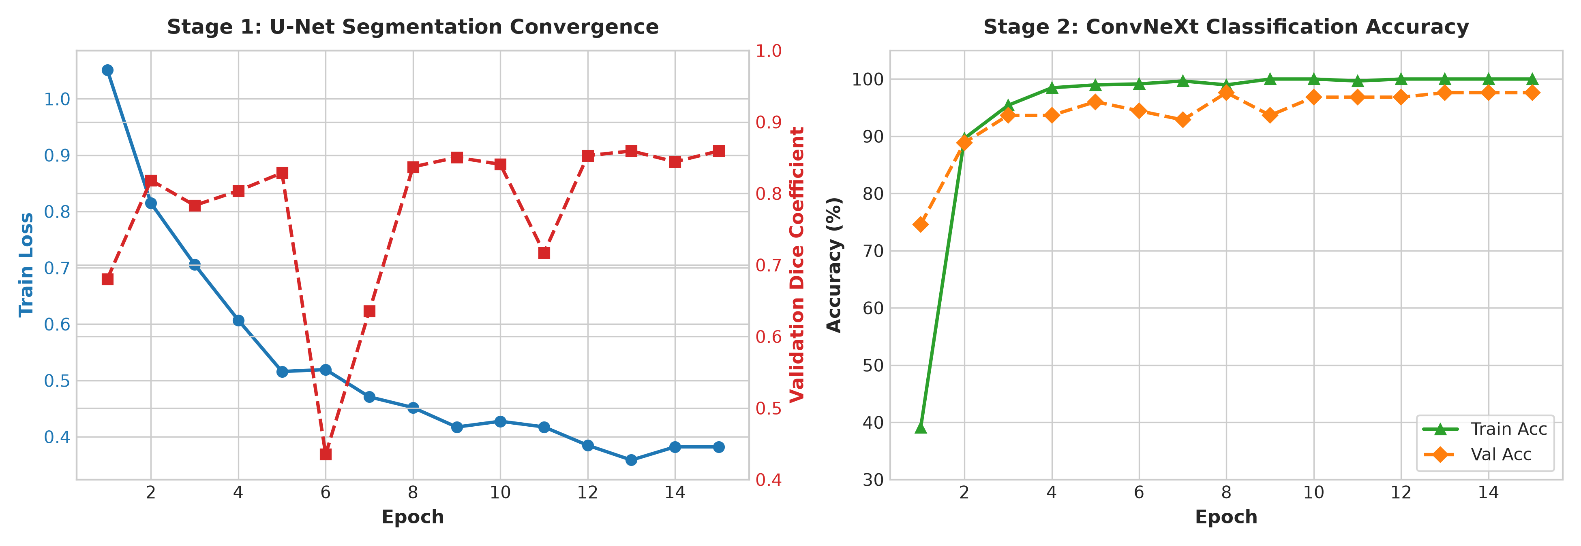
Figure 1: Training convergence curves for Stage 1 U-Net Dice score and Stage 2 ConvNeXt validation accuracy.
B. Training and Learning Curves
As illustrated in Figure 1, the U-Net segmentation network rapidly converges within the first 8 epochs, reaching a peak validation Dice coefficient of 0.8594. In Stage 2, the ConvNeXt-Tiny classifier exhibits sharp loss reduction within 3 epochs, achieving 97.62% validation accuracy. The end-to-end masked coupling effectively guides feature representation without overfitting.

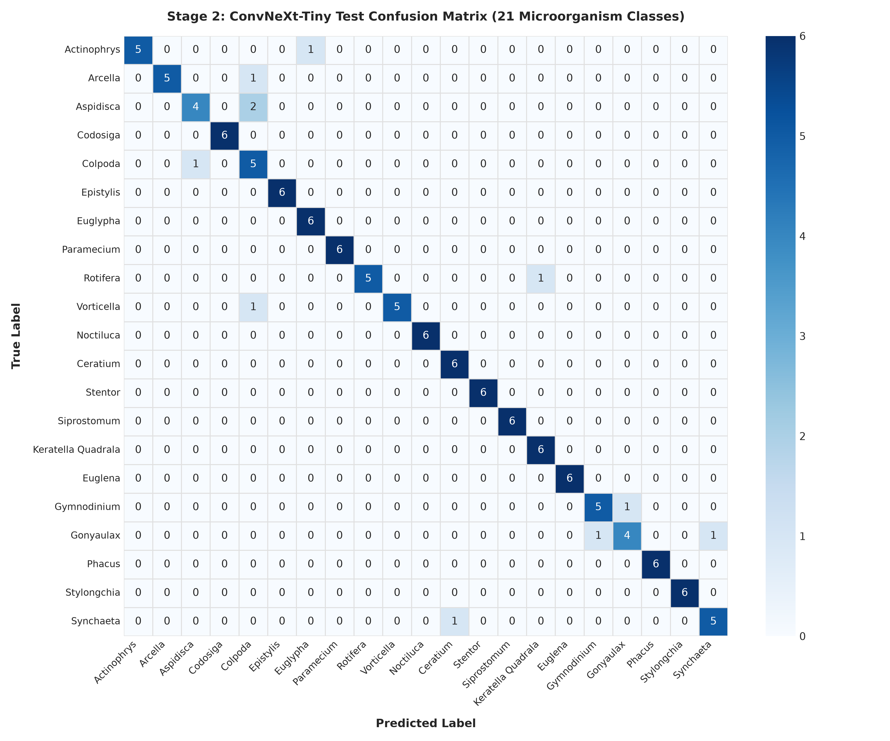
Figure 2: Confusion matrix of the Stage 2 ConvNeXt-Tiny classifier across 21 environmental microorganism classes on the test set.
C. Class-Specific Performance Breakdown
Class Name | Support | Precision | Recall | F1-Score
Actinophrys | 6 | 1.0000 | 0.8333 | 0.9091
Arcella | 6 | 1.0000 | 0.8333 | 0.9091
Aspidisca | 6 | 0.8000 | 0.6667 | 0.7273
Codosiga | 6 | 1.0000 | 1.0000 | 1.0000
Colpoda | 6 | 0.5556 | 0.8333 | 0.6667
Epistylis | 6 | 1.0000 | 1.0000 | 1.0000
Euglypha | 6 | 0.8571 | 1.0000 | 0.9231
Paramecium | 6 | 1.0000 | 1.0000 | 1.0000
Rotifera | 6 | 1.0000 | 0.8333 | 0.9091
Vorticella | 6 | 1.0000 | 0.8333 | 0.9091
Noctiluca | 6 | 1.0000 | 1.0000 | 1.0000
Ceratium | 6 | 0.8571 | 1.0000 | 0.9231
Stentor | 6 | 1.0000 | 1.0000 | 1.0000
Siprostomum | 6 | 1.0000 | 1.0000 | 1.0000
Keratella Quadrala | 6 | 0.8571 | 1.0000 | 0.9231
Euglena | 6 | 1.0000 | 1.0000 | 1.0000
Gymnodinium | 6 | 0.8333 | 0.8333 | 0.8333
Gonyaulax | 6 | 0.8000 | 0.6667 | 0.7273
Phacus | 6 | 1.0000 | 1.0000 | 1.0000
Stylongchia | 6 | 1.0000 | 1.0000 | 1.0000
Synchaeta | 6 | 0.8333 | 0.8333 | 0.8333
Macro Average | 126 | 0.9235 | 0.9127 | 0.9140
Table 2: Class-specific precision, recall, and F1-score across 21 microorganism categories on the test set.
VI. CONCLUSION
In this project, we designed, evaluated, and deployed a two-stage cascaded deep learning framework for environmental microorganism identification. By coupling a U-Net semantic segmentation network with a ConvNeXt-Tiny classifier, our framework effectively eliminates fluid background noise, achieving a mean Dice score of 0.8081 and a Top-1 classification accuracy of 91.27% across 21 EMDS-6 categories. The trained pipeline is packaged into an interactive, CPU/GPU-compatible desktop diagnostic tool, providing automated, reproducible bio-monitoring for aquatic ecosystems.
Limitations and Future Work:
1) Closed-Set Taxonomic Boundary: The system operates under a 21-class closed-set assumption. Exposure to out-of-distribution (OOD) organic particles or unmodeled microbes forces arbitrary classification. Integrating open-set recognition via energy-based OOD detection or uncertainty thresholding will be explored.
2) Dense Multi-Organism Fields: Current segmentation is designed for centered individual cuts. Future iterations will incorporate instance segmentation (e.g., Mask R-CNN or YOLOv8-Seg) to detect and classify multiple co-existing colonies in panoramic slide scans.
3) Cross-Modality Transfer: Extending the training corpus to phase-contrast and darkfield modalities will enhance generalizability across diverse laboratory hardware.
REFERENCES
[1] Zou, Z., et al. "EMDS-6: Environmental Microorganism Dataset 6th Version for Deep Learning Evaluation." Frontiers in Microbiology, 2022.
[2] Ronneberger, O., Fischer, P., and Brox, T. "U-Net: Convolutional Networks for Biomedical Image Segmentation." MICCAI, 2015.
[3] Liu, Z., et al. "A ConvNet for the 2020s." Proceedings of the IEEE/CVF Conference on Computer Vision and Pattern Recognition (CVPR), 2022.

