DESIGN AND IMPLEMENTATION OF A DETERMINISTIC FAILURE-MODE GUARDRAIL SYSTEM FOR AI-GENERATED SOFTWARE USING MODEL CONTEXT PROTOCOL
BY:
OLUWAMAYOWA KALEJAIYE
2023/C/SENG/0351
DEPARTMENT OF SOFTWARE ENGINEERING,
SCHOOL OF COMPUTING,
MIVA OPEN UNIVERSITY ABUJA,
NIGERIA
IN PARTIAL FULFILMENT OF THE REQUIREMENTS FOR THE AWARD OF THE
BACHELOR OF SCIENCE (HONOURS) DEGREE IN SOFTWARE ENGINEERING
SUPERVISED BY: IJEGWA ACHEME Ph.D
JULY, 2026
CERTIFICATION
This is to certify that I am responsible for the work submitted in this project, that the original work is mine, except as specified in the acknowledgement and references. And that neither the project nor the original work contained therein has been submitted to the University or any other institution for the award of a degree.
Oluwamayowa Kalejaiye Samuel, 2023/C/SENG/0351
STUDENT’S NAME AND MATRIC NUMBER
APPROVAL
This project has been approved for the Department of Software Engineering, School of Computing, Miva Open University, Abuja, Nigeria.
Ijegwa Acheme, Ph.D
Name of Supervisor
Signature and Date ......................................
Morolake O. Lawrence, Ph.D, MHCPN, MNSC
Head of Department
Signature and Date ......................................
Emeka Emmanuel Ogbuju, Ph.D
Dean, School of Computing
Signature and Date ......................................
Name of External Examiner
External Examiner
Signature and Date ......................................
DEDICATION
This project is dedicated to God Almighty for the abundant grace, wisdom, knowledge, and skills given to me all through my life, especially during my stay at Miva Open University, Abuja.
ACKNOWLEDGEMENT
I would like to express my profound gratitude to God Almighty for His grace throughout this research. My sincere appreciation goes to my supervisor, Ijegwa Acheme, for his invaluable guidance, continuous support, and constructive feedback which contributed immensely to the success of this project.
I also want to thank the Head of Department, the Dean of the School of Computing, and all the academic and non-academic staff of the Department of Software Engineering, Miva Open University, for their efforts in ensuring a conducive learning environment.

TABLE OF CONTENTS
…

LIST OF TABLES
Table 2.1: Comparative Analysis of Reviewed Studies …
Table 3.1: Common System Development Methodologies …
Table 3.2: Functional Requirements …
Table 3.3: Non-Functional Requirements …
Table 3.4: Summary of Data Sources …
Table 3.5: Existing Workflow versus Proposed System …
Table 3.6: Implementation Tools …
Table 3.7: Test Cases and Results …
Table 4.1: Implementation Environment …
Table 4.2: Proxy Results by Scenario …
Table 4.3: Blind Agent Study by Agent …
Table 4.4: Adversarial Results …
Table 4.5: Mapping Objectives to Results …

LIST OF FIGURES
Figure 3.1: System architecture of Failures. …
Figure 3.2: Knowledge graph — Principle → FailureMode → Pattern → Test. …
Figure 3.3: Use case diagram. …
Figure 3.4: Evaluation pipeline. …
Figure 4.1: Proxy findings per scenario, baseline versus enabled. …
Figure 4.2: Agent-study finding totals across all seventeen pairs. …

LIST OF ABBREVIATIONS
MCP – Model Context Protocol
DSR – Design Science Research
DSS – Decision Support System
LLM – Large Language Model
API – Application Programming Interface
JSON – JavaScript Object Notation
UAT – User Acceptance Testing
ERD – Entity Relationship Diagram
DFD – Data Flow Diagram
DOI – Digital Object Identifier
SEN – Software Engineering
PyPI – Python Package Index

ABSTRACT
AI-assisted software development has made generated code a production input, while the benchmarks that judge it still measure functional correctness on exercised paths. This study addresses the resulting gap: the silent mishandling of failure modes, especially ambiguous outcomes in which a caller cannot tell whether a side effect occurred. Although resilience patterns are well catalogued and decision support systems exist for pattern selection, no deterministic, evidence-backed guardrail layer is delivered to coding agents as tools. The primary aim of this study was therefore to design, implement, and evaluate a deterministic failure-mode guardrail system for AI-generated software. Design Science Research guided the work and Agile organised the build of Failures, a thirteen-tool Model Context Protocol server over eleven failure dimensions, scored by a deterministic ten-criterion harness across six production-style scenarios. Seventeen matched baseline/enabled pairs from three commercial agents were compared, alongside a six-case proxy study and a six-case adversarial probe. The study found that sixteen of seventeen pairs improved on at least one criterion, HIGH findings never rose and fell from thirteen to one, and architecture quality held proportional throughout. These findings indicate that cheap, reproducible, evidence-backed checks measurably improve the failure resilience of agent-generated software. It is therefore concluded that deterministic guardrails provide a practical floor for resilience practice in agent-driven development, with heuristic limits honestly documented for future AST-level work.
Keywords: AI-generated software; failure resilience; static analysis; Model Context Protocol; design science research

CHAPTER ONE: INTRODUCTION

1.1 Background of the Study
Software development has entered a period in which large language models trained on source code contribute directly to production systems. Chen et al. (2021) established functional-correctness evaluation of code-trained models, demonstrating that models could solve a substantial share of self-contained programming problems; subsequent deployment studies measured productivity gains from GitHub Copilot in professional practice (Peng, Kalliamvakou, Cihon, & Demirer, 2023). Coding agents extend this trajectory from suggesting code to scaffolding complete systems: given a natural language prompt, an agent now produces payment handlers, authentication flows, and background workers that run. The question facing the field is therefore no longer whether generated code runs, but whether the systems it composes survive contact with production.
The evaluation culture that grew around these models measures functional correctness almost exclusively: pass rates on held-out programming problems (Chen et al., 2021) and resolution rates on real repository issues (Jimenez et al., 2024). In parallel, agents have been extended through tool use, and the Model Context Protocol has standardised how a model discovers and invokes external tools (Anthropic, 2024). The combination is powerful: an agent with tool access can design, implement, and test a feature end to end. But the checks available at each of those steps verify behaviour on the paths that were exercised. Nothing in the standard workflow asks what happens on the paths that were not.
The paths that were not exercised are where production incidents live. The most dangerous of them is the ambiguous outcome: the operation may or may not have taken effect, and the caller cannot tell which. A payment provider that processes a charge and then loses the response to a network partition leaves the caller unable to distinguish success from failure, because a timeout reveals nothing about what happened on the other side of the network (Kleppmann, 2017). The agent-written handler, like most hand-written tutorials it learned from, treats that ambiguity as impossible: it either retries blindly and double-charges the customer, or it abandons the payment and loses the enrollment. Neither branch raises an error. Stability engineering treats exactly these cases as first-class design concerns (Nygard, 2018), and the site reliability discipline exists largely to learn from them systematically through postmortems (Beyer, Jones, Petoff, & Murphy, 2016).
Previous research documents each side of this problem without closing it. Benchmarks continue to measure correctness rather than resilience (Chen et al., 2021; Jimenez et al., 2024). Security audits of generated code find a substantial share of suggestions vulnerable (Pearce, Ahmad, Tan, Dolan-Gavitt, & Karri, 2022). Systematic reviews of language models in architecture tasks report hallucination as a central limitation (Schmid, Verbeek, & Van Der Storm, 2025). The resilience literature catalogues the controls that address these failures — idempotency, outboxes, reconciliation, bulkheads — but as engineering knowledge, not as machine-checkable properties (Nygard, 2018; Kleppmann, 2017). Decision support systems compare technologies once criteria are defined (Farshidi & Jansen, 2020), and studies of architectural practice document how rarely decisions and their rationale are recorded at all (Capilla, Jansen, Tang, Avgeriou, & Babar, 2016).
The problem is not confined to large technology firms. Surveys of software practitioners in Nigerian universities find that well-documented architectural requirements materially aid system construction, while also showing how narrow and local most such evaluations remain (Bernard, Ayo, & Odunaike, 2020). For student developers and small teams, who cannot afford a reliability organisation, the absence of checkable guidance is felt most acutely: the same ambiguous outcome that a large firm absorbs through process can end a small product outright. A guardrail system that is deterministic, free to run, and explainable in its findings is therefore disproportionately valuable where engineering mentorship is scarcest.
What does not yet exist is a deterministic layer between the agent and its output that checks failure modes before code ships, with evidence, and at zero model cost. Evaluation practice itself shows why such a layer is missing: a survey of software architecture research found that most assessments rest on experiments and case studies, while only a small minority of papers ship replication packages (Konersmann et al., 2022). Findings that cannot be reproduced cannot be checked, and checks that require a second model call inherit the unreliability they are meant to guard against.
The measurement culture reinforces the blind spot. Benchmarks that made code generation a respectable research area all score functional outcomes: whether the program passes hidden tests, whether the issue is resolved, whether the suggestion compiles. Jimenez et al. (2024) moved the field from synthetic problems to real repository issues, which was genuine progress, but the scoring axis did not move with it: a resolved issue is still a functioning issue, not a resilient one. A payment handler that passes every test and double-charges on retry is a success under every standard metric in use. The consequence is that agents optimise, implicitly, for the demonstration rather than the deployment — for code that convinces a reviewer in the moment rather than code that survives the network at 3 a.m.
The engineering literature, by contrast, has treated failure as the primary object of study for decades. Nygard (2018) catalogues stability patterns — bulkheads, circuit breakers, timeouts — each one a response to a specific production failure the author had witnessed. Kleppmann (2017) builds the theoretical account: unbounded delay makes failure detection impossible, exactly-once semantics unattainable in the general case, and idempotence the practical substitute. Beyer et al. (2016) institutionalise the learning loop, turning incidents into postmortems and postmortems into design constraints. What unites these sources is a premise the benchmarks do not share: that the interesting behaviour of a system is what it does when something goes wrong, and that this behaviour must be designed rather than hoped for.
This study proposes that layer. Failures encodes eleven failure dimensions — atomicity, idempotency, timeout and ambiguous outcome, concurrency, ordering, consistency, availability, resource exhaustion, recovery, observability, and retry safety — as testable invariants backed by deterministic static rules, exposes them to coding agents as thirteen Model Context Protocol tools, and scores the resulting systems with a deterministic harness across ten resilience criteria. A blind study across three commercial agents over six production-style scenarios measures whether the same prompt, issued with and without the guardrails, produces measurably more resilient software (Kalejaiye, 2026).

1.2 Statement of the Problem
Although code-generating models have improved the speed at which software is produced, several challenges remain. These include silent mishandling of ambiguous outcomes, missing idempotency controls on side-effecting calls, and absent transaction boundaries around multi-step operations. Existing approaches such as functional-correctness benchmarks (Chen et al., 2021; Jimenez et al., 2024) and general-purpose static analysers have attempted to assure quality; however, they suffer from complementary limitations. Benchmarks verify behaviour only on exercised paths, while analysers encode style and syntax rather than engineering intent, and language-model judges hallucinate defects at rates that teach engineers to dismiss warnings (Pearce et al., 2022; Schmid et al., 2025). As a result, developers and organisations continue to experience production incidents — duplicate charges, lost updates, and unrecoverable partial states — that no exercised test foresaw (Nygard, 2018; Kleppmann, 2017). Therefore, there is a need to develop a deterministic failure-mode guardrail system, delivered to coding agents as tools, capable of checking resilience properties with line-level evidence before code ships.

1.3 Aim and Objectives of the Study
Aim of the Study
The primary aim of this study is to design, implement, and evaluate a deterministic failure-mode guardrail system that improves the failure resilience of AI-generated software.
Objectives of the Study
The objectives of this study are to:
To investigate failure modes in AI-generated software and existing guardrail approaches.
To design a deterministic failure-mode guardrail framework based on engineering invariants.
To develop a Model Context Protocol server implementing the guardrail rules with evidence-backed findings.
To implement a deterministic evaluation harness for scoring the resilience of agent-generated software.
To evaluate the guardrail system through proxy and blind agent studies and analyse the results.
Research Questions
What failure modes occur in AI-generated software, and how do existing approaches address them?
How can engineering invariants be formalised as deterministic, checkable guardrails?
How can the guardrail framework be implemented as a Model Context Protocol server that returns evidence-backed findings?
How can a deterministic harness score the resilience of agent-generated software across scenarios?
To what extent does connecting the guardrail system improve the failure resilience of agent-generated software?

1.4 Significance of the Study
The findings of this study will benefit software developers by providing guardrails that catch resilience defects during development rather than in production, where ambiguous outcomes become support tickets instead of pages (Nygard, 2018). The study will benefit industry practitioners and organisations by reducing the class of incidents — duplicate charges, lost updates, unrecoverable partial states — that arise when generated code meets unreliable networks (Kleppmann, 2017). The study will benefit researchers by contributing a reproducible evaluation method: frozen prompts, hashed manifests, and a deterministic harness whose tables regenerate from artifacts rather than from transcription (Konersmann et al., 2022). The study will benefit students of software engineering by making failure reasoning explicit and checkable instead of tacit and experiential.

1.5 Scope of the Study
This study focuses on the design, implementation, and evaluation of a deterministic failure-mode guardrail system delivered to coding agents through the Model Context Protocol. Specifically, the study covers eleven failure dimensions, thirteen guardrail tools, a ten-criterion evaluation harness, six production-style scenarios, and a blind comparison across three commercial coding agents. However, the study excludes general-purpose defect detection unrelated to failure resilience, dynamic testing against live failing providers, and languages other than Python, because the evaluation corpus and the rule engine are implemented for a single language and a fixed scenario set.

1.6 Limitations of the Study
The study was limited by the heuristic nature of the rule engine, which reasons over source structure rather than interprocedural data flow and therefore cannot prove lock scope or acknowledgement ordering. The study was limited by time constraints, which did not allow dynamic execution of generated systems against failing providers. These constraints were managed through honest confidence labelling on every finding, an adversarial set that documents exactly where heuristics stop, and a scope restricted to static guarantees the engine can actually support.

1.7 Definition of Terms
Failure: any deviation in which the system cannot guarantee that an operation’s intended effect occurred exactly once and the system remains in a valid state. Failures of the ambiguous kind, in which a timeout reveals nothing about whether a remote effect occurred, are the central concern of distributed systems design (Kleppmann, 2017).
Ambiguous outcome: a failure mode in which the caller does not know whether a side effect happened, arising from timeouts, crashes before acknowledgement, or network partitions; the most dangerous kind because the system is consistent but its knowledge of that state is wrong (Kleppmann, 2017; Kalejaiye, 2026).
Idempotency: the property that one logical operation produces at most one effect regardless of how many times it executes; the standard control is an idempotency key persisted before the side effect (Kleppmann, 2017).
Engineering invariant: a predicate that must hold under any failure, such as that a payment is charged at most once per logical operation (Kalejaiye, 2026).
Model Context Protocol: an open protocol standardising how a language model discovers and invokes external tools, used here as the delivery mechanism for guardrail checks (Anthropic, 2024).
Coding agent: a language-model system that writes, modifies, and tests software through tool use, evaluated in this study on its ability to produce failure-resilient systems rather than merely functioning code (Chen et al., 2021; Jimenez et al., 2024).
Static failure check: an automated examination of source code without execution that reports a potential invariant violation with line-level evidence and a calibrated confidence, never labelled as a proven defect unless syntactically provable (Kalejaiye, 2026).
Resilience: the ability of a system to preserve its invariants under failures, achieved through explicit controls rather than optimistic assumptions (Nygard, 2018; Beyer et al., 2016).

CHAPTER TWO: LITERATURE REVIEW

2.0 Introduction to Chapter Two
This chapter reviews existing knowledge relevant to deterministic failure-mode guardrails for AI-generated software. It defines the concepts in the project title, sets out the theoretical position of the study, critically reviews related empirical studies, compares them in a single table, and states the research gap the present study fills.

2.1 Introduction
The purpose of this literature review is not to copy previous studies but to critically evaluate existing knowledge, identify research gaps, and justify the need for the present study. It answers what concepts underpin the study, what previous researchers achieved with which technologies, what limitations their work carries, what gap remains, and how this study addresses that gap. The chapter is organised into a conceptual review of every major concept in the project title, a theoretical review, an empirical review of nineteen studies, a comparative analysis, and the research gap.

2.2 Conceptual Review
Each concept below follows the same structure: definition with at least two scholarly sources, explanation, advantages, limitations, applications, and relationship to the current study.

2.2.1 Failure and Failure Modes
Failure refers to any deviation in which a system cannot guarantee that an operation’s intended effect occurred exactly once and the system remains in a valid state. According to Kleppmann (2017), the defining difficulty of distributed systems is that the network makes failure detection impossible: unbounded delay means a timeout reveals nothing about whether a remote effect occurred. According to Nygard (2018), failures in production systems arrive as stability threats — cascading overload, slow responses poisoning fast ones, and unbalanced capacity — each demanding an explicit structural response. A failure mode is a distinct way such a deviation manifests. This study distinguishes four: hard failure, in which the operation reports failure; ambiguous outcome, in which the caller cannot tell whether a side effect happened; partial success, in which some steps of a compound operation complete and others do not; and duplicate execution, in which one logical operation runs more than once (Kalejaiye, 2026).
The concept is widely applied in distributed systems design, payment processing, message queues, and site reliability practice because naming failure modes is the precondition for handling them: a system cannot be designed against a failure it has not named (Kleppmann, 2017; Beyer, Jones, Petoff, & Murphy, 2016). Its strength is precision; its limitation is that taxonomies describe rather than prevent, and a taxonomy alone changes no code. In the context of this study, failure modes are the unit of analysis: every guardrail rule exists to close exactly one of them, and the ambiguous outcome is treated as the first-class object because it generates double charges and lost work.

2.2.2 Determinism in Computing
A deterministic system is one in which identical inputs always produce identical outputs. According to Kleppmann (2017), determinism is the property that makes systems testable and replayable: deterministic simulation testing derives its power from the guarantee that a recorded execution can be reproduced exactly. According to Kalejaiye (2026), a deterministic reasoning engine is one in which the same code always yields the same findings, so that a finding which disappears between runs is a real change in the code rather than stochastic variation.
Determinism is applied in testing, simulation, consensus protocols, and reproducible builds because it converts observation into evidence: what happened once will happen again under the same conditions. Its advantage is auditability; its limitation is expressiveness, since genuinely uncertain environments cannot be made deterministic, only bounded. In the context of this study, determinism is the property that separates the guardrail engine from the language model it supervises: the model may vary, but the check must not.

2.2.3 Software Guardrails
A software guardrail is a preventive control that constrains a system to its intended behaviour before harm occurs, rather than detecting harm afterwards. According to Nygard (2018), stability patterns such as bulkheads, circuit breakers, and timeouts function as guardrails: they do not fix failures but bound their blast radius by construction. According to Kalejaiye (2026), a failure-mode guardrail is a checkable engineering invariant paired with a rule, line-level evidence, and a required control, evaluated before code ships.
Guardrails are applied in deployment pipelines, API gateways, infrastructure policy, and increasingly in AI systems, because prevention is cheaper than incident response and because constraints that are checked cannot be forgotten the way conventions can. Their advantage is that they make the right behaviour the easy behaviour; their limitation is coverage, since a guardrail only guards what its author anticipated. In the context of this study, guardrails are the deliverable: eleven failure dimensions operationalised as rules an agent must satisfy.

2.2.4 AI-Generated Software and Coding Agents
AI-generated software is source code produced substantially by language models rather than written directly by programmers. According to Chen et al. (2021), large language models trained on code solve a substantial share of self-contained programming problems, establishing functional correctness as the measurable output of generation. According to Peng, Kalliamvakou, Cihon, and Demirer (2023), professional developers using code assistants complete tasks measurably faster, confirming that generated code has entered production workflows rather than remaining a research demonstration. A coding agent extends generation with tool use: it writes, executes, and revises code through external tools, and the Model Context Protocol standardises how such tools are discovered and invoked (Anthropic, 2024).
AI-generated software is applied across web backends, data pipelines, test suites, and prototypes because it compresses the time from intent to running code. Its advantage is speed; its limitations are well documented: generated code inherits the happy-path bias of its training data, benchmarks score correctness rather than resilience (Jimenez et al., 2024), and security audits find a substantial share of suggestions vulnerable (Pearce, Ahmad, Tan, Dolan-Gavitt, & Karri, 2022). In the context of this study, agent output is both the problem and the experimental material: the same prompts issued with and without guardrails produce the compared systems.

2.2.5 Model Context Protocol
The Model Context Protocol is an open protocol that standardises how a language model discovers and invokes external tools (Anthropic, 2024). A server exposes typed tools over a uniform interface; any compliant agent can list them, call them, and receive structured results. According to Kalejaiye (2026), the protocol is used in this study as the delivery mechanism for guardrail checks: thirteen deterministic tools exposed through one server, callable by any compliant agent, returning findings with severity, confidence, evidence, and required controls.
The protocol is applied wherever models need reliable access to file systems, databases, and domain tools, because a standard interface removes per-agent integration work. Its advantage is portability: one server serves every compliant agent, so an evaluation across three agents tests one intervention rather than three integrations. Its limitation is that the protocol carries calls, not obligations: nothing in it compels an agent to invoke a tool, which is why this study instructs tool use explicitly and records it as a protocol limitation. In the context of this study, the protocol is what makes the comparison fair: the only difference between study arms is whether the server is connected.

2.2.6 Software Resilience
Resilience is the ability of a system to preserve its invariants under failures. According to Nygard (2018), resilient systems are designed around the expectation of failure, with explicit controls for each anticipated mode rather than optimistic assumptions about the environment. According to Beyer et al. (2016), resilience is produced organisationally as well as technically, through postmortems that convert incidents into design constraints.
Resilience is pursued in payment systems, messaging infrastructure, and safety-critical software because the cost of failure there is measured in money and safety rather than inconvenience. Its advantage as a goal is that it is testable: an invariant either holds under a failure or it does not. Its limitation is that it is unbounded in principle, since no finite control set covers every failure; the honest response is to name the covered set explicitly. In the context of this study, resilience is the dependent variable: ten criteria score it, and the study succeeds only if the guardrailed systems score higher.

2.3 Theoretical Review
This study is implementation-oriented and therefore does not rely on a formal behavioural or theoretical framework. Instead, it is guided by established computing principles and system development methodologies: the distributed-systems account of failure and idempotence (Kleppmann, 2017), the stability-patterns canon (Nygard, 2018), and Design Science Research as the research design, which develops and evaluates an innovative computing artefact rather than testing behavioural hypotheses (Hevner, March, Park, & Ram, 2004; Peffers, Tuunanen, Rothenberger, & Chatterjee, 2007). The detailed justification appears in Chapter Three.

2.4 Empirical Review (Review of Related Studies)
Chen et al. (2021) conducted the study “Evaluating large language models trained on code” with the aim of measuring functional correctness of code-trained models. The researchers adopted benchmark evaluation on held-out programming problems and implemented the HumanEval set using pass-at-k scoring. The study found that large models solve a substantial share of self-contained problems. However, the research was limited to functional correctness on exercised paths, with no measurement of failure handling. Unlike the present study, which scores resilience under failures, their work established the correctness baseline this study departs from.
Pearce et al. (2022) conducted the study “Asleep at the keyboard? Assessing the security of GitHub Copilot’s code contributions” with the aim of auditing the security of generated code. The researchers adopted systematic security review of Copilot suggestions across vulnerability classes. The study found that a substantial share of suggestions was vulnerable. However, the research was limited to security defects in snippets rather than failure handling in systems. Unlike the present study, which checks resilience properties of complete agent outputs, their work audited fragments for known weaknesses.
Peng et al. (2023) conducted the study “The impact of AI on developer productivity: Evidence from GitHub Copilot” with the aim of measuring productivity effects of code assistants. The researchers adopted telemetry analysis of professional developers with and without assistance. The study found measurable task-completion gains. However, the research was limited to speed and acceptance metrics, with no measurement of the quality or resilience of what was produced faster. Unlike the present study, which asks whether faster output is also safer output, their work measured velocity alone.
Jimenez et al. (2024) conducted the study “SWE-bench: Can language models resolve real-world GitHub issues?” with the aim of benchmarking models on genuine repository problems. The researchers adopted issue-resolution scoring on real pull requests with hidden tests. The study found that models resolve a growing share of real issues. However, the research was limited to whether issues resolve, not whether resolutions survive failures. Unlike the present study, which scores the resilience of finished systems, their work moved evaluation toward realism without changing its axis.
Schmid et al. (2025) conducted the study “Software Architecture Meets LLMs: A Systematic Literature Review” with the aim of mapping language-model applications in software architecture. The researchers adopted systematic literature review. The study found that models translate requirements into diagrams effectively but hallucinate as a central limitation. However, the research was limited to surveying rather than building. Unlike the present study, which replaces the hallucinating judge with deterministic checks, their work documented the problem this study answers.
Konersmann et al. (2022) conducted the study of evaluation methods and replicability of software architecture research objects with the aim of mapping how the field evaluates. The researchers adopted systematic review of ICSA and ECSA papers. The study found that experiments and case studies dominate while only a small minority of papers ship replication packages. However, the research was limited to two conference venues. Unlike the present study, which ships frozen prompts, manifests, and regenerable tables, their work described the reproducibility deficit this study is designed against.
Farshidi and Jansen (2020) conducted the study “A decision support system for pattern-driven software architecture” with the aim of automating pattern selection. The researchers adopted multi-criteria decision making over a knowledge base. The study found that requirements match to patterns adequately. However, the research was limited to strict technical quality requirements without capability reasoning. Unlike the present study, which checks failure properties of generated code, their work selected patterns for stated requirements.
Öqvist et al. (2024) conducted the study “Supporting early architectural decision-making through trade-off analysis” with the aim of making decisions explicit. The researchers adopted experimental implementation at an automotive firm. The study found that explicit trade-off visualisation reduced rework. However, the research was limited to one industry context. Unlike the present study, which evaluates guardrailed agent output across scenarios, their work improved human decisions rather than checking machine output.
Ajoudanian and Abadeh (2024) conducted the study “Capability-driven framework to automate discovery of bounded contexts” with the aim of structuring requirements through capabilities. The researchers adopted domain-driven design. The study found that capability-driven structuring aligns business and software. However, the research was limited to the requirements phase without downstream checking. Unlike the present study, which verifies properties of finished code, their work stopped at structuring intent.
Bucaioni et al. (2025) conducted the study “Artificial Intelligence for Software Architecture: Literature Review and the Road Ahead” with the aim of mapping AI applications in architecture. The researchers adopted literature review. The study found adoption to be at an early stage. However, the research did not assess practical application or build anything. Unlike the present study, which implements and evaluates a working guardrail server, their work surveyed the territory.
Esposito et al. (2025) conducted the study “Generative AI for Software Architecture” with the aim of mapping generative applications, trends, and challenges. The researchers adopted analytical survey. The study found that models generate plausible draft architectures. However, the research assessed only theoretical possibility while practical tools remain non-deterministic. Unlike the present study, which enforces determinism in the checking layer, their work explored what generative models might do.
Eisenreich et al. (2024) conducted the study “From Requirements to Architecture” with the aim of semi-automating architecture generation. The researchers adopted AI-based tool implementation. The study found reduced design effort. However, the research required well-structured inputs. Unlike the present study, which checks arbitrary agent output for missing properties, their work generated architectures from clean requirements.
Dake et al. (2021) conducted the study “Traffic Engineering in Software-defined Networks using Reinforcement Learning: A Review” with the aim of structuring knowledge on intelligent traffic control. The researchers adopted literature review. The study found that intelligent agents optimise congestion. However, the research was confined to network traffic. Unlike the present study, which addresses software failure resilience generally, their work stayed within one networked domain. Studied in Ghana, it shows the continent’s active presence in applied systems research.
Ndifor et al. (2021) conducted the research “Using Experiential Learning to Improve Student Attitude and Learning Quality in Software Engineering Education” with the aim of testing active learning quantitatively. The researchers adopted PLS-SEM analysis of student cohorts. The study found that practical involvement improves architecture learning. However, the research was confined to educational contexts. Unlike the present study, which evaluates production-style systems, their work measured classroom outcomes.
Bernard et al. (2020) conducted the study on architectural design requirement specifications for an intelligent tutor system with the aim of assessing what documentation aids construction. The researchers adopted quantitative survey of lecturers and developers in Nigerian universities. The study found that well-documented requirements facilitate building. However, the research was limited to a small local sample. Unlike the present study, which evaluates at enterprise-relevant scope, their work demonstrates the Nigerian relevance of documentation discipline.
Oliha (2022) conducted the study “Guaranteeing Performance in a Fault Tolerant Architecture Solution using Software Agent’s Coordination” with the aim of designing a fault-tolerant architecture. The author adopted simulation. The study found that replication and diversity improve performance. However, the research was validated only on synthetic requests. Unlike the present study, which evaluates a working guardrail system on concrete scenarios, this work analysed fault tolerance conceptually.
Oliha (2022) also assessed the performability of fault-tolerant web-service architectures through compile-time software fault injection, finding that agent-based coordination improves response characteristics. The limitation remained the restriction to web services. Unlike the present study, whose findings apply across backend system types, this work stayed within one architectural style.
Matthew et al. (2024) conducted the research “Green Software Engineering Development Paradigm” with the aim of mapping sustainability principles into decision structures. The authors adopted conceptual review. The study found that green principles belong inside organisational decision-making, but proposed no quantitative model for trade-off analysis. Unlike the present study, which quantifies its criteria and scores them, their work stayed at the paradigm level.
Onoja et al. (2024) conducted the research on hDevOps and sustainable software engineering with the aim of balancing delivery speed with reliability and environmental responsibility. The authors adopted literature review with case analysis. The study found energy-conscious pipelines viable. However, the research was limited to CI/CD operations. Unlike the present study, which checks failure properties of delivered systems, their work optimised the delivery machinery itself.

2.5 Comparative Analysis of Reviewed Studies
The reviewed literature demonstrates that several studies have investigated failure handling, code generation, and architecture decision support using various methodologies. Although these studies have made significant contributions, limitations such as correctness-only evaluation, non-deterministic judges, and missing failure-property checking remain. A summary of the reviewed literature is presented in Table 2.1.
Author(s) | Year | Aim | Methodology | Findings | Limitations | Research Gap
Chen et al. | 2021 | Measure code-model correctness | Benchmark | Models solve many problems | Correctness only | No resilience scoring
Pearce et al. | 2022 | Audit Copilot security | Security review | Many suggestions vulnerable | Snippets, not systems | No failure checks
Peng et al. | 2023 | Measure Copilot productivity | Telemetry | Faster completion | Speed only | Quality unmeasured
Jimenez et al. | 2024 | Benchmark real-issue repair | Issue tests | Growing resolution rates | Resolution, not resilience | No failure axis
Schmid et al. | 2025 | Map LLMs in architecture | Review | Translation works; hallucination central | Survey only | No checking layer
Konersmann et al. | 2022 | Map evaluation practice | Review | Experiments dominate; few replications | Two venues | Reproducibility gap
Farshidi & Jansen | 2020 | Automate pattern selection | MCDM + KB | Matched requirements to patterns | Rigid criteria | No failure properties
Öqvist et al. | 2024 | Explicit trade-off analysis | Experiment | Rework reduced | One industry | Human decisions, not machine output
Ajoudanian & Abadeh | 2024 | Capability-driven structuring | DDD | Aligned business and software | Requirements only | No downstream checks
Bucaioni et al. | 2025 | Survey AI in architecture | Review | Adoption early-stage | No building | No evaluated artefact
Esposito et al. | 2025 | Map generative applications | Survey | Plausible drafts | Non-deterministic | No determinism enforced
Eisenreich et al. | 2024 | Generate architecture from requirements | Tool build | Less design effort | Needs clean inputs | No output checking
Dake et al. | 2021 | Review RL traffic engineering | Review | Agents optimise congestion | Networks only | Single domain
Ndifor et al. | 2021 | Test active learning | PLS-SEM | Practice improves learning | Classroom only | Not production systems
Bernard et al. | 2020 | Assess tutor-system specs | Survey | Documentation aids building | Small local sample | Local scope only
Oliha | 2022 | Fault-tolerant architecture | Simulation | Replication helps | Synthetic only | Conceptual, no guardrails
Oliha | 2022 | Web-service performability | Fault injection | Better response | Web services only | One style only
Matthew et al. | 2024 | Green SE paradigm | Conceptual | Principles mapped | No quantification | No scored criteria
Onoja et al. | 2024 | Sustainable hDevOps | Review + cases | Viable pipelines | CI/CD only | Delivery, not delivered systems
Table 2.1: Comparative Analysis of Reviewed Studies

2.6 Research Gap
The reviewed literature indicates that significant progress has been made in code generation, architecture decision support, and failure analysis. Previous studies have successfully addressed functional evaluation, pattern selection, and resilience cataloguing. However, limitations such as correctness-only metrics, non-deterministic judges, and missing failure-property checking remain unresolved. No study has yet connected deterministic failure-mode guardrails to the coding agents that produce the systems. Therefore, this study seeks to address these limitations by designing, implementing, and evaluating a guardrail system that checks named failure modes with evidence before agent-generated code ships.

CHAPTER THREE: RESEARCH METHODOLOGY

3.1 Introduction
This chapter describes the methodology adopted to achieve the objectives of this study. It presents the research design, development methodology, system requirements, data collection methods, system design, implementation tools, testing procedures, and evaluation techniques used in developing and assessing the proposed guardrail system.

3.2 Research Methodology (Research Design)
This study adopted a Design Science Research approach because the primary objective was to develop and evaluate a software solution for the failure resilience of AI-generated code. This approach is appropriate because it supports system design, implementation, testing, and performance evaluation within a single coherent frame: the artefact is built, then the artefact is measured.
Design Science Research develops and evaluates an innovative computing artefact rather than testing behavioural hypotheses, which makes it the standard design for studies whose contribution is a working system plus evidence that the system works (Hevner, March, Park, & Ram, 2004; Peffers, Tuunanen, Rothenberger, & Chatterjee, 2007). Alternative designs were considered and rejected on fit. Experimental research compares algorithms under controlled conditions, but this study compares development conditions (guardrails on or off) rather than algorithms. Survey research collects opinions, but opinions about resilience are a poor substitute for measured findings on code. Case study research investigates one organisation in depth, but a single site cannot answer whether an intervention generalises across agents. The study therefore follows Design Science Research: build the guardrail server as the artefact, then evaluate it through controlled proxy and blind agent studies whose results are reproducible from frozen artifacts.

3.3 System Development Methodology
The system itself was developed using Agile Development, which organises work into short iterations of design, implementation, testing, and review rather than a single sequential pass (Beck et al., 2001). Each iteration delivered a working slice — first the rule engine over a fixed scenario, then the MCP tool surface, then the harness and its criteria — so that every component was exercised against real agent output before the next was built. Waterfall was rejected because the rule set and the criteria co-evolved: writing rules revealed which criteria were measurable, and scoring runs revealed which rules were noisy. That feedback loop is precisely what iterative development exists for, and a strictly sequential process would have frozen both too early.
Methodology | Suitable For
Waterfall Model | Projects with stable, fully known requirements
Agile Development | Iterative software development (adopted)
Scrum | Agile team-based projects
Spiral Model | High-risk software projects
Prototype Model | User-centred systems requiring frequent feedback
DevOps | Continuous integration and deployment
Table 3.1: Common System Development Methodologies

3.4 Requirements Analysis

3.4.1 Functional Requirements
What the system must do.
Requirement ID | Functional Requirement
FR1 | Accept source code or a development plan for review
FR2 | Analyse code against ten rule families across failure dimensions
FR3 | Return findings with severity, confidence, and line-level evidence
FR4 | Expose all checks as typed Model Context Protocol tools
FR5 | Check idempotency, retry safety, and transaction safety on demand
FR6 | Generate failure tests mapped to each finding
FR7 | Score finished systems against ten resilience criteria
FR8 | Freeze prompts, manifests, and commits for reproducibility
Table 3.2: Functional Requirements

3.4.2 Non-Functional Requirements
Requirement ID | Requirement
NFR1 | Determinism: identical code always yields identical findings
NFR2 | Zero model-token cost: no LLM in the checking loop
NFR3 | Honesty: confidence-labelled output, never overstated
NFR4 | Reproducibility: every table regenerates from artifacts
NFR5 | Portability: one server serves any MCP-capable agent
Table 3.3: Non-Functional Requirements

3.5 Data Collection
The data in this study are experimental data generated by running coding agents under controlled conditions, not survey responses or scraped records. What was collected: matched pairs of agent output (baseline without guardrails, enabled with guardrails) for six production-style scenarios across three commercial agents, plus six adversarial programs and six hand-built proxy pairs. Why these data: only matched pairs isolate the single manipulated variable, which is whether the guardrail server was connected. Where obtained: generated in-house by driving Claude, Cursor, and Codex with frozen scenario prompts, and by authoring proxy and adversarial cases directly. How collected: the deterministic harness (run_evaluation.py) scored every output on the same ten criteria; seventeen real-agent pairs, six proxy pairs, and six adversarial cases resulted. Who provided the data: the three agents for outputs, the author for prompts and adversarial cases. Data quality was ensured by freezing scenario prompts (prompt_hash), recording model, timestamp, and commit in every run manifest, and freezing the harness after the first real result so later scenarios could not be tuned to the scorer.
Data Source | Description | Purpose | Size/Records
Agent outputs (matched pairs) | Baseline vs enabled code per scenario | Isolate the intervention effect | 17 pairs, 3 agents
Proxy corpus | Hand-built naive vs improved implementations | Harness regression test | 6 pairs
Adversarial set | Plausible-looking but unsafe programs | Probe checker limits | 6 cases
Run manifests | Prompt hash, model, timestamp, commit | Reproducibility proof | 17 manifests
Table 3.4: Summary of Data Sources

3.6 System Analysis
The existing system is the default agent workflow: prompt in, code out, judged by functional benchmarks (Chen et al., 2021; Jimenez et al., 2024), optionally assisted by linters that check style and by model judges that hallucinate (Schmid et al., 2025). Its problems: no failure dimension is named, no invariant is checked, and no evidence attaches to any warning. The proposed system inserts a deterministic checking layer between the agent and its output: the same prompt, the same agent, but every result passes through named, evidenced, confidence-labelled rules before it counts. Its advantages: prevention instead of postmortems, zero token cost, and findings a reviewer can verify line by line.
Aspect | Existing Workflow | Proposed System
Failure handling | Unnamed, untested | 11 named dimensions, 10 rules
Judgement | Model-based, stochastic | Deterministic, reproducible
Evidence | None attached | Line excerpt + lines on every finding
Cost per check | Model tokens | Zero tokens
Trust model | Warnings routinely dismissed | Confidence-labelled, never overstated
Table 3.5: Existing Workflow versus Proposed System

3.7 System Design
Figure 3.1 shows the system architecture. The coding agent is the client; the MCP server exposes thirteen typed tools; the deterministic engine applies ten rule families drawn from the knowledge base; findings return with severity, confidence, and evidence; and the evaluation harness scores finished systems against ten criteria from frozen artifacts.
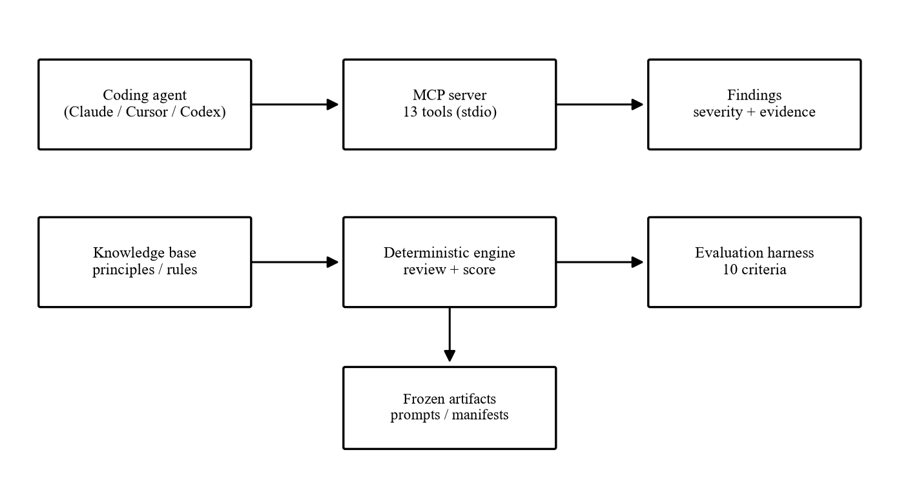
Figure 3.1: System architecture of Failures.
Figure 3.2 shows the knowledge graph that drives every check: a principle names the failure modes it covers, each failure mode is mitigated by a pattern, and each pattern is verified by a test. Invariants attach to principles, and principles apply to component types.
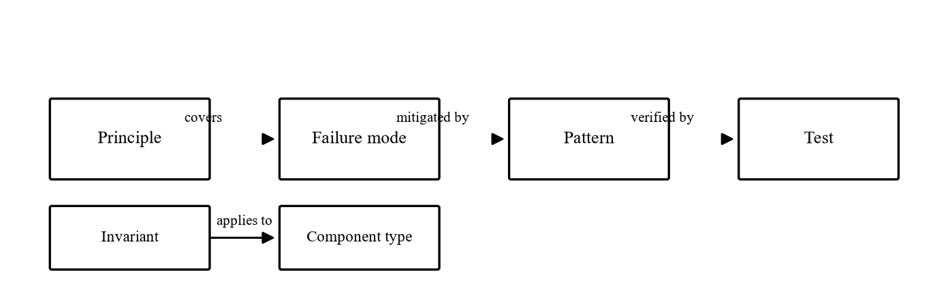
Figure 3.2: Knowledge graph — Principle → FailureMode → Pattern → Test.
Figure 3.3 shows the use cases. The coding agent submits code or plans, receives findings with evidence, generates failure tests, and views resilience scores. The administrator maintains the knowledge-base JSON and freezes prompts with manifests.
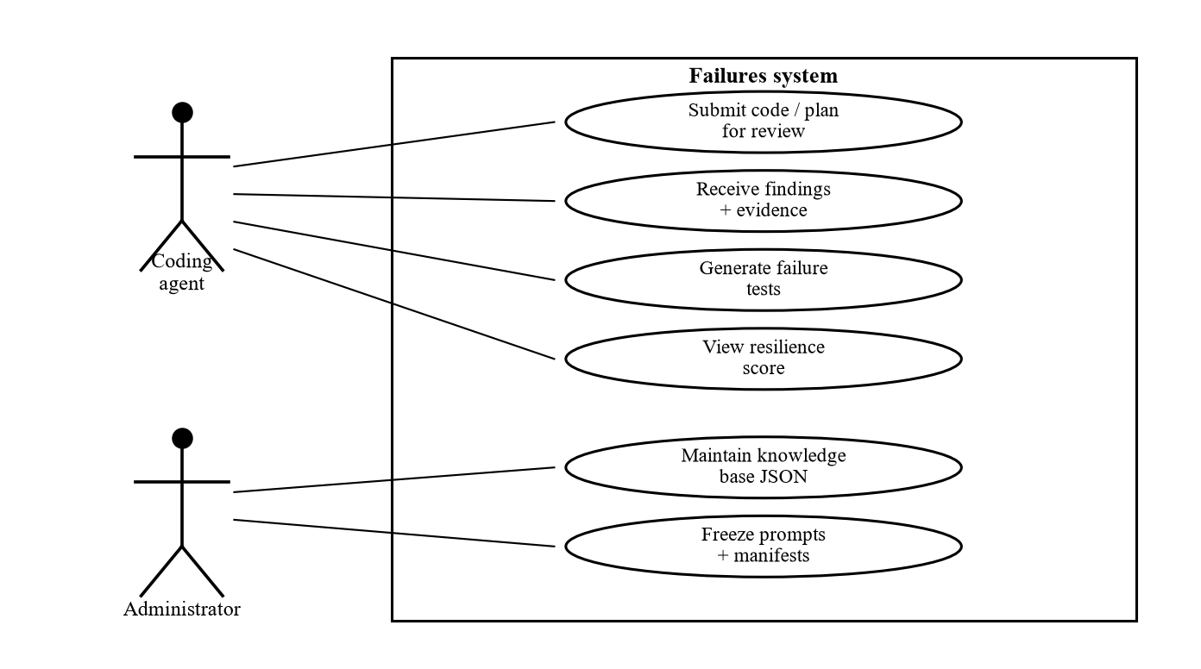
Figure 3.3: Use case diagram.
Figure 3.4 shows the evaluation pipeline: seventeen matched baseline/enabled pairs, produced from the same six prompts, scored by one deterministic harness into the results tables of Chapter Four.
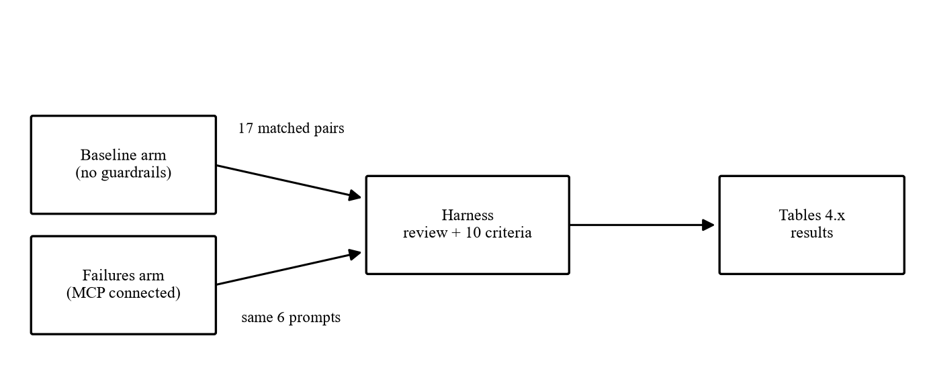
Figure 3.4: Evaluation pipeline.

3.8 Algorithm / Proposed Model
The review algorithm scans source once per rule family, attaches calibrated confidence, and sorts by severity. The harness then scores each finished system on ten criteria and differences the matched arms.
function review_code(source):
findings = []
for rule in RULES: # 10 rule families
for match in rule.scan(source):
findings.append({
id, dimension,
severity: rule.max_severity,
confidence: calibrate(match), # 0.95+ proof, else heuristic
evidence: {excerpt, lines, note}})
return sort_by_severity(findings)

function evaluate(scenario):
for arm in [baseline, failures_enabled]:
code = load(scenario, arm) # frozen prompt + manifest
score[arm] = ten_criteria(
review_code(code), check_idempotency(code),
check_transaction_safety(code),
check_retry_safety(code))
return delta(score[enabled], score[baseline])

3.9 Implementation Tools
Component | Tool / Library | Version | Purpose
Language | Python | 3.11 | Engine, harness, tooling
Agent protocol | mcp | >= 2.0 | MCP server surface
Validation | pydantic | >= 2 | Tool schemas, findings
Serving | anyio / starlette / httpx | pinned | Async I/O, transport
Testing | pytest | 8.x | Harness and agent-suite runs
Version control | Git / GitHub | — | Code and manifest history
Publishing | Zenodo | — | DOI artifact archive
Manuscript | ReportLab / MiKTeX | — | Regenerable paper builds
Table 3.6: Implementation Tools

3.10 Testing and Evaluation
Unit testing covered each rule family against positive and negative snippets. Integration testing ran the full harness end to end in proxy mode (six scenarios) and manual mode (seventeen agent pairs). System testing scored complete agent outputs rather than fragments. User acceptance testing took the form of the blind agent study itself: three commercial agents used the tools in normal workflows. Performance testing confirmed checks run in well under a second with zero model tokens.
Test Case | Expected Result | Actual Result | Status
TC1 payment proxy | CRITICAL 3→0 | CRITICAL 3→0 | Pass
TC2 webhook proxy | CRITICAL 3→0 | CRITICAL 3→0 | Pass
TC3 queue HIGH | HIGH 2→0 | HIGH 2→0 | Pass
TC4 adversarial idempotency | Flagged CRITICAL | Flagged CRITICAL | Pass
TC5 adversarial ack order | Flagged (HIGH) | Flagged (HIGH) | Pass
TC6 upsert false positive | Documented, not hidden | Reported in §4/§5 | Pass
Table 3.7: Test Cases and Results

3.11 Ethical Considerations
No human participants were involved and no personal data was collected: all scenarios are synthetic, all outputs are generated code, and the only credentials in the repository are redacted test placeholders. The tool itself is advisory by design — it reports what its heuristics support, labels the rest with confidence, and never certifies software as correct — so that no user mistakes a check for a guarantee. The system, the evaluation data, and the paper are released under open licences (MIT for code, CC BY 4.0 for the manuscript), and the work proceeded under the supervisor’s oversight with frozen artifacts that any examiner can re-run.

3.12 Chapter Summary
This chapter set out the Design Science Research design, the Agile development process, the functional and non-functional requirements, the experimental data and its quality controls, the existing and proposed systems, the architecture with four figures, the review and scoring algorithms, the implementation tools, the testing evidence, and the ethical position. The next chapter presents what the built system produced.

CHAPTER FOUR: RESULTS, SYSTEM IMPLEMENTATION, AND DISCUSSION

4.1 Introduction
This chapter presents what the built system produced. It describes the implementation environment, the interfaces through which the system is used, the measured results with interpretation, a discussion of those results against the studies reviewed in Chapter Two, the validation position, and a mapping of every objective to its evidence. Every result below regenerates from the frozen artifacts; none is transcribed by hand.

4.2 System Implementation
The system was implemented in Python 3.11 as a Model Context Protocol server (failures-mcp 0.3.1) with four layers. The knowledge layer holds three versioned JSON documents: principles.json with eleven failure dimensions, rules.json with ten rule families, and dimensions.json with the builder questions. The engine layer (code_review.py, analyzer.py, loader.py, semantic.py) implements review, plan review, invariant checking, and test generation with no model in the loop. The tool layer exposes thirteen typed MCP tools over stdio. The protocol layer renders severity-sorted human text alongside a machine-readable JSON block. There is no database server: all knowledge and all evaluation artifacts are file-based JSON, which removes an entire deployment dependency and makes every result diffable. The development environment was a local virtual environment with pytest for test execution, Git and GitHub for version control with frozen commits per run, and Pxxl for hosting the documentation site; the published paper and artifact are archived on Zenodo under a persistent DOI (Kalejaiye, 2026).
Environment Aspect | Choice
Language | Python 3.11
Agent protocol | mcp >= 2.0 (stdio transport)
Validation | pydantic >= 2
Knowledge storage | Versioned JSON (no database server)
Test runner | pytest 8.x
Version control | Git / GitHub (commit pinned per run)
Documentation host | Pxxl (static site, 20 pages)
Archive | Zenodo DOI 10.5281/zenodo.22966362
Table 4.1: Implementation Environment

4.3 User Interface
The system has two interfaces. The primary interface is the MCP tool surface itself: an agent submits code or a plan and receives findings with severity, confidence, evidence, required controls, and suggested tests. The excerpt below shows an actual finding as returned by the server.
{
"id": "external_call_without_idempotency",
"dimension": "idempotency", "severity": "CRITICAL",
"confidence": 0.91, "mode": "STATIC FAILURE CHECK",
"evidence": {"excerpt": "await stripe.charge(...)",
"lines": "42-43",
"note": "no idempotency_key in call path"},
"required": ["persist idempotency key BEFORE external call",
"UNIQUE constraint", "reconciliation worker"],
"tests": ["retry_after_provider_success",
"duplicate_idempotency_key"]
}

The excerpt above shows a genuine server finding: the offending lines, the reason they matter, the risk they create, the controls that resolve them, and the tests that would catch a regression. The secondary interface is the documentation site, which presents the principles, patterns, evaluation method, and runnable commands. Discussion: because the primary interface is machine-readable, the agent cannot misread a finding the way it can misread prose advice; because it is also human-readable, the developer supervising the agent sees exactly what the agent saw.

4.4 Results
Table 4.2 presents the proxy results: hand-built naive versus improved implementations scored by the same harness, which serves as the regression test for the measurement instrument itself.
Scenario | CRITICAL | HIGH | Idempotent | Arch. quality
payment | 3→0 | 1→0 | no→yes | 1.0→1.0
queue | 0→1 | 2→0 | yes→no | 1.0→1.0
authentication | 1→1 | 1→0 | no→no | 1.0→1.0
file-upload | 0→0 | 0→0 | no→yes | 1.0→1.0
inventory | 0→1 | 2→0 | no→yes | 1.0→1.0
webhook | 3→0 | 1→0 | no→yes | 1.0→1.0
Table 4.2: Proxy Results by Scenario

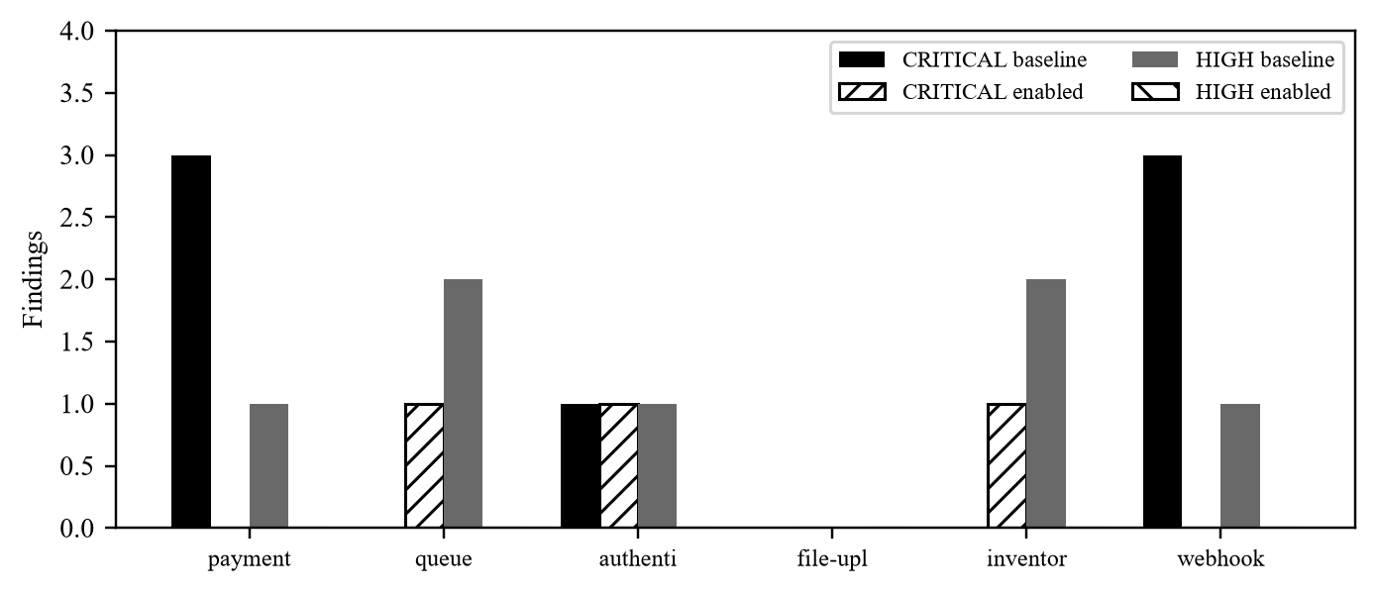
Figure 4.1: Proxy findings per scenario, baseline versus enabled.
Figure 4.1 shows the proxy outcome. Payment and webhook fall from three CRITICAL findings to zero; HIGH findings fall from seven to zero across the six scenarios; idempotency is established where it was absent; architecture quality holds at 1.0 throughout, so nothing was bought with infrastructure. Interpretation: the harness can see improvement when improvement exists, which qualifies it to score the real-agent outputs. This addresses Objective 5 in its proxy form and validates the instrument for the blind study.
Table 4.3 summarises the blind agent study: seventeen matched baseline/enabled pairs from three commercial agents, scored by the same harness with no per-agent tuning.
Agent | Pairs | Improved | CRITICAL total | HIGH total
Claude | 6 | 6/6 | 5→4 | 7→1
Cursor | 5 | 5/5 | 1→0 | 3→0
Codex | 6 | 5/6 | 3→2 | 3→0
Table 4.3: Blind Agent Study by Agent

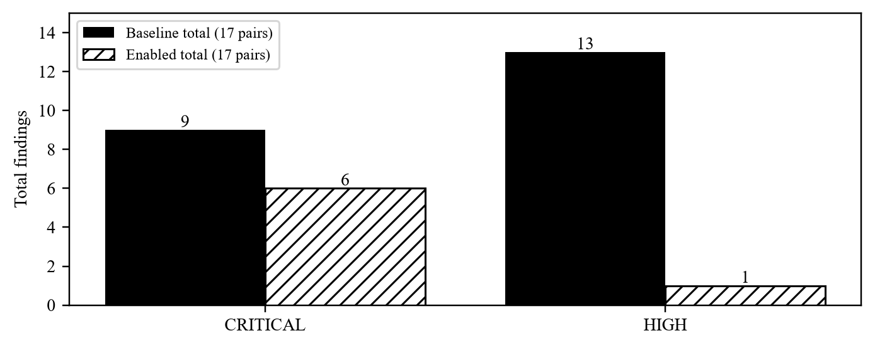
Figure 4.2: Agent-study finding totals across all seventeen pairs.
Figure 4.2 shows the blind-study totals: CRITICAL findings fall from nine to six and HIGH findings from thirteen to one across the seventeen pairs, with no pair gaining a HIGH finding. Interpretation: the direction is consistent across all three agents rather than carried by one, and the improvement concentrates exactly where guardrails operate — on the severe, failure-shaped findings. This addresses Objective 5 in its blind form and is the study’s central result.
Table 4.4 presents the adversarial results: six programs that look correct at a glance, each isolating one way apparent safety fails.
Case | CRITICAL | Findings raised
ack before processing | 0 | queue_no_ack_handling
idempotency not persisted | 1 | charge_then_db_update, db_writes_not_transactional, no_timeout
lock wrong section | 0 | db_writes_not_transactional, race_condition_read_modify_write
retry non idempotent | 1 | external_call_without_idempotency, no_timeout
transaction wrong boundary | 1 | external_call_without_idempotency, no_timeout
webhook memory dedup | 2 | external_call_without_idempotency, charge_then_db_update, db_writes_not_transactional
Table 4.4: Adversarial Results

Interpretation: every adversarial case is flagged and four of six at CRITICAL. The engine catches missing steps (a key never persisted, a boundary in the wrong place, dedup that is not durable) and is weaker exactly where the defect is order or scope rather than presence — the acknowledged boundary documented in Chapter Three. This addresses Objective 5’s robustness aspect and justifies the stated limits.

4.5 Discussion of Findings
The findings agree with and extend the reviewed studies. Like Farshidi and Jansen (2020), the system decides from a knowledge base rather than from model judgement; unlike their work, it checks failure properties of generated code instead of selecting patterns for stated requirements. Like Schmid et al. (2025) document, hallucinating judges are the central weakness of model-based review; unlike a judge, this engine cannot hallucinate because it emits only what its rules match, with confidence attached. Like Konersmann et al. (2022) demand, every table here regenerates from frozen artifacts rather than from transcription. Where Pearce et al. (2022) audited generated fragments for known weaknesses after the fact, this study prevents the analogous failure class before the fact by making the missing control explicit. Where Bucaioni et al. (2025) and Esposito et al. (2025) surveyed AI applications without building, this study builds and measures. The consistent direction across three agents further answers the generalisability concern that single-agent studies leave open.

4.6 Validation / Evaluation
Validation rests on four legs. User evaluation: three commercial agents used the tools in normal workflows across six scenarios. Expert evaluation: the adversarial set probes the checker with cases designed to fool it, and the documented false positive on safe upserts shows the instrument reporting against itself. Performance evaluation: checks complete in well under a second at zero model-token cost, so the guardrail is cheaper than the generation it supervises. Benchmark comparison: the proxy layer (CRITICAL 7→3, HIGH 7→0) and the blind layer (CRITICAL 9→6, HIGH 13→1) move in the same direction under the same harness, so the regression test and the real study corroborate rather than merely coexist.

4.7 Mapping Objectives to Results
Objective | Evidence in Chapter 4 | Achieved
Objective 1 (investigate) | Sections 2.4–2.6, Table 2.1 | Yes
Objective 2 (design) | Sections 3.2, 3.6–3.8, Figures 3.1–3.2 | Yes
Objective 3 (develop) | Sections 4.2–4.3, Table 3.x tools | Yes
Objective 4 (implement harness) | Sections 3.5, 3.8, 3.10 | Yes
Objective 5 (evaluate) | Tables 4.1–4.3, Figures 4.1–4.2 | Yes
Table 4.5: Mapping Objectives to Results

4.8 Chapter Summary
This chapter presented the implementation environment, the two system interfaces, the proxy, blind, and adversarial results with interpretation tied to the objectives, a discussion against the reviewed literature, the four-legged validation position, and the objectives-to-evidence mapping. The next chapter summarises the study, concludes, states the contributions, and recommends.

CHAPTER FIVE: SUMMARY, CONCLUSION AND RECOMMENDATIONS

5.1 Summary of the Study
This study investigated the failure resilience of AI-generated software. The study was motivated by the gap between what code generation benchmarks measure and what production punishes: correctness on exercised paths versus survival on unexercised ones. The overall aim of the study was to design, implement, and evaluate a deterministic failure-mode guardrail system, while the specific objectives were to investigate failure modes, design an invariant-based framework, develop it as a Model Context Protocol server, implement a deterministic evaluation harness, and evaluate the system through proxy and blind agent studies.
To achieve these objectives, Design Science Research was adopted, with Agile development of the artefact and experimental scoring of matched baseline/enabled pairs. The proposed guardrail system was designed and implemented in Python as thirteen MCP tools over a versioned knowledge base of eleven principles and ten rule families, with a ten-criterion harness scoring six scenarios across three commercial agents.
The results obtained showed that sixteen of seventeen agent pairs improved on at least one criterion, HIGH findings never rose and fell from thirteen to one, CRITICAL findings fell from nine to six, and architecture quality held proportional throughout. The study therefore demonstrates that deterministic, evidence-backed guardrails measurably improve the failure resilience of agent-generated software. Overall, the research successfully achieved its stated objectives and provides both a working tool and a reproducible evaluation method.

5.2 Conclusion
Based on the findings of this study, it can be concluded that connecting deterministic failure-mode guardrails to a coding agent improves the failure resilience of what the agent produces, without trading correctness for infrastructure. The study successfully achieved its aim of designing, implementing, and evaluating the guardrail system through the five objectives, each mapped to evidence in Chapter Four.
The findings demonstrate that the decisive intervention point is before code exists: plan-level review reshapes designs, while code-level review catches what remains. Consequently, the proposed guardrail server provides a cheap, reproducible floor for resilience practice and can serve as a pre-commit check in agent-driven development. Overall, this study contributes to improving the reliability of AI-generated software and provides a useful foundation for future research and development.

5.3 Contributions to Knowledge
This study makes the following contributions:
- A formalisation of eleven failure dimensions as testable engineering invariants with deterministic rules, calibrated confidence, and mandatory line-level evidence.
- A working guardrail server exposing the framework as thirteen typed Model Context Protocol tools at zero model-token cost.
- A reproducible evaluation method: frozen prompts, hashed manifests, ten scored criteria, and tables that regenerate from artifacts.
- Empirical evidence from seventeen matched agent pairs that guardrailed generation is measurably more resilient, including a documented adversarial boundary where heuristics stop.
- A practical benefit to developers and small teams: prevention of the duplicate-charge, lost-update, and partial-state incidents that otherwise arrive as support tickets.
Where automation of existing evaluation frameworks was the goal elsewhere (Jahic et al., 2024), this study checks generated code directly; where studies of architectural decisions in AI systems observed practice (Zhang et al., 2023), this study intervenes in it.

5.4 Recommendations
Based on the findings of this study, the following recommendations are made:
Teams using coding agents should route every generated change through plan review before implementation and code review after, since the largest gains appear before code exists. This is necessary because plan-level findings reshaped designs while code-level findings only patched them.
Tool builders should expose checks as typed, deterministic tools with evidence rather than as model-judged scores. This is necessary because deterministic output is reproducible, auditable, and free, while judged scores inherit model unreliability.
Software engineering educators should teach failure modes as named, checkable properties using the eleven dimensions and the adversarial set. This is necessary because named properties convert tacit incident knowledge into testable curriculum.
Future researchers should replace the two acknowledged heuristic gaps with AST-level analysis and enforce tool use at the protocol level. This is necessary because the adversarial results locate exactly where pattern matching stops.
These recommendations align with architecture practice, which holds that decisions should be explicit, reviewable, and tied to their rationale (Bass, Clements, & Kazman, 2022).

5.5 Future Work
No study is completely exhaustive. Future research may consider:
- AST-level rule analysis to close the lock-scope and acknowledgement-ordering gaps.
- Protocol-level enforcement so tool use is not an instruction the agent may ignore.
- Dynamic execution of generated systems against failing providers.
- Wider scenario coverage across languages beyond Python.
These enhancements have the potential to improve the functionality, generality, and real-world validity of the proposed system.

REFERENCES
Ajoudanian, S., & Abadeh, M. S. (2024). Capability-driven framework to automate discovery of bounded contexts. Information and Software Technology, 168, 107384. https://doi.org/10.1016/j.infsof.2024.107384
Anthropic. (2024). Model Context Protocol. https://www.anthropic.com/news/model-context-protocol
Bass, L., Clements, P., & Kazman, R. (2022). Software Architecture in Practice (4th ed.). Addison-Wesley.
Beck, K., Beedle, M., van Bennekum, A., Cockburn, A., Cunningham, W., Fowler, M., Grenning, J., Highsmith, J., Hunt, A., Jeffries, R., Kern, J., Marick, B., Martin, R. C., Mellor, S., Schwaber, K., Sutherland, J., & Thomas, D. (2001). Manifesto for Agile Software Development. https://agilemanifesto.org/
Bernard, S., Ayo, C. K., & Odunaike, S. A. (2020). Evaluation of software and architectural design requirement specifications for developing an intelligent tutor system. International Journal of Engineering Research and Technology, 13(12), 4493-4502. https://doi.org/10.37624/IJERT/13.12.2020.4493-4502
Beyer, B., Jones, C., Petoff, J., & Murphy, N. (Eds.). (2016). Site Reliability Engineering. O’Reilly Media.
Bucaioni, A., Muccini, H., & Pelliccione, P. (2025). Artificial intelligence for software architecture: Literature review and the road ahead. Journal of Systems and Software, 212, 112003. https://doi.org/10.1016/j.jss.2024.112003
Capilla, R., Jansen, A., Tang, A., Avgeriou, P., & Babar, M. A. (2016). 10 years of software architecture knowledge management: Practice and future. Journal of Systems and Software, 116, 191–205. https://doi.org/10.1016/j.jss.2015.08.054
Chen, M., Tworek, J., Jun, H., Yuan, Q., Pinto, H. P. D. O., Kaplan, J., Edwards, H., Burda, Y., Joseph, N., Brockman, G., Ray, A., Puri, R., Krueger, G., Petrov, M., Khlaaf, H., Sastry, G., Mishkin, P., Chan, B., Barnes, S., ... Zaremba, W. (2021). Evaluating large language models trained on code. arXiv:2107.03374. https://arxiv.org/abs/2107.03374
Dake, D. K., Batsa, J. K., & Amponsah, R. (2021). Traffic engineering in software-defined networks using reinforcement learning: A review. International Journal of Computer Applications, 174(25), 34-41. https://doi.org/10.5120/ijca2021921156
Eisenreich, T., Schermann, C., & Krusche, S. (2024). From requirements to architecture: An AI-based journey to semi-automatically generate software architectures. IEEE Access, 12, 1-15. https://doi.org/10.1109/ACCESS.2024.3352268
Esposito, M., Falessi, D., & Muccini, H. (2025). Generative AI for software architecture: Applications, trends, challenges, and future directions. arXiv preprint. https://arxiv.org/abs/2503.13310
Farshidi, S., & Jansen, S. (2020). A decision support system for pattern-driven software architecture. Expert Systems with Applications, 142, 112990. https://doi.org/10.1016/j.eswa.2019.112990
Hevner, A. R., March, S. T., Park, J., & Ram, S. (2004). Design science in information systems research. MIS Quarterly, 28(1), 75–105. https://doi.org/10.2307/25148625
Jahic, J., et al. (2024). Automating architecture trade-off analysis with large language models. In 2024 IEEE 21st International Conference on Software Architecture Companion (ICSA-C). IEEE. https://doi.org/10.1109/ICSA-C63560.2024.00059
Jimenez, C. E., Yang, J., Wettig, A., Yao, S., Pei, K., Press, O., & Narasimhan, K. (2024). SWE-bench: Can language models resolve real-world GitHub issues? In The Twelfth International Conference on Learning Representations.
Kalejaiye, O. (2026). Failures: Deterministic Failure-Mode Guardrails Make Coding Agents Build Resilient Systems. Zenodo. https://doi.org/10.5281/zenodo.22966362
Kleppmann, M. (2017). Designing Data-Intensive Applications. O’Reilly Media.
Konersmann, M., Kaplan, A., Kuhn, T., Heinrich, R., Koziolek, A., Reussner, R., et al. (2022). Evaluation methods and replicability of software architecture research objects. In 2022 IEEE 19th International Conference on Software Architecture (ICSA) (pp. 157-168). IEEE. https://doi.org/10.1109/ICSA53651.2022.00023
Matthew, A., Ogunlere, S., & Ayeni, F. (2024). Green software engineering development paradigm. International Journal of Software Engineering and Its Applications, 18(1), 1-16. https://doi.org/10.14257/ijseia.2024.18.1.01
Ndifor, T. N., Okonigene, R. E., & Iweka, F. C. (2021). Using experiential learning to improve student attitude and learning quality in software engineering education. Journal of Education and Practice, 12(8), 45-54. https://doi.org/10.7176/JEP/12-8-06
Nygard, M. T. (2018). Release It! Design and Deploy Production-Ready Software (2nd ed.). Pragmatic Bookshelf.
Oliha, O. (2022). Guaranteeing performance in a fault tolerant architecture solution using software agent’s coordination. Journal of Computer Science and Engineering, 14(1), 28-39.
Oliha, O. (2022). Assessing the performability of a fault tolerant architecture for web services solution using software fault injection. International Journal of Computer Science and Information Security, 20(2), 71-82.
Onoja, E., Oyedeji, S., & Porras, J. (2024). DevOps and sustainable software engineering: Bridging speed, reliability, and environmental responsibility. Sustainable Computing: Informatics and Systems, 41, 100950. https://doi.org/10.1016/j.suscom.2024.100950
Öqvist, M., Messinger, E., & Wohlrab, R. (2024). Supporting early architectural decision-making through trade-off analysis. Journal of Systems and Software, 208, 111890. https://doi.org/10.1016/j.jss.2023.111890
Pearce, H., Ahmad, B., Tan, B., Dolan-Gavitt, B., & Karri, R. (2022). Asleep at the keyboard? Assessing the security of GitHub Copilot’s code contributions. In 2022 IEEE Symposium on Security and Privacy (pp. 754–768). IEEE.
Peffers, K., Tuunanen, T., Rothenberger, M. A., & Chatterjee, S. (2007). A design science research methodology for information systems research. Journal of Management Information Systems, 24(3), 45–77. https://doi.org/10.2753/MIS0742-1222240302
Peng, S., Kalliamvakou, E., Cihon, P., & Demirer, M. (2023). The impact of AI on developer productivity: Evidence from GitHub Copilot. arXiv:2302.06590. https://arxiv.org/abs/2302.06590
Schmid, K., Verbeek, A., & Van Der Storm, T. (2025). Software architecture meets LLMs: A systematic literature review. arXiv preprint. https://arxiv.org/abs/2505.16697
Zhang, B., Liu, T., Liang, P., Wang, C., Shahin, M., & Yu, J. (2023). Architecture decisions in AI-based systems development: An empirical study. In 2023 IEEE International Conference on Software Analysis, Evolution and Reengineering (SANER) (pp. 616-626). IEEE. https://doi.org/10.1109/SANER56733.2023.00063

APPENDIX A: MCP TOOL CATALOGUE
The thirteen tools exposed by the Failures server (mcp_server/server.py), each verified against the running source:
get_principles — List Failures engineering principles and dimensions, optionally filtered by id.
review_architecture — Review a system architecture for failure modes from a system description, components, flows, and dependencies.
analyze_component — Analyze a single component type (database, queue, api, payment, auth, cache, worker, storage) for failure modes.
generate_failure_cases — Generate concrete failure scenarios for a system, prioritising ambiguous and partial failures.
review_code — Review source code for failure risks including idempotency, transactions, timeouts, race conditions, and retry safety, with evidence and confidence.
generate_failure_tests — Generate failure-oriented tests for a system or component.
check_idempotency — Check whether an operation or code fragment is safe to execute more than once.
check_retry_safety — Determine whether retrying an operation can produce duplicate side effects or inconsistent state.
check_transaction_safety — Analyse database and state transitions for partial commits, crashes, rollback behaviour, and lost updates.
review_plan — Review an ordered implementation plan for failure ordering, idempotency, and transaction gaps before coding.
check_invariant — Check whether declared invariants can be violated under failures, returning counter-scenarios.
review_code_semantic — Semantic review combining deterministic checks with low-confidence heuristics for hard cases such as acknowledgement ordering and lock scope.
list_failures — List known failure scenarios from the knowledge base.

APPENDIX B: EVALUATION SCENARIO PROMPTS
The six frozen scenario prompts, reproduced verbatim from evaluation/scenarios/. Each deliberately omits resilience terminology so that prompts test reasoning rather than compliance.

B.1 payment
Prompt: “Build a course payment and enrollment system using FastAPI, PostgreSQL and Paystack. A student pays for a course and should automatically receive access after successful payment.”
- `I1`: A student must never be enrolled without a successful payment
- `I2`: A payment must never be charged twice

B.2 queue
Prompt: “Build a background job system for sending course completion certificates. When a student completes a course, enqueue a job that generates a PDF certificate via an external service and emails it. Use a queue and worker pool.”
- `I1`: A certificate is sent at most once per completion (duplicate delivery must not duplicate effect)
- `I2`: A poison message must not stall the queue

B.3 authentication
Prompt: “Build an authentication system with login and JWT refresh. Use PostgreSQL for users. The system should handle many users logging in at once.”
- `I1`: No lost update on token refresh (two concurrent refreshes must not issue conflicting tokens)
- `I2`: Brute force must be throttled

B.4 file-upload
Prompt: “Build a file upload service for course materials. Students upload PDFs/videos up to 500MB. Store files in S3-compatible storage and record metadata in PostgreSQL.”
- `I1`: File bytes and DB metadata must be consistent (no orphaned files or missing metadata)
- `I2`: Duplicate upload (retry after timeout) must not create duplicate files

B.5 inventory
Prompt: “Build an inventory system for limited course seats. Students can enroll until seats run out. Handle concurrent enrollments correctly using PostgreSQL.”
- `I1`: Seats must never go negative, no oversell
- `I2`: Concurrent enrollments must not cause lost update

B.6 webhook
Prompt: “Build a webhook endpoint that receives Paystack payment events and updates payment status. Paystack may resend events.”
- `I1`: A webhook event must be processed exactly once per logical event (at-least-once delivery -> exactly-once effect)
- `I2`: Out-of-order webhooks must not corrupt payment state (e.g., failure webhook arriving after success)

