**MAIN SOURCE OF DRINKING WATER**

Using main source of drinking water dataset that contains information on Dwelling occupants owning the dwelling they live in and are using piped water which was collected for the Maji-data project. MajiData is the pro-poor database covering all the urban low income areas of Kenya which has been prepared by the Ministry of Water and Irrigation (MWI) and the Water Services Trust Fund (WSTF) in cooperation with UN-Habitat, the German Development Bank (KfW), Google org. and GIZ, I was able to visualize data as per county.

TOTAL WATER POINTS PER COUNTY.

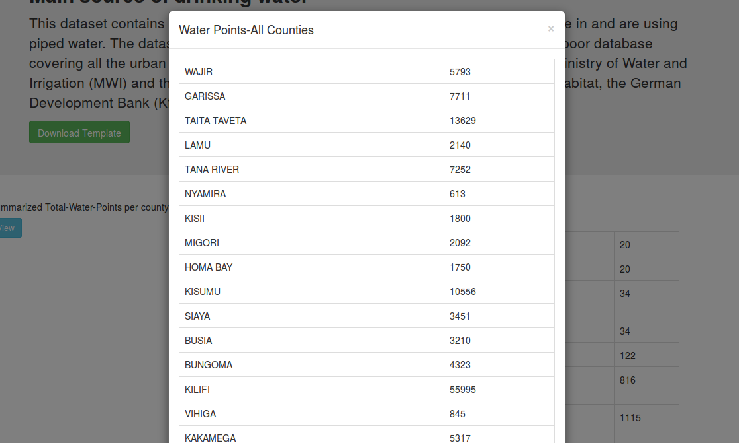

The display is presented by identifying distinct counties and getting the total number of water points in a tabular form.

COUNTY-WISE DETAILED.

Every county has variety of sources , I have used a dropdown for user to select the county he/she needs to view and the detailed water sources information is displayed for that county selected

 1.step one. - select the county from the drop down list

2.Step 2.

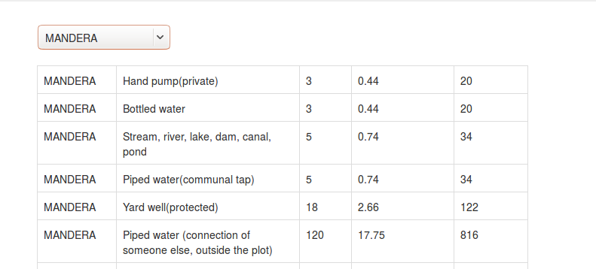Detailed water source data of that county will be displayed in tabular.- in this case I have selected mandera.

TOOLS USED.

* CSV dataset from https://data.humdata.org/dataset/main-source-of-drinking-water
* D3 Javascript Library for visualizing database
* Javascript.