 

________________________________________________

**PIDEV REPORT:**

**Implementation of Smart Virtual Classroom Application**

________________________________________________

**Elaborated By:**

               Habbachi Maysa

Fajraoui Khaled

Ghazouani Neji

Harrath Ali

**University Year: 2020/2021s**

**Table of content**

Introduction 1

Chapter 1: Preliminary Study 2

I. Project Context: 2

II. Problematic: 2

III. Project objectives: 3

IV. Existing Solution: 3

V. Proposed solution: 5

Chapter 2: Planning the Application 10

I. Requirement Analysis: 10

II. ADVANCED FEATURES: 12

III. PHYSICAL ARCHITECTURE 16

IV. TECHNICAL ENVIRONMENT: 17

V. CONCEPTION: 18

VI. TOOLS AND LIBRARIES: 21

VII. CONCLUSION: 24

**Table of figures**

Figure 1:Pear web application 4

Figure 2:PeerGrade web application 5

Figure 3:Sign up form 6

Figure 4:profile Form 7

Figure 5:workshop form 7

Figure 6:scores form 8

Figure 7:login form 9

Figure 8:Peer Evaluation Canvas Model 15

Figure 9:Mern Architecture 16

Figure 10:Web Storm 17

Figure 11:Visual Code 17

Figure 12:MongoDB 17

Figure 13:Use Case Global 18

Figure 14:Data Model 19

Figure 15:Sequence Diagram 20

Figure 16:JWT 21

Figure 17:Passport.js 21

Figure 18:NodeMailer 22

Figure 19:Full Calendar 22

Figure 20:Canvas JS 22

Figure 21:Chart JS 23

# **Introduction**

Nowadays, the new technologies and communications are invading all sectors and becoming more and more indispensable to ensure a fluid flow of information

Smart classroom the representative of the modern teaching. With the advent of modern technology it becomes easier for the students as well as teachers to perform their task more efficiently.

With the aid of modern technology it has become easier for the students and teachers across the world to get a good grasp of the theoretical as well as practical knowledge.

The smart classroom is rectification to various problems that teacher as well as student faces inside the classroom.

This projects aims to make use of the modern technology for helping the teachers in utilizing more time for teaching and students to easily get access to the study material.

In this project we are building a prototype of smart classroom in which an application would be pivotal for carrying out various operations in classroom.

Our report is composed of two chapters:

• **Preliminary Study:** First we will set our goals in which we will describe the context and project objectives. Then we will precede with the state of the art: we will talk about the existing solution and competitors. Finally, we will describe our work plan

**•Planning the application:** we will talk about the requirement analysis and we will precede with some uses cases and finally we will show you some prototypes.

**Chapter 1: Preliminary Study**

1. **Project Context:**

Peer evaluation is an effective collaborative learning strategy.

Related to self-assessment, peer evaluation encourages students to critically examine a task and its performance, then communicate constructive suggestions for improvement.

In the process of examining the work of peers, students reflect on the meaning of quality work in general, especially when consulting a detailed rubric or checklist as a guide.

The use of peer evaluation in group work can increase motivation, engagement and social presence in a course while maximizing instructional time.

In effect, the students themselves provide feedback to one another, while the instructor focuses on more targeted guidance.

The key for successful peer feedback is a constructive, honest environment in which students feel safe to share honest, yet helpful criticism.

1. **Problematic:**

Regarding the Teaching/learning strategies deployed in our universities there's a lack of history record regarding the student's performance.

Teachers rarely detect the student’s deficiencies early on which will conclude to the student’s failure

Peer Evaluation isn’t deployed in our universities, we only rely on the teacher’s feedback

This whole process is underestimated.

1. **Project objectives:**

**Why Peer Evaluation?**

It provides a structured learning process for students to criticize and provide feedback to each other on their work.

What Peer Evaluation can solve?

It engages students in the learning process and develops their capacity to reflect on and critically evaluate their own learning and skill development.

**What Peer Evaluation can solve?**

It engages students in the learning process and develops their capacity to reflect on and critically evaluate their own learning and skill development.

1. **Existing Solution:**

We found out some web applications that could serve our purpose. This are some examples:

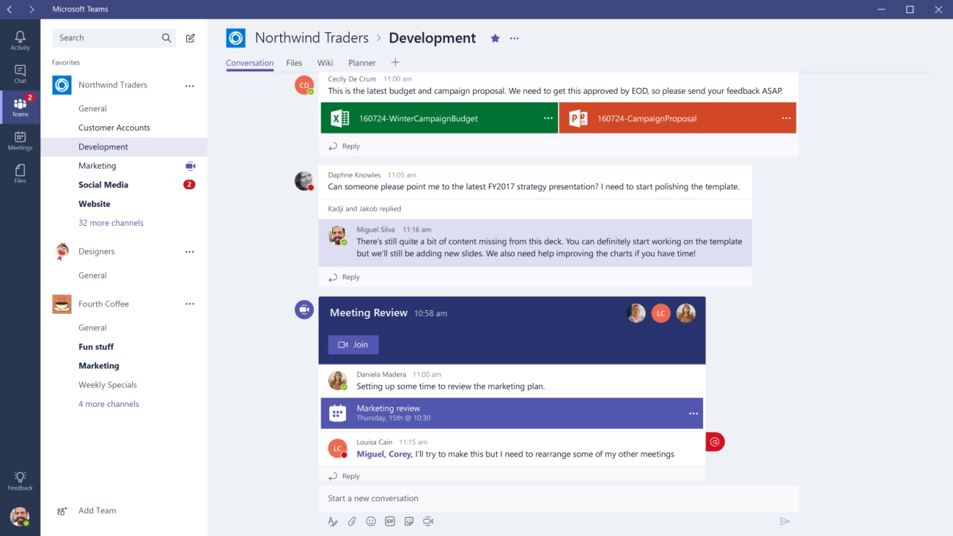

**Figure 1:Microsoft teams application**

**Microsoft Teams** is a proprietary business communication platform developed by [Microsoft](https://en.wikipedia.org/wiki/Microsoft), as part of the [Microsoft 365](https://en.wikipedia.org/wiki/Microsoft_365) family of products. Teams primarily competes with the similar service [Slack](https://en.wikipedia.org/wiki/Slack_(software)), offering workspace chat and videoconferencing, file storage, and application integration.

Teams is replacing other Microsoft-operated business messaging and collaboration platforms, including [Skype for Business](https://en.wikipedia.org/wiki/Skype_for_Business) and [Microsoft Classroom](https://en.wikipedia.org/wiki/Microsoft_Classroom). Throughout the [COVID-19 pandemic](https://en.wikipedia.org/wiki/COVID-19_pandemic), Teams has gained much interest as many meetings have moved to a virtual environment.

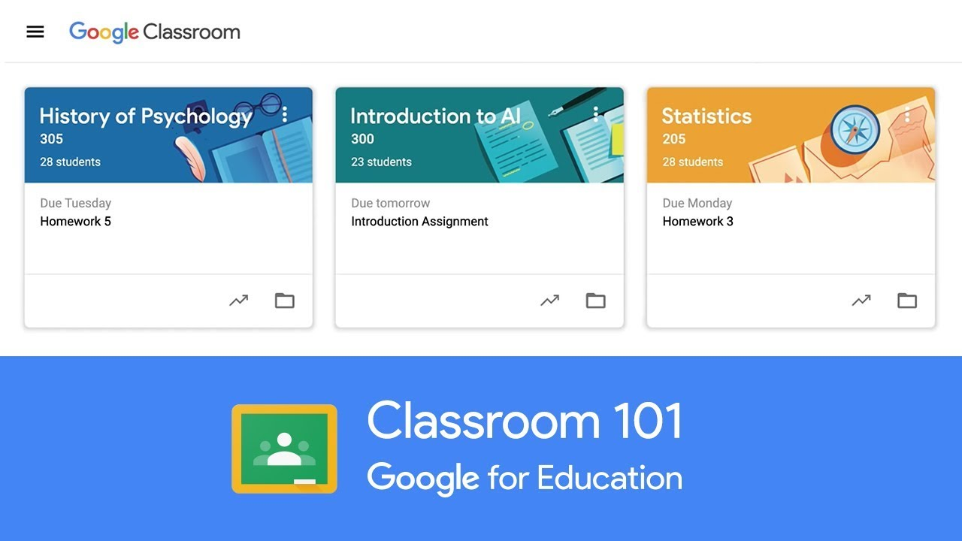

**Figure 2: Google Classroom web application**

**Google Classroom** is a free web service developed by [Google](https://en.wikipedia.org/wiki/Google) for schools that aims to simplify creating, distributing, and grading assignments. The primary purpose of Google Classroom is to streamline the process of sharing files between teachers and students.

1. **Proposed Solution:**

Our Solution called Edutopia

1. **Work Plan:**

**Chapter 2: Planning the Application**

1. **Requirement Analysis:**

The requirements specification is the initial phase of any application to be developed in which we will identify the needs of our application. We distinguish functional needs that present the features expected from our application and non-functional needs to avoid the development of an unsatisfactory application and to find a common agreement between specialists and users to make the project a success.

1. **Functional needs:**

**▪ The system must allow the student to:**

- Apply for registration

- Authenticate

-Check history record

-Give feedback on another student’s work

-Apply for a course’s workshop

-Review a student’s work

-Apply for an online course

-Apply for a course training

-Train online

**▪ The system must allow the teacher to:**

-Give his feedback

-Check the student’s performance

-Check student’s history

-Offer a private training class

-Accept student to his private class

**▪ The system must allow the administrator to:**

- Add or Delete students / teachers

-Edit students/teacher information

-Upgrade students/teachers from basic user to pro

-Check Dashboard

1. **Non-functional needs:**

These are requirements that are not related to the behavior of the system but that identify the internal and external constraints of the system. The main non-functional needs of my application can be summed up in the following points:

**•Data Access Security:** This application must provide maximum security through the identification of users who have the right to access data stored at the database level.

**•Maintainability**: The code of the application must be legible and understandable to be able to stay easily and quickly on setting up an understandable application with a readable and well-organized code with comments.

**•Availability:** The system must always be working.

**•Performance**: The application must be above all efficient, that is to say to cross its functionalities, it meets all the requirements of users in an ideal way.

**•Scalability:** The application has the capability to handle a growing amount of work, it has the potential to be enlarged to accommodate that growth

1. **Advanced features**

* **Peer Evaluation:** After logging in, the student can exercise the peer assessment, so first of all he needs to choose one of the projects he’s participating in. After selecting the project, he’ll be able to evaluate all the members engaged in it.
* **Self-Evaluation:** The Student can check himself, how good he is by passing an online Quiz in all the macro skills such as Communication Quiz or Leadership Quiz.
* **Profiling Students:** Teachers can see the student’s progression in all the

macro skills and can also compare all the students.

* **Skills Progression:** In every Project, a student can check his progression through a radar in which he sees the average grade he got
* **Workshop Training:** Teachers can specify a workshop training in which they choose a macro skill and a date so that when students connect, they can see them in a Calendar

**Thechnical architecture**

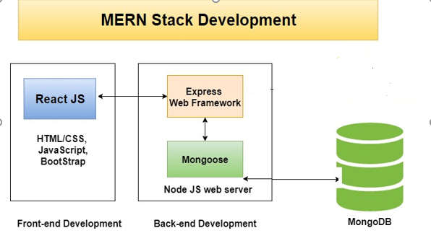

**Figure 9:Mern Architecture**



To develop our application, we used the MERN (MongoDB, Express, React, NodeJS) stack architecture, in which we would develop front-end interfaces using React, NodeJS as a web server in which we would use Express as a middleware, and mongoose, to connect with our Mongo Data Base.

1. **Languages and Frameworks**

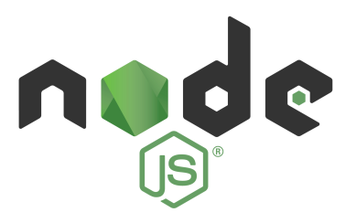

**NodeJS**: Node.js (Node) is an open source development platform for executing JavaScript code server-side.

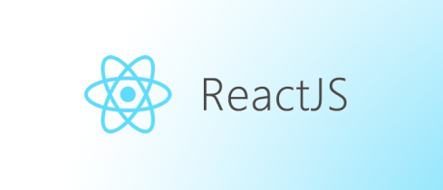



**React JS: React** (also known as **React**. **js** or **ReactJS**) is an open-source, front end, JavaScript library for building user interfaces or UI components



**Express JS: Express**, is a back end web application framework for **Node**. **js**, released as free and open-source software under the MIT License.



**MongoDB:** which is an open source document-oriented database program, classified as NoSQL database program. It uses JSON-like documents, which means that fields can vary from document to document and data structure can be changed over time.

1. **Conception**

* **Global Use Case**:

A use case is a methodology used in system analysis to identify, clarify and organize system requirements. The use case is made up of a set of possible sequences of interactions between systems and users in a particular environment and related to a particular goal. The method creates a document that describes all the steps taken by a user to complete an activity

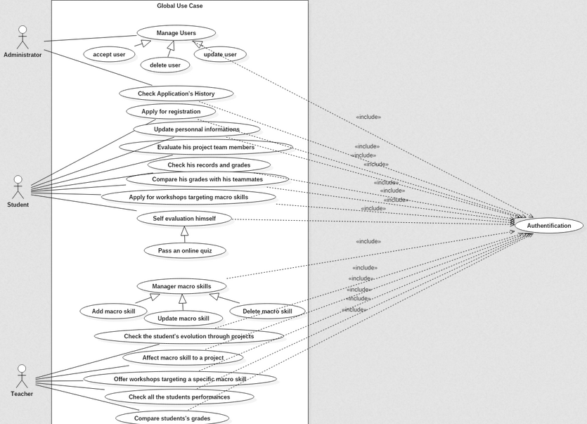

**Figure 13: Use Case Global**

1. **Prototyping**

**Conclusion**